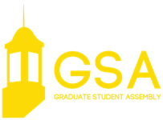

February 5, 2019 | 7:00 p.m.
Nebraska Union | Ballroom

CALL TO ORDER

APPROVAL OF THE MINUTES

OPEN FORUM

A presentation on forming departmental GSAs

EXECUTIVE REPORTS

President Reilly
Executive Vice President Ratcliff
Vice President of Student Affairs Martin
Vice President of Representation Stehle
Vice President of Finance Bhinderwala

COMMITTEE REPORTS

Diversity and Inclusion Co-Chairs Sotelo and Suchato
GTAP Chair Dahdolan
Professional Development Chair Atieno

NEW BUSINESS

GSA Bill #13 A bill amending the GSA bylaws

ANNOUNCEMENTS

ADJOURNMENT

