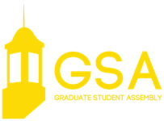

November 6, 2018 | 7:00 p.m.
Nebraska Union | Centennial Room

CALL TO ORDER

APPROVAL OF THE MINUTES

OPEN FORUM
Representatives from the American Association of University Professors

EXECUTIVE REPORTS

Executive Vice President Ratcliff
Vice President of Student Affairs Martin
Vice President of Representation Stehle
Vice President of Finance Ismert

COMMITTEE REPORTS

Academic Affairs Chair Juritsch
Quality of Life Co-Chairs Sandhu and Rodene
Social Events Chair Perez

NEW BUSINESS

GSA Bill #5 A bill allocating funds for a winter social and networking event
GSA Bill #6 A bill to form a committee to draft a letter to professors
GSA Bill #7 A bill authorizing a letter to upper administration on graduate student stipends
GSA Bill #8 A bill authorizing use of funds for GSA coffee hour events

EXECUTIVE REPORT

President Reilly

ANNOUNCEMENTS

ADJOURNMENT

