For the complete bibliography with references as well as an explanation of the classification scheme go to:
Demonstration Bibliography
The demonstration name listed in the bibliography is either the name listed on the reference or, if none is given, a simple descriptive name. In cases where there are several common names for a demonstration, the committee has chosen a preferred name.
The description is very brief. It is not intended to be a summary of the reference. One sentence is, in general, sufficient to describe the unique characteristics, if any, of an item. Each source has a unique numbering format. These unique formats are used identify references in the Bibliography.
The formats for the reference column and links to the sources are listed below:
Reference | Source
M-1 | Sutton
Ma-1 | Freier & Anderson
M-1d | Hilton
8-2.8 | Meiners
M-108 | Dick & Rae
1A 12.01 | University of Minnesota Handbook
AJP 52(1),85 | American Journal of Physics
TPT 15(5),300 | The Physics Teacher
Disc 01-01 | The Video Encyclopedia of Physics Demonstrations
PIRA 200 | Physics Instructional Resource Association
PIRA 500 | PIRA 500
PIRA 1000 | PIRA 1000
Each demonstration is listed in only one location, even if it is commonly used to illustrate several concepts.

11/13/17

1
SURFACE TENSION 4
Force of Surface Tension 4
Floating Metals 4
Cohesion Plates 5
Minimal Surface 6
Soap Film Minimal Surfaces 6
Capillary Action 7
Capillary Tubes 7
STATICS OF FLUIDS 8
Static Pressure 8
Pressure Independent of Direction 8
Pressure Dependence on Depth 9
Weigh Water in a Tube 10
Pascal's Vases 11
Pascal's Fountain 12
Hydraulic Press 13
Two Pistons 14
Hovercraft 15
Atmospheric Pressure 16
Brass Bar 16
Crush the Can 17
Magdeburg Hemispheres 18
Inverted Glass 19
Differential Pressure Bottle 20
Lift a Stool 21
Vacuum Bazooka 22
Measuring Pressure 23
Mercury Barometer 23
Torricelli’s Experiment 24
Manometer 25
Aneroid Barometer 26
Density and Buoyancy 27
Weigh Submerged Block 27
Archimedes' Principle 28
Battleship in a Bathtub 29
Ship Empty and Full 30
Cartesian Diver 31
Buoyancy of Air 32
Buoyancy Balloon 33
Water and Mercury “U” Tube 34
Density Ball 35
Density Rods 36
Hydrometer 37
Poly Density Bottle 38
Siphons, Fountains and Pumps 39
Hero’s Fountain 39
Tantulus Cup 40
Mariotte Flask and Siphon 41
Lift Pump 42
DYNAMICS OF FLUIDS 43
Flow Rate 43
Torricelli’s Tank 43
Forces in Moving Fluids 44
Bernoulli / Venturi Tubes 44
Atomizer 45
Floating Ball 46
Funnel and Ball 47
Lifting Plate 48
Attracting Sheets 49
Coanda Effect 50
Curve Ball 51
Flettner Rotator 52
Frisbee 53
Viscosity 54
Viscosity of Oil 54
Terminal Velocity 55
Vortices 56
Vortex Cannon 56
Tornado-in-a-Box 57
Paraboloids and Vortices 58

FLUID MECHANICS | 2A10.10, 2A10.20, 2A10.25 | SURFACE TENSION

Force of Surface Tension

Floating Metals
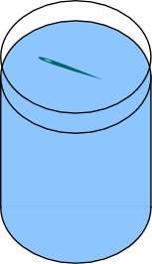 | Place the needle on a bit of tissue and place on the surface of fresh water. Sink the tissue with a stick, leaving the needle floating. Add a little soap to sink the needle.  Other surface tension items are shown in the photograph.
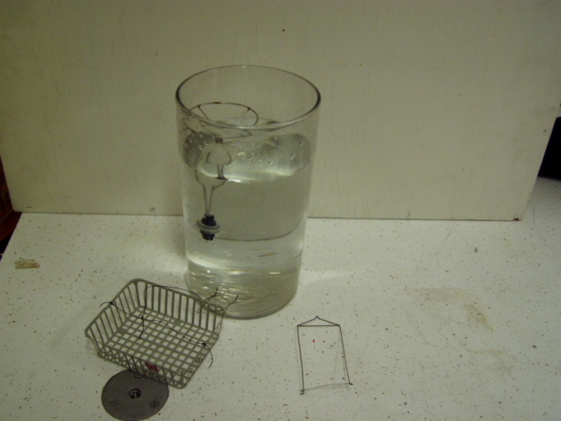
Location Dd2
FLUID MECHANICS | 2A10.35 | SURFACE TENSION
Force of Surface Tension

Cohesion Plates
 | Show the plates can be lifted off of one another dry; then wet them and try again.
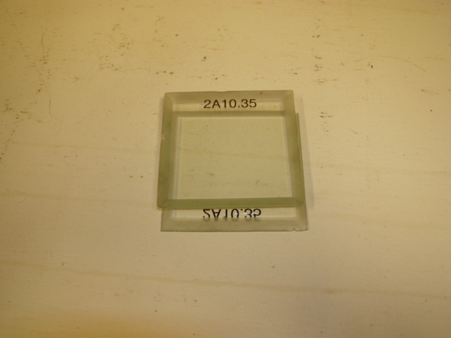Location: Dd2
FLUID MECHANICS | 2A15.20 | SURFACE TENSION

Minimal Surface

Soap Film Minimal Surfaces
 | Wire frames of different sizes and shapes form minimal surfaces when dipped in soap solution.
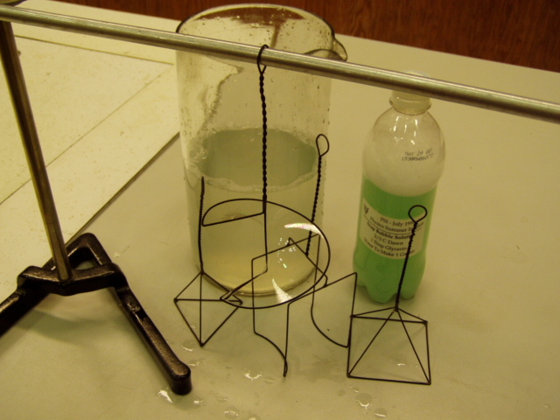Location: Dd2
FLUID MECHANICS | 2A20.10 | SURFACE TENSION

Capillary Action

Capillary Tubes
 | Fill a set of capillary tubes with water.
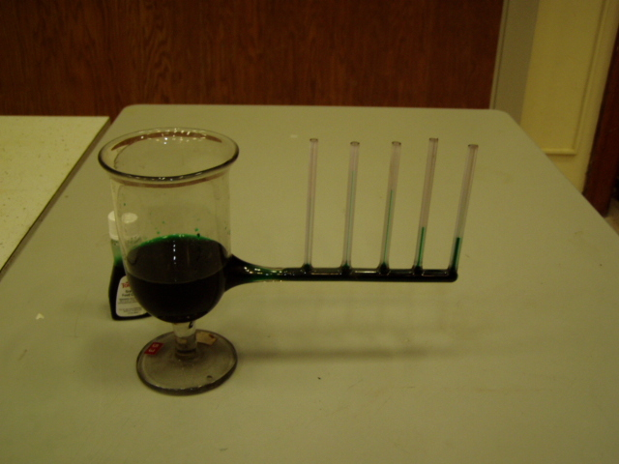Location: Dd2
FLUID MECHANICS | 2B20.10 | STATICS OF FLUIDS

Static Pressure

Pressure Independent of Direction
 | Immerse a tube connected to a pressure sensor and orient in various directions while keeping the depth constant. The Capstone File “Pressure and Depth.cap” displays the output of the sensor.
Location: Science Workshop Cabinet, Glassware Cabinet, Dd3
FLUID MECHANICS | 2B20.15 | Statics of Fluids
Static Pressure

Pressure Dependence on Depth
 | Immerse a tube connected to a pressure sensor to various depths. The depth is measured to the level of the meniscus. The Capstone File “Pressure and Depth.cap” displays the output of the sensor.
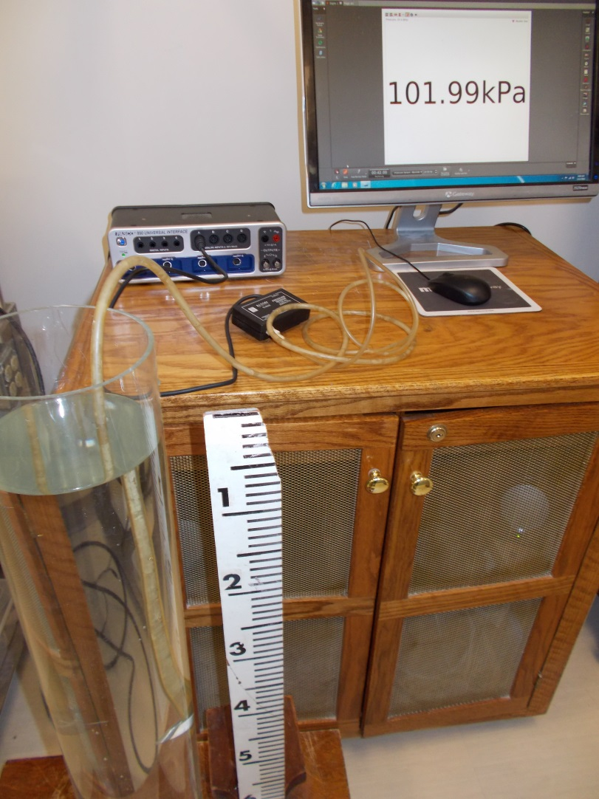
Location: Science Workshop Cabinet, Dd3, Fd1
FLUID MECHANICS | 2B20.30 | Statics of Fluids
Static Pressure

Weigh Water in a Tube
 | Suspend a tube, open at the bottom, from a spring scale in a vessel of water (colored with food dye) and suck up water into the tube. If the water column is supported by the atmosphere, why does the scale read higher (in this case, several newtons)?
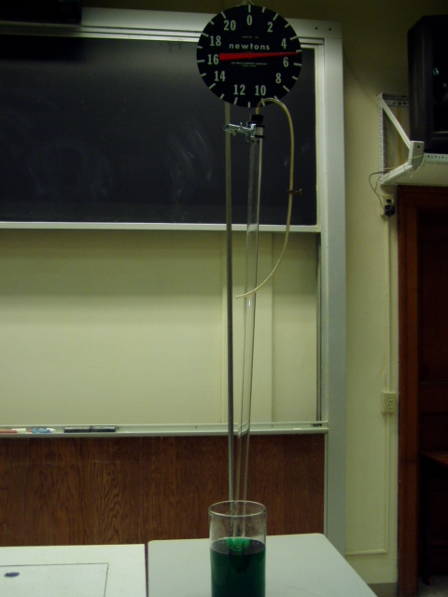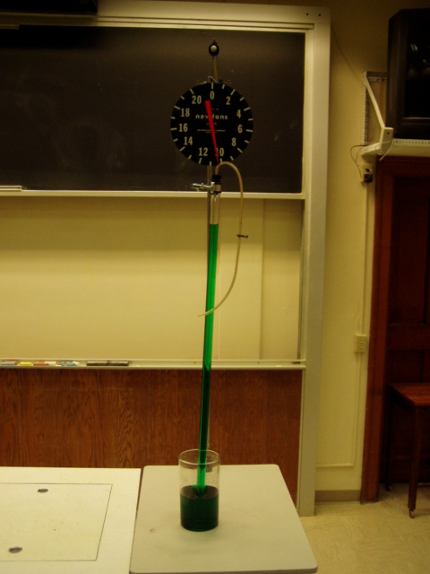
Location: Dd1
FLUID MECHANICS | 2B20.40 | STATICS OF FLUIDS
Static Pressure

Pascal's Vases
Disc 12-01
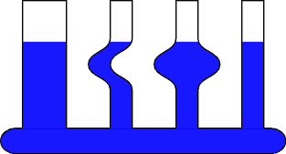 | Water levels in different shaped containers attached to a common reservoir will reach the same height no matter what the shape of the container.
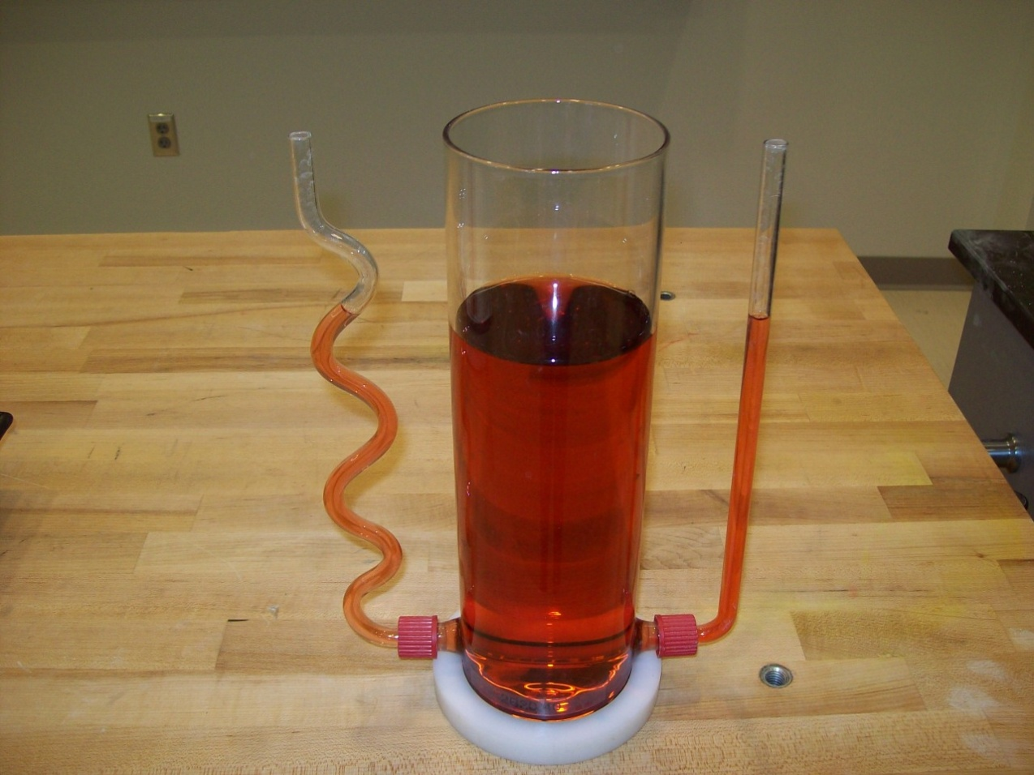
Location: Dd3

FLUID MECHANICS | 2B20.50 | STATICS OF FLUIDS
Static Pressure

Pascal's Fountain
 | Water squirts out equally in all directions from a spherical reservoir that has holes drilled along a circumference.
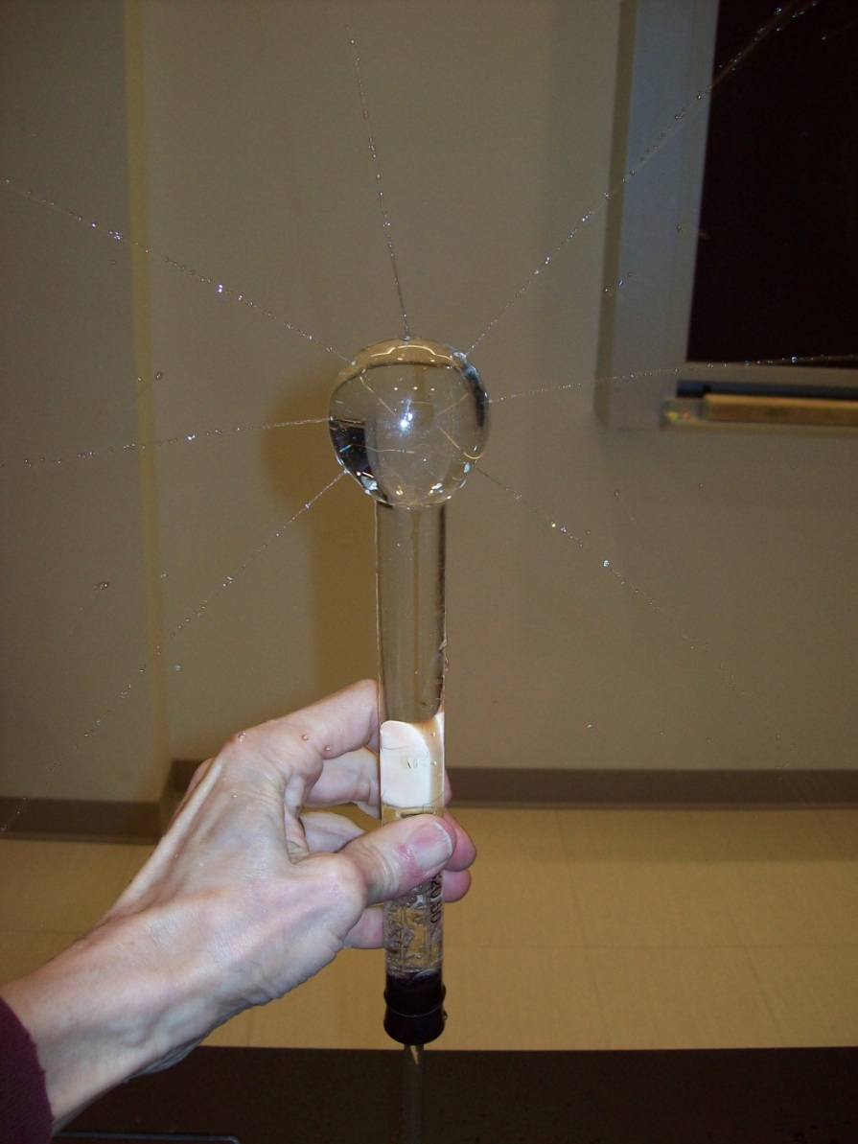
LocationDd3
FLUID MECHANICS | 2B20.60 | STATICS OF FLUIDS
Static Pressure

Hydraulic Press
 | A hydraulic press is used to crush a 2X4.
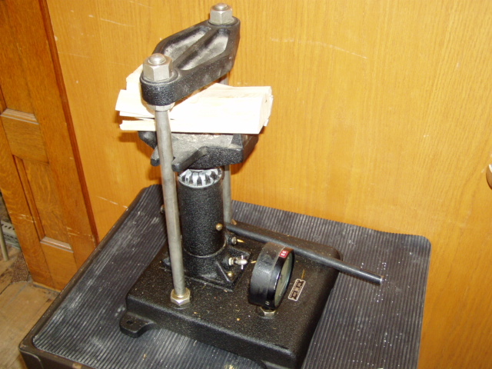Location Dd1

FLUID MECHANICS | 2B20.61 | STATICS OF FLUIDS
Static Pressure

Two Pistons
 | Two cylinders with pistons of different sizes (one is about twice the diameter of the other) are hooked together to show that different weights are needed for balance.
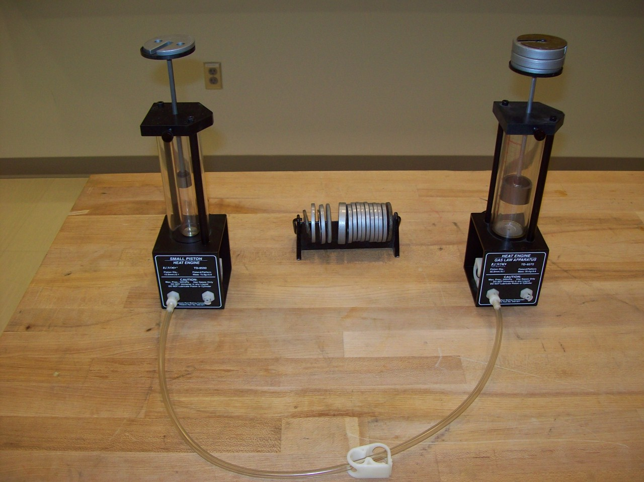Location: Ga4, See 4E10.15
FLUID MECHANICS | 2B20.80 | STATICS OF FLUIDS
Static Pressure

Hovercraft
 | A large disk with passenger is floated on a cushion of air.
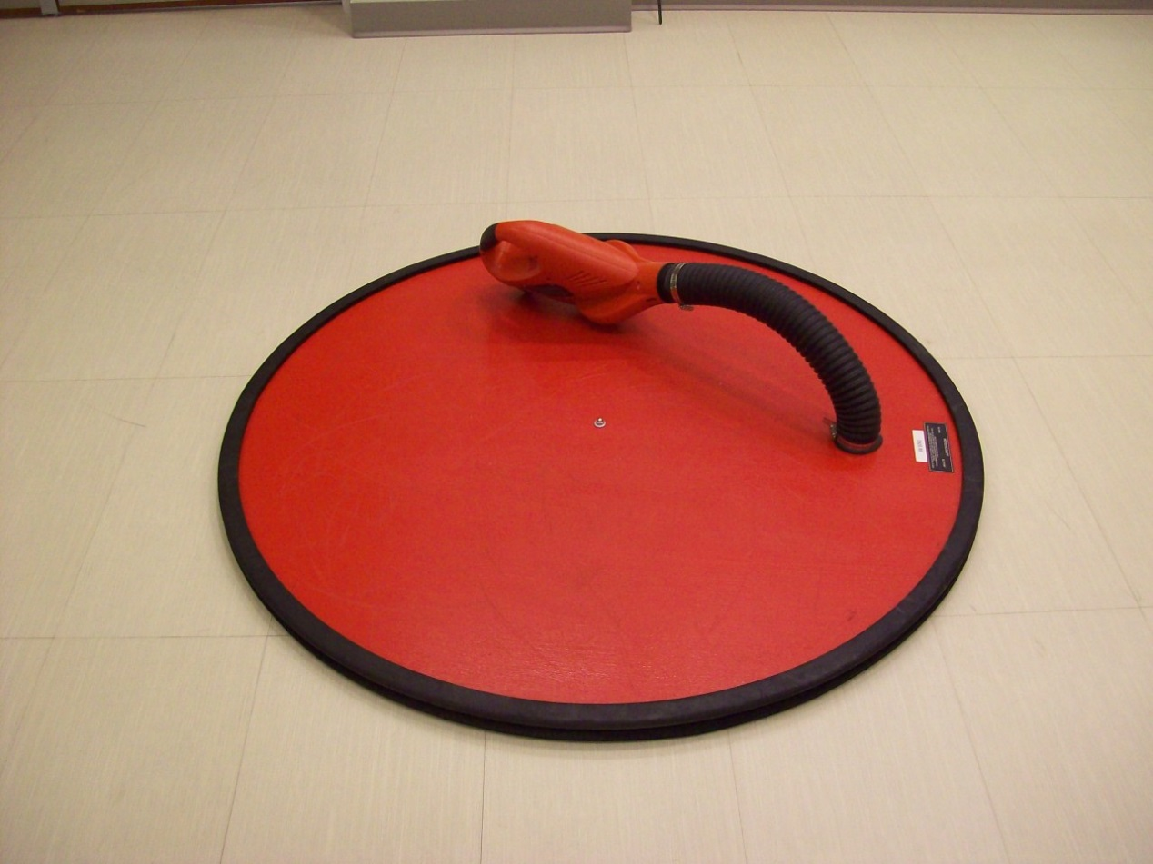
Location: PcT, Dd4

FLUID MECHANICS | 2B30.05 | STATICS OF FLUIDS

Atmospheric Pressure

Brass Bar
 | A brass bar weighing 10 N and having a cross sectional area of 1 cm² represents the weight of the atmosphere. Also shown is a square inch and an iron brick weighing 14 pounds.
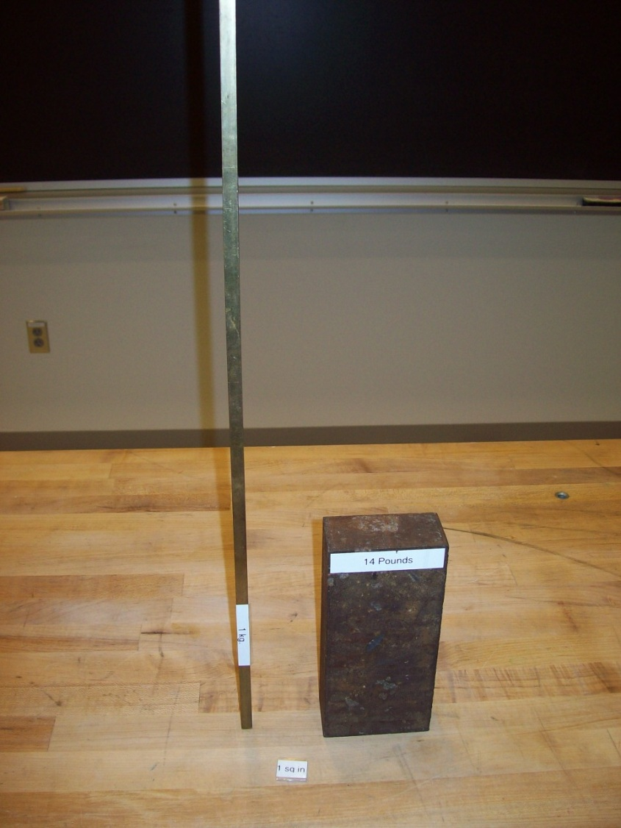
Location: Dc1
FLUID MECHANICS | 2B30.10, 2B30.25 | STATICS OF FLUIDS
Atmospheric Pressure

Crush the Can
Disc 12-01
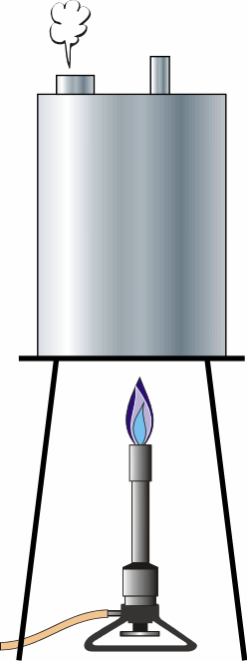 | Pour an inch of water into the can. Set it on a stand and start the gas burner. Let it boil for a while to displace all the air. Use insulated gloves to tighten the cap onto the can and at the same time, turn off the heat. Spray it with water to cool it faster. If the cap is tight, and as the steam inside cools and contracts, the can will collapse from atmospheric pressure. We usually do the second version in which a pump is used to crush the can.
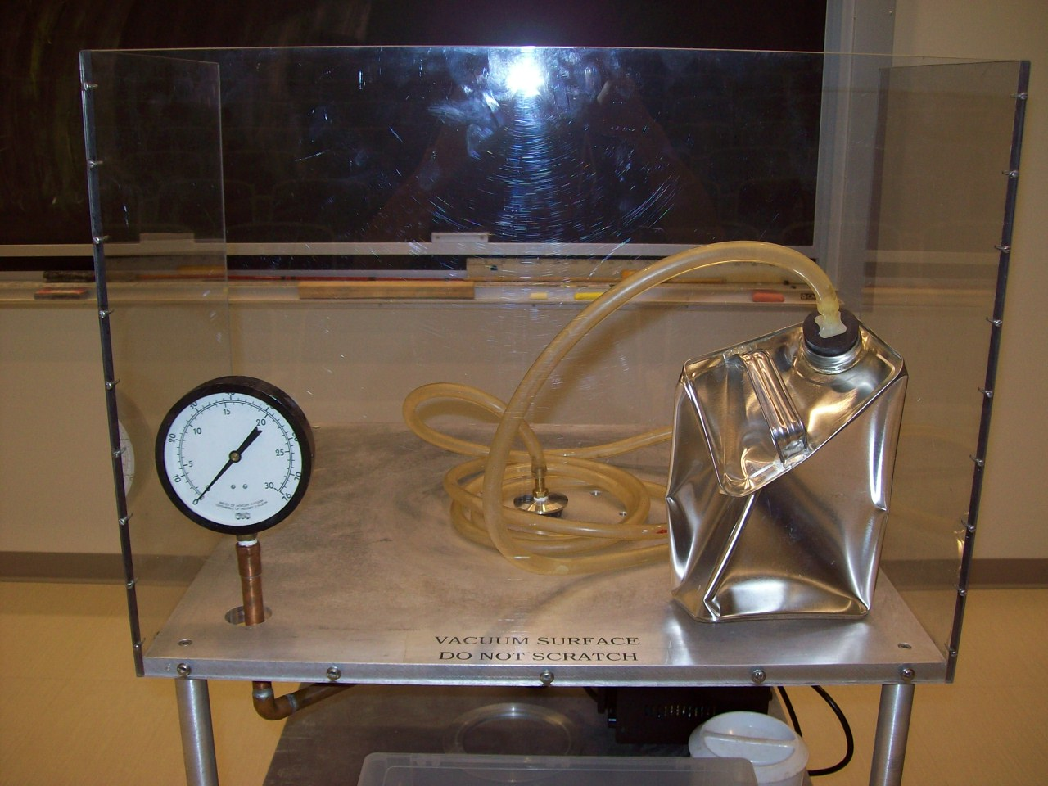
Location: Vacuum Station: DdT
FLUID MECHANICS | 2B30.30 | STATICS OF FLUIDS
Atmospheric Pressure

Magdeburg Hemispheres
Disc 11-12
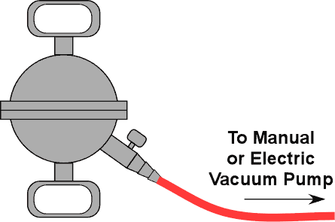 | Make sure the valve is open. Turn on the vacuum pump to evacuate the hemispheres. Shut the valve and remove the hose. Have two students try to pull the hemispheres apart. You may also use your lungs to create a partial vacuum or a hand pump.
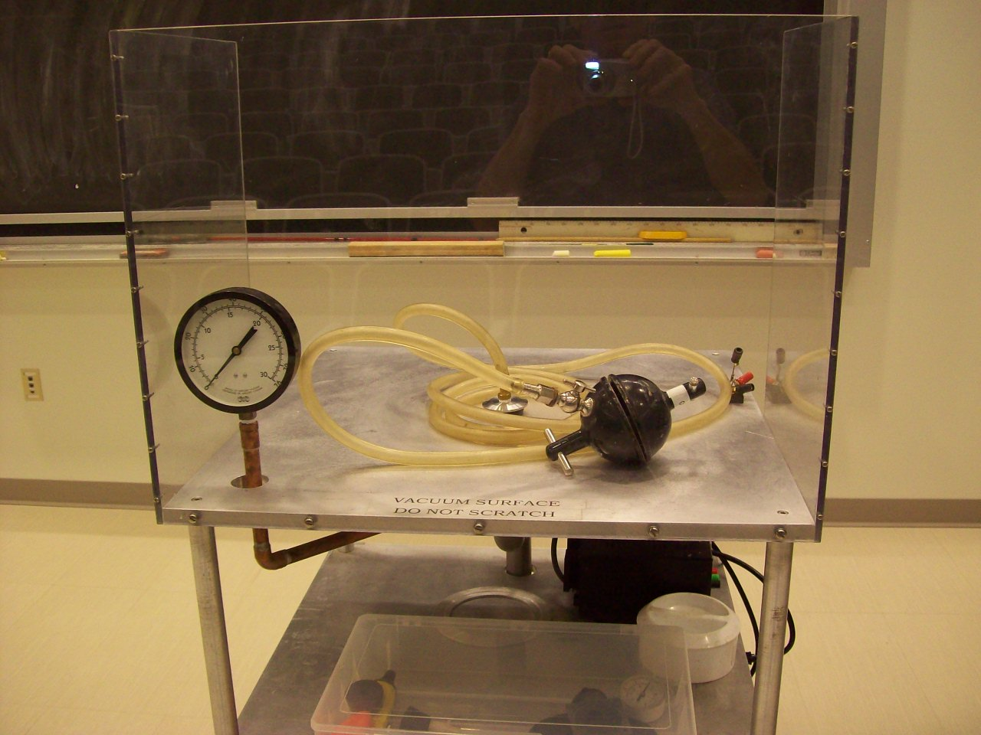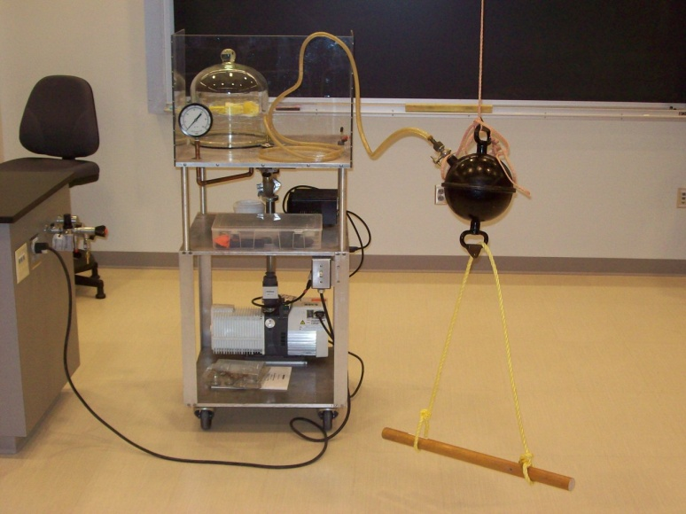
Location: Vacuum Station: Dd4

FLUID MECHANICS | 2B30.45 | STATICS OF FLUIDS
Atmospheric Pressure

Inverted Glass
 | Fill a glass with water; place a stiff card over the opening and invert. The card remains in place due to the atmospheric pressure below the card. Variation: water cooler demo a half filled bottle is inverted in a beaker of water.
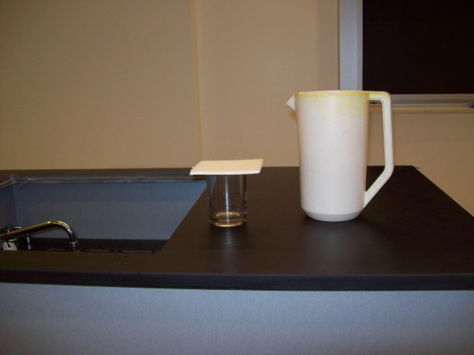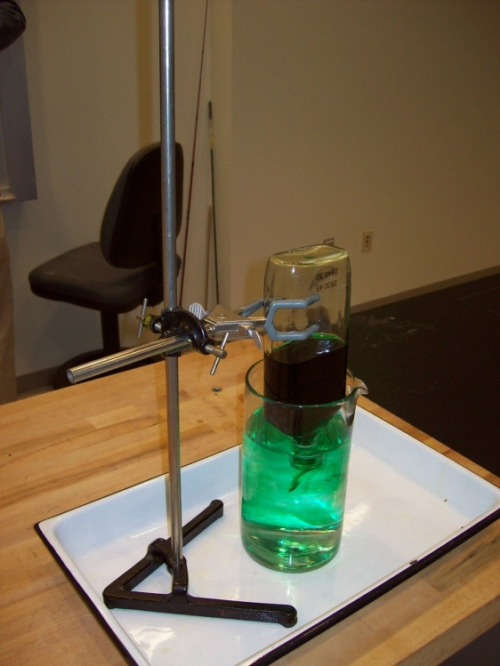
Location: Dd4

FLUID MECHANICS | 2B30.48 | STATICS OF FLUIDS
Atmospheric Pressure

Differential Pressure Bottle
 | Fold the opening of the balloon over the lip of the bottle. Insert the cork in the bottom of the bottle and try to blow up the balloon. Now repeat with the cork removed. After the balloon is inflated while still blowing into it, insert the cork and show the balloon remains inflated even after you quit blowing into it. Remove the cork and watch the balloon collapse.
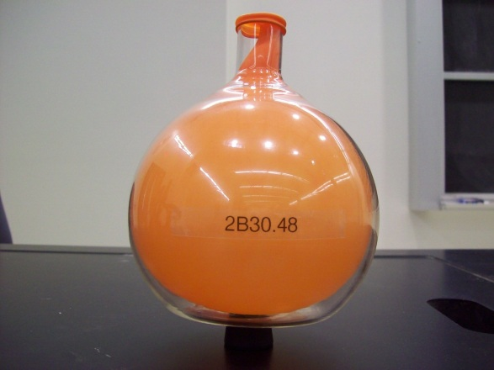
Location: Dd4
FLUID MECHANICS | 2B30.50 | STATICS OF FLUIDS
Atmospheric Pressure

Lift a Stool
 | Place a square foot of 1/16” rubber on a chair and lift the chair by pulling on a handle attached to the rubber sheet.
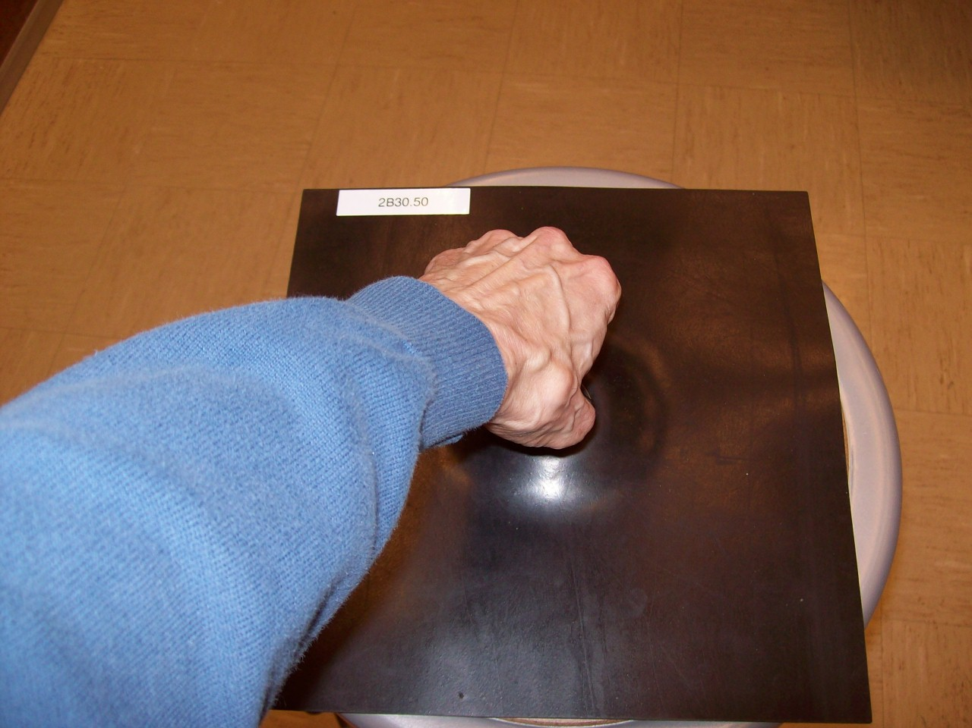
Location: Dd4

FLUID MECHANICS | 2B30.70 | STATICS OF FLUIDS
Atmospheric Pressure

Vacuum Bazooka
Load a 40 mm ping pong ball. Seal the ends with tape, and evacuate the bazooka with a pump. Use ear protection. Puncture the tape on the vacuum valve end to break the seal and the ball will be propelled fast enough to penetrate the pop cans. With a strong puff of breath, the ball can achieve 6 m/s; using the vacuum and the pressure of the inrushing atmosphere, it can reach 300 m/s.
The arrow point used to puncture the tape is very sharp. Use with care and always store it in the protective cover.

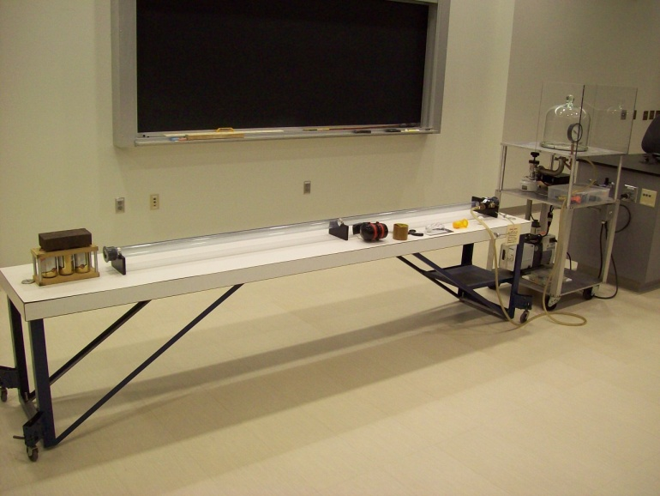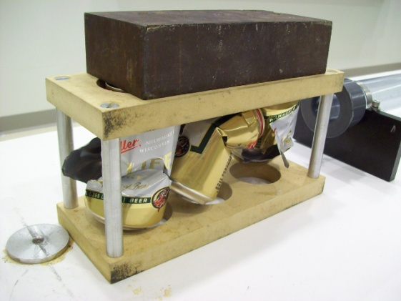
Location: DdT
FLUID MECHANICS | 2B35.10 | STATICS OF FLUIDS

Measuring Pressure

Mercury Barometer
 | A simple mercury barometer.
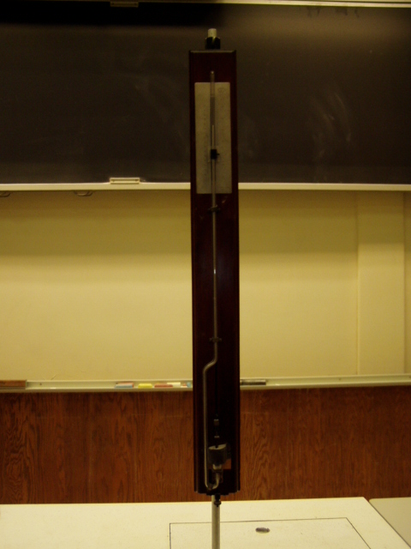
Location: Dc1

FLUID MECHANICS | 2B35.10 | STATICS OF FLUIDS
Measuring Pressure

Torricelli’s Experiment
 | Show Torricelli’s experiment in the following way: With the stopcock on one side of a mercury manometer open, carefully pressurize the other side, forcing all the air out of the side with the stopcock on it. Close the stopcock and then remove the source of pressurized air.
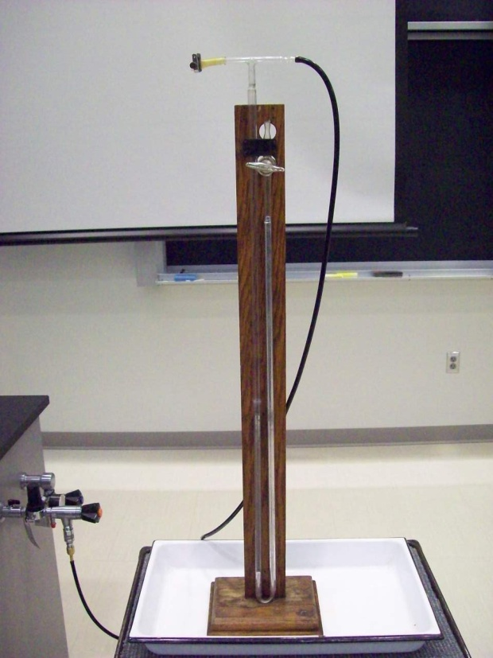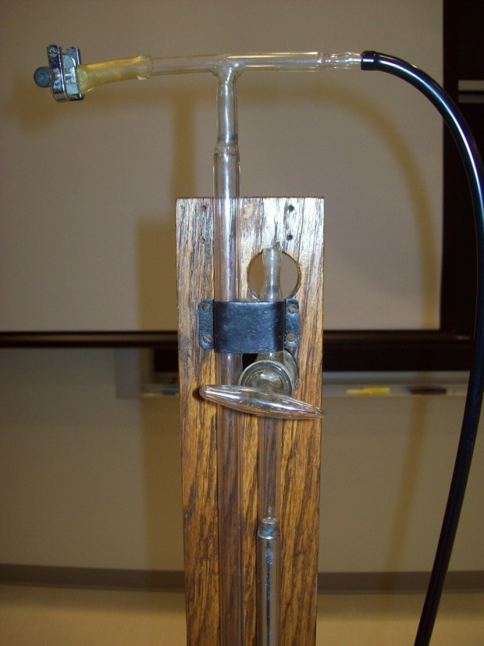
Location: Dc1
FLUID MECHANICS | 2B35.30 | STATICS OF FLUIDS
Measuring Pressure

Manometer
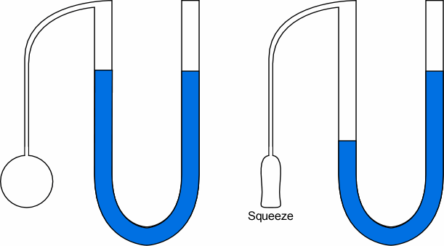 | Simple water and mercury manometers.
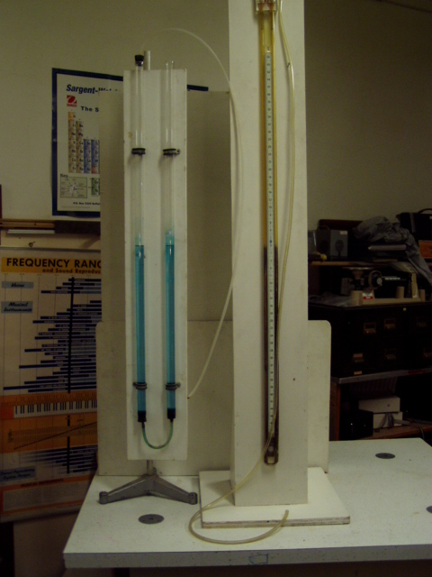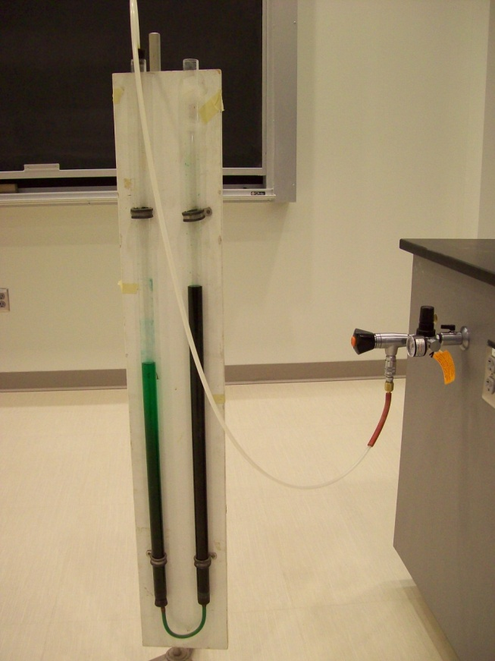
Location: Dc1
FLUID MECHANICS | 2B35.40 | STATICS OF FLUIDS
Measuring Pressure

Aneroid Barometer
 | A large open aneroid barometer and an aneroid pressure sensor connected to the computer using the Science Workshop equipment (Pressure Depth.ds). One can blow opr suck on tubes connected to the barometers.
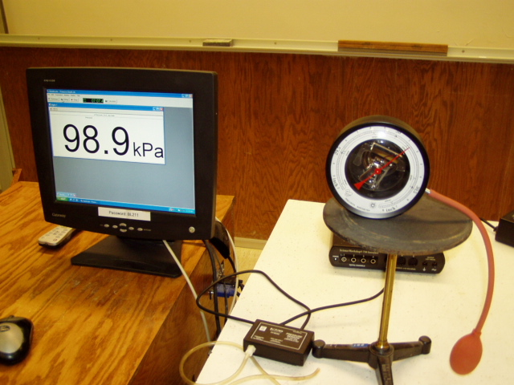Location: Science Workshop Cabinet, Dd4
FLUID MECHANICS | 2B40.10 | STATICS OF FLUIDS

Density and Buoyancy

Weigh Submerged Block
Disc 12-11
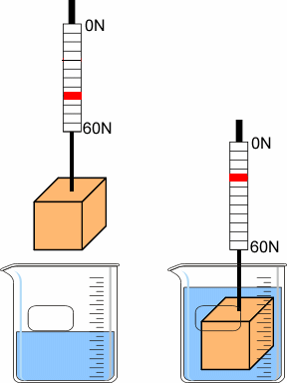 | Weigh the block in air, then submerged in water. The difference is the buoyant force.
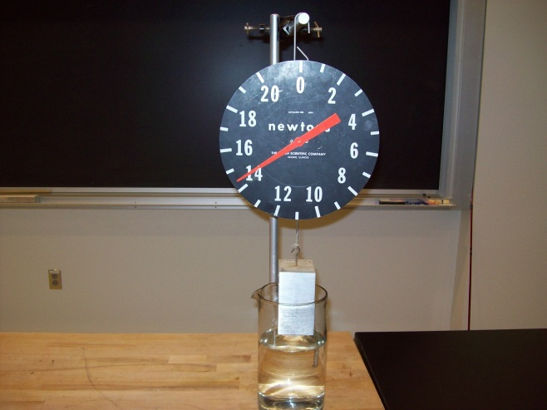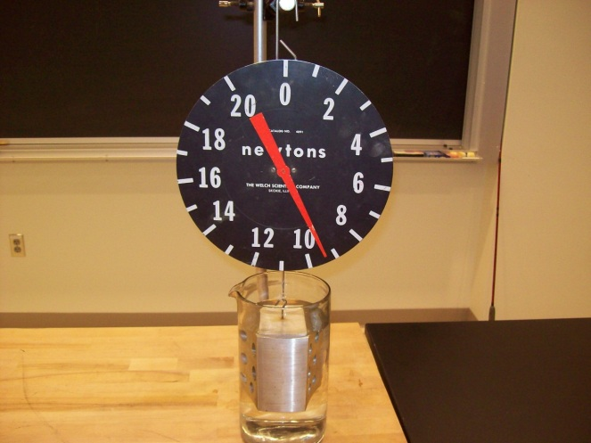
Location: Dd5

FLUID MECHANICS | 2B40.20 | STATICS OF FLUIDS
Density and Buoyancy

Archimedes' Principle
Disc 12-12
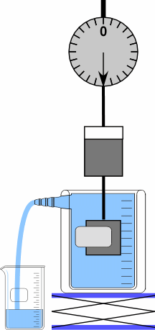 | A cylindrical mass and bucket are suspended from a spring scale above a beaker with an overflow spout. Note the scale reading. Submerge the mass by raising the beaker with the lab jack. Pour the water from the catch bucket into the hanging bucket to return to the original scale reading. You may also show that the mass exactly fits inside the hanging bucket.
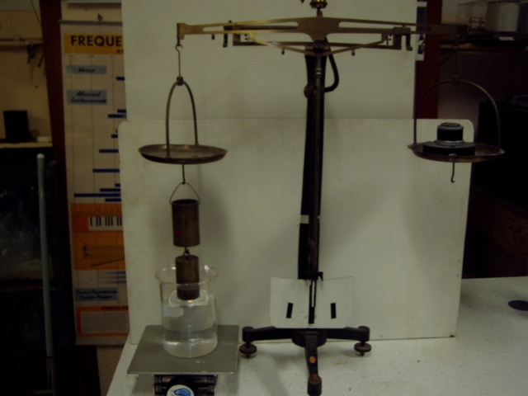Location: Dd1

FLUID MECHANICS | 2B40.25 | STATICS OF FLUIDS
Density and Buoyancy

Battleship in a Bathtub
 | A wooden cylinder, 513.4 ml in volume, mass 468.5 g, floats in just 100 ml of water.
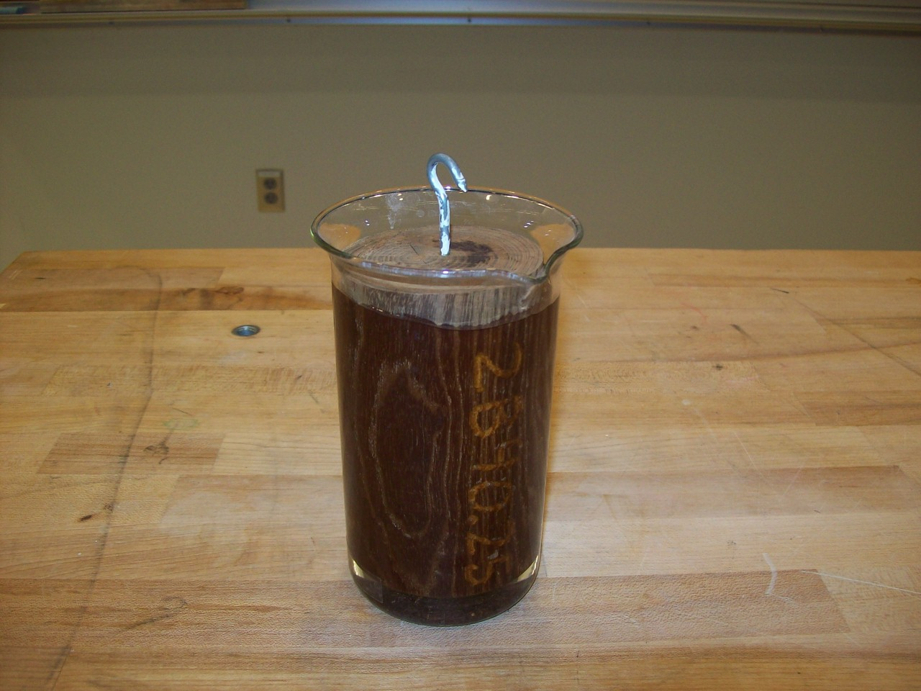Location: Dd5

FLUID MECHANICS | 2B40.26 | STATICS OF FLUIDS
Density and Buoyancy

Ship Empty and Full
 | A “ship” (Styrofoam cup) is loaded with a brass weight and the water level in the vessel it floats in is noted. The weight is removed and allowed to sink to the bottom and the new water level is noted as well as the new water line on the “ship.” Repeat using wooden weight which floats when you put it in the water
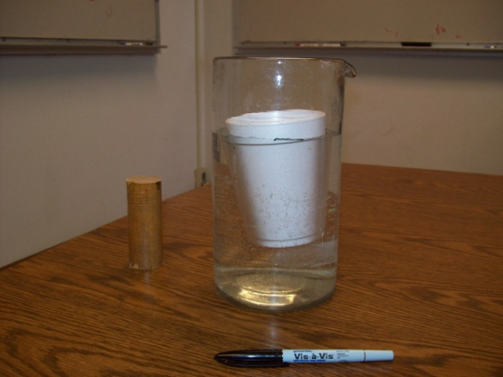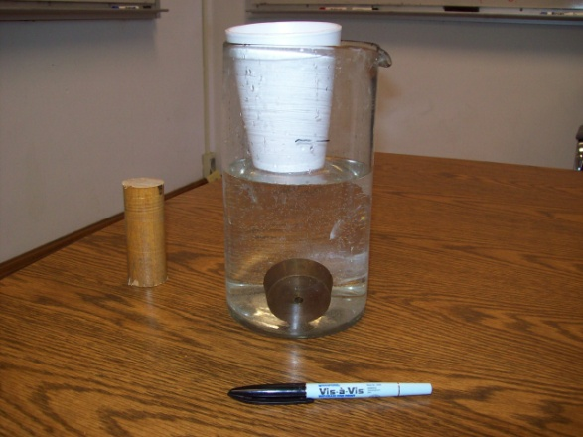
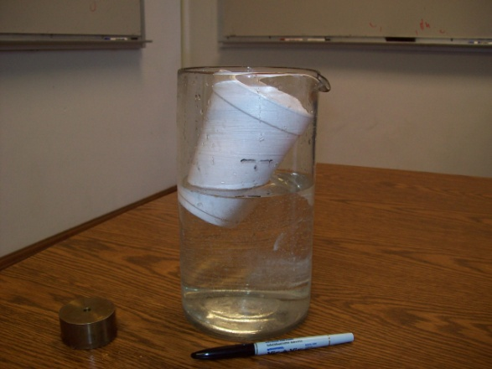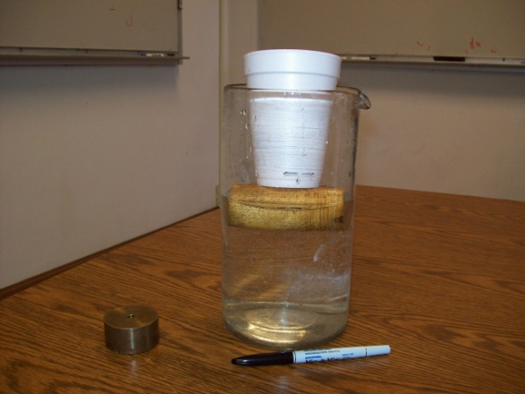
Location: Dd5

FLUID MECHANICS | 2B40.30 | STATICS OF FLUIDS
Density and Buoyancy

Cartesian Diver
 | Fill the whiskey bottle to the top. Put the eye dropper in it and then the rubber stopper. Insert the rubber stopper until the dropper just barely floats. It can then be made to sink by squeezing the broad sides of the bottle. If it is balanced carefully, the dropper will stay at the bottom of the bottle until you squeeze the narrow sides of the bottle, causing it to float back up to the top.
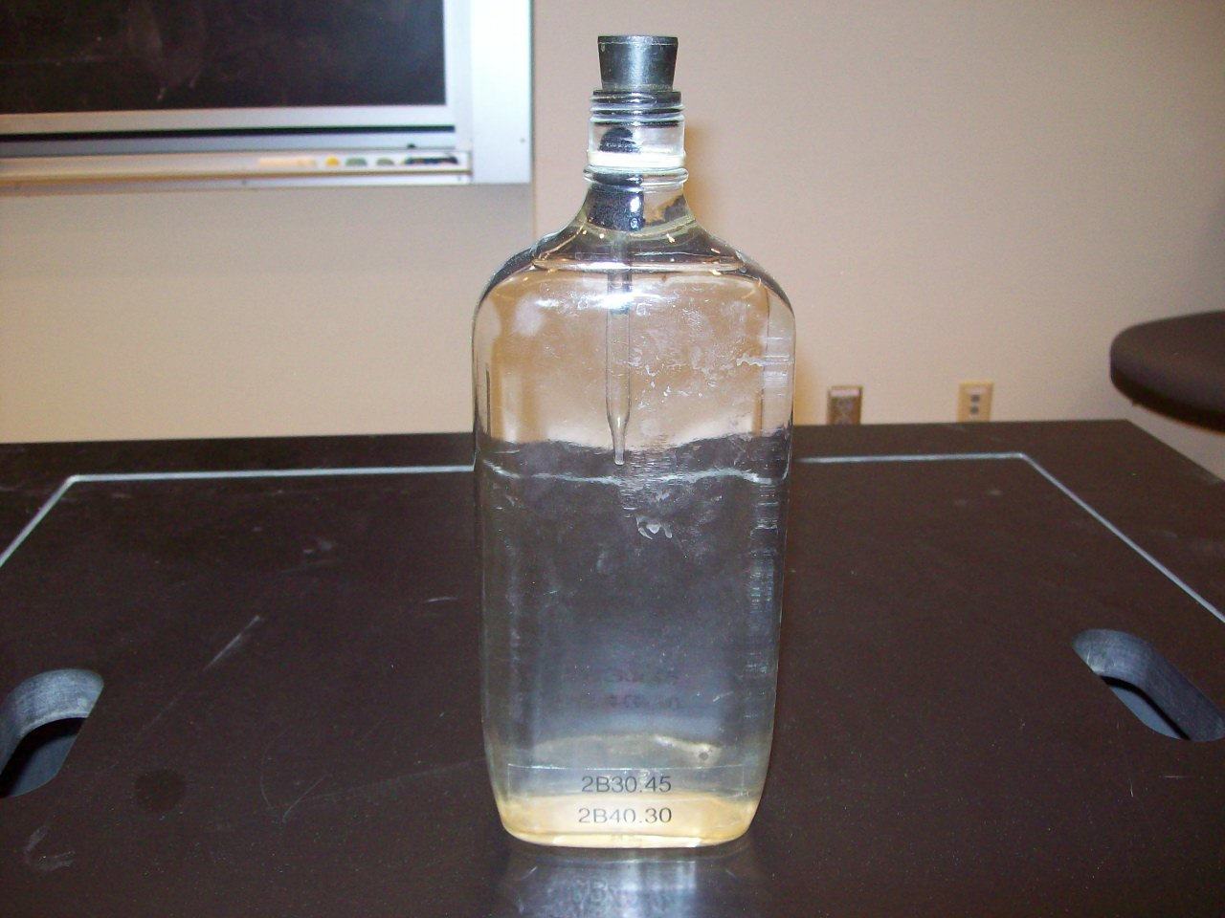
Location: Dd5
FLUID MECHANICS | 2B40.40 | STATICS OF FLUIDS
Density and Buoyancy

Buoyancy of Air
 | The pop bottle is sealed and hung on the balance, with the balance adjusted to be in balance. Then the balance is placed in the Bell jar and the jar is evacuated. When the buoyant force is removed, the balance tips to the bottle side.
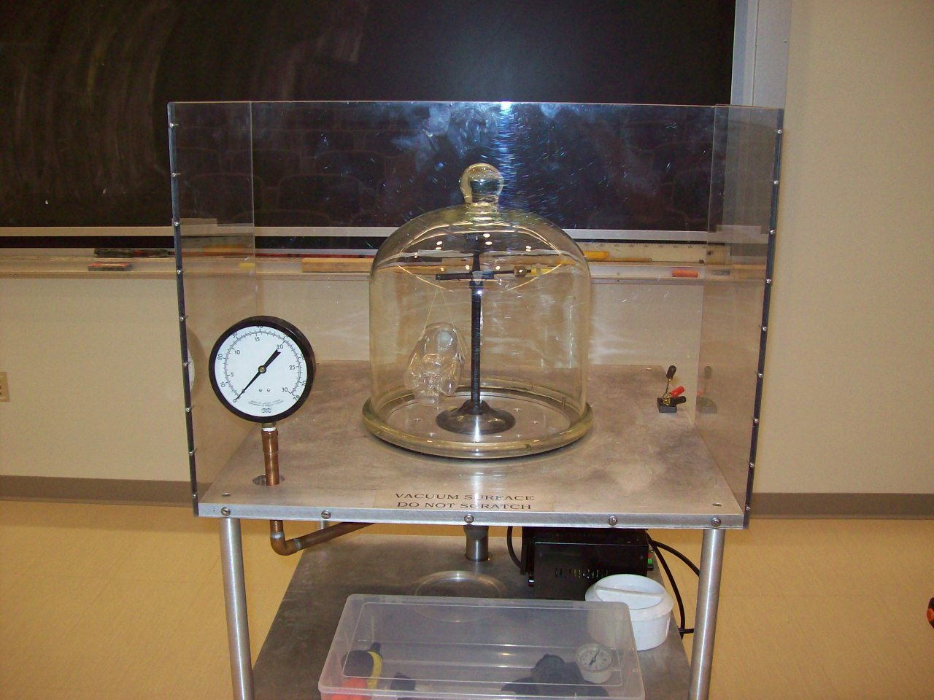
Location: Dd5, Ec7
FLUID MECHANICS | 2B40.42 | STATICS OF FLUIDS
Density and Buoyancy

Buoyancy Balloon
 | Weigh a sealed, 17” balloon filled with dry ice and watch the weight change as the dry ice sublimes. Use about 200 grams (4 moles) of dry ice.
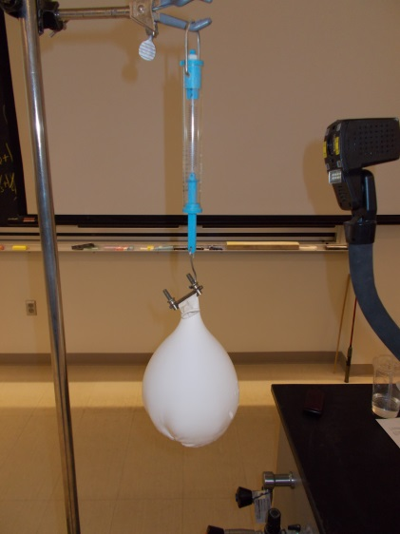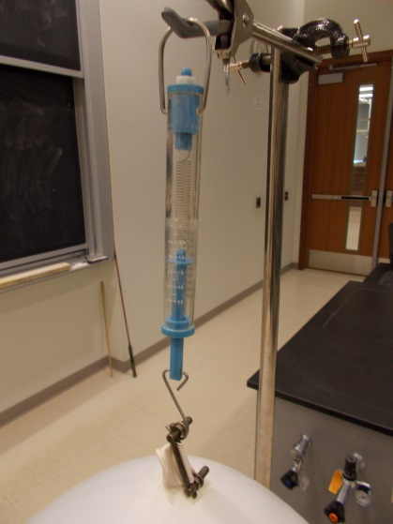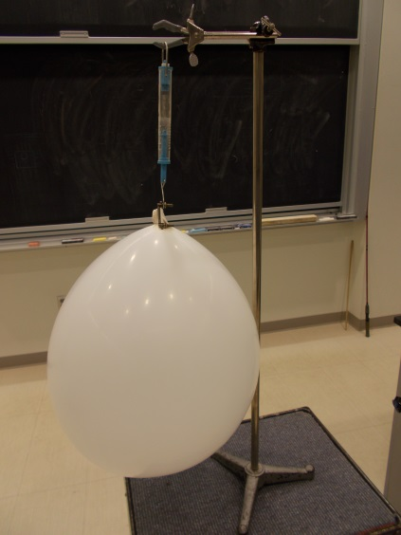
Location: Gb1
FLUID MECHANICS | 2B40.53 | STATICS OF FLUIDS
Density and Buoyancy

Water and Mercury “U” Tube
 | A “U” tube with different fluids on each side.
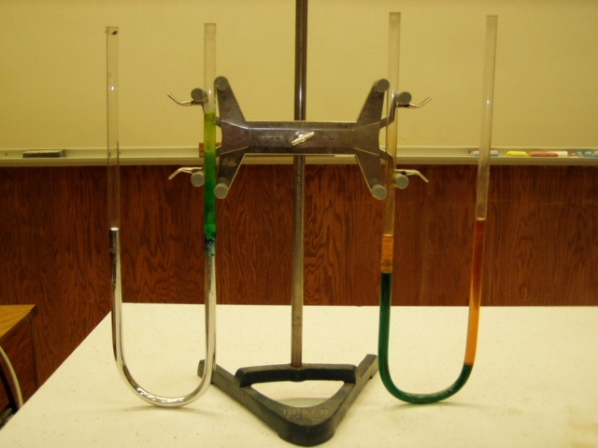Location: Dd5
FLUID MECHANICS | 2B40.59 | STATICS OF FLUIDS
Density and Buoyancy

Density Ball
 | A metal ball is made so that it floats in cold water and sinks in hot water. Sinks at 67 C, rises at 54 C

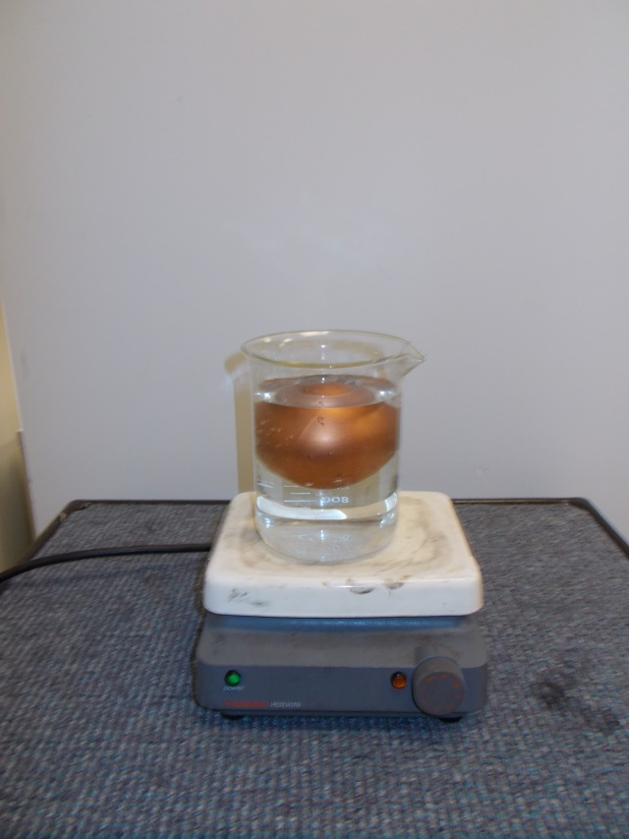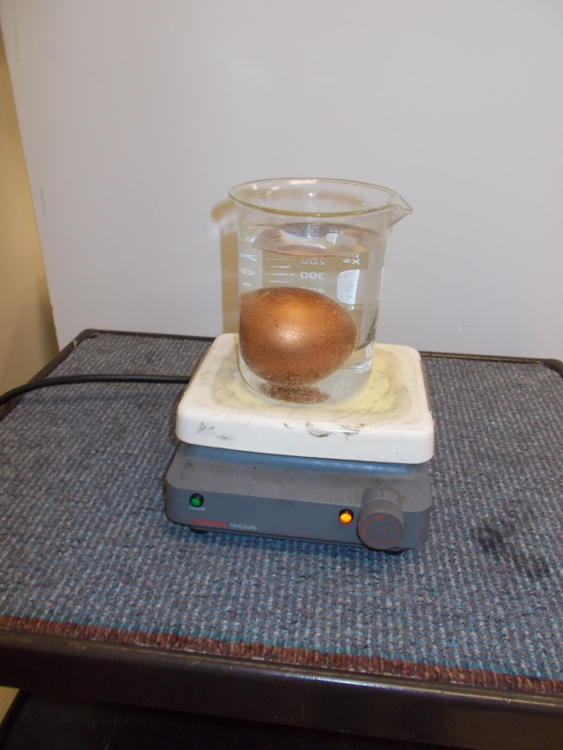
Location: Dd5

FLUID MECHANICS | 2B40.59 | STATICS OF FLUIDS
Density and Buoyancy

Density Rods
 | A hydrometer (aluminum) is made so it sinks in warm water and floats in cold. Another one (PVC) floats in warm water and sinks in cold.
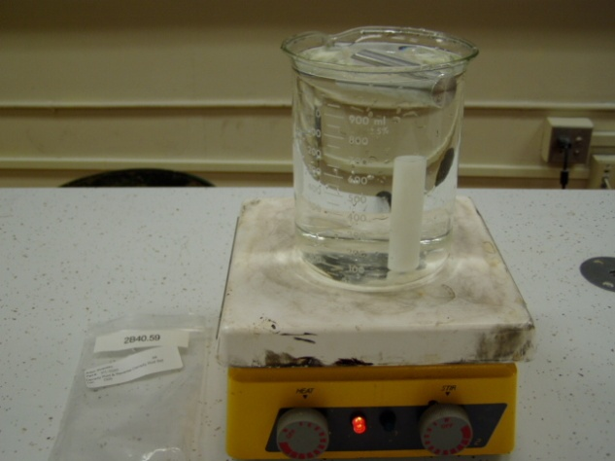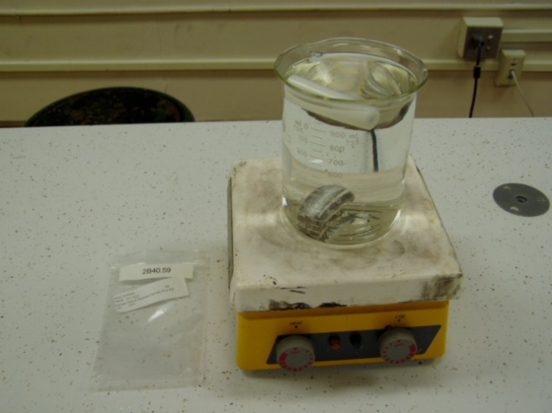
Location: Dd5
FLUID MECHANICS | 2B40.60 | STATICS OF FLUIDS
Density and Buoyancy

Hydrometer
 | Display various hydrometers.
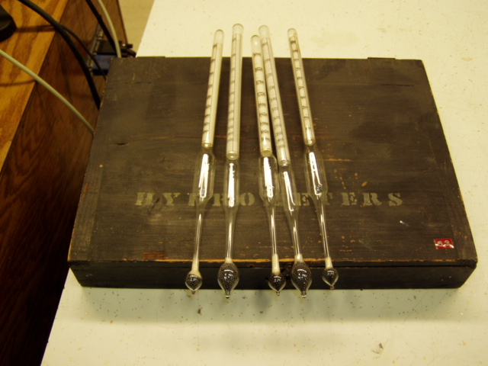Location: Dd5

FLUID MECHANICS | 2B40.71 | STATICS OF FLUIDS
Density and Buoyancy

Poly Density Bottle
 | A bottle contains salt solution, isopropanol and plastic beads of two different densities. Shake it up and watch them separated by densities.
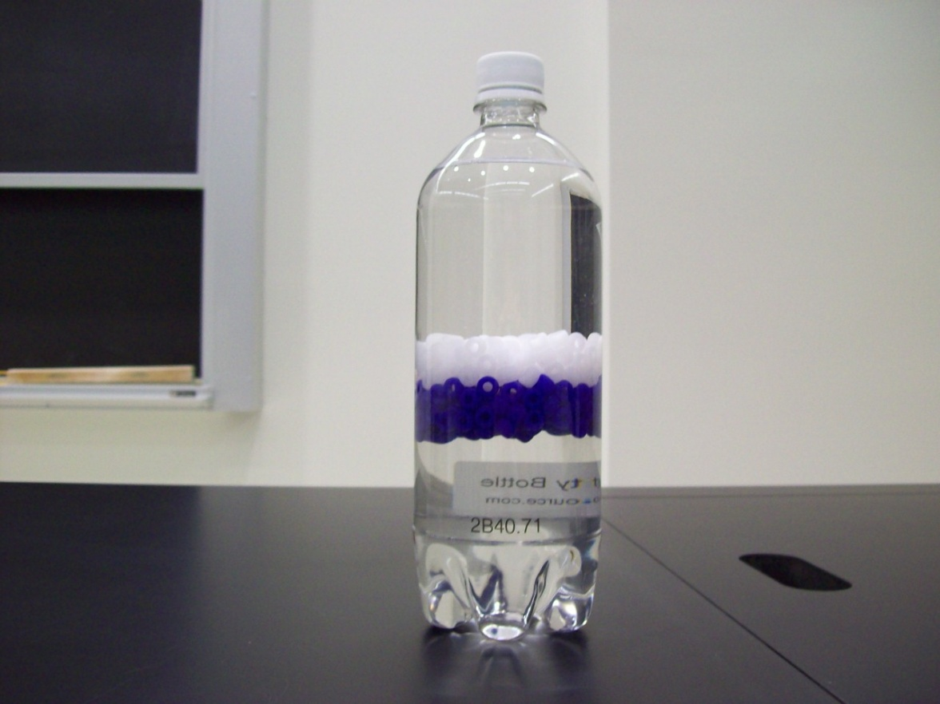
Location: Dd5

FLUID MECHANICS | 2B60.10 | STATICS OF FLUIDS

Siphons, Fountains and Pumps

Hero’s Fountain
 | A clever arrangement of reservoirs that forces a stream of water above the highest reservoir. Fill by removing the lower flask, inverting the upper flask into a tall beaker of water, and sucking on the bottom of the short tube until the reservoir is as full as possible. Then, placing a finger over the short tube, invert the apparatus and insert the stopper into the lower flask, and fill the upper open reservoir with water. If the fountain doesn’t start right away, check to see if the long tube is blocked by bubbles; if it is, try pushing a long wire down it to free them.
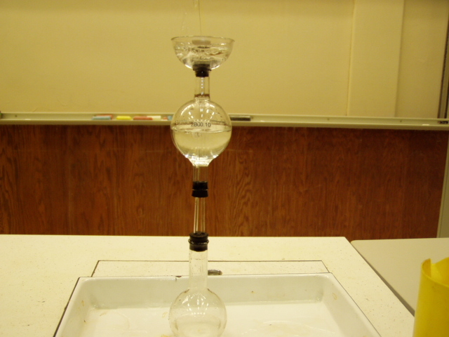Location: Dd6

FLUID MECHANICS | 2B60.35 | STATICS OF FLUIDS
Siphons, Fountains and Pumps

Tantulus Cup
 | Try to fill the cup. This is an intermittent siphon
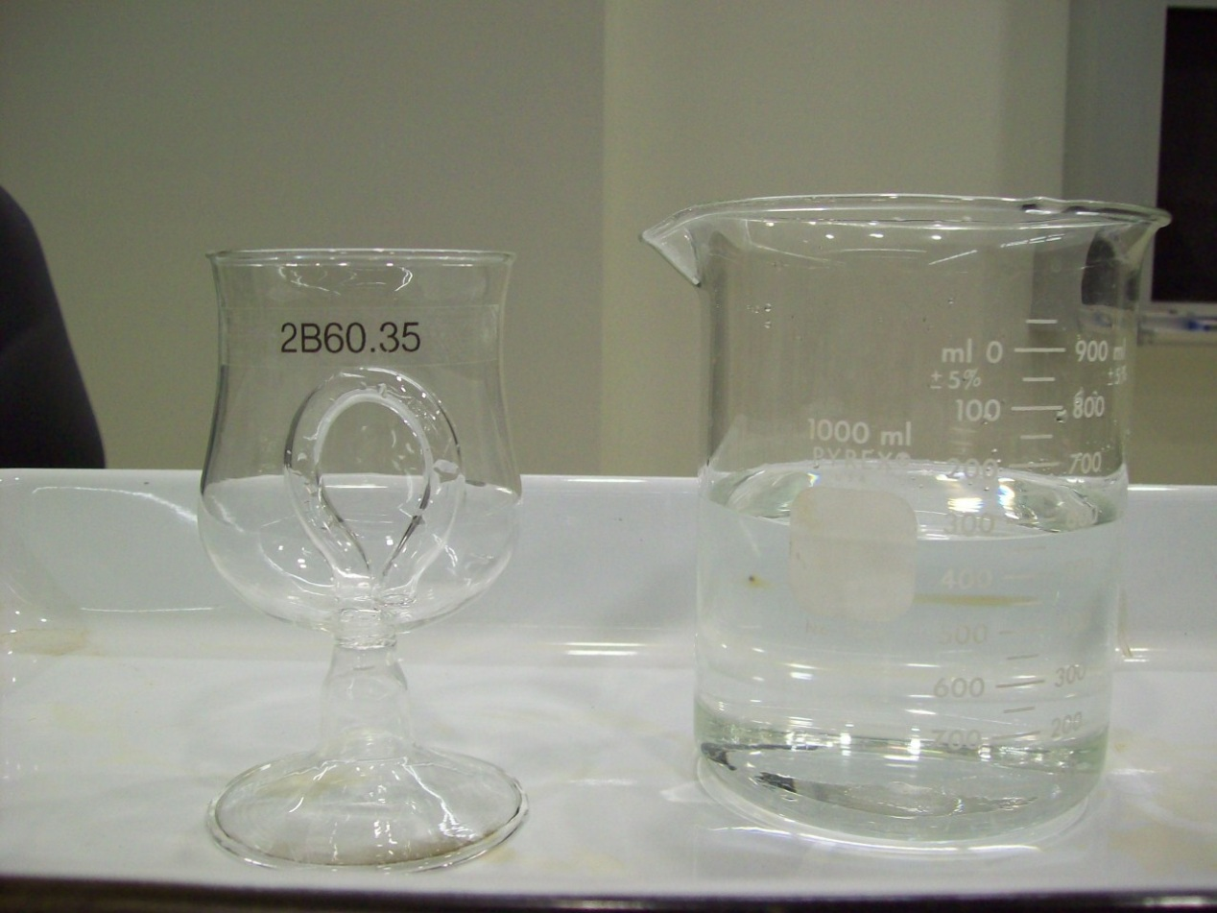
Location: Dd6

FLUID MECHANICS | 2B60.40 | STATICS OF FLUIDS
Siphons, Fountains and Pumps

Mariotte Flask and Siphon
 | A Mariotte flask is used to make a siphon with a constant flow rate.
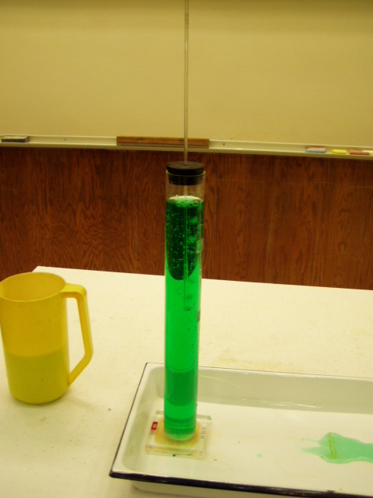
Location: Dd6
FLUID MECHANICS | 2B60.75 | STATICS OF FLUIDS
Siphons, Fountains and Pumps

Lift Pump
 | A plastic model of a lift pump.
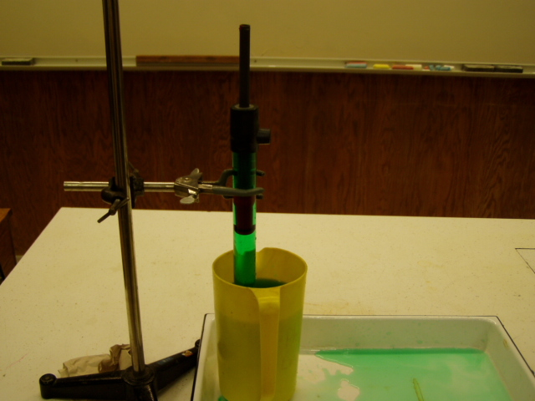Location: Dd6
FLUID MECHANICS | 2C10.10 | DYNAMICS OF FLUIDS

Flow Rate

Torricelli’s Tank
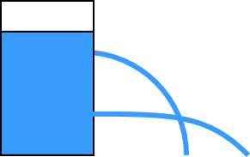 | Water streams from holes at different heights in a vertical acrylic tube.
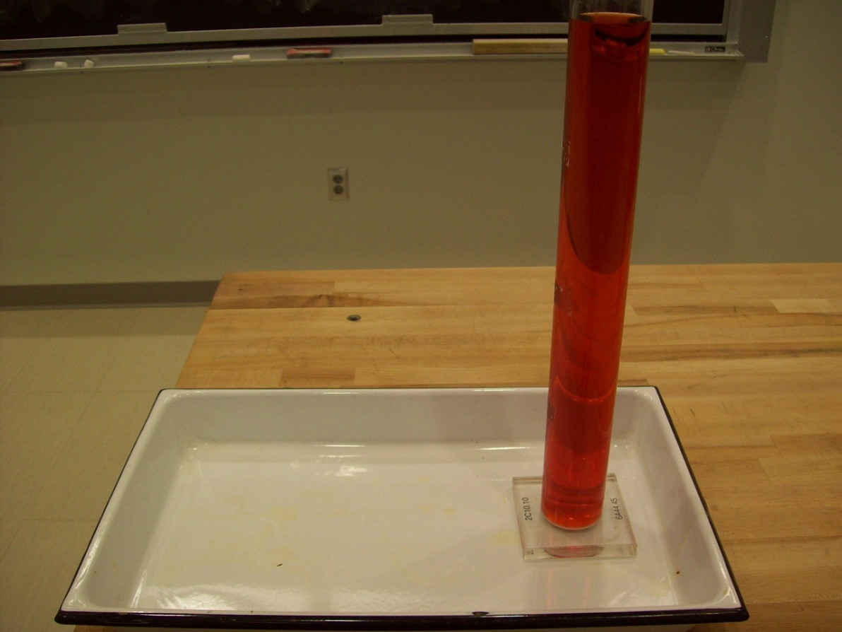
Location: Dd6
FLUID MECHANICS | 2C20.15 | DYNAMICS OF FLUIDS

Forces in Moving Fluids

Bernoulli / Venturi Tubes
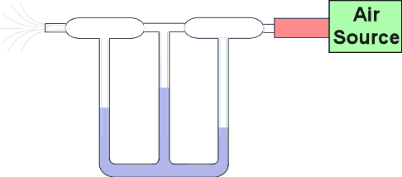 | Air (we use water) flows through a restricted tube. Manometers show the pressure differences.
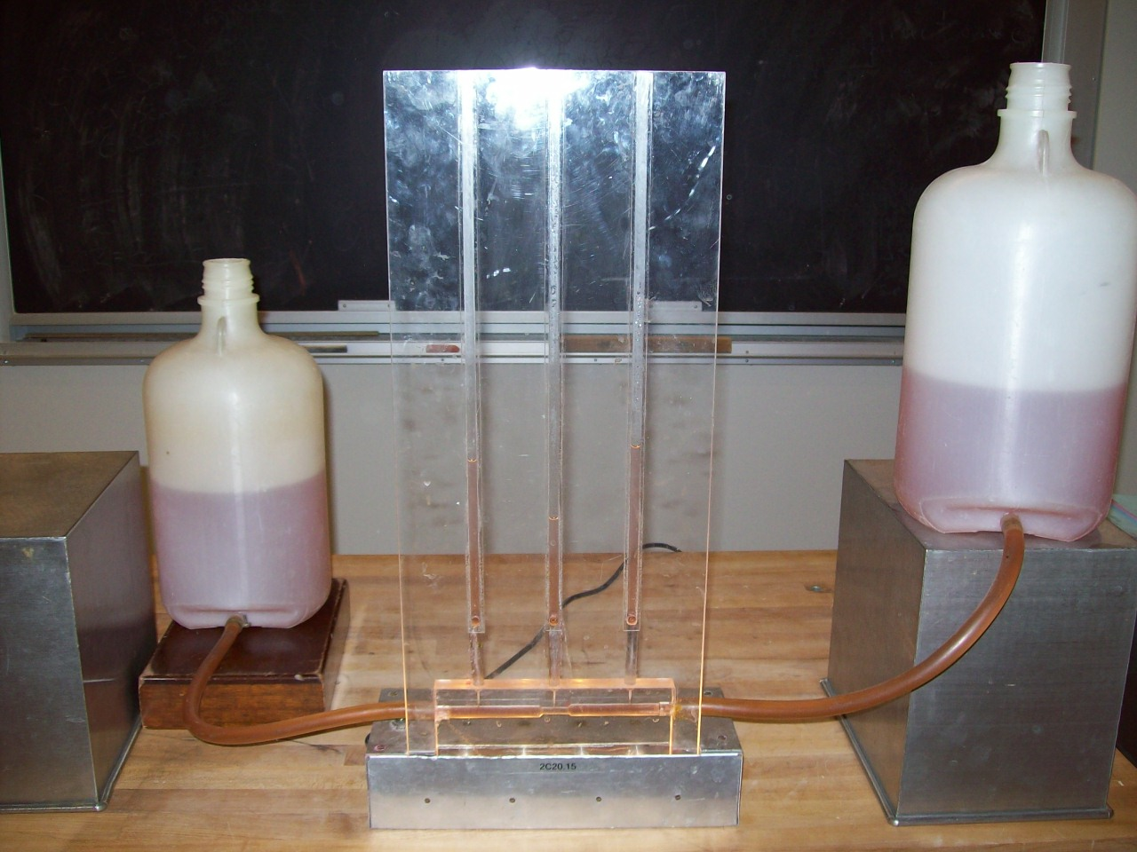Location: Dc1

FLUID MECHANICS | 2C20.20 | DYNAMICS OF FLUIDS
Forces in Moving Fluids

Atomizer
 | A jet is blown across one end of a tube connected to a manometer. The apparatus shown (Welch apparatus) can also be used to show that the pressure is not reduced if there is a flat plate at the end of the tube, parallel to the flow. The reduction in pressure at the top of the open tube is caused by the deflection of the air stream and the radial pressure gradient created by it. The Bernoulli principle is not an explanation for this demonstration.
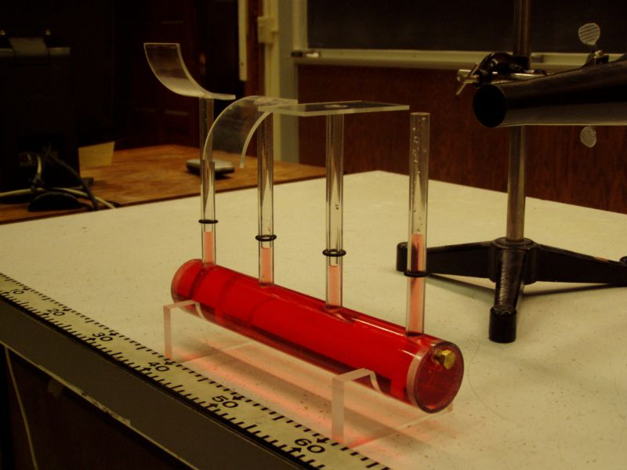 Location: Ea1

FLUID MECHANICS | 2C20.30 | DYNAMICS OF FLUIDS
Forces in Moving Fluids

Floating Ball
 | A beach ball is levitated by the stream of air from a blower. The lifting force is caused by the deflection of the air stream. Bernoulli’s principle is not an explanation for this demonstration.
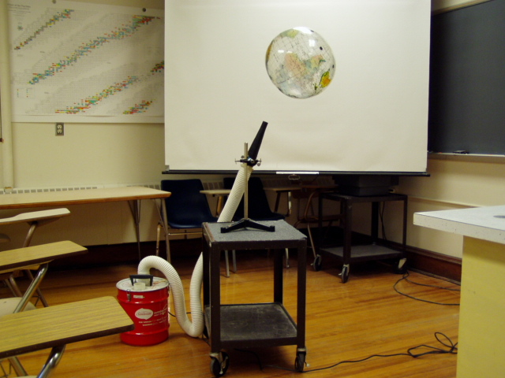
Location: Ea3

FLUID MECHANICS | 2C20.35 | DYNAMICS OF FLUIDS
Forces in Moving Fluids

Funnel and Ball
 | Support a ping pong ball by air coming out of an inverted funnel. The lifting force is caused by the deflection of the air stream. Bernoulli’s principle is not an explanation for this demonstration.
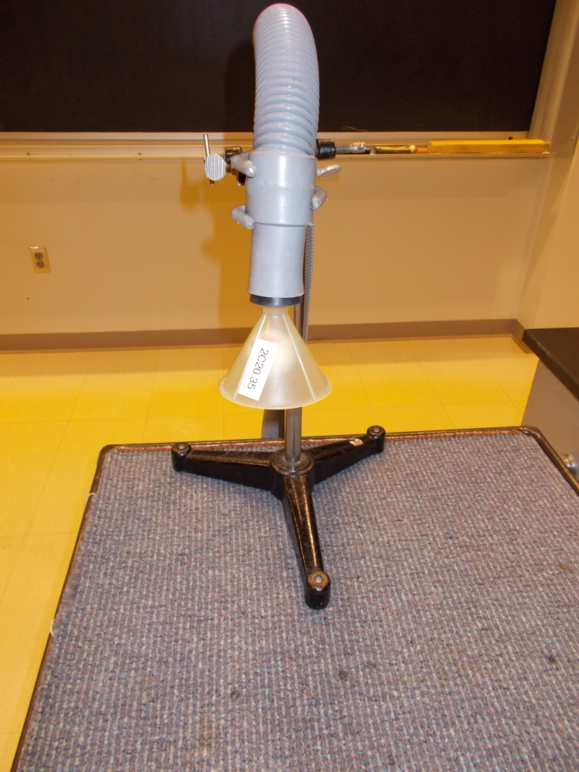
Location: Ea1

FLUID MECHANICS | 2C20.40 | DYNAMICS OF FLUIDS
Forces in Moving Fluids

Lifting Plate
 | Air blows out radially between two plates, lifting the lower plate. Bernoulli’s principle is not an explanation for this demonstration.
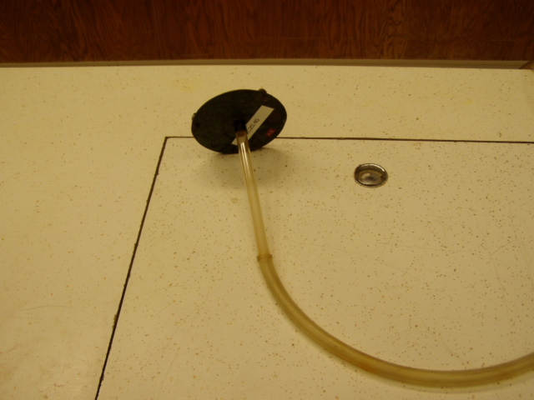Location: Ea1
FLUID MECHANICS | 2C20.45 | DYNAMICS OF FLUIDS
Forces in Moving Fluids

Attracting Sheets
 | Blow air between two suspended sheets and observe the attraction. The attracting force is caused by the deflection of the air stream. Bernoulli’s principle is not an explanation for this demonstration.
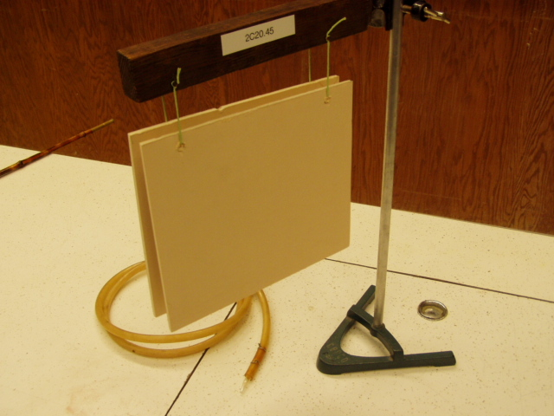Location: Ea1
FLUID MECHANICS | 2C20.50 | DYNAMICS OF FLUIDS
Forces in Moving Fluids

Coanda Effect
Welch Apparatus.
This apparatus illustrates a common misinterpretation of Bernoulli’s principle. Pressure in a free air stream is not less than the ambient pressure. Discuss air foils, Pitot tubes, atomizers, roofs, prairie dog mounds etc.

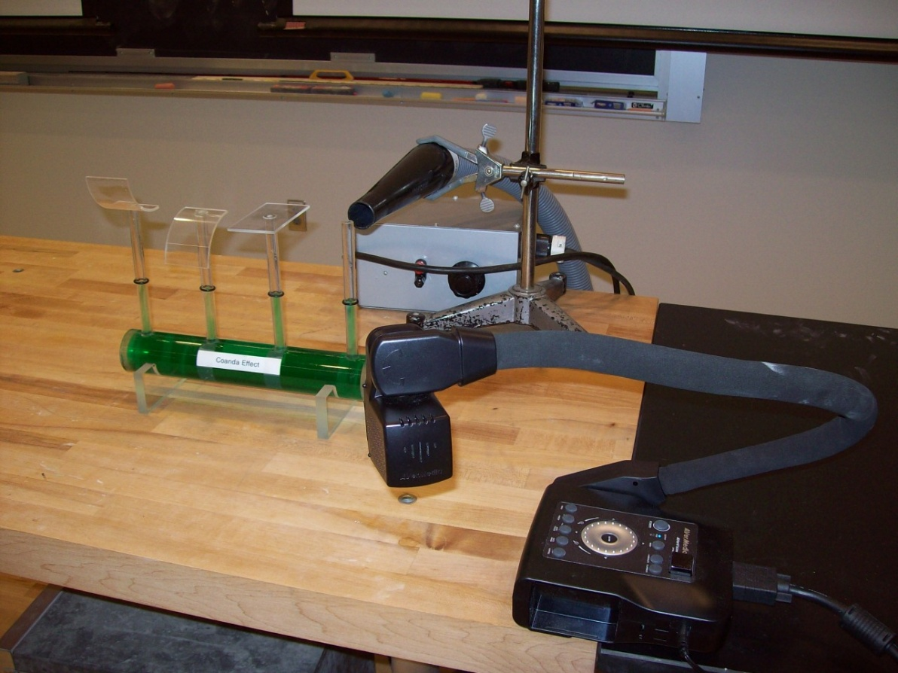
Location: Ea1

FLUID MECHANICS | 2C20.60 | DYNAMICS OF FLUIDS
Forces in Moving Fluids

Curve Ball
 | Use a “V” shaped launcher to throw curve balls. The force responsible for causing the ball to curve is caused by the deflection of the air stream around the spinning ball. Bernoulli’s principle is not an explanation for this demonstration.
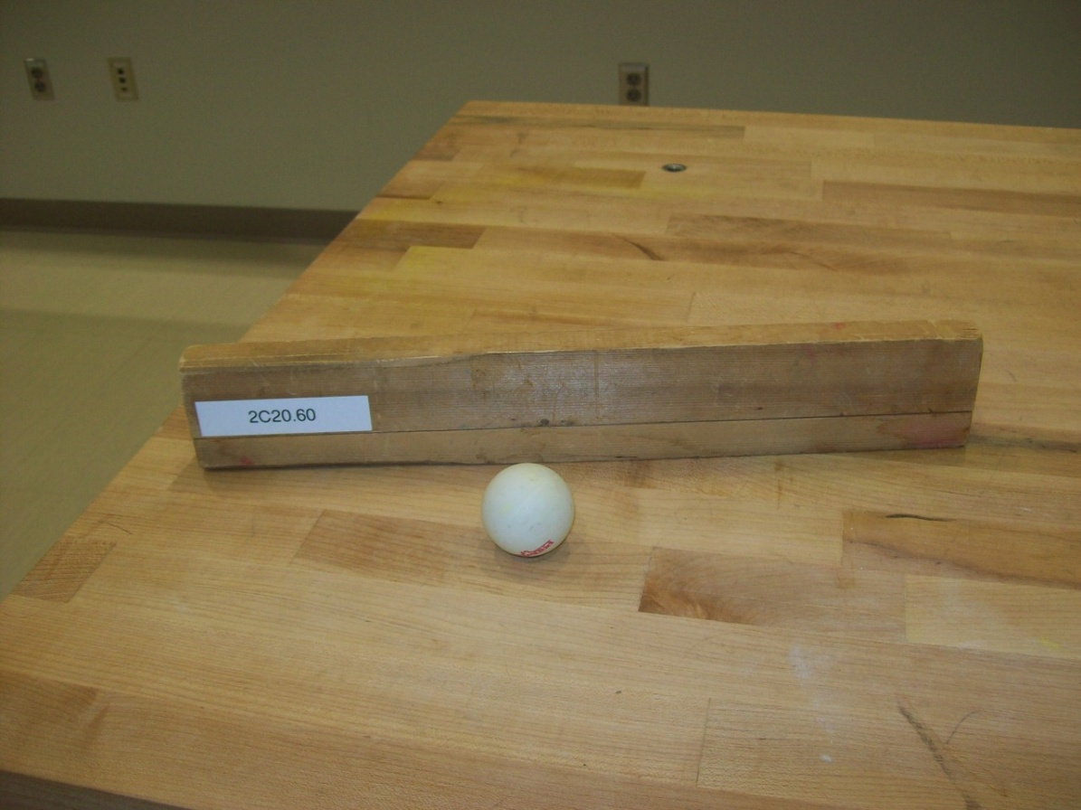
Location: Ea1

FLUID MECHANICS | 2C20.80 | DYNAMICS OF FLUIDS
Forces in Moving Fluids

Flettner Rotator
 | Direct an air stream at a rotating vertical cylinder on a light car. The car will move at right angles to the air stream. The motive force is caused by the deflection of the air stream by the rotating cylinder. Bernoulli’s principle is not an explanation for this demonstration.
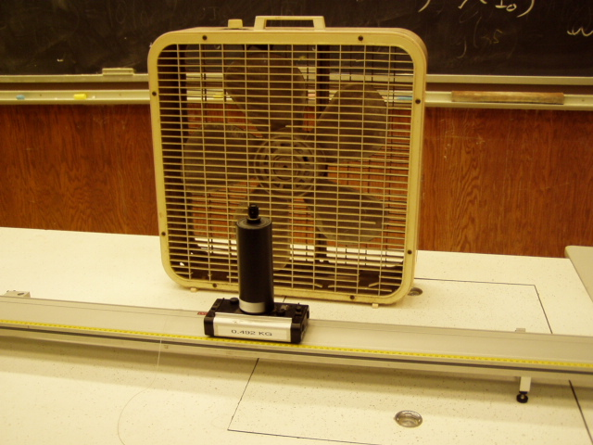Location: Ea1

FLUID MECHANICS | 2C20.95 | DYNAMICS OF FLUIDS
Forces in Moving Fluids

Frisbee
 | Of frisbees, can lids, and gyroscopic effects.
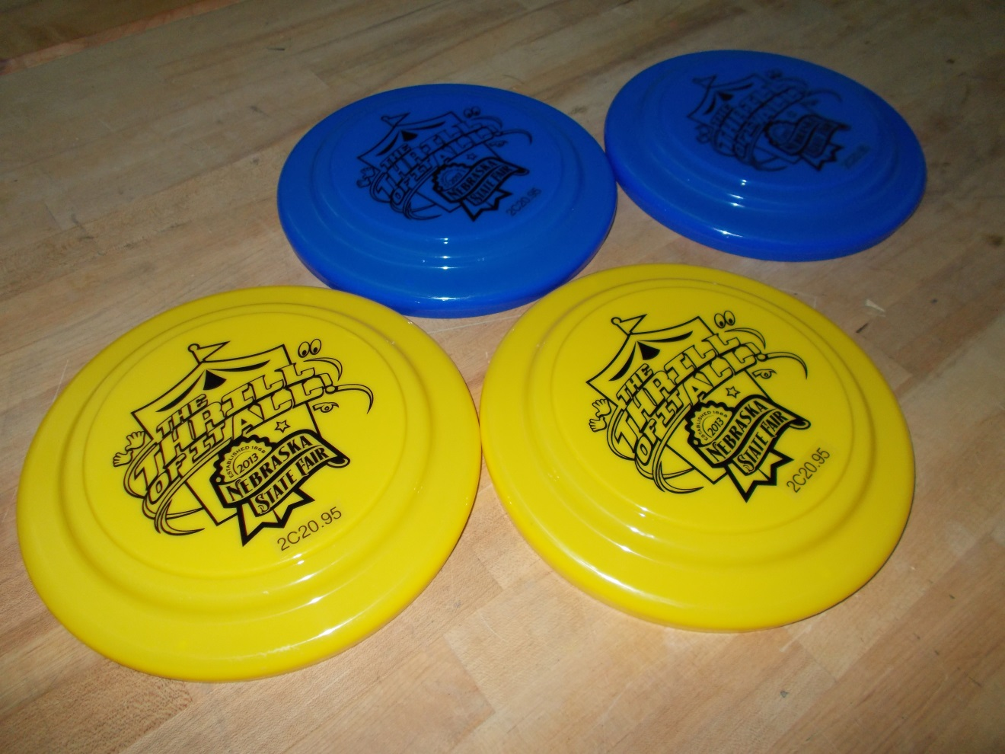Location: Ea3

FLUID MECHANICS | 2C30.25 | DYNAMICS OF FLUIDS

Viscosity

Viscosity of Oil
 | Invert several sealed tubes filled with oil. The air bubble in each rises. The tubes contain two colored oil-based liquids of two different velocities, and there are three different lengths of liquid columns (for a kinematics experiment). The red orange and yellow tubes contain Chevron Hydraulic Oil AW ISO 22 (kinetic viscosity: 23.1 centistokes @ 40 °C). The green, blue, and violet tubes contain CITGO AW Hydraulic Oil 46 (kinetic viscosity: 46 centistokes @ 40 °C). (1 centistokes = 1 mm²/s)
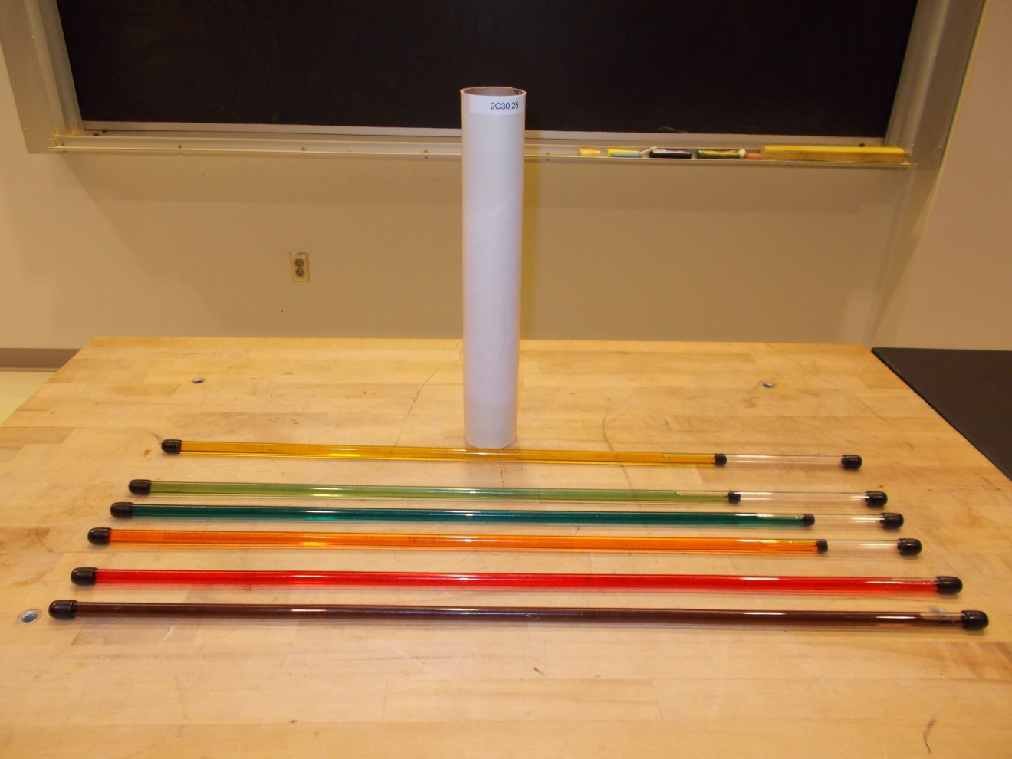
Location: Dc1
FLUID MECHANICS | 2C30.60 | DYNAMICS OF FLUIDS
Viscosity

Terminal Velocity
 | Drop a coffee filter under a motion sensor connect to a computer using the Capstone software (Terminal Velocity.cap). The software plots the velocity as a function of time. Compare various objects. It is a little tricky to get a good drop so practice. The data collection starts when the objects velocity is above 0 and stops after it reaches a distance of 1.5 m from the sensor.
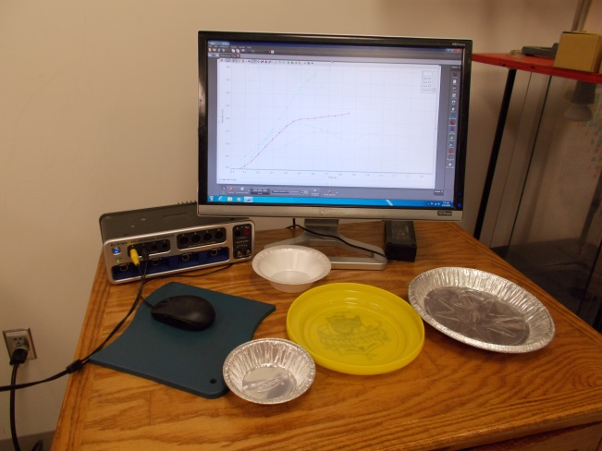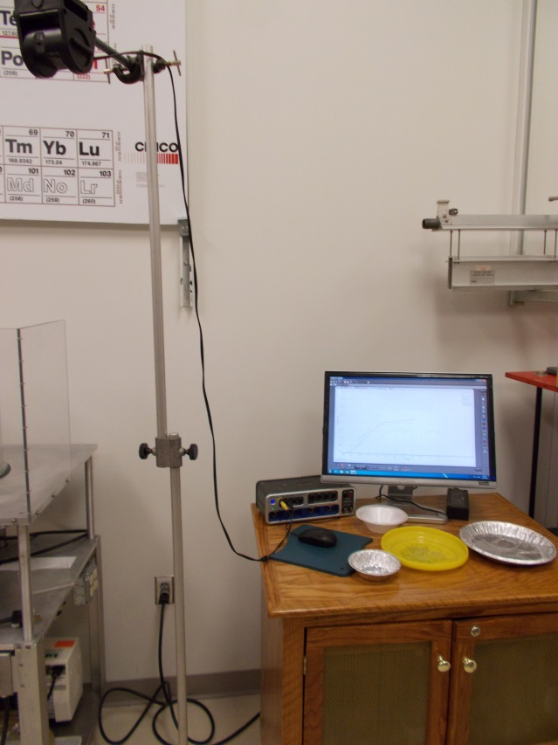Location: Science Workshop Cabinet, Ea4
FLUID MECHANICS | 2C50.15 | DYNAMICS OF FLUIDS

Vortices

Vortex Cannon
 | Use a large box with a hole in one end and a heavy plastic diaphragm in the other to blow smoke rings and blow out candles.
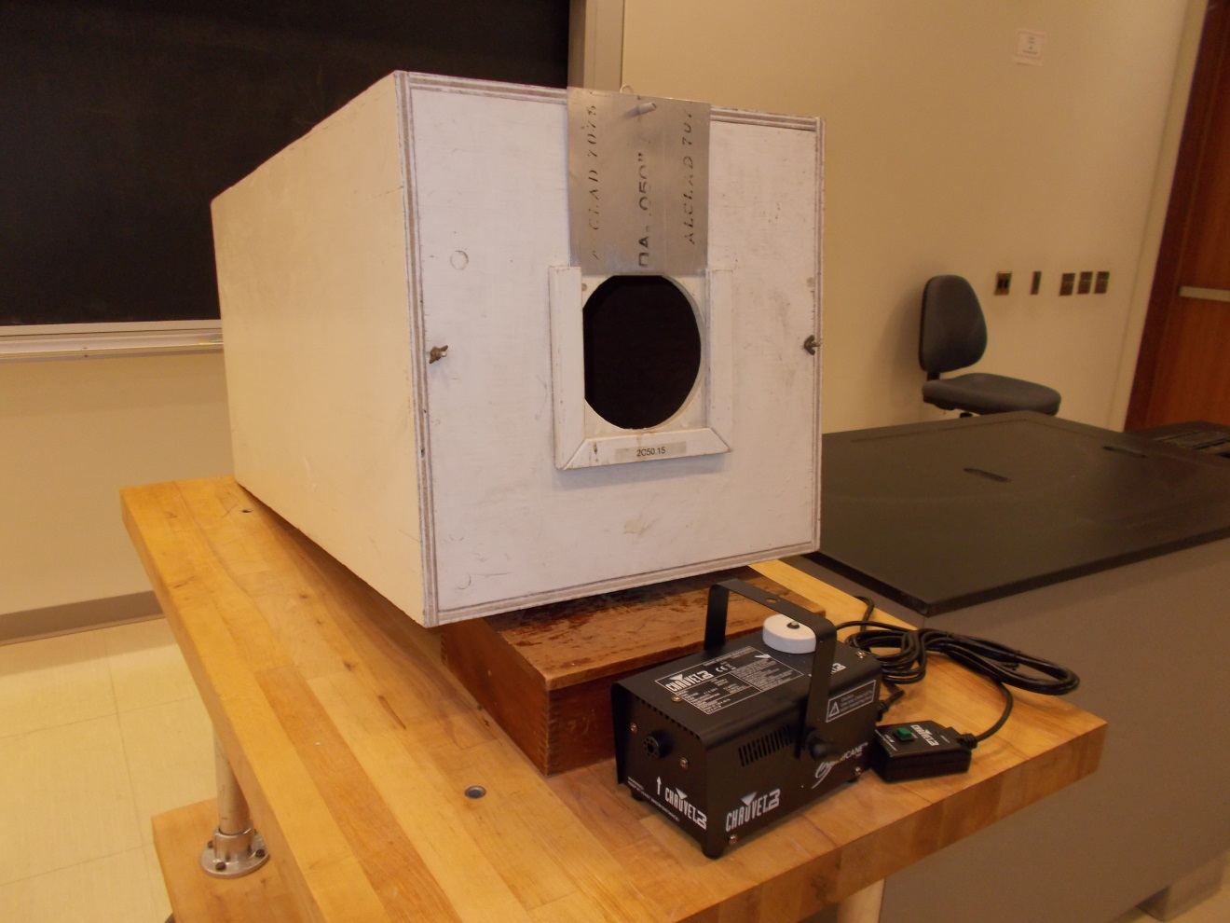
Location: Ea2
FLUID MECHANICS | 2C50.34 | DYNAMICS OF FLUIDS
Vortices

Tornado-in-a-Box
 | Our version uses a fan to create the vortex and water vapor from an ultrasonic vaporizer to make it visible.
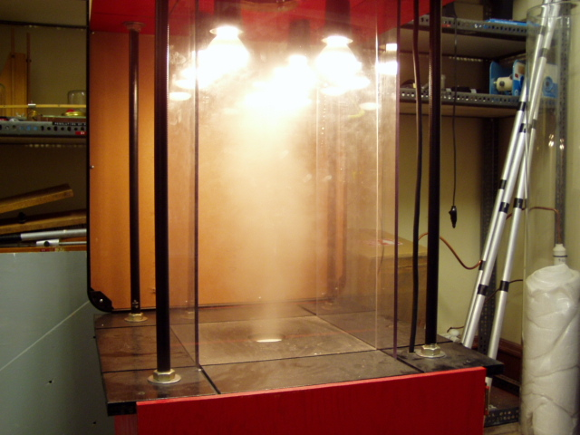Location: On the Floor
FLUID MECHANICS | 2C50.35 | DYNAMICS OF FLUIDS
Vortices

Paraboloids and Vortices
A paraboloid is formed when a liquid is rotated.
Also see 1D52.20: Water Parabola.

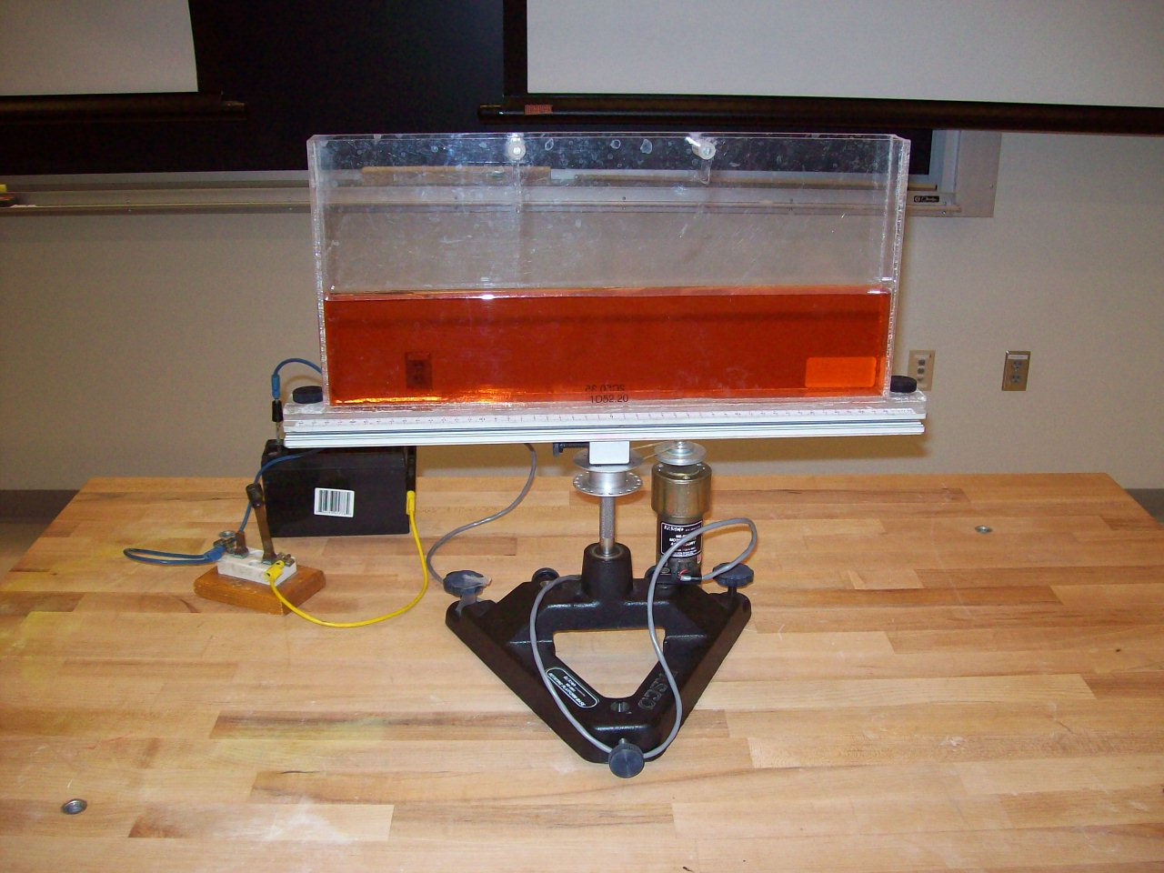
Location: Bc3

