For the complete bibliography with references as well as an explanation of the classification scheme go to:
Demonstration Bibliography
The demonstration name listed in the bibliography is either the name listed on the reference or, if none is given, a simple descriptive name. In cases where there are several common names for a demonstration, the committee has chosen a preferred name.
The description is very brief. It is not intended to be a summary of the reference. One sentence is, in general, sufficient to describe the unique characteristics, if any, of an item. Each source has a unique numbering format. These unique formats are used identify references in the Bibliography.
The formats for the reference column and links to the sources are listed below:
Reference | Source
M-1 | Sutton
Ma-1 | Freier & Anderson
M-1d | Hilton
8-2.8 | Meiners
M-108 | Dick & Rae
1A 12.01 | University of Minnesota Handbook
AJP 52(1),85 | American Journal of Physics
TPT 15(5),300 | The Physics Teacher
Disc 01-01 | The Video Encyclopedia of Physics Demonstrations
PIRA 200 | Physics Instructional Resource Association
PIRA 500 | PIRA 500
PIRA 1000 | PIRA 1000
Each demonstration is listed in only one location, even if it is commonly used to illustrate several concepts.

11/20/2023

1
KINETIC THEORY 4
Brownian Motion 4
Brownian Motion Cell 4
QUANTUM EFFECTS 5
Photoelectric Effect 5
Discharging Zinc Plate 5
Stopping Potential 6
Millikan Oil Drop 7
Millikan Oil Drop Experiment 7
Wave Mechanics 8
Frustrated Total Internal Reflection 8
Vibrating Circular Wire 9
X-ray and Electron Diffraction 10
Electron Diffraction 10
Microwave Bragg Diffraction 11
Sample X-Ray Tube 12
Condensed Matter 13
Quantum Levitation and Flux Pinning 13
Electron Conduction Model 14
Blackbodies 15
Hole in a Box 15
Black Body Spectrum 16
ATOMIC PHYSICS 17
Spectra 17
Student Gratings and Line Sources 17
Spectrum With TV Camera 18
Absorption 19
Band Absorption Spectrum 19
Resonance Radiation 20
Projected Mercury Spectrum 20
Fluorescence and Phosphorescence 21
Particle in a Box 22
Ionization Potentials 23
Photoionization in a Glow Lamp 23
Electron Properties 24
Plasma Globe 24
Atomic Models 25
Electron Orbital Models 25
NUCLEAR PHYSICS 26
Radioactivity 26
Geiger Counter and Samples 26
Half Life with Isotope Generator 27
Half Life of Silver 28
Cosmic Rays 29
Discharge an Electroscope 30
Nuclear Reactions 31
Mousetrap Chain Reaction 31
Particle Detectors 32
Ludlum Detectors 32
Deflection of Beta Rays 33
Diffusion Cloud Chamber 34
Models of the Nucleus 35
Rutherford Scattering 35
Rutherford Scattering on an Air Table 36
Rutherford Model 37
RELATIVITY 38
Special Relativity 38
Induction Coil Relativity 38
Lorentz Transformation / Time Dilation 39
Lasers 40
Laser Polarization and Intensity - Modes 40
Optical Resonator 40

THERMODYNAMICS | 4D10.10 | KINETIC THEORY

Brownian Motion

Brownian Motion Cell
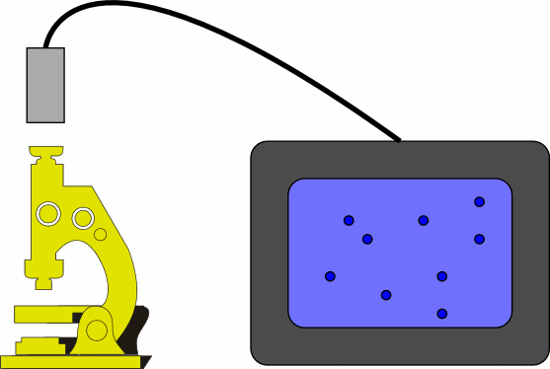 | Observe the motion of particles in a smoke cell through a microscope. The balls are about 1 micron in diameter. Put a drop of the solution on a slide then place a cover slide on top of it. Use a drop of oil with the oil immersion objective. The well slide works best (less systematic movement); if you use it, place a drop in the well then dilute it with water.
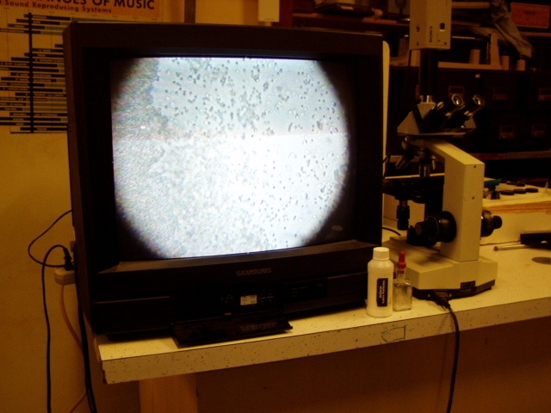
Location: Ga3
MODERN PHYSICS | 7A10.10 | QUANTUM EFFECTS

Photoelectric Effect

Discharging Zinc Plate
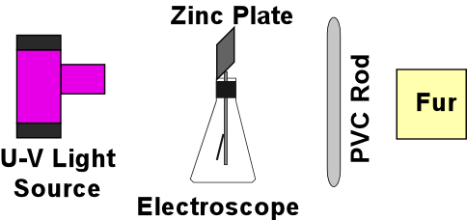 | A polished (with fine abrasive paper) zinc plate sits atop an electroscope. Charge the electroscope with a rod. Turn on the UV light. Expose the zinc plate to the UV rays. Do not turn the UV light towards the students. Compare what happens when you charge the plate positively with what happens when you charge it negatively.
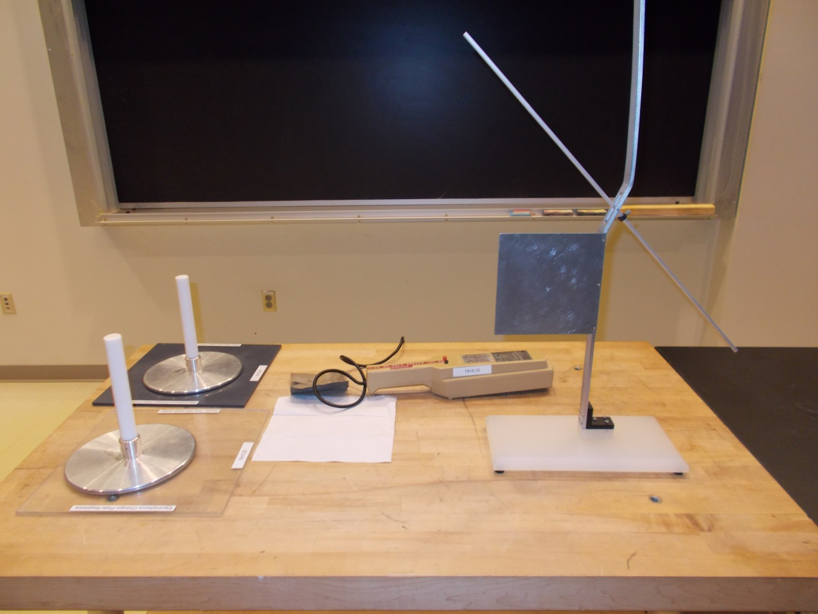Location: Ka2, Gc1, Gd1
MODERN PHYSICS | 7A10.30 | QUANTUM EFFECTS
Photoelectric Effect

Stopping Potential
 | h/e apparatus. Measure the stopping potential of the lines of the mercury spectrum with a photodiode.
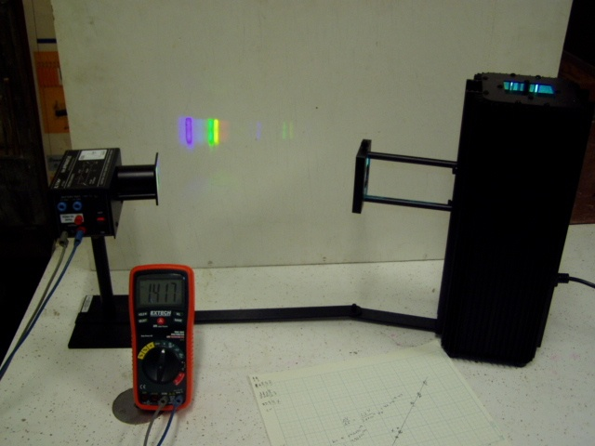Location: Ka2
MODERN PHYSICS | 7A15.10 | QUANTUM EFFECTS

Millikan Oil Drop

Millikan Oil Drop Experiment
 | The oil drop experiment.
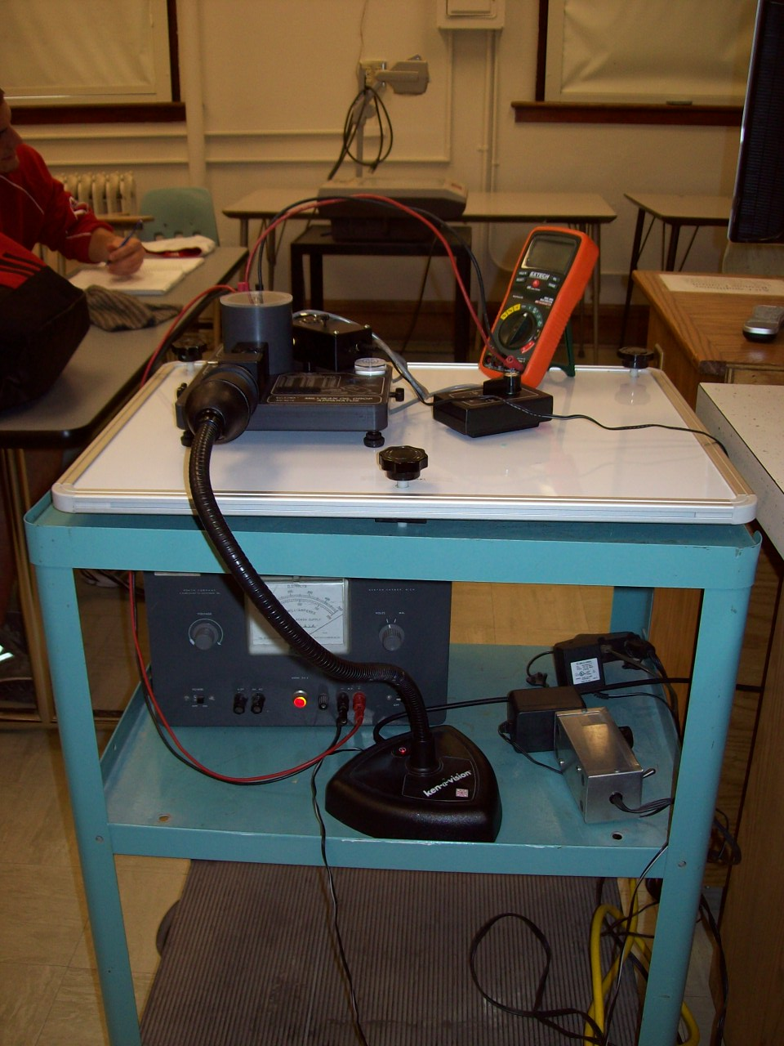
Location: Ka3

MODERN PHYSICS | 7A50.10 | QUANTUM EFFECTS

Wave Mechanics

Frustrated Total Internal Reflection
 | Squeeze two right angle prisms together using a C Clamp and some notched blocks of wood while directing a beam of light at the interface. Use the blackboard optics equipment for this.
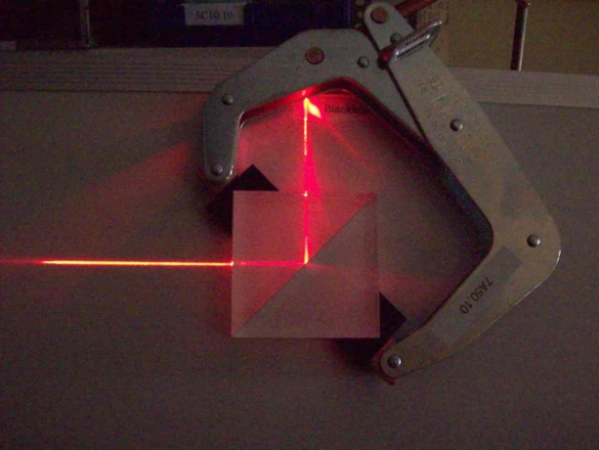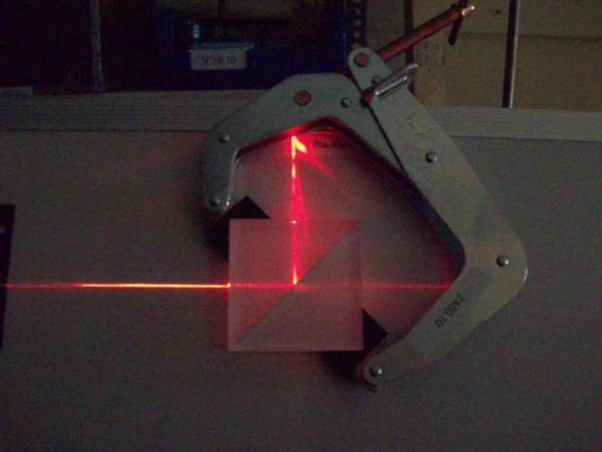
Location: Blackboard Optics Cart
MODERN PHYSICS | 7A50.40 | QUANTUM EFFECTS
Wave Mechanics

Vibrating Circular Wire
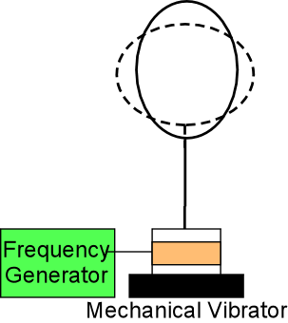 | The PASCO signal generator drives the PASCO mechanical vibrator. The three node resonance is at 20Hz. Turn up the amplitude after finding the resonance. Other resonances are at 60, 100, and 140 Hz. Pin the wire at 180 degrees from the mechanical vibrator to get full numbers of waves.
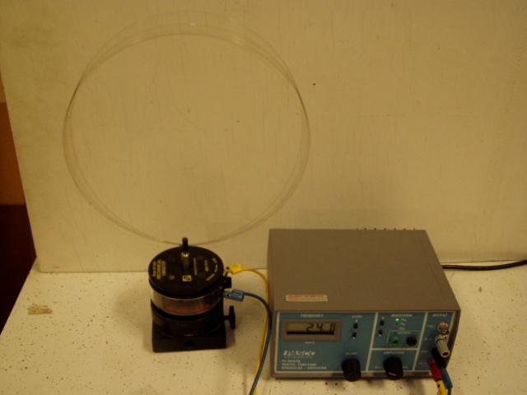Location: Ka3, Ec2, Fb4
MODERN PHYSICS | 7A60.10 | QUANTUM EFFECTS

X-ray and Electron Diffraction

Electron Diffraction
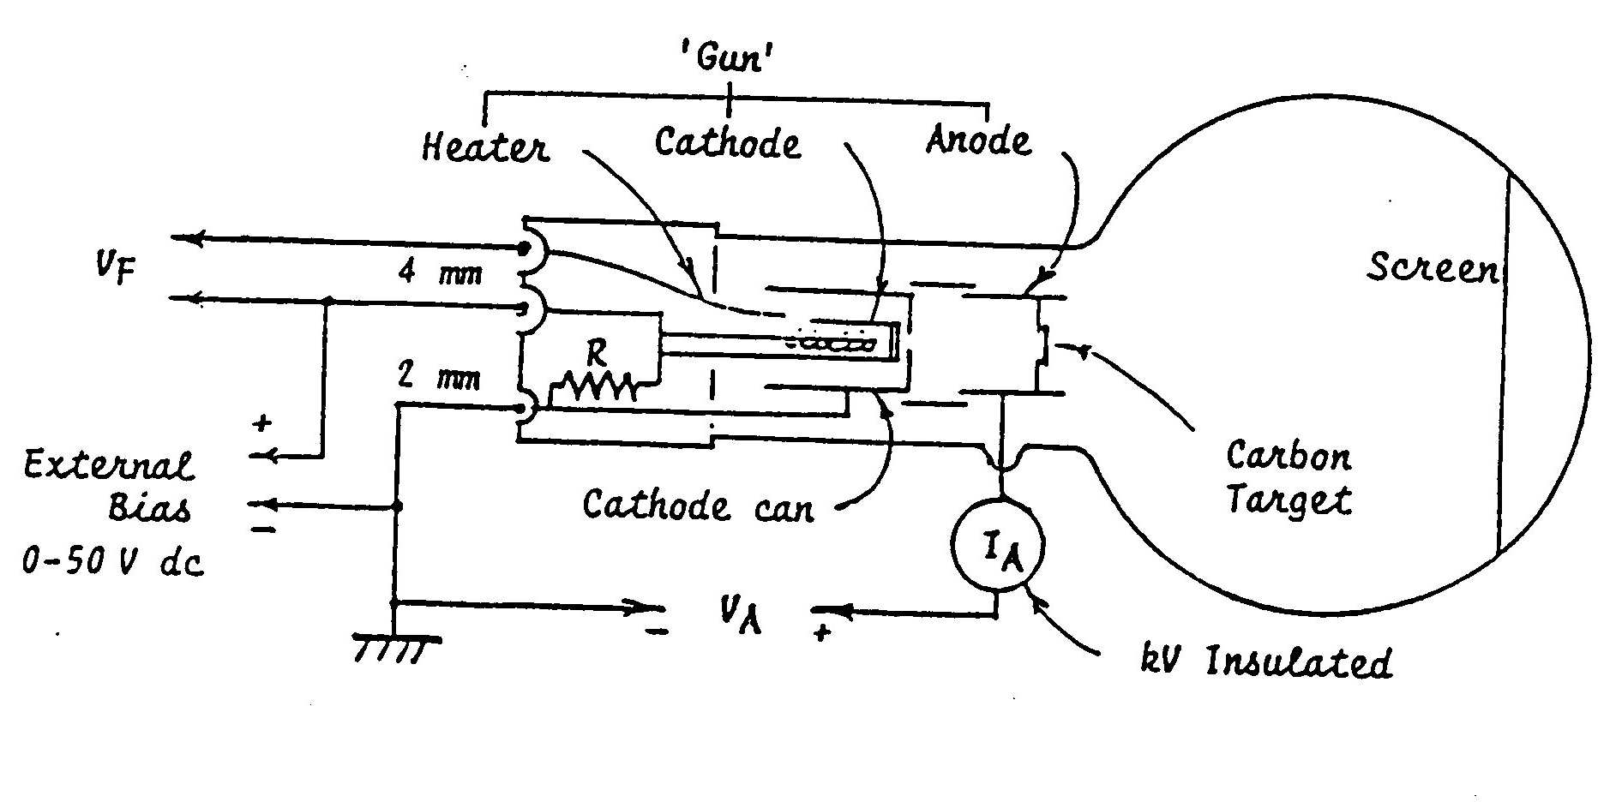 | Rings or spots diffraction patterns can be shown to the class using a TV camera. The beam and bias will already be adjusted. Turn up the HV until the pattern appears. Do not let the current exceed 170 microamps. Turn down the HV when you are done. The small jack at the back has a negative bias (20 V or so) on it. The filament voltage is 6.3 V and one side is connected to the common ground for the HV and negative bias supply.
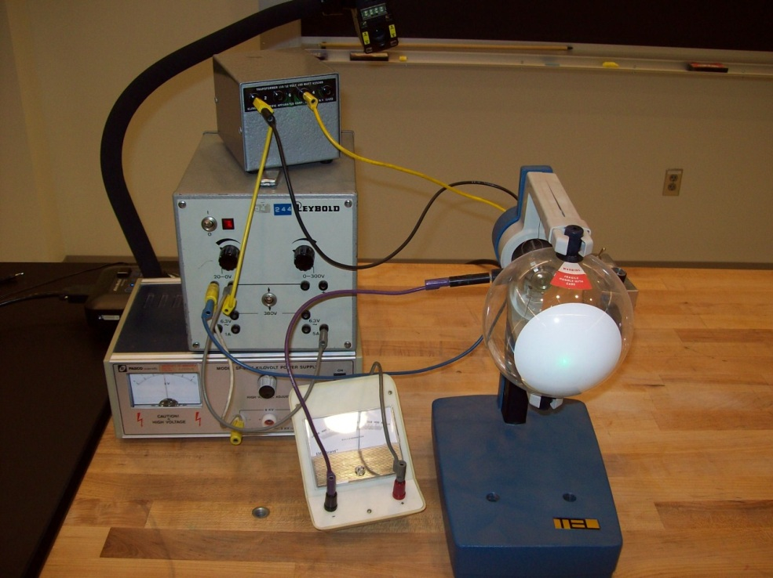
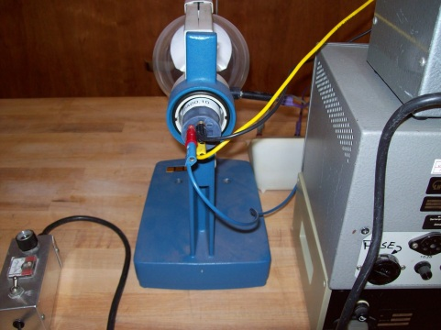
Location: Ka4
MODERN PHYSICS | 7A60.50 | QUANTUM EFFECTS
X-ray and Electron Diffraction

Microwave Bragg Diffraction
 | Microwave diffraction is observed from a crystal model made of steel ball bearings mounted in a Styrofoam cube.
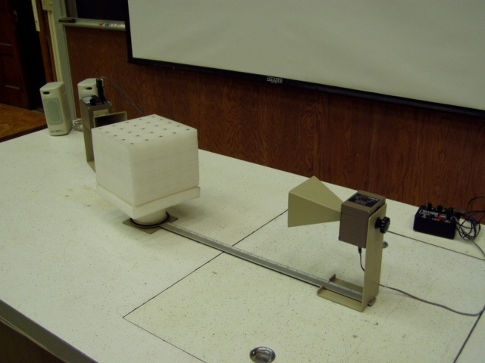Location: Ia7, Ka5
MODERN PHYSICS | 7A60.95 | QUANTUM EFFECTS
X-ray and Electron Diffraction

Sample X-Ray Tube
 | Show a large X-ray tube.
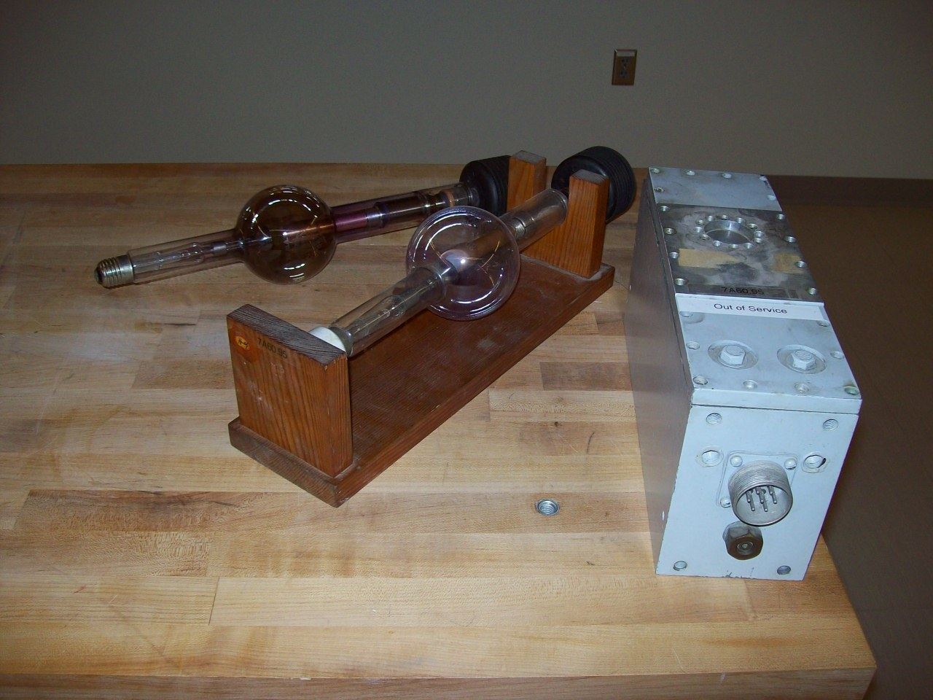Location: Kd1
MODERN PHYSICS | 7A70.20 | QUANTUM EFFECTS

Condensed Matter

Quantum Levitation and Flux Pinning
 | A thin film superconductor levitates over a magnet pinned in place by flux quanta.
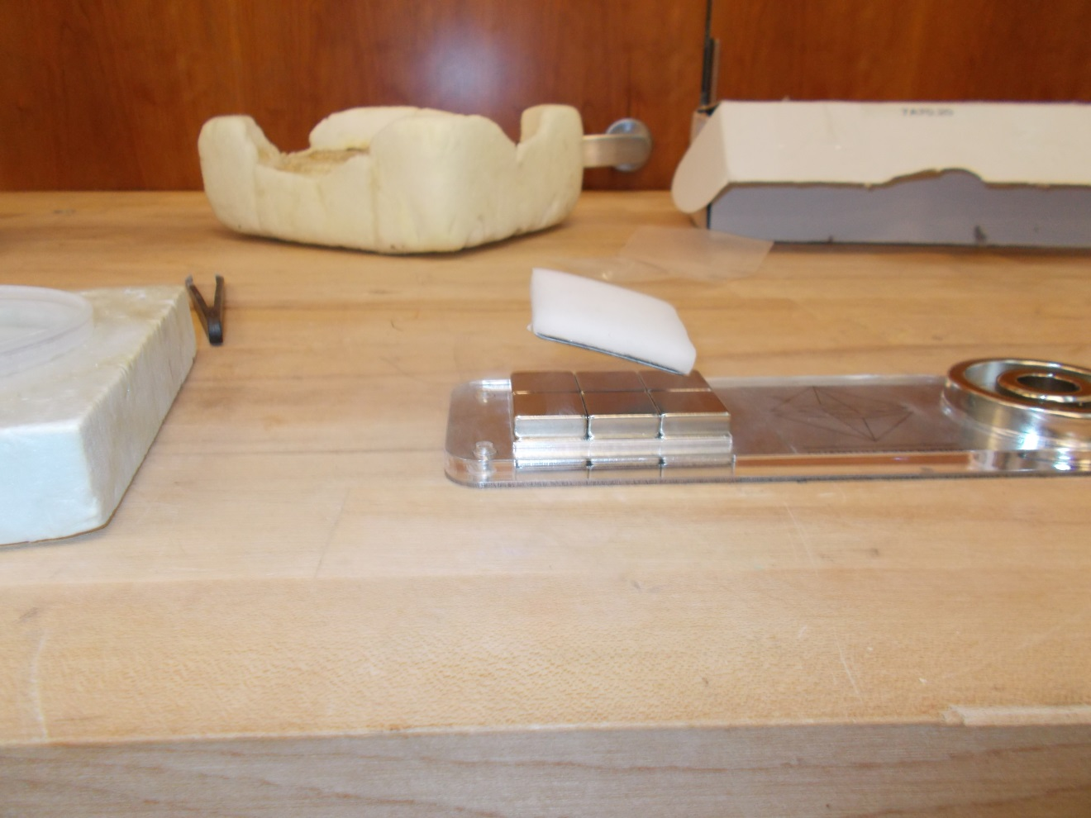Location: Ga5

MODERN PHYSICS | 7A70.40 | QUANTUM EFFECTS
Condensed Matter

Electron Conduction Model
 | The Air Cushion Table is used to show bound charge carriers in an insulator; a free charge in an insulator, conduction in a semiconductor (N type and P type. Air Cushion Table manual: 2.4.9, 2.4.10, 2.4.11, 2.4.12, 2.4.13.
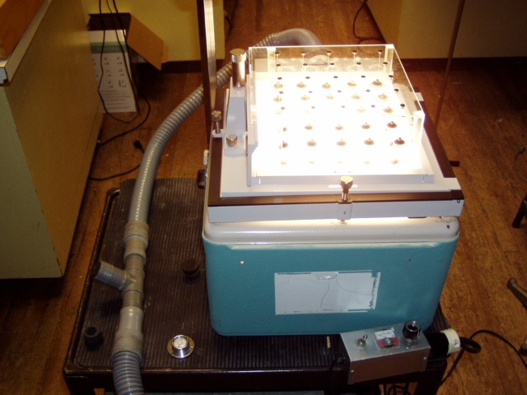Location: Ga5

OPTICS | 6B40.20 | PHOTOMETRY

Blackbodies

Hole in a Box
 | A box that is painted black has a hole in a hinged door. The hole appears blacker than the box, When the door is opened, you see the box is actually painted white on its inside surfaces. Use an infrared camera to look at a hole in a heated aluminum block (100 C).
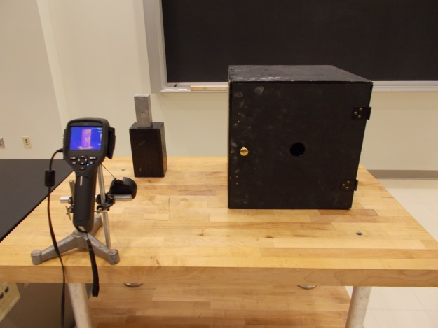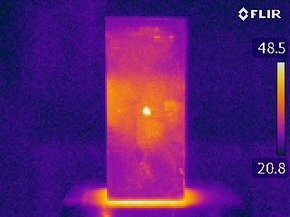

Location: Jb2, Fc5, FLIR Cabinet
OPTICS | 6B40.40 | PHOTOMETRY
Blackbodies

Black Body Spectrum
 | A spectrometer and bolometer connected to Science Workshop is used to record the spectrum from an incandescent bulb at various temperatures. The second version uses a bulb, grating, variac and TV camera. Use fixed focus and exposure. Change the variac setting to show the spectrum shift.
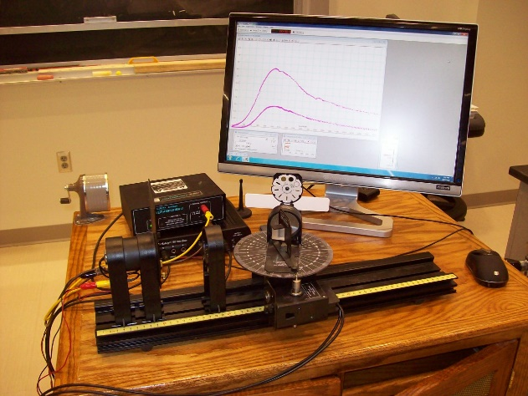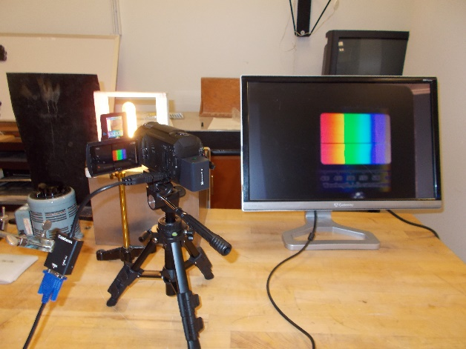
Location: Science Workshop Cabinet, Optics Table Cabinet, Kb2, Ib2
MODERN PHYSICS | 7B10.10 | ATOMIC PHYSICS

Spectra

Student Gratings and Line Sources
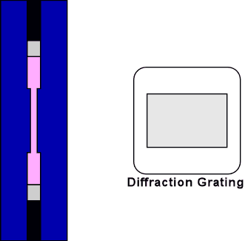 | Pass out the 1"x1" gratings to the students. These have 13,400 lines per inch. Turn on one of the light sources. There is a single filament white light source and three discharge tubes, Hg, He, and Ne. The Didymium filter can be placed in front of the white light source to show selective absorption. Also shown is a spectrometer with a TV camera showing hydrogen Balmer lines and the Ride Tide USB spectrometer showing the line spectrum on the computer. Use the door lite curtains to darken the room.
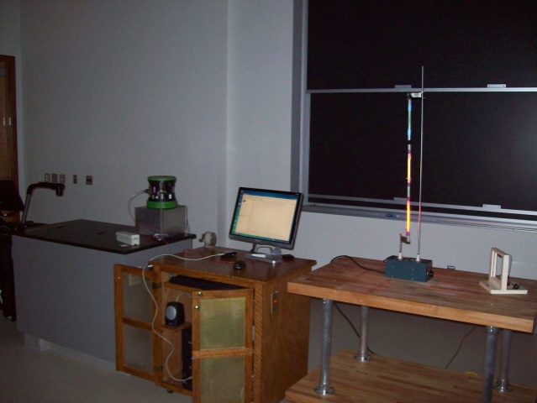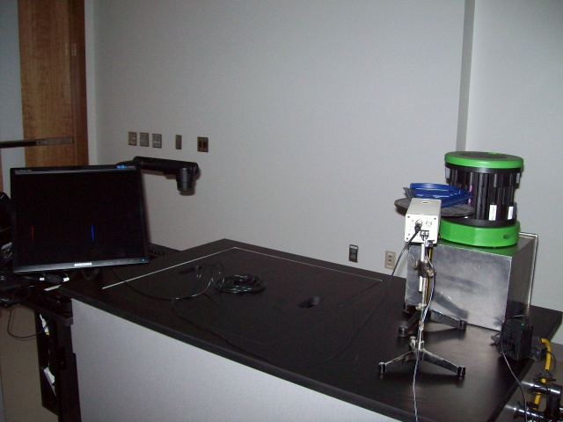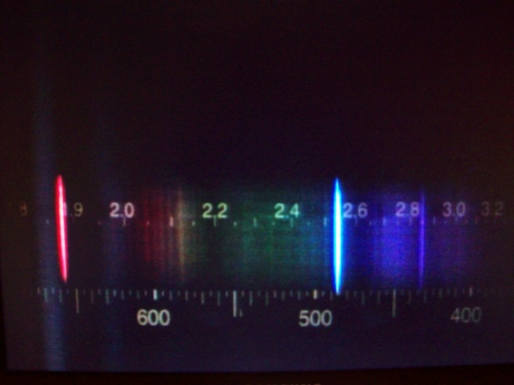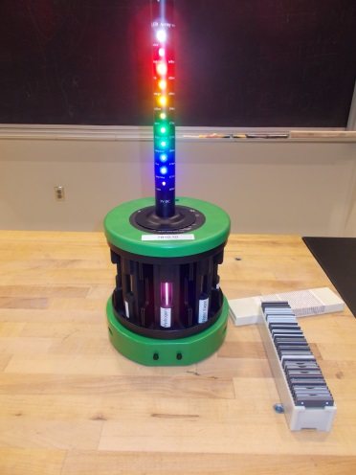
Location: Ka1, Kb2
MODERN PHYSICS | 7B10.10a | ATOMIC PHYSICS
Spectra

Spectrum With TV Camera
 | A TV camera, grating and monitor are used to display a spectrum. Use fixed focus and exposure.
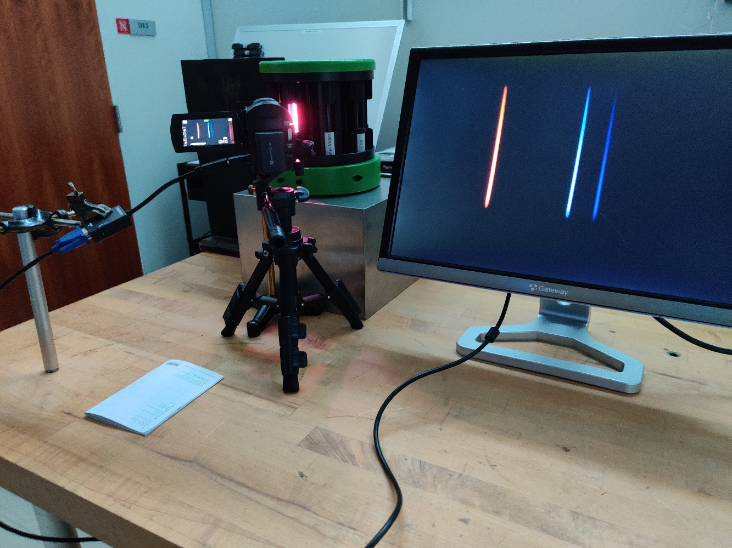
Location: Ka1, Kb2

OPTICS | 7B11.65 | ATOMIC PHYSICS

Absorption

Band Absorption Spectrum
 | Didymium glass is used to show band absorption. The Reveal 60 bulb is used with both a grating and the Red Tide spectrometer to show the bands. An ordinary bulb is shown for comparison. Use fixed focus and exposure for the TV camera.
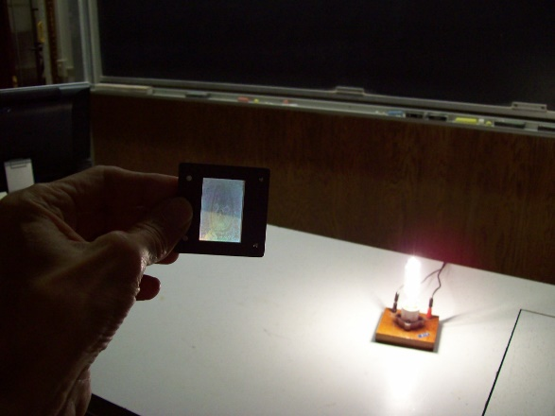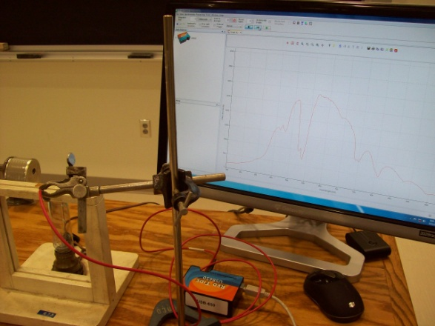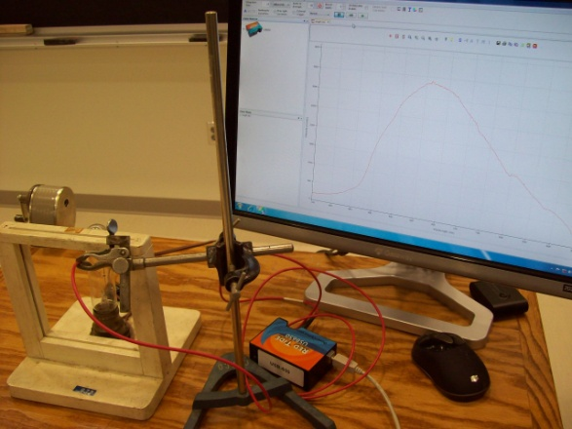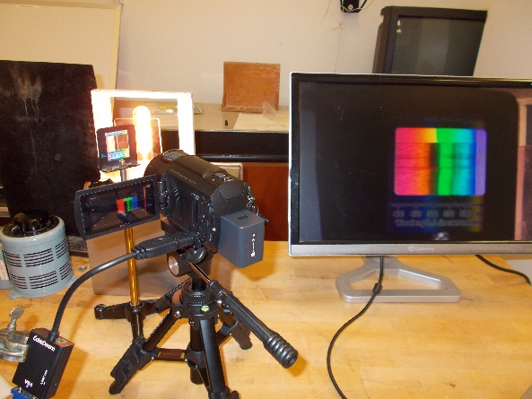
Location: Jb2, Ib1
MODERN PHYSICS | 7B13.42 | ATOMIC PHYSICS

Resonance Radiation

Projected Mercury Spectrum
 | The UV lines of the projected spectrum are made visible using a fluorescent board
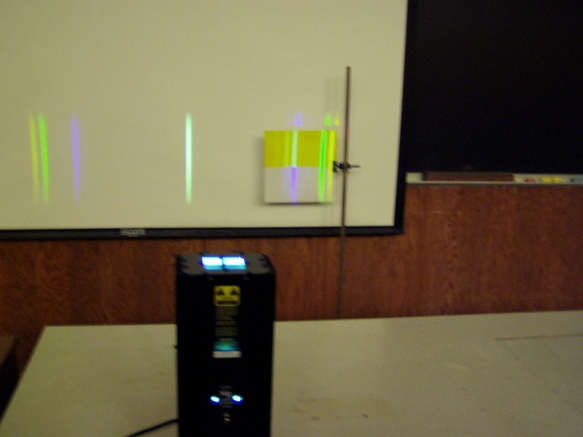Location: Ka2
MODERN PHYSICS | 7B13.50 | ATOMIC PHYSICS
Resonance Radiation

Fluorescence and Phosphorescence
 | Fluorescent and phosphorescent materials are shown with a black light.
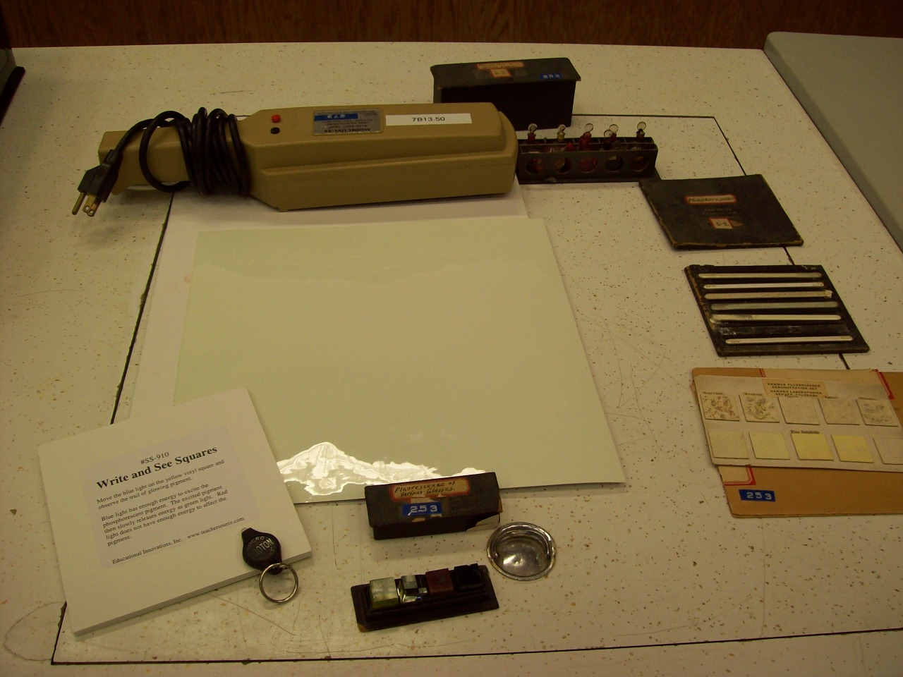
Location: Kb3

MODERN PHYSICS | 7B13.51 | ATOMIC PHYSICS
Resonance Radiation

Particle in a Box
Nanobeads (quantum dots) of 4 different sizes in solution fluoresce when illuminated with a UV light. The energy calculation is based on the calculation of a particle in a potential sphere (see the appendix of the instructions for more info). The quantum "sphere" or "box" is not empty but filled with a semiconductor. In order for the students to understand this they must first start with the derivation of a 1D particle in a box calculation, the sphere is basically the same physical concept with a different mathematical geometry.
Using the Red Tide spectrometer the peaks from the different fluorescing vials can be measured and compared with theory.
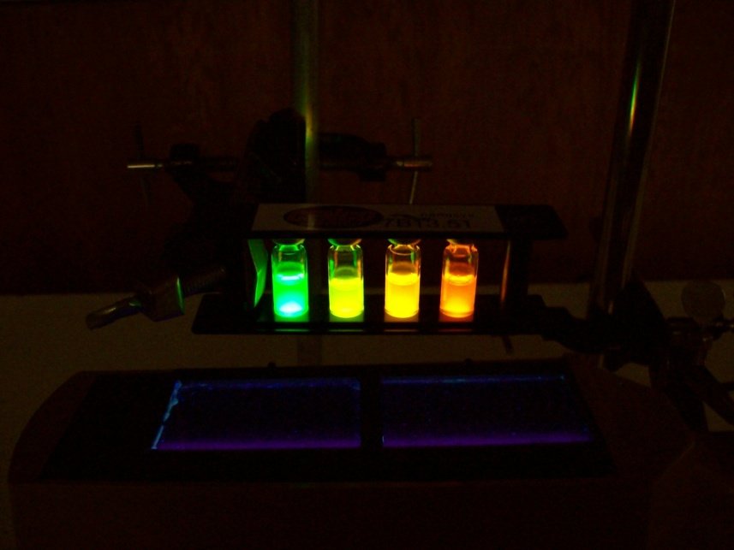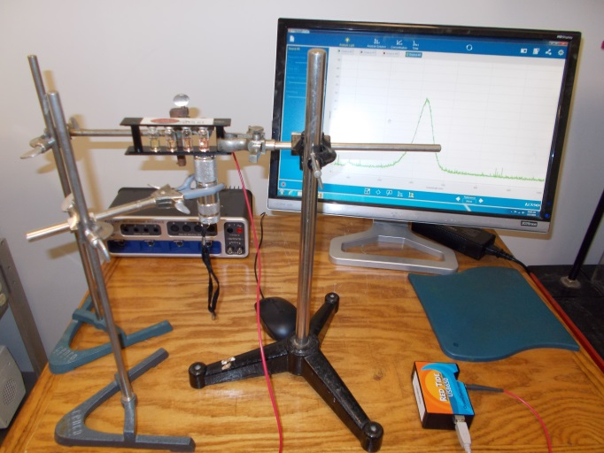
Location: Kb3
MODERN PHYSICS | 7B30.45 | ATOMIC PHYSICS

Ionization Potentials

Photoionization in a Glow Lamp
In a glow lamp, when the potential across it is high enough, electrons will ionize the gas. The positive ions get attracted to the cathode and shield the electrons from the anode in the sense that there's a much reduced electric field beyond the cathode glow and Faraday dark space, so the electrons just scatter off of the neutral atoms without imparting much energy to them in that region. Between the cathode and dark space (the cathode fall), the electric field is strong enough to accelerate the electrons to excite the neon atoms causing them to glow they also provide ionizing energy to sustain the glow. If the potential is not high enough, the electrons just scatter off the neutral atoms never gaining enough energy to ionize them or excite them to emit light.

The glow does not come from the ions recombining with electrons, but a level-to-level transition in the neon atoms. The ions just serve to let the electrons accelerate to high enough energy to excite the atoms. So, when you shine the violet laser on or near the cathode when the potential across the tube is below the striking voltage, you're just initiating the formation of the ion cloud, which allows the electrons to attain enough energy in the cathode fall to excite the atoms. If a red laser is used instead, there is not enough photon energy to ionize the neon atoms and the tube remains dark. The tube can also be started by holding an electrically charged rod nearby
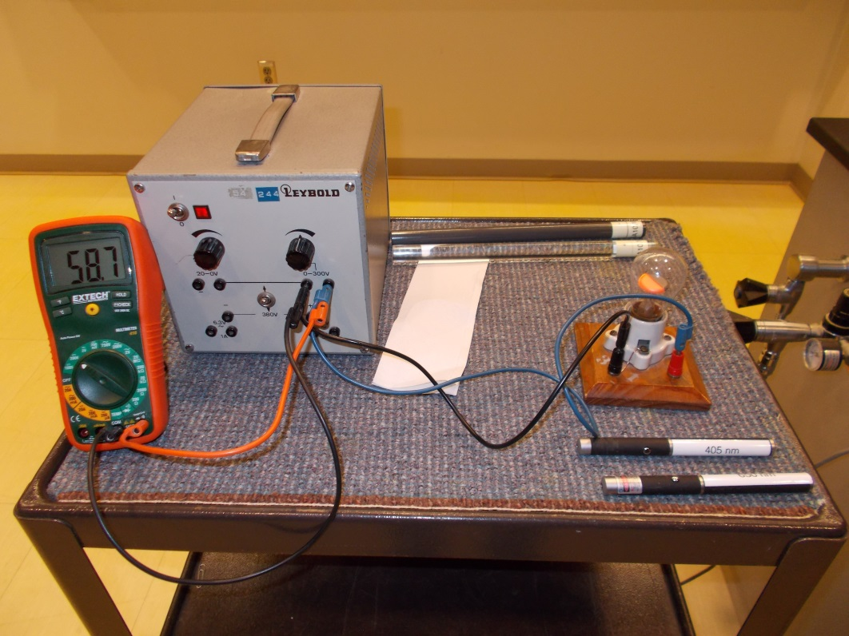
Location: Gc1, Ha5, Jc2
MODERN PHYSICS | 7B35.75 | ATOMIC PHYSICS

Electron Properties

Plasma Globe
 | Commercial plasma tubes are discussed. Bring your hand near the globe.

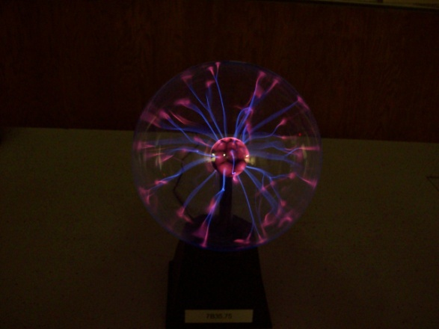
Location: Kb4
MODERN PHYSICS | 7B50.10 | ATOMIC PHYSICS

Atomic Models

Electron Orbital Models
 | A set of Klinger electron orbital models.
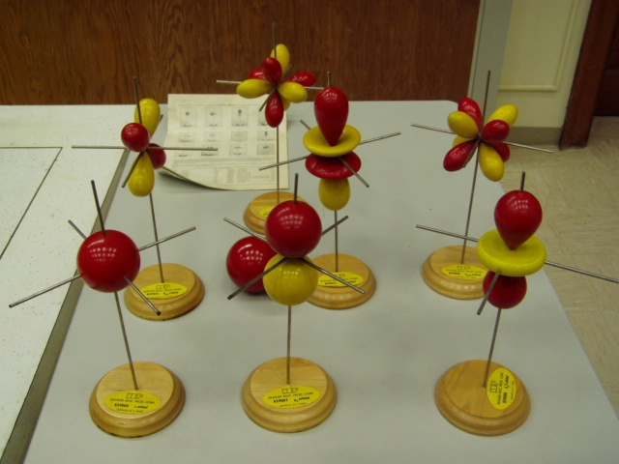
Location: Kb5

MODERN PHYSICS | 7D10.10 | NUCLEAR PHYSICS

Radioactivity

Geiger Counter and Samples
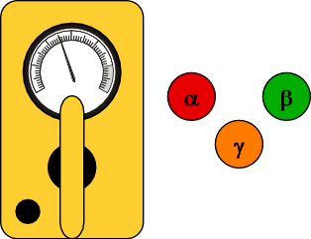 | Turn on the counter and place sample under Geiger Tube. Test to see how distance from the sample affects the count. Place objects like: paper, wood, lead and other items between the source and the tube to check their shielding properties. The alpha paddle can be used to selectively detect alpha particles only.
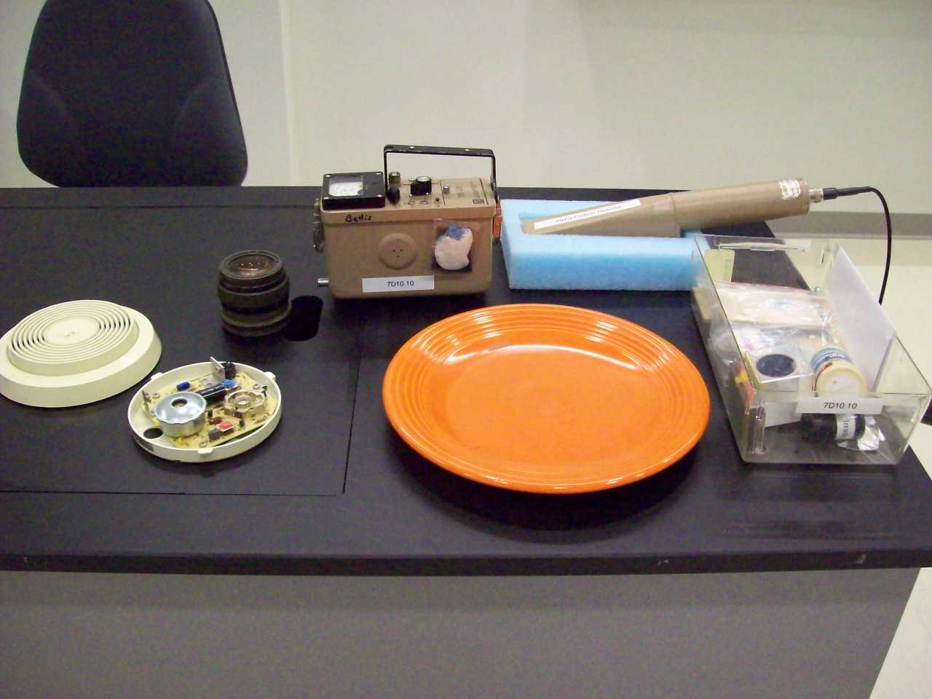
Location: Kb6
MODERN PHYSICS | 7D10.20 | NUCLEAR PHYSICS
Radioactivity

Half Life with Isotope Generator
 | Follow the instructions on how to “milk” the generator. It is good practice to survey the work area before and after for contamination. The Geiger counter can be connected to the computer and using Capstone (Half Life of an Isotope.cap) one can plot the count rate as a function of time and fit an exponential curve to it..
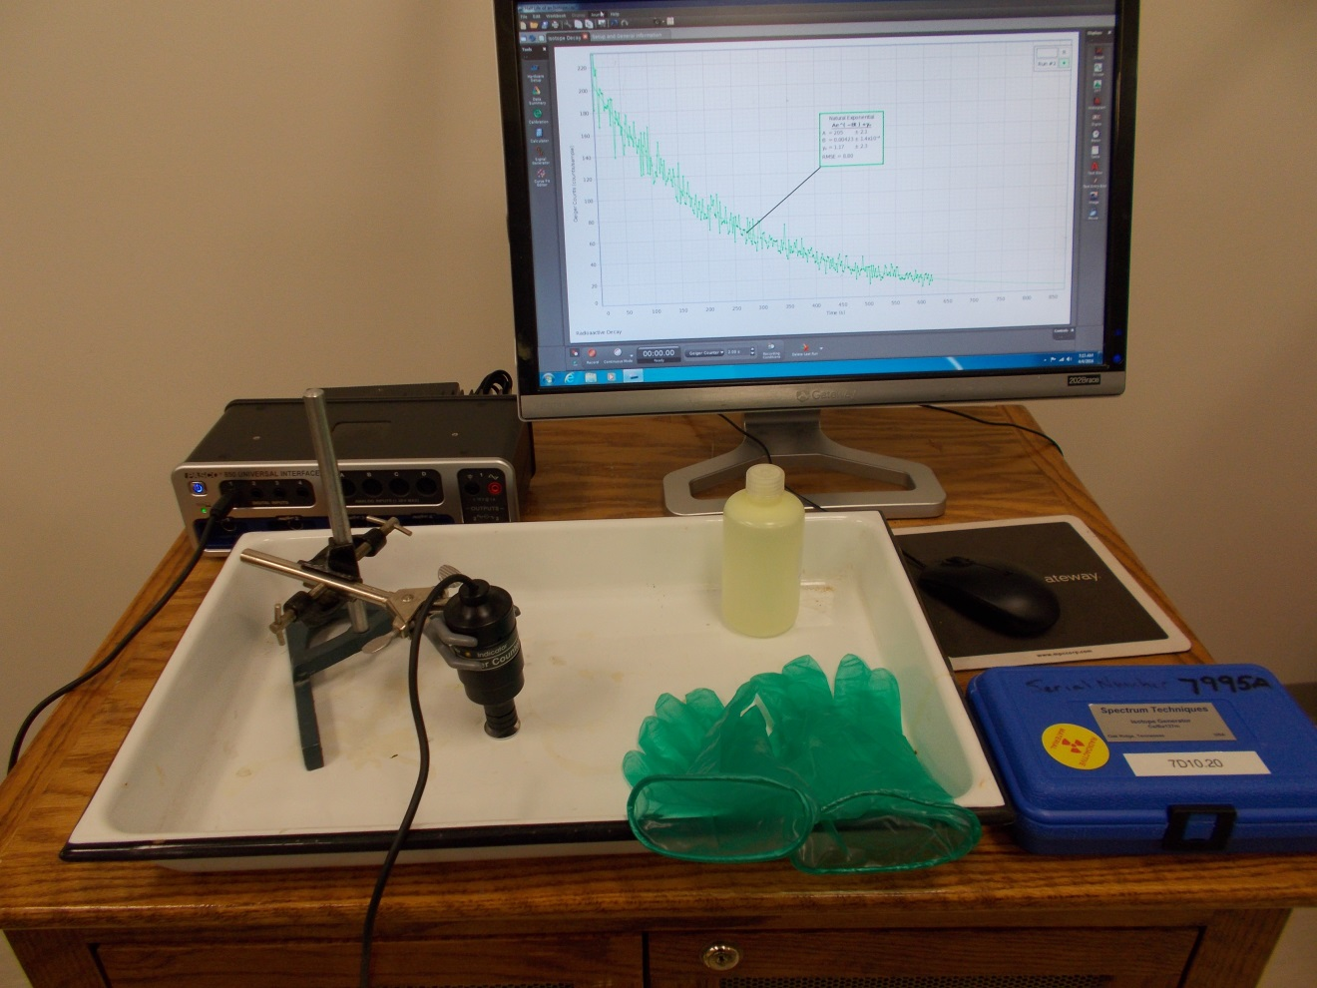Location: Kb6
MODERN PHYSICS | 7D10.33 | NUCLEAR PHYSICS
Radioactivity

Half Life of Silver
 | Measure the half life of silver activated by a neutron source. Use a glove to handle the “hot” silver as it is a beta emitter. Leave as the closest position to the neutron source for a few minutes to activate it.
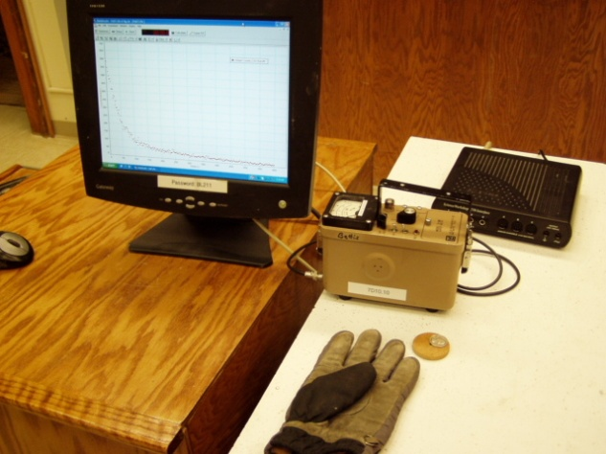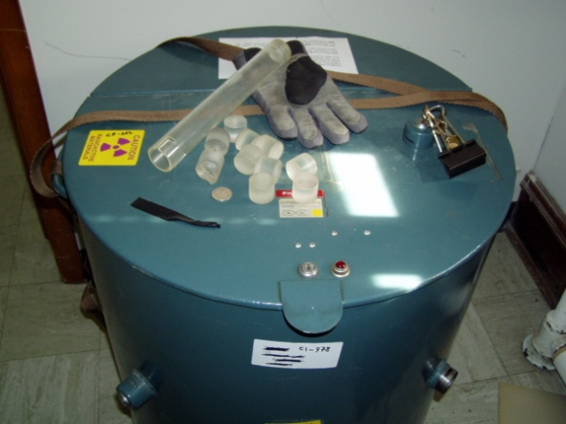
Location: Advanced Lab, Kb6
MODERN PHYSICS | 7D10.80 | NUCLEAR PHYSICS
Radioactivity

Cosmic Rays
 | Scintillator detectors show the passage of a cosmic ray by coincidence counting.

Electricity and Magnetism | 5D40.30 | RESISTANCE
Conduction in Gases

Discharge an Electroscope
 | Charge the electroscope either positively or negatively by induction. Then place the Po-210 source (0.5 mCi when new) in the electroscope and watch the electroscope discharge in a couple of seconds. Use safety protocols when handling the source.
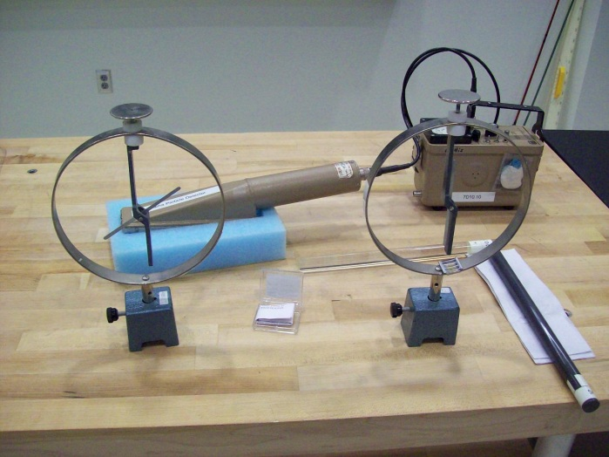

Location: Kb6, Gc2

MODERN PHYSICS | 7D20.10 | NUCLEAR PHYSICS

Nuclear Reactions

Mousetrap Chain Reaction
 | A 72 mousetraps with corks set on them. Trigger with a single “neutron” (cork). This requires about 20 minutes and nerves of steel to set up. Each trap stores about a joule of energy when set.
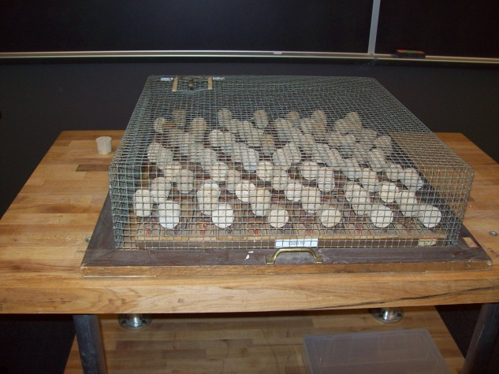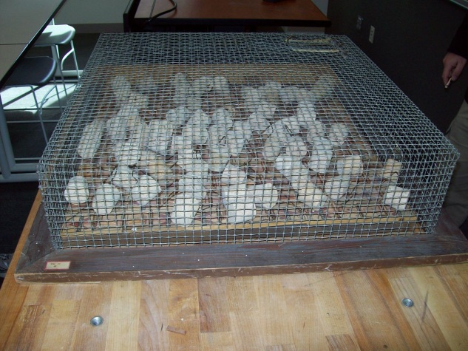
Location: KbT
MODERN PHYSICS | 7D30.05 | NUCLEAR PHYSICS

Particle Detectors

Ludlum Detectors
 | Ludlum hand held alpha, beta and gamma detectors are used with a variety of sources.
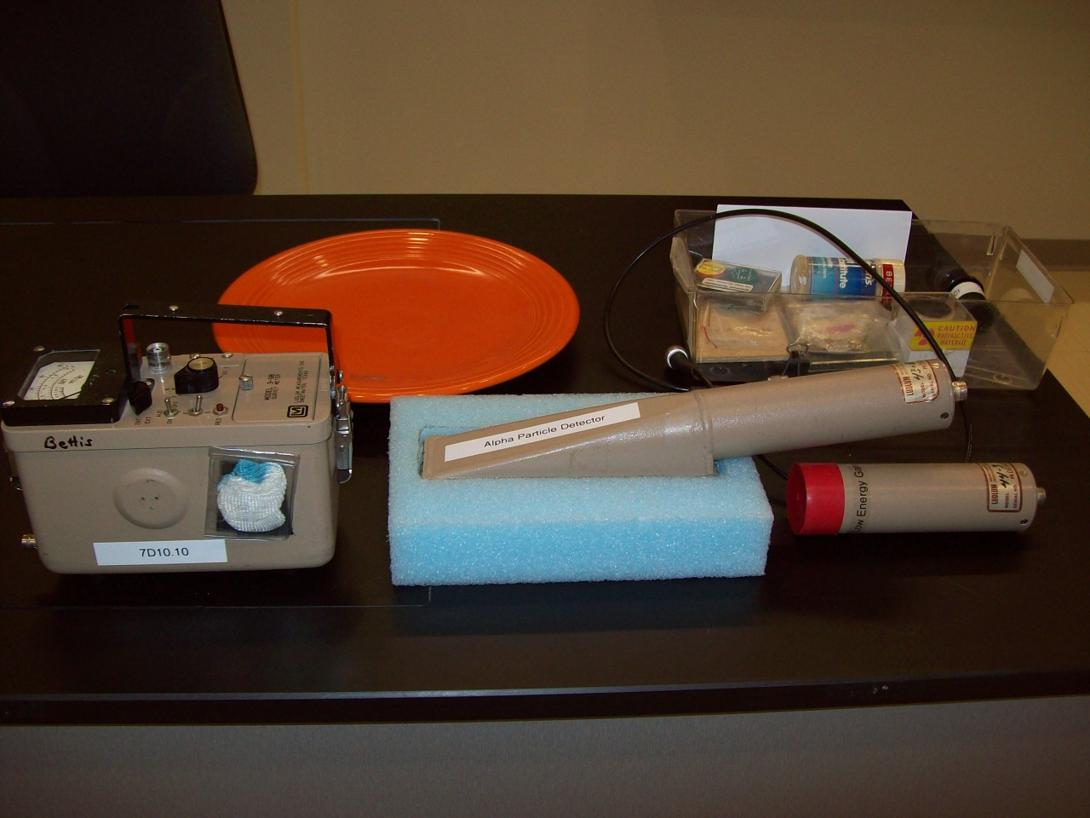Location: Kb6
MODERN PHYSICS | 7D30.30 | NUCLEAR PHYSICS
Particle Detectors

Deflection of Beta Rays
 | Turn on the counter and lay it on its side. Open the beta window. Place a beta source nearby, being sure the emitting side is toward the counter. Then bring a strong magnet near the source. The count rate will drop.
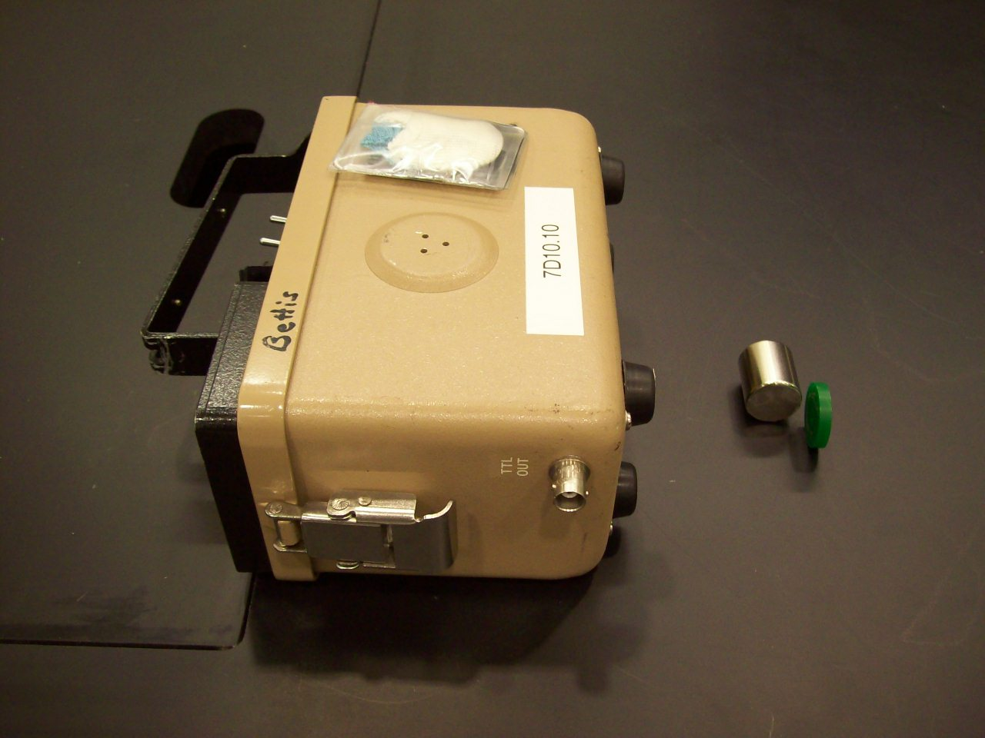
Location: Kb6, Hd5

MODERN PHYSICS | 7D30.60 | NUCLEAR PHYSICS
Particle Detectors

Diffusion Cloud Chamber
 | This demo requires advance notice to obtain ice and let the chamber cool (about 40 minutes). Tracks are most impressive if the students are allowed to view individually. The TV works quite well too. Use either ambient cosmic rays or Pb 210 as a source.

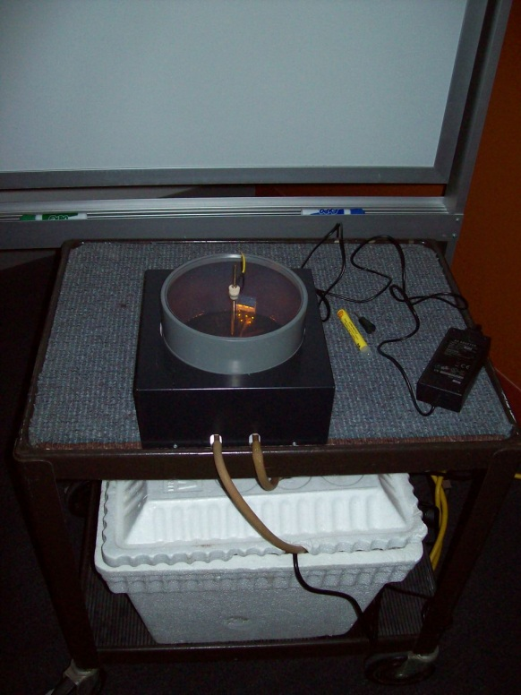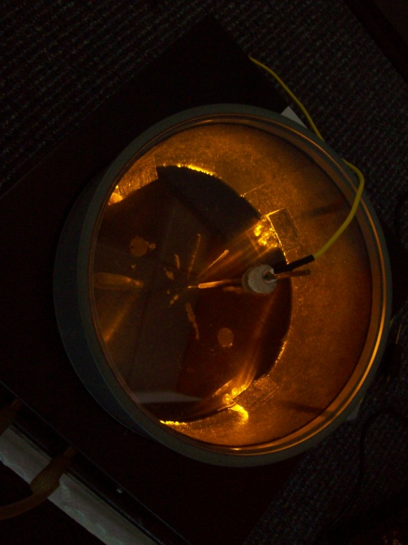
Location: Kc1
MODERN PHYSICS | 7D50.10 | NUCLEAR PHYSICS

Models of the Nucleus

Rutherford Scattering
 | Balls roll down a ramp onto a potential surface to model Rutherford scattering.
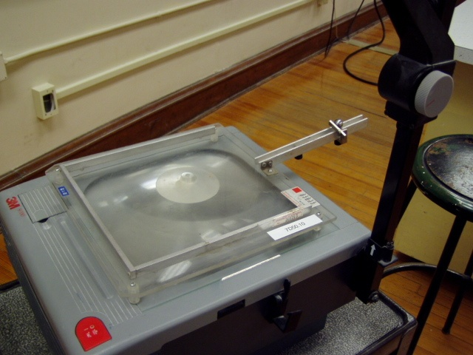Location: Kc2
MODERN PHYSICS | 7D50.14 | NUCLEAR PHYSICS
Models of the Nucleus

Rutherford Scattering on an Air Table
 | The Air Cushion Table is set up with a plastic platform that holds a magnet which repels a magnetic puck that is set in motion beneath it (Air Cushion Manual, 2.5.1). One can also illustrate the scattering of alpha particles through a foil using a foil made of a 1D lattice four magnets that repel a magnetic puck that is set in motion toward it (Air Cushion Table Manual 2.5.2.
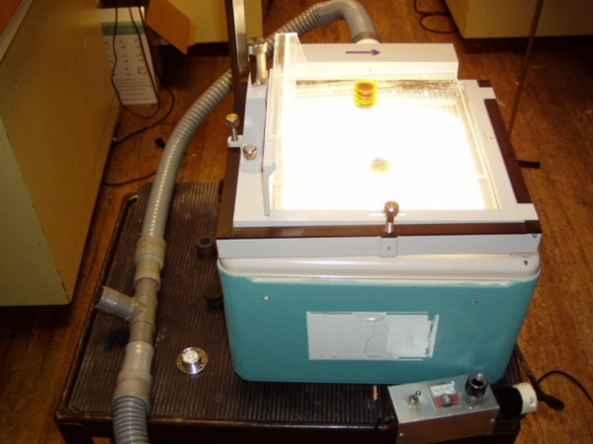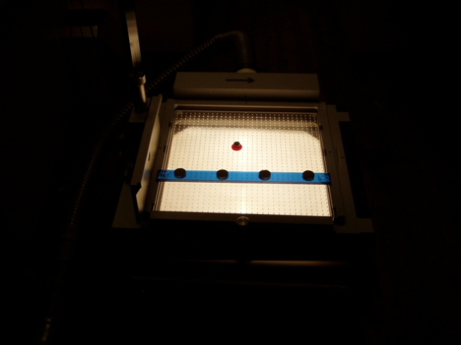
Location: Ga4
MODERN PHYSICS | 7D50.25 | NUCLEAR PHYSICS
Models of the Nucleus

Rutherford Model
 | The Air Cushion Table is set up with a plastic platform that holds a magnet which attracts a magnetic puck that is set in motion beneath it (Air Cushion Manual, 2.5.3). The moving puck goes into orbit beneath the attracting magnet.
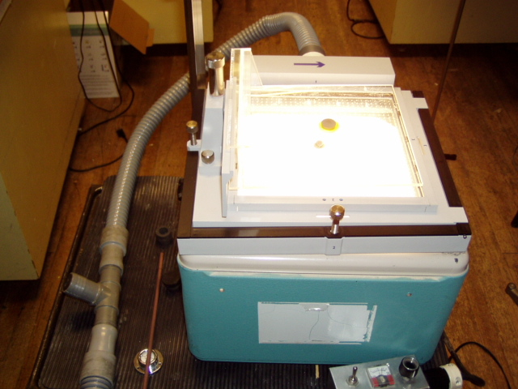Location: Ga4
MODERN PHYSICS | 7F10.35 | RELATIVITY

Special Relativity

Induction Coil Relativity
 | On using the simple induction coil and galvanometer as a special relativity demonstration: AJP 48(9), 780.
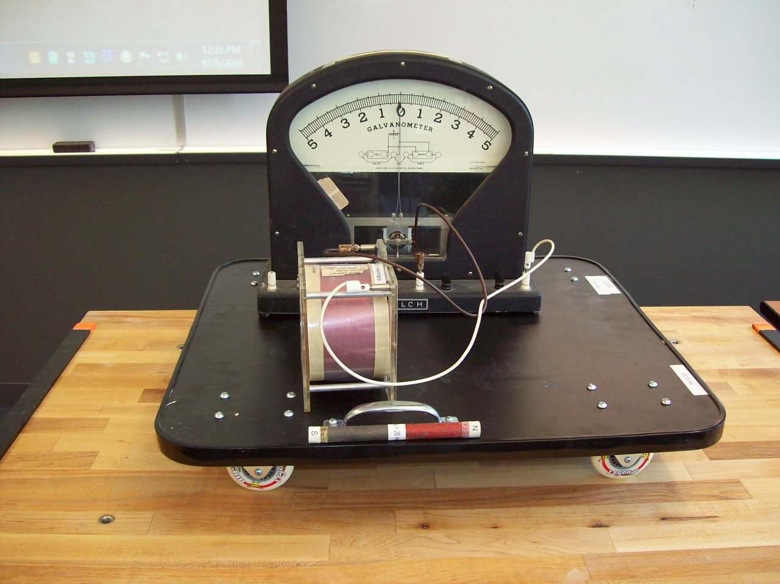
Location: BdT, Hc2, Ib3

MODERN PHYSICS | 7F10.60 | RELATIVITY
Special Relativity

Lorentz Transformation / Time Dilation
 | The Mechanical Universe, chapter 42, and the Hewitt film "Relativistic Time Dilation"
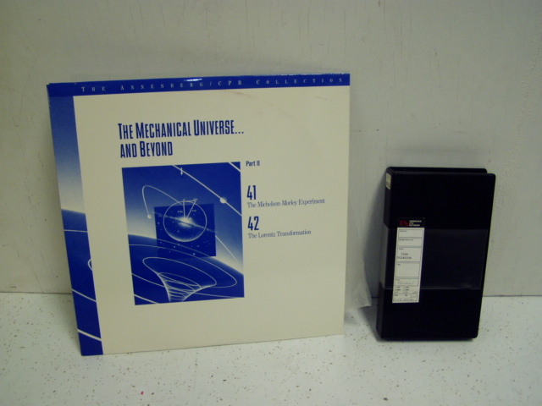
Location: Ad5

MODERN PHYSICS | 7G20.20 | Lasers

Laser Polarization and Intensity - Modes

Optical Resonator
 | Light from a laser is directed down the optical cavity of an old laser tube. The cavity acts as an optical resonator and as the exciting laser warms up, its frequency slews through a spectrum of frequencies. As the frequencies match resonate frequencies in the old tube (it can be thought of as a Fabry Perot interferometer), light is transmitted through it and shows up as a spot on a screen placed down beam from the exit side. Various modes can be observed as the exciting lasers frequency changes.

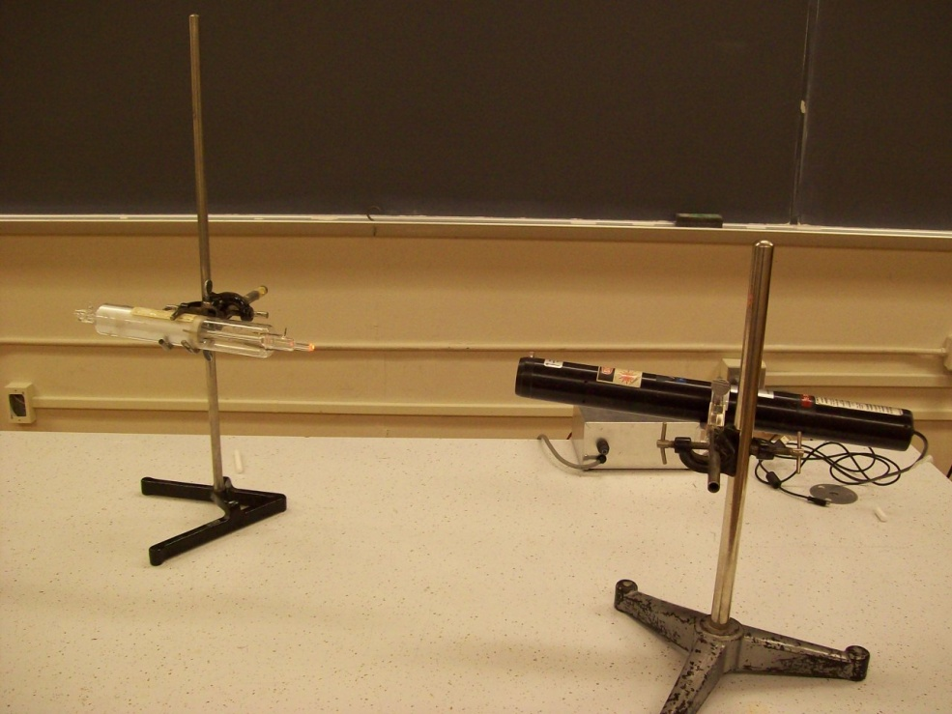
Location: Ia1, Ja6

