For the complete bibliography with references as well as an explanation of the classification scheme go to:
Demonstration Bibliography
The demonstration name listed in the bibliography is either the name listed on the reference or, if none is given, a simple descriptive name. In cases where there are several common names for a demonstration, the committee has chosen a preferred name.
The description is very brief. It is not intended to be a summary of the reference. One sentence is, in general, sufficient to describe the unique characteristics, if any, of an item. Each source has a unique numbering format. These unique formats are used identify references in the Bibliography.
The formats for the reference column and links to the sources are listed below:
Reference | Source
M-1 | Sutton
Ma-1 | Freier & Anderson
M-1d | Hilton
8-2.8 | Meiners
M-108 | Dick & Rae
1A 12.01 | University of Minnesota Handbook
AJP 52(1),85 | American Journal of Physics
TPT 15(5),300 | The Physics Teacher
Disc 01-01 | The Video Encyclopedia of Physics Demonstrations
PIRA 200 | Physics Instructional Resource Association
PIRA 500 | PIRA 500
PIRA 1000 | PIRA 1000
Each demonstration is listed in only one location, even if it is commonly used to illustrate several concepts.
5/16/2023

1
GEOMETRIC OPTICS 5
Speed of Light 5
Speed of Light 5
Straight Line Propagation 6
Shadows 6
Chalk Dust 7
Reflection from Flat Surfaces 8
Microwave Reflection 8
Diffuse and Specular Reflection 9
Ripple Tank Reflection 10
Corner Reflection 11
Angled Mirrors 12
Parallel Mirrors 13
Full View Mirror 14
Mirror Box 15
Reflection from Curved Surfaces 16
Blackboard Optics - Curved Mirrors 16
Parallel Lasers and Curved Mirrors 17
Lamp in the Socket 18
Optic Mirage 19
Projected Arrow with Mirror 20
Concave and Convex Mirrors 21
Refractive Index 22
Disappearing Beaker 22
Mirage with Laser 23
Refraction at Flat Surfaces 24
Blackboard Optics - Refraction 24
Refraction Tank 25
Big Plastic Refraction Tank 26
Ripple Tank Refraction 27
Seeing a Coin 28
Stick in Water 29
Total Internal Reflection 30
Blackboard Optics – Prism, Semicircle 30
Critical Angle in a Refraction Tank 31
Laser and Fiber Optics 32
Laser Waterfall 33
Thin Lenses 34
Blackboard Optics – Thin Lenses 34
Ripple Tank – Lens Model 35
Parallel Lasers and Lenses 36
Projected Arrow w/Lens 37
Schlieren Image of a candle 38
Thick Lenses 39
Improving an Image with a Stop 39
Chromatic and Spherical Aberration 40
CHOICE MATERIAL GLASS OXIDE 41
Fresnel Lens 42
Optical Instruments 43
Telescope Models 43
Camera Model 44
Lens Combinations 45
Invisibility 46
PHOTOMETRY 47
Luminosity 47
Inverse Square Model 47
Inverse Square Law with a Photometer 48
Blackbodies 49
Hole in a Box 49
Black Body Spectrum 50
DIFFRACTION 51
Diffraction Through One Slit 51
Single Slit and Laser 51
Two Finger Slit 52
Ripple Tank – Single Slit 53
Microwave Single Slit Diffraction 54
Diffraction Around Objects 55
Arago (Poisson) Spot 55
Diffraction around Objects 56
Babinet’s Principle 57
Pinhole Diffraction 58
Square and Rectangular Apertures 59
Zone Plate Lens 60
INTERFERENCE 61
Interference From Two Sources 61
Double Slits and Laser 61
Ripple Tank – Two Point 62
Microwave Double Slit 63
Fresnel Biprism 64
Gratings 65
Number of Slits 65
Fine Mesh and Laser 66
Optical Crystal Set 67
Thin Films 68
Newton's Rings 68
Soap Film Interference 69
Air Wedge 70
Step Gauge 71
Interferometers 72
Michelson Interferometer 72
Lloyd’s Mirror 73
Optical Resonator 74
COLOR 75
Synthesis and Analysis of Color 75
Color Box 75
Color Mixing 76
Recombining the Spectrum 77
Scattering 78
Sunset 78
POLARIZATION 79
Dichroic Polarization 79
Polaroids on the Overhead 79
Polaroid Box 80
Microwave Polarization 81
Polarization by Reflection 82
Brewster's Angle 82
Stack of Plates 83
Circular Polarization 84
Three Polaroids 84
Circular Polarizer,1/4 Wave Plate, Polaroid and Mirror 85
Karo Syrup 86
Faraday Rotation 87
Birefringence 88
Calcite and Polaroid on the OHP 88
Wavefront Model 89
Quarter Wave Plate 90
Butterfly 91
Polarization by Scattering 92
Sunset with Polarizers 92
THE EYE 93
The Eye 93
Eye Model 93
Eye Glasses 94
MODERN OPTICS 95
Holography 95
Holograms 95
Physical Optics 96
Abbe’s Theory of Imaging 96

OPTICS | 6A01.10 | GEOMETRIC OPTICS

Speed of Light

Speed of Light
 | A pulsed IR laser, a couple of photodiodes and a retro-reflector are used with a fast scope to measure the speed of light. The scope settings are stores in a file on the scope. An IR sensitive card can be used to show the beam.
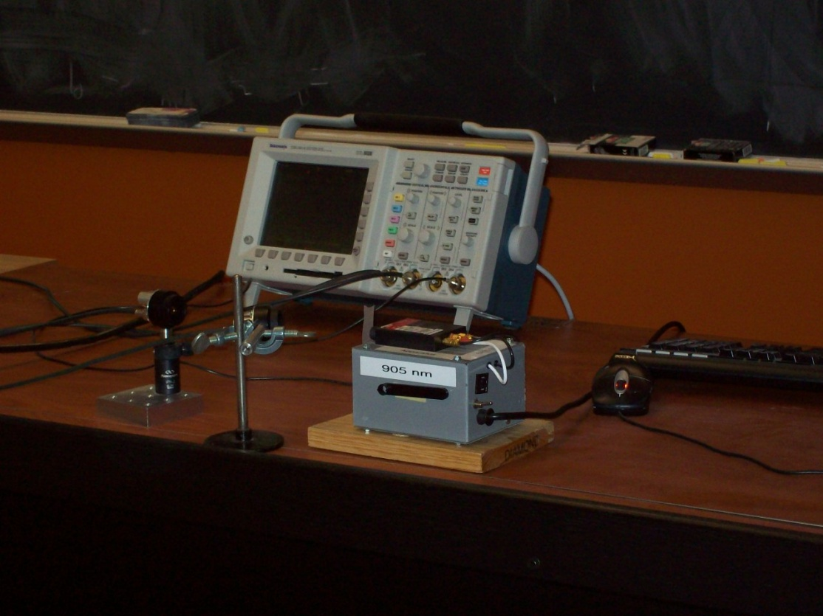
Location: Id2, Fb5
OPTICS | 6A02.15 | GEOMETRIC OPTICS

Straight Line Propagation

Shadows
 | Use a point source to cast sharp shadows.
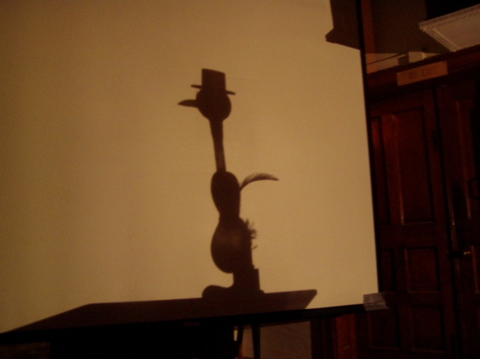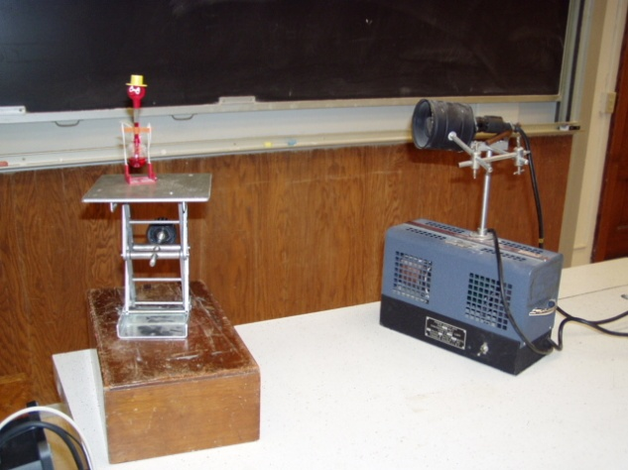
Location: Id2
OPTICS | 6A02.35 | GEOMETRIC OPTICS
Straight Line Propagation

Chalk Dust
 | Use chalk dust to make a laser beam visible.
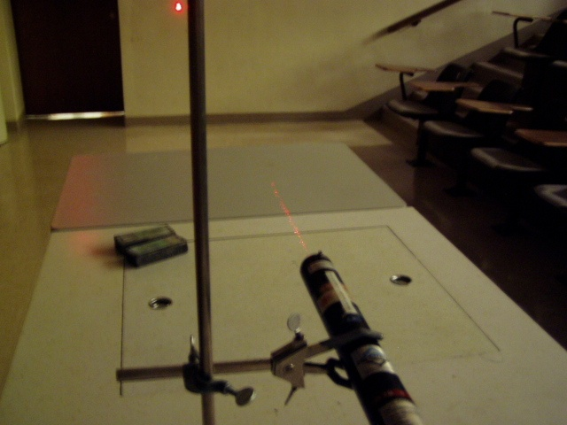Location: Ja6
OPTICS | 6A10.18 | GEOMETRIC OPTICS

Reflection from Flat Surfaces

Microwave Reflection
 | Reflect a microwave beam off of a metal plate into receiver.
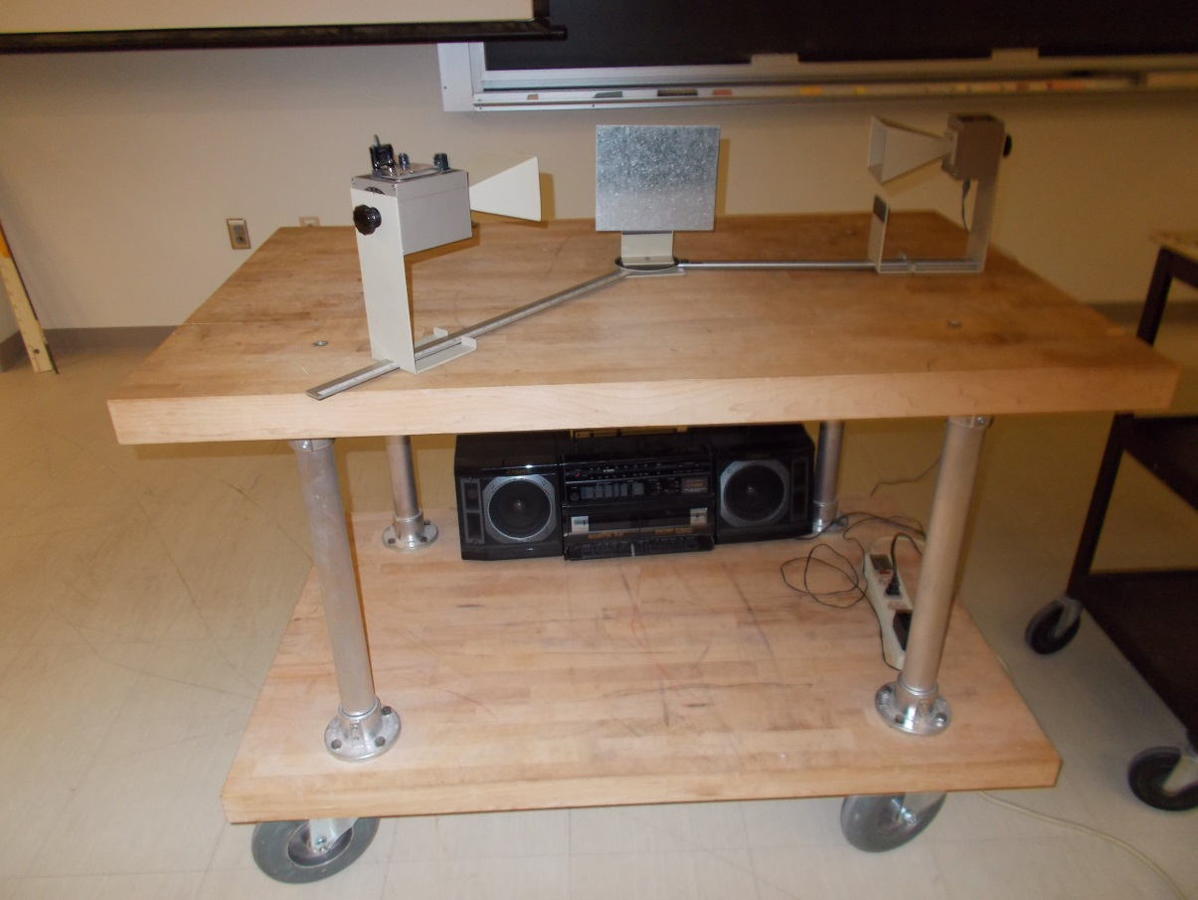
Location: Ia7
OPTICS | 6A10.20 | GEOMETRIC OPTICS
Reflection from Flat Surfaces

Diffuse and Specular Reflection
 | Use the blackboard optics equipment to show specular reflection off of a mirror then replace the mirror with a sheet of paper.
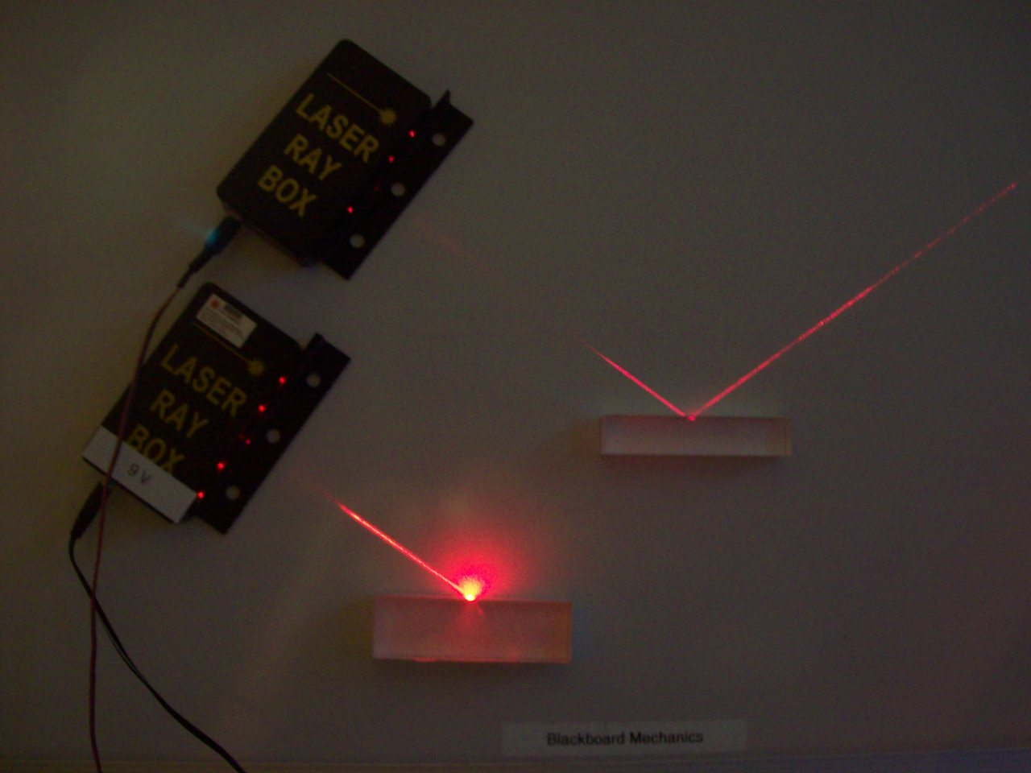
Location: Blackboard Optics Cart
OPTICS | 6A10.25 | GEOMETRIC OPTICS
Reflection from Flat Surfaces

Ripple Tank Reflection
 | A barrier in a ripple tank reflects plain waves. This can also be done with a point source to illustrate image formation in a plain mirror.
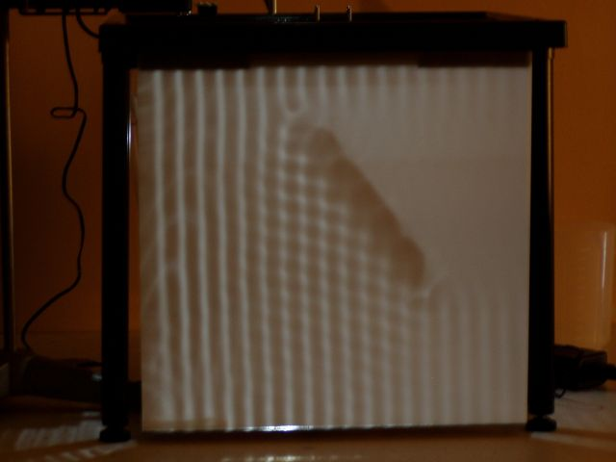
Location: Fb4
OPTICS | 6A10.30 | GEOMETRIC OPTICS
Reflection from Flat Surfaces

Corner Reflection
 | Look at your image in a corner mirror. Also use the TV camera to look into a corner reflector.
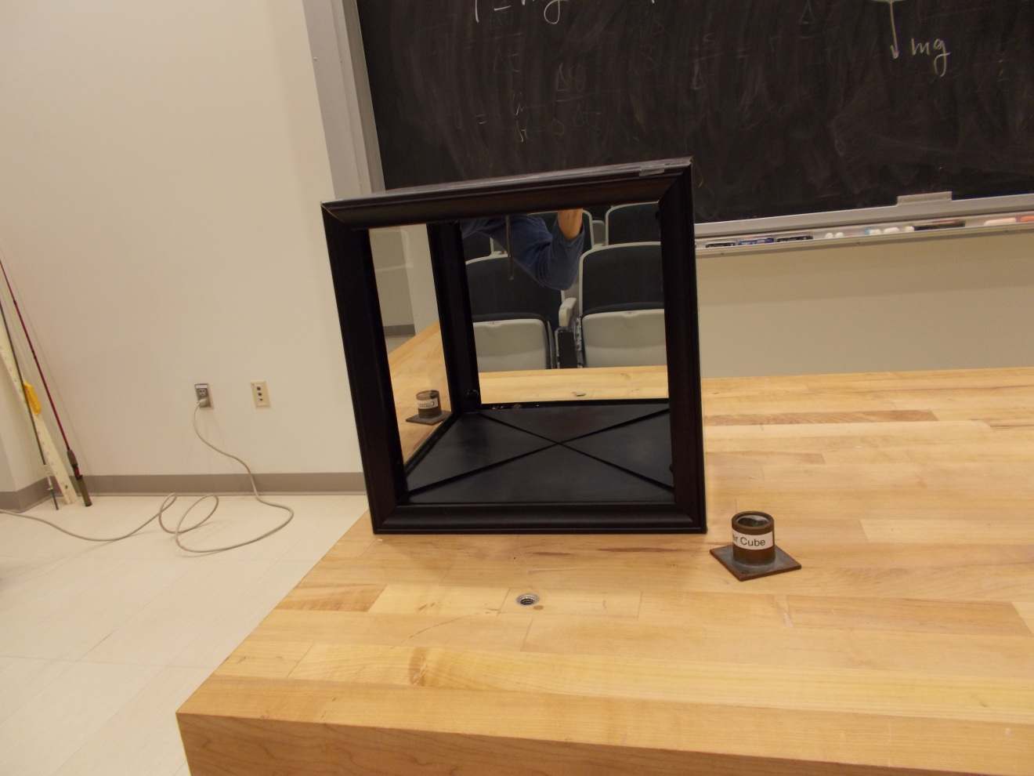Location: Id3, Optics Table Cabinet
OPTICS | 6A10.40 | GEOMETRIC OPTICS
Reflection from Flat Surfaces

Angled Mirrors
 | Two hinged mirrors show multiple images of an object placed between them.
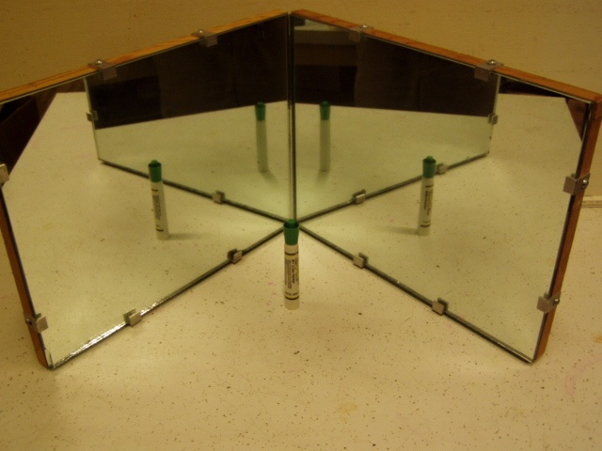
Location: Id4

OPTICS | 6A10.45 | GEOMETRIC OPTICS
Reflection from Flat Surfaces

Parallel Mirrors
 | An infinite number of images are formed with a light bulb between parallel mirrors.
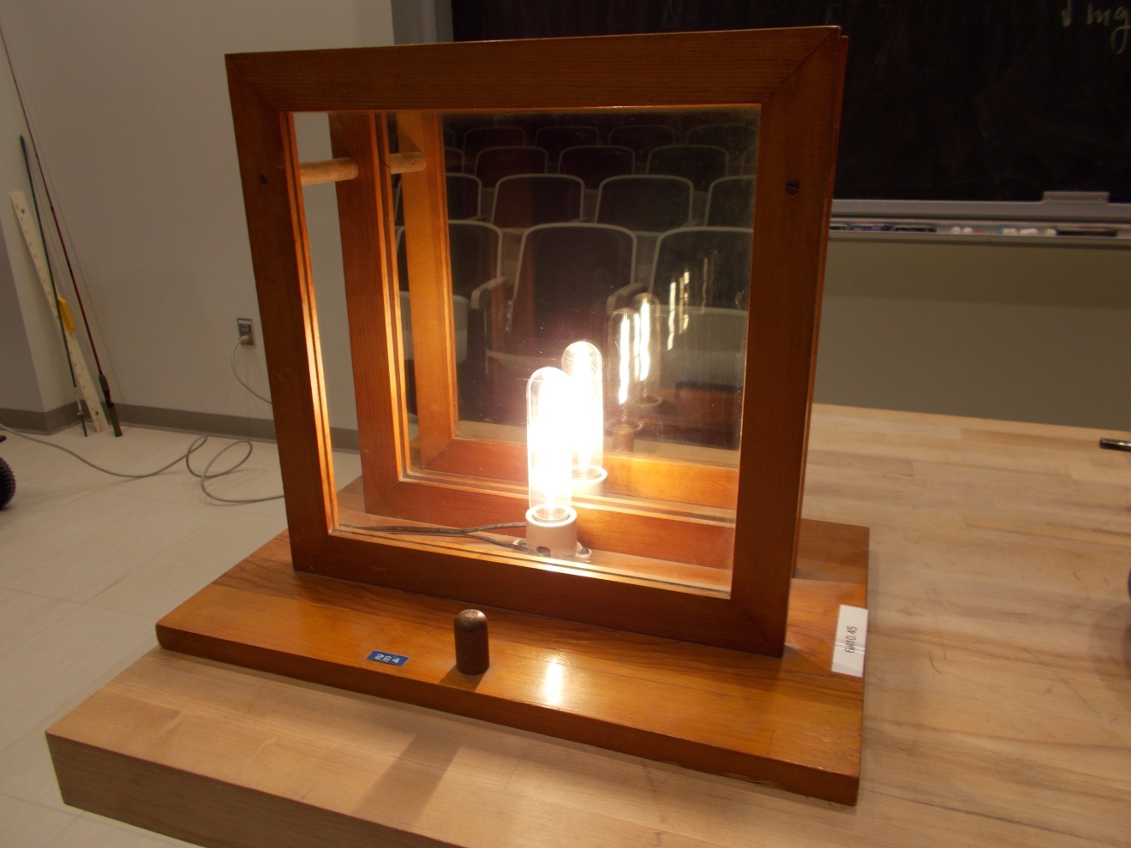Location: Id4
OPTICS | 6A10.50 | GEOMETRIC OPTICS
Reflection from Flat Surfaces

Full View Mirror
 | A mirror is covered with paper so that a person can just see their entire height.
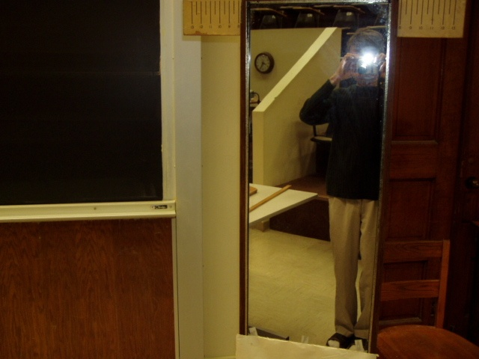Location: IdT
OPTICS | 6A10.65 | GEOMETRIC OPTICS
Reflection from Flat Surfaces

Mirror Box
 | “Pepper’s Ghost”, an old stage illusion. As the light on the subjects face is dimmed another light on a plastic skull brightens causing an apparent metamorphosis.
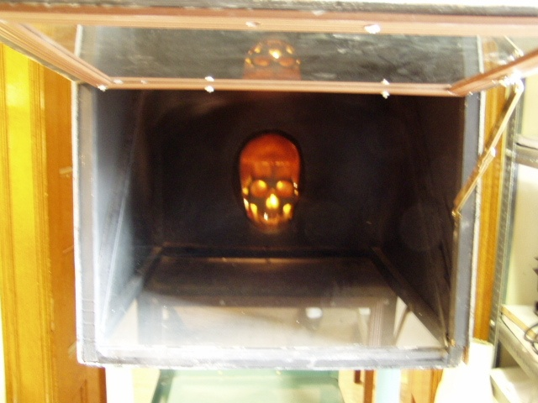Location: Ja1
OPTICS | 6A20.10 | GEOMETRIC OPTICS

Reflection from Curved Surfaces

Blackboard Optics - Curved Mirrors
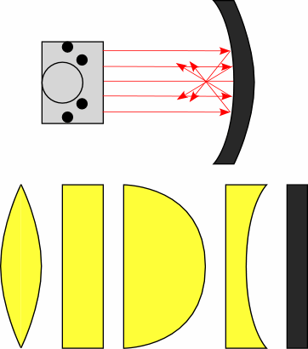 | Shine parallel beams at convex and concave mirrors. Use the Blackboard optics for two dimensional representations.
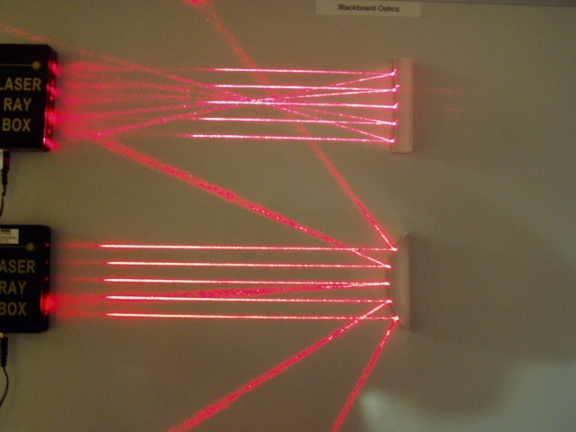
Location: Blackboard Optics Cart

OPTICS | 6A20.15 | GEOMETRIC OPTICS
Reflection from Curved Surfaces

Parallel Lasers and Curved Mirrors
 | Shine parallel beams at convex and concave mirrors.
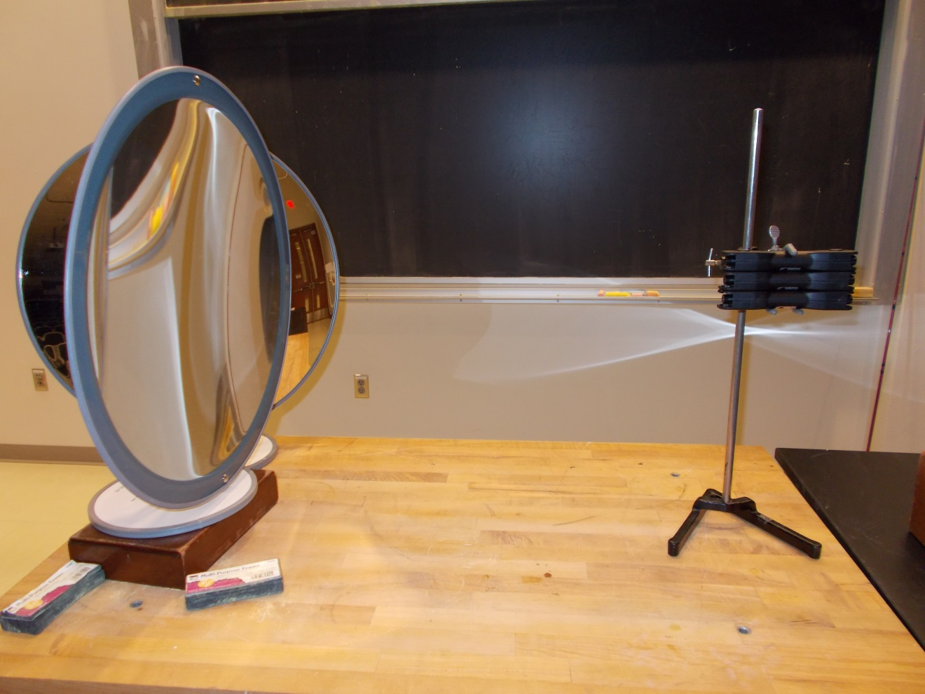Location: Ja4, Blackboard Optics Cart
OPTICS | 6A20.30 | GEOMETRIC OPTICS
Reflection from Curved Surfaces

Lamp in the Socket
 | The image of a hidden light bulb is projected at the location of an empty socket.
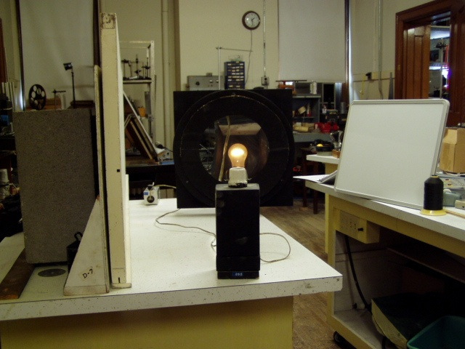
Location: IdT
OPTICS | 6A20.35 | GEOMETRIC OPTICS
Reflection from Curved Surfaces

Optic Mirage
 | Two concave mirrors face each other. Images of objects resting on the bottom mirror appear at the center hole of the top mirror.
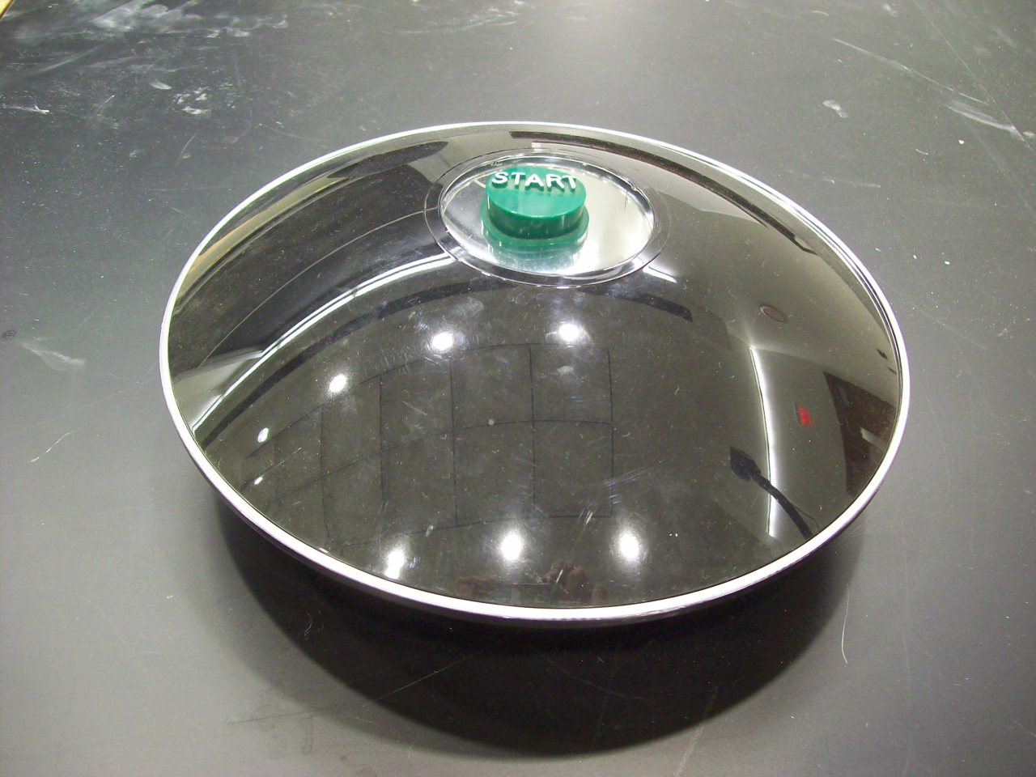
Location: Ja2
OPTICS | 6A20.40 | GEOMETRIC OPTICS
Reflection from Curved Surfaces

Projected Arrow with Mirror
 | A converging mirror is used to project the image of an illuminated arrow on a screen. Focal Length 0.75 m, diameter 0,203 m.
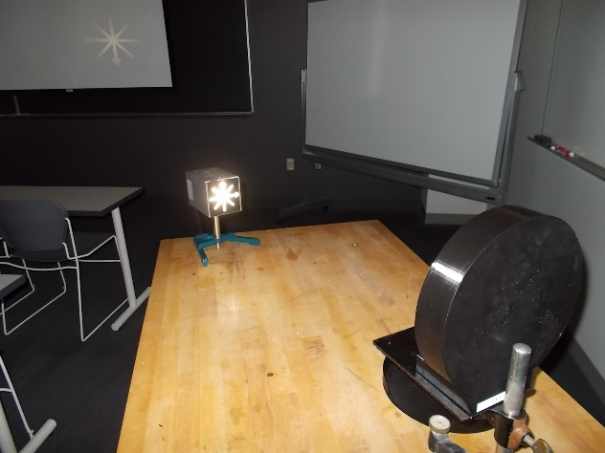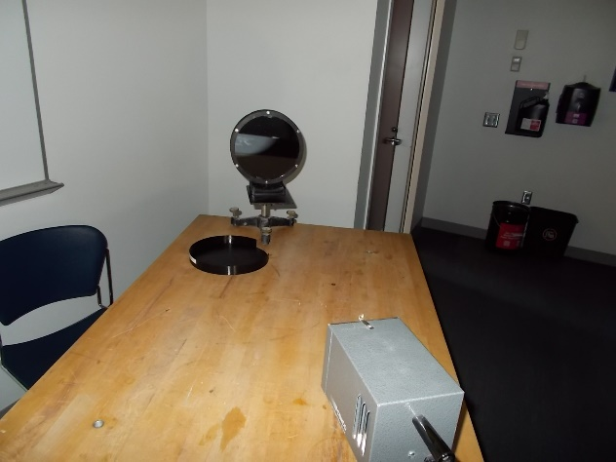
Location: Ja2
OPTICS | 6A20.45 | GEOMETRIC OPTICS
Reflection from Curved Surfaces

Concave and Convex Mirrors
 | Large convex and concave mirrors are shown.
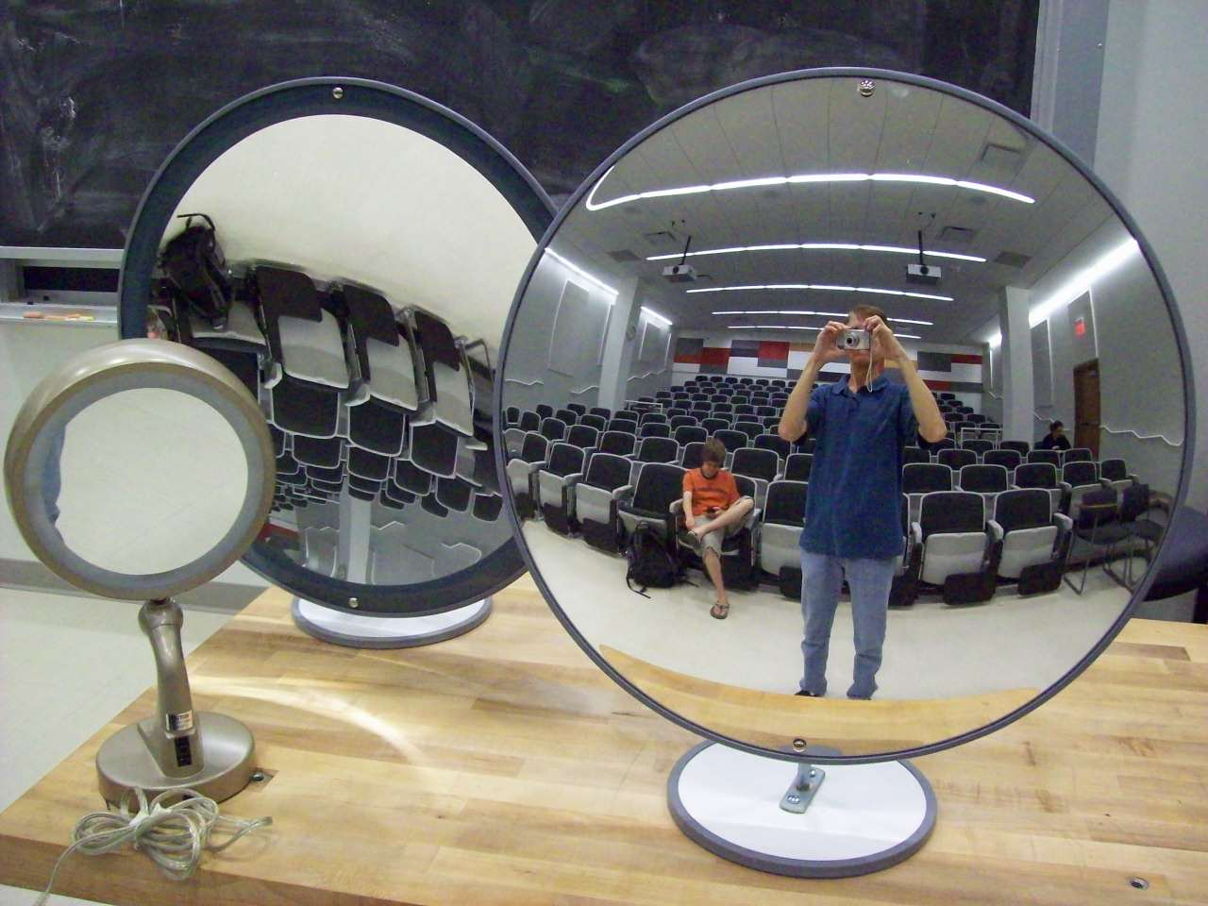
Location: Id5
OPTICS | 6A40.30 | GEOMETRIC OPTICS

Refractive Index

Disappearing Beaker
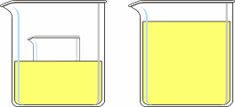 | Use Johnson's baby oil or Wesson oil to make a small beaker disappear when immersed. If the beaker has graduations or words they will appear to be floating in the liquid.
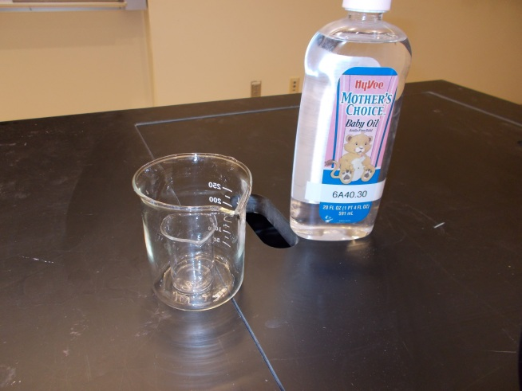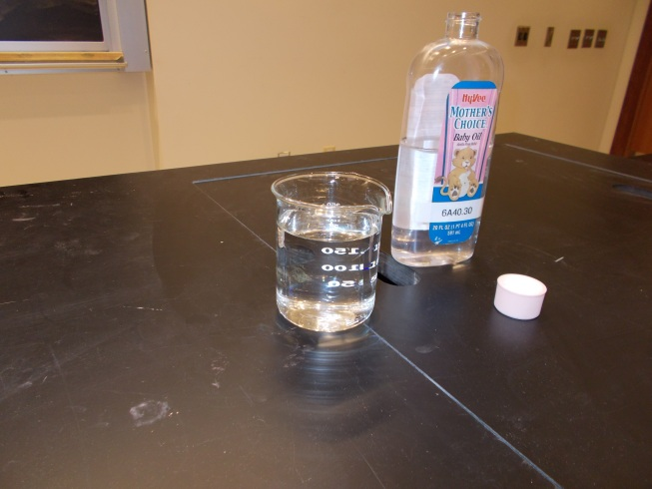
Location: Ja3
OPTICS | 6A40.47 | GEOMETRIC OPTICS
Refractive Index

Mirage with Laser
 | A laser beam almost grazing a hot plate will show a deflection when the plate is turned on. Level the laser and aim the beam so that it just goes over the hot plate and hits the scale at “0”, In the arrangement shown the laser spot on the scale moves up about 2 cm as the plate heats up. It takes a few minutes.
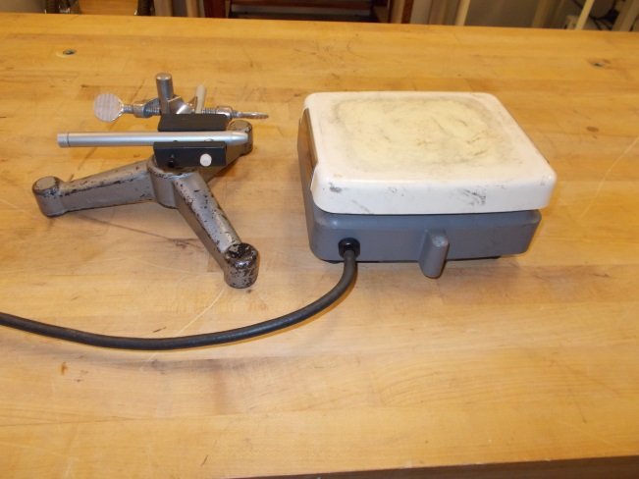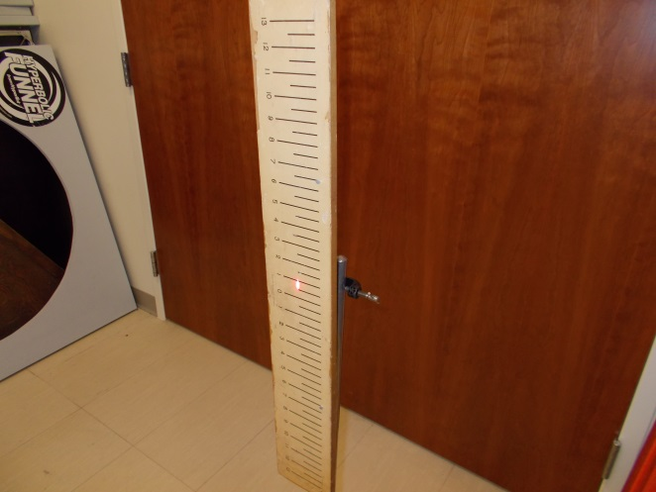
Location: Ja6, Gb2
OPTICS | 6A42.10 | GEOMETRIC OPTICS

Refraction at Flat Surfaces

Blackboard Optics - Refraction
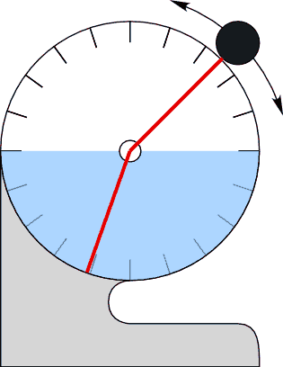 | The light source can be rotated through 270 degrees to show refraction and total internal reflection for both air/plastic and plastic/air interfaces. One can also use a rectangular prism (not shown but in the supplied BBO equipment) to show refraction and internal reflection.
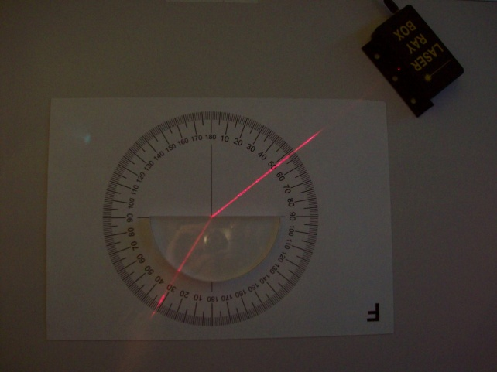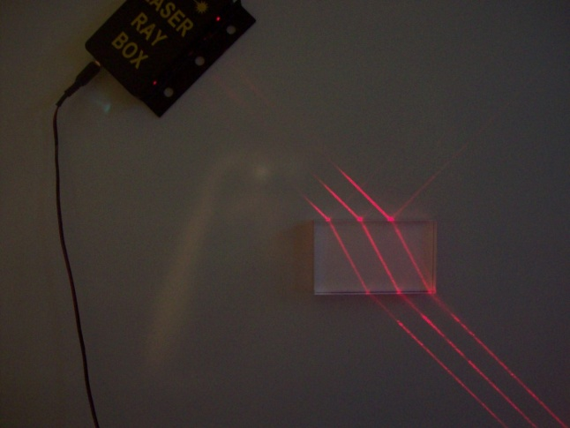
Location: Blackboard Optics Cart
OPTICS | 6A42.20 | GEOMETRIC OPTICS
Refraction at Flat Surfaces

Refraction Tank
 | The light source can be rotated through 270 degrees to show refraction and total internal reflection for both air/plastic and plastic/air interfaces. Also can be done with an aquarium tank, water and a laser.
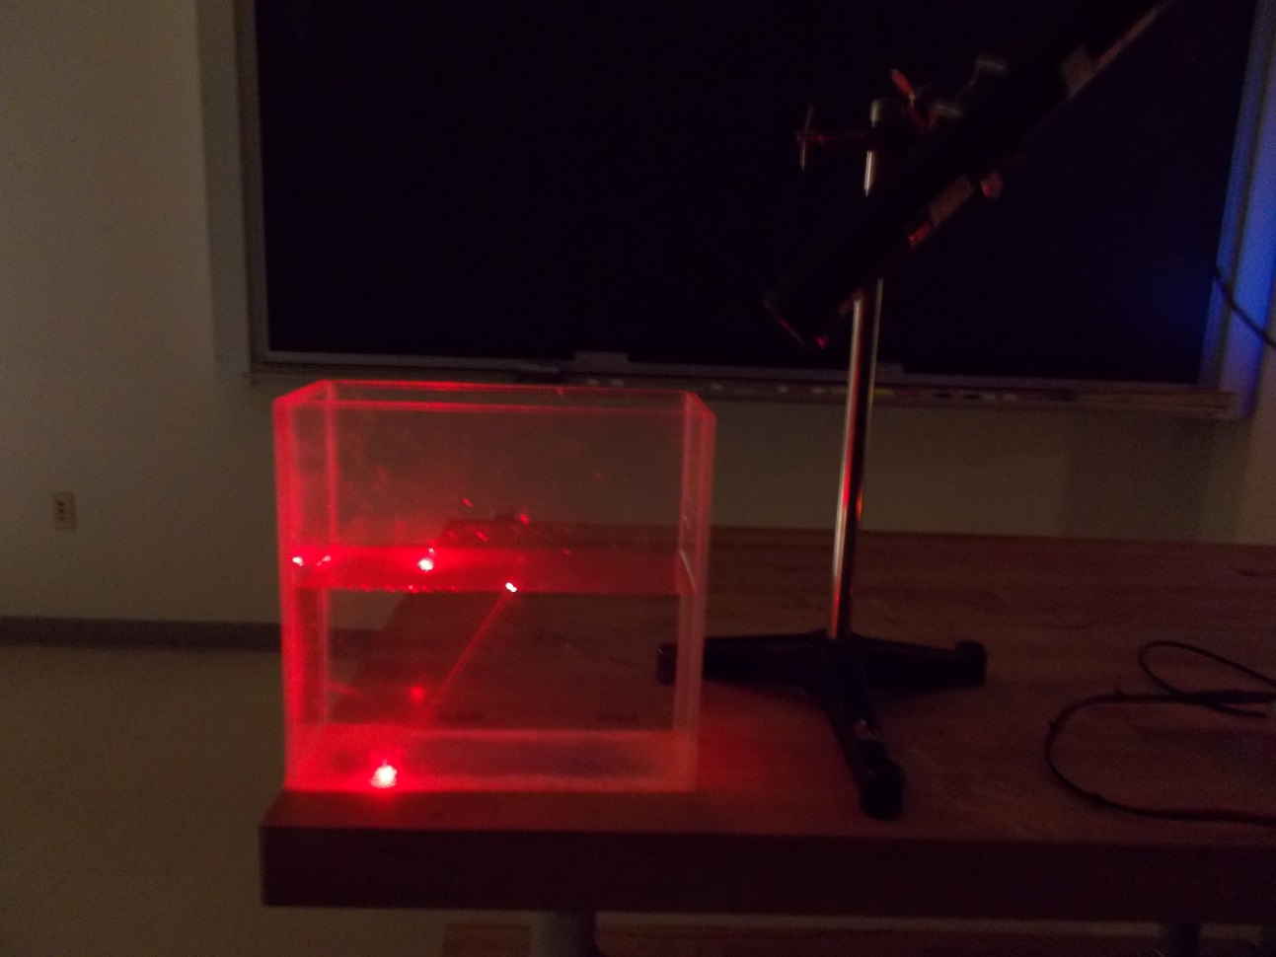
Location: Ja3, Ja6
OPTICS | 6A42.22 | GEOMETRIC OPTICS
Refraction at Flat Surfaces

Big Plastic Refraction Tank
 | The light source can be rotated through 270 degrees to show refraction and total internal reflection for both air/plastic and plastic/air interfaces. Be careful using the bright (20 mw) green laser.
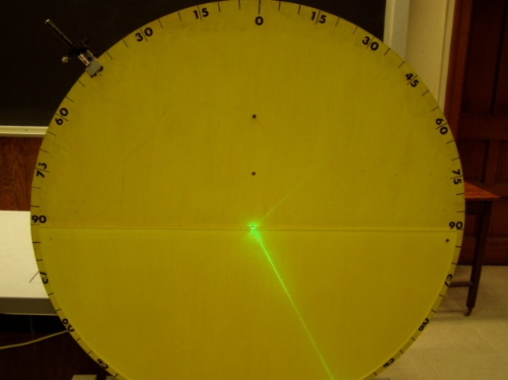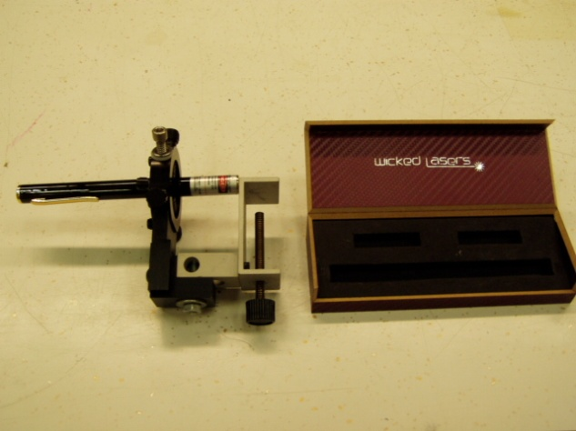
Location: PbT, Jd1
OPTICS | 6A42.35 | GEOMETRIC OPTICS
Refraction at Flat Surfaces

Ripple Tank Refraction
 | The wave velocity over a shoal is smaller than that over deeper water and thus refraction of the ripples occurs over the plastic shoal.
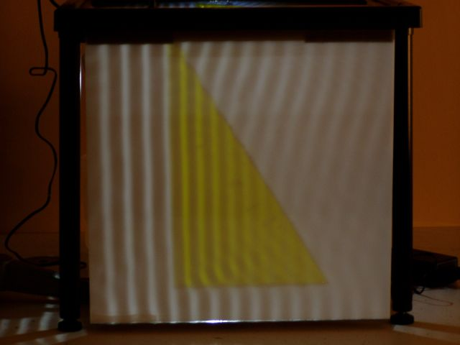
Location: Fb4
OPTICS | 6A42.40 | GEOMETRIC OPTICS
Refraction at Flat Surfaces

Seeing a Coin
 | Pour water in a cup until a coin at the bottom (use double stick tape to hold it in place) previously hidden by the side is visible.
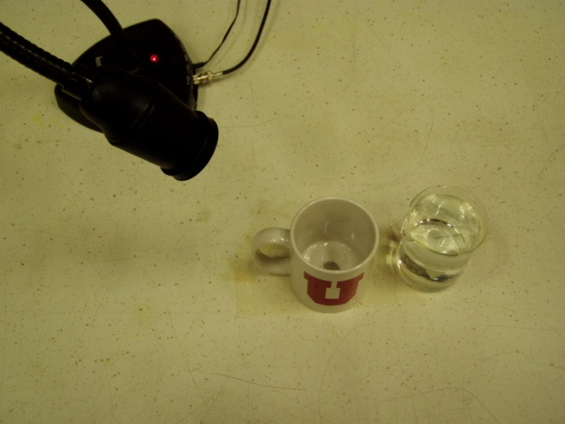Location: Ja3
OPTICS | 6A42.45 | GEOMETRIC OPTICS
Refraction at Flat Surfaces

Stick in Water
 | A stick appears bent when inserted into water.
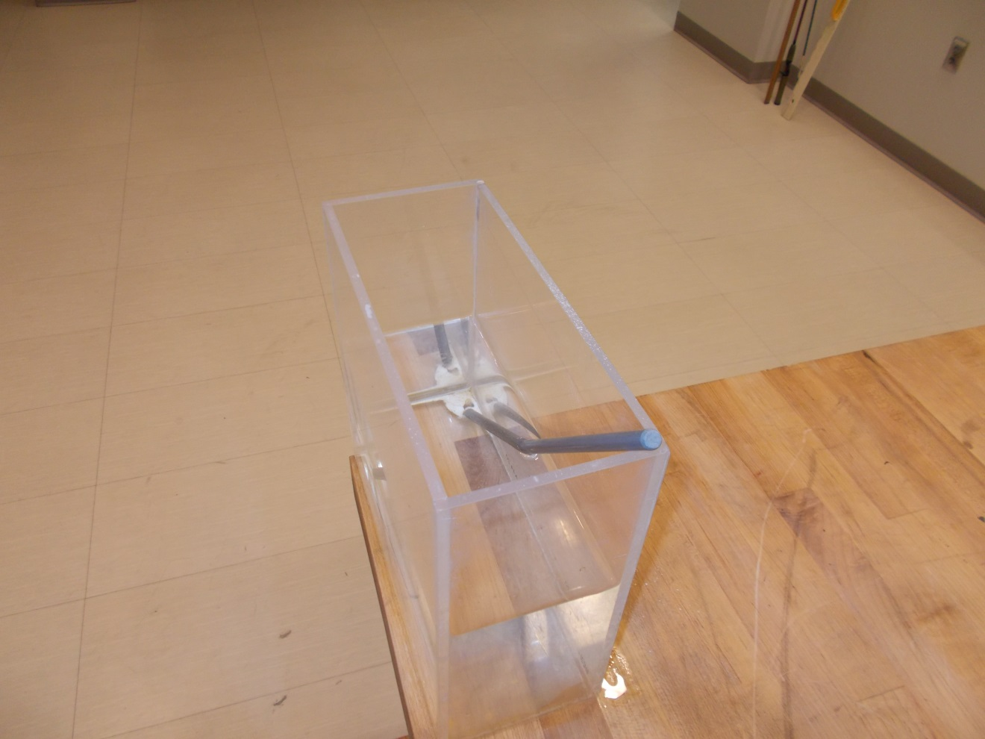Location: Ja4
OPTICS | 6A44.10 | GEOMETRIC OPTICS

Total Internal Reflection

Blackboard Optics – Prism, Semicircle
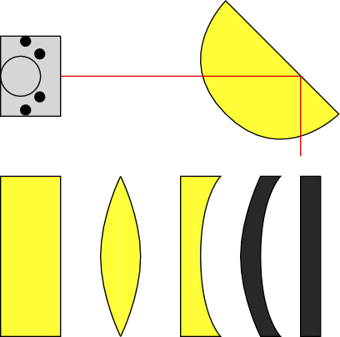 | Rotate the semicircular slab of Plexiglas with the light ray entering the exiting through the curved surface. Rotate the semicircular slab until the critical angle is reached and total internal reflection is obtained.
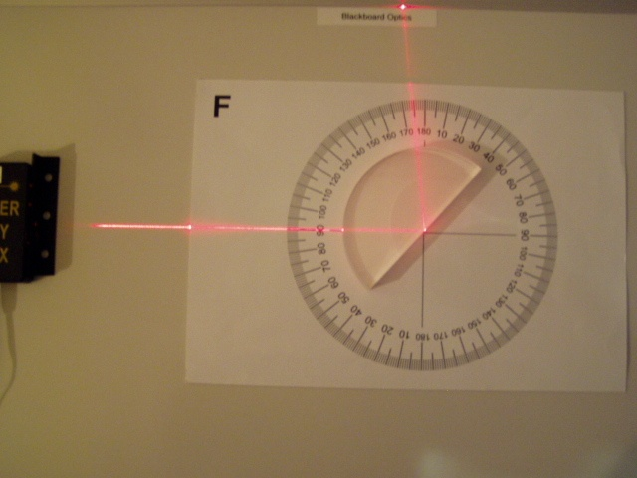Location: Blackboard Optics Cart
OPTICS | 6A44.20 | GEOMETRIC OPTICS
Total Internal Reflection

Critical Angle in a Refraction Tank
 | A beam in a tank of water is rotated until there is total internal reflection at the surface.
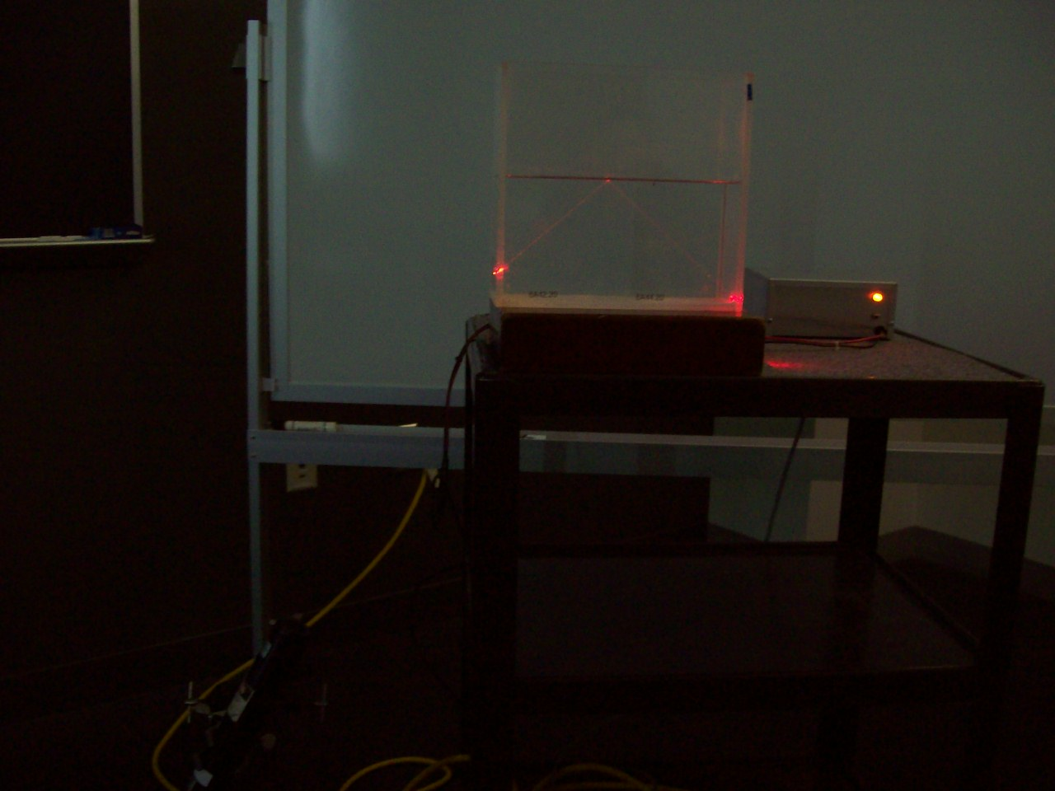
Location: Ja3, Ja6

OPTICS | 6A44.40 | GEOMETRIC OPTICS
Total Internal Reflection

Laser and Fiber Optics
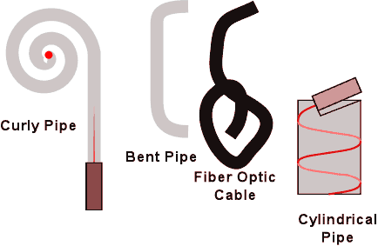 | You are provided with a Plexiglas rod, Plexiglas curly Q and a section of fiber optic cable. Hold their ends in the beam near the laser. Vary the number of reflections in the rod by changing the angle.
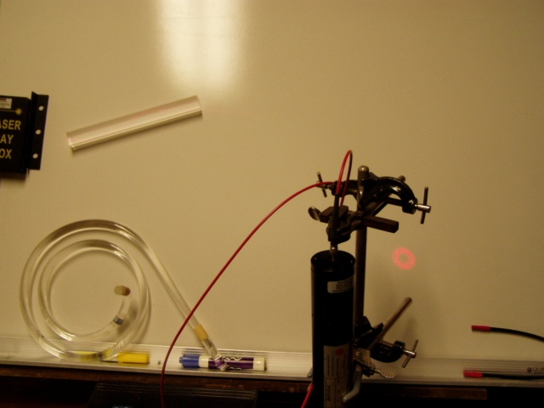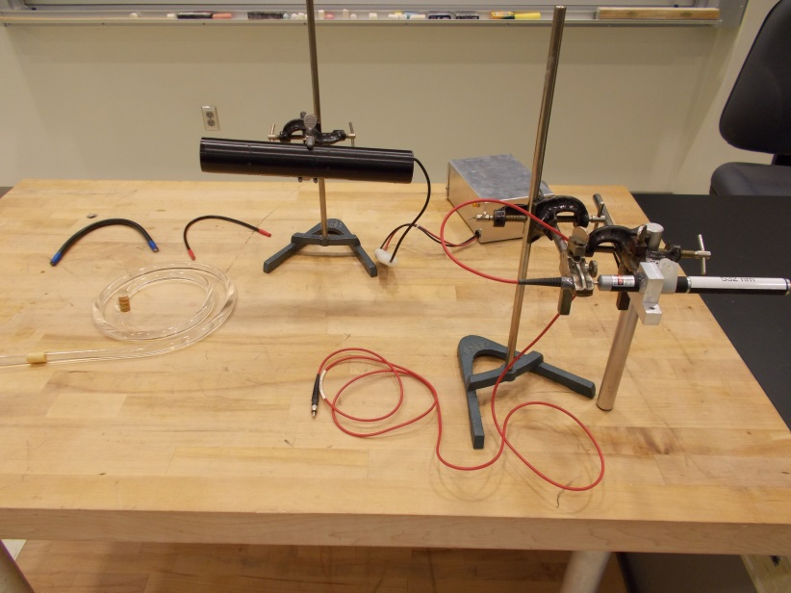
Location: Blackboard Optics Cart, Ja4, Ja6
OPTICS | 6A44.45 | GEOMETRIC OPTICS
Total Internal Reflection

Laser Waterfall
 | Shine a laser down the center of a nozzle and it follows the water stream.
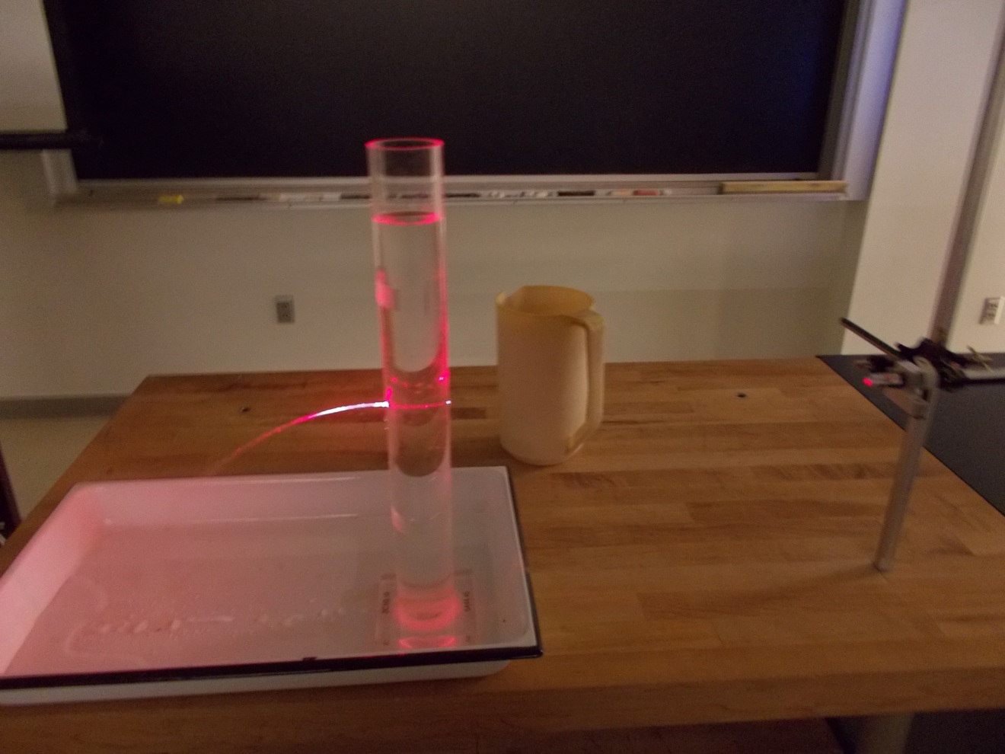
Location: Dd6, Ja6
OPTICS | 6A60.10 | GEOMETRIC OPTICS

Thin Lenses

Blackboard Optics – Thin Lenses
 | Blackboard optics are used with convex and concave thin lens elements
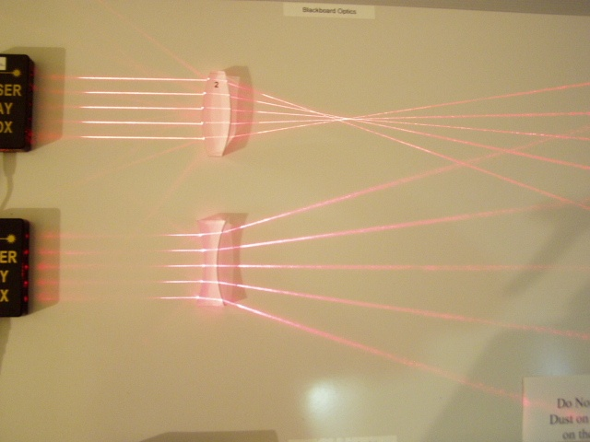Location: Blackboard Optics Cart
OPTICS | 6A60.15 | GEOMETRIC OPTICS
Thin Lenses

Ripple Tank – Lens Model
 | Refraction due to depth differences over a lens shaped area in the ripple tank.
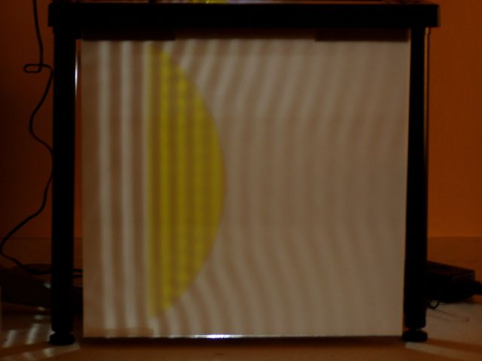
Location: Fb4
OPTICS | 6A60.20 | GEOMETRIC OPTICS
Thin Lenses

Parallel Lasers and Lenses
 | Parallel lasers are passed through converging and diverging lenses. Chalk dust illuminates the beams.
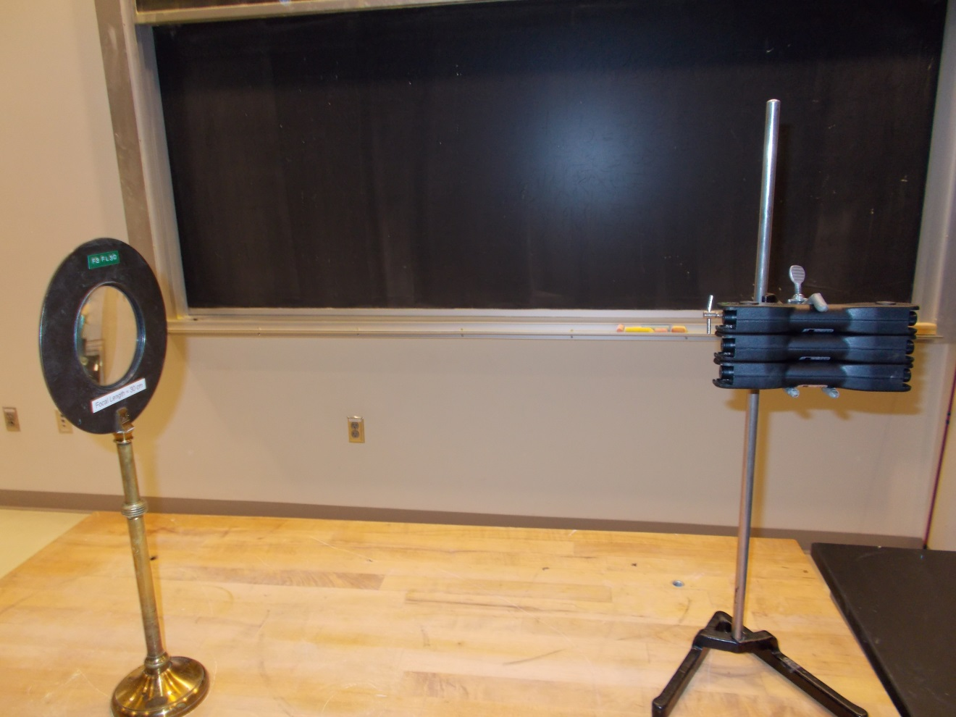Location: Id1, Blackboard Optics Cart
OPTICS | 6A60.31 | GEOMETRIC OPTICS
Thin Lenses

Projected Arrow w/Lens
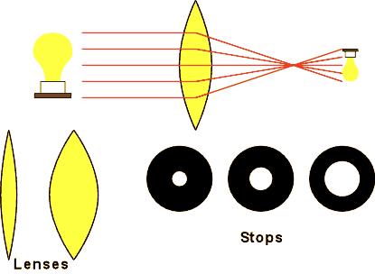 | Turn on the light bulb. Move the light bulb to focus the image on the side wall. The focal lengths are marked on the lenses. Show the effect of aperture size on the sharpness on the focus by placing different sized stops in front of the lens.
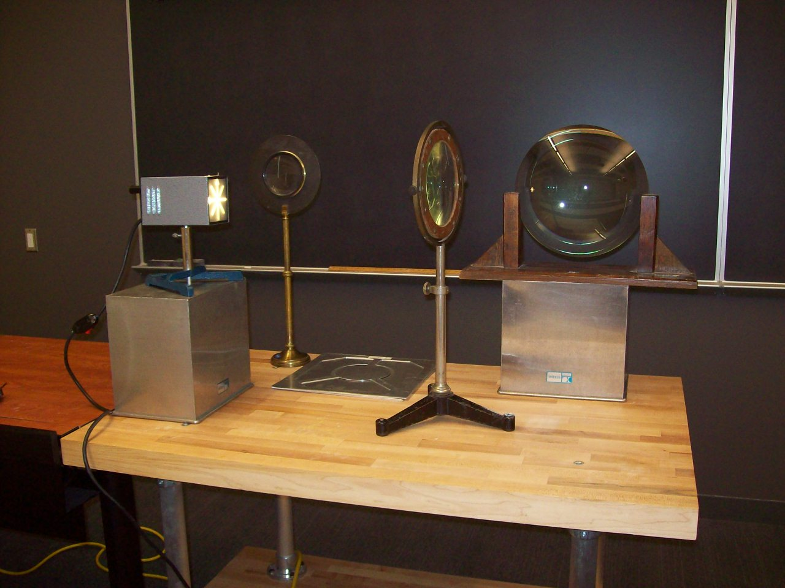
Location: Id1, Jd3

OPTICS | 6A60.41 | GEOMETRIC OPTICS
Thin Lenses

Schlieren Image of a candle
 | A point source, a mirror and a candle.
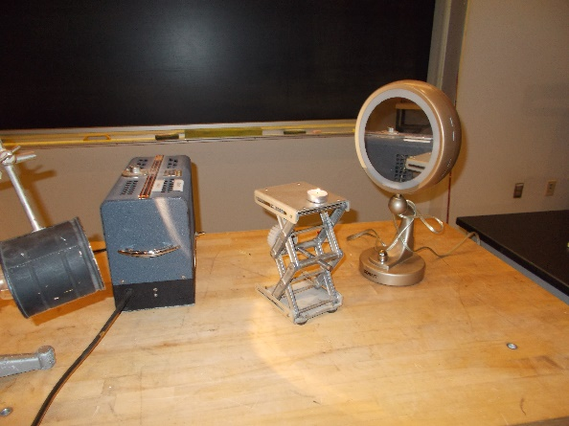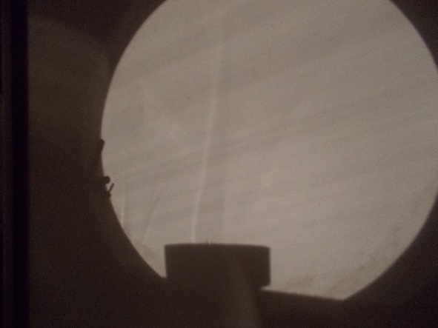
Location: Id1, Jd3

OPTICS | 6A65.10 | GEOMETRIC OPTICS

Thick Lenses

Improving an Image with a Stop
 | Turn on the light bulb. Move the light bulb to focus the image on the side wall. The focal lengths are marked on the lenses. Show the effect of aperture size on the sharpness on the focus by placing different sized stops in front of the lens. Use the thick, short focal length lens.
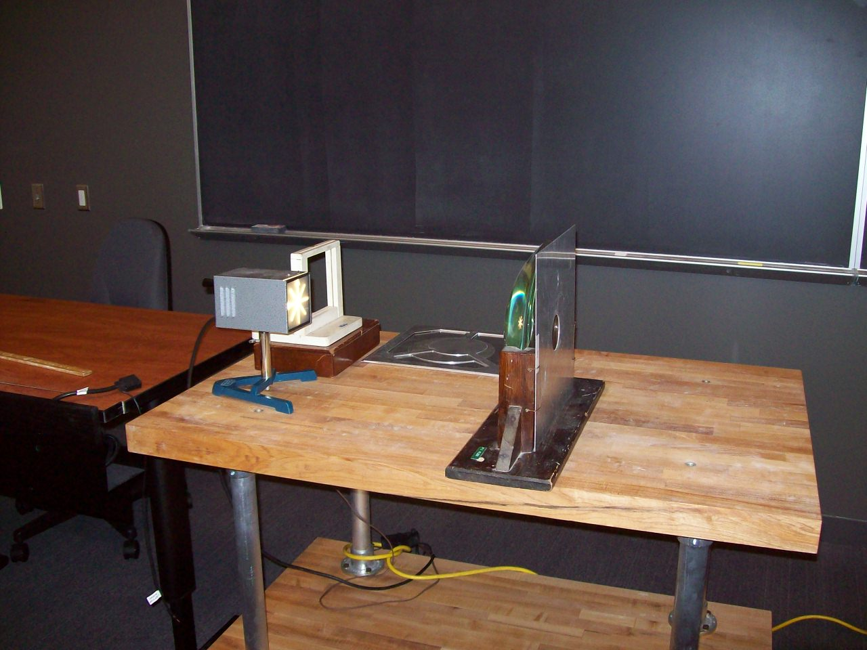
Location: Ja5, Jd3
OPTICS | 6A65.24 | GEOMETRIC OPTICS
Thick Lenses

Chromatic and Spherical Aberration
 | Use diaphragms with central, annular, and other openings to show spherical and chromatic aberration.
Location: Ja6, Jd3
OPTICS | 6A65.56 | GEOMETRIC OPTICS
Thick Lenses

CHOICE MATERIAL GLASS OXIDE
 | CHOICE MATERIAL GLASS OXIDE is viewed through an acrylic rod or a plastic tube filled with water.
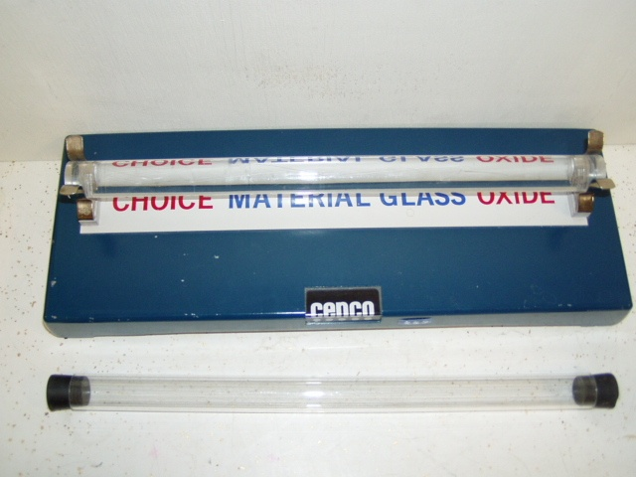Location: Ja3
OPTICS | 6A65.70 | GEOMETRIC OPTICS
Thick Lenses

Fresnel Lens
 | Show some Fresnel Lenses and a model of them.
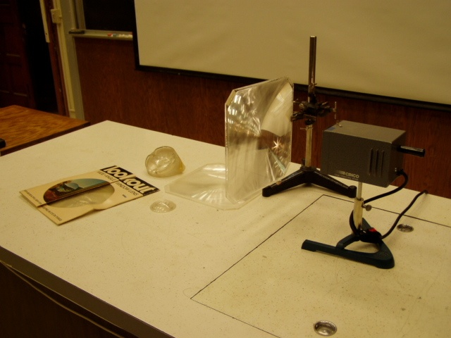Location: Ja5, Jd3
OPTICS | 6A70.20 | GEOMETRIC OPTICS

Optical Instruments

Telescope Models
 | Blackboard optics illustrations of a Keplerian telescope and a Gallilean telescope.
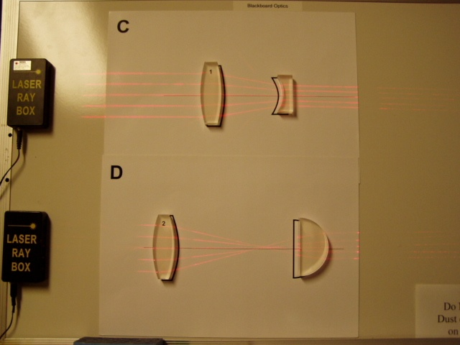Location: Blackboard Optics Cart
OPTICS | 6A70.30 | GEOMETRIC OPTICS
Optical Instruments

Camera Model
 | Blackboard optics illustration of a camera.
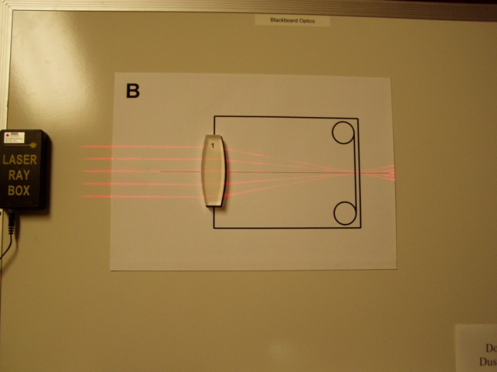 Location: Blackboard Optics Cart
OPTICS | 6A70.45 | GEOMETRIC OPTICS
Optical Instruments

Lens Combinations
 | Set up some optical systems with more than one lens. Use the TV camera and screen to show intermediate images. It is helpful to use a dimmer on the source object box to keep the TV image from being washed out.
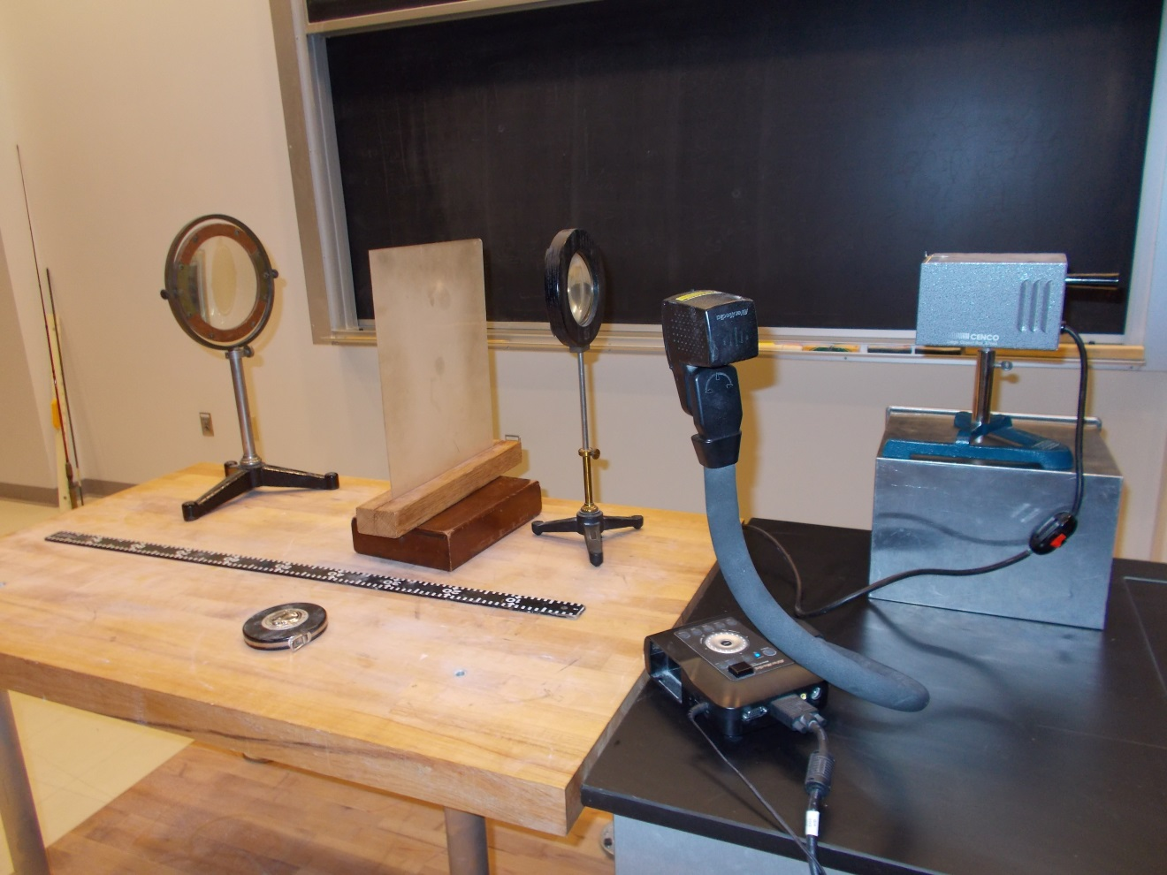Location: Id4, Jd3

OPTICS | 6A70.46 | GEOMETRIC OPTICS
Optical Instruments

Invisibility
 | Four lenses (two 15 cm focal length and two 5 cm focal length) are arranged so that an aluminum rod seems “cloaked” when passed through certain regions.
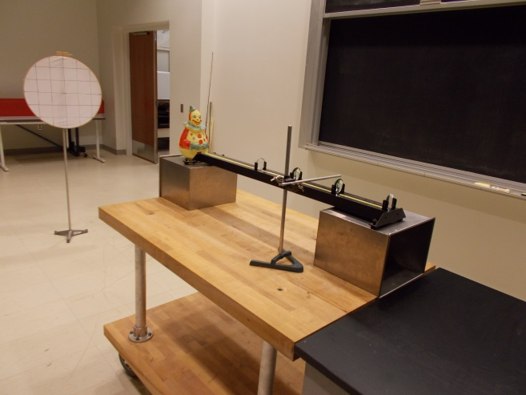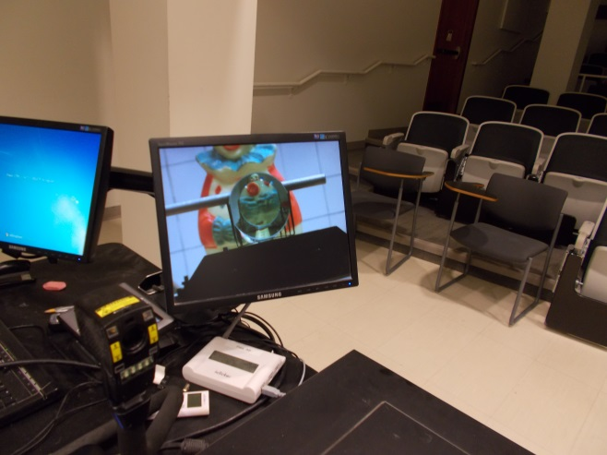
Location: Ja3, Jd2, Lb5, Bd1
OPTICS | 6B10.15 | PHOTOMETRY

Luminosity

Inverse Square Model
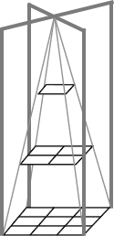 | A point source casts a shadow from a square frame. A screen four times the area is placed twice as far from the source as the frame. The light going through the frame just fills the screen.
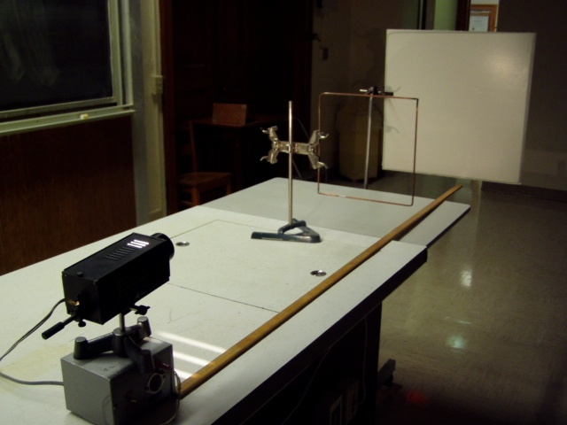Location: JaT, Ja6, Jd3
OPTICS | 6B10.20 | PHOTOMETRY
Luminosity

Inverse Square Law with a Photometer
 | A photometer is used with a smart cart, a computer, and the Capstone software to plot intensity of light vs distance. The Capstone file is Inverse Square Law for Light.
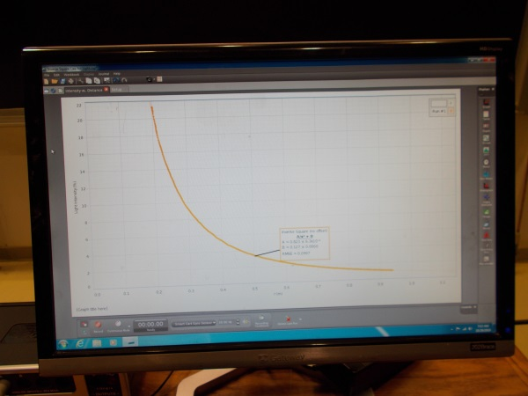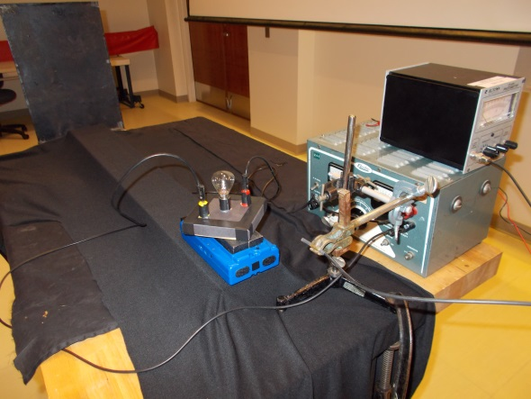
Location: Jb1, Bb2, Cc1
OPTICS | 6B40.20 | PHOTOMETRY

Blackbodies

Hole in a Box
 | A box that is painted black has a hole in a hinged door. The hole appears blacker than the box, When the door is opened, you see the box is actually painted white on its inside surfaces. Use an infrared camera to look at a hole in a heated aluminum block (100 C).
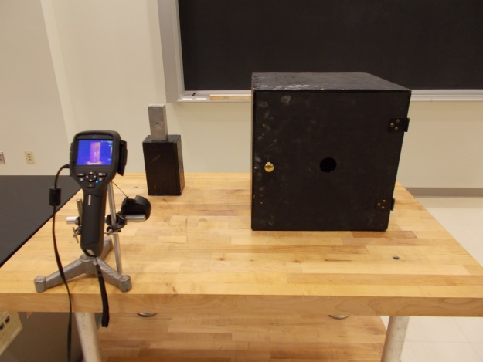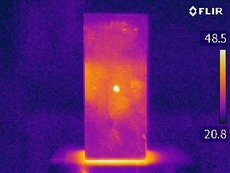

Location: Jb2, Fc5, FLIR Cabinet
OPTICS | 6B40.40 | PHOTOMETRY
Blackbodies

Black Body Spectrum
 | A spectrometer and bolometer connected to Science Workshop is used to record the spectrum from an incandescent bulb at various temperatures. For the TV camera version, use fixed focus and exposure. Change the variac setting to show the spectrum shift.
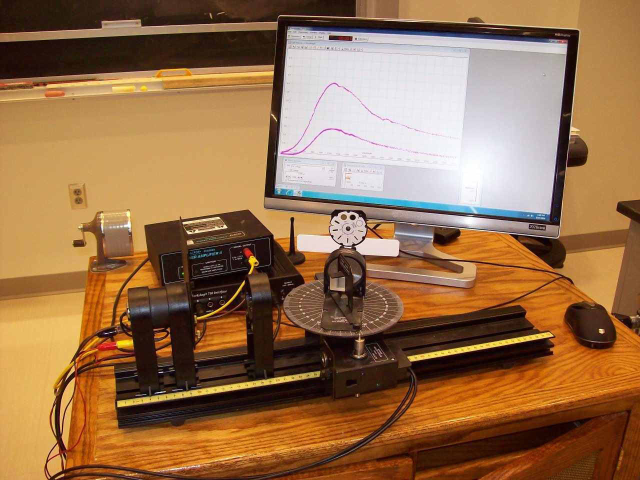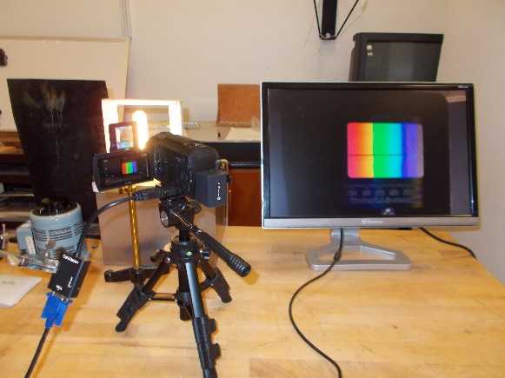
Location: Science Workshop Cabinet, Optics Table Cabinet, Kb2, Ib2
OPTICS | 6C10.10, 6C10.15 | DIFFRACTION

Diffraction Through One Slit

Single Slit and Laser
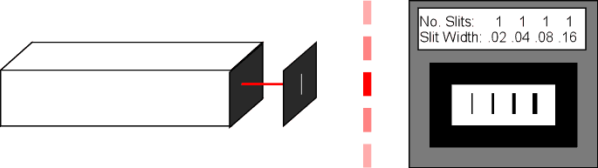 | Turn on the laser. The pattern appears on the wall. The slit widths are printed on the wheel. To select a different slit, turn the wheel. We also have the Cornell slitfilm card, which includes a slit of gradually increasing width. There is also a variable slit one can also use to “choke” the laser beam. Also shown is the computerized version (Diffraction.cap, uses the Capstone software). Use the 40 mW green diode laser, shimmed to the proper beam height. CAUTION: the undiffracted beam is bright enough to be harmful.
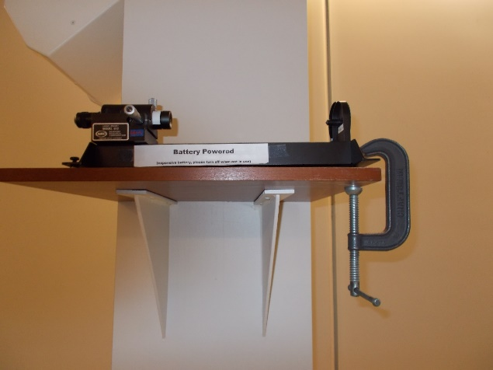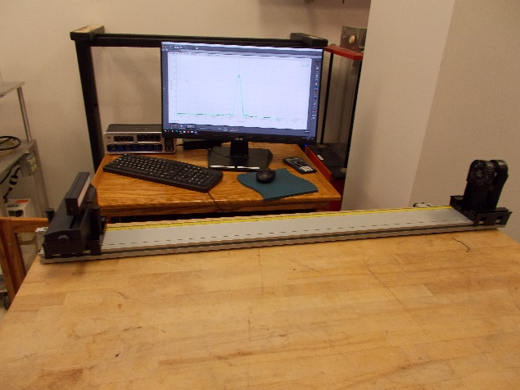
Location: Ja6, Jb3
OPTICS | 6C10.20 | DIFFRACTION
Diffraction Through One Slit

Two Finger Slit
 | Have each student look at a vertical filament lamp through the slit formed by holding two fingers closely together.
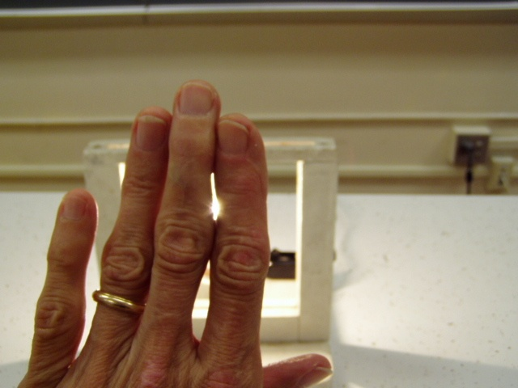
Location: Jd3
OSCILLATIONS AND WAVES | 3B50.10 | WAVE MOTION
Interference and Diffraction

Ripple Tank – Single Slit
 | Set up the ripple tank with a plane wave source and a single slit.
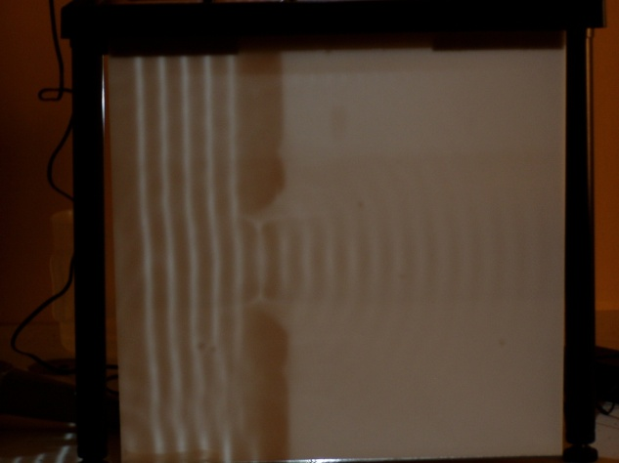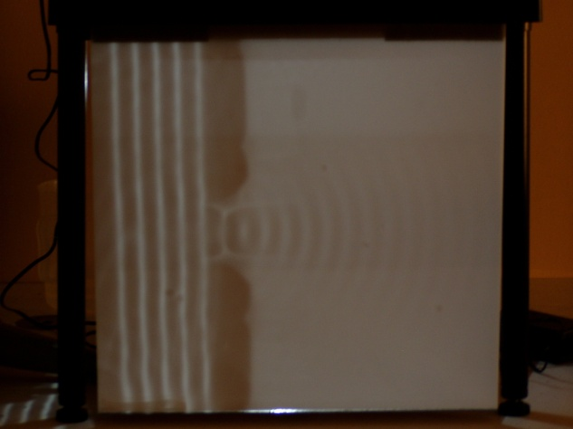
Location: Fb4
OPTICS | 6C10.50 | DIFFRACTION
Diffraction Through One Slit

Microwave Single Slit Diffraction
 | 3 cm microwave and a single slit.
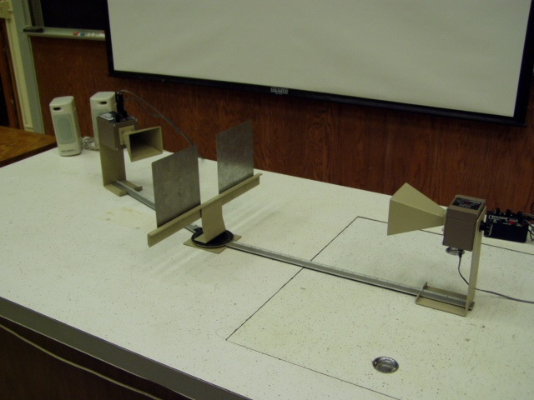Location: Ia7
OPTICS | 6C20.10 | DIFFRACTION

Diffraction Around Objects

Arago (Poisson) Spot
 | Shine an expanded laser beam at a ball bearing and look at the diffraction pattern.
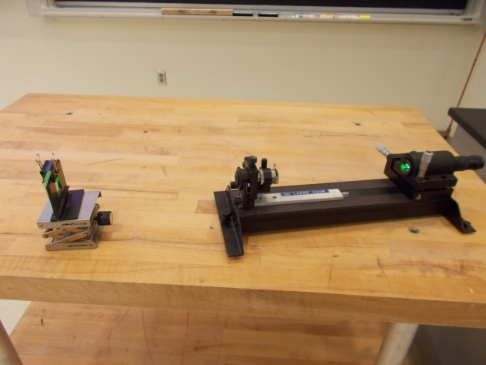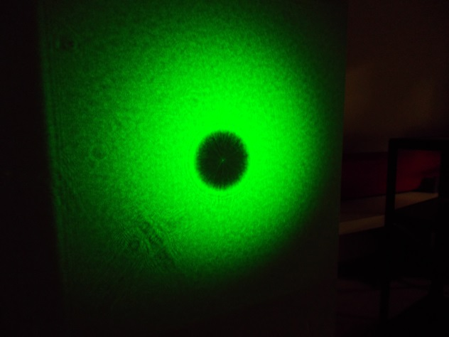
Location: Jb3, Ja6
OPTICS | 6C20.15 | DIFFRACTION
Diffraction Around Objects

Diffraction around Objects
 | Diffraction of a divergent laser beam around a razor blade or needle.
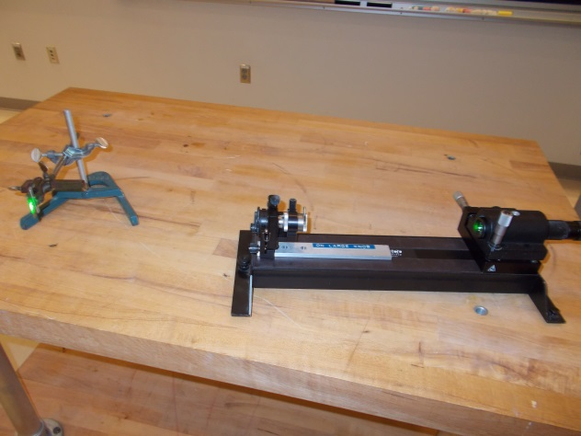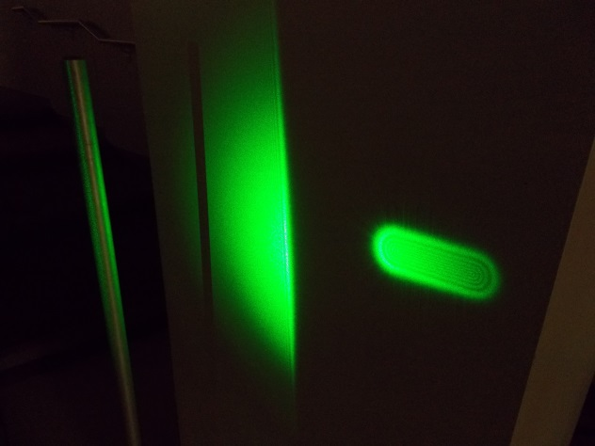
Location: Jb3, Ja6

OPTICS | 6C20.20 | DIFFRACTION
Diffraction Around Objects

Babinet’s Principle
 | Diffraction of a divergent laser beam around a thin line (0.08 mm) is compared to diffraction by a slit of the same size. Use the brighter laser on the slit. The wheel has both the individual line and slit that you can use by turning the wheel. Alternatively, there is a slide on the wheel that has the slit and line side by side (move the whole wheel holder from side to side to go from one to the other). Use the 40 mW green diode laser, shimmed to the proper beam height. CAUTION: the undiffracted beam is bright enough to be harmful.
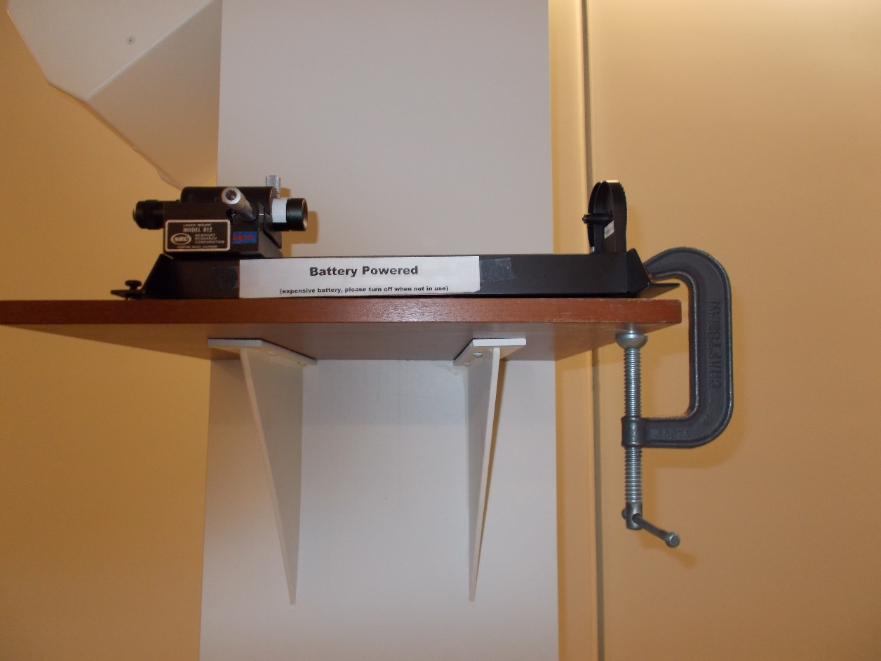
Location: Jb3, Ja6
OPTICS | 6C20.30 | DIFFRACTION
Diffraction Around Objects

Pinhole Diffraction
 | Shine a laser beam through pinholes of various sizes. Use the 40 mW green diode laser, shimmed to the proper beam height. CAUTION: the undiffracted beam is bright enough to be harmful.
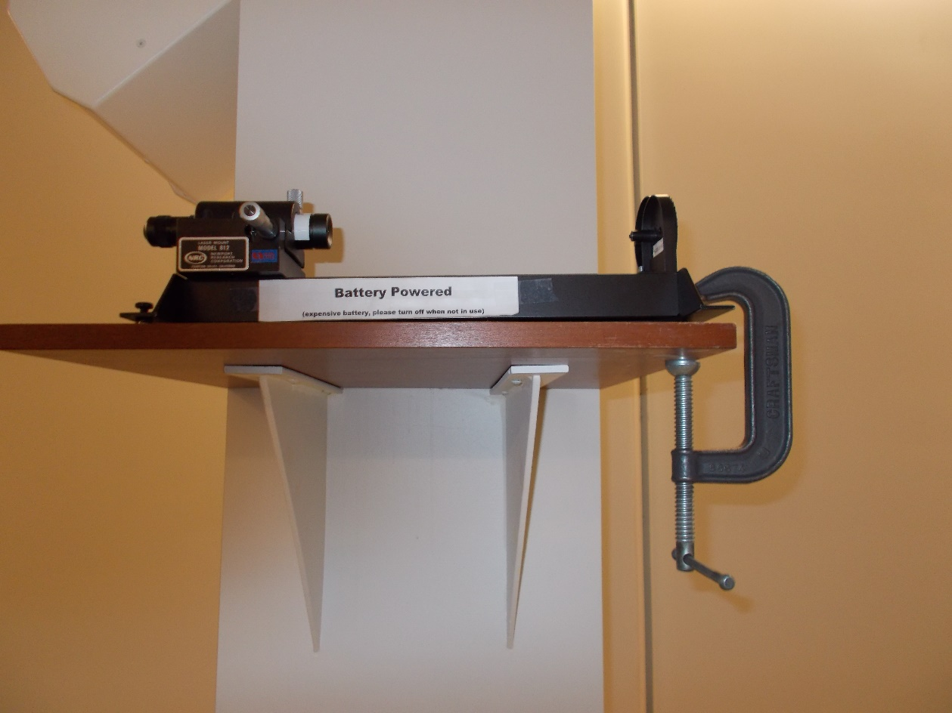
Location: Jb3, Ja6

OPTICS | 6C20.35 | DIFFRACTION
Diffraction Around Objects

Square and Rectangular Apertures
 | Shine a laser beam through a square (0.16 mm x 0.16 mm) or rectangular aperture (0.16 mm x 0.08 mm) aperture. The Mounting hardware (mirror mounts) for the apertures is in the Newport Holography kit. Remove Newport mirror mount, MM2-1A, from riser (RB-MM2-2), and mount aperture slide in it. The lens (18 mm) is from the Pasco Advanced optics kit. Use steel nuts as spacers on the mounting slide so it can be moved close enough to the aperture.
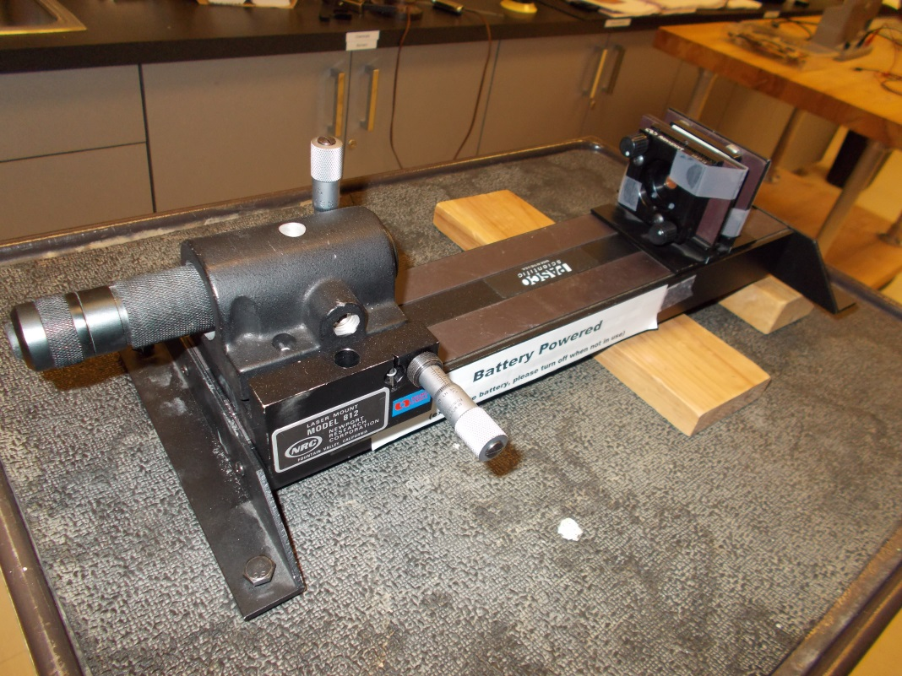
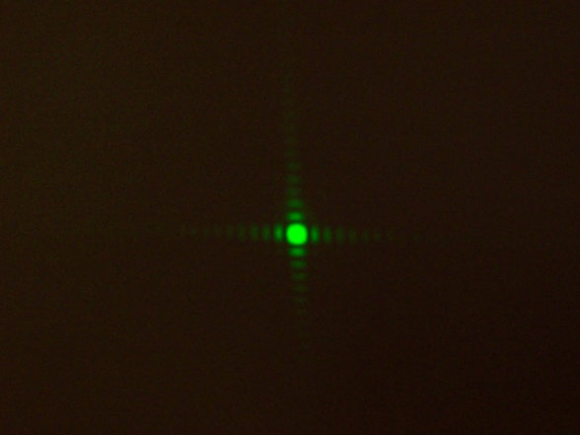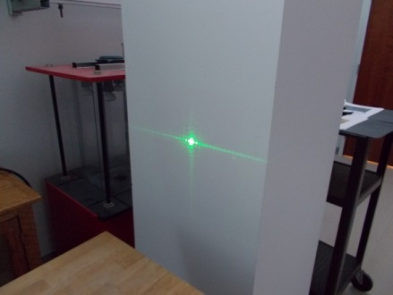
Location: Jb3, Ja6
OPTICS | 6C20.40 | DIFFRACTION
Diffraction Around Objects

Zone Plate Lens
 | Use a zone plate. The source is a spatially filtered diverging beam. Also place a zone plate on the overhead projector to show the center is an opaque spot (note we also have one that is not opaque in the center).
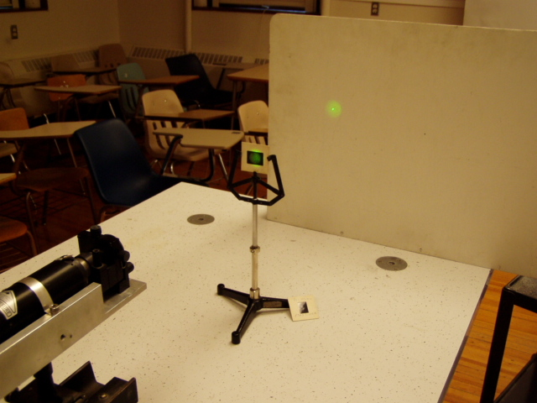Location: Jb3, Ja6
OPTICS | 6D10.10 | INTERFERENCE

Interference From Two Sources

Double Slits and Laser
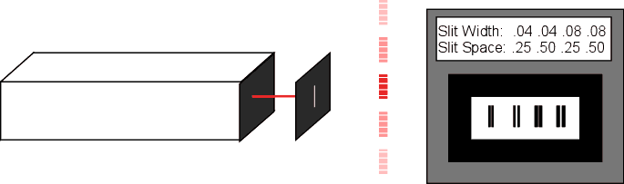 | Turn on the laser. The pattern appears on the wall. The slit widths and spacings are printed on the wheel. To select different slits, turn the wheel. There is a continuously variable double slit that varies the slit spacing on the wheel. We also have the Cornell slitfilm card, which includes double slits of increasing width and spacing. Use the 40 mW green diode laser, shimmed to the proper beam height. CAUTION: the undiffracted beam is bright enough to be harmful.
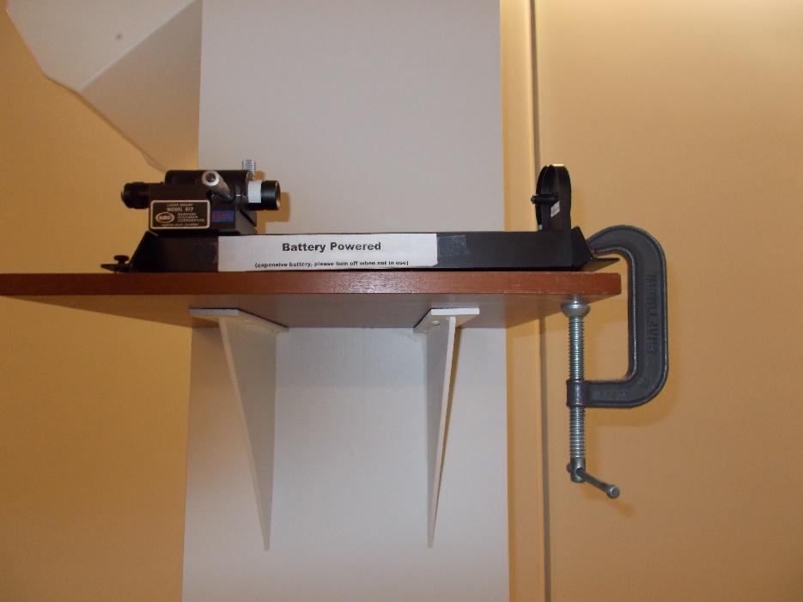
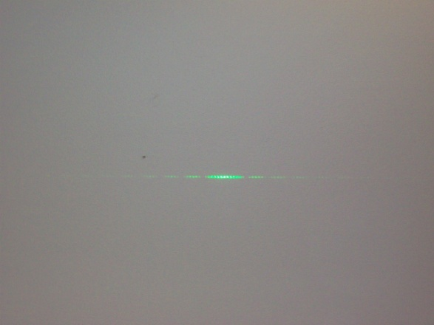
Location: Jb4, Ja6
OSCILLATIONS AND WAVES | 3B50.20 | WAVE MOTION
Interference and Diffraction

Ripple Tank – Two Point
 | Set up the ripple tank with a double point source.
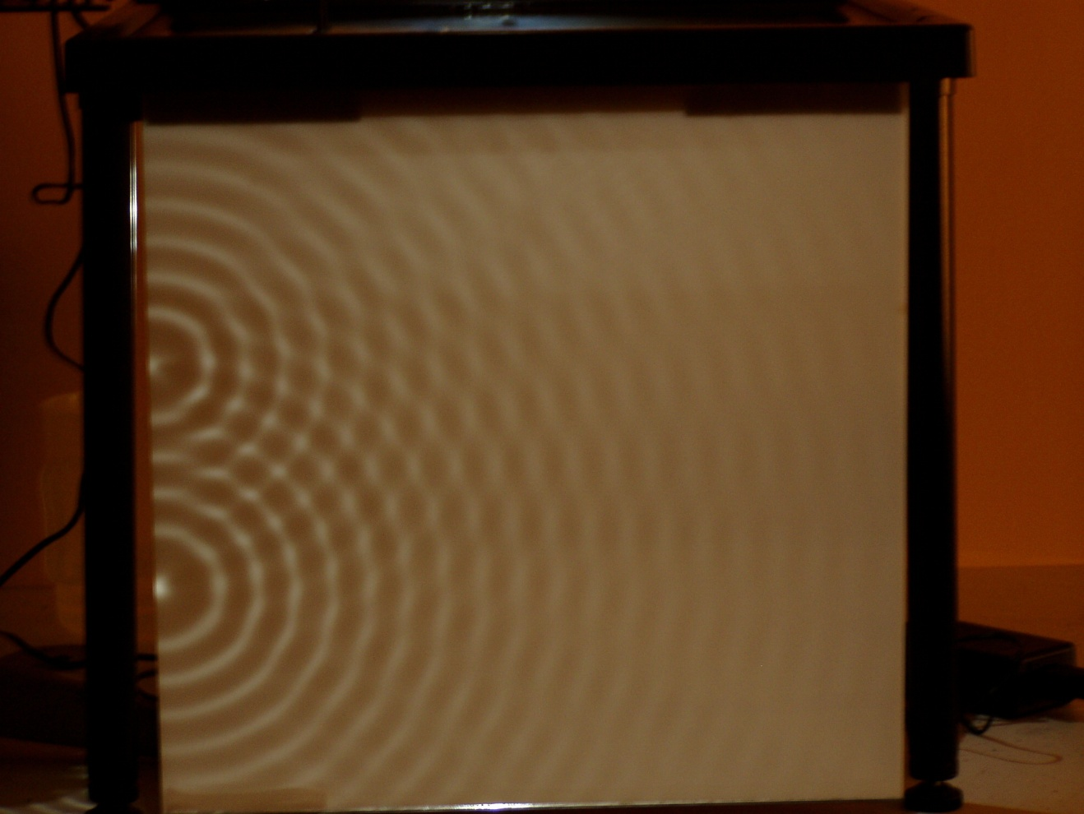
Location: Fb4

OPTICS | 6D10.20 | DIFFRACTION
Interference From Two Sources

Microwave Double Slit
 | 3 cm microwave and a double slit.
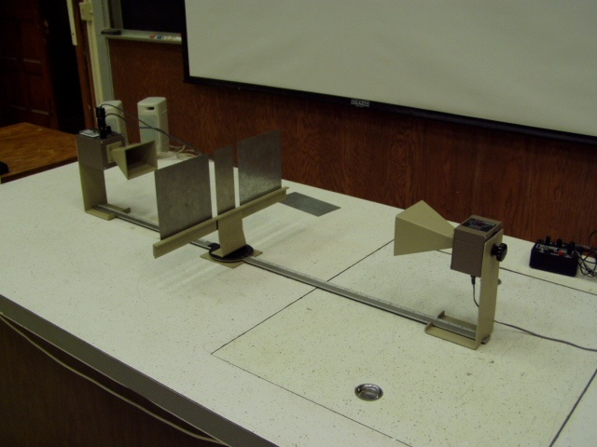 Location: Ia7
OPTICS | 6D10.41 | DIFFRACTION
Interference From Two Sources

Fresnel Biprism
 | A spatially filtered diverging beam illuminates a Fresnel biprism. A pattern similar to a double slit is produced.
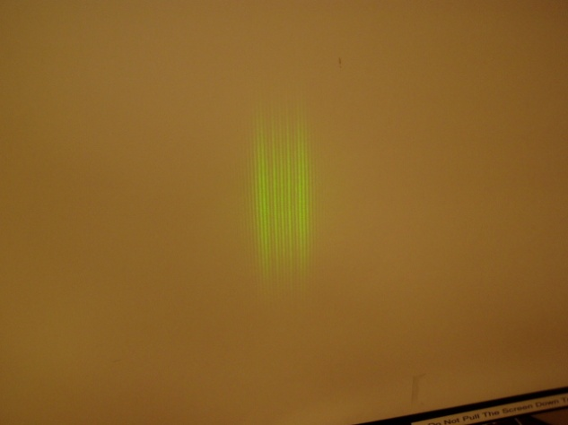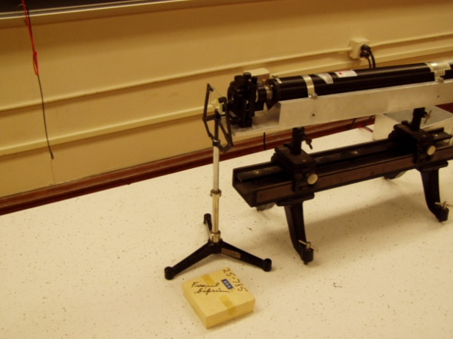
Location: Jb4, Ja6, Optics Table Cart
OPTICS | 6D20.10 | INTERFERENCE

Gratings

Number of Slits
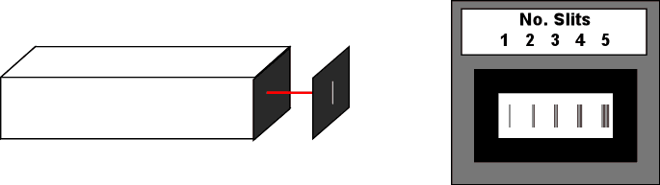 | Turn on the laser. The pattern appears on the wall. The slit widths, numbers and spacings are printed on the wheel. To select different slits, turn the wheel. View the results of the interference pattern on the wall. The lights in the room may need to be darkened. Use the 40 mW green diode laser, shimmed to the proper beam height. CAUTION: the undiffracted beam is bright enough to be harmful.
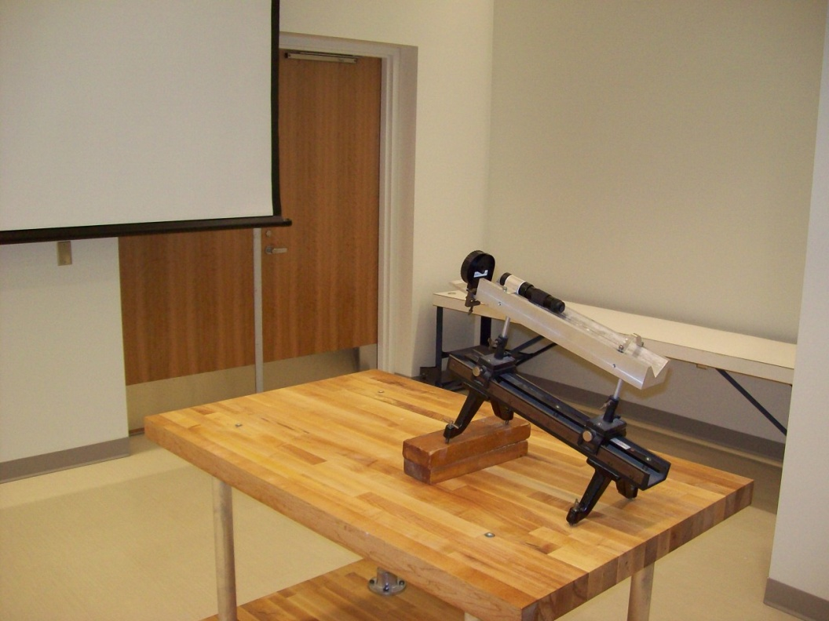
Location: Jb4, Ja6
OPTICS | 6D20.55 | INTERFERENCE
Gratings

Fine Mesh and Laser
 | Shine a laser through a fine mesh and observe the patterns.
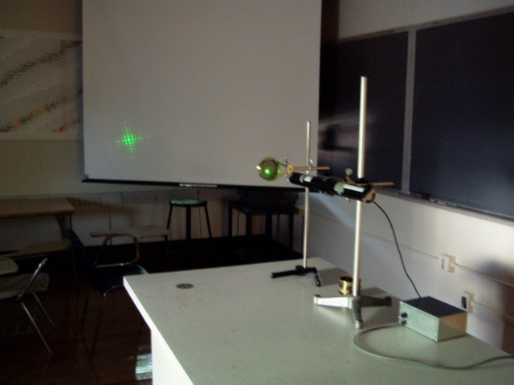Location: Jb4, Ja6
OPTICS | 6D20.57 | INTERFERENCE
Gratings

Optical Crystal Set
 | Seven sequences of 2x2 slides used in the simple Laue approach to diffraction by crystals.
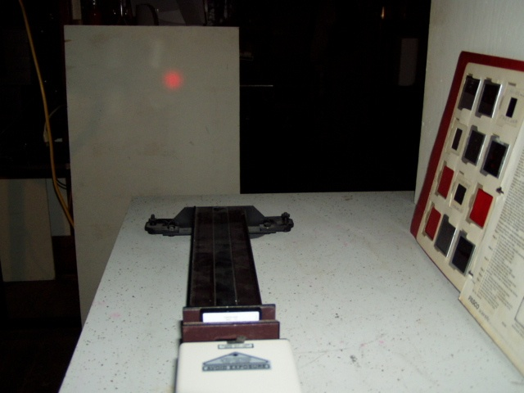
Location: Jb4, Jd2

OPTICS | 6D30.10 | INTERFERENCE

Thin Films

Newton's Rings
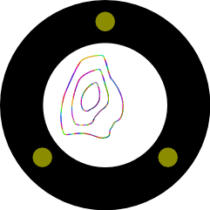 | Turn on the light. The interference pattern is projected onto the side wall. Change the pattern by tightening a screw on the edge of the glass disk.
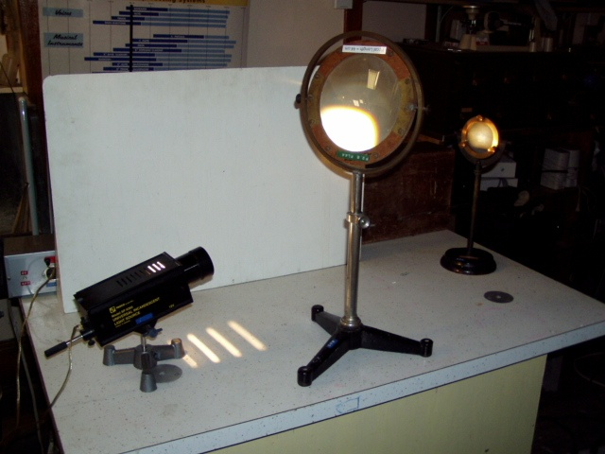
Location: Id1, Jb4, Jd3
OPTICS | 6D30.20 | INTERFERENCE
Thin Films

Soap Film Interference
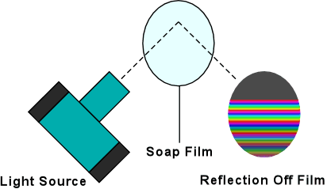 | Turn on the light. Dip the wire frame into the soap solution and secure with the clip. Adjust the angle until the pattern appears on the side wall.
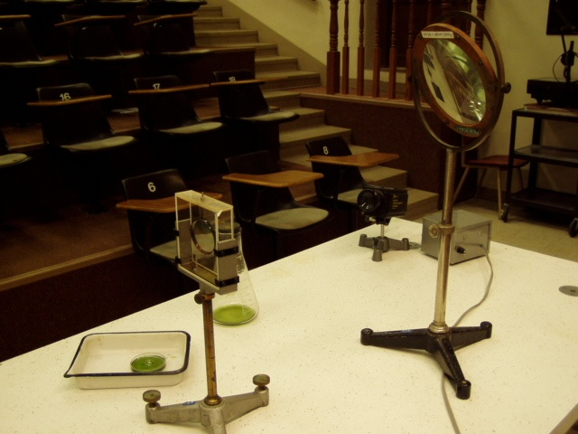
Location: Id1, Jb4, Jd3
OPTICS | 6D30.30 | INTERFERENCE
Thin Films

Air Wedge
 | A sodium lamp illuminates two plates of glass (in the picture two quartz surface plates are shown). Compare with a piece of glass that is not an optical flat.
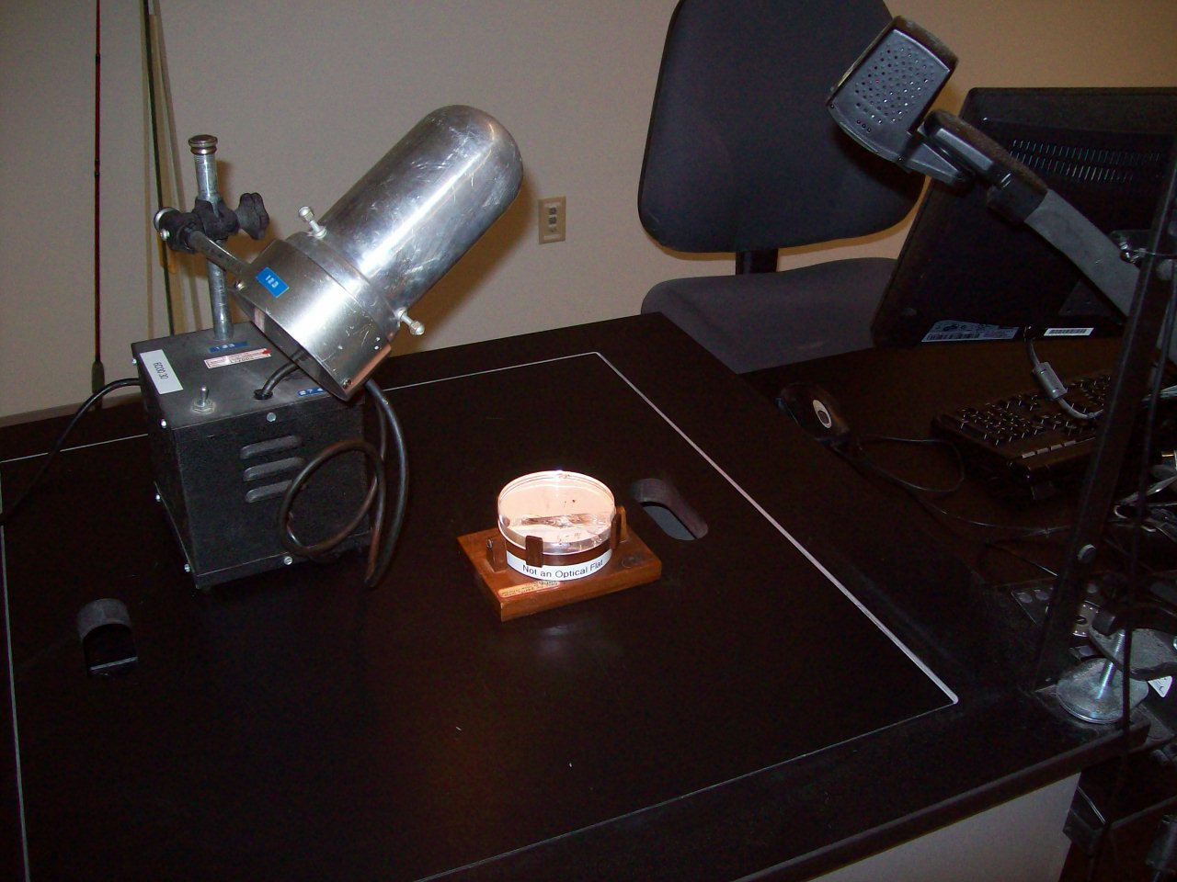Location: Jb3, Ka2
OPTICS | 6D30.55 | INTERFERENCE
Thin Films

Step Gauge
 | Thin films of barium stearate, from 2 x10⁻⁶ to 16 x10⁻⁶ inches in microinch increments are deposited on a glass plate. The steps reflect a vivid series of interference colors when illuminated by white light.
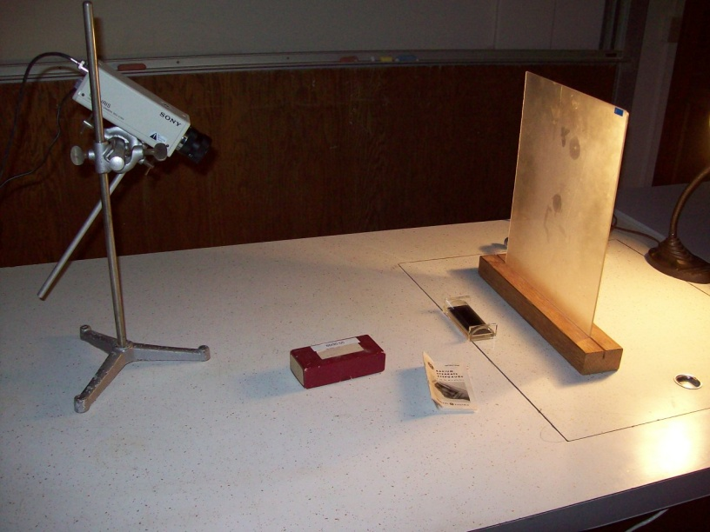
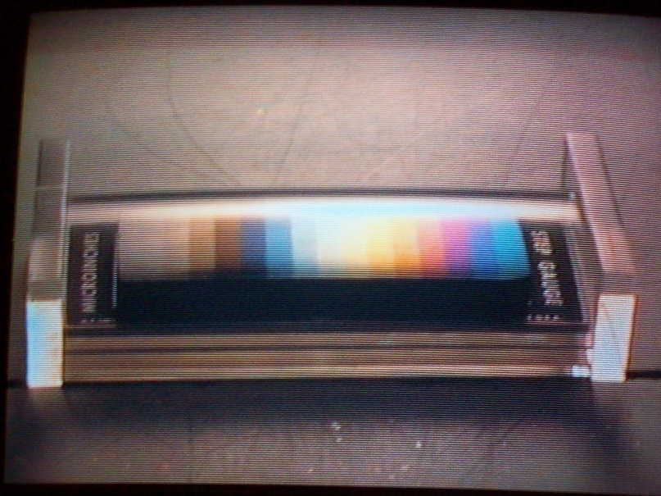
Location: Jb4
OPTICS | 6D40.10 | INTERFERENCE

Interferometers

Michelson Interferometer
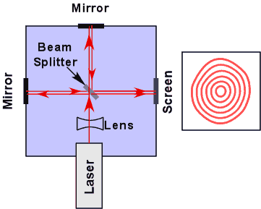 | Turn on the laser. Read the initial position of the micrometer. Count the number of fringes while turning the micrometer slowly in one direction only. Read the final position. This can also be done with white light. A spatial filter is used to create a clean, diverging beam.
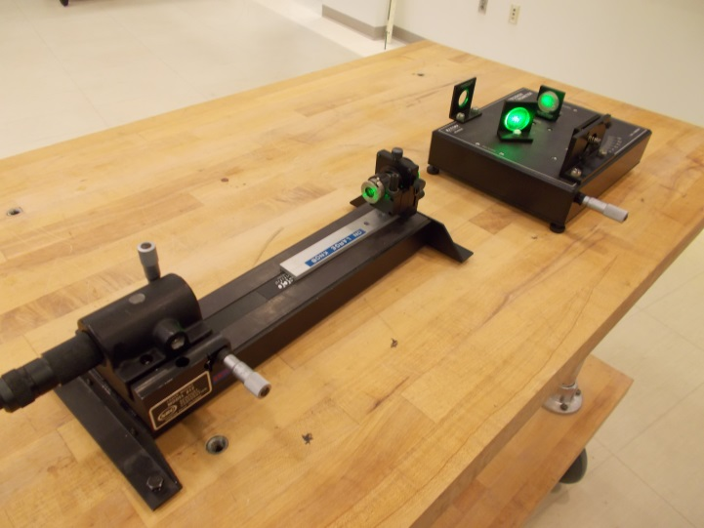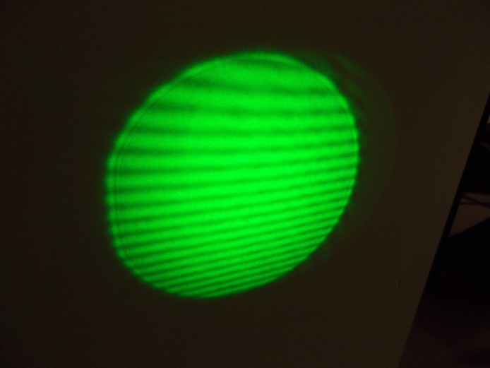
Location: Optics Table Cabinet, Jb5, Ja6

OPTICS | 6D40.27 | INTERFERENCE
Interferometers

Lloyd’s Mirror
 | The laser is aligned so that the beam grazes the surface of the glass plate. Two spots are seen on a distant screen, one from the light passing directly over the plate and the other from the light reflected from the plate. As the plate is raised into the beam, the spot of light from the reflection will lower and merge with the spot that passes directly over the plate. As it does, an interference pattern will appear.
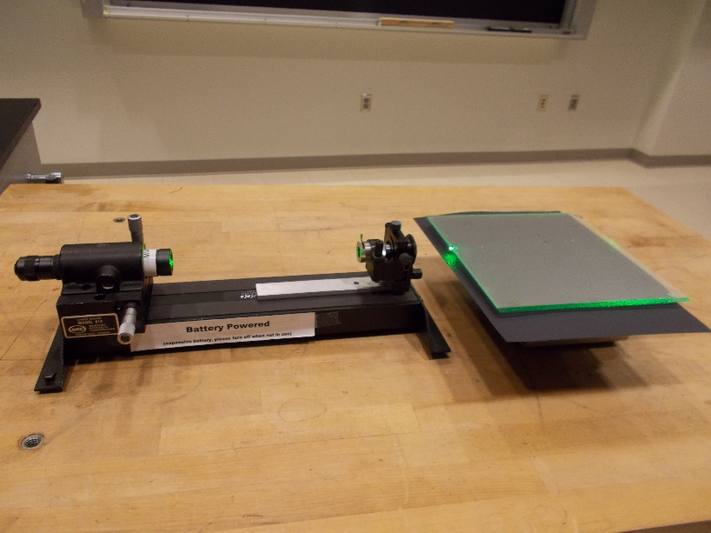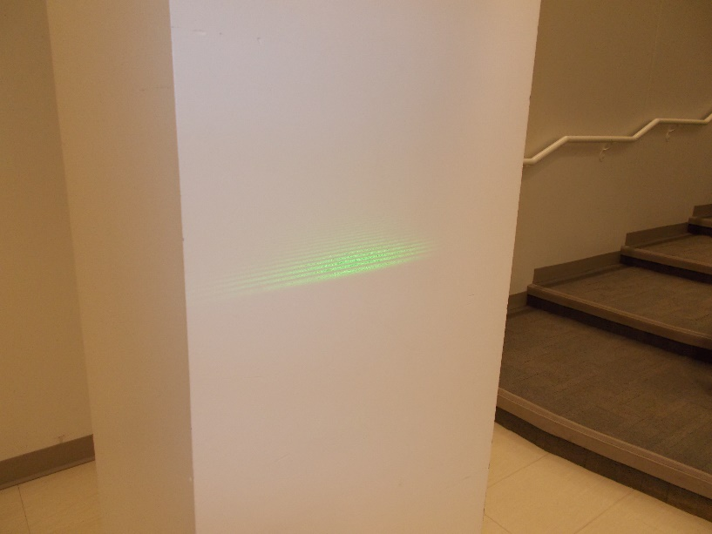
Location: Id3, Jb3,

Modern Physics | 7G20.20 | Lasers
Laser Polarization and Intensity Fluctuation - Modes

Optical Resonator
 | Light from a laser is directed down the optical cavity of an old laser tube. The cavity acts as an optical resonator and as the exciting laser warms up, its frequency slews through a spectrum of frequencies. As the frequencies match resonate frequencies in the old tube (it can be thought of as a Fabry Perot interferometer), light is transmitted through it and shows up as a spot on a screen placed down beam from the exit side. Various modes can be observed as the exciting lasers frequency changes.
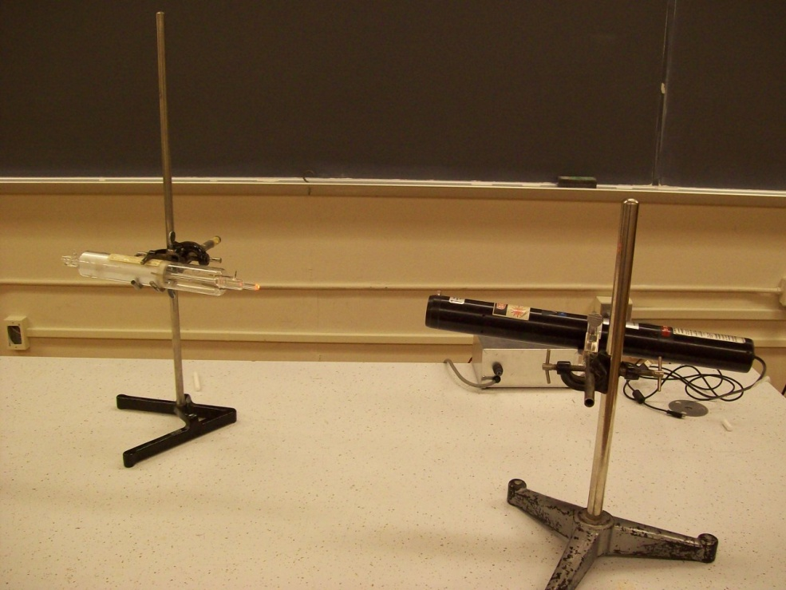
Location: Ia1, Ja6

OPTICS | 6F10.10 | COLOR

Synthesis and Analysis of Color

Color Box
 | Three spot lights with color filters are used to project colored spots on a screen. The spots overlap to show color mixing. Colorful shadows can be cast as well.
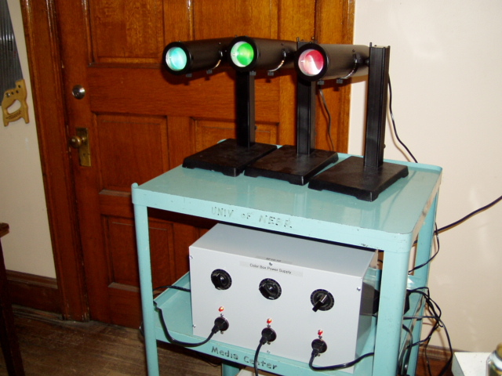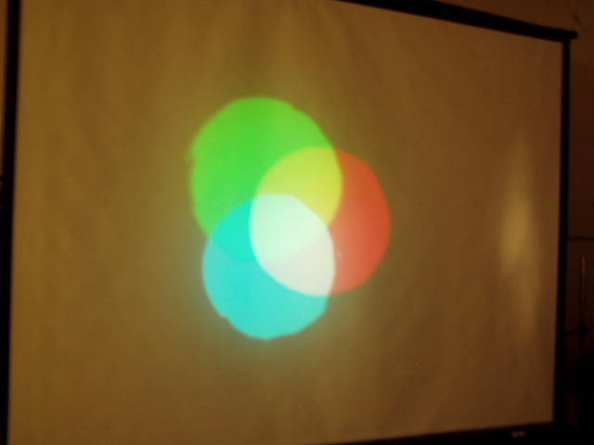
Location: Jb6

OPTICS | 6F10.14 | COLOR
Synthesis and Analysis of Color

Color Mixing
 | Use an old LCD projector to split a white beam of light into RGB and then recombine it.
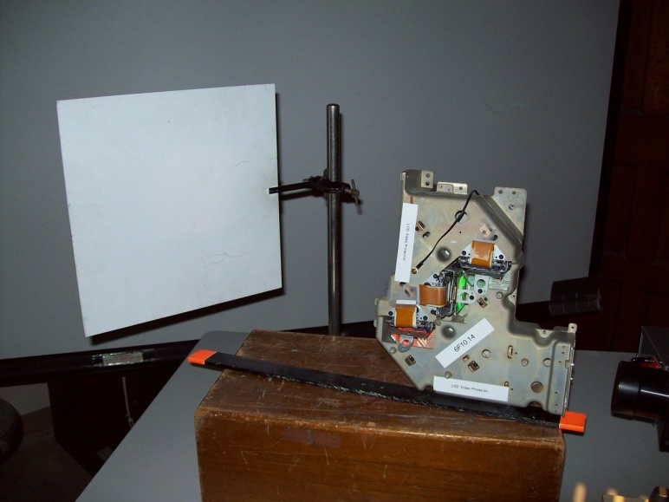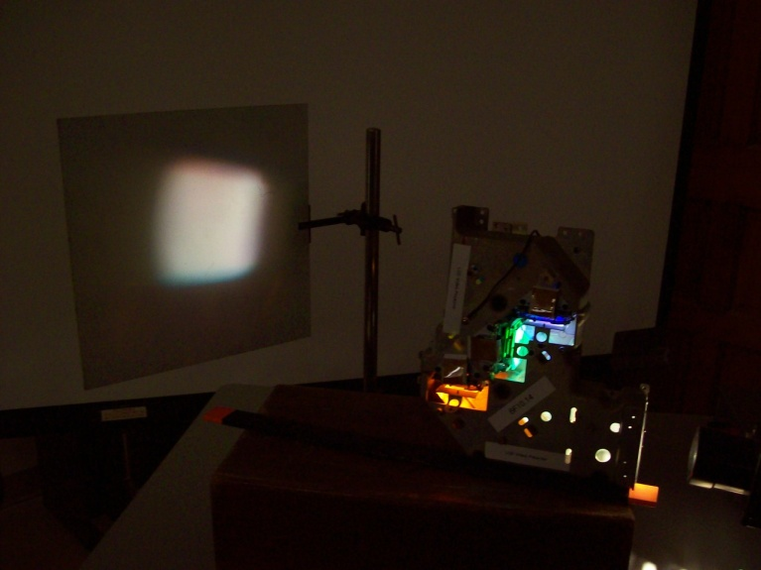
Location: Jb6

OPTICS | 6F10.30 | COLOR
Synthesis and Analysis of Color

Recombining the Spectrum
 | Recombine the spectrum after passing through a prism to get white light or remove a color to get the complement.
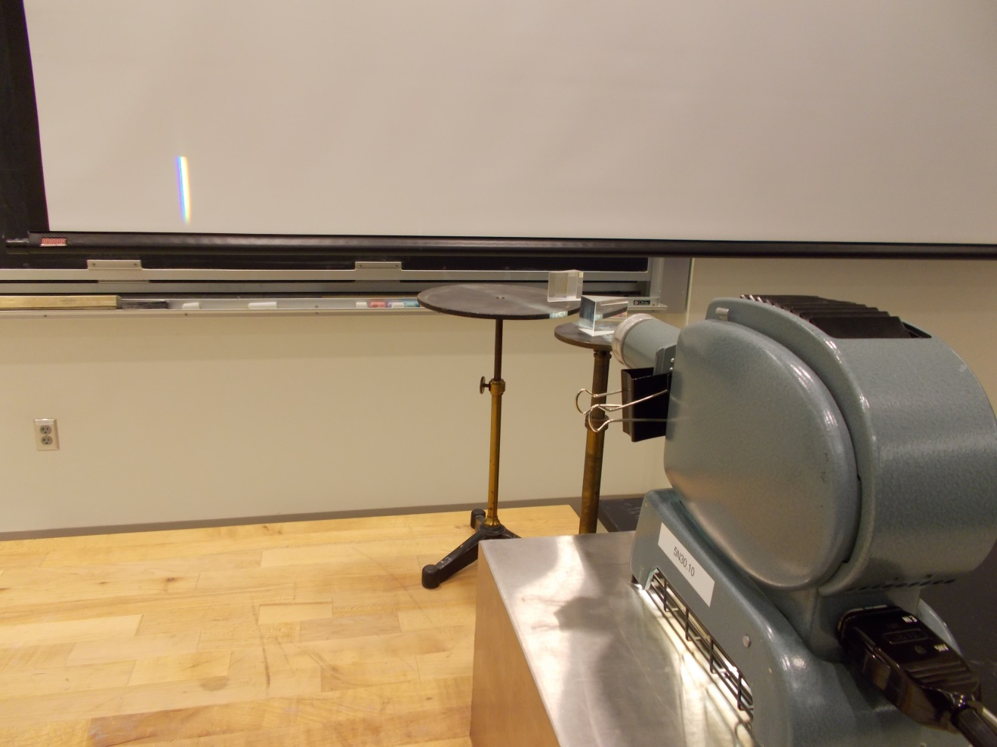
Location: Ib1, Jb3, Jc1

OPTICS | 6F40.10 | COLOR

Scattering

Sunset
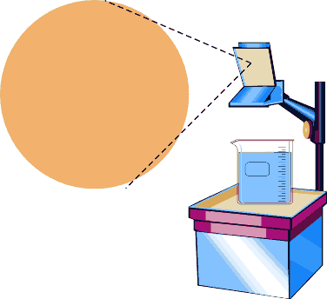 | A beam of light shines through a circular slide on the overhead projector and then through one liter of water and onto the side wall. Add a few drops of Pinesol (cedarwood oil in alcohol or Lysol) to the water and stir with the stick. The "sun" will begin to turn yellow. To increase the scattering to an orange sun, add more Pinesol. It takes about 15 minutes to fully achieve the effect. Use the Polaroid film to show the scattered blue light is polarized (it becomes less so as you get double scattering).
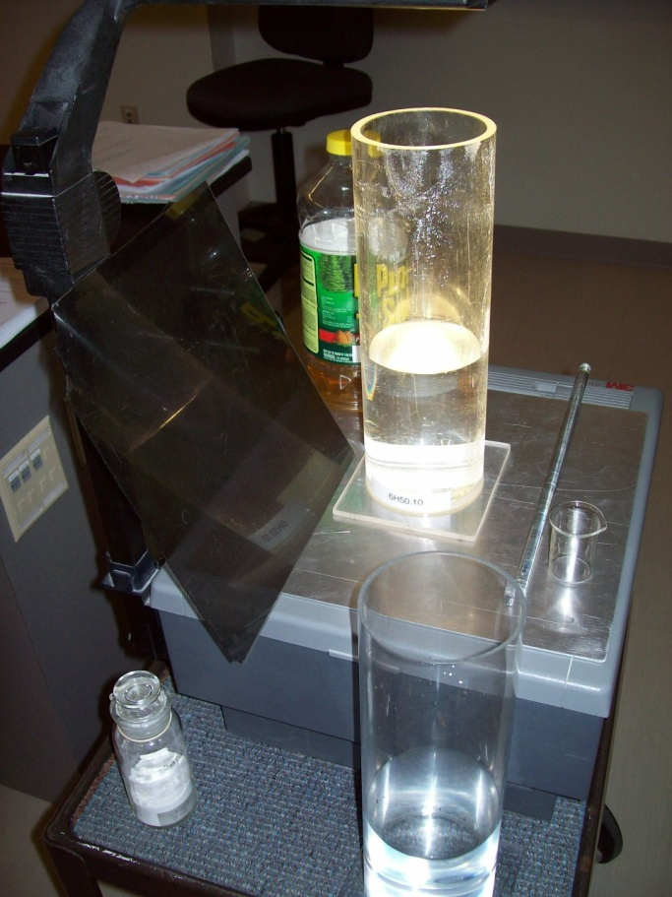
Location: Jc2
OPTICS | 6H10.10 | POLARIZATION

Dichroic Polarization

Polaroids on the Overhead
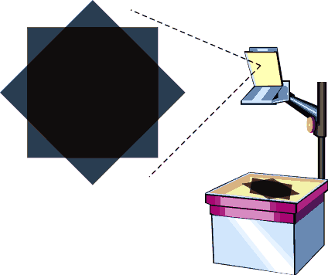 | You get two sheets of Polaroid and a pair of Polaroid sunglasses. Rotate one on the Polaroids or the sunglasses.
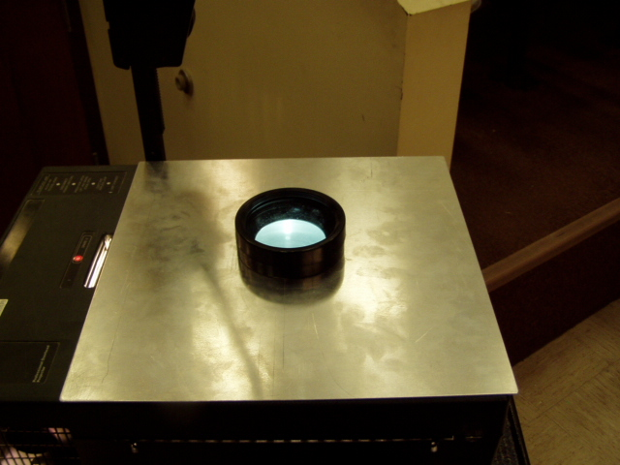
Location: Jc3, Ja5

OPTICS | 6H10.12 | POLARIZATION
Dichroic Polarization

Polaroid Box
 | An arrangement of cross polarizers makes it appear that there is a solid barrier inside a box.
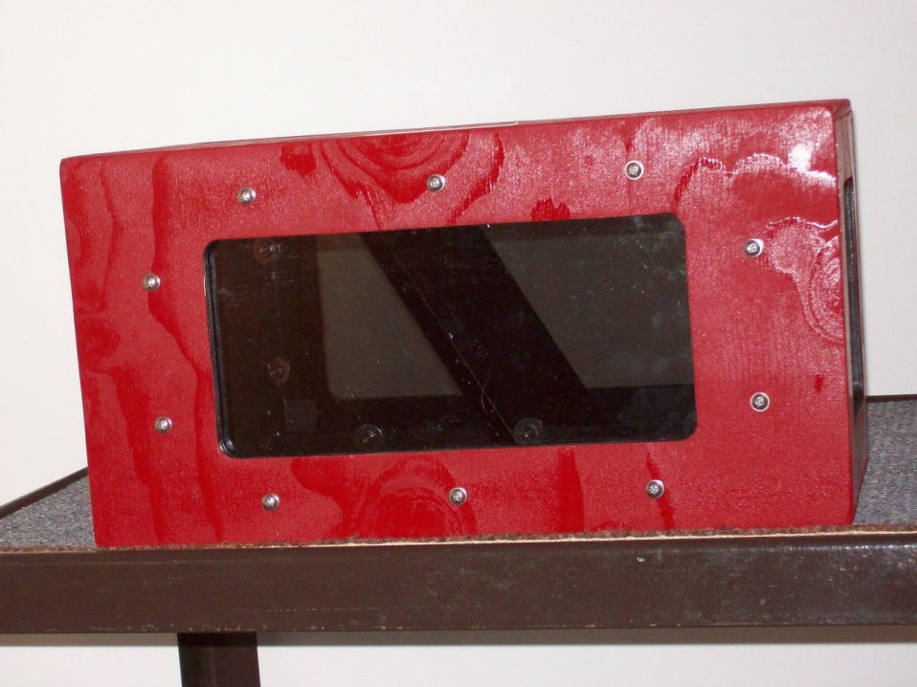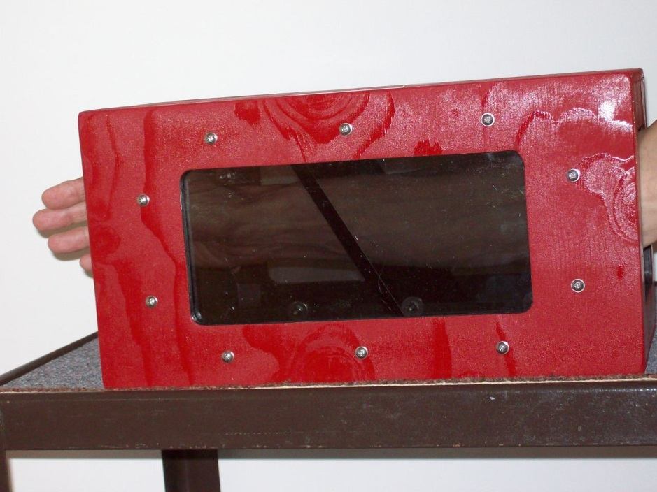
Jc3

OPTICS | 6H10.20 | POLARIZATION
Dichroic Polarization

Microwave Polarization
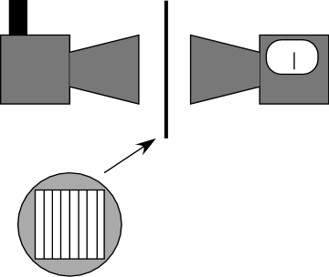 | Hold a grid of parallel wires in a microwave beam and rotate the grid.
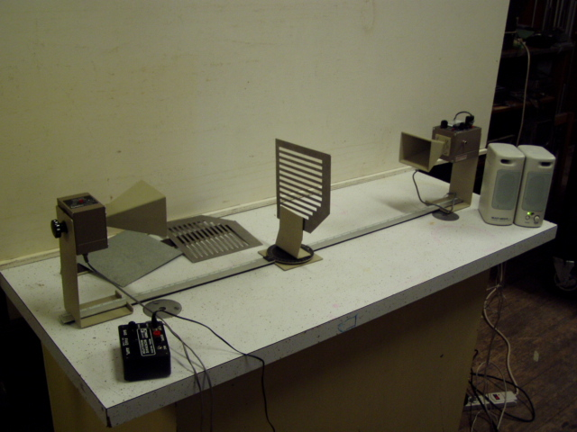Location: Ia7
OPTICS | 6H20.10 | POLARIZATION

Polarization by Reflection

Brewster's Angle
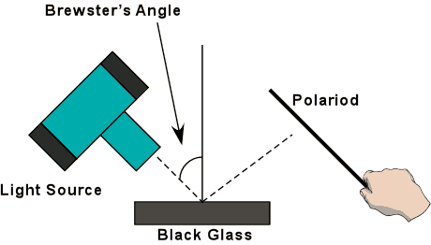 | Light is reflected from a sheet of black glass onto the wall. Rotate a sheet of Polaroid in the path of the reflected light. We set the light at Brewster's Angle. Vary the incident angle by rotating the light.
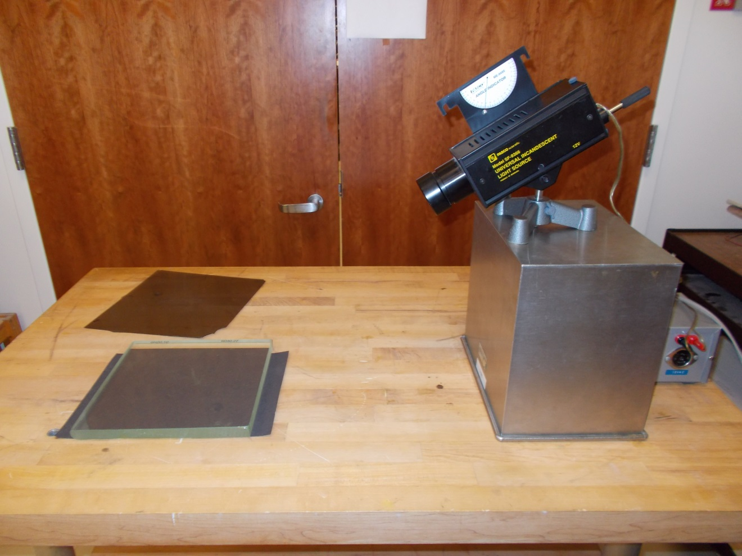Location: Jc3, Jd3
OPTICS | 6H20.40 | POLARIZATION
Polarization by Reflection

Stack of Plates
 | A stack of glass plates at 57 degrees will transmit and reflect light that is cross polarized. In this apparatus, the black mirror serves as an analyzer for the transmitted beam and when the ray reflected off of it is in the same direction as the rays reflected off of the stack of plates, the intensity is low because the plane of polarization of the transmitted ray is normal to a line in the plane of the black glass; however, if you rotate the black mirror 90 degrees so the reflected beam is normal to the direction of the rays reflected off of the stack, then the plane of polarization of the transmitted ray is in the plane of the black glass and the ray is more intense. Use the green, unpolarized laser as the light source.
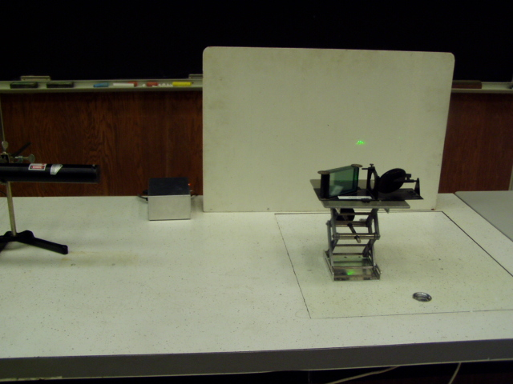Location: Ja6, Jc3
OPTICS | 6H30.10 | POLARIZATION

Circular Polarization

Three Polaroids
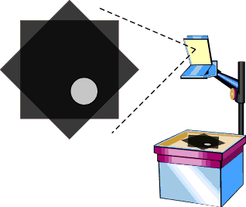 | Three sheets of Polaroid are provided with an overhead projector. Also shown in the photograph is a circular polarizer.  The second picture shows a version that does not use the overhead projector
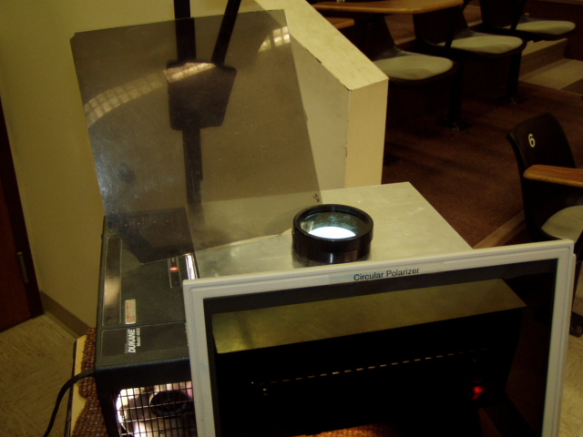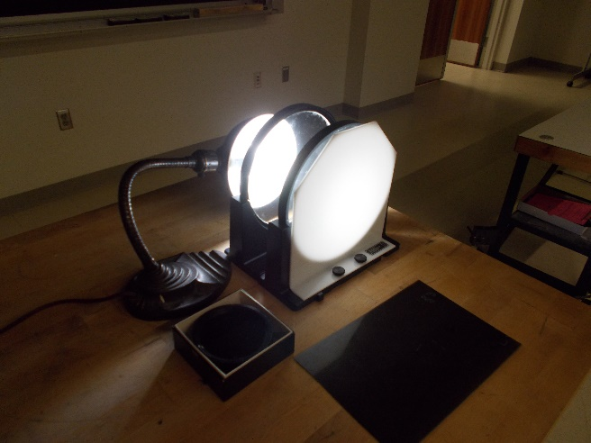
Location: Jc2, Jc3

OPTICS | 6H30.20 | POLARIZATION
Circular Polarization

Circular Polarizer,1/4 Wave Plate, Polaroid and Mirror
 | Look through a circular polarizer at your image in a mirror with the ¼ wave plate side toward the mirror. Now flip the circular polarizer so that the ¼ wave plate is on the side opposite the mirror. Also try a retroreflector and various orientations with a linear polarizer.
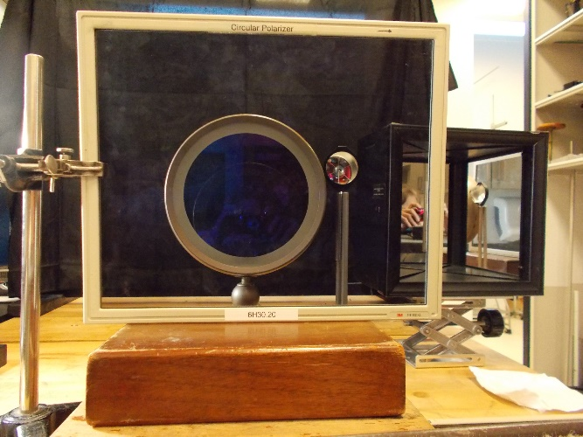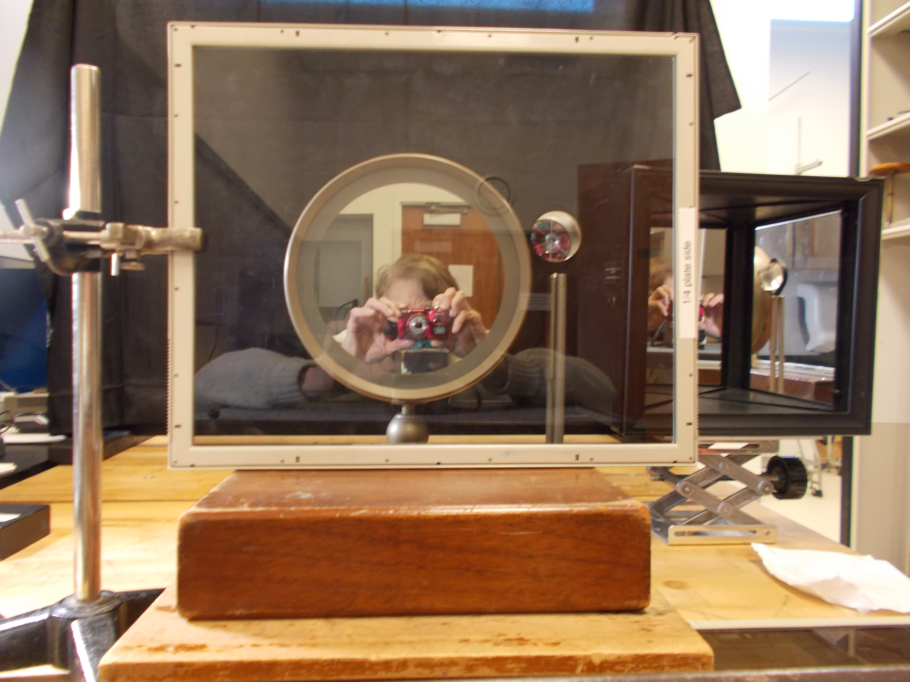
Location: Id5, Jc3
OPTICS | 6H30.40 | POLARIZATION
Circular Polarization

Karo Syrup
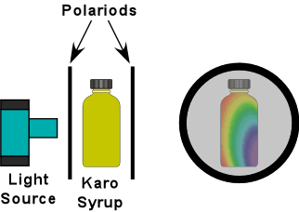 | Place the Karo syrup between two circular polarizers. Place the light source behind the rear polarizer and turn the lamp on. Rotate the front polarizer and watch the syrup change colors. Use a point source with a diffuser. Show with a polarization axis finder (disk) is for fun.
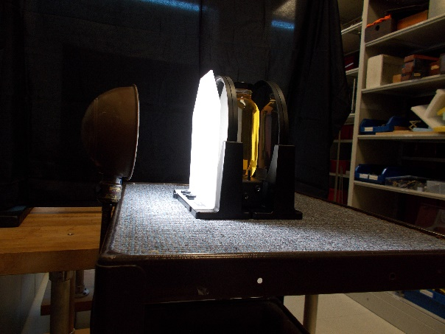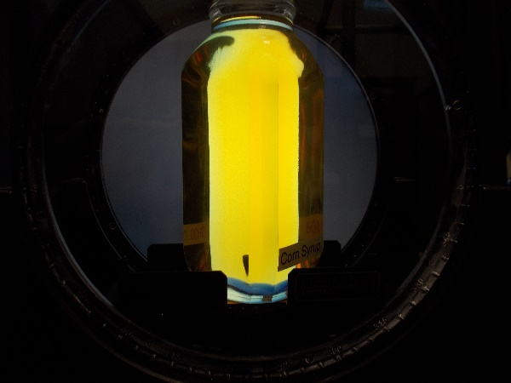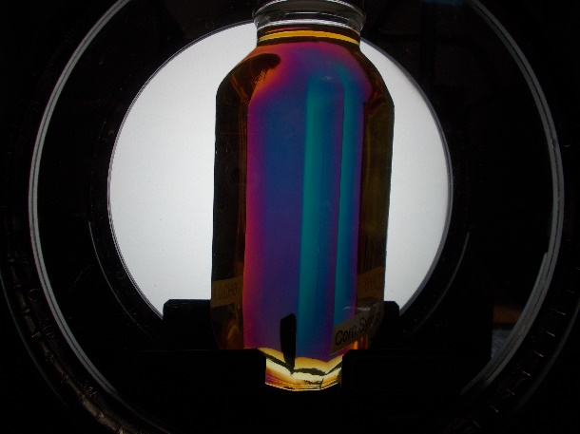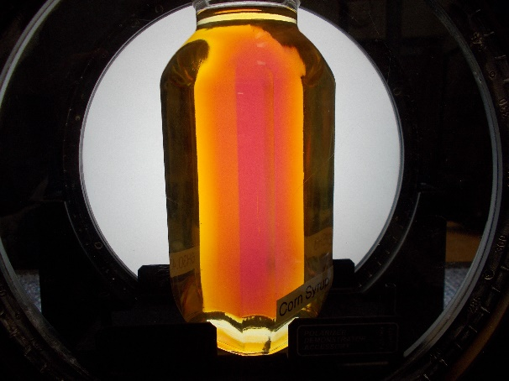
Location: Jc2, Jc4

OPTICS | 6H30.80 | POLARIZATION
Circular Polarization

Faraday Rotation
 | A TGG (Terbium Gallium Garnet) glass sample is placed in a polarimeter and illuminated with one of 3 lasers (405 nm, 532 nm and 605 nm). The polarimeter is adjusted for minimum throughput. A magnetic field is applied (0.13 T) and the Faraday rotation is observed by finding the new minimum.
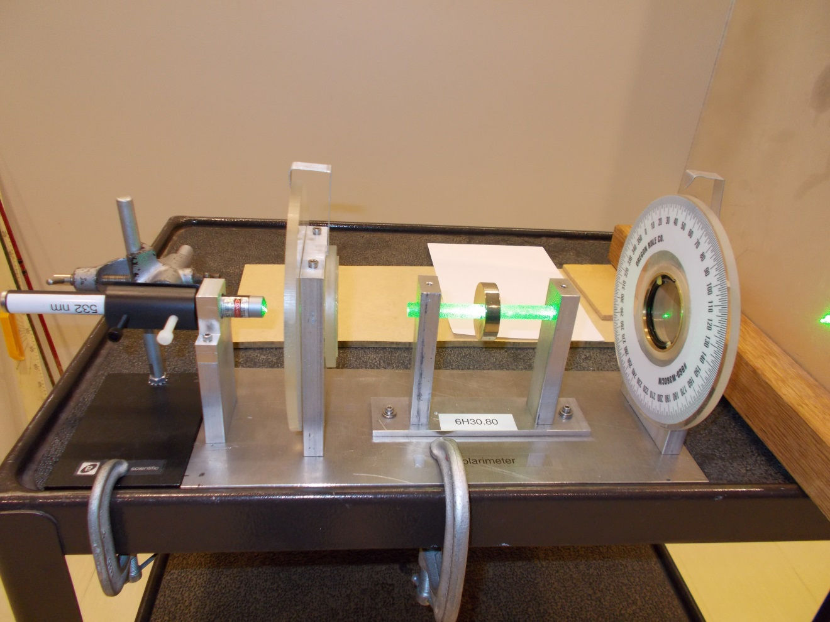
Jc2

OPTICS | 6H35.15 | POLARIZATION

Birefringence

Calcite and Polaroid on the OHP
 | A calcite rhomb is placed on an overhead projector with a slide underneath. The double image can then be seen and manipulated with a polarizer.
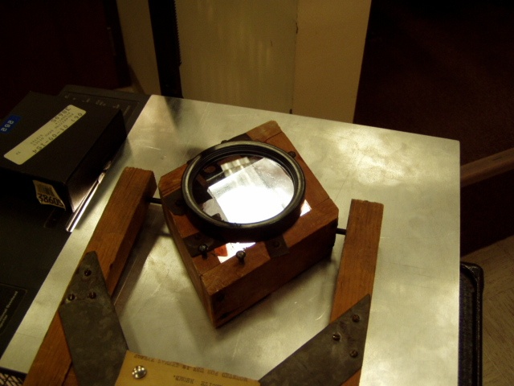Location: Jc4

OPTICS | 6H35.24 | POLARIZATION
Birefringence

Wavefront Model
 | Cast plaster model shows spherical and elliptical wavefronts in crystals.
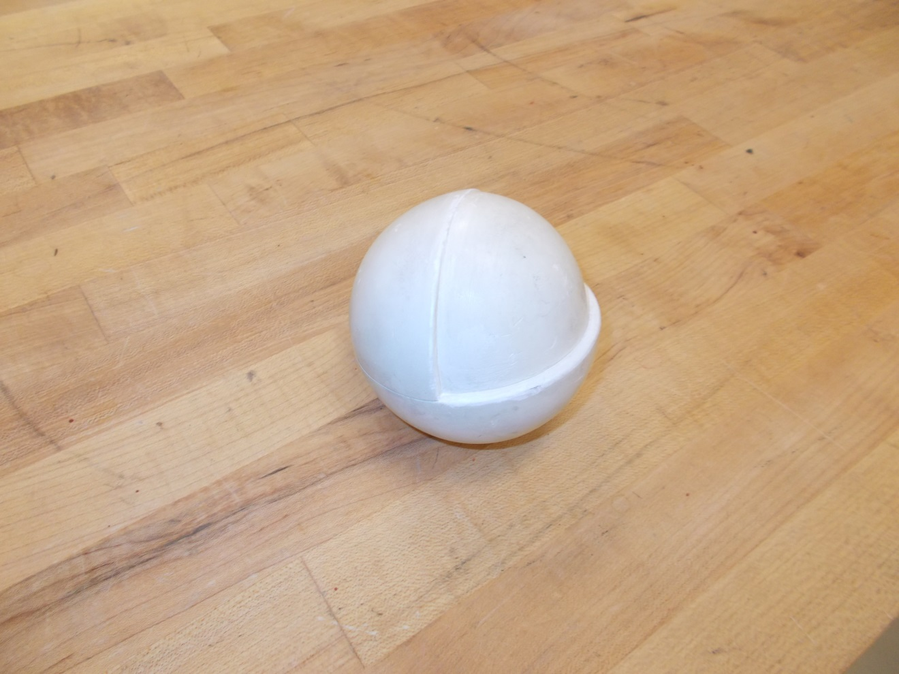
Location: Jc3

OPTICS | 6H35.40 | POLARIZATION
Birefringence

Quarter Wave Plate
 | Show two plates with attached polarizers and the Magic glass trick wherein light appears to go through one way but not the reverse path (it’s a trick). One can also do this with one plate/polarizer by looking through it at a mirror and then flipping 180 degrees about a horizontal axis and looking again.
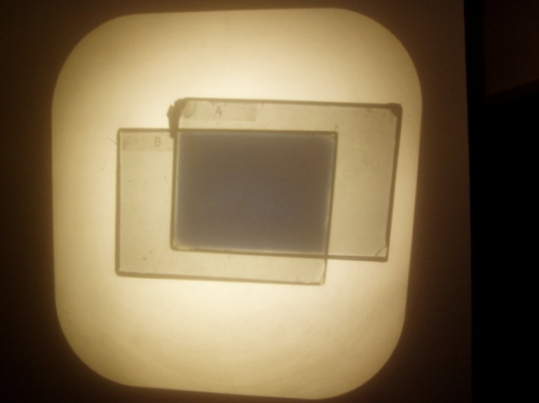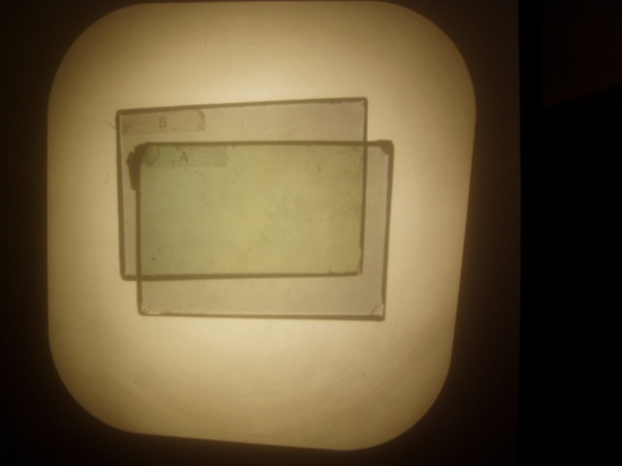
Location: Jc3
OPTICS | 6H35.53 | POLARIZATION
Birefringence

Butterfly
 | Mica, cellophane, butterfly slide, etc. are placed between crossed polarizers.
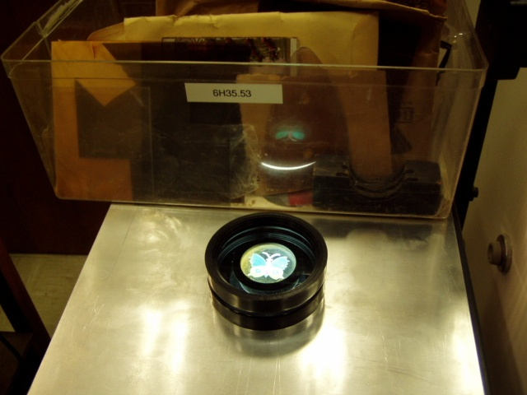Location: Jc3
OPTICS | 6H50.10 | POLARIZATION

Polarization by Scattering

Sunset with Polarizers
 | Use a sheet of Polaroid to check the polarization of scattering from a beam of light passing through a tank with scattering particles.
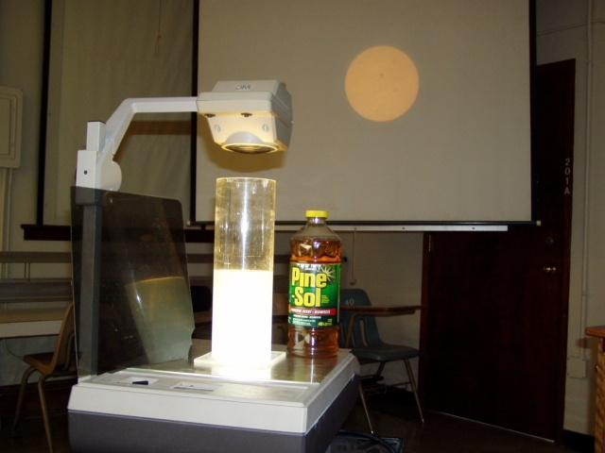
Location: Jc2
OPTICS | 6J10.10 | THE EYE

The Eye

Eye Model
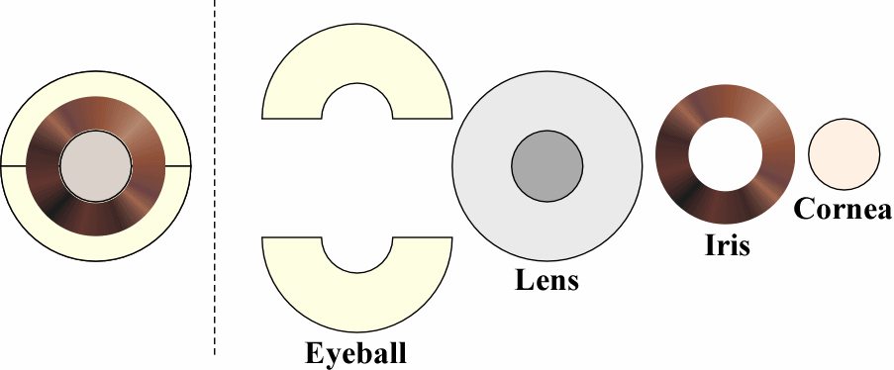 | The standard take-apart eye model. A Blackboard optics two dimensional version is also shown in the photograph.
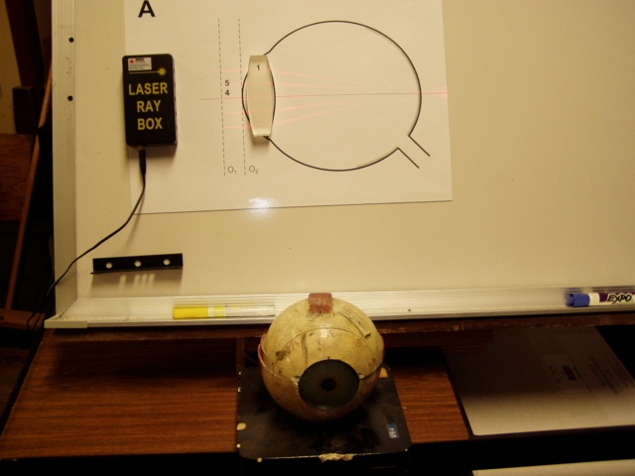
Location: Blackboard Optics Cart, Jc5

OPTICS | 6J1055 | THE EYE
The Eye

Eye Glasses
An antique optometrist’s refracting kit can be used to show how to correct vision problems.
.

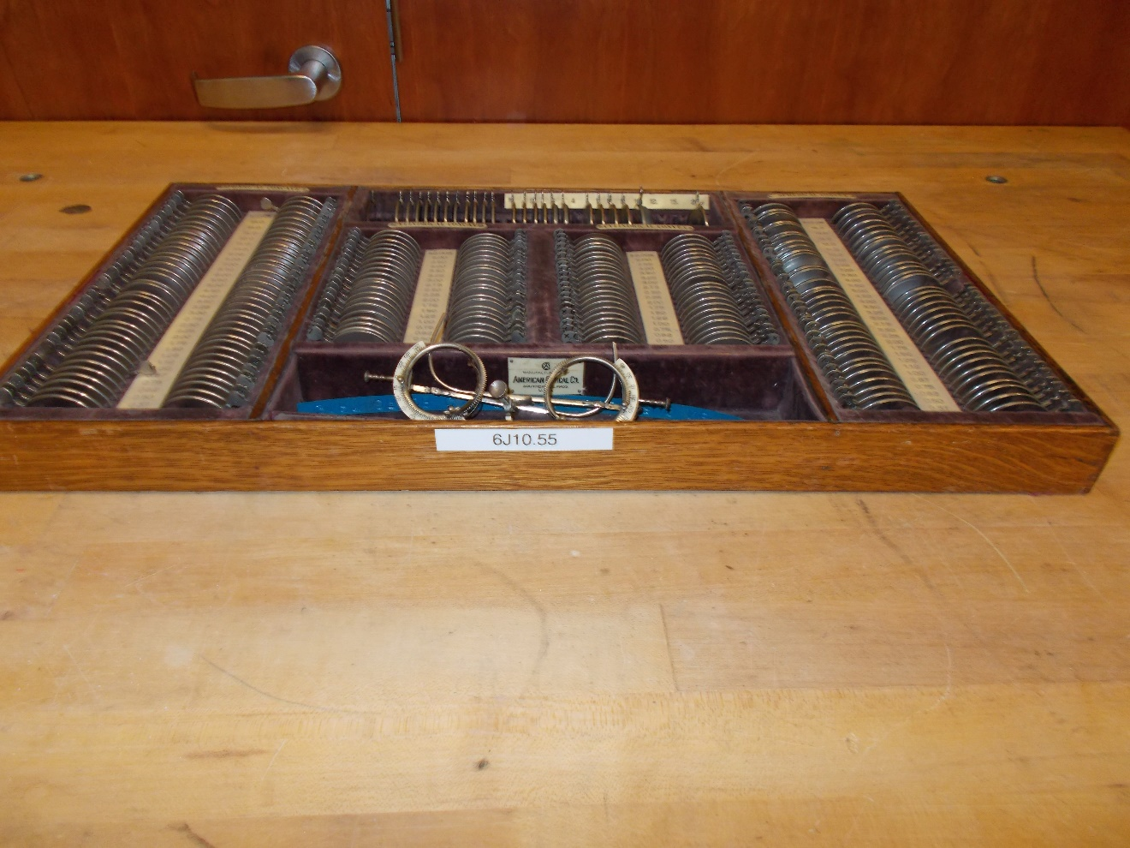
Location: Jc5

OPTICS | 6Q10.10 | MODERN OPTICS

Holography

Holograms
 | Use a laser with a spatial filter to illuminate the hologram.
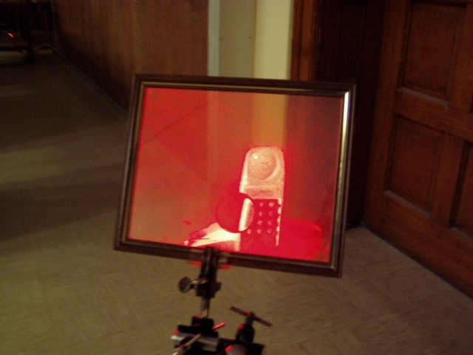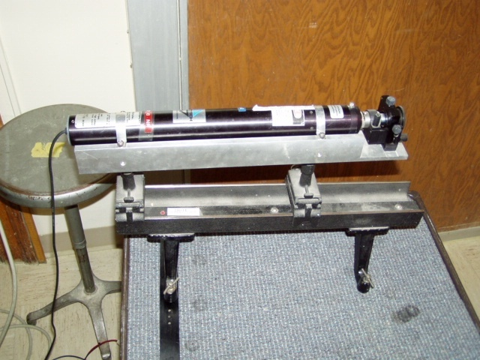
Location: Ja6, Jc6, Optics Table Cart

OPTICS | 6Q20.10 | MODERN OPTICS

Physical Optics

Abbe’s Theory of Imaging
 | A laser beam illuminates an “Optical Crystal” (a geometric array of small characters). You see the diffraction pattern consisting of the body factor convolved with the form factor. Insert a lens and you see its Fourier transform, the real image of the Optical Crystal
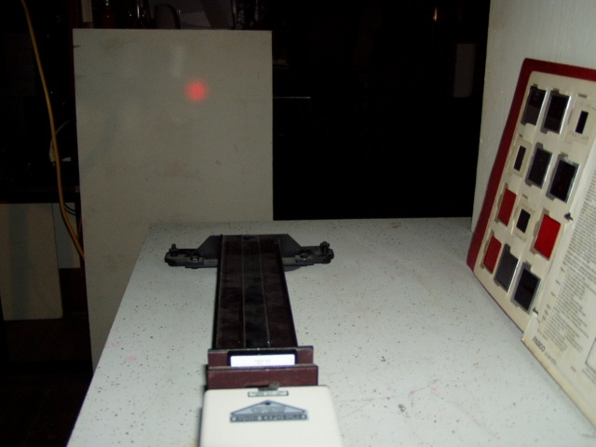
Location: Jb4, Jd2

