Standalone Sulphur Springs Instructions:
- When you download the zipped file, you will need to extract the contents somewhere on your PC.
- A folder called Sulphur Springs Feb 2019 will be created. Inside the folder should be six items that match the following image:
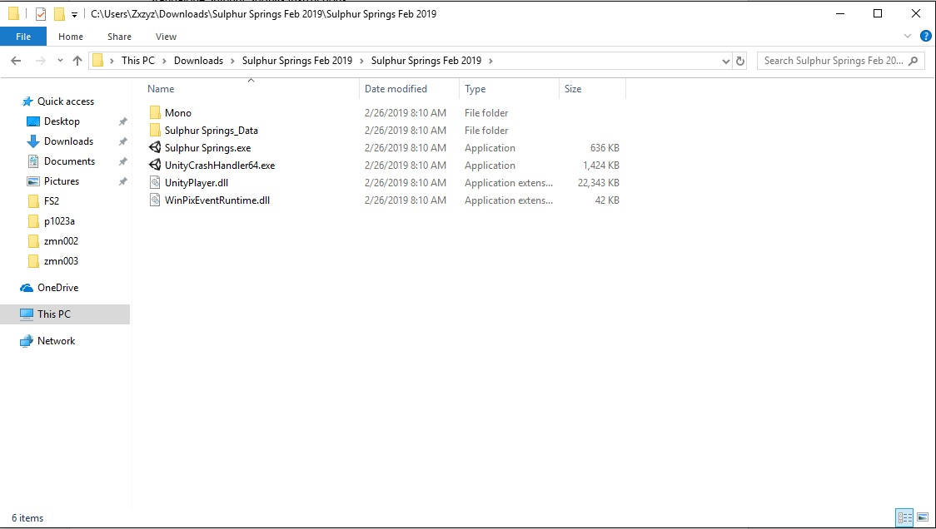

- Double click Sulphur Springs.exe
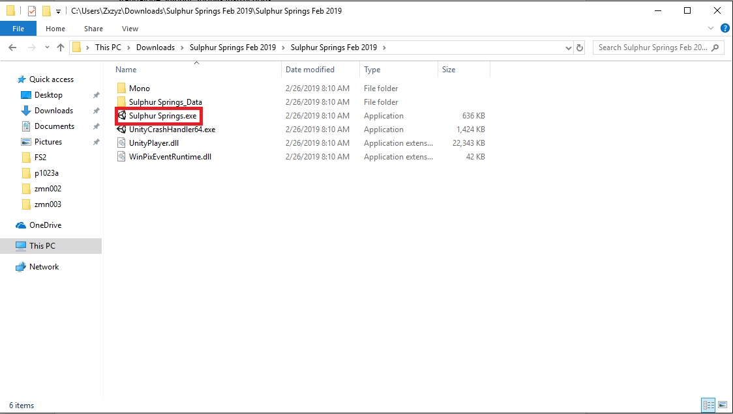

- A new window like the following will open (note: some computers that have highly sensitive security might give a warning as this is a 3rd party application)
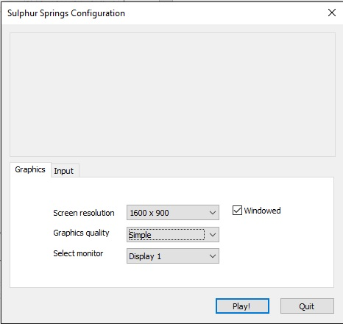

- We recommend a few things.
  - First, we recommend you always run this program Windowed. In the image below, we have the Windowed option checked. This will make it so you can easily close the program (we currently do not have a menu system in place).
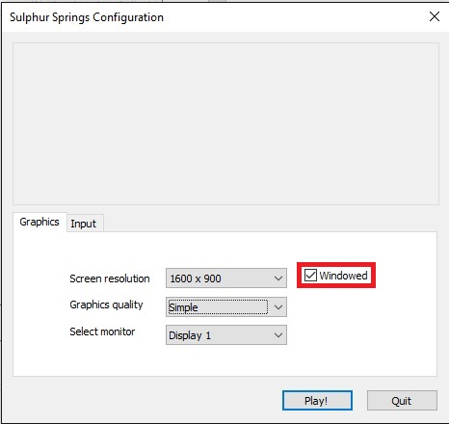
  - Next, a note on quality. There are two setting that will impact how the reconstruction program looks: Screen Resolution and Graphics quality. Screen Resolution will make the window on your screen bigger, while the Graphics quality setting will adjust in-program settings such as draw-distance (how far away objects will be drawn); shadows and lighting. It is recommended you use a fairly high screen resolution and adjust the graphics quality first.
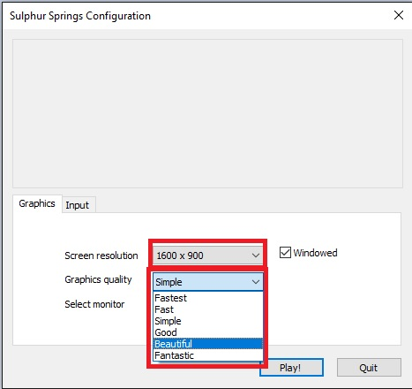

- Once you have adjusted the settings to how you want, click the Play! Button in the lower right-hand corner. Controls in the program use the arrow keys (or w,a,s,d) to move forward, backwards, left and right and the computer mouse to look around.

