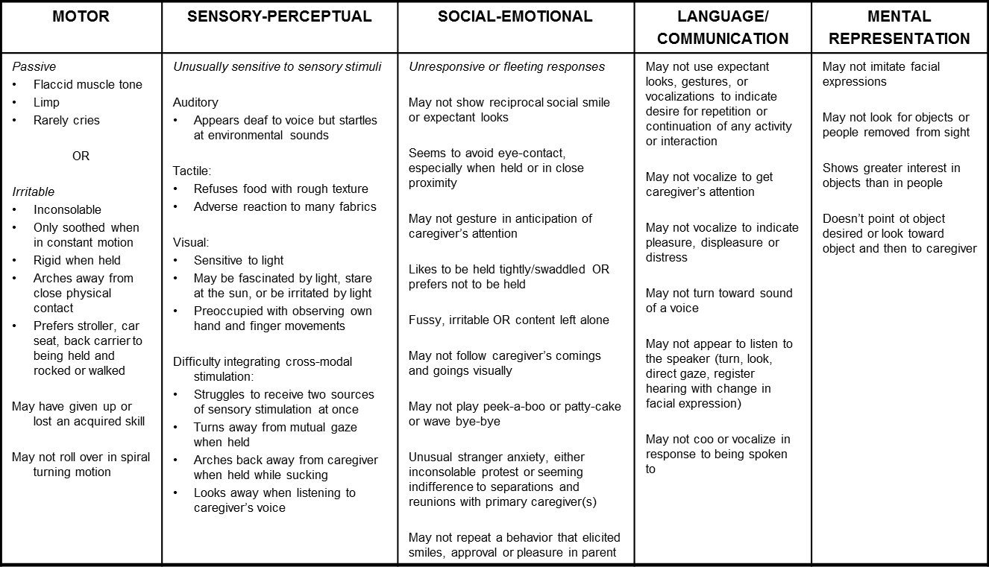

**Signs In Infancy**

© Barbara Kalmanson 2003

**Developmental Signs of Autism in the**

**First Two Years of Life**