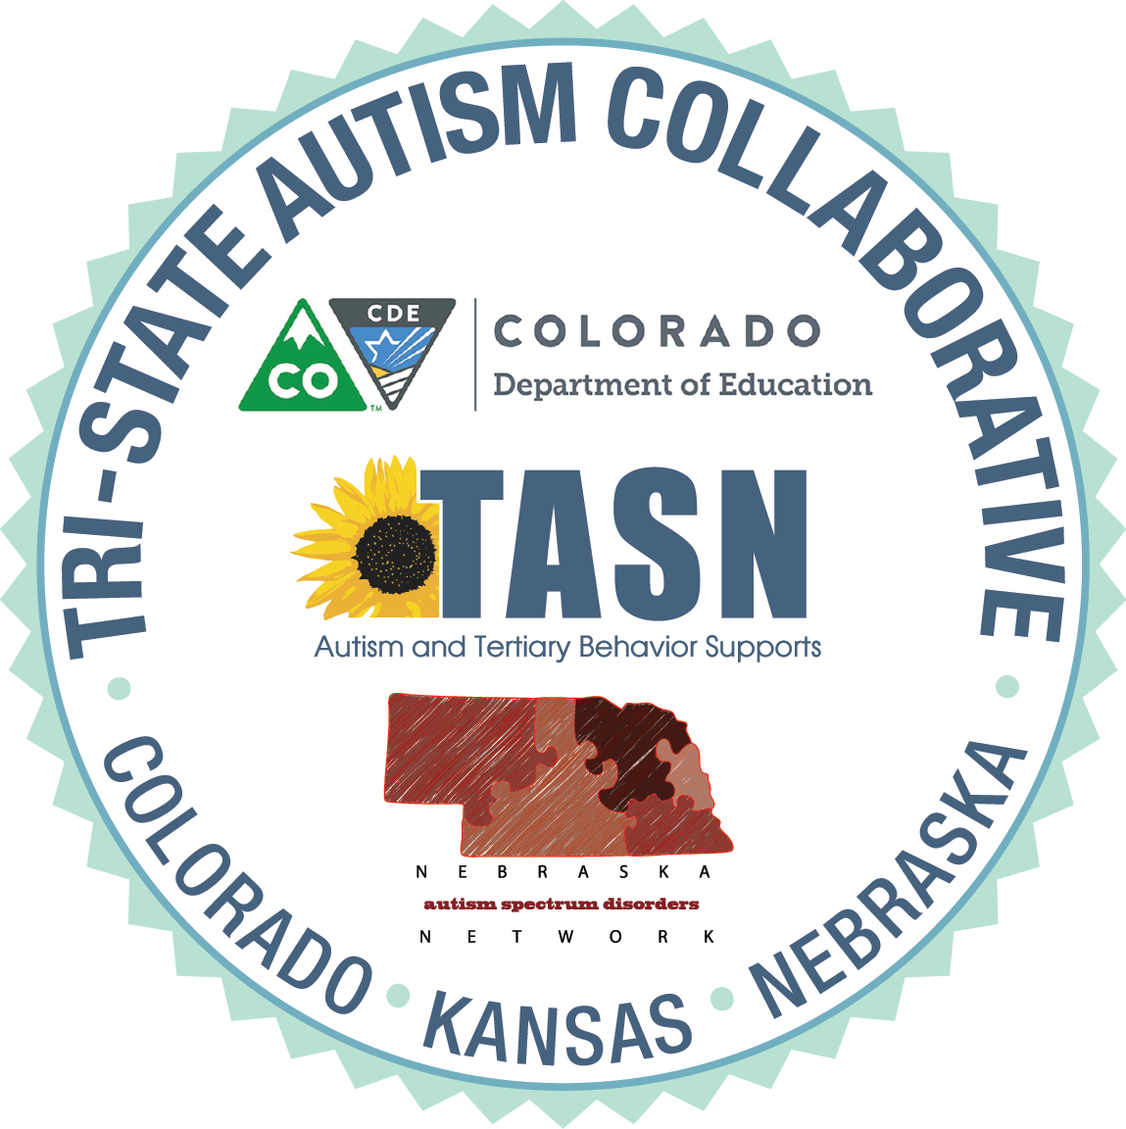

LEARNER OBJECTIVES

WEBINAR – Assessments and Curriculum Guides for
Secondary Students with ASD

At the end of this webinar, participants will be able to:
- Identify several assessments and curriculum guides that will assist with the development of age appropriate goals and objectives for middle and high school, and transition students with ASD.
- Identify several priorities of instruction for secondary students with ASD.
- Identify a variety of specific skills to target within in each assessment or curriculum guide.

