[Work Systems]
Virtual Strategie Toolkit
Virtual Stratebies toolkit

Examples
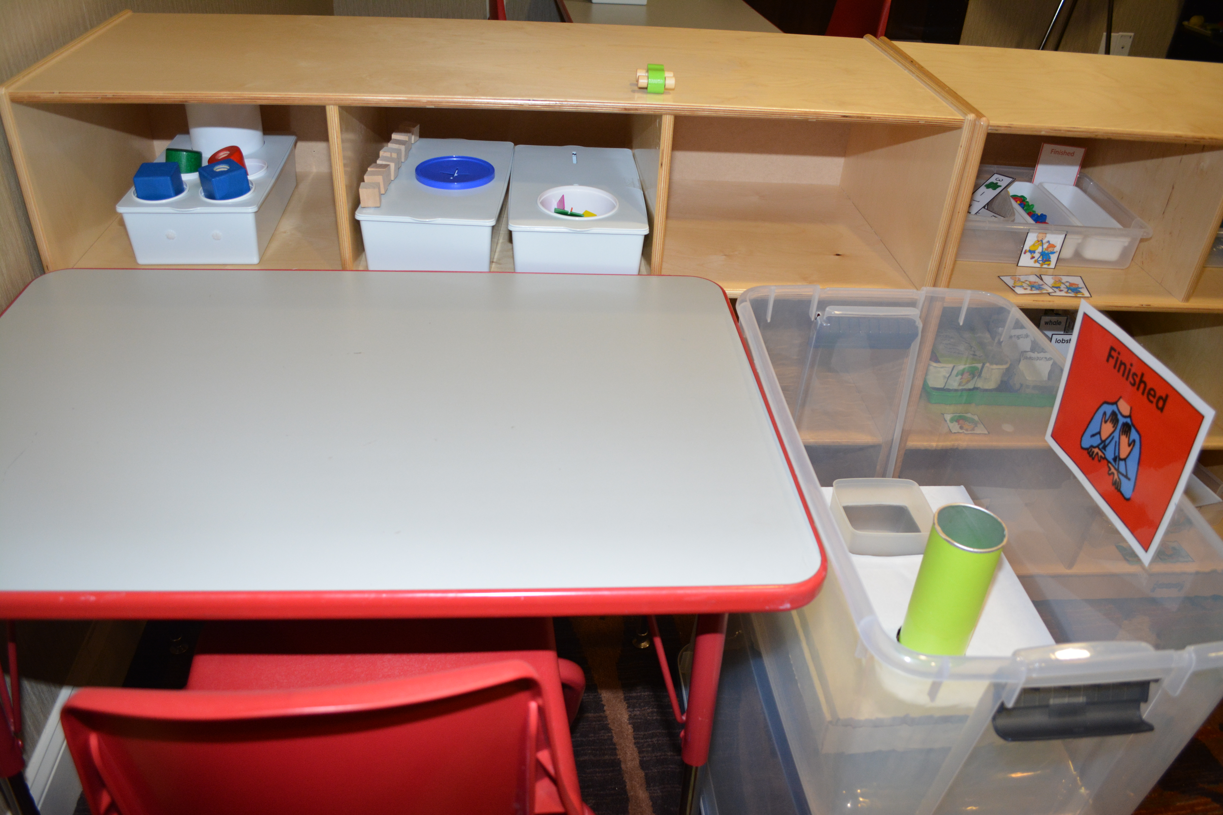 Work system where student pulls tubs off of shelf in no particular order. Finished basket is on right.

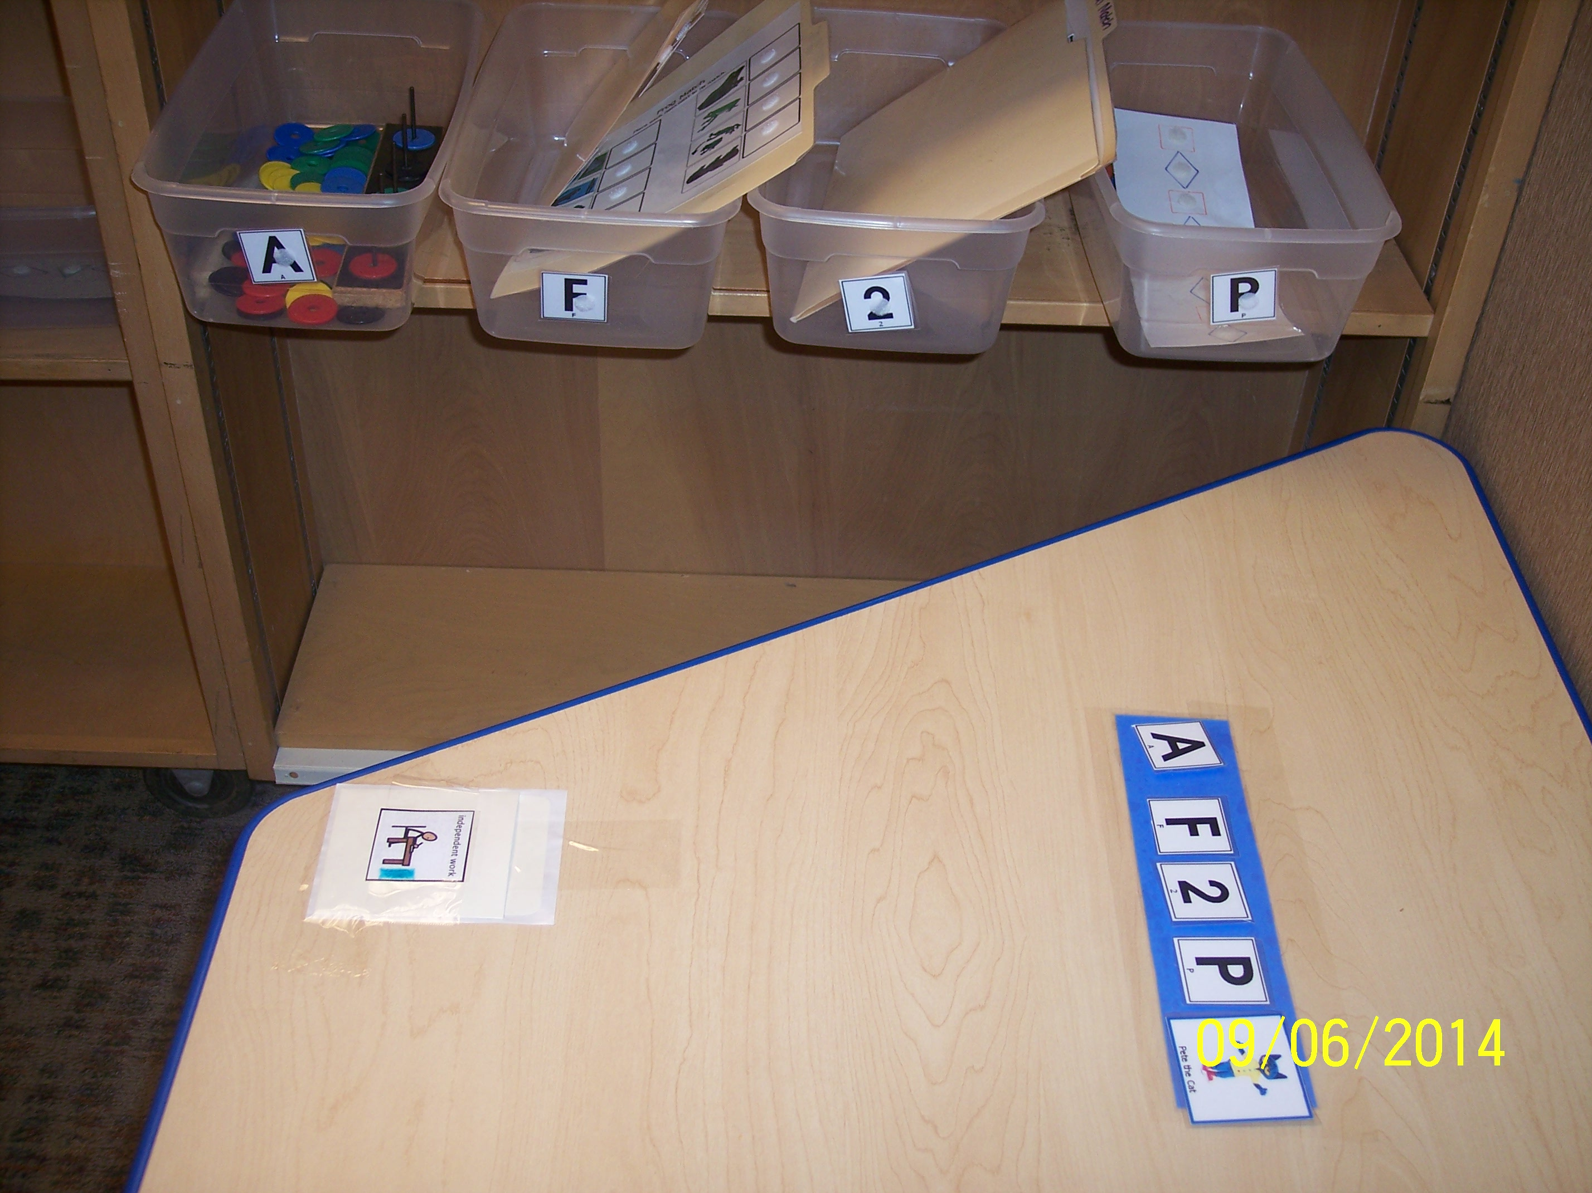
Work system where student matches letters and numbers on the strip to numbers and letters on the tubs.

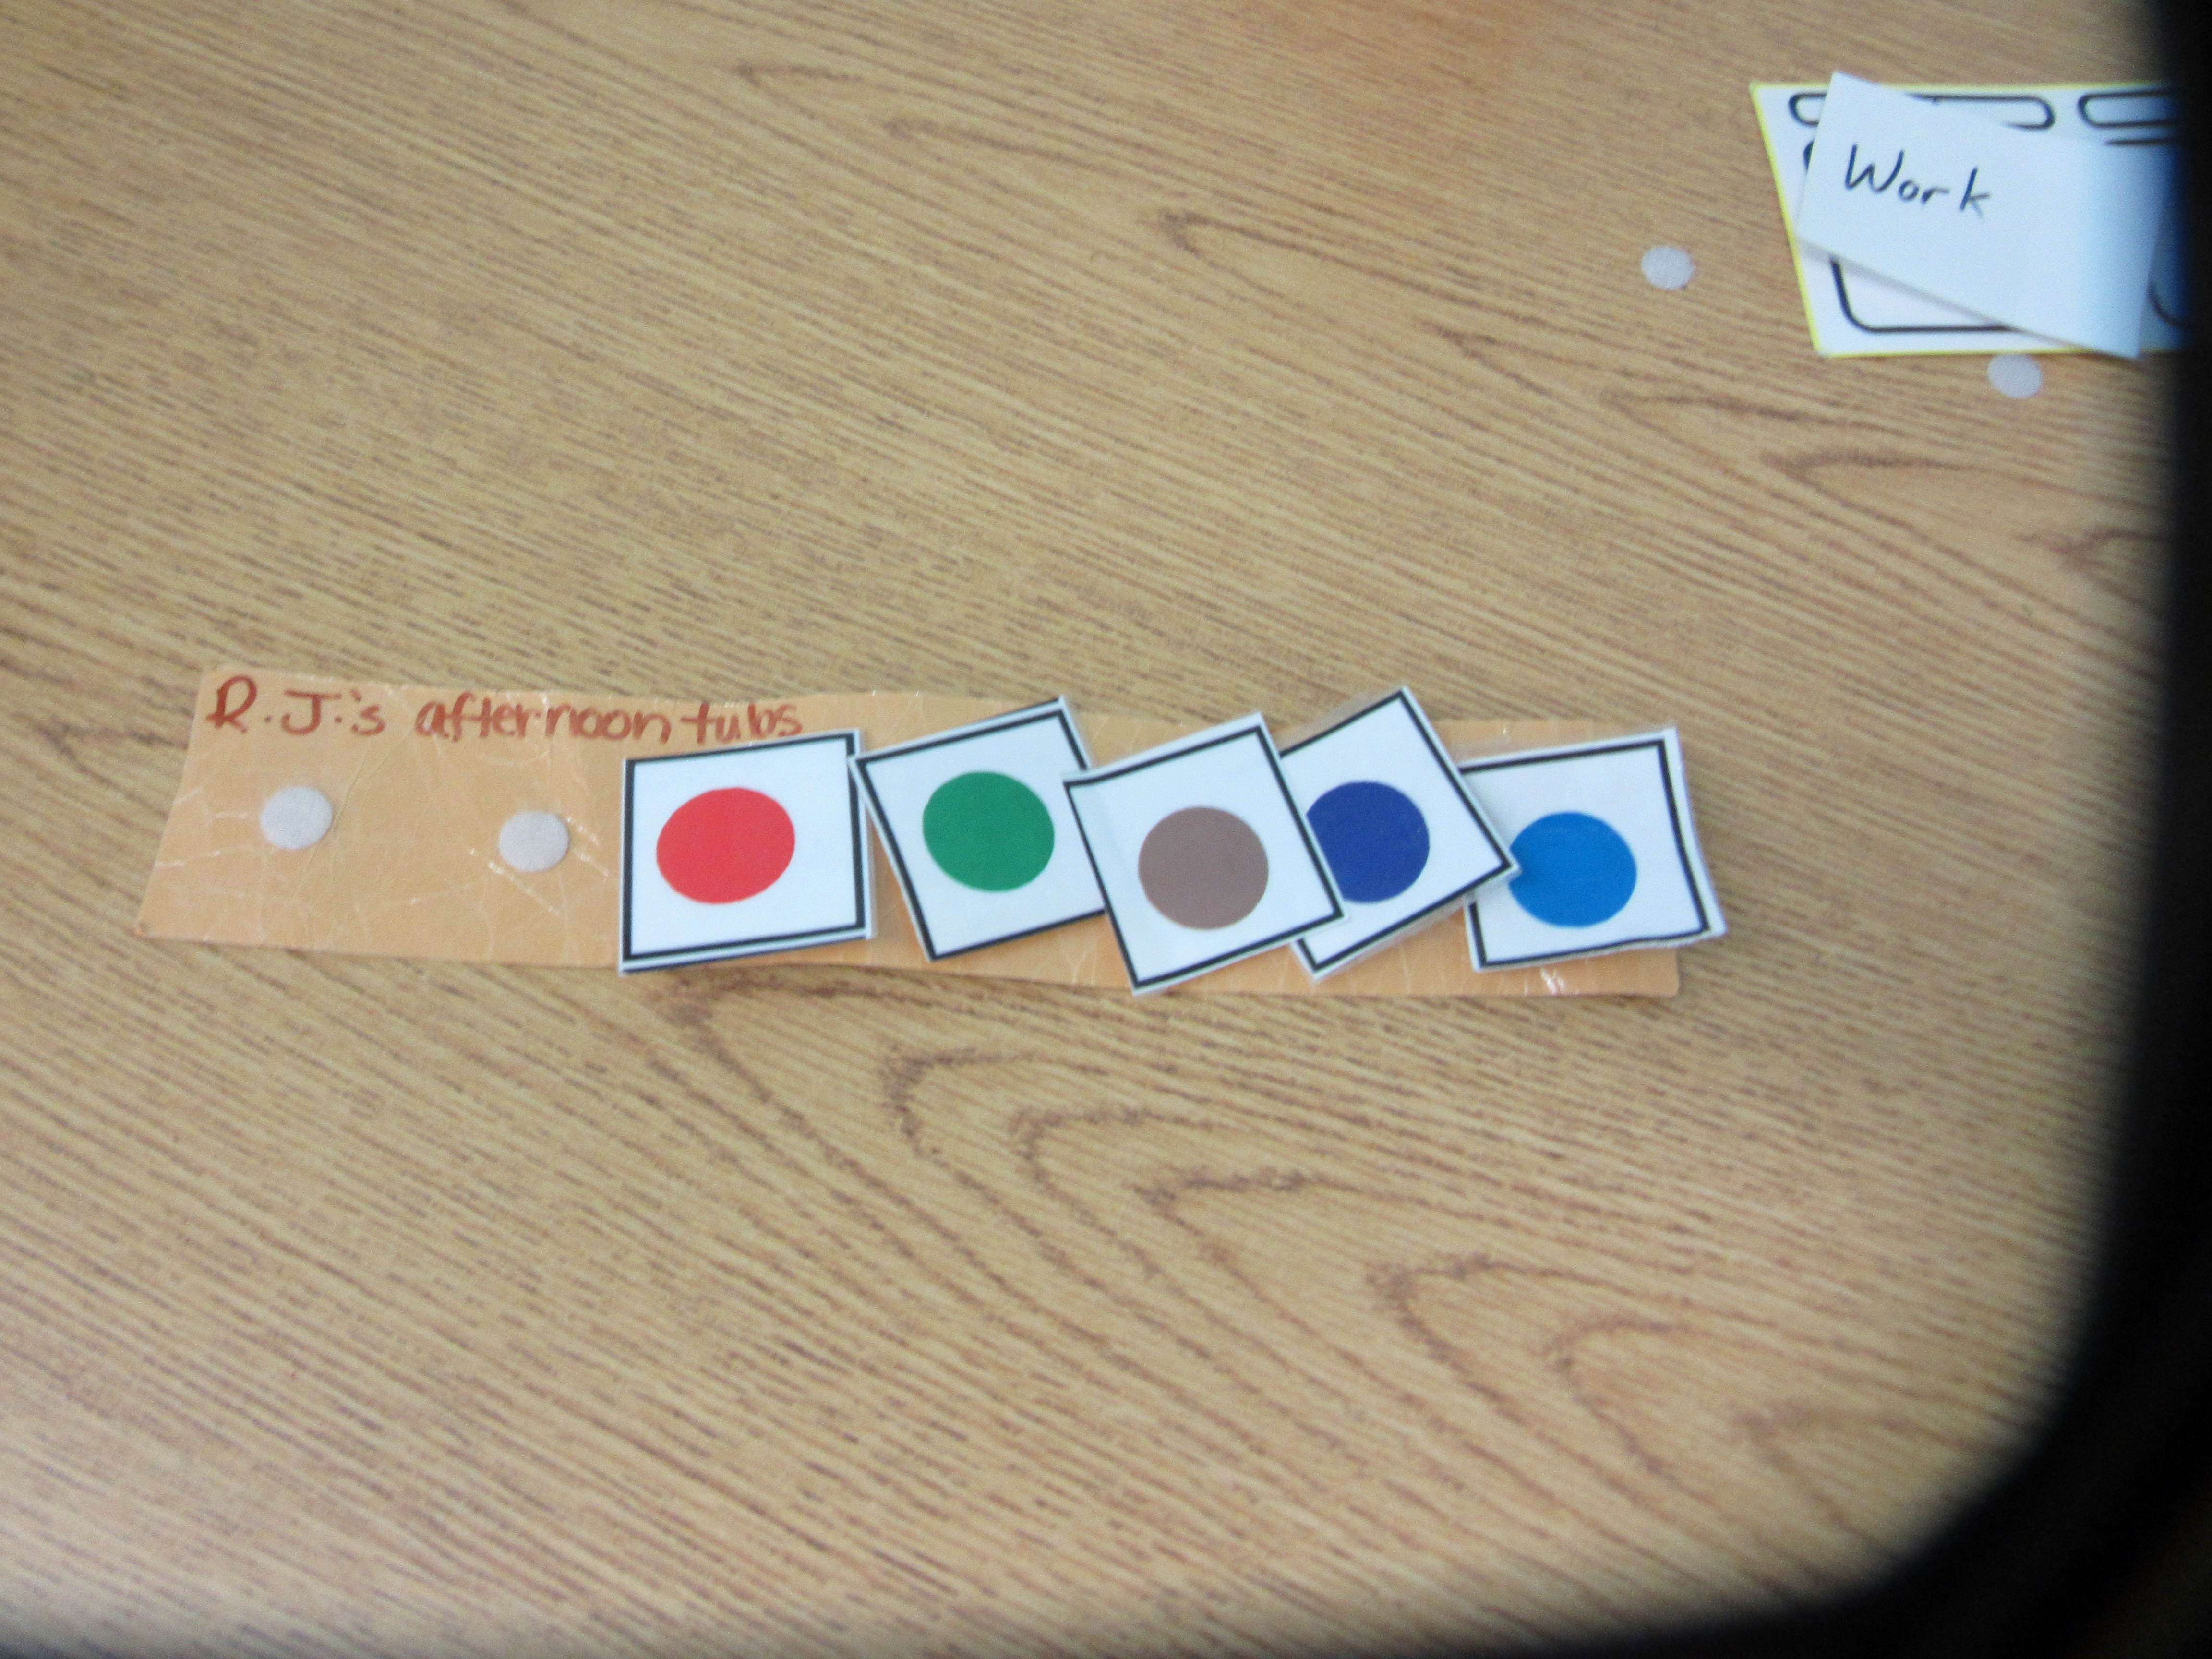

Work system where student matches shape on the strip to the shape on the tub.

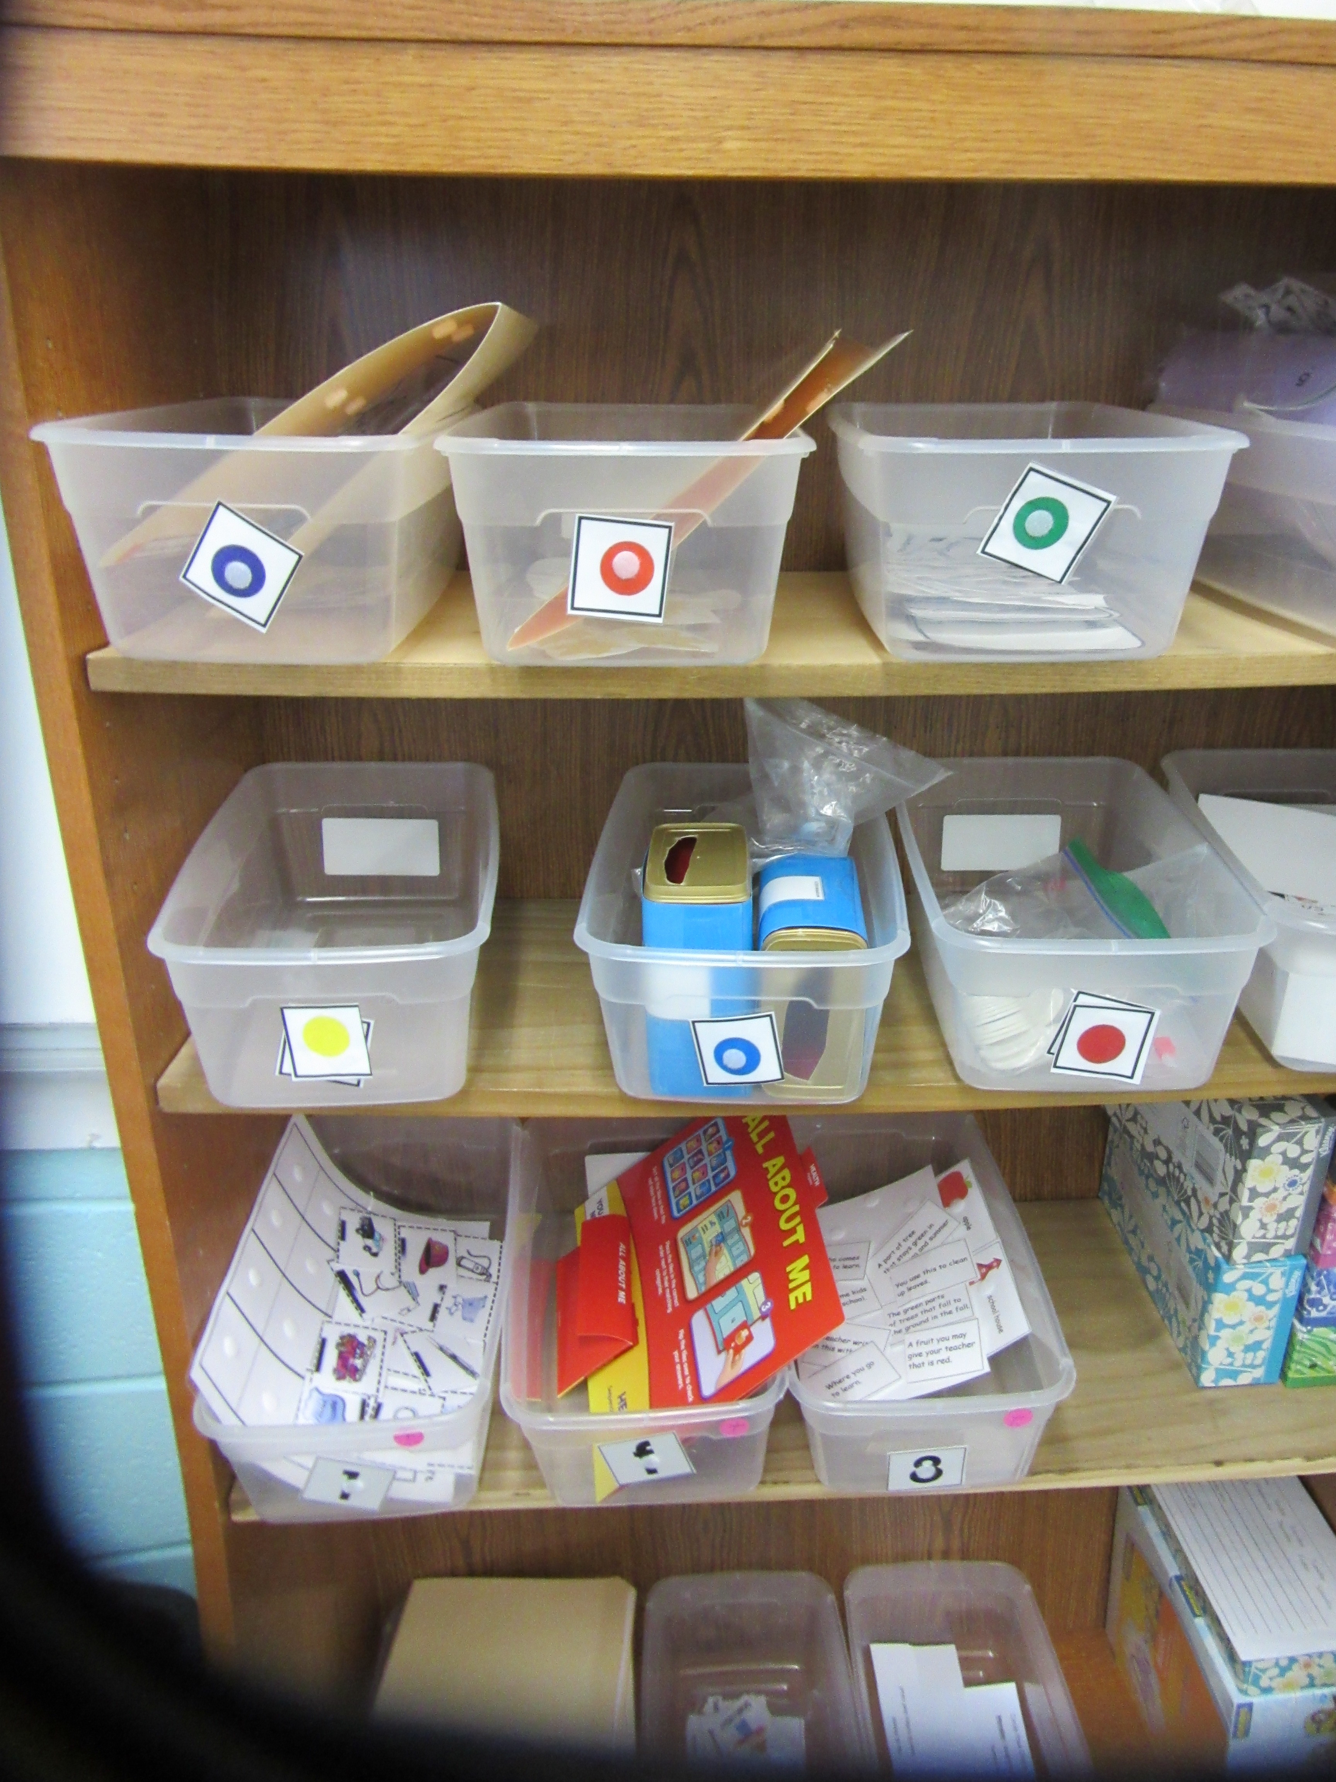

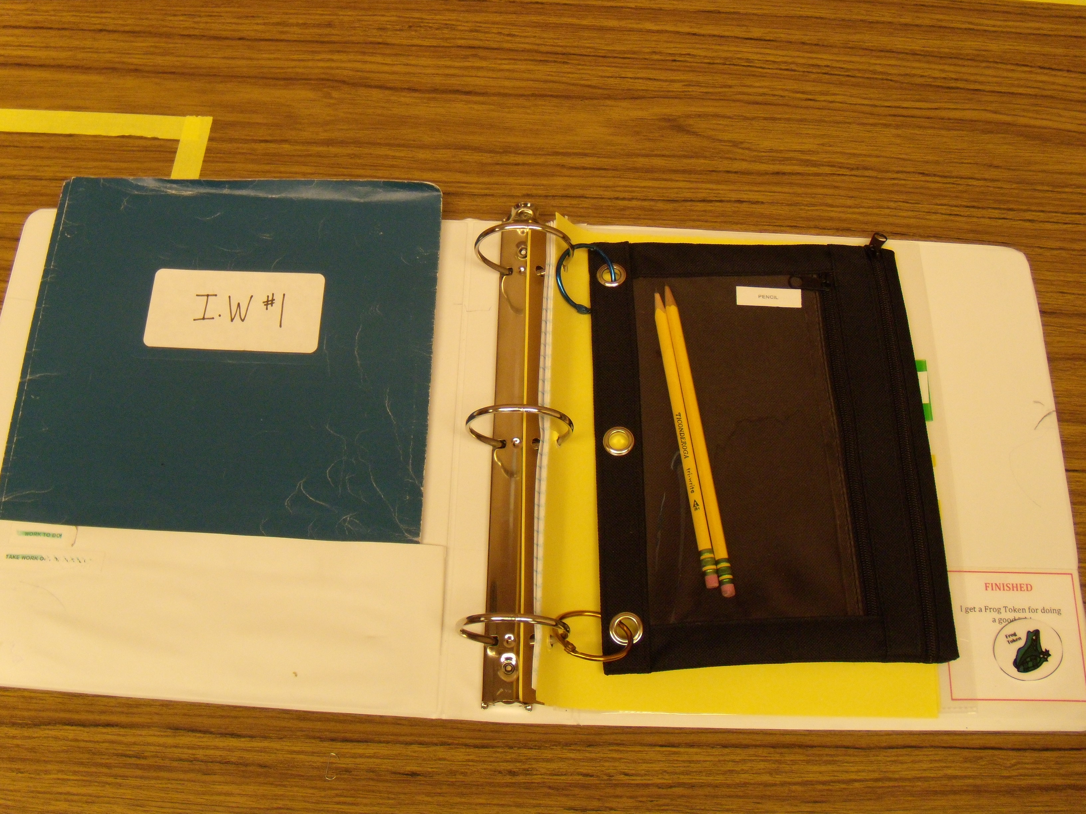

Binder system where student work is in numbered folders.

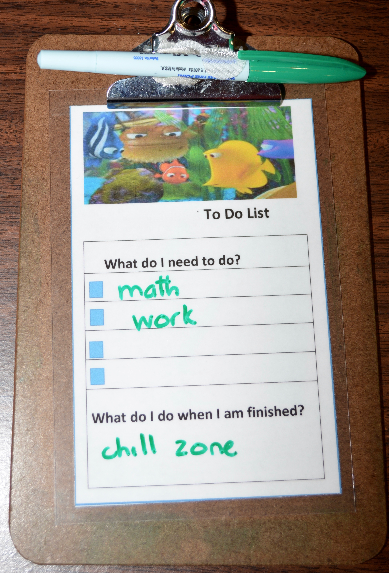Written list work system on clipboard.

This material was developed under a grant from the Colorado Department of Education. The content does not necessarily represent the policy of the U.S. Department of Education, and you should not assume endorsement by the Federal Government.

The content of this material was developed under an agreement from the Federal Department of Education to the Kansas Department of Education. However, those contents do not necessarily represent the policy of the Department of Education, and you should not assume endorsement by the Kansas Department of Education or the Federal Government. TASN Autism and Tertiary Behavior Supports does not discriminate on the basis of race, color, national origin, sex, disability, or age in its programs and activities. The following person has been designated to handle inquiries regarding the non-discrimination policies: Deputy Director, Keystone Learning Services, 500 E. Sunflower, Ozawkie, KS 66070, 785-876-2214.

The contents of this handout were developed under a grant from the Nebraska Department of Education, IDEA parts B and C from the U.S. Department of Education. However, this content does not necessarily represent the policy of the U.S. Department of Education and you should not assume endorsement by the Federal Government.

