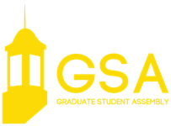

January 8, 2019 | 7:00 p.m.
Nebraska Union | Centennial Room

CALL TO ORDER

APPROVAL OF THE MINUTES

OPEN FORUM

EXECUTIVE REPORTS

President Reilly
Executive Vice President Ratcliff
Vice President of Student Affairs Martin
Vice President of Representation Stehle

COMMITTEE REPORTS

Academic Affairs Chair Juritsch
Quality of Life Co-Chairs Sandhu and Rodene
Social Events Chair Perez

NEW BUSINESS

GSA Bill #11 A bill authorizing REACH training for graduate and professional students on suicide prevention

ANNOUNCEMENTS

ADJOURNMENT

