Martin Luther
Saint, Sinner, Monk, Heretic, Theologian, Revolutionary

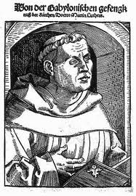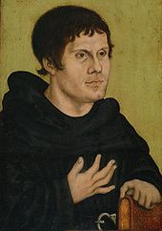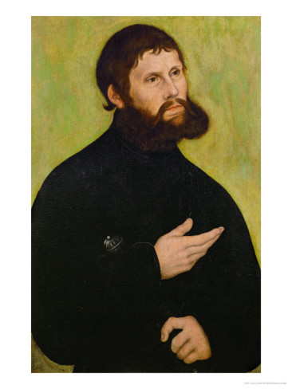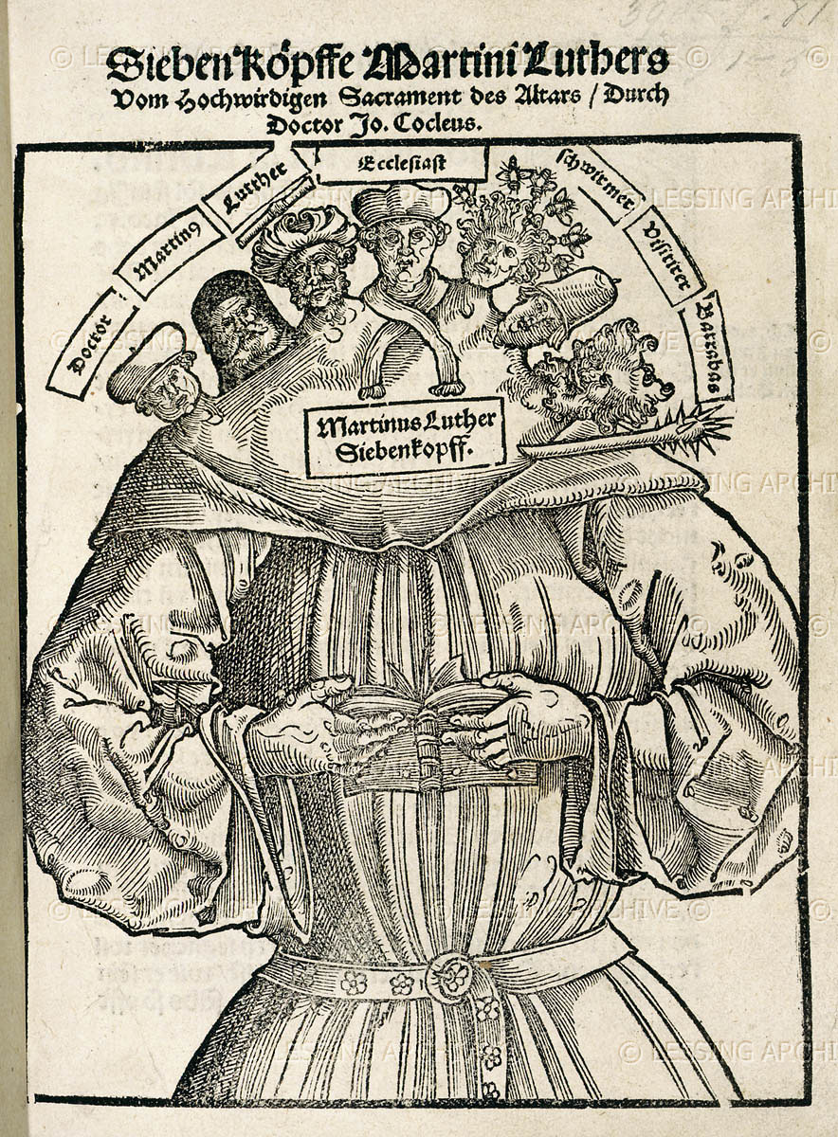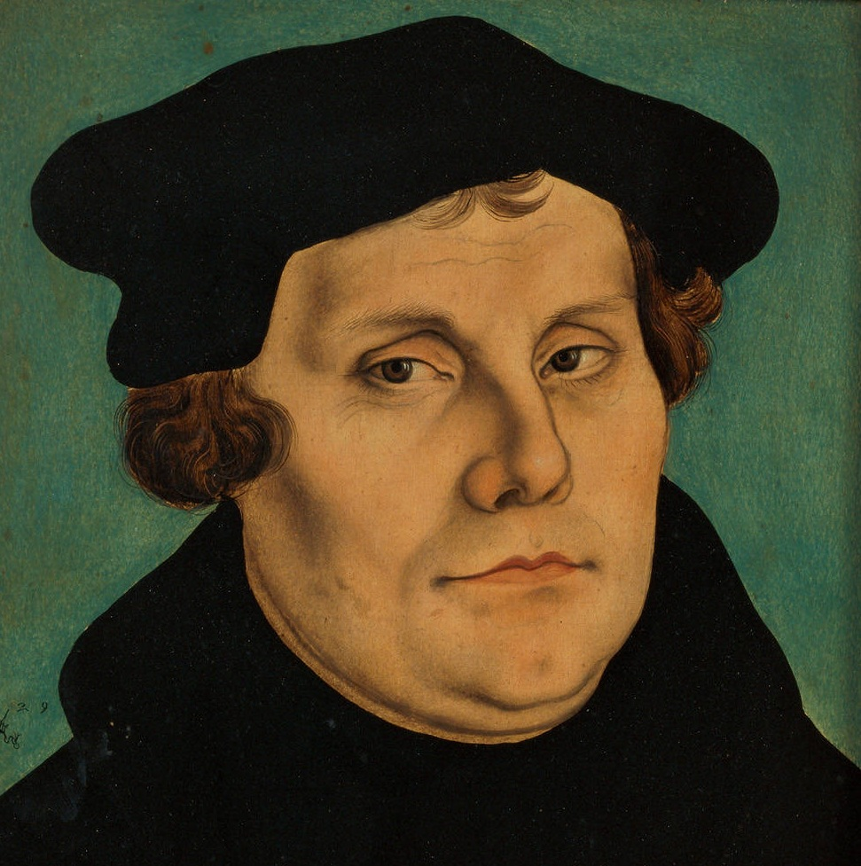

HIST/MRST/RELG/MODL 426/826: Reformation Thought

A new course that will focus on the life, thought and impact of Martin Luther
Fall semester, 2013
T/Th 2:00-3:15

