NeWP Summer Writing Retreat
July 25-27, 2018
St. Benedict Retreat Center in Schuyler, Nebraska

Details The retreat takes place over three days and two nights. Participants should arrive prepared for a 10:00 start on July 25th. The final read around will conclude Friday the 27th at 3:30. The expectation is that participants are available for the entire retreat.
Support from colleagues and coaches as well as shared reading time will be scheduled throughout the retreat; however, space and time to write will be the priority. The fee for the retreat is $250 which includes two-nights lodging (single room) and all meals. Participants are responsible for travel costs and incidentals.

Summer Writing Retreat Application In your application letter, please include the following information: name, Writing Project affiliation and experience (if applicable), email address, mailing address, phone number, professional affiliation or school/district where writing may be utilized.
In addition, please respond to the following questions in no more than a total of 500 words:
1. Tell us about your professional or personal writing experience and your interest in participating in this retreat?
2. Describe the work [project or writing pieces] you hope to accomplish at the retreat?
3. As a writer, what type of support will you need at the retreat and what do you hope to accomplish during this time?

APPLY BY May 14th 2018. Space is limited so early application is encouraged.
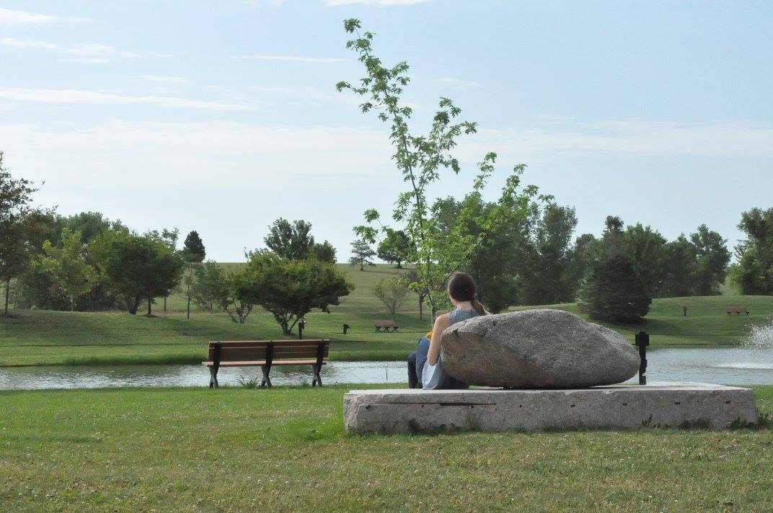

• Send e-mail application to Jane Connealy, NeWP Co-Director and Retreat Coordinator: janeconnealy3@gmail.com

• Or, if you prefer, send PAPER APPLICATION to: NeWP University of Nebraska-Lincoln 202 Andrews Hall Lincoln, NE 68588-0333 Attn: Summer Writing Retreat.

Registration fee is collected only upon applicant’s acceptance.

