# 

For the complete bibliography with references as well as an explanation of the classification scheme go to:

[Demonstration Bibliography](http://physicslearning.colorado.edu/Pira.asp)

The **demonstration name** listed in the bibliography is either the name listed on the reference or, if none is given, a simple descriptive name. In cases where there are several common names for a demonstration, the committee has chosen a preferred name.

The **description** is very brief. It is not intended to be a summary of the reference. One sentence is, in general, sufficient to describe the unique characteristics, if any, of an item. Each source has a unique numbering format. These unique formats are used identify references in the Bibliography.

The formats for the **reference** column and links to the sources are listed below:

|  |  |
| --- | --- |
| **Reference** | **Source** |
| M-1 | [Sutton](http://physicslearning.colorado.edu/PiraHome/Sutton/Sutton.htm) |
| Ma-1 | [Freier & Anderson](http://www.aapt.org/Store/description.cfm?ID=OP-40&Category=All&Type=Print%20Products&Level=All&Keywords=&Site=" \t "_blank) |
| M-1d | [Hilton](http://www.abebooks.com/servlet/SearchResults?an=wallace+hilton&y=0&tn=Physics+Demonstration+Experiments&x=0) |
| 8-2.8 | [Meiners](http://www.amazon.com/exec/obidos/tg/detail/-/0471067598/qid=1114018608/sr=1-2/ref=sr_1_2/002-3048814-4251265?v=glance&s=books) |
| M-108 | [Dick & Rae](http://physicslearning.colorado.edu/Pirahome/index.htm) |
| 1A 12.01 | [University of Minnesota Handbook](http://groups.physics.umn.edu/demo/old_page/) |
| AJP 52(1),85 | [American Journal of Physics](http://scitation.aip.org/ajp/) |
| TPT 15(5),300 | [The Physics Teacher](http://scitation.aip.org/tpt/) |
| Disc 01-01 | [The Video Encyclopedia of Physics Demonstrations](http://www.physicsdemos.com/) |
| PIRA 200 | [Physics Instructional Resource Association](http://physicslearning.colorado.edu/Pirahome/pira200/pira200.htm) |
| PIRA 500 | [PIRA 500](http://physicslearning.colorado.edu/Pirahome/index.htm) |
| PIRA 1000 | [PIRA 1000](http://physicslearning.colorado.edu/Pirahome/index.htm) |

**Each demonstration is listed in only one location, even if** **it is commonly used to illustrate several concepts.**

10/20/22

[1](#_Toc112744937)

[RELATIVE MOTION 4](#_Toc112744938)

[Rotating Reference Frames 4](#_Toc112744939)

[Foucault Pendulum 4](#_Toc112744940)

[GRAVITY 5](#_Toc112744941)

[Solar System Mechanics 5](#_Toc112744942)

[Ellipse Drawer 5](#_Toc112744943)

[PLANETARY ASTRONOMY 6](#_Toc112744944)

[Historical Astronomy 6](#_Toc112744945)

[Sundial 6](#_Toc112744946)

[Celestial Navigation Instruments 7](#_Toc112744947)

[Solar System Mechanics 8](#_Toc112744948)

[Orrery 8](#_Toc112744949)

[Earth - Moon Mechanics 9](#_Toc112744950)

[Phases of the Moon 9](#_Toc112744951)

[Eclipse Model 10](#_Toc112744952)

[Eclipse Stick 11](#_Toc112744953)

[Views from Earth 12](#_Toc112744954)

[Retrograde Motion Model 12](#_Toc112744955)

[Views from Earth - 2 13](#_Toc112744956)

[Celestial Sphere 13](#_Toc112744957)

[Armillary Sphere 14](#_Toc112744958)

[Planetary Characteristics 15](#_Toc112744959)

[Rotational Banding 15](#_Toc112744960)

[Protoplanet Cooling 16](#_Toc112744961)

[STELLAR ASTRONOMY 17](#_Toc112744962)

[The Sun 17](#_Toc112744963)

[Solar Convection Cells 17](#_Toc112744964)

[Sunspots on the Overhead 18](#_Toc112744965)

[Student Gratings and Line Sources 19](#_Toc112744966)

[Random Walk 20](#_Toc112744967)

[Stellar Spectra 21](#_Toc112744968)

[Radial Velocity 21](#_Toc112744969)

[Stellar Evolution 22](#_Toc112744970)

[Binary Star Models 22](#_Toc112744971)

[Eclipsing Binary Light Curve 23](#_Toc112744972)

[Supernova Core Bounce 24](#_Toc112744973)

[Black Holes 25](#_Toc112744974)

[Gravity Well 25](#_Toc112744975)

[Membrane Table / Black Hole 26](#_Toc112744976)

[COSMOLOGY 27](#_Toc112744977)

[Models of the Universe 27](#_Toc112744978)

[Expanding Universe 27](#_Toc112744979)

[Gravitational Effects 28](#_Toc112744980)

[Klein Bottle 28](#_Toc112744981)

[Saddle Shape/Paul Trap Model 29](#_Toc112744982)

[Gravitational Lens 30](#_Toc112744983)

|  |  |  |
| --- | --- | --- |
| MECHANICS | 1E20.10 | RELATIVE MOTION |
| ****Rotating Reference Frames**** | | |
| Foucault Pendulum | | |
|  | | |
|  | A Foucault Pendulum with a Charron ring drive. Use the machine shop’s appliance dolly to move it into the lecture hall. | |

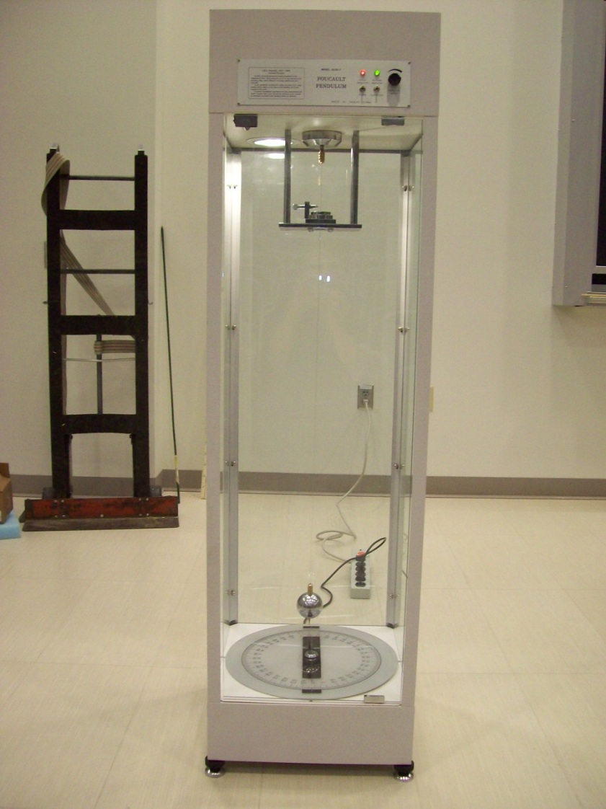

Location: Outside 134A

|  |  |  |
| --- | --- | --- |
| Mechanics | 1L20.50 | GRAVITY |
| ****Solar System Mechanics**** | | |
| Ellipse Drawer | | |
|  | | |
|  | Magnets hold a string and while the string is pulled taut with a piece of chalk, an ellipse can be drawn. | |

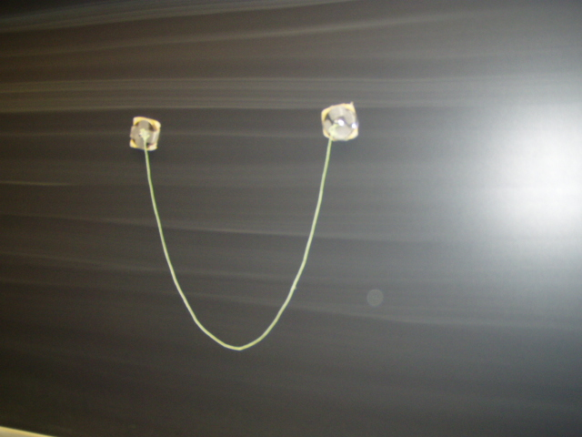Location: Ca4

|  |  |  |
| --- | --- | --- |
| ASTRONOMY AND ASTROPHYSICS | 8A05.50 | PLANETARY ASTRONOMY |
| ****Historical Astronomy**** | | |
| Sundial | | |
|  | | |
|  | A simple sundial made of card stock | |

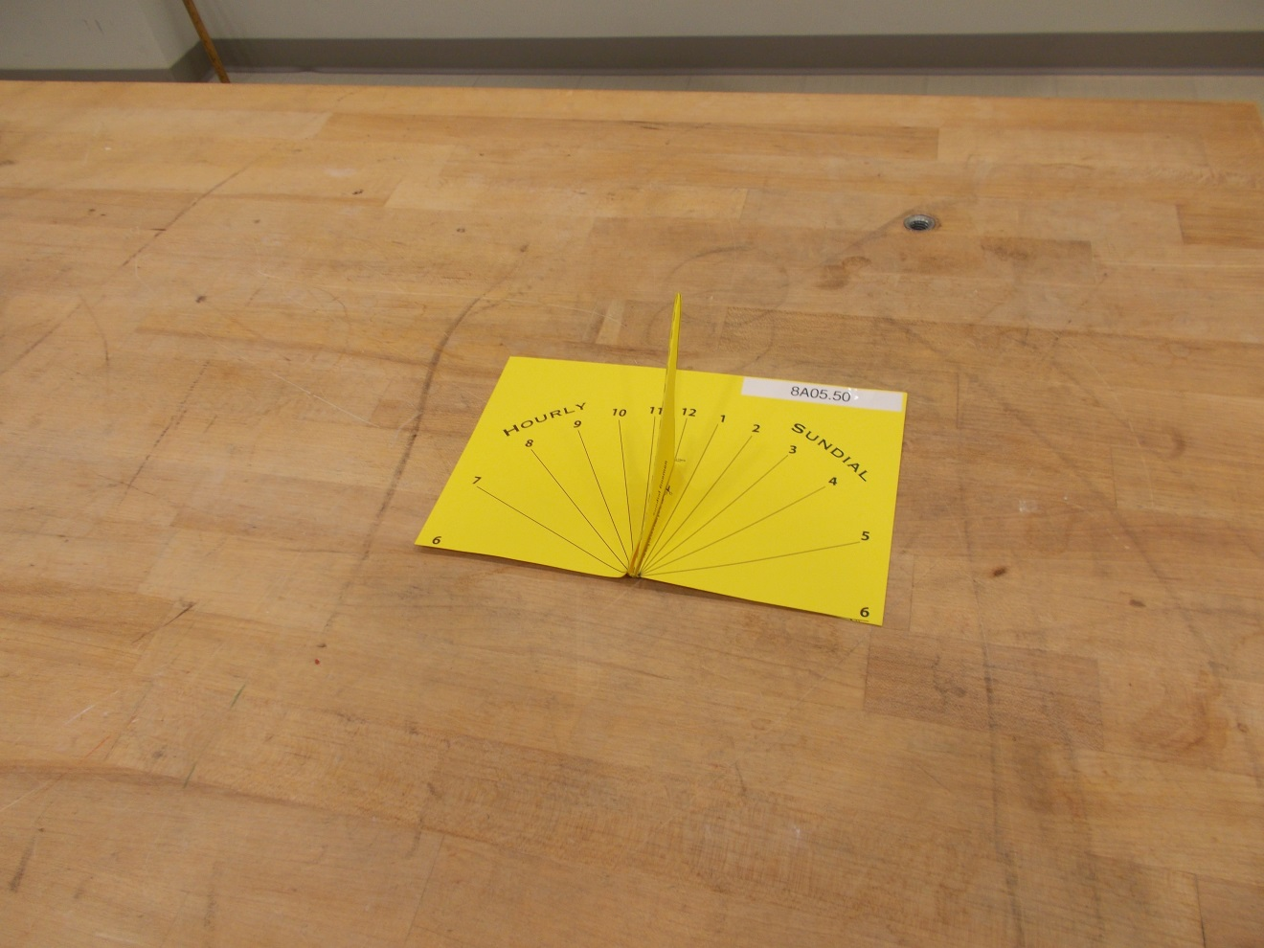

Location:   
La3

|  |  |  |
| --- | --- | --- |
| ASTRONOMY AND ASTROPHYSICS | 8A05.70 | PLANETARY ASTRONOMY |
| **Historical Astronomy** | | |
| Celestial Navigation Instruments | | |
|  | | |
|  | A sextant and astro-compass (the astro-compass was used to find true bearings in locations where the deviation of the magnetic compass was too great to use the compass accurately). | |

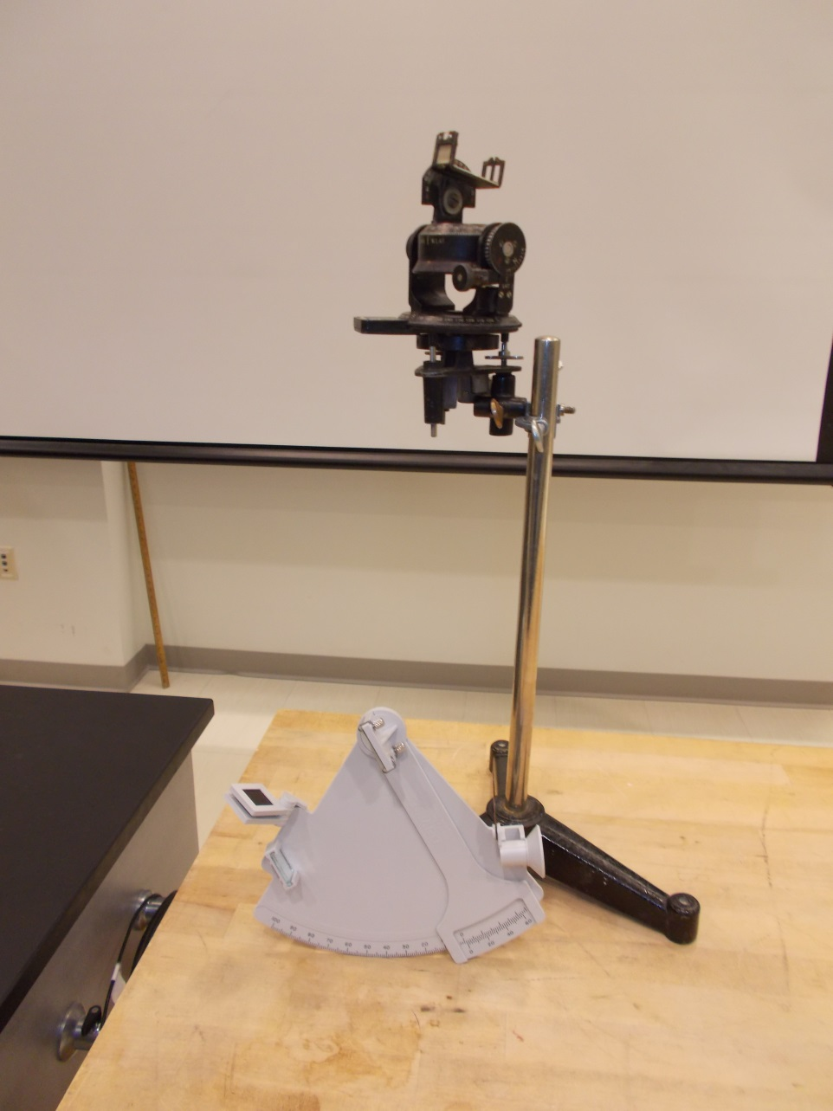

Location: La3

|  |  |  |
| --- | --- | --- |
| ASTRONOMY AND ASTROPHYSICS | 8A10.10 | PLANETARY ASTRONOMY |
| **Solar System Mechanics** | | |
| Orrery | | |
|  | | |
|  | The system is not to scale. The periods of the orbit are scaled. All the planets are on friction clutches and can be positioned by hand. | |

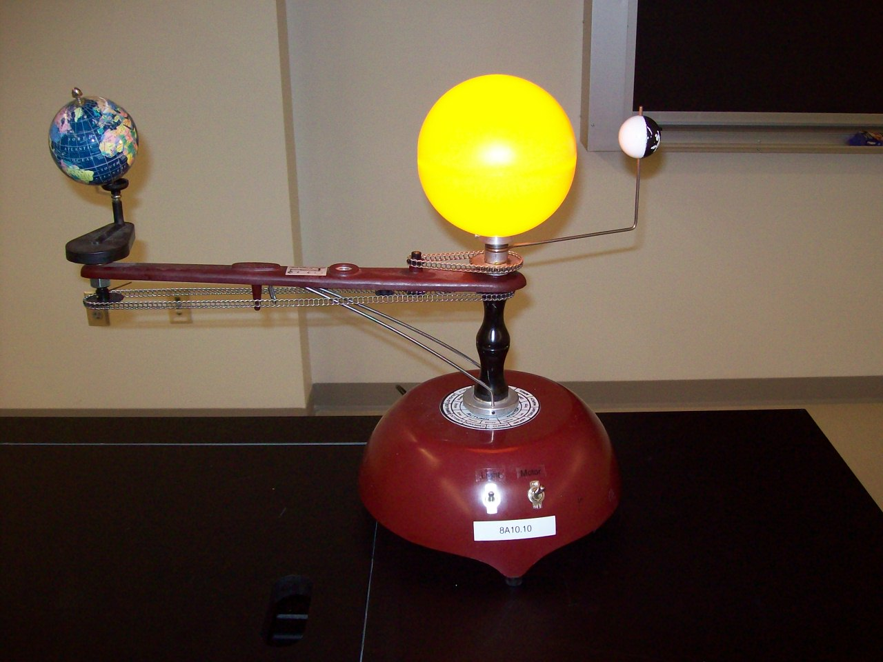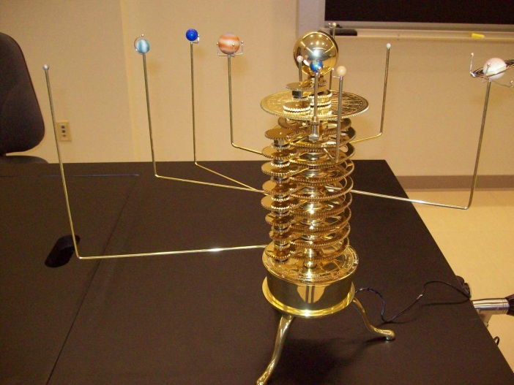

|  |  |  |
| --- | --- | --- |
| ASTRONOMY AND ASTROPHYSICS | 8A20.15 | PLANETARY ASTRONOMY |
| **Earth - Moon Mechanics** | | |
| Phases of the Moon | | |
|  | | |
|  | Rotate the camera in a complete circle keeping the softball used as the Moon, in the light.  [Workshop Video](astro/astrovideos/8a1025.wmv) | |

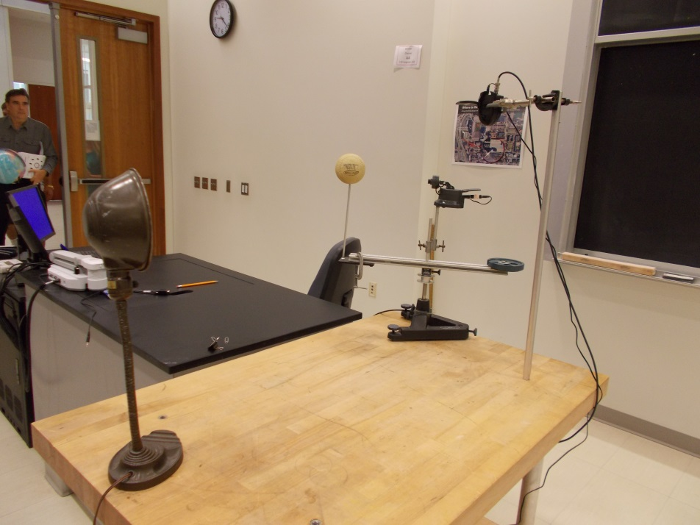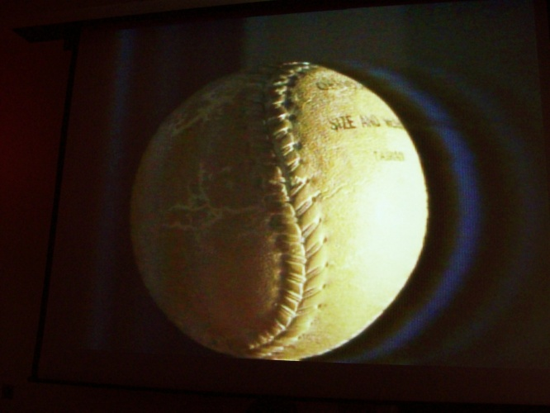

|  |  |  |
| --- | --- | --- |
| ASTRONOMY AND ASTROPHYSICS | 8A20.25 | PLANETARY ASTRONOMY |
| **Earth - Moon Mechanics** | | |
| Eclipse Model | | |
|  | | |
|  | Using a point light source for the sun, a globe for the earth and a hanging ping pong ball for the moon, various eclipses can be modeled.  Also shown is a model using a pair of hula hoops and Styrofoam balls. | |

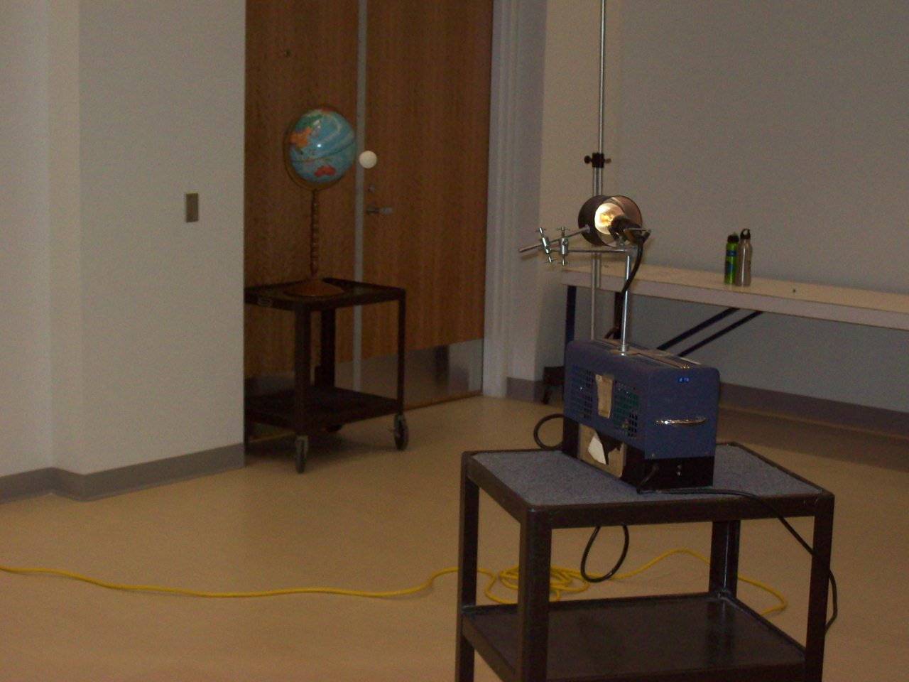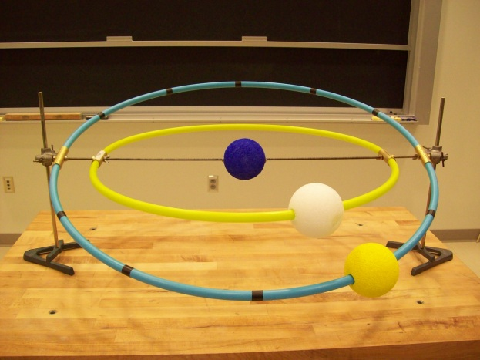

Location: La2, LaT, Id2

|  |  |  |
| --- | --- | --- |
| ASTRONOMY AND ASTROPHYSICS | 8A20.26 | PLANETARY ASTRONOMY |
| **Earth - Moon Mechanics** | | |
| Eclipse Stick | | |
|  | | |
|  | A Scale model of the Earth-Moon system to illustrate eclipses. | |

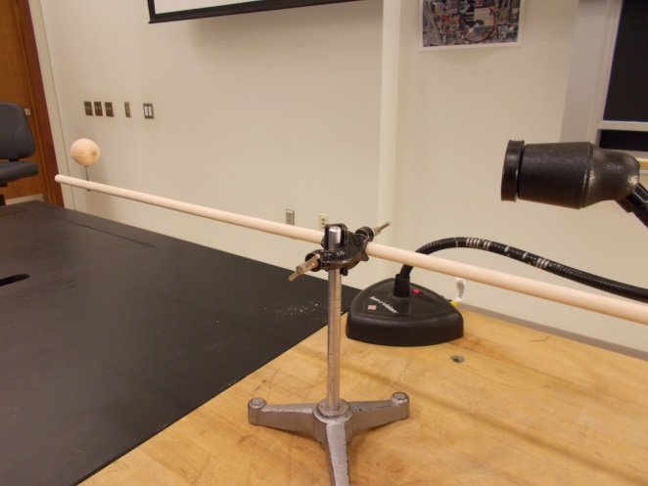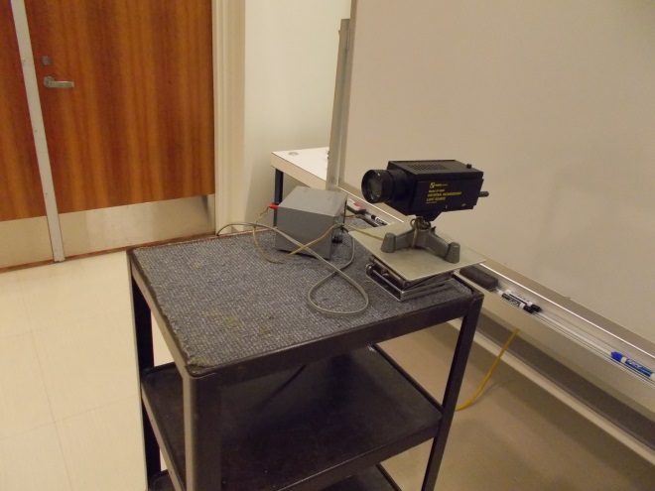

LaT

|  |  |  |
| --- | --- | --- |
| ASTRONOMY AND ASTROPHYSICS | 8A30.30 | PLANETARY ASTRONOMY |
| Views from Earth | | |
| Retrograde Motion Model | | |
|  | | |
|  | Use the crank on the back to move the two planets around the sun. A sliding rod shows the relative motion of the two planets. | |

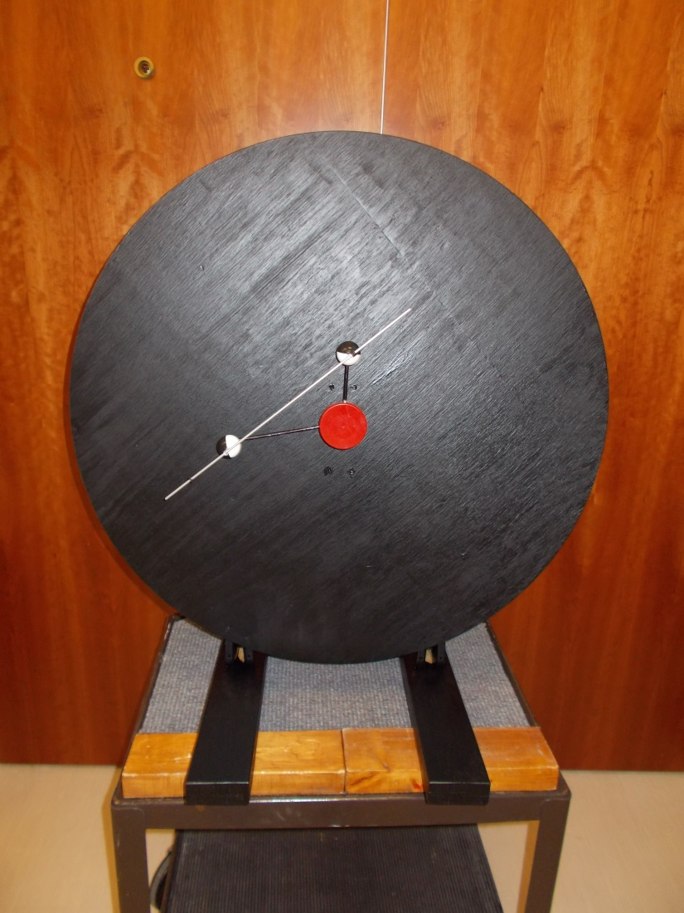

La2

|  |  |  |
| --- | --- | --- |
| ASTRONOMY AND ASTROPHYSICS | 8A35.10 | PLANETARY ASTRONOMY |
| ****Views from Earth - 2**** | | |
| Celestial Sphere | | |
|  | | |
|  | No instructions | |

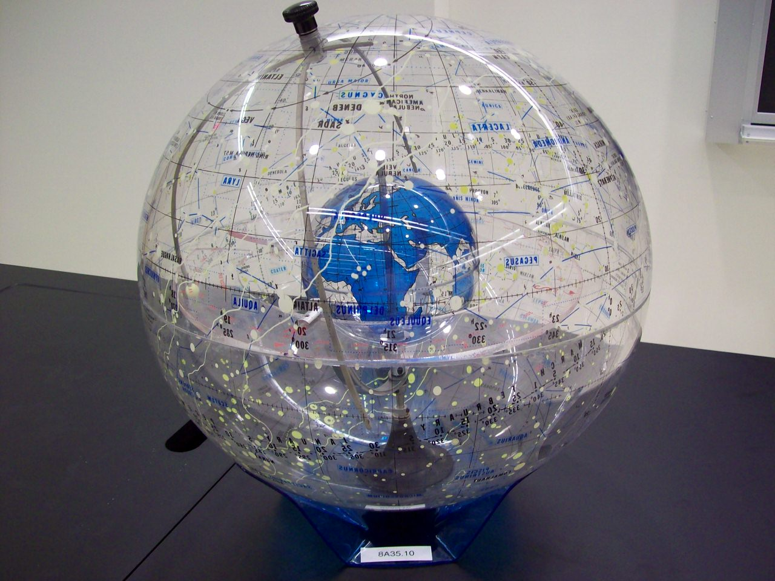

Location: La1

|  |  |  |
| --- | --- | --- |
| ASTRONOMY AND ASTROPHYSICS | 8A35.20 | Planetary Astronomy |
| **Views from the Earth - 2** | | |
| Armillary Sphere | | |
|  | | |
|  | Use to show celestial equator, ecliptic etc. A collection of magnetic celestial objects can be added to gradually build up a model of a celestial sphere. | |

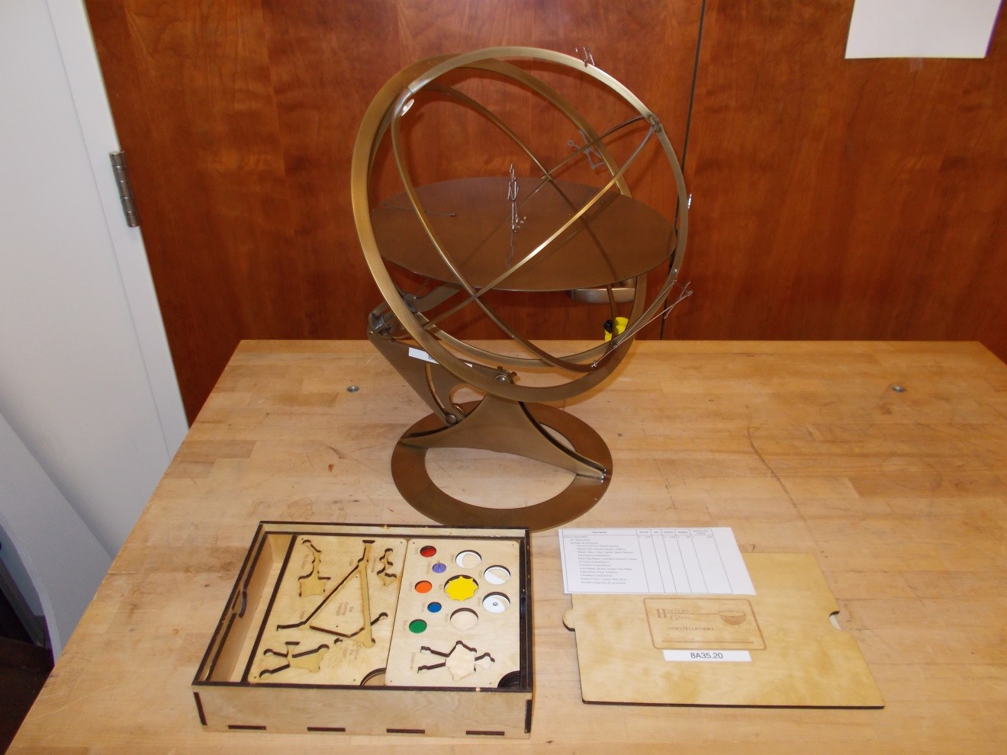Lb1

|  |  |  |
| --- | --- | --- |
| ASTRONOMY AND ASTROPHYSICS | 8A70.55 | PLANETARY ASTRONOMY |
| **Planetary Characteristics** | | |
| Rotational Banding | | |
|  | | |
|  | Rheoscopic fluid in a clear plastic ball will show rotational banding when spun up on a turntable and then stopped. | |

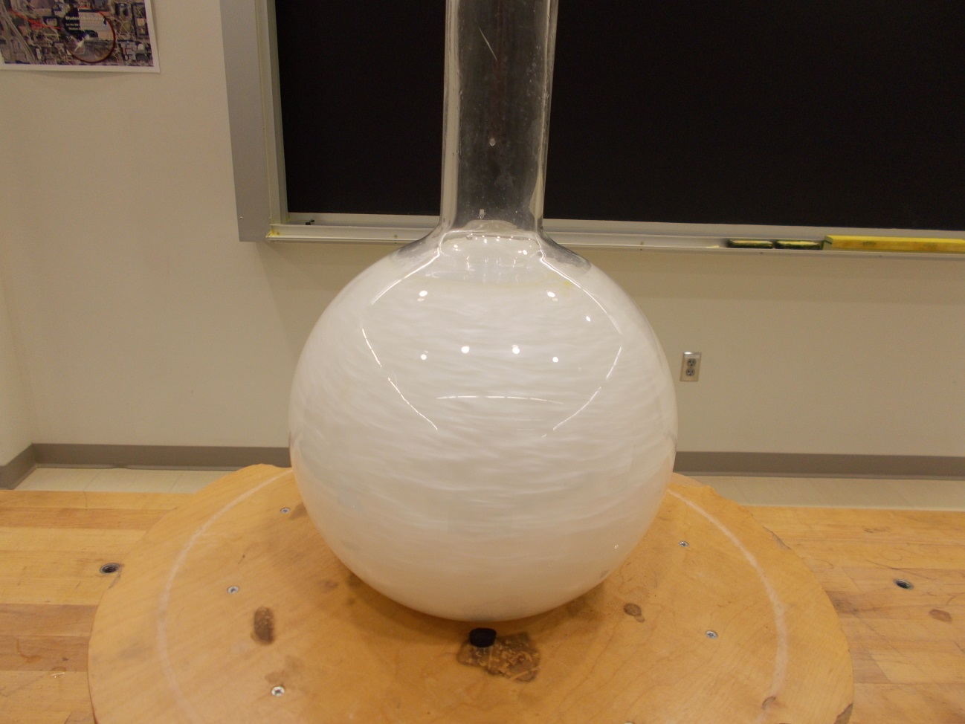

Location: Bc3, La3

|  |  |  |
| --- | --- | --- |
| ASTRONOMY AND ASTROPHYSICS | 8A70.82 | Planetary Astronomy |
| **Planetary Characteristics** | | |
| Protoplanet Cooling | | |
|  | | |
|  | Three solid aluminum spheres (4, 2 and 1 inch in diameter) are heated in boiling water and then viewed with an IR camera as they cool. | |

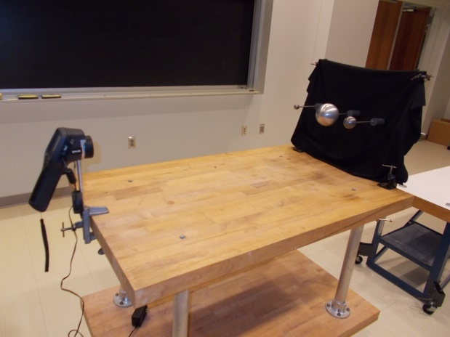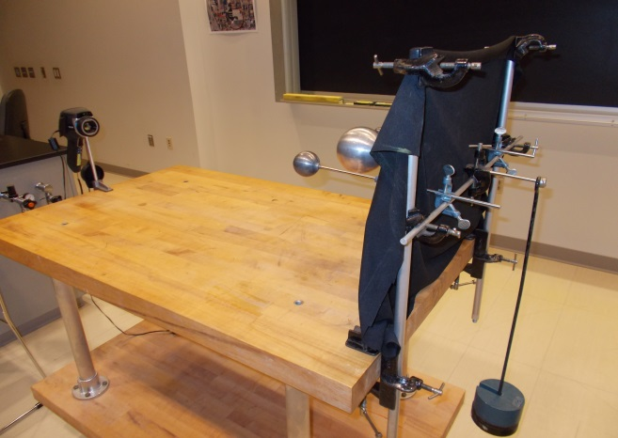

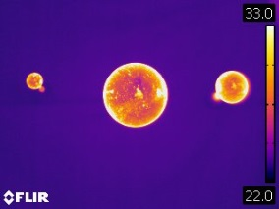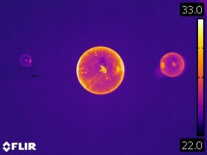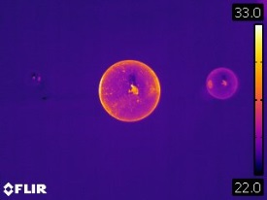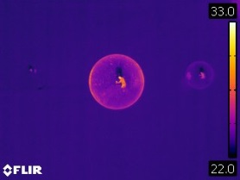

Location: FLIR Shelf, Lb5

|  |  |  |
| --- | --- | --- |
| ASTRONOMY AND  ASTROPHYSICS | 8B10.31 | STELLAR ASTRONOMY |
| ****The Sun**** | | |
| Solar Convection Cells | | |
|  | | |
|  | Place the frying pan on the hot plate.  Turn the hot plate to between 350 and 400 on the temperature dial.  Pour in the oil/aluminum powder mixture to a depth of about a cm.**CAUTION:  The oil does not have to be very hot to give good convection cells.  If the temperature is too high the oil may ignite.**  Once the cells have formed they will appear very stable.  You can use a spoon to disturb the cell structure and watch its reformation. | |

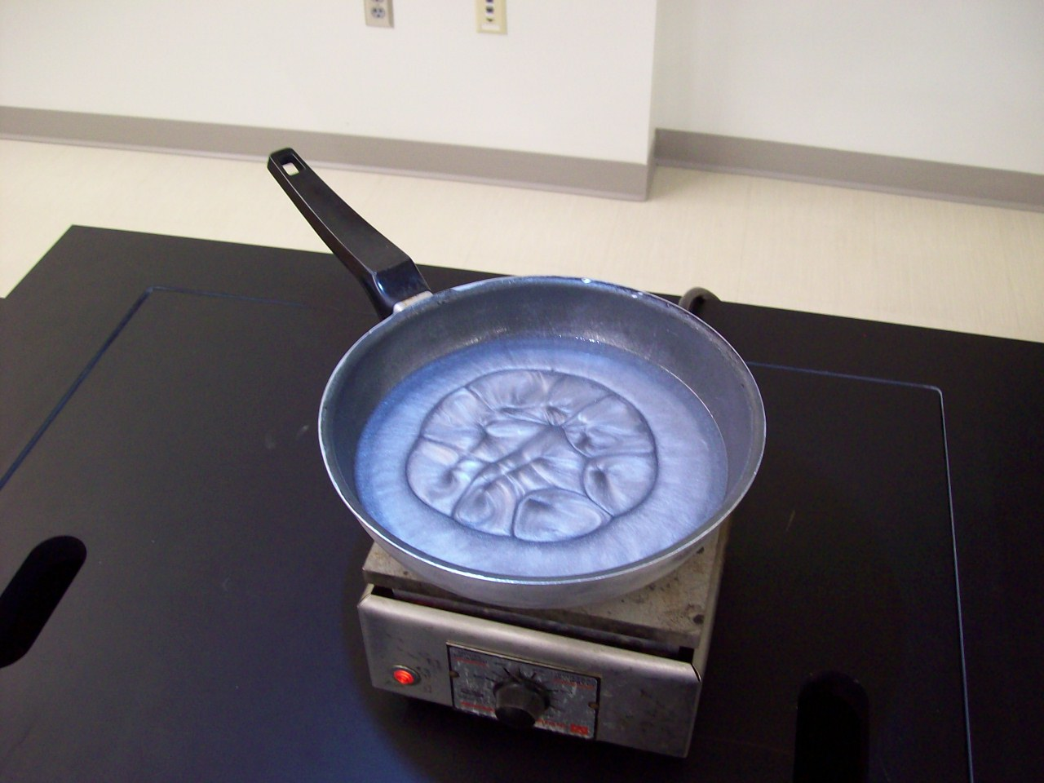

Location: La4

|  |  |  |
| --- | --- | --- |
| ASTRONOMY AND ASTROPHYSICS | 8B10.50 | STELLAR ASTRONOMY |
| **The Sun** | | |
| Sunspots on the Overhead | | |
|  | | |
| 8b1030 | A light bulb on a variac is turned up to visible glow and placed on an overhead projector that is turned off. When the overhead is turned on, the filament appears as a dark spot. | |

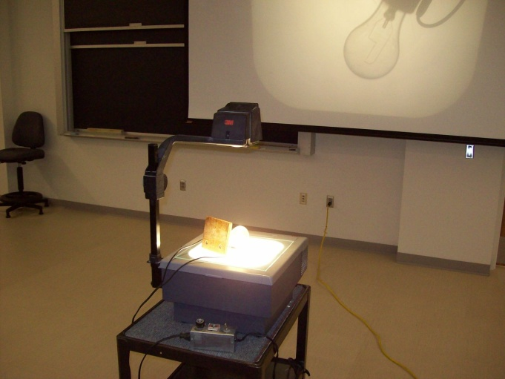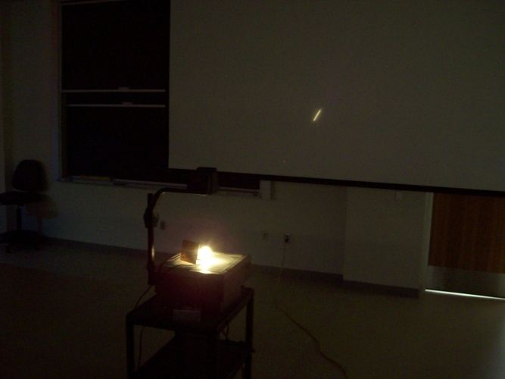

Location: La4

|  |  |  |
| --- | --- | --- |
| MODERN PHYSICS | 7B10.10 | ATOMIC PHYSICS |
| **Spectra** | | |
| Student Gratings and Line Sources | | |
|  | | |
| 7b1010 | Pass out the 1"x1" gratings to the students. These have 13,400 lines per inch. Turn on one of the light sources. There is a single filament white light source and three discharge tubes, Hg, He, Ne. The Didymium filter can be placed in front of the white light source to show selective absorption. The green carousel has a variety of tubes including H, He, Ne and Hg. The LEDs show individual colors and a white light spectrum. | |

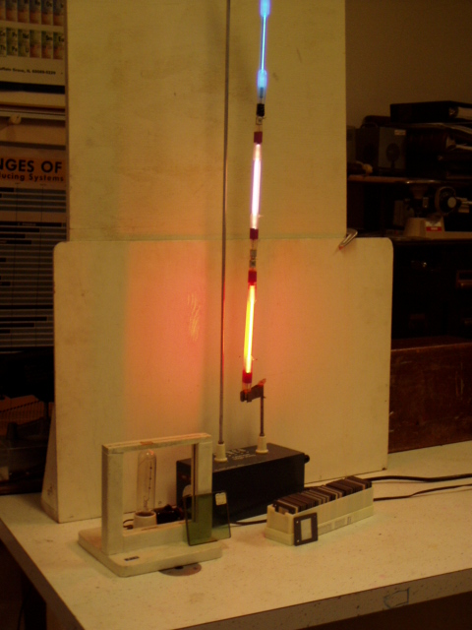 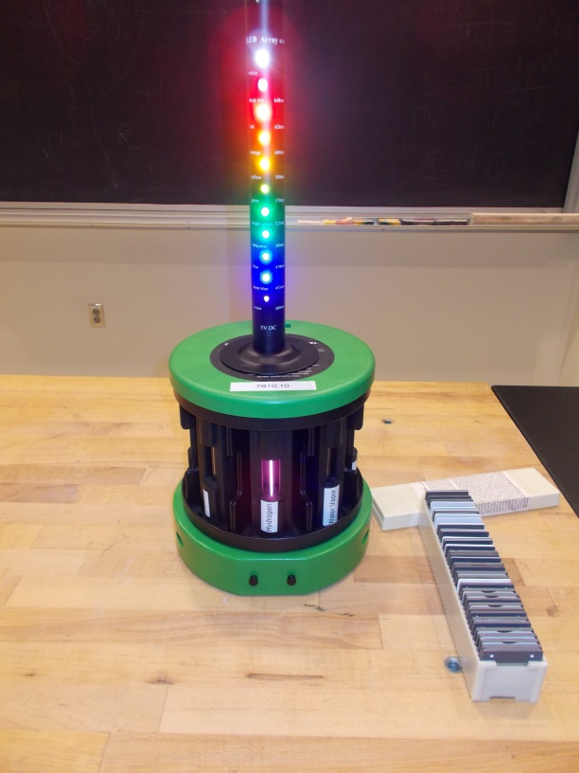

Location: Ja1, Jb2

|  |  |  |
| --- | --- | --- |
| ASTRONOMY AND ASTROPHYSICS | 8B10.60 | STELLAR ASTRONOMY |
| **The Sun** | | |
| Random Walk | | |
|  | | |
| 8b1035 | Use a Bumble Ball (a common toy) to illustrate the random walk of high energy photons in a star. | |

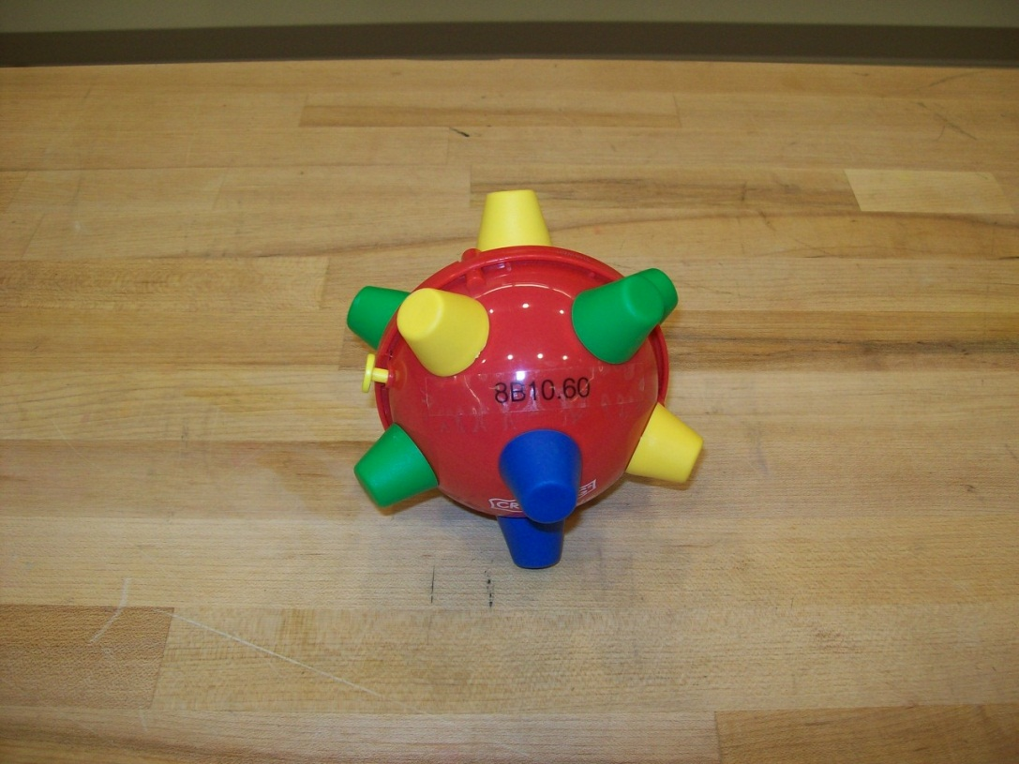

Location: La4

|  |  |  |
| --- | --- | --- |
| ASTRONOMY AND ASTROPHYSICS | 8B20.35 | STELLAR ASTRONOMY |
| ****Stellar Spectra**** | | |
| Radial Velocity | | |
|  | | |
|  | A conical pendulum is used with a sonic ranger to display velocity along the line of sight. Capstone file: Radial Velocity.cap. | |

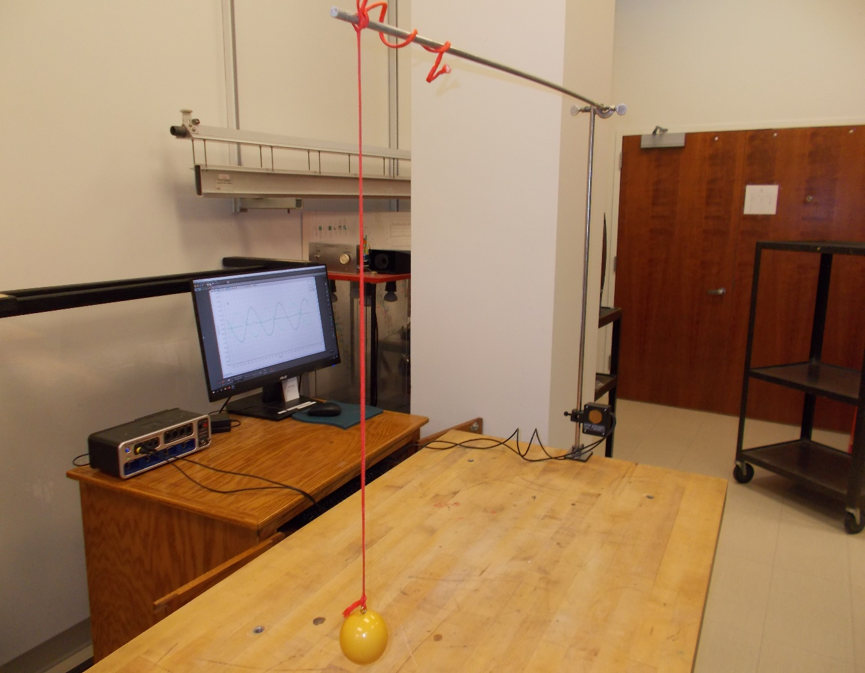

Location: Science Workshop, Ca2

|  |  |  |
| --- | --- | --- |
| ASTRONOMY AND ASTROPHYSICS | 8B30.35 | STELLAR ASTRONOMY |
| ****Stellar Evolution**** | | |
| Binary Star Models | | |
|  | | |
|  | Balls at the end of a rod with the barycenter marked are used to illustrate a binary system. Also, a couple of balls on a plastic sheet with orbits and the barycenter marked can be used to illustrate orbital inclination. | |

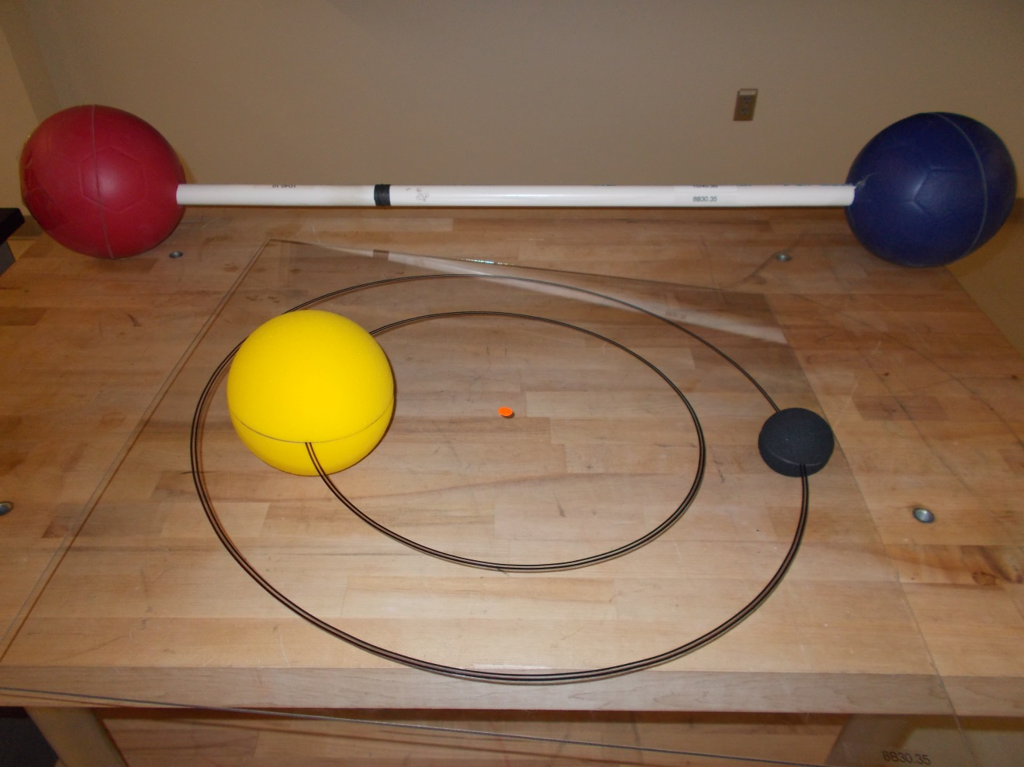Location: La5

|  |  |  |
| --- | --- | --- |
| ASTRONOMY AND ASTROPHYSICS | 8B30.35a | STELLAR ASTRONOMY |
| **Stellar Evolution** | | |
| Eclipsing Binary Light Curve | | |
|  | | |
|  | Two battery-powered light bulbs on a rotating platform are used with a photometer and the Capstone software (Eclipsing Binary.cap) to model an eclipsing binary light curve. | |

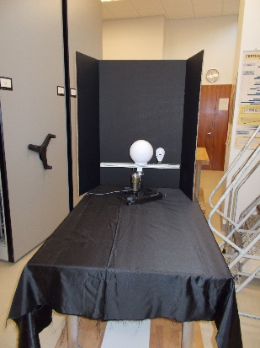

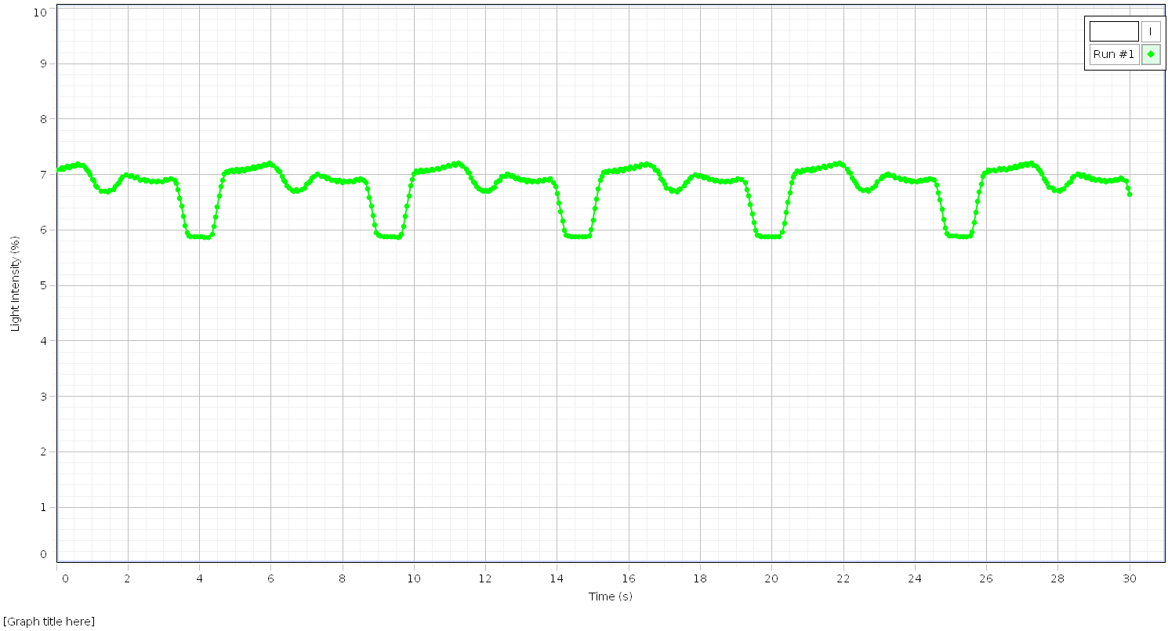

Location: La5, Jb1, Hb2, Hb3, Bc3

|  |  |  |
| --- | --- | --- |
| ASTRONOMY AND ASTROPHYSICS | 8B30.50 | STELLAR ASTRONOMY |
| **Stellar Evolution** | | |
| Supernova Core Bounce | | |
|  | | |
|  | Use the double ball bounce to illustrate supernova core bounce. | |

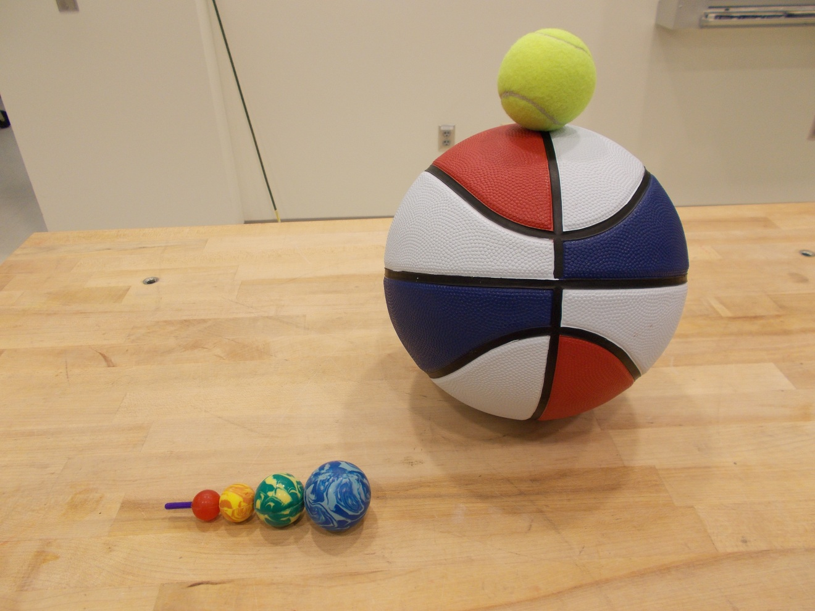Location: La5, Cd3

|  |  |  |
| --- | --- | --- |
| ASTRONOMY AND ASTROPHYSICS | 8B40.20 | STELLAR ASTRONOMY |
| ****Black Holes**** | | |
| Gravity Well | | |
|  | | |
|  | Use this demonstration when discussing black holes and gravity wells. | |

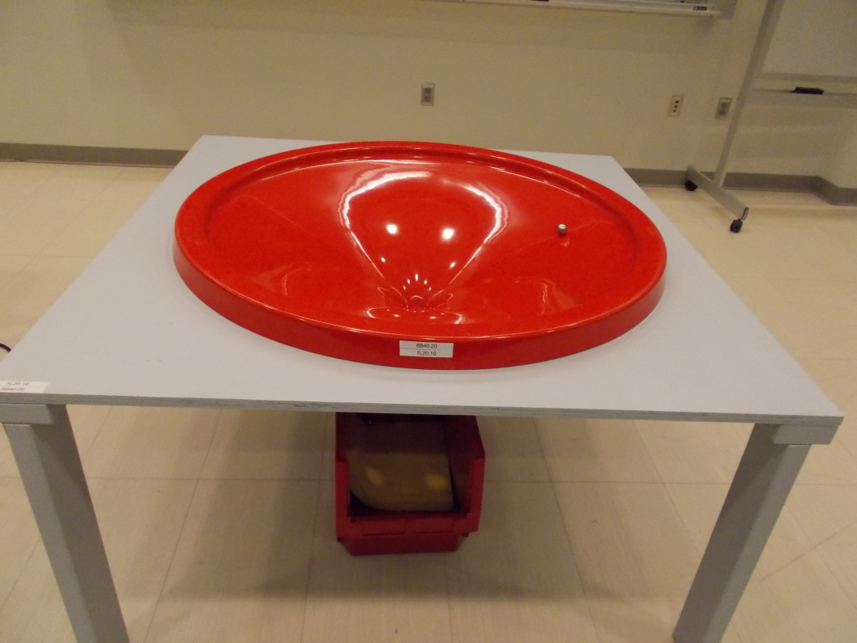

Location: OaT

|  |  |  |
| --- | --- | --- |
| ASTRONOMY AND ASTROPHYSICS | 8B40.30 | STELLAR ASTRONOMY |
| **Black Holes** | | |
| Membrane Table / Black Hole | | |
|  | | |
| 8c2020 | Swimsuit fabric stretched over a wood frame is deformed with a weight and balls are rolled around. | |

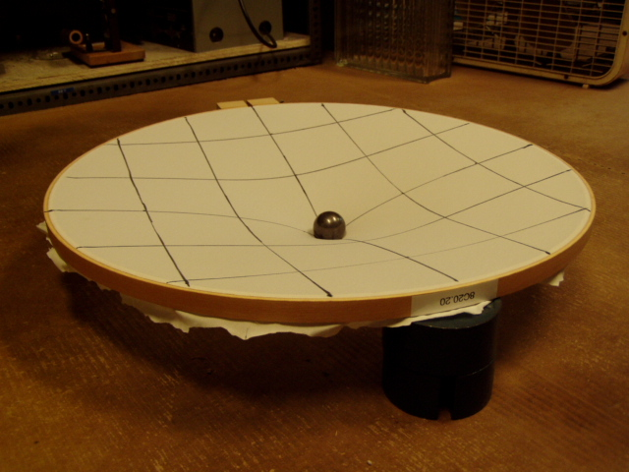

Location: Lb3

|  |  |  |
| --- | --- | --- |
| ASTRONOMY AND ASTROPHYSICS | 8C10.30 | COSMOLOGY |
| ****Models of the Universe**** | | |
| Expanding Universe | | |
|  | | |
|  | Fifteen plastic balls are threaded onto a rod and connected by springs with equal intervals. Pull on the ends and watch the expanding intervals. | |

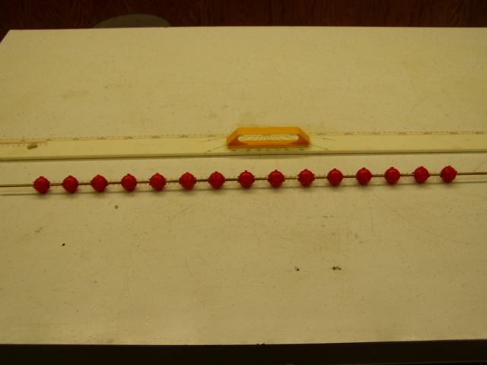

Location: Lb2

|  |  |  |
| --- | --- | --- |
| ASTRONOMY AND ASTROPHYSICS | 8C20.10 | Cosmology |
| ****Gravitational Effects**** | | |
| Klein Bottle | | |
|  | | |
|  | All surface and no volume. | |

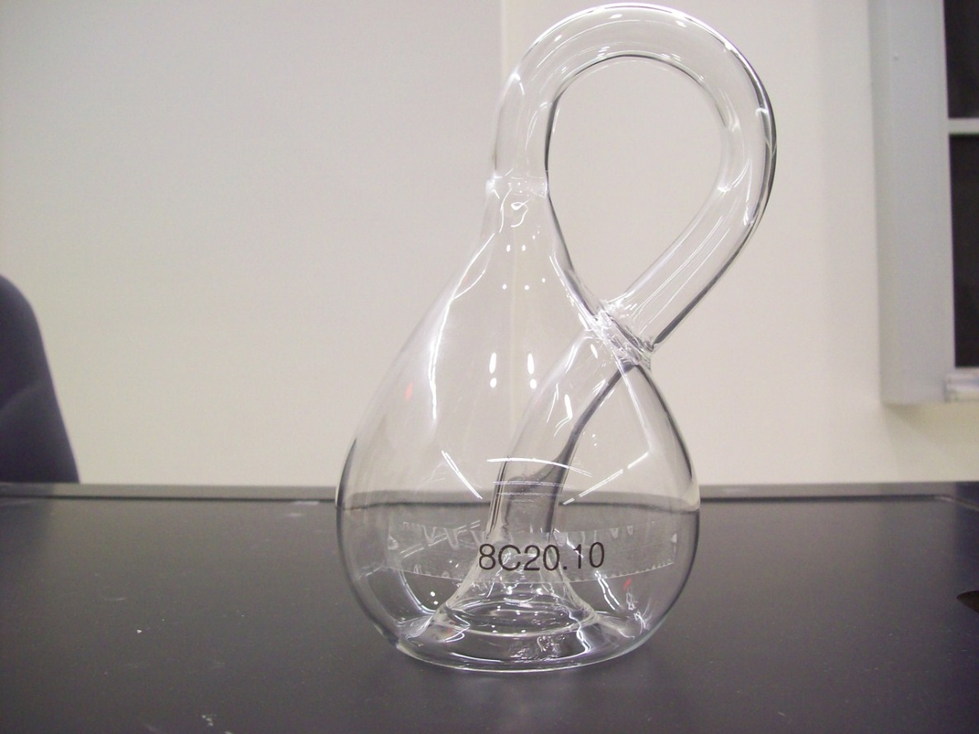

Location: Lb4

|  |  |  |
| --- | --- | --- |
| ASTRONOMY AND ASTROPHYSICS | 8C20.30 | Cosmology |
| **Gravitational Effects** | | |
| Saddle Shape/Paul Trap Model | | |
|  | | |
|  | A model of a negatively curved two-dimensional space. Also shown is a rotating saddle Paul trap model. A ping pong ball is not stable when placed on a saddle shape. The ball becomes stable (trapped) when the saddle is rotated. | |

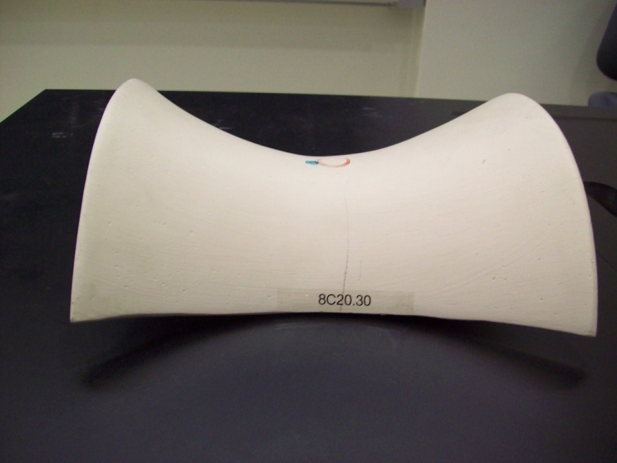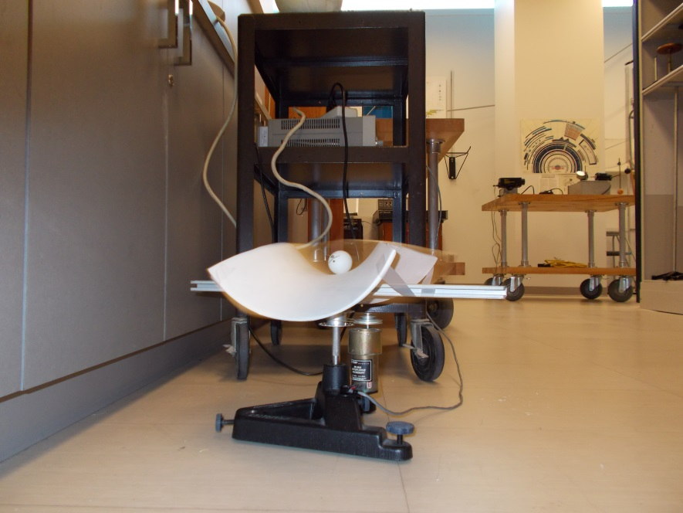

Location: Lb4

|  |  |  |
| --- | --- | --- |
| ASTRONOMY AND ASTROPHYSICS | 8C20.40 | Cosmology |
| **Gravitational Effects** | | |
| Gravitational Lens | | |
|  | | |
|  | The bottom of a wine glass is used as a gravitational lens and a small ball is used as a distant galaxy. Depending on where the ball is placed you can see a ring, an arc or two arcs. | |

Location: LB4