For the complete bibliography with references as well as an explanation of the classification scheme go to:
Demonstration Bibliography
The demonstration name listed in the bibliography is either the name listed on the reference or, if none is given, a simple descriptive name. In cases where there are several common names for a demonstration, the committee has chosen a preferred name.
The description is very brief. It is not intended to be a summary of the reference. One sentence is, in general, sufficient to describe the unique characteristics, if any, of an item. Each source has a unique numbering format. These unique formats are used identify references in the Bibliography.
The formats for the reference column and links to the sources are listed below:
Reference | Source
M-1 | Sutton
Ma-1 | Freier & Anderson
M-1d | Hilton
8-2.8 | Meiners
M-108 | Dick & Rae
1A 12.01 | University of Minnesota Handbook
AJP 52(1),85 | American Journal of Physics
TPT 15(5),300 | The Physics Teacher
Disc 01-01 | The Video Encyclopedia of Physics Demonstrations
PIRA 200 | Physics Instructional Resource Association
PIRA 500 | PIRA 500
PIRA 1000 | PIRA 1000
Each demonstration is listed in only one location, even if it is commonly used to illustrate several concepts.
11/17/2023

1
MEASUREMENT 9
Basic Units 9
Standards of Mass 9
Meter Stick 10
One Liter Cube 11
Mass, Volume and Density 12
Avagadro’s Number Box 13
Mole Samples 14
Error and Accuracy 15
Reaction Time 15
Coordinate Systems 16
XYZ Axes 16
Chalkboard Globe 17
Vectors 18
Vectors 18
Math Topics 19
Radian 19
Scaling 20
Powers of Ten 20
MOTION IN 1D 21
Velocity 21
Ultrasonic Ranger and Student 21
Bulldozer on Moving Sheet 22
PASCO Dynamics Carts 23
Approaching Instantaneous Velocity 24
Uniform Acceleration 25
Penny and Feather 25
Freefall and Air Resistance 26
Equal Time, Equal Distance Drop 27
Inclined Dynamics Track (Smart Cart) 28
Inclined Dynamics Track (photogates) 29
Galilean Inclined Plane 30
Measuring g 31
PASCO Free Fall 31
MOTION IN TWO DIMENSIONS 32
Displacement in Two Dimensions 32
Cycloid Generator 32
Mounted Wheel 33
Measuring Angular Velocity 34
Velocity, Position and acceleration 35
High Road – Low Road, Brachistochrone 35
Motion of the Center of Mass 36
Throw Objects 36
Throw the Dumbbell 37
Earth-Moon System 38
Air Track Pendulum Glider 39
Momentum Pendulum 40
Central Forces 41
Ball on a String 41
Ball on Cord 42
Conical Pendulum 43
Carnival Ride Model 44
Pail of Water, Pail of Nails 45
Centripetal Force Apparatus 46
Deformation by Central Forces 47
Flattening Earth 47
Water Parabola 48
Rotating Corks in Water 49
Centrifugal Escape 50
Release the String 50
Falling off the Merry-go-round 51
Projectile Motion 52
Howitzer and Tunnel 52
Simultaneous Fall 53
Monkey and Hunter 54
Range of a Gun 55
Parabolic Trajectory 56
RELATIVE MOTION 57
Moving Reference Frames 57
Bulldozer on Moving Sheet 57
Frames of Reference Film 58
Rotating Reference Frames 59
Foucault Pendulum 59
Foucault Pendulum Model 60
Coriolis Effect 61
Coriolis 61
NEWTON'S FIRST LAW 62
Measuring Inertia 62
Inertia Balance 62
Inertia of Rest 63
Inertia Ball 63
Smash Your Hand 64
Smashing Cups 65
Tablecloth Pull 66
Coin/card Snap 67
Pen and Embroidery Hoop 68
Daruma Otoshi 69
Inertia of Motion 70
Persistence of Motion 70
Air Puck 71
Cup and Chain 72
Cart on a Cart 73
NEWTON'S SECOND LAW 74
Force, Mass and Acceleration 74
Accelerating Air / Dynamics Cart 74
Accelerating Cart on an Incline 75
Accelerating Fan Car 76
Accelerating Fan Car with Smart Cart 77
Mass on a Scale 78
Atwood's Machine 79
Accelerated Reference Frames 80
Leaky Pail Drop 80
Cup and Weights 81
Vanishing Weight 82
Dropped Slinky 83
Float Accelerometer 84
NEWTON'S THIRD LAW 85
Action and Reaction 85
Push Me Pull Me Carts 85
Fan Cart with Sail 86
Recoil 87
Floor Cart and Medicine Ball 87
Liquid Nitrogen Cannon 88
STATICS OF RIGID BODIES 89
Finding Center of Gravity 89
Map of State 89
Exceeding Center of Gravity 90
Leaning Tower of Pisa 90
Tower of Lire 91
Stable, Unstable, and Neutral Equilibrium 92
Gömböc 92
Bowling Ball Stability 93
Balance the Cone 94
Block on the Cylinder 95
Twelve Nails on One 96
Horse and Rider 97
Wine Butler 98
Double Cone 99
Train Wheel Stability 100
Resolution of Forces 101
Suspended Block 101
Normal Force 102
Tension in a String 103
Rope and Three Students 104
Vertical Force Table 105
Force Table on OHP 106
Static Torque 107
Grip Bar 107
Torque Wrench 108
Meter Stick Balance 109
Trap Door 110
Loaded Beam 111
Roberval Balance 112
Moment Arms 113
Crane Boom 114
Hanging Sign 115
Arm Model 116
APPLICATIONS OF NEWTON'S LAWS 117
Dynamic Torque 117
Ladder Against a Wall 117
Ladder Against a Wall 118
Walking the Spool 119
String Unwinding from a Pole 120
Friction 121
Friction Blocks - Surface Materials 121
Phonebook Friction 122
Static vs. Sliding Friction 123
Angle of Repose 124
Capstan 125
Pressure 126
Bed of Nails 126
GRAVITY 127
Universal Gravitational Constant 127
Cavendish Balance Video 127
Cavendish Balance 128
Orbits 129
Gravitational Wells 129
Sections of a Cone 130
Ellipse Drawer 131
WORK AND ENERGY 132
Work 132
Pile Driver 132
Simple Machines 133
Simple Machines 133
Pulleys 134
Inclined Plane 135
Levers 136
Non-Conservative Forces 137
The Woodpecker 137
Conservation of Energy 138
Nose Basher 138
Stopped Pendulum 139
Loop the Loop 140
Ball in a Track 141
Deformed Air Track 142
Roller Coaster 143
Ballistic Pendulum 144
Yo-Yo 145
Height of a Spring Launched Ball 146
Rattleback 147
High Bounce Paradox 148
Trebuchet 149
LINEAR MOMENTUM AND COLLISIONS 150
Impulse and Thrust 150
Impulse Measurement 150
Egg in a Sheet 151
Conservation of Linear Momentum 152
See-Saw Center of Mass 152
Car on a Rolling Track 153
Train on an Air Track 154
Spring Apart Carts 155
Putt Putt Boat 156
Mass and Momentum Transfer 157
Carts and Medicine Ball 157
Ballistic Cart 158
Rockets 159
Fire Extinguisher Rocket 159
Water Rocket 160
Collisions in 1D 161
Collision Balls 161
Air Track Collision Gliders 162
Pasco Collision Carts 163
Rebounding Happy and Sad Balls 164
Double Ball Drop 165
Velocity Amplifier 166
Collisions in Two Dimensions 167
Orthogonal Hammers 167
Air Table Collisions 168
ROTATIONAL DYNAMICS 169
Moment of Inertia 169
Inertia Wands and Two Students 169
Moment of Inertia Measurement 170
Angular Acceleration 171
Ring, Disk, and Sphere Race 172
Racing Soups 173
Parallel Axis Pendulum 174
Rotational Energy 175
Adjustable Angular Momentum 175
Bicycle Wheel Acceleration 176
Faster than ”g” 177
Falling Pencil 178
Flywheel Car 179
Transfer of Angular Momentum 180
Passing the Wheel 180
Conservation of Angular Momentum 181
Rotating Stool and Masses 181
Squeezatron 182
Rotating Hoberman Sphere 183
Centrifugal Governor 184
Rotating Stool and Wheel 185
Pocket Watch 186
Rotational Collision 187
Counter Rotating Disks 188
Sewer Pipe Pull 189
Hero’s Engine 190
Feynman Sprinkler (Acoustic Version) 191
Gyros 192
Precessing Pulley 192
Bike Wheel Precession 193
Double Gyro 194
Air Bearing Gyro 195
Precessing Gyro 196
Rotational Stability 197
Old Fashioned Top 197
Spinning Coin 198
Spinning Rod 199
Tippe Top 200
Spinning Football 201
Hurricane Balls 202
Tossing the Book 203
Spinning Lariat, Rod, Hoop and Disc 204
String Shooter 205
PROPERTIES OF MATTER 206
Hooke’s Law 206
Stretching a Spring 206
Pull on a Horizontal Spring 207
Springs in Series and Parallel 208
Tensile and Compressive Stress 209
Breaking Wire 209
Elastic Limit (Stress vs. Strain) 210
Young’s Modulus 211
Shear Stress 212
Spring Cube 212
Torsion Rod 213
Coefficient of Restitution 214
Happy and Sad Balls 214
Crystal Structure 215
Crystal Models 215
Faults in Crystal 216

MECHANICS | 1A10.20 | MEASUREMENT

Basic Units

Standards of Mass
Disc 01-01
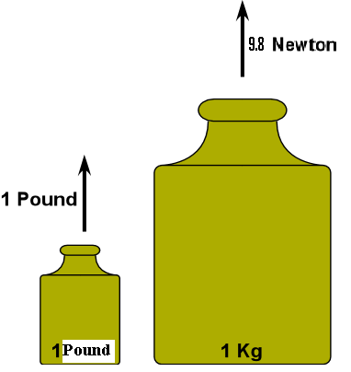 | Show students 1 kg and 1 lb masses to illustrate their size.  Have students lift both to illustrate their weights.  A 1 slug mass can also be shown and lifted.
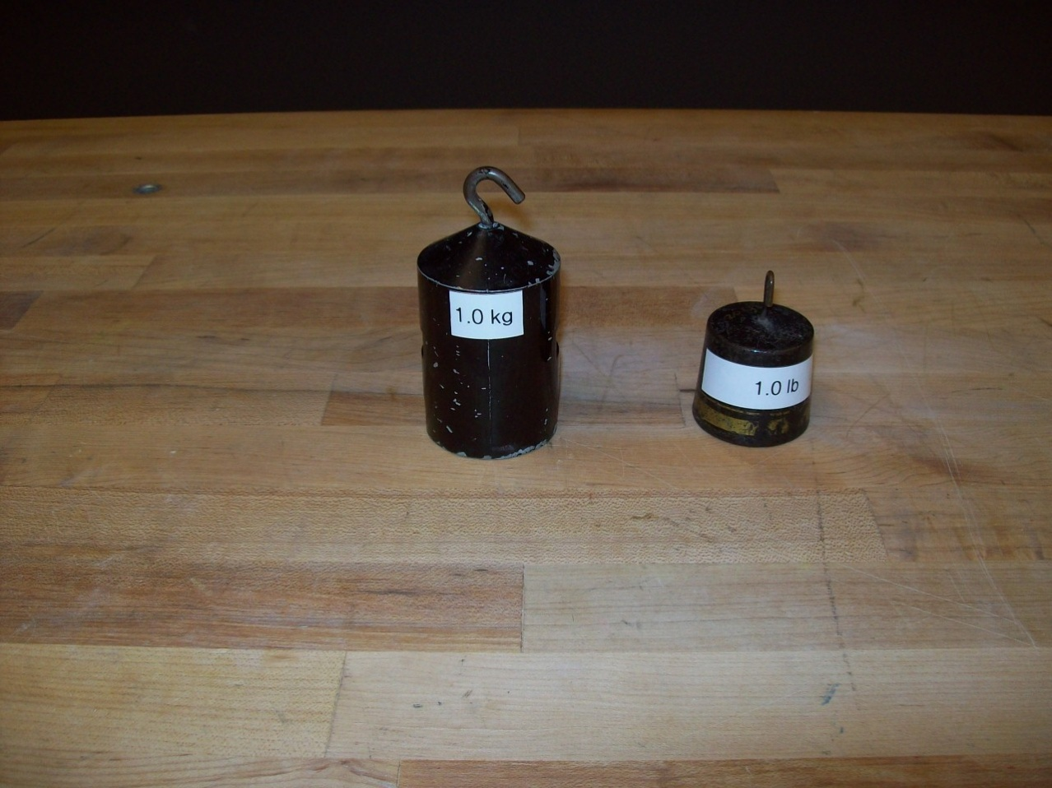
Location: Ba3
MECHANICS | 1A10.35, 1A10.36 | MEASUREMENT
Basic Units

Meter Stick
Disc 01-01
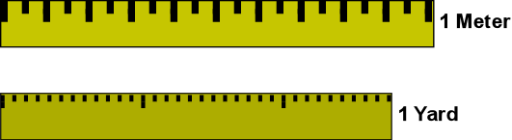 | Show the relative length of the meter and the yard.  The standard yard and meter are also available.  A globe can be used to talk about the original definition of the kilometer: the line from the pole to the equator through Paris was 10,000 kilometers.
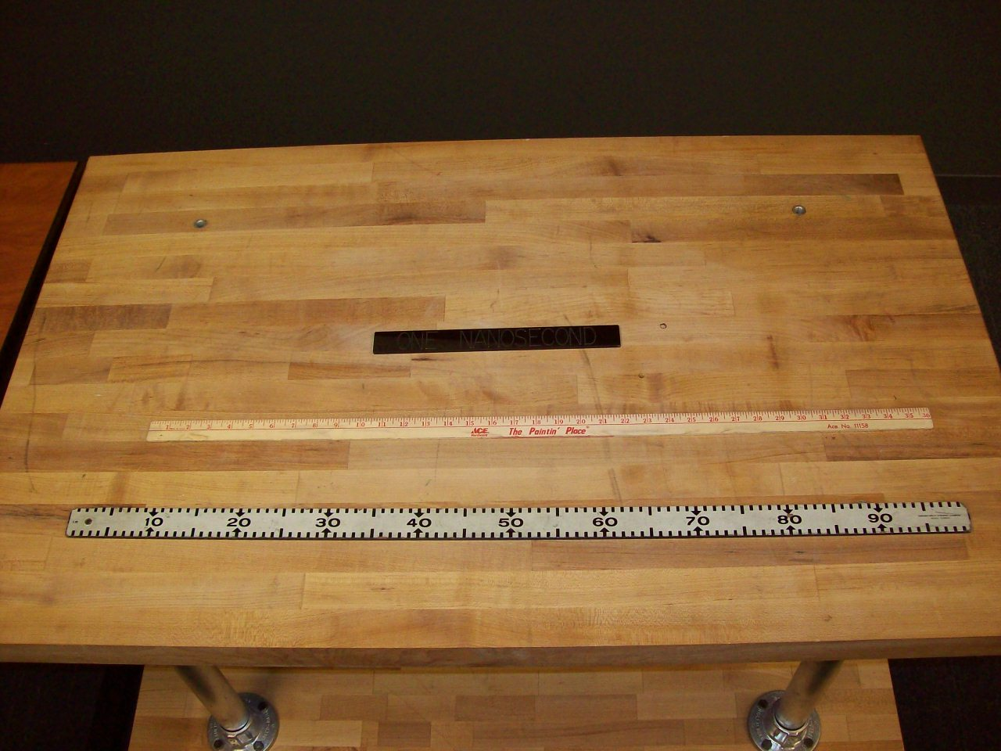
Location: Ba3
MECHANICS | 1A10.50 | MEASUREMENT
Basic Units

One Liter Cube
 | A one liter wooden cube has cm square rules on each face and removable one cc cube and one cm x 1 dm blocks.
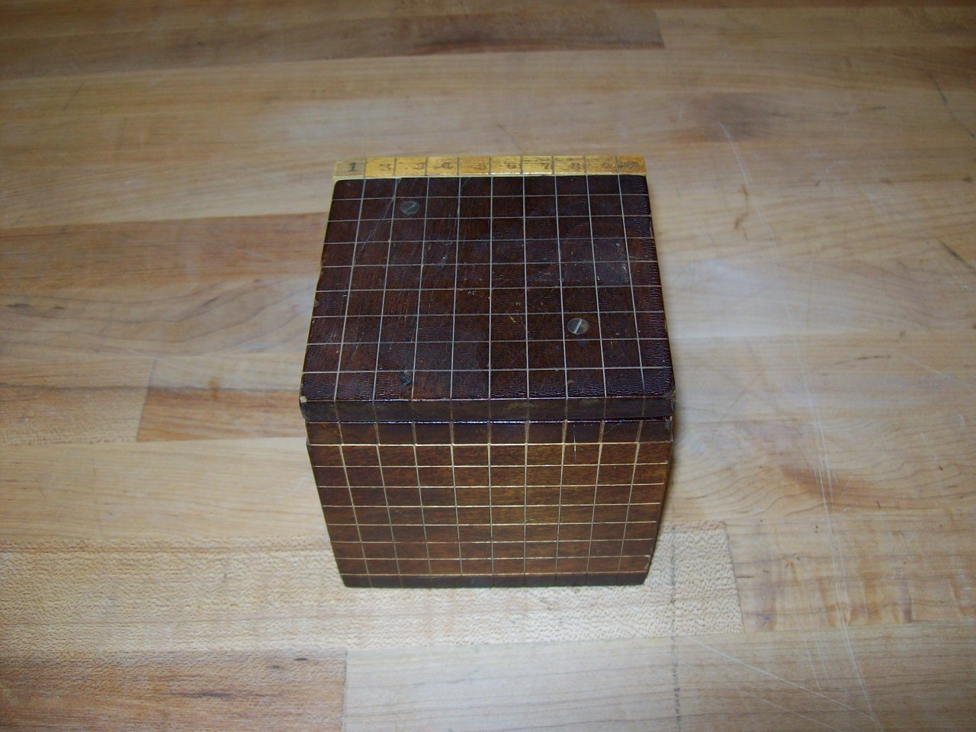
Location: Ba4

MECHANICS | 1A10.55 | MEASUREMENT
Basic Units

Mass, Volume and Density
 | Two spheres of the same mass but different volumes..
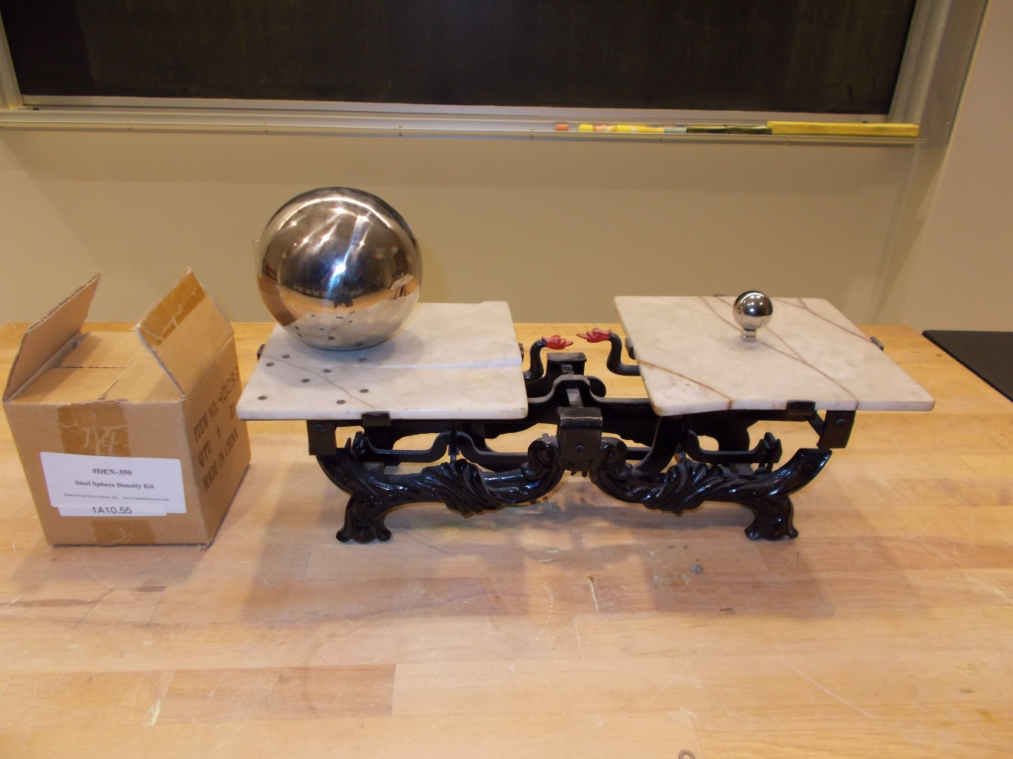 Location: Ba4, Ba5

MECHANICS | 1A10.60 | MEASUREMENT
Basic Units

Avagadro’s Number Box
 | A cube 28.2 cm on a side has a volume of 22.4 L (the one shown is actually slightly larger.
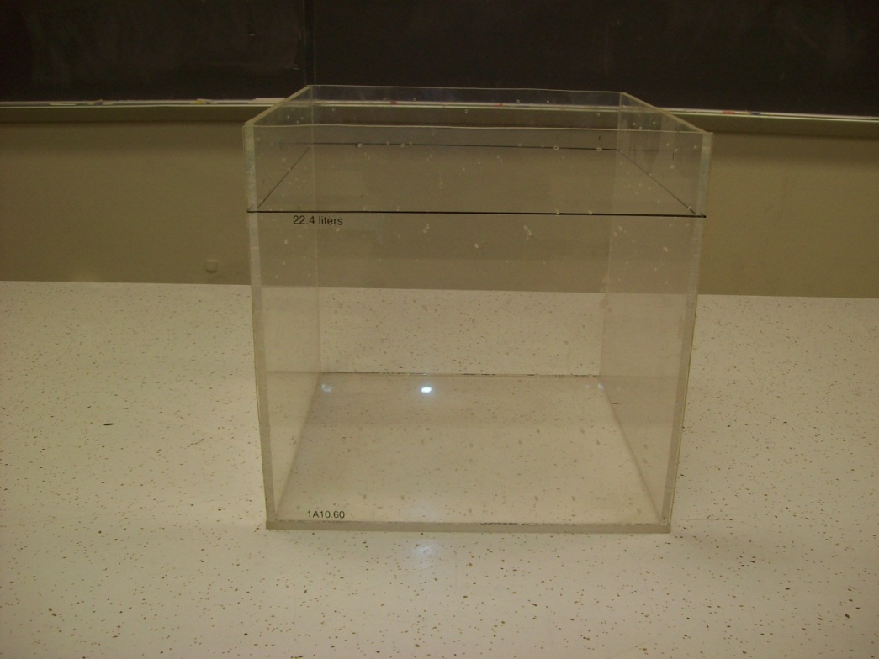
Location: Ba4
MECHANICS | 1A10.65 | MEASUREMENT
Basic Units

Mole Samples
 | Show mole samples of various materials. The metals are: iron, zinc, aluminum and copper.
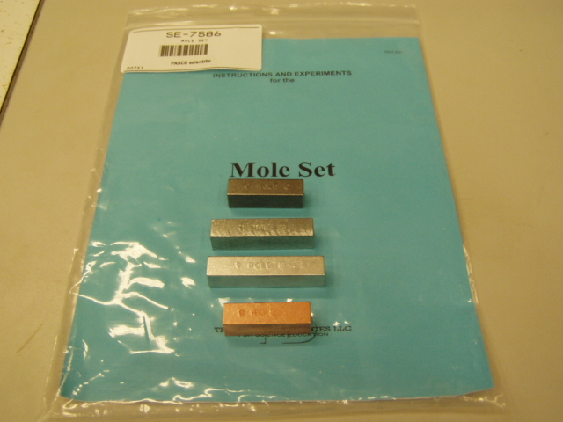Location: Ba4
MECHANICS | 1A20.60 | MEASUREMENT

Error and Accuracy

Reaction Time
 | The reaction timer either sounds a beep or flashes an LED and measures the time it takes to press a button in response to the stimulus. The display is in msec. Use either a Unilab display or Capstone with the file Reaction Timer.cap
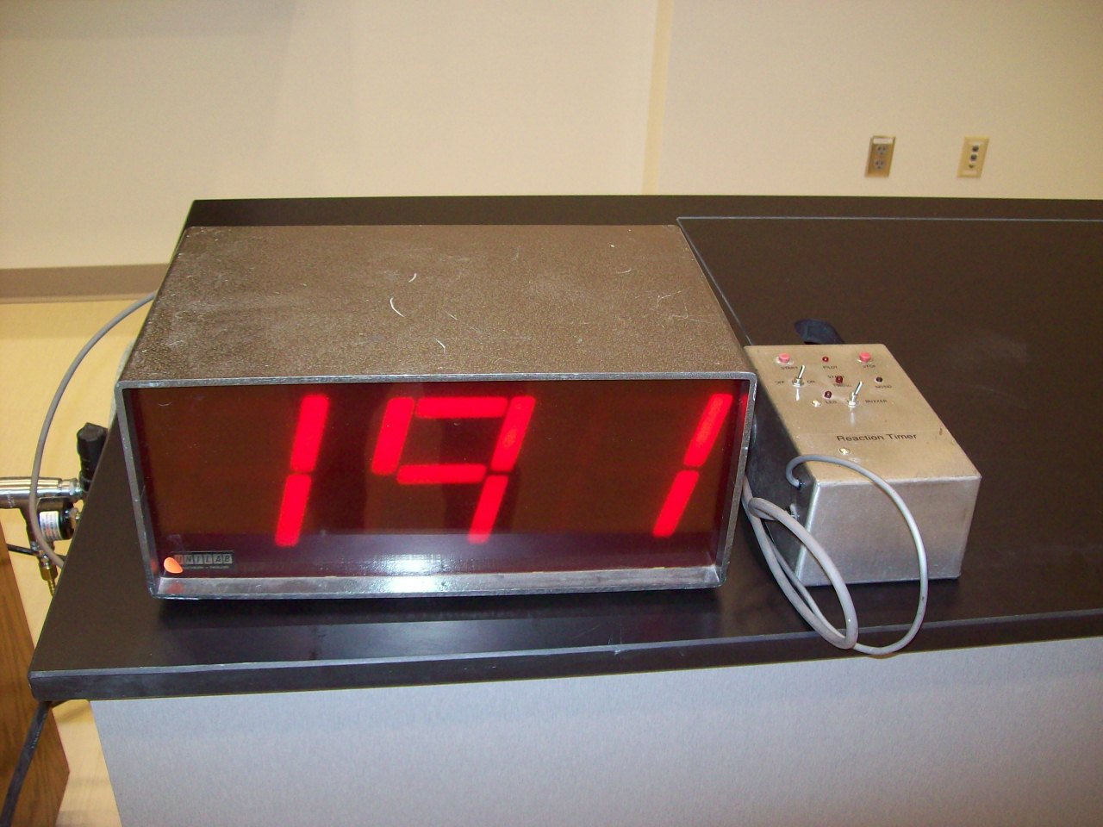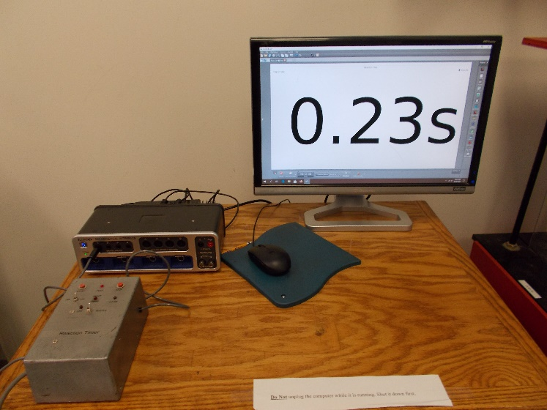
Location: Ba6

MECHANICS | 1A30.10 | MEASUREMENT

Coordinate Systems

XYZ Axes
 | Various orthogonal triads and a coordinate system model
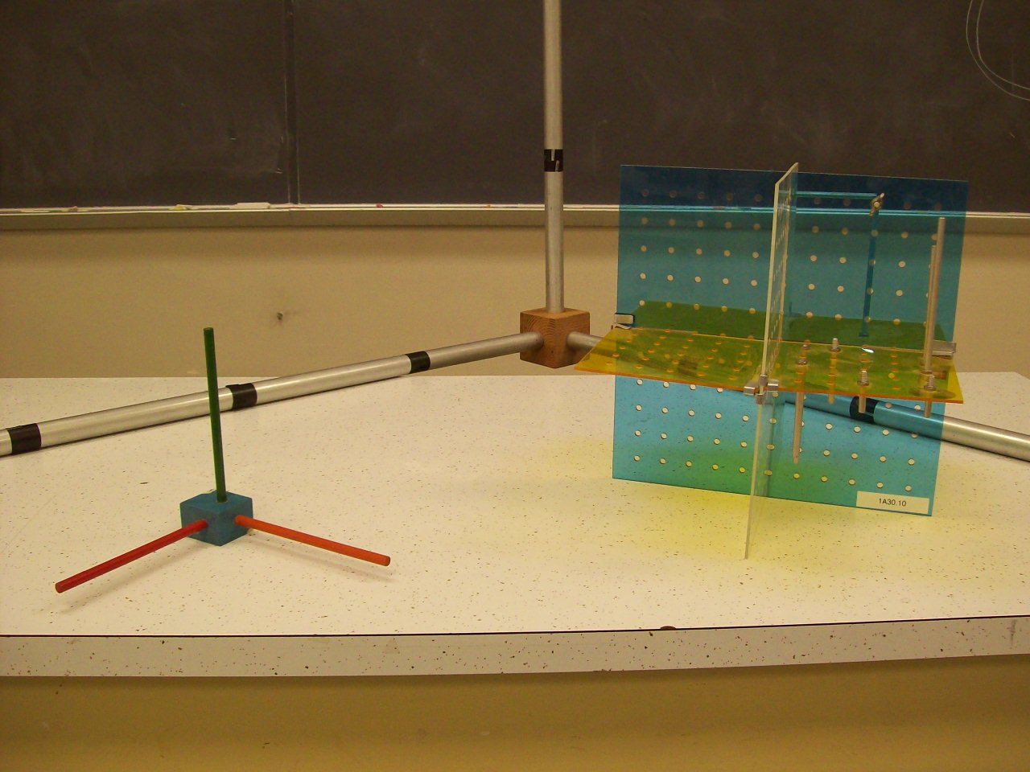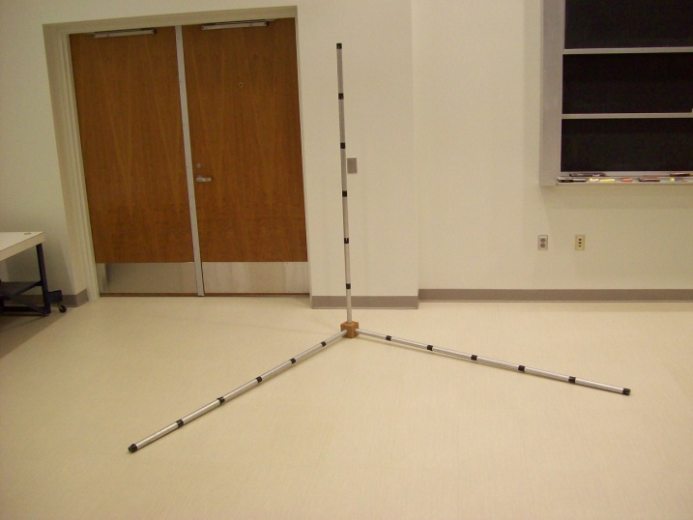
Location: Ba6

MECHANICS | 1A30.40 | MEASUREMENT
Coordinate Systems

Chalkboard Globe
 | Draw coordinates on a 20 inch diameter spherical chalkboard.
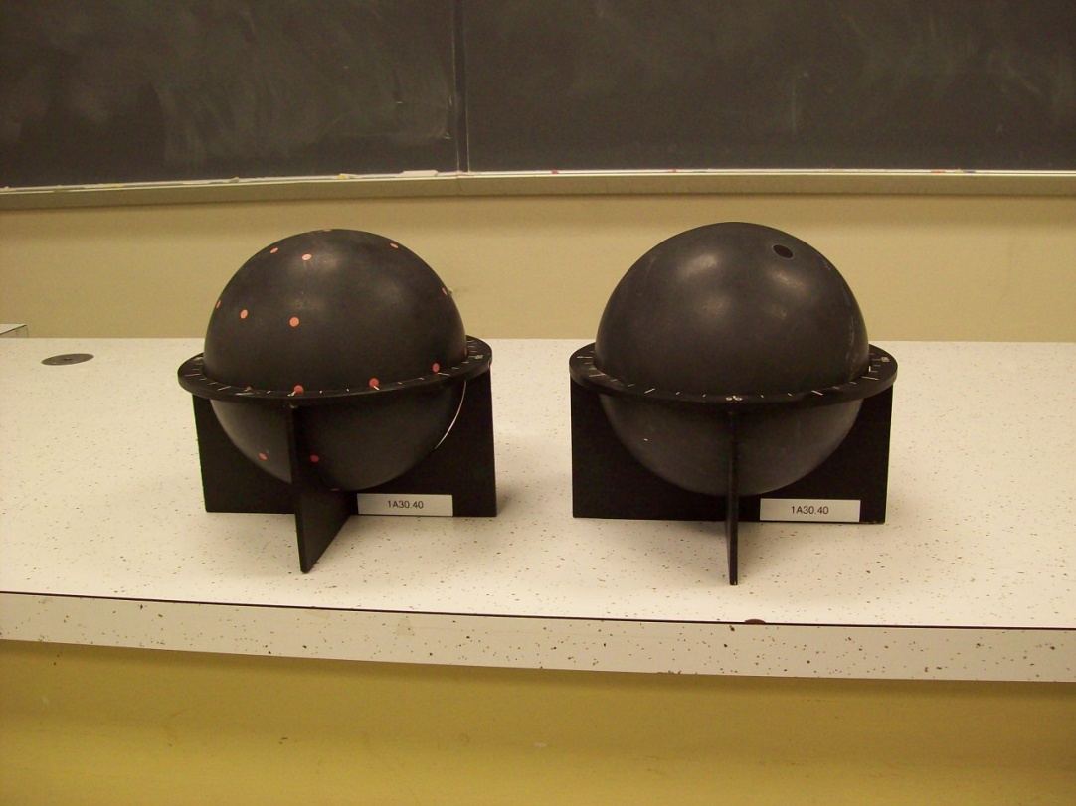
Location: Ba7

MECHANICS | 1A40.10, 1A40.31 | MEASUREMENT

Vectors

Vectors
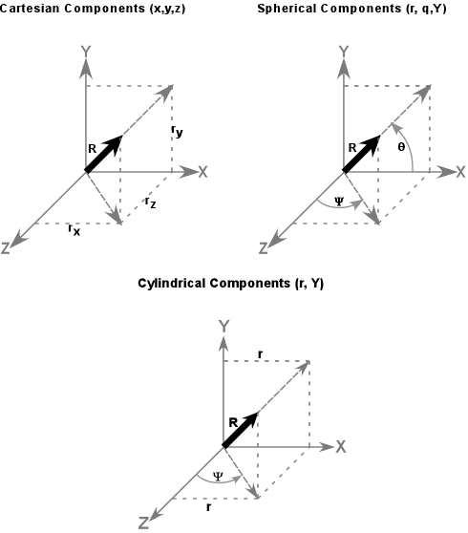 | The angle between the vector and any axis is not the same as the angle between the axis and the projection of the vector onto a place defined by two axes.  Also shown in the photograph is the vector addition parallelogram.
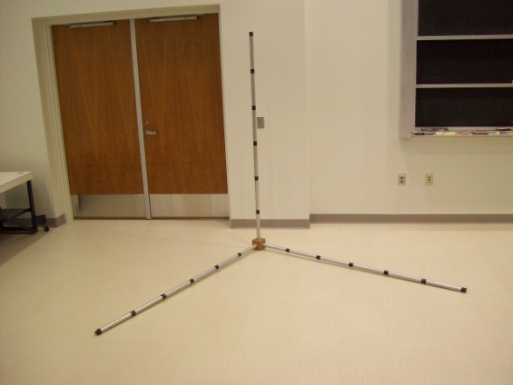
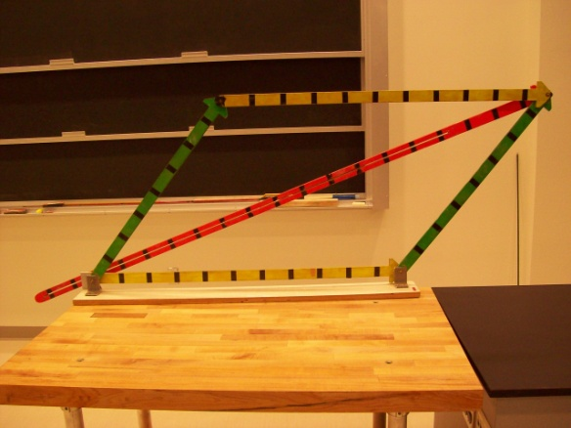
Location: Ba6, BaT
MECHANICS | 1A50.10 | MEASUREMENT

Math Topics

Radian
Disc 05-12
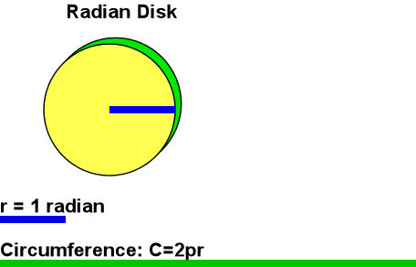 | Show a string with the length of one radius.  Mark off the radii on the circumference of the large white board disk.
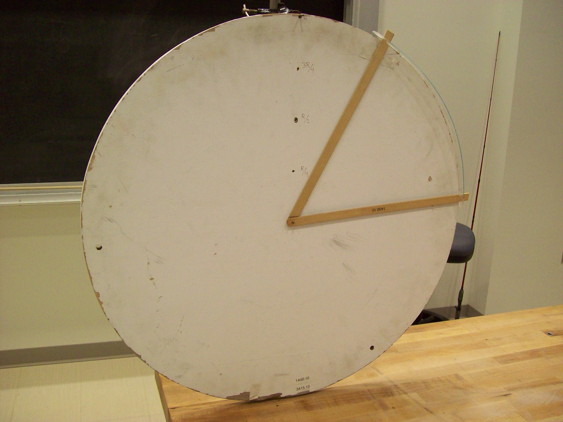
Location: BaT
MECHANICS | 1A60.10 | MEASUREMENT

Scaling

Powers of Ten
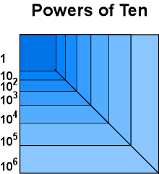 | DVD version  For those that haven't seen this film, it has a picture of a couple having a picnic in a park and the camera starts with a 1 meter frame from 1 meter off the ground, then steps back to a 10 meter frame, then 100 meters frame and continues to the furthest reaches of space. It also goes in the opposite direction into the subatomic regions on the hand of one of the two people in the park. Great film in teaching the significance of using the powers of ten in our world. 17 Minutes  Cosmic Voyage is a glitzier rendition of the same concept. 36 Minutes
Location: Video Cabinet
MECHANICS | 1C10.05 | MOTION IN 1D

Velocity

Ultrasonic Ranger and Student
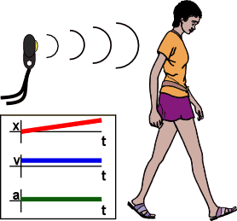 | A student walks toward and away from a sonic ranger. The computer displays graphs of position and velocity Vs. time. Science workshop file “Walking.ds”
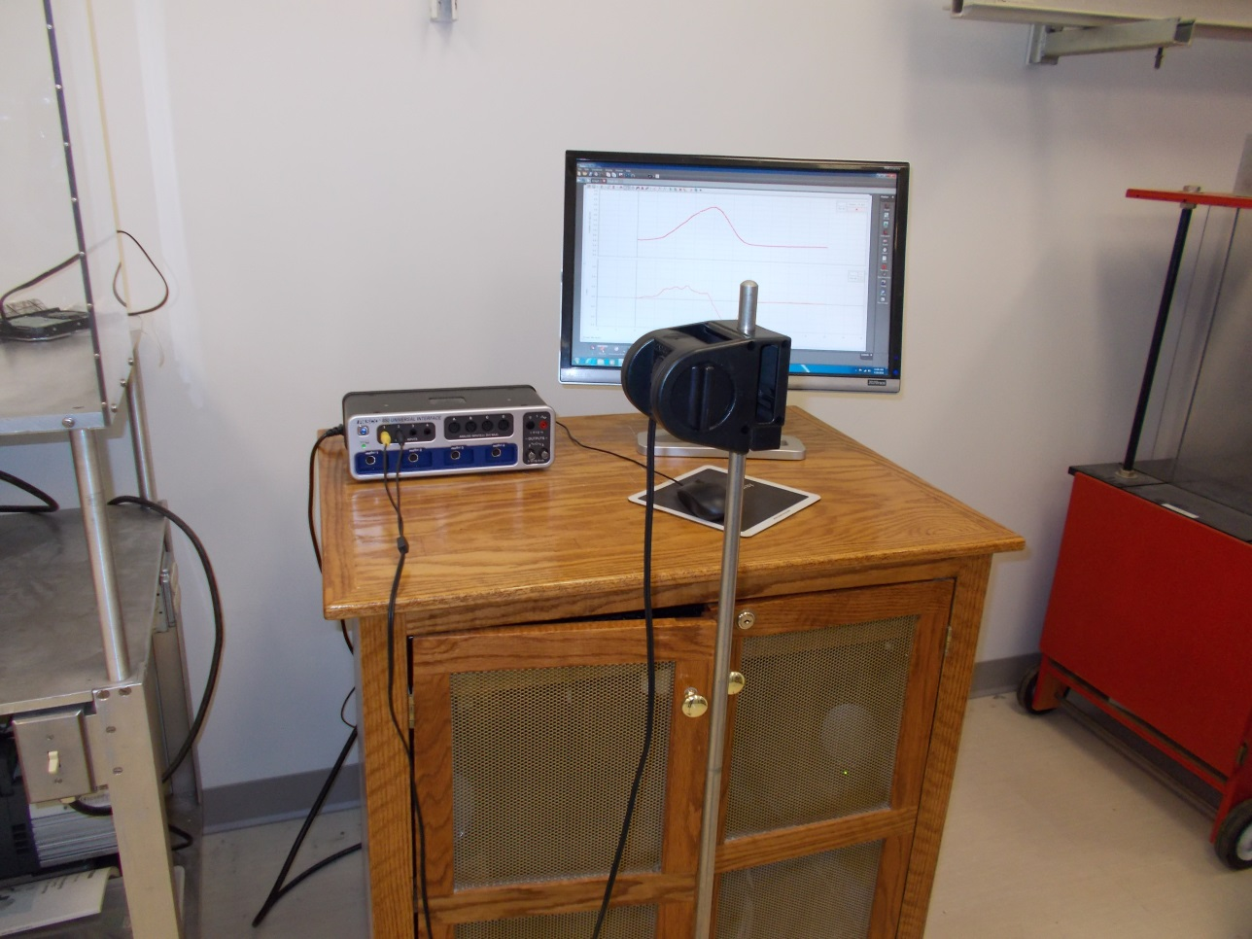
Location: Science Workshop Cabinet
MECHANICS | 1C10.10 | MOTION IN 1D
Velocity

Bulldozer on Moving Sheet
 | The bulldozer on a moving sheet moves in the same direction or opposite direction as the moving sheet, not at an angle, to show the addition and subtraction of velocities. The wooden vectors can be used to illustrate the addition and subtraction. The bulldozer is also used in 1E10.10 and 1N20.15.
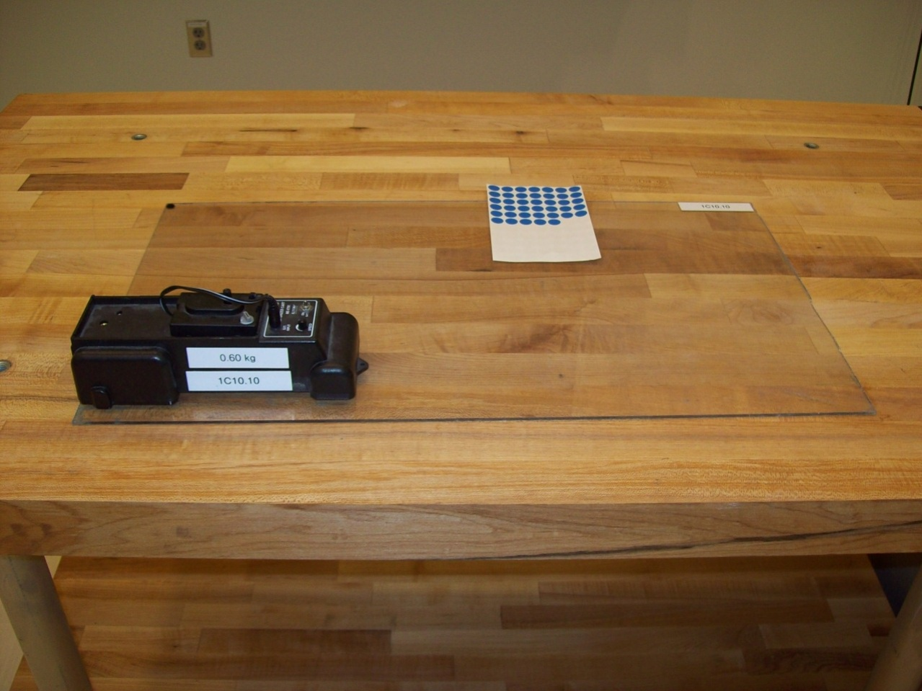
Location:Bb1

MECHANICS | 1C10.20 | MOTION IN 1D
Velocity

PASCO Dynamics Carts
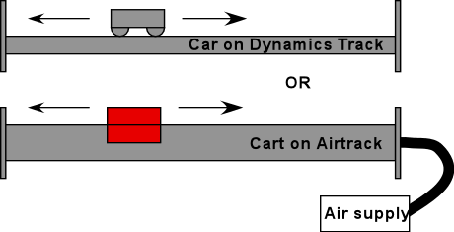 | Demonstrate the principle of velocities with the aid of the Pasco dynamics carts. Use Capstone file Pasco Dynamics Carts, 2 Photogates.cap
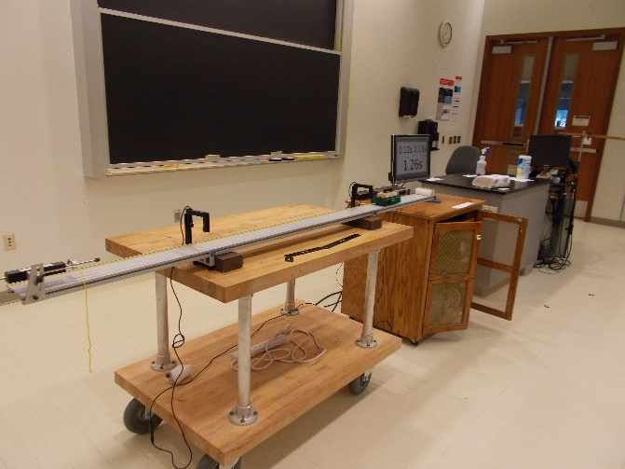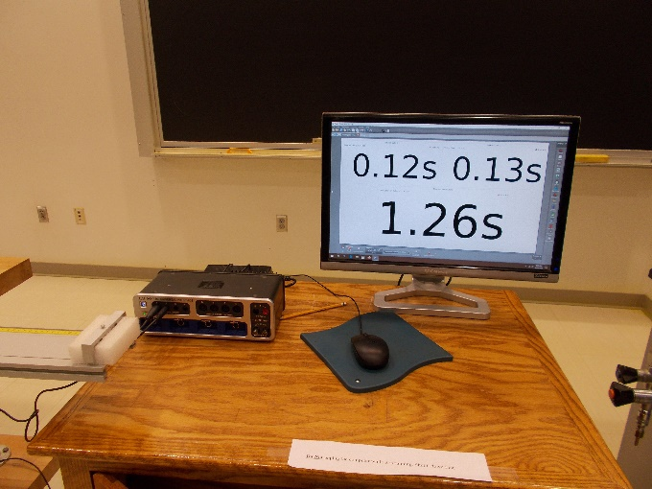
Location: Bb2, Bc3, AcT
MECHANICS | 1C10.30 | MOTION IN 1D
Velocity

Approaching Instantaneous Velocity
 | A dynamics cart is given a reproducible velocity by a spring loaded launcher. Flags of decreasing length interrupt a photogate timer. Use Capstone file Pasco Dynamics Cart, 1 Photogate.cap.
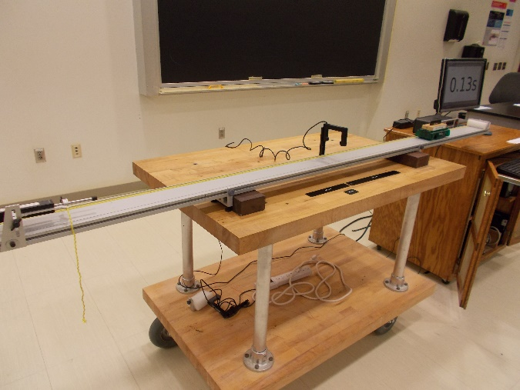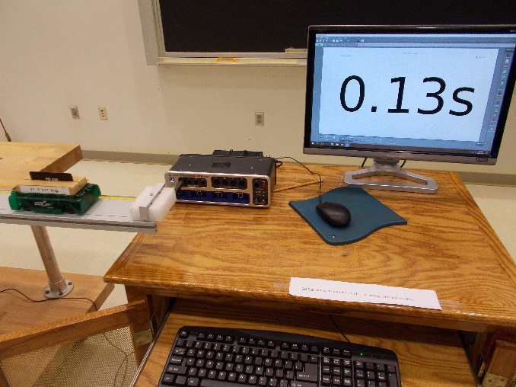
Location Bb2, Bc2, AcT
MECHANICS | 1C20.10 | MOTION IN 1D

Uniform Acceleration

Penny and Feather
Disc 01-04
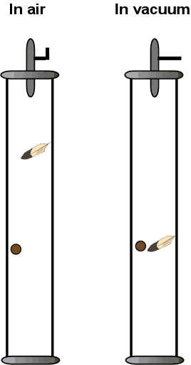 | We use a ball and feather that are resting on a shelf held up by a magnet. When the release button is pressed, a pulse to a coil cancels the magnetic field and the ball and feather fall. Another ball and feather set is provided so that what happens in the presence of the atmosphere can be shown. To prevent premature release, leave the signal cable unplugged from the control box until you’re ready to do the demonstration.  The tube is about 150cm long.
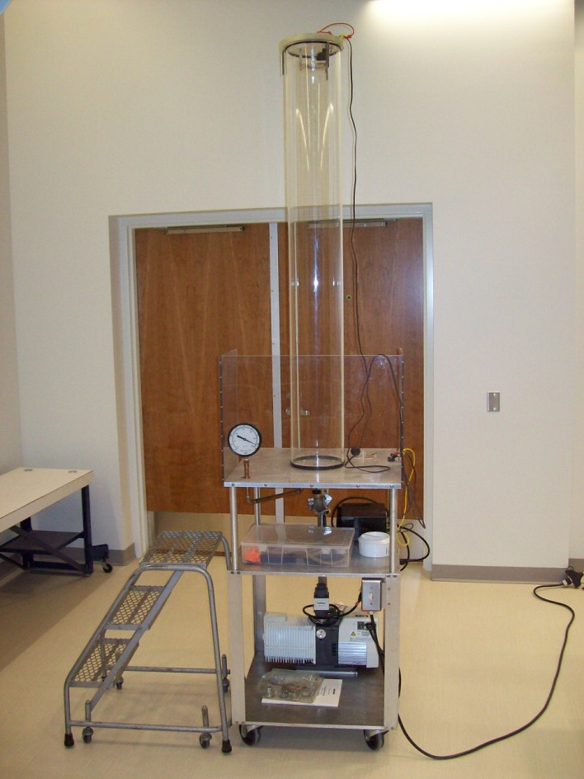
Location: Bb3, Ca1
MECHANICS | 1C20.18 | MOTION IN 1D
Uniform Acceleration

Freefall and Air Resistance
 | Use Capstone (Free Fall.cap) to plot the position and velocity of a medicine ball as it is thrown up toward the motion sensor. The motion sensor is mounted 2 meters above the floor and the program is set up to begin recording data when the object is within 0.5 m of it. So throw the ball up vertically toward the sensor from about 0.75 meter above the floor. Repeat using a beach ball. An assistant to toss the balls is helpful
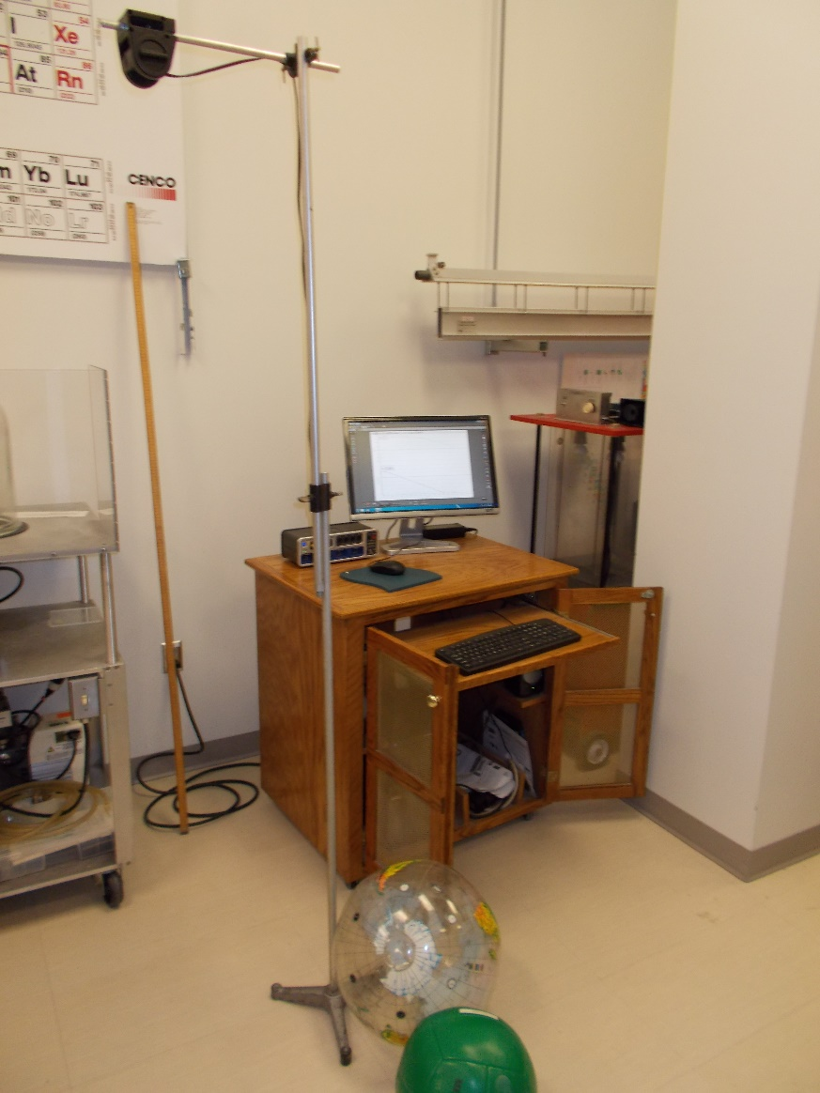
Location: Science Workshop, Db2, Ea3
MECHANICS | 1C20.20 | MOTION IN 1D
Uniform Acceleration

Equal Time, Equal Distance Drop
 | Climb a ladder and drop two long strings with balls – one with equal distance intervals and the other with equal time intervals. The bottom ball should be touching the plastic bin. Listen to the sounds of the balls sequentially hitting the floor
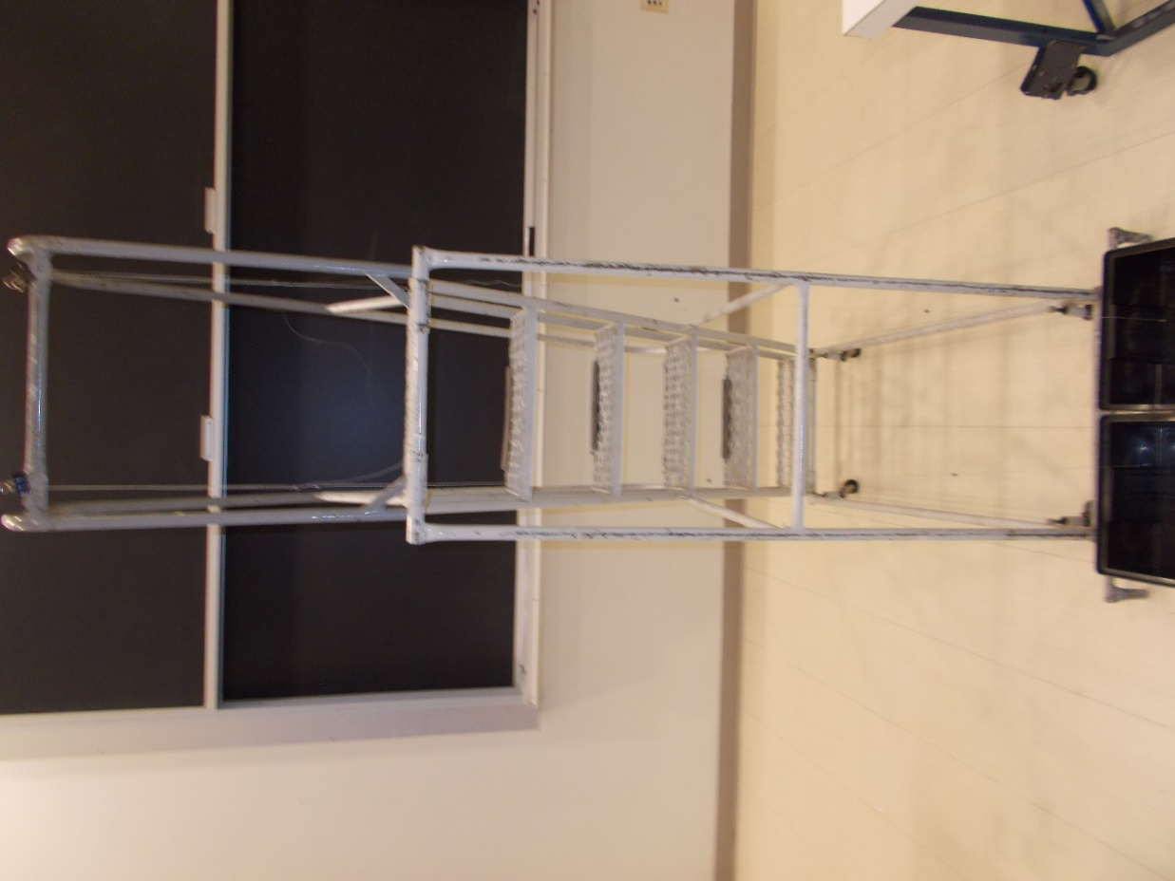
Location: Bb4

MECHANICS | 1C20.30a | MOTION IN 1D
Uniform Acceleration

Inclined Dynamics Track (Smart Cart)
 | Use a Smart Cart to measure the distance, velocity and acceleration as a function of time. Capstone file “Smart Cart on an Incline”. Note; The interface box is not necessary, just the BlueTooth USB plug-in.
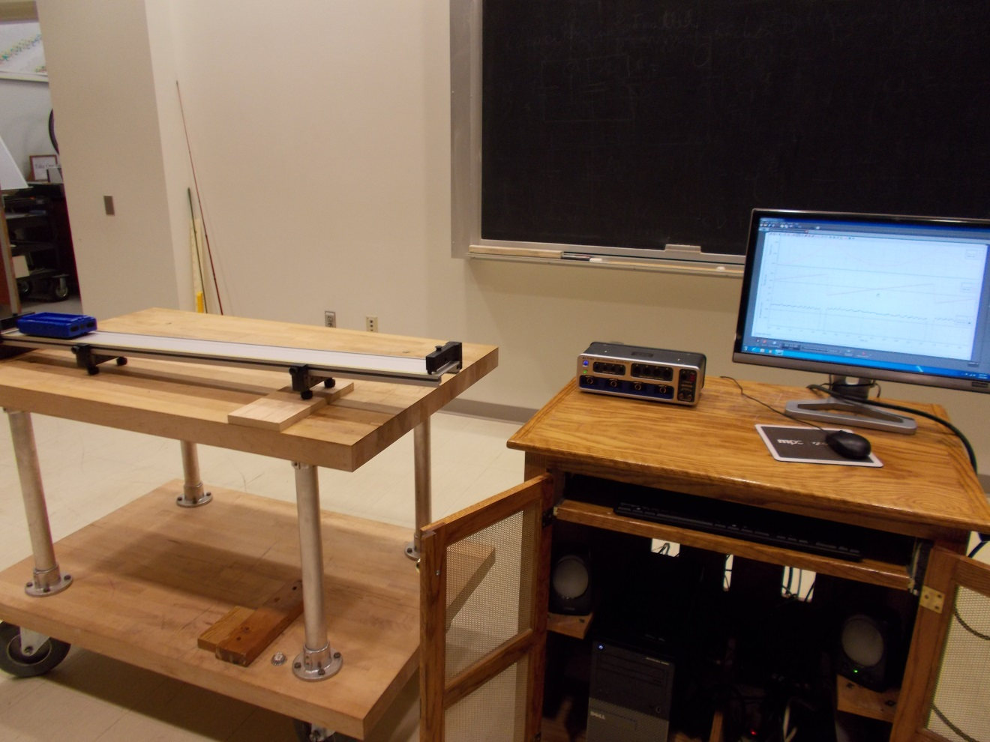Location: Bb2, Cb1

MECHANICS | 1C20.30b | MOTION IN 1D
Uniform Acceleration

Inclined Dynamics Track (photogates)
 | Timing on an inclined track. The photogates are connected to timers that measure the time it takes for the flag to pass through the photogates and the time interval between the gates. Use Capstone file Cart on an incline, 2 photogates.cap
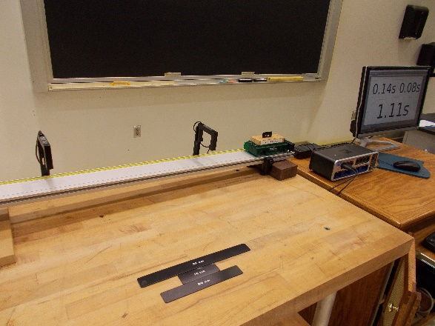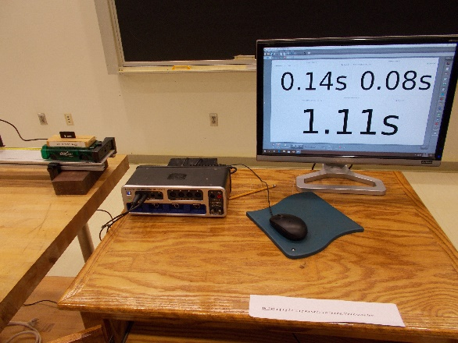
Location: Bb2, Bc2, Cb1
MECHANICS | 1C20.45 | MOTION IN 1D
Uniform Acceleration

Galilean Inclined Plane
 | The passage of a ball down a 225 cm grooved incline and onto a horizontal section (150 cm long) is timed using a metronome. The metronome is set so that the ball rolls down from the 25 cm mark on the incline in one click. (The horizontal section is shimmed to compensate for friction.) It will then take two clicks when released from 100 cm and 3 clicks when released from 225 cm. The flat portion is covered in 3 clicks when the ball is released from the 25 cm mark, 1.5 clicks, and one click when released from the 100 and 225 cm marks respectively (the final speed on the horizontal being twice the average on the incline).
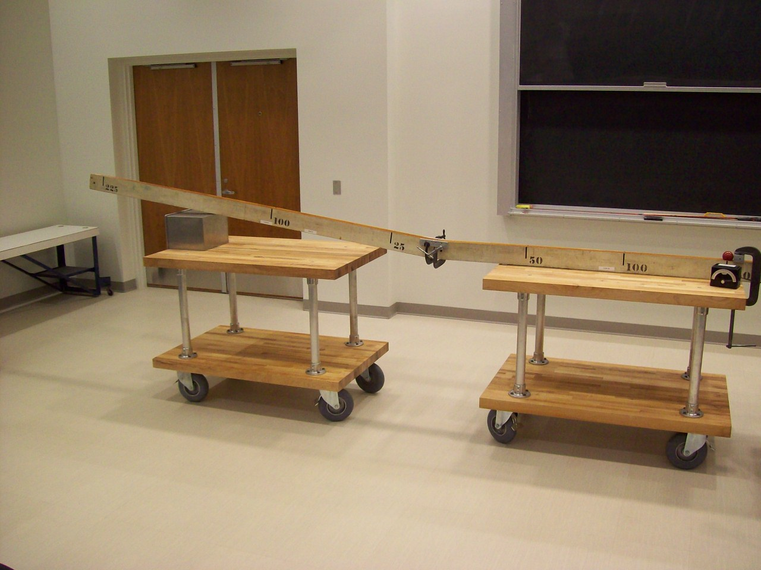
Location: AcT
MECHANICS | 1C30.10 | MOTION IN 1D

Measuring g

PASCO Free Fall
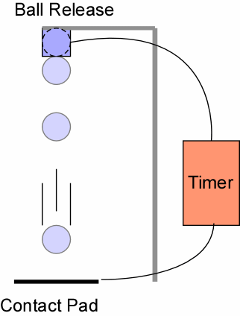 | The ball can be released from different heights, say 1m and 2m. Use the Capstone file Free Fall Timer.cap  Place the ball on the magnet. Clear the old data and click on the start button. Press the release button. The ball will drop and the timer will start. The timer stops when the ball strikes the pad. Move ball release to a new position and repeat.  Gives g to within 5%.
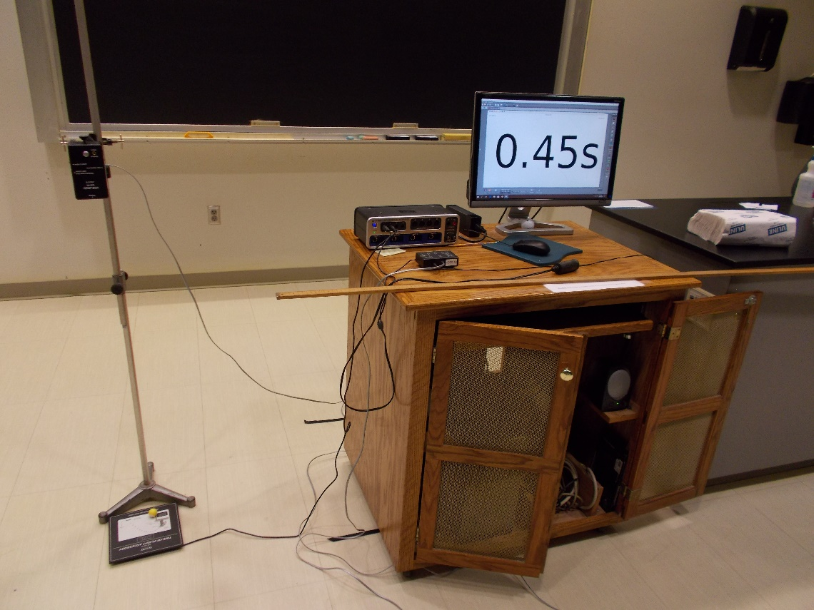
Location: Bb4

MECHANICS | 1D10.20 | MOTION IN TWO DIMENSIONS

Displacement in Two Dimensions

Cycloid Generator
 | A disc with a piece of chalk at the edge is rolled along the chalk tray..
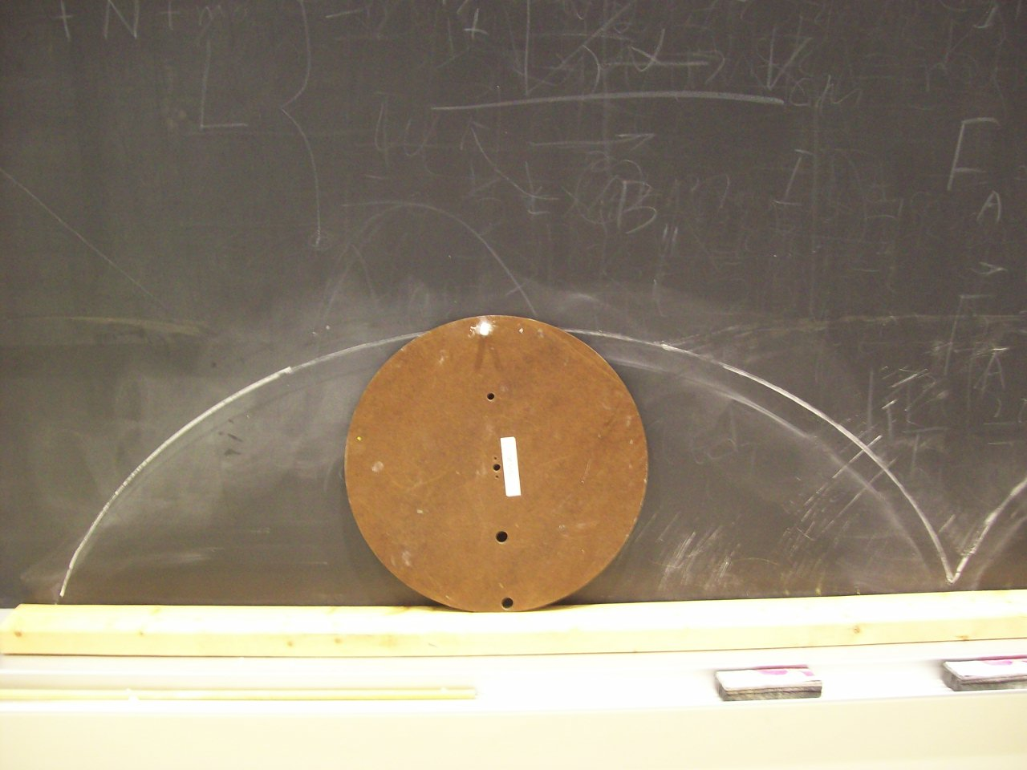
Location: Ca2, GcT

MECHANICS | 1D10.40 | MOTION IN 2D
Displacement in Two Dimensions

Mounted Wheel
 | A bicycle wheel is mounted vertically and used to illustrate motion in a circle.
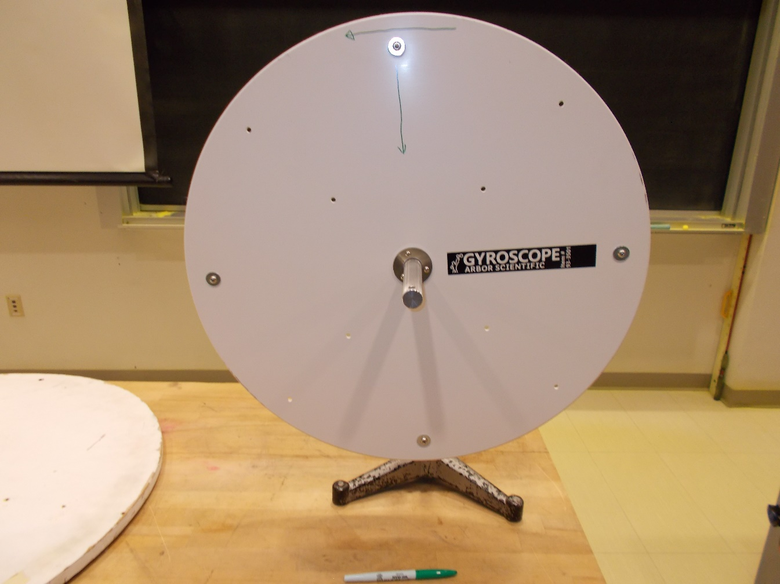
Location: Bb5

MECHANICS | 1D10.60 | MOTION IN 2D
Displacement in Two Dimensions

Measuring Angular Velocity
 | Use an electronic strobe to measure the angular velocity of a fan blade.
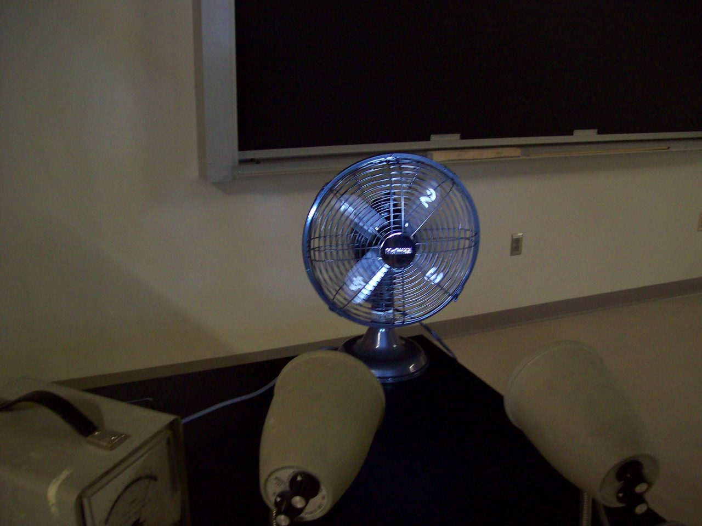
Location: Bb5

MECHANICS | 1D15.20, 1D15.50 | MOTION IN TWO DIMENSIONS

Velocity, Position and acceleration

High Road – Low Road, Brachistochrone
Release two balls at the same time and ask students to predict which will reach the end of the track first.
The lowest track is a brachistochrone.

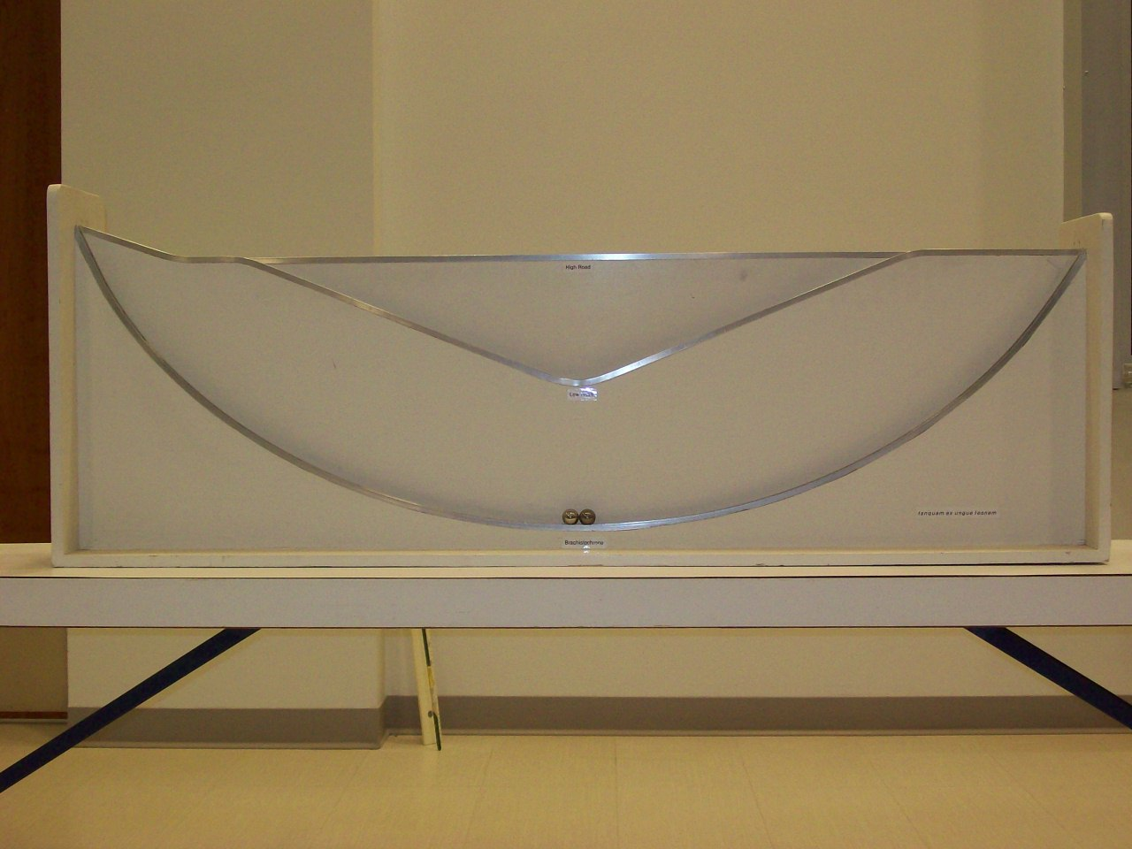Location: Unistrut

MECHANICS | 1D40.10 | MOTION IN 2D

Motion of the Center of Mass

Throw Objects
Disc 03-21
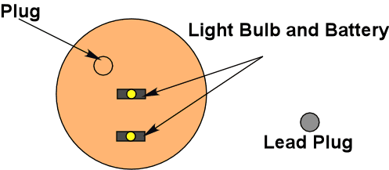 | The foam rectangle has a weighted plug in it. The blue LED is located at the center of mass and the red one is at the geometric center. The LED’s can be turned on individually. Give it a toss with a spin about an axis perpendicular to its plane so the students can see the motion of the center of mass compared to the geometric center.
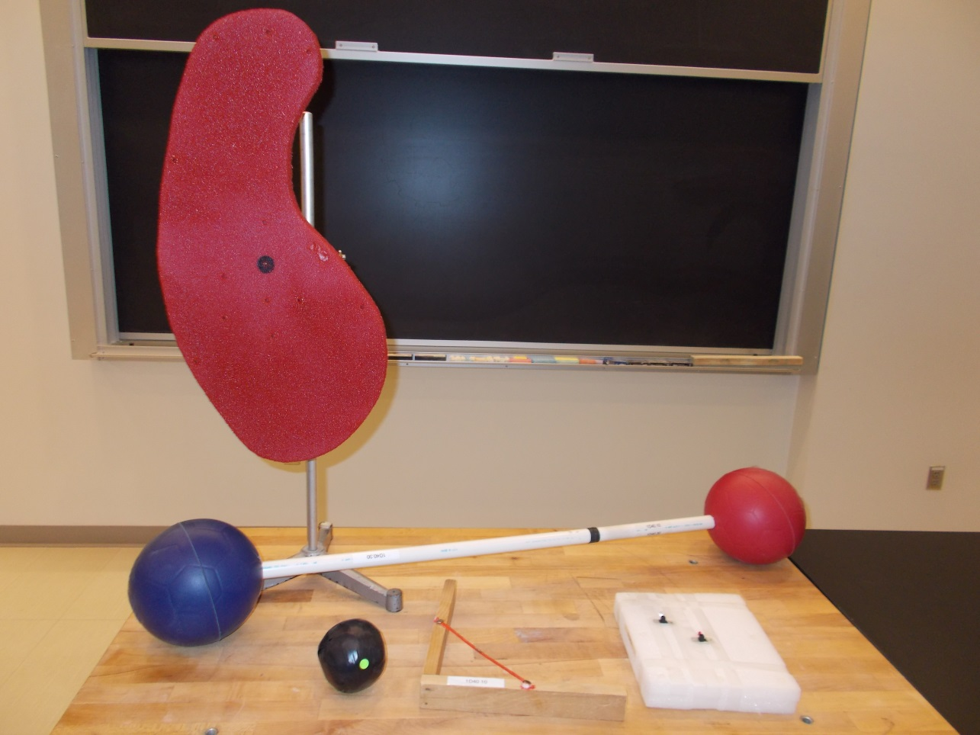
Location: Bb6
MECHANICS | 1D40.30 | MOTION IN 2D
Motion of the Center of Mass

Throw the Dumbbell
 | A dumbbell with unequal masses is thrown without rotation when the force is applied at the center of mass.
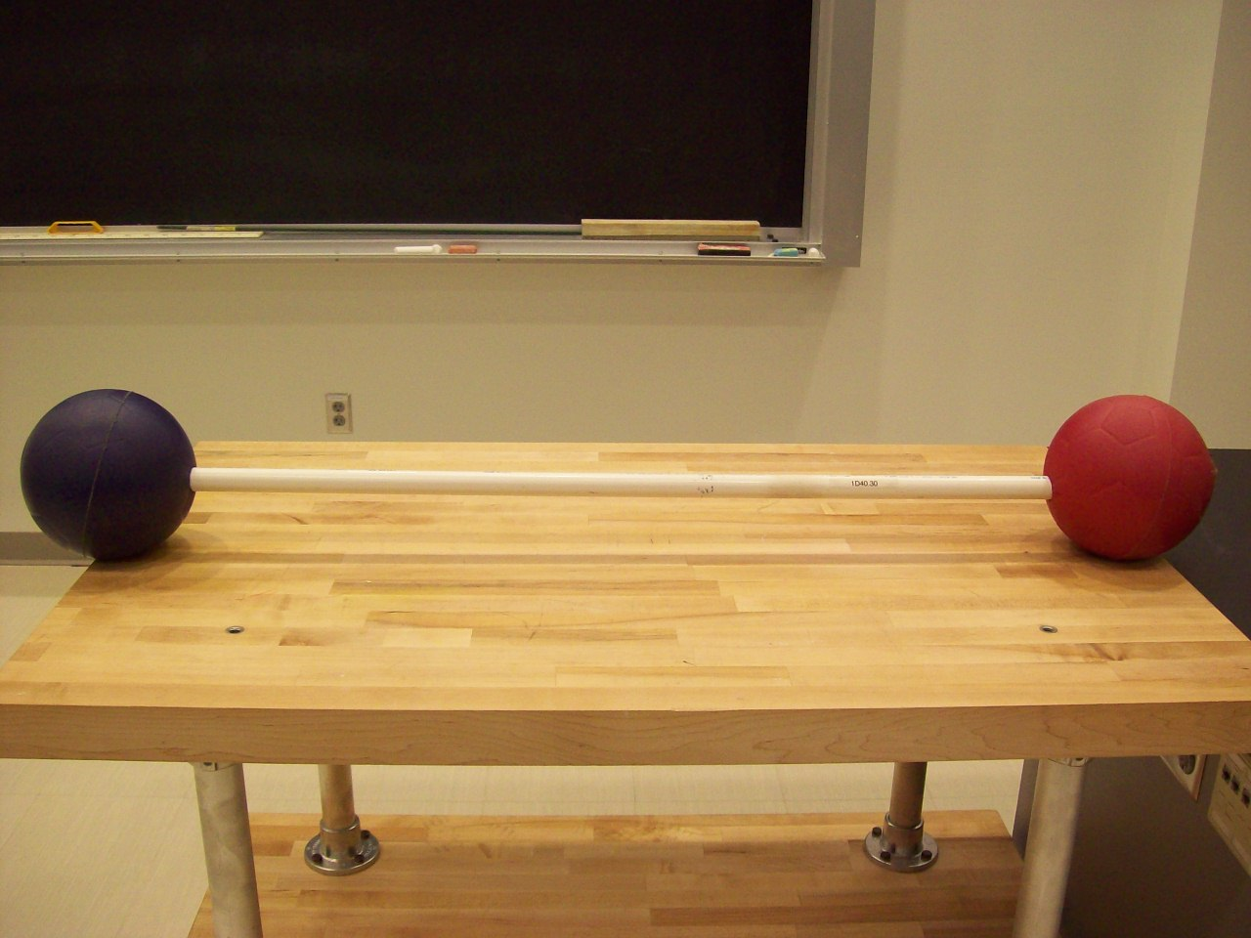
Location: BbT
MECHANICS | 1D40.35 | MOTION IN 2D
Motion of the Center of Mass

Earth-Moon System
 | Two unequal masses (27 and 70 grams) connected by a string and free to slide along a horizontal rod are spun about a vertical axle. If the center of mass of the system is not near the center of rotation, the masses will slide to one side or the other.
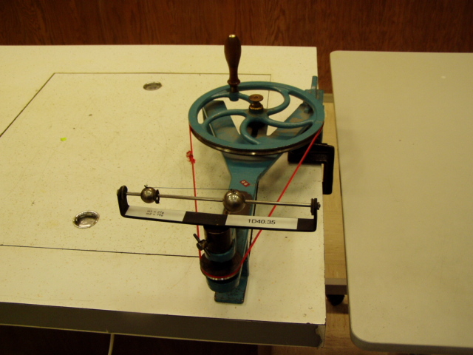Location: Bb6
MECHANICS | 1D40.50 | MOTION IN 2D
Motion of the Center of Mass

Air Track Pendulum Glider
 | A double pendulum hangs from an air track cart with a mounted spot marking the center of mass. Set the system in motion and the spot will remain still or translate smoothly.
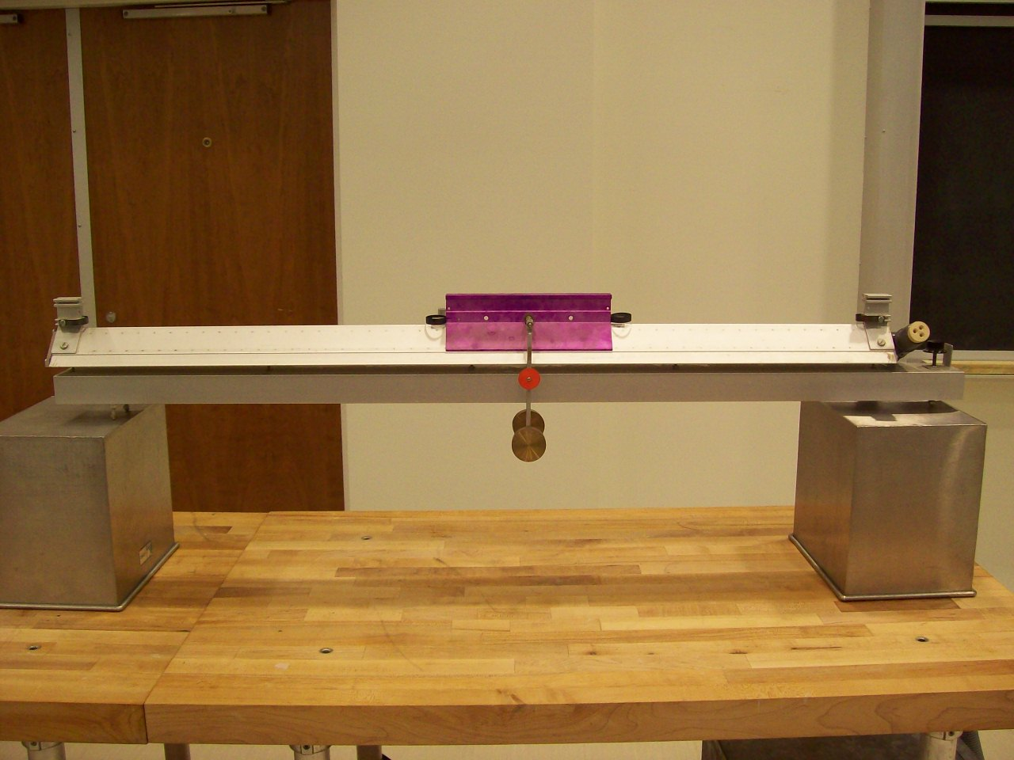Location: Bb6
MECHANICS | 1D40.51 | MOTION IN 2D
Motion of the Center of Mass

Momentum Pendulum
 | A massive pendulum is mounted on a car.
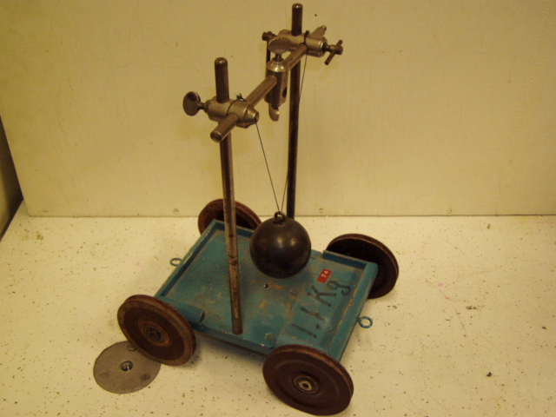Location: Bb6
MECHANICS | 1D50.10 | MOTION IN 2D

Central Forces

Ball on a String
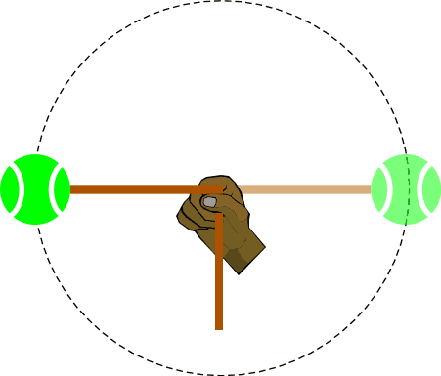 | A ball (we use a bean bag) tried to a string. Twirl in a vertical direction so students can see the path of the ball.
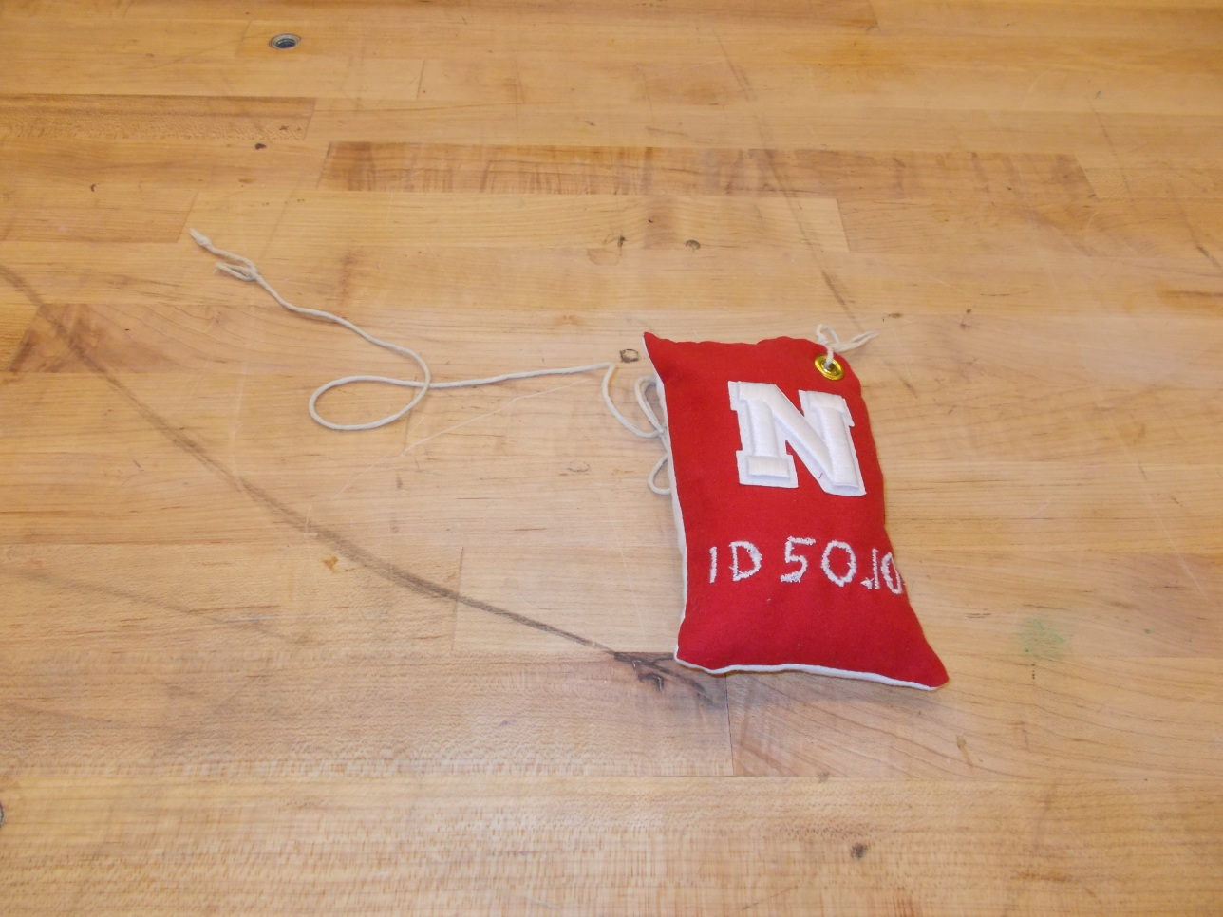
Location: Bb7
MECHANICS | 1D50.20 | MOTION IN 2D
Central Forces

Ball on Cord
 | A string with a ball on one end passes through a wooden sleeve and weights are attached at the other end. A metronome can be used to time the rotation period. If the length of the string is measured, the centripetal force can be calculated and compared with the tension in the string that the hanging weight provides.
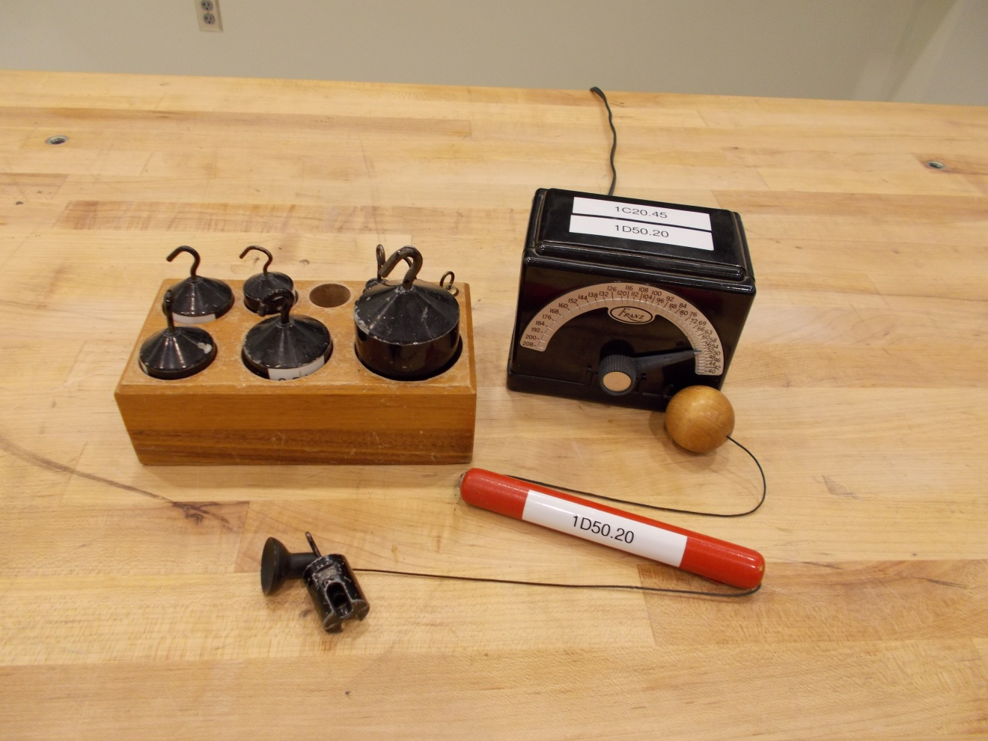Location: Bb7
MECHANICS | 1D50.25 | MOTION IN 2D
Central Forces

Conical Pendulum
 | A ball hanging from a string serves as a conical pendulum. One can also use the bowling ball pendulum
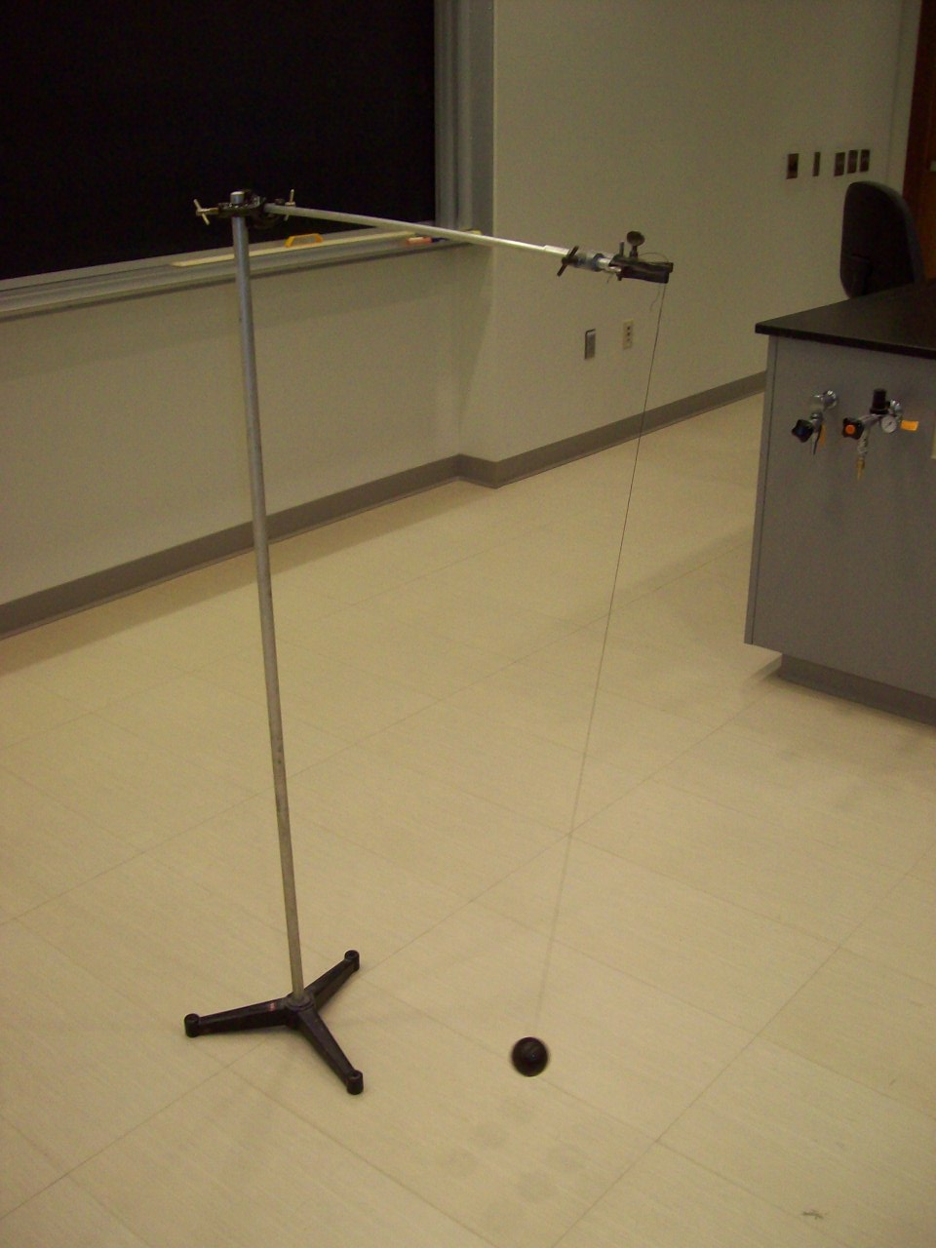
Location: Eb1
MECHANICS | 1D50.30 | MOTION IN 2D
Central Forces

Carnival Ride Model
 | A small block is held vertical against the side of a rotating jar.
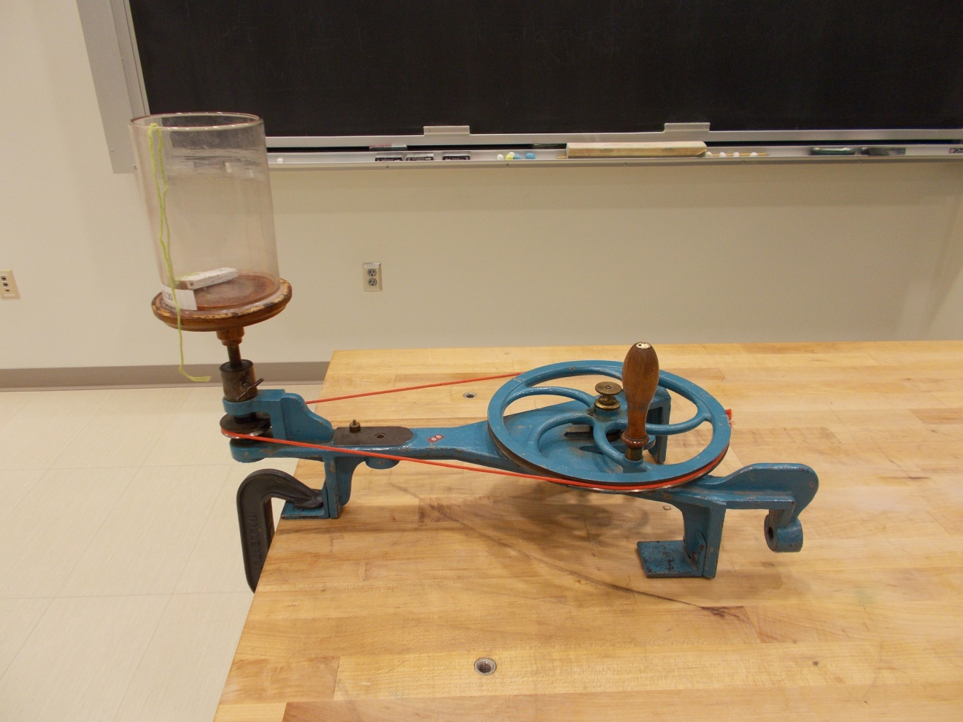Location: Bb8
MECHANICS | 1D50.40 | MOTION IN 2D
Central Forces

Pail of Water, Pail of Nails
Disc 05-21
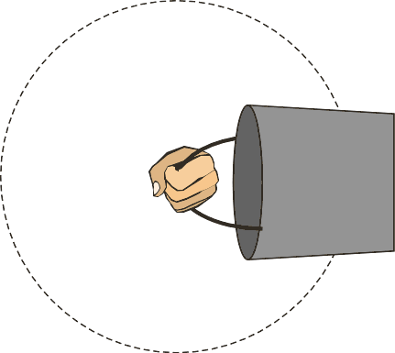 | Swing a pail filled with water in a large vertical circle just fast enough so that the water doesn't spill out.  The pail may also be filled with nails. They can be heard dropping away and hitting the pail at the top of the swing, if swung just right.
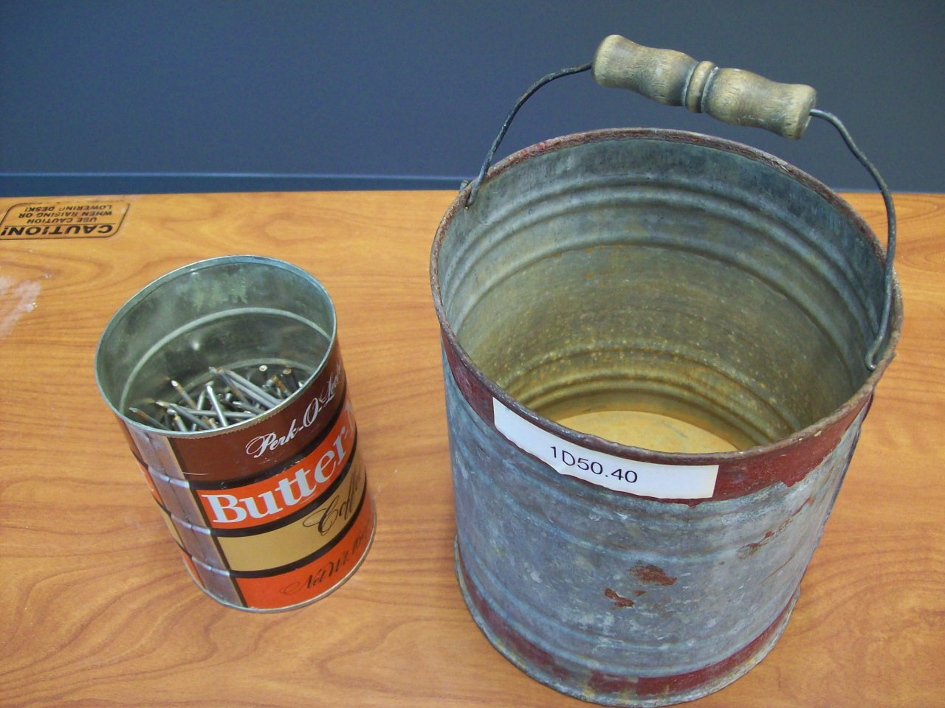
Location: Bb7

MECHANICS | 1D50.50 | MOTION IN 2D
Central Forces

Centripetal Force Apparatus
The Pasco apparatus can be used to plot force v. angular velocity. The mass used is 0.250 kg. Capstone file: Centripetal Force.
Also shown is a photograph of more qualitative apparatus that is hand cranked
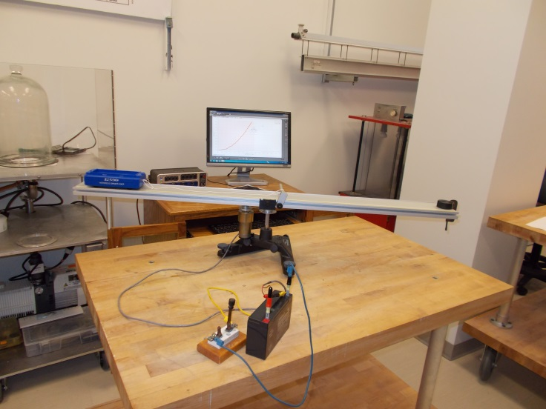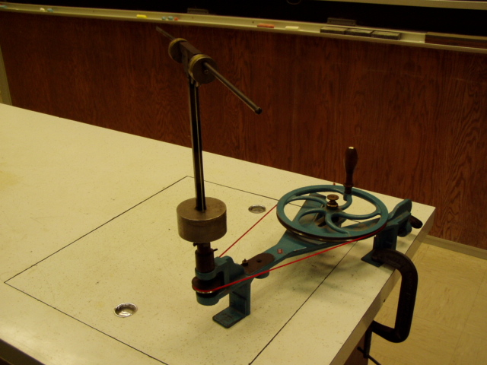
Location: Bb7, Bc3
MECHANICS | 1D52.10 | MOTION IN 2D

Deformation by Central Forces

Flattening Earth
 | Flexible hoops when spun on a hand crank rotator.
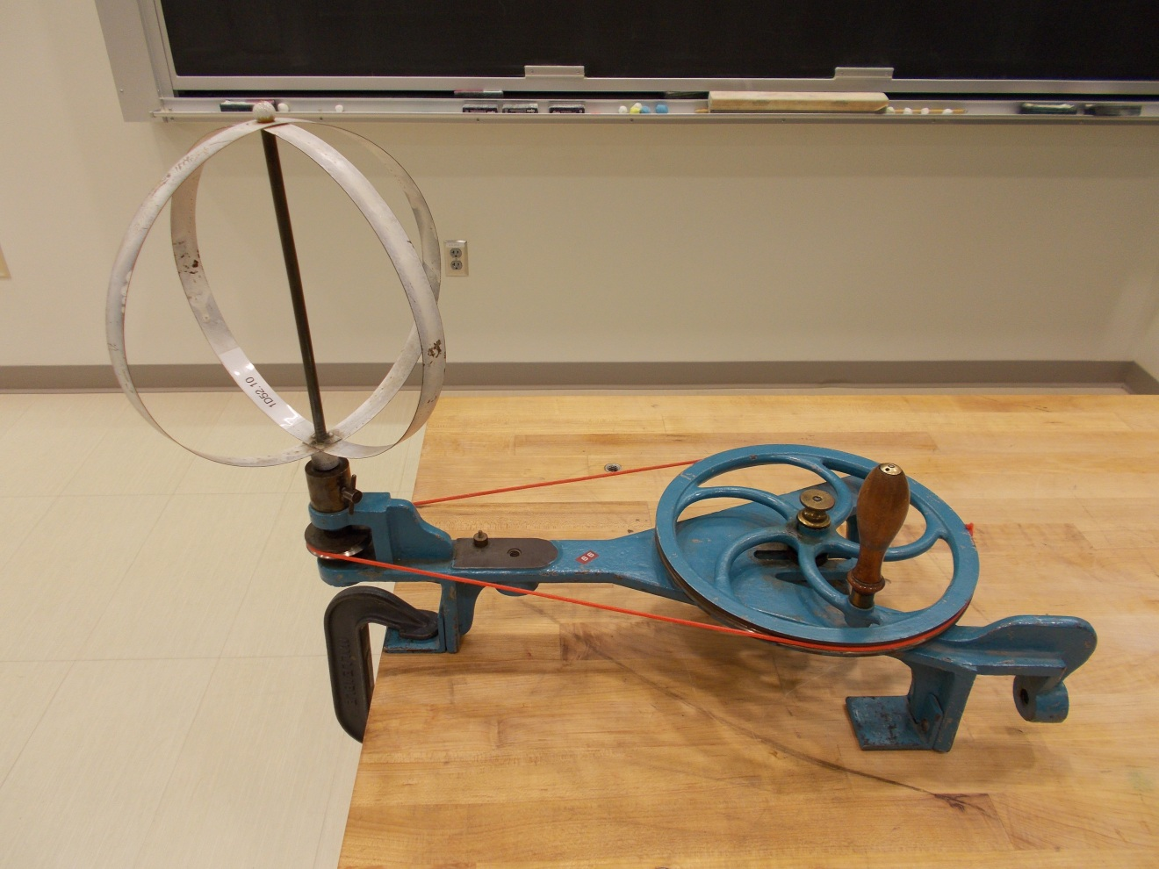Location: Bb8
MECHANICS | 1D52.20 | MOTION IN 2D
Deformation by Central Forces

Water Parabola
 | A paraboloid is formed when a liquid is rotated.
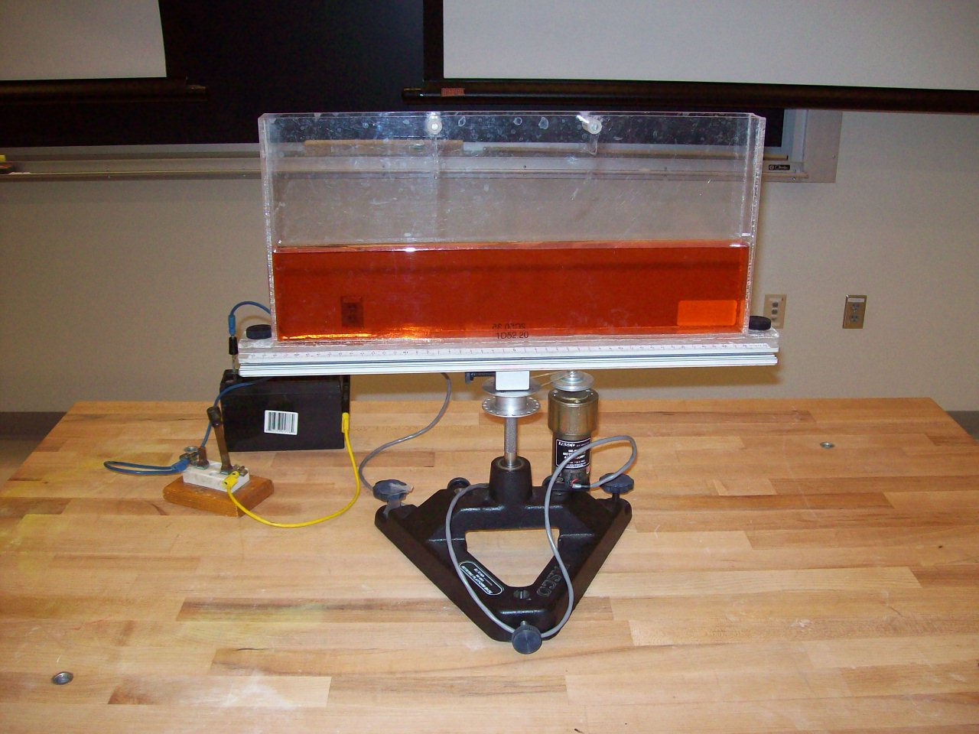
Location: Bc3

MECHANICS | 1D52.33 | MOTION IN 2D
Deformation by Central Forces

Rotating Corks in Water
 | Corks tied to the bottom of two jars full of water are first translated on a cart and then rotated about a pivot.
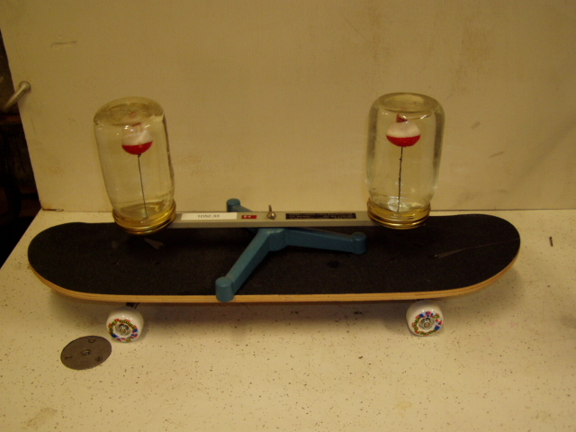Location: Bb7
MECHANICS | 1D55.15 | MOTION IN 2D

Centrifugal Escape

Release the String
 | Whirl the bean bag overhead in a horizontal circle. A metronome can be used to synchronize the position of the bean bag. It can then be released on the beat and its direction of travel noted as a consequence of the First Law.
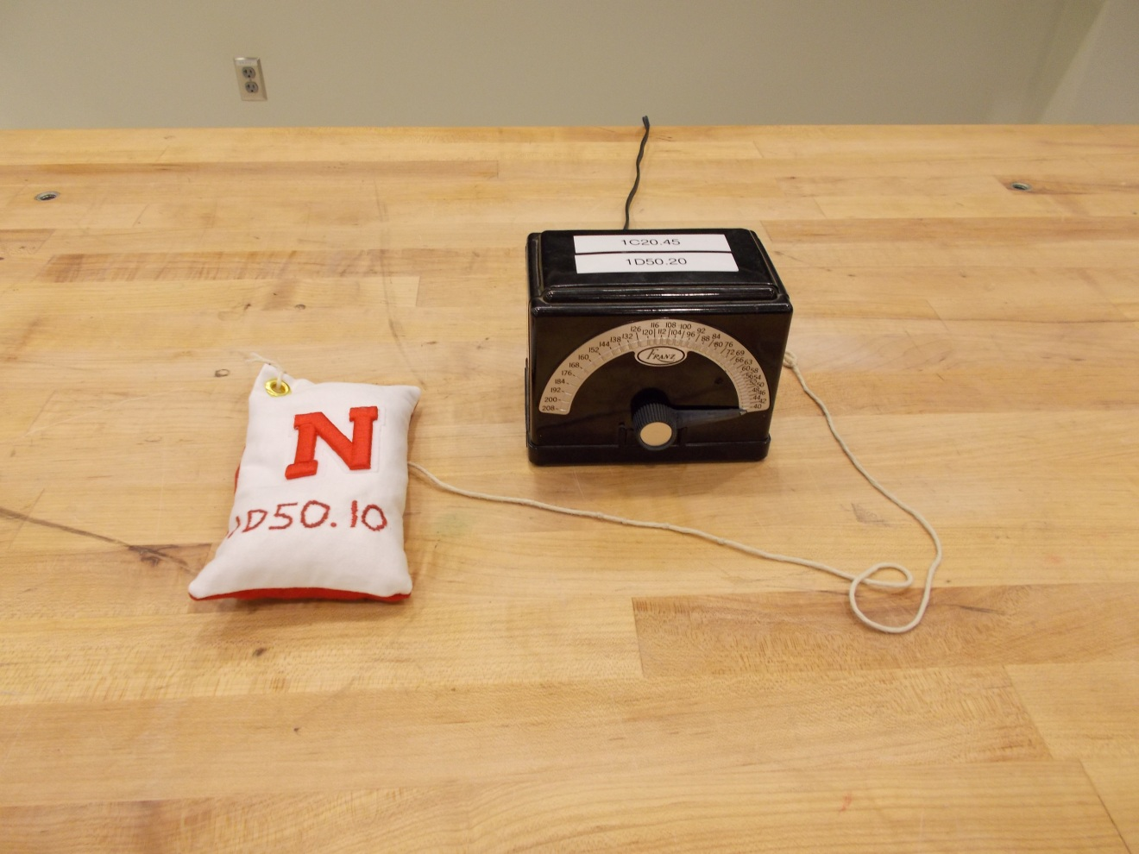Location: Bb7
MECHANICS | 1D55.30 | MOTION IN 2D
Centrifugal Escape

Falling off the Merry-go-round
 | A large turntable is rotated until objects slide or tip over. The blocks shown in the photograph have different surfaces on them with differing coefficients of friction.
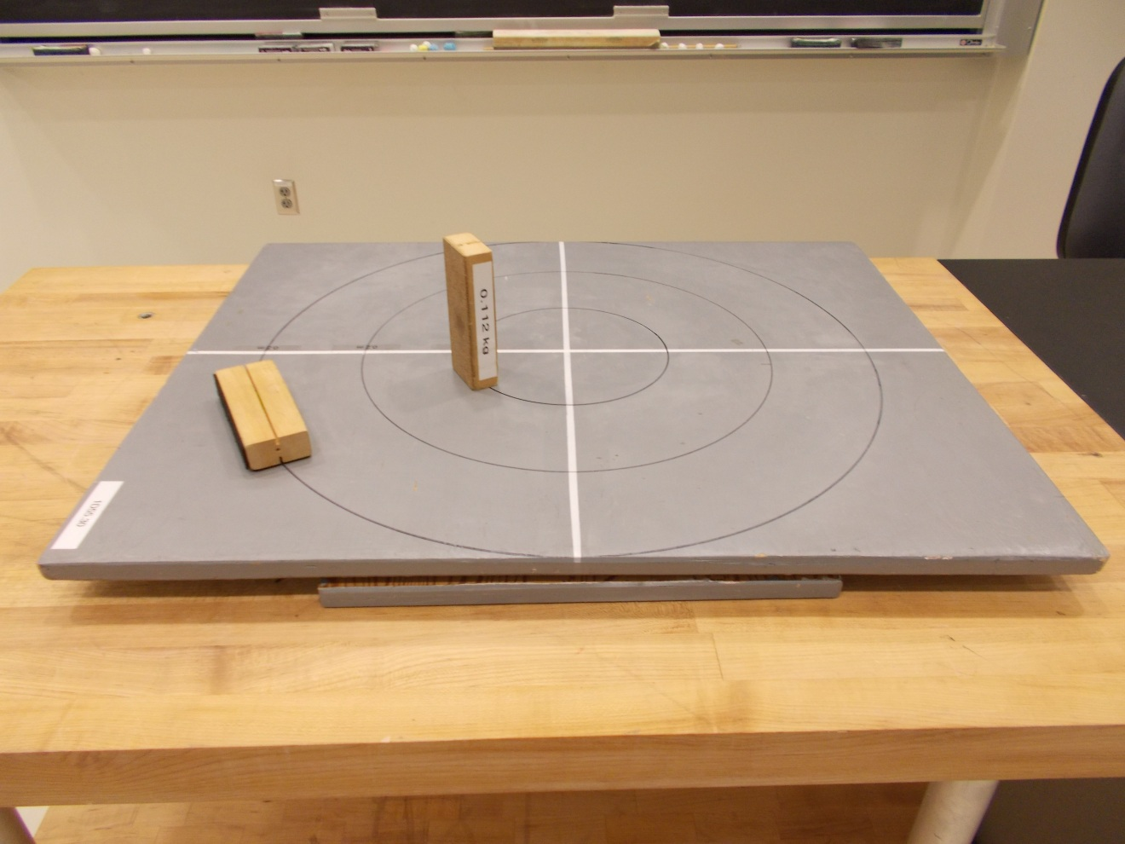Location: BcT, Ca3
MECHANICS | 1D60.10, 1D60.15 | MOTION IN 2D

Projectile Motion

Howitzer and Tunnel
Disc 02-03
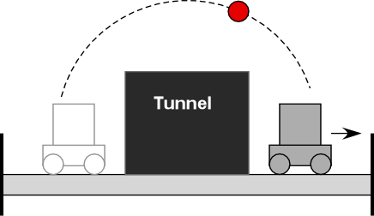 | Set the trigger on the cart. Give the cart a strong push towards the tunnel. If the ball hits the tunnel, you've not pushed the cart hard enough. Track is 10 feet long. This can also be done with track inclined by propping up one end of the track with a block.
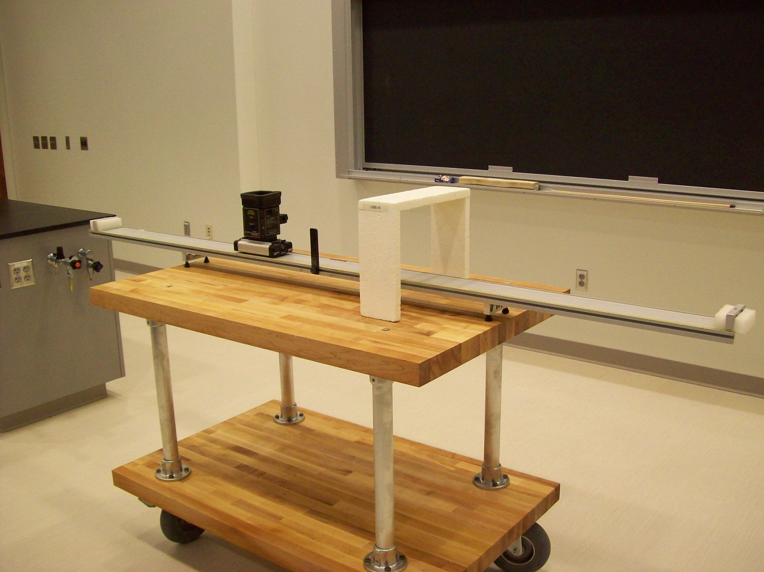
Location: Bc1
MECHANICS | 1D60.20 | MOTION IN 2D
Projectile Motion

Simultaneous Fall
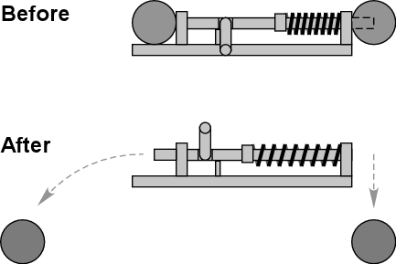 | A spring loaded device drops one ball and projects the other horizontally.
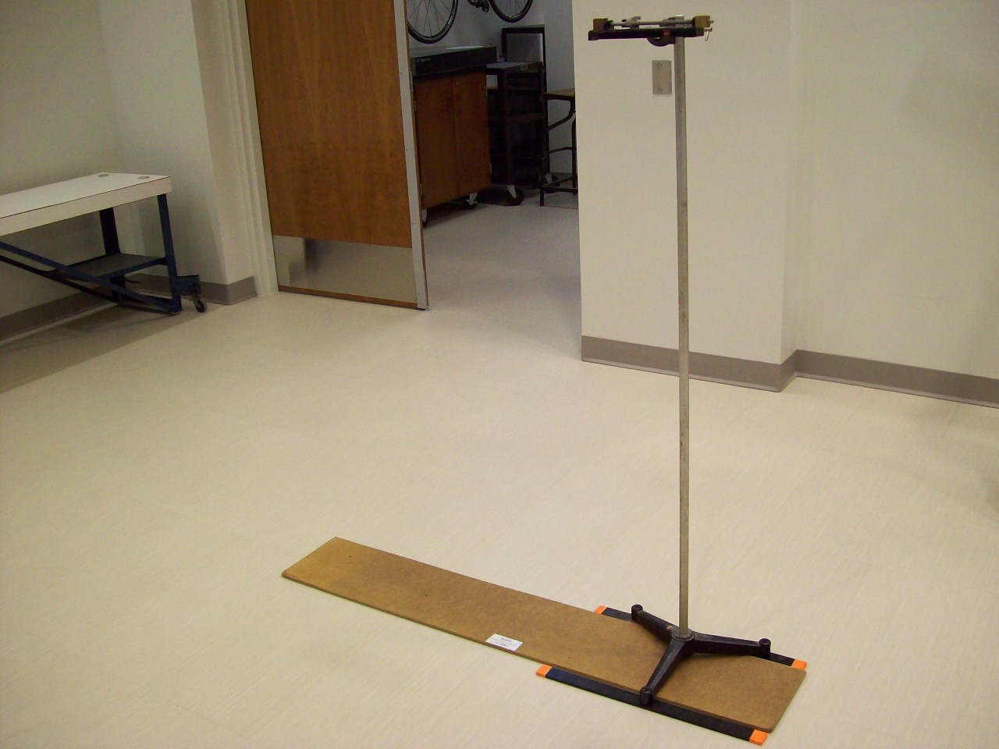
Location: Bc1
MECHANICS | 1D60.30 | MOTION IN 2D
Projectile Motion

Monkey and Hunter
Disc 02-02
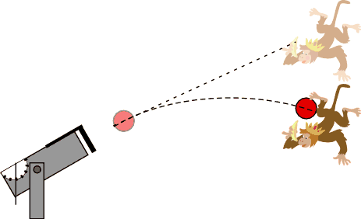 | Aim the cannon at the monkey when the monkey is held up high. When the ball leaves the cannon, the monkey should drop. The ball will hit the monkey since they fall at the same rate. Lower velocity means each falls a greater distance before hitting.
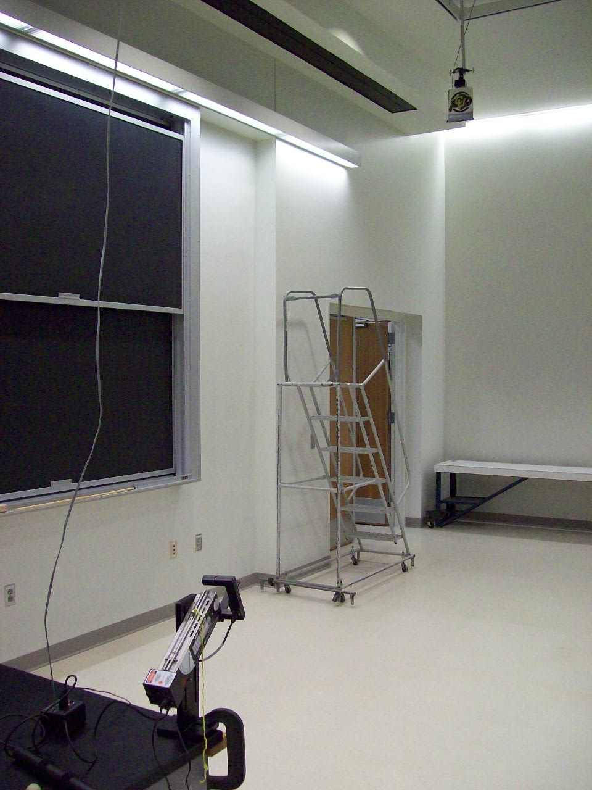
Location: Bc1
MECHANICS | 1D60.40 | MOTION IN 2D
Projectile Motion

Range of a Gun
 | Load a ball and cock the gun to the first stop. Aim the cannon so that the ball hits the pad. Use the Capstone file Range of a Gun.cap. Click on the record button and then launch the ball. The velocity of the ball between the gates and the total time of flight are shown on the monitor. The elevation is displayed on the side of the gun using a plumb bob.
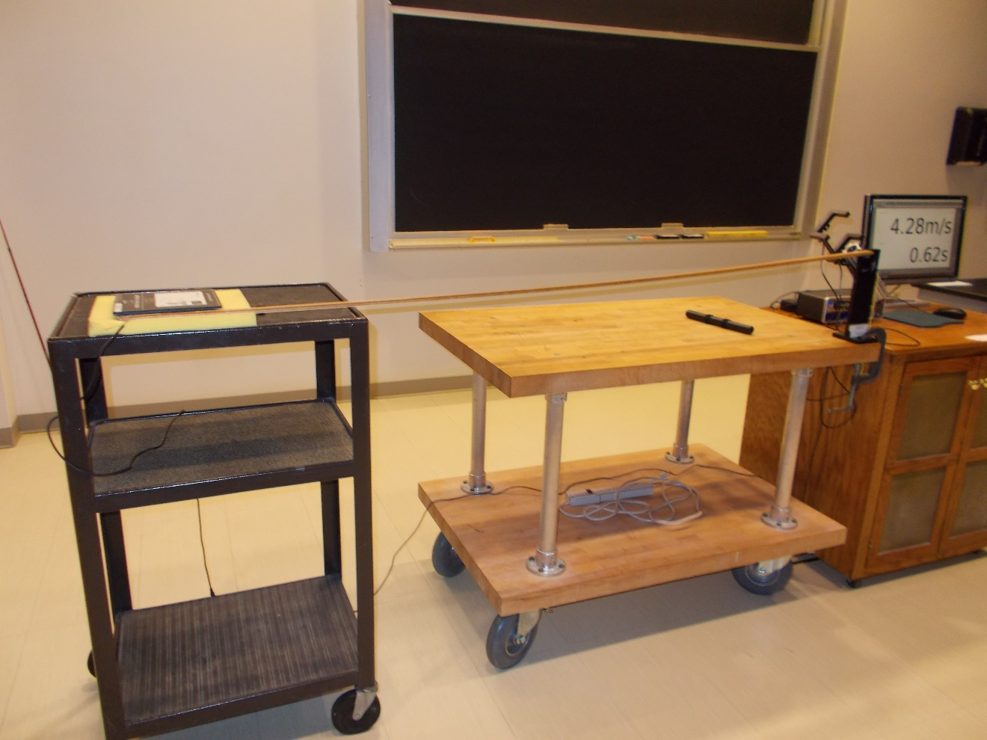Location: Bb4,Bc1
MECHANICS | 1D60.65 | MOTION IN 2D
Projectile Motion

Parabolic Trajectory
 | Streams of water from nozzles are aimed at various angles (70, 60, 45, 30 and 20 degrees) to show a parabolic trajectories and range.
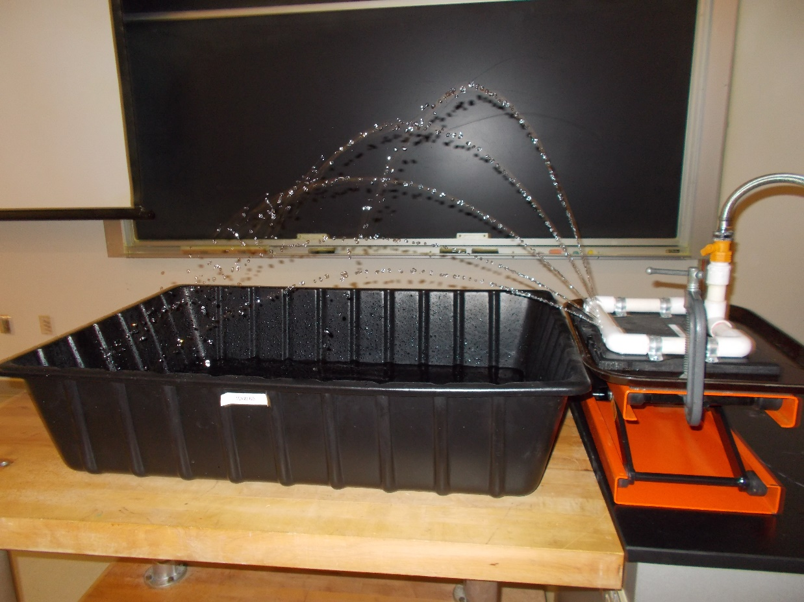
Location: Ac2
MECHANICS | 1E10.10 | RELATIVE MOTION

Moving Reference Frames

Bulldozer on Moving Sheet
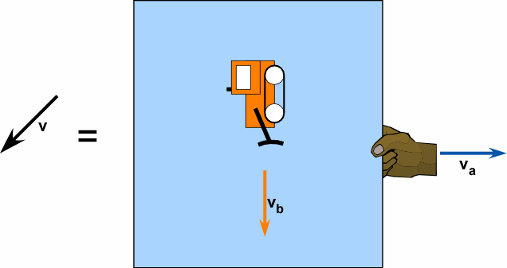 | This is a demonstration of “The Boat Crossing a River” problem.  The bulldozer moves perpendicular across a pulled sheet of paper moving at half the speed of the bulldozer or at the same speed.  Demonstrate superposition principle of velocities by pulling on the sheet below the moving bulldozer. Adjust the “bulldozer” so it travels the length of the sheet when you press the button.
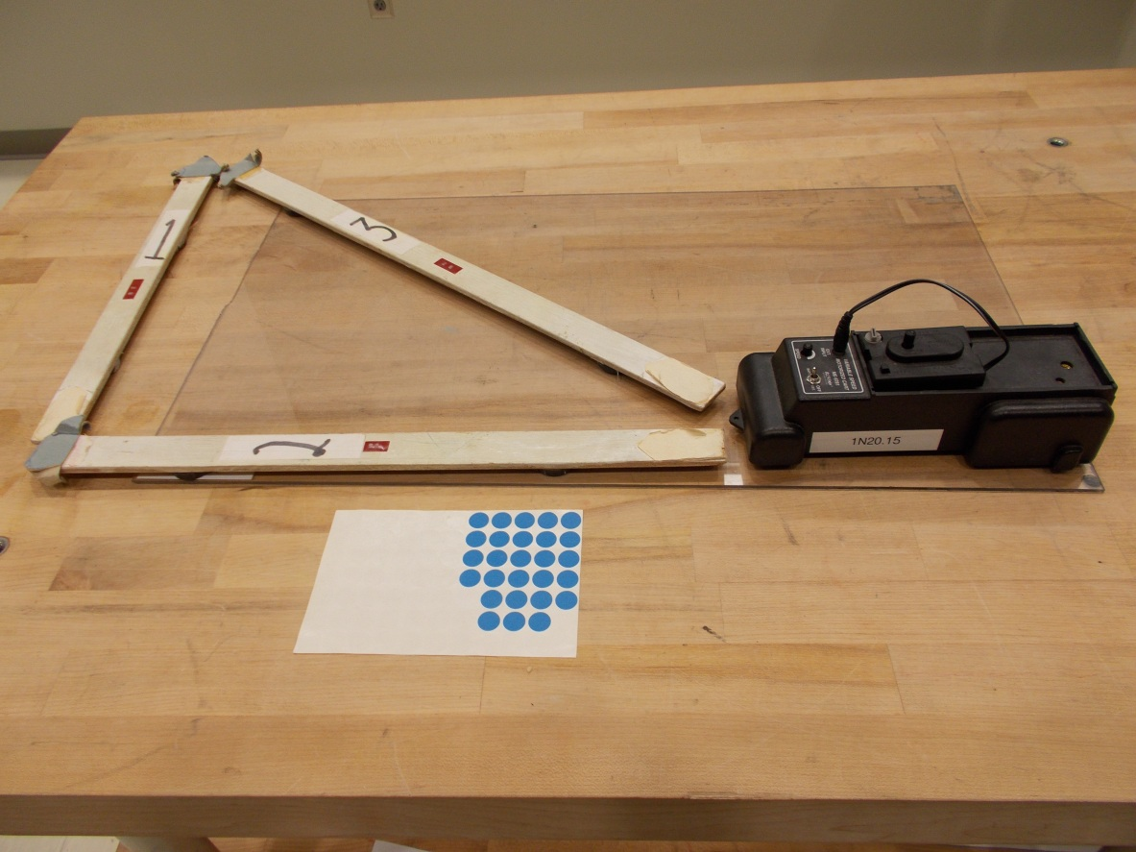
Location: Bb1, Ba6

MECHANICS | 1E10.20 | RELATIVE MOTION
Moving Reference Frames

Frames of Reference Film
 | The classic film available on video disc or DVD permits use of selective parts.
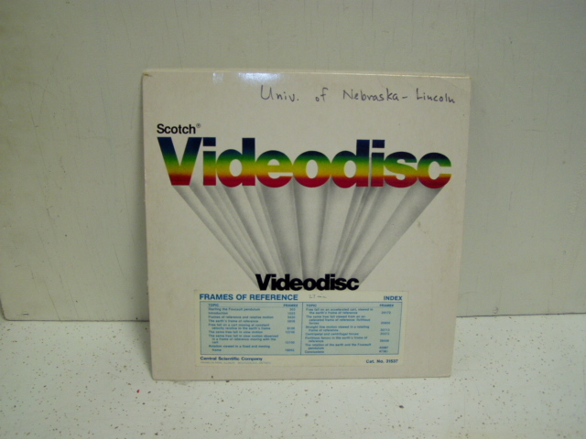Location Video Cabinet

MECHANICS | 1E20.10 | RELATIVE MOTION

Rotating Reference Frames

Foucault Pendulum
 | A Foucault Pendulum with a Charron ring drive. Use the machine shop’s appliance dolly to move it into the lecture hall.
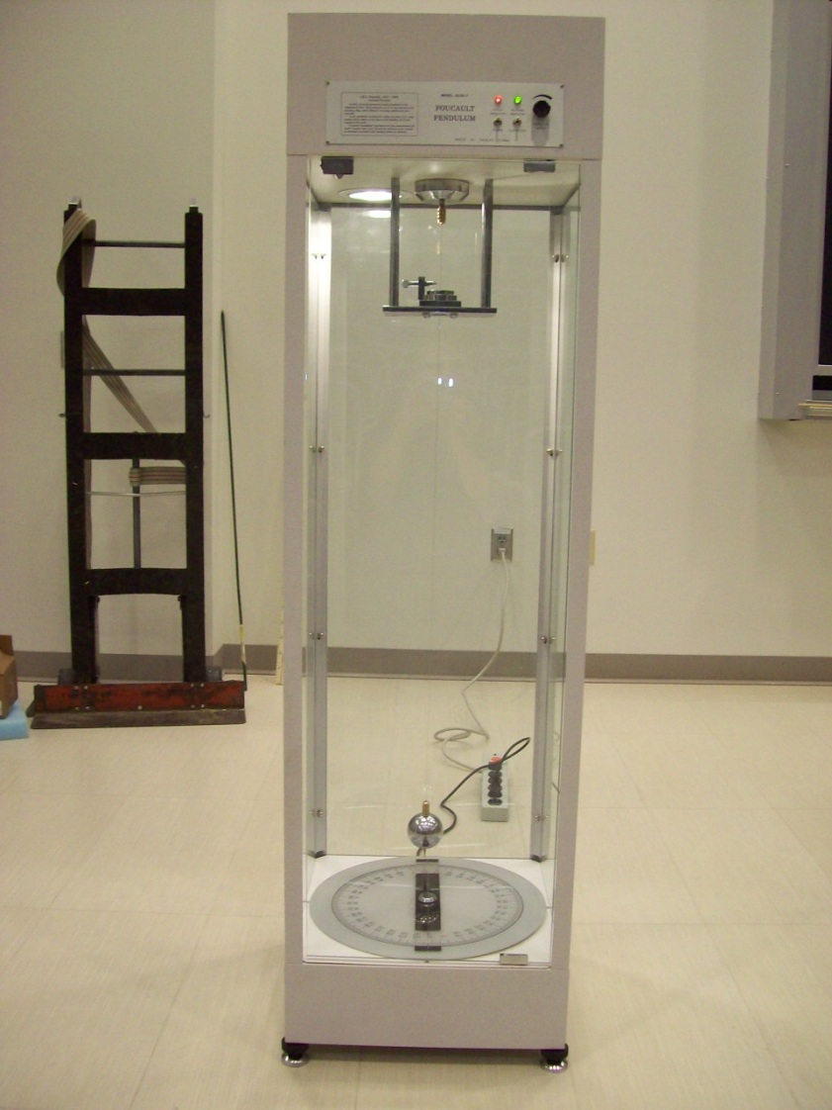
Location: Outside 134A

MECHANICS | 1E20.20 | RELATIVE MOTION
Rotating Reference Frames

Foucault Pendulum Model
 | A conical pendulum on a rotating table.

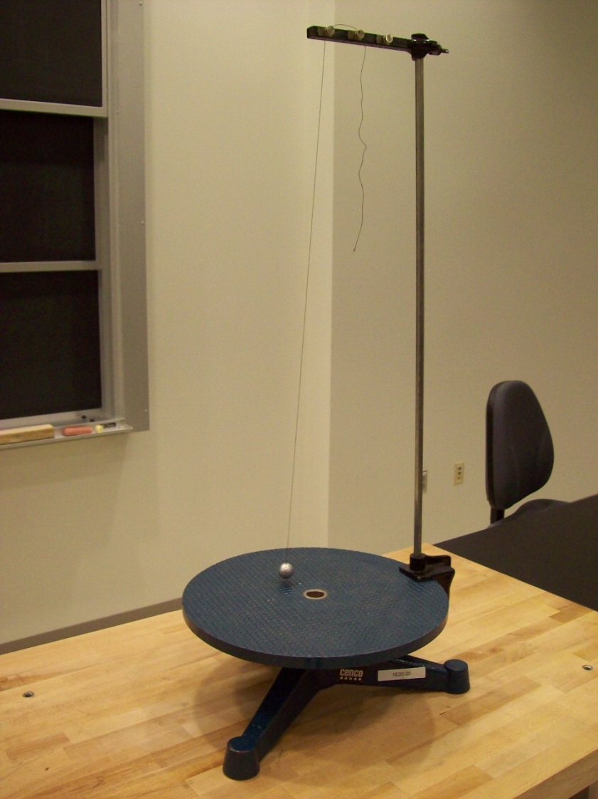
Bc2
MECHANICS | 1E30.36 | RELATIVE MOTION

Coriolis Effect

Coriolis
 | A pan of water on a rotating platform has a recirculating pump on it that shoots a stream over the pan. When the pan is made to rotate, the stream deflects.
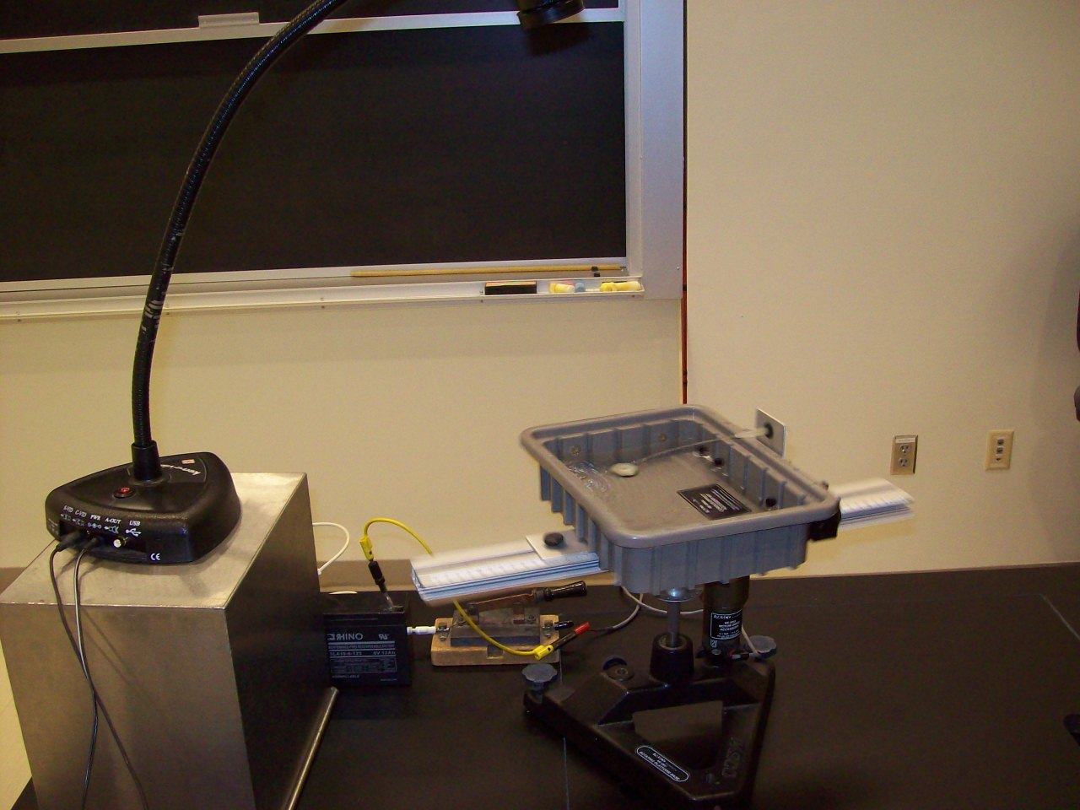Location: Bc3
MECHANICS | 1F10.11 | NEWTON'S FIRST LAW

Measuring Inertia

Inertia Balance
 | A horizontal leaf spring as an inertia balance.
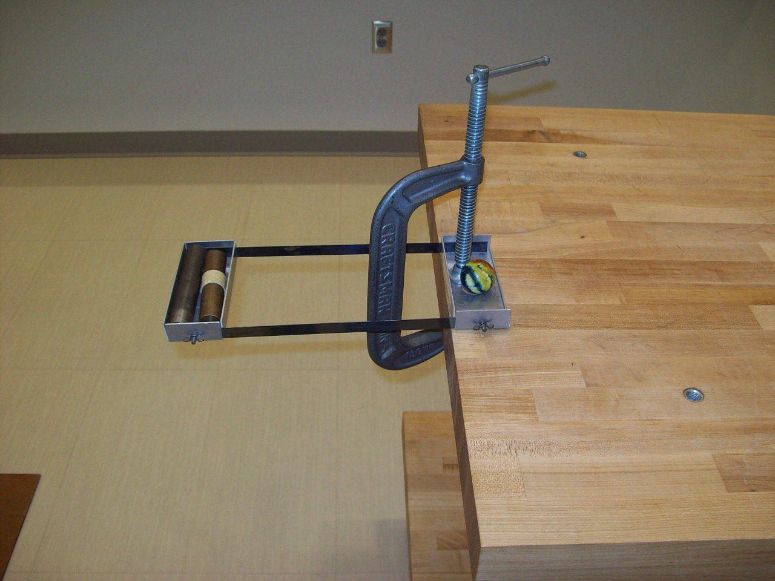
Location: Bc4
MECHANICS | 1F20.10 | NEWTON'S FIRST LAW

Inertia of Rest

Inertia Ball
Disc 02-13
Pull down slowly to overcome the inertia of the heavy ball and break the upper string. Pull down fast to break the lower string.
Have the students guess beforehand which string will break.

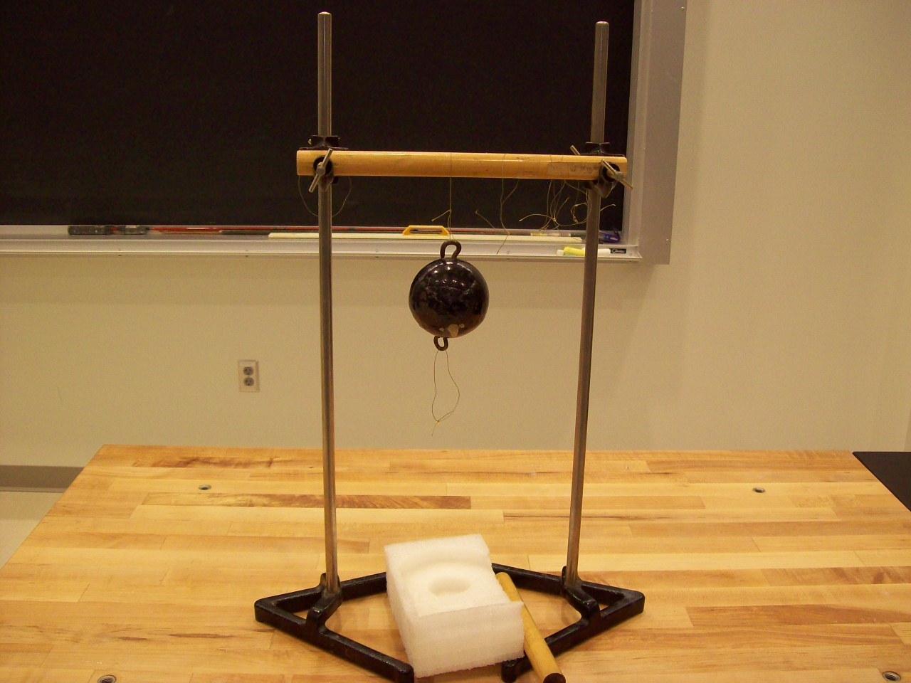
Location: Bc4
MECHANICS | 1F20.20 | NEWTON'S FIRST LAW
Inertia of Rest

Smash Your Hand
 | Place an iron block on your hand and hit with a hammer.
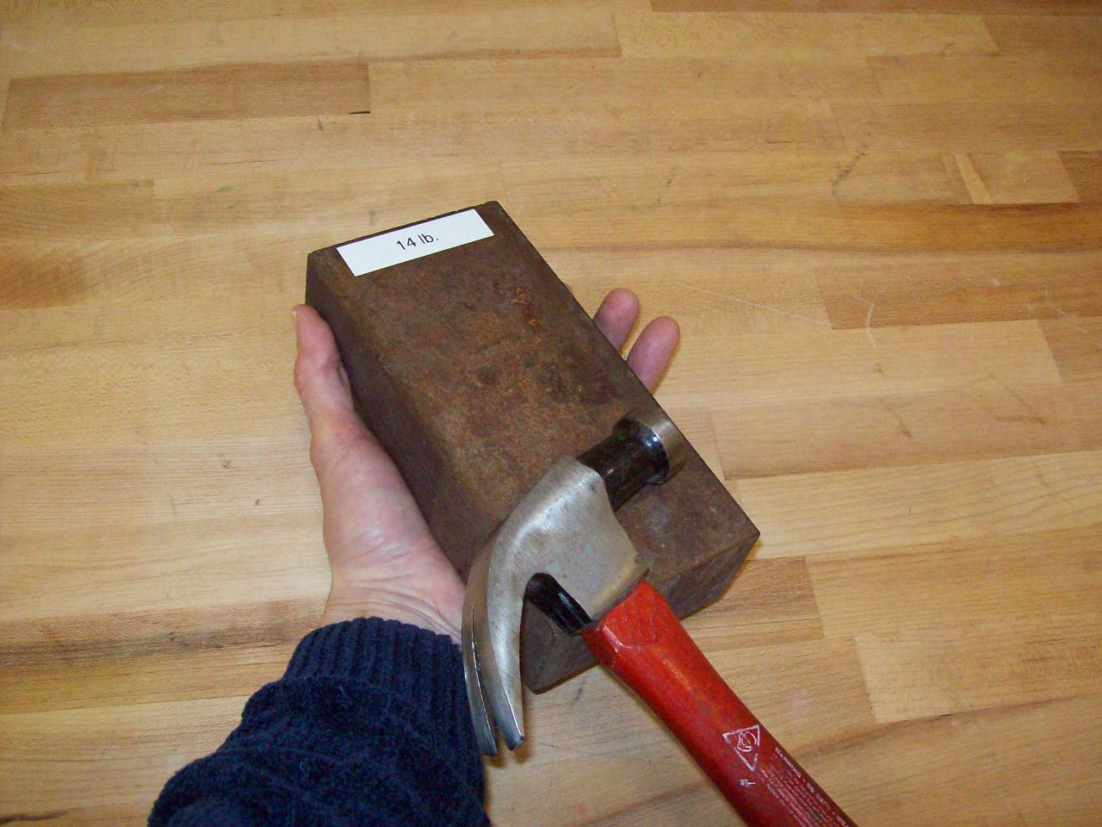
Location: Bc4
MECHANICS | 1F20.25 | NEWTON'S FIRST LAW
Inertia of Rest

Smashing Cups
 | Drop a lead ball on an iron or wood block supported by Styrofoam cups. Drop the ball from about a half meter above the blocks. In which case are the cups damaged the most?
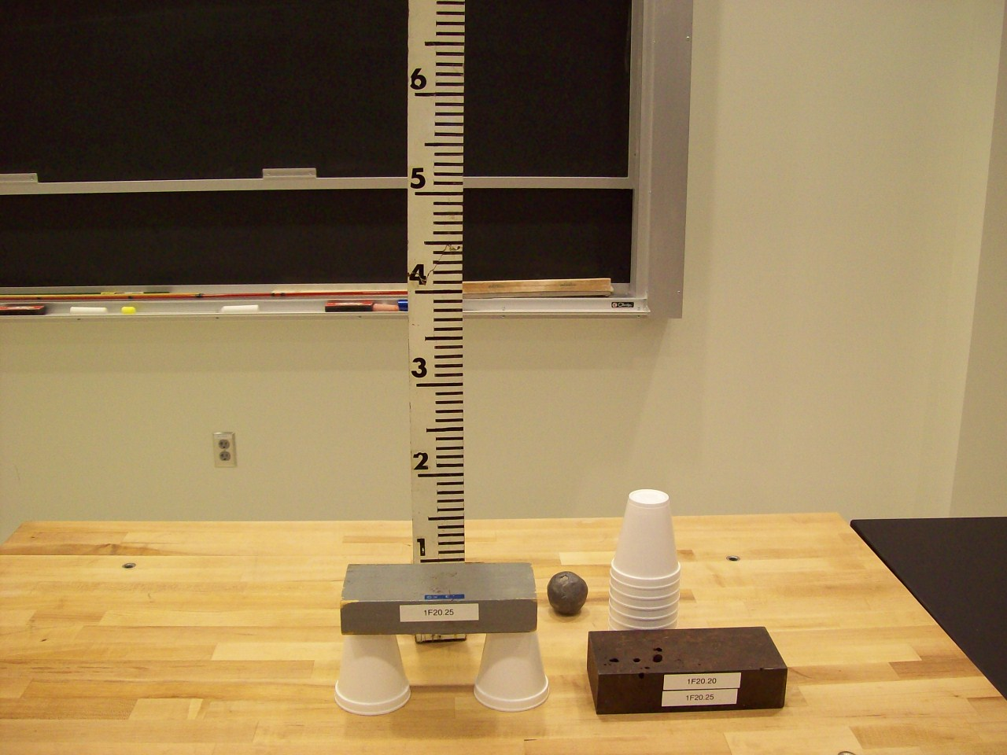
Location: Bc4
MECHANICS | 1F20.30 | NEWTON'S FIRST LAW
Inertia of Rest

Tablecloth Pull
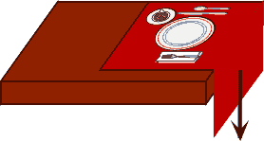 | Pull the tablecloth out from under a place setting.
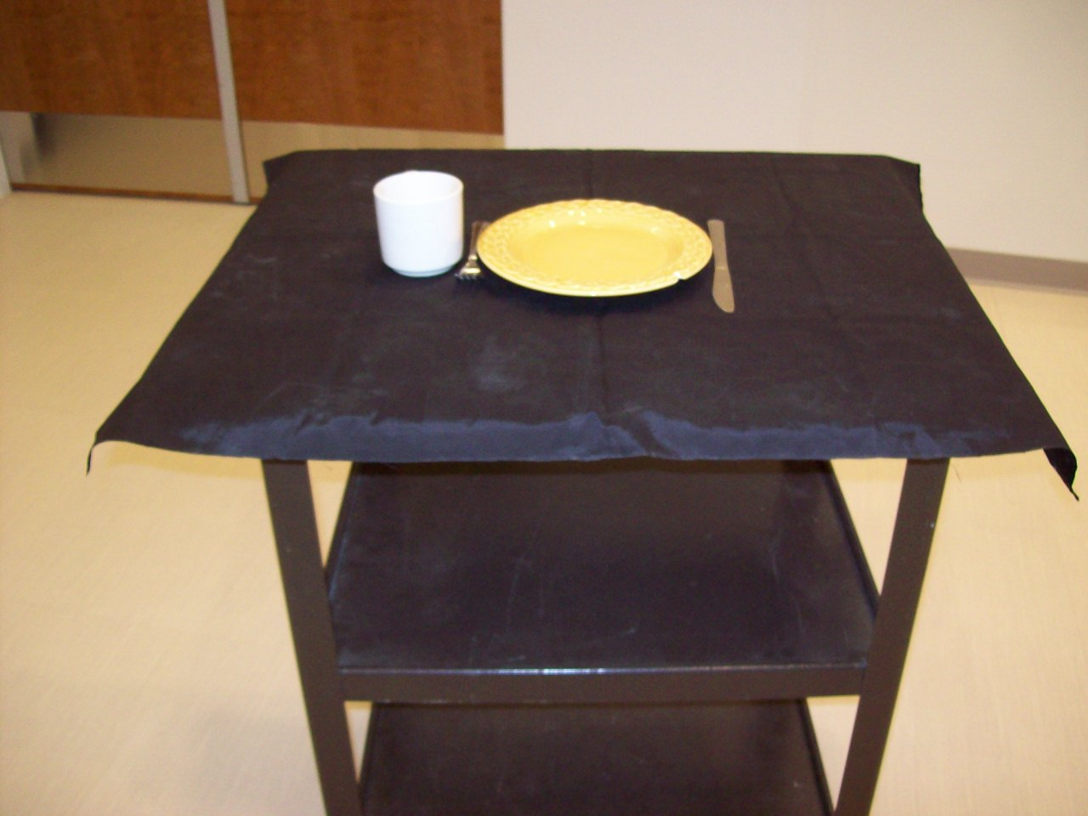
Location: Bc4

MECHANICS | 1F20.34 | NEWTON'S FIRST LAW
Inertia of Rest

Coin/card Snap
 | Snap a card out from under a steel ball.
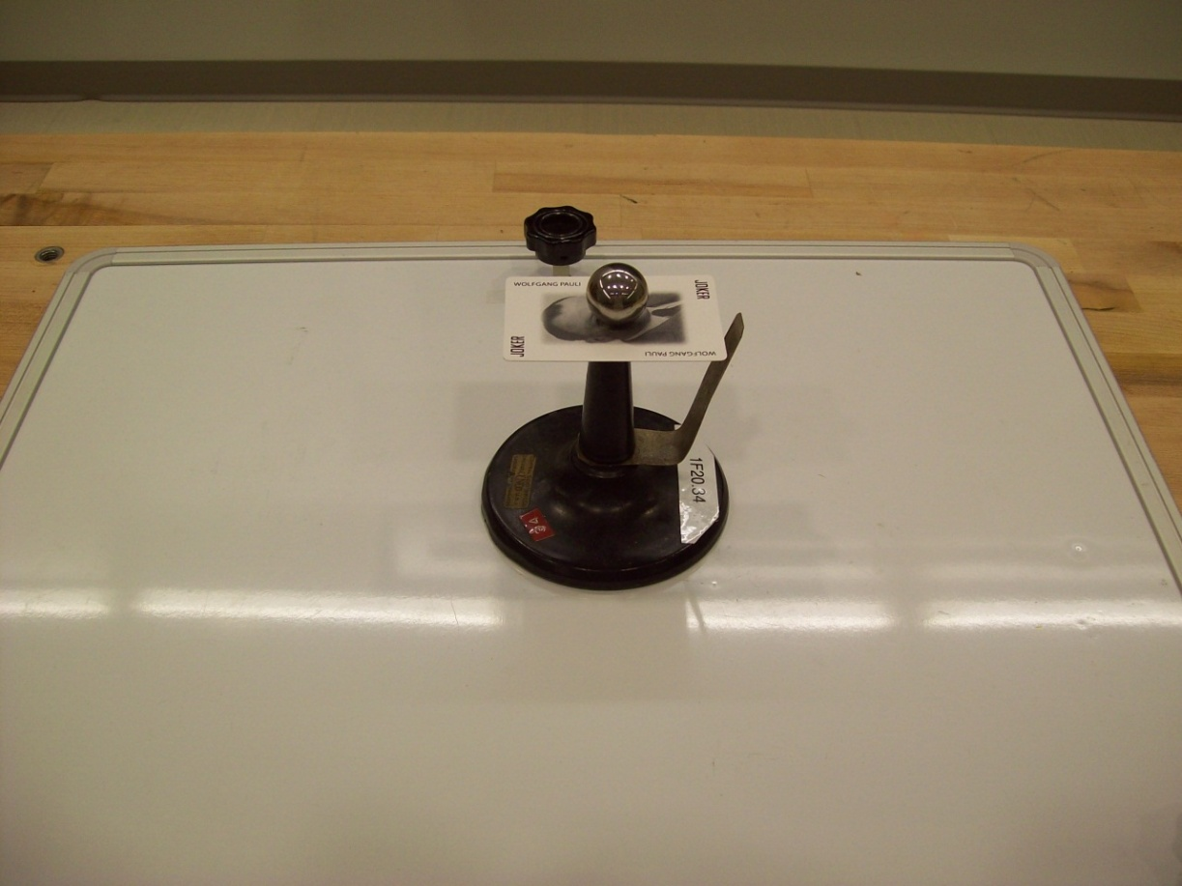
Location: Bc4
MECHANICS | 1F20.36 | NEWTON'S FIRST LAW
Inertia of Rest

Pen and Embroidery Hoop
 | Balance an embroidery hoop on the mouth of a bottle, and then balance a pen on the embroidery hoop. Snap the hoop sideways and the pen will fall into the bottle. Be sure to strike the hoop with your finger on the inner surface of it at a point where the tangent is vertical.
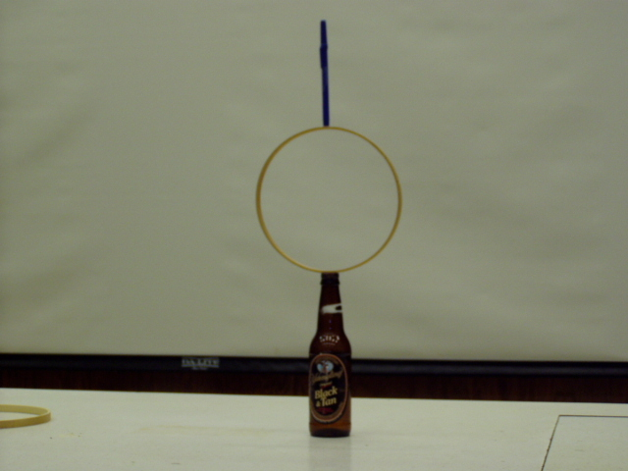Location: Bc4

MECHANICS | 1F20.37 | NEWTON'S FIRST LAW
Inertia of Rest

Daruma Otoshi
 | A Japanese toy. The objective is to knock the lower cylinders out from under the head one at a time without toppling the whole thing. Ask your students: should it be easier or harder to do as the number of cylinders decrease? Is it easier or harder with a smaller version?
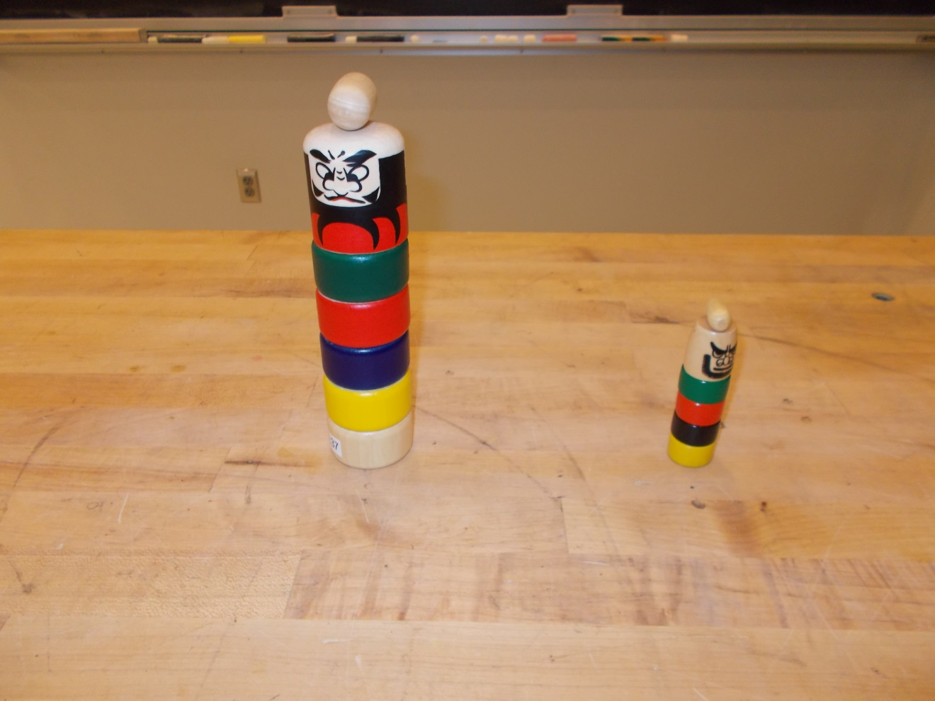Location: Bc4

MECHANICS | 1F30.10 | NEWTON'S FIRST LAW

Inertia of Motion

Persistence of Motion
 | Level the track. Give the cart a push and watch it bounce end to end along the track. The air track works better, but is noisier.
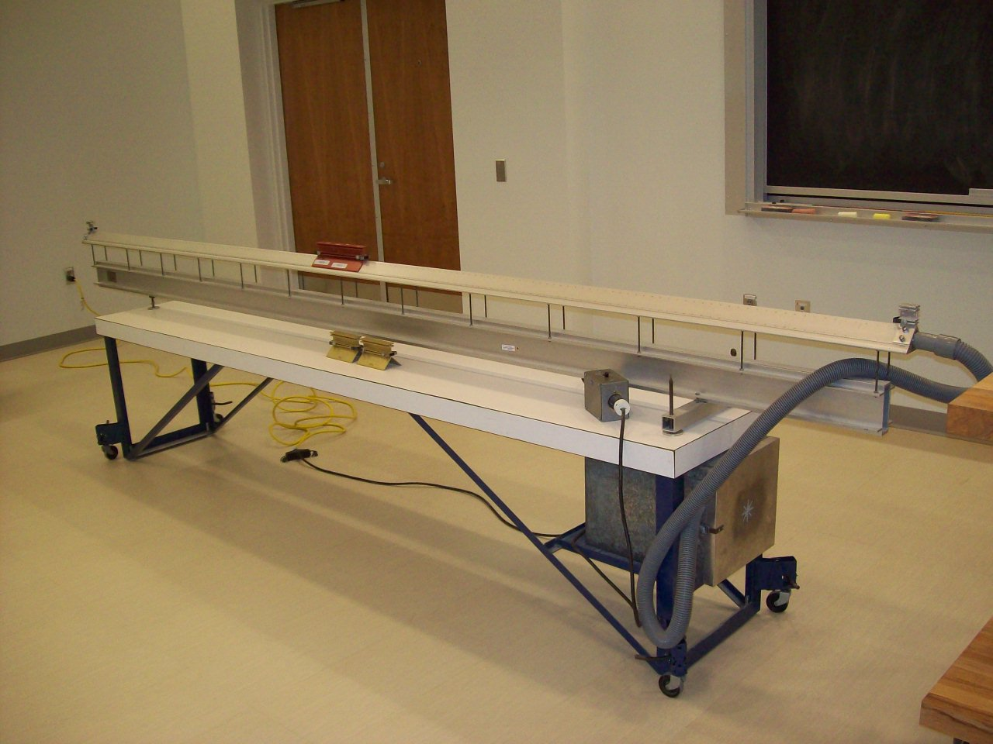
Location: Unistrut, Bc5

MECHANICS | 1F30.11 | NEWTON'S FIRST LAW
Inertia of Motion

Air Puck
 | An air puck is pushed across the floor to demonstrate Newton’s First Law.
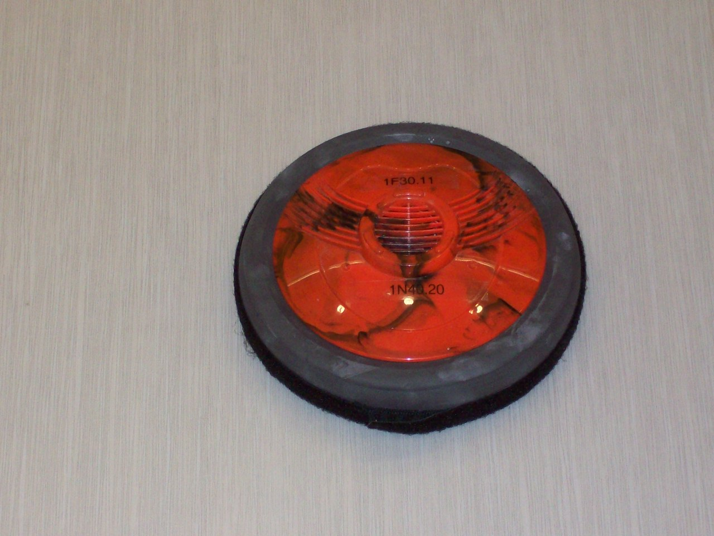
Location: Cd4

MECHANICS | 1F30.15 | NEWTON'S FIRST LAW
Inertia of Motion

Cup and Chain
 | A beaded chain in a cup is pulled over the lip of the cup and allowed to fall. As it does, it rises above the lip of the cup.
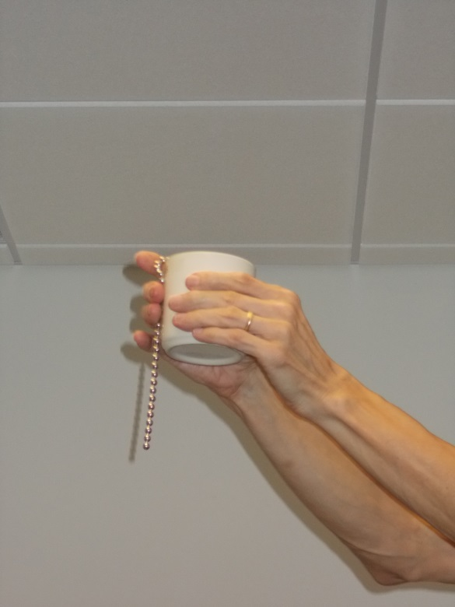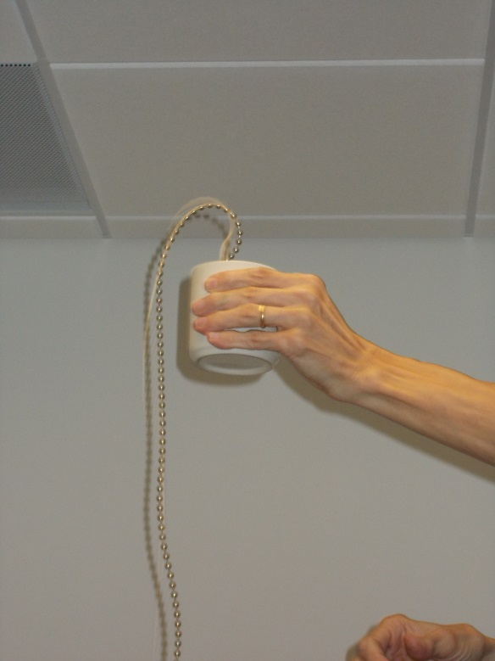
Location: Bc5

MECHANICS | 1F30.30 | NEWTON'S FIRST LAW
Inertia of Motion

Cart on a Cart
 | A small cart is placed on a larger one and both are set in motion. When the larger one is stopped, the smaller one keeps going.
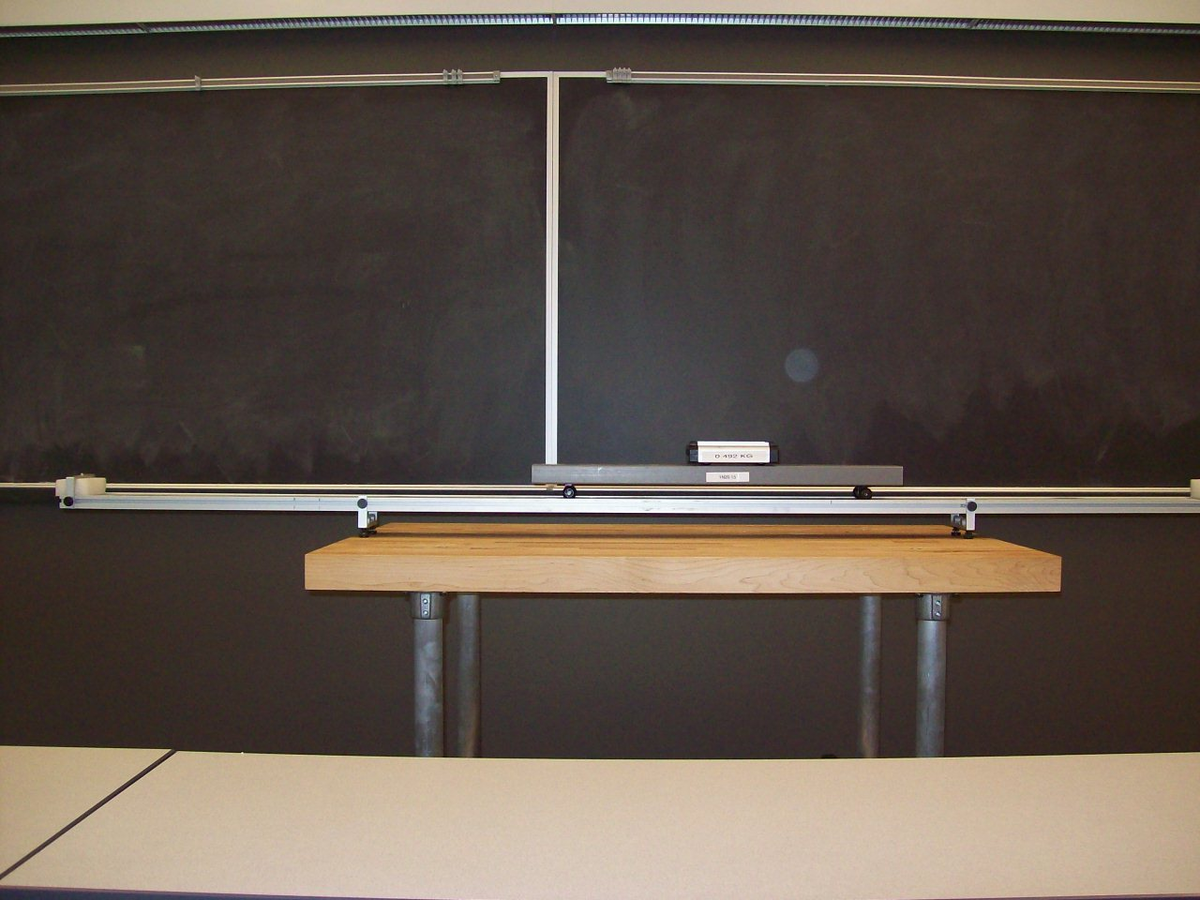
Location: Bc5, AcT
MECHANICS | 1G10.10 | NEWTON'S SECOND LAW

Force, Mass and Acceleration

Accelerating Air / Dynamics Cart
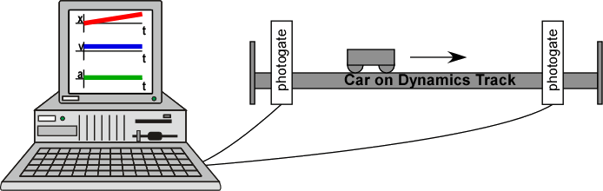 | A Smart Cart position, velocity and acceleration is plotted while pulled by a mass on a string over a pulley. Capstone file “Smart Cart and Pulley”.  .
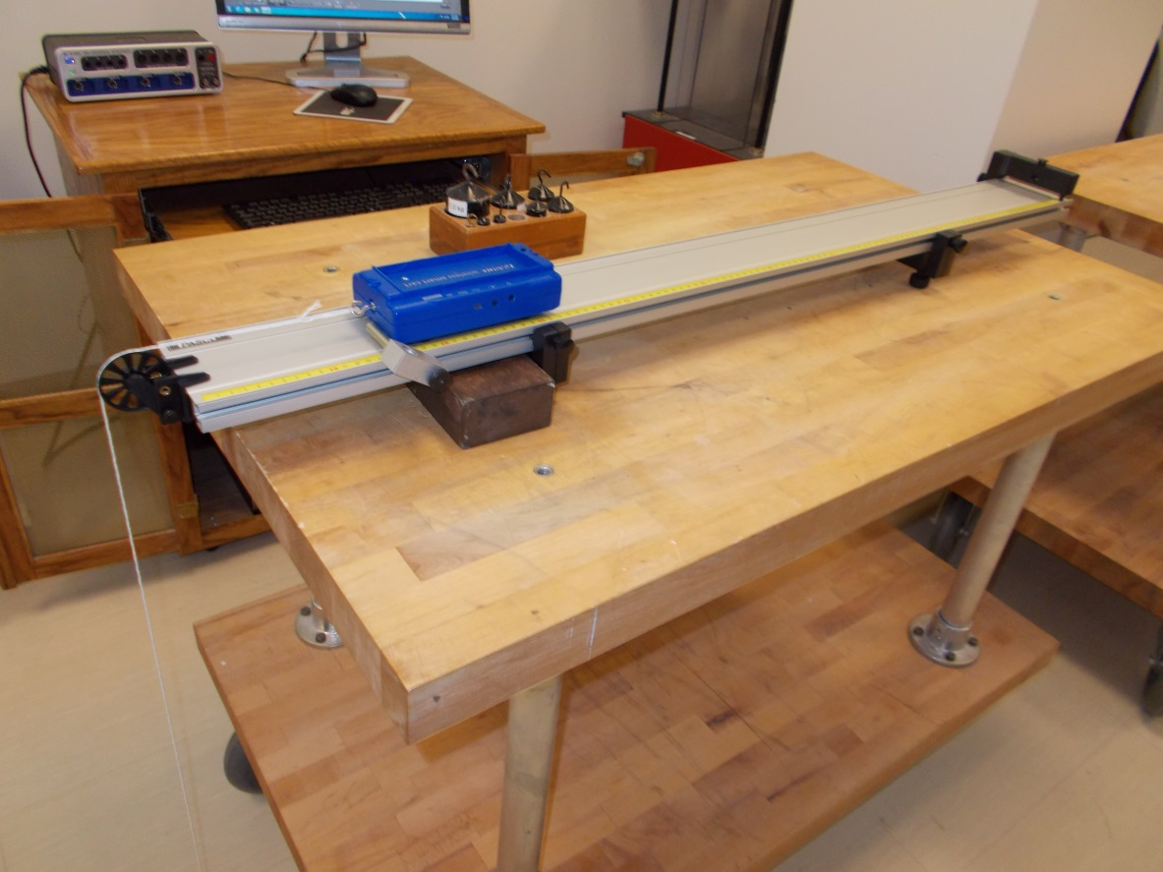
Location: Bb2, Cb2

MECHANICS | 1G10.12 | NEWTON'S SECOND LAW
Force, Mass and Acceleration

Accelerating Cart on an Incline
 | A cart is placed on an inclined plane with a string going over a pulley to a mass. The Capstone file is Inclined Plane with Pulley. The software will display components of g perpendicular and parallel to the track and also plot position and velocity
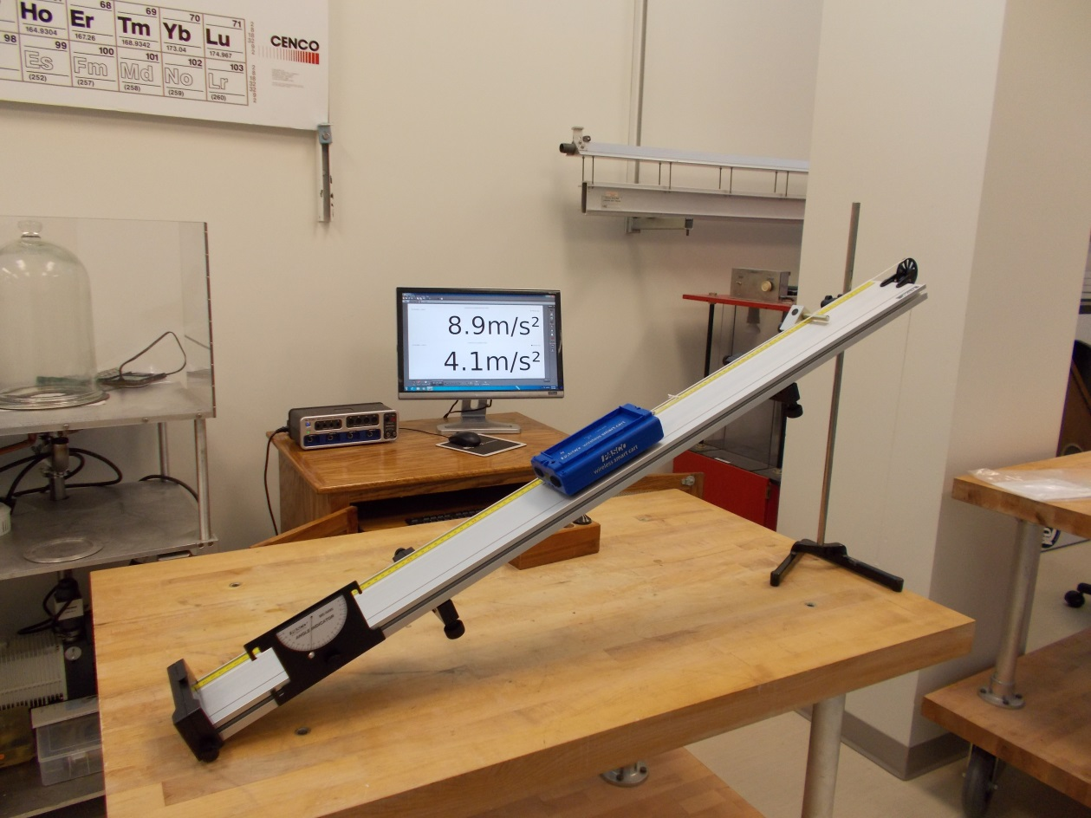
Location: Bb2, Cb2
MECHANICS | 1G10.20 | NEWTON'S SECOND LAW
Force, Mass and Acceleration

Accelerating Fan Car
 | A car is accelerated by the thrust of its propeller. The built-in timer causes the propeller to spin a pre-chosen length of time. The mass of the cart is varied to show Newton’s Second Law. The thrust can be measured either with a hanging mass over a pulley or using an inclined plane. The car is 311 g; the add on masses are about 250 g.
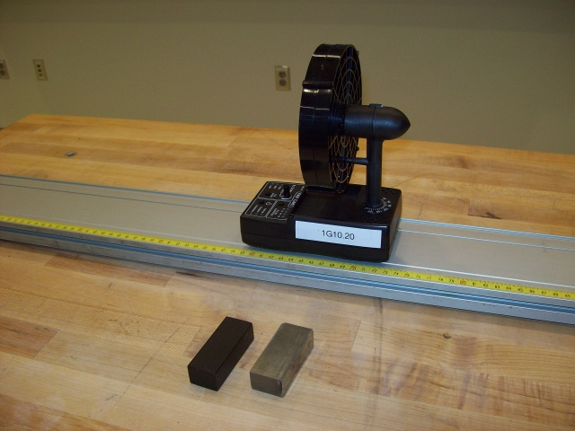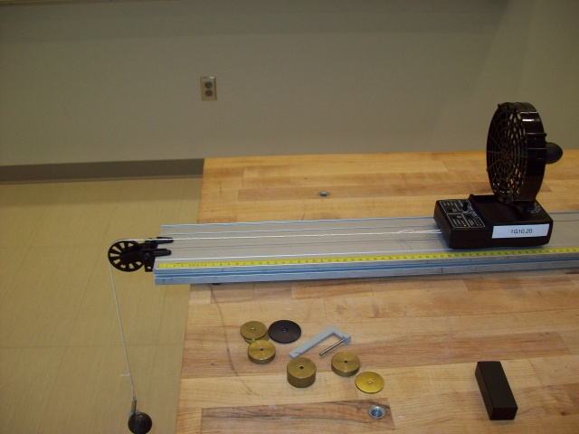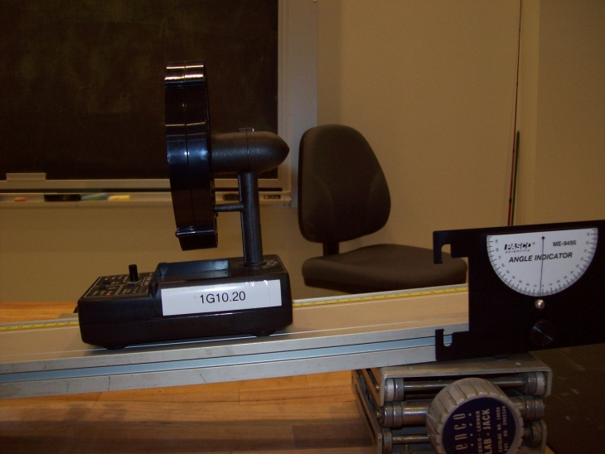
Location: Bc7

MECHANICS | 1G10.20b | NEWTON'S SECOND LAW
Force, Mass and Acceleration

Accelerating Fan Car with Smart Cart
 | A fan is mounted on a smart cart and its position and velocity are graphed on the computer screen. The Capstone file is Smart Cart Fan Cart.
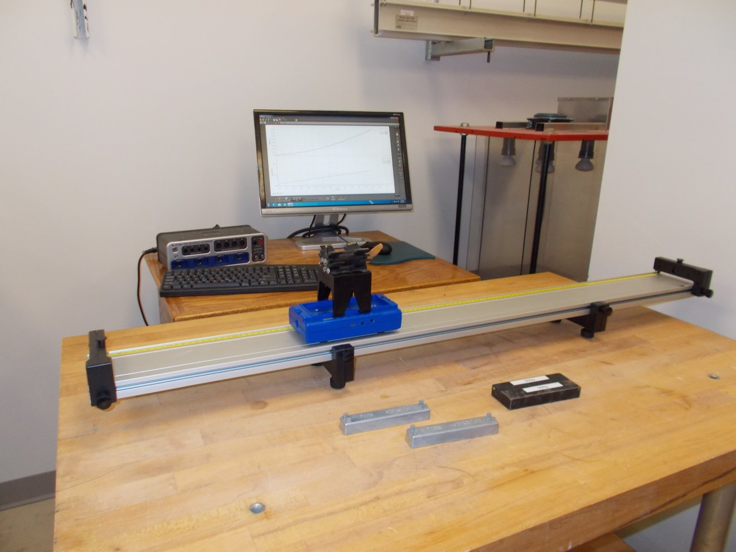
Location: Bb2, Cb1
MECHANICS | 1G10.30 | NEWTON'S SECOND LAW
Force, Mass and Acceleration

Mass on a Scale
 | Hang a mass from a large spring balance.
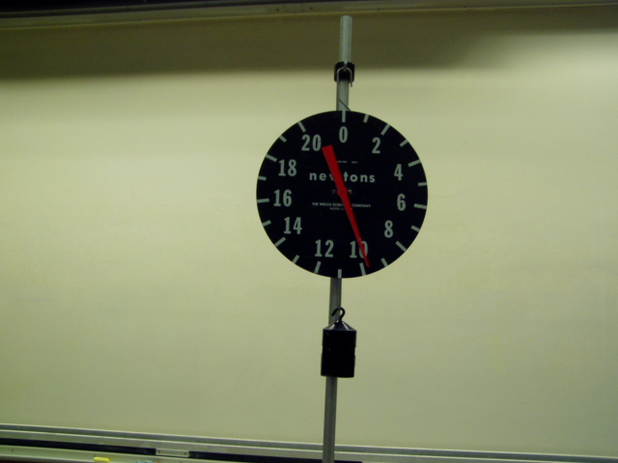Location: Ba5
MECHANICS | 1G10.40 | NEWTON'S SECOND LAW
Force, Mass and Acceleration

Atwood's Machine
Disc 01-16
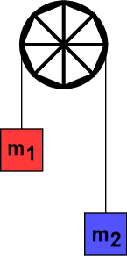 | Place 1kg on each side. Add a 2g mass to the high side. Measure the distance the mass falls and the time it takes to fall this distance. Large pulley is used without timing as the rotational inertia of the pulley is significant. There is also a “smart Pulley” version used with Capstone (Atwood’s Machine.cap) and a computer.
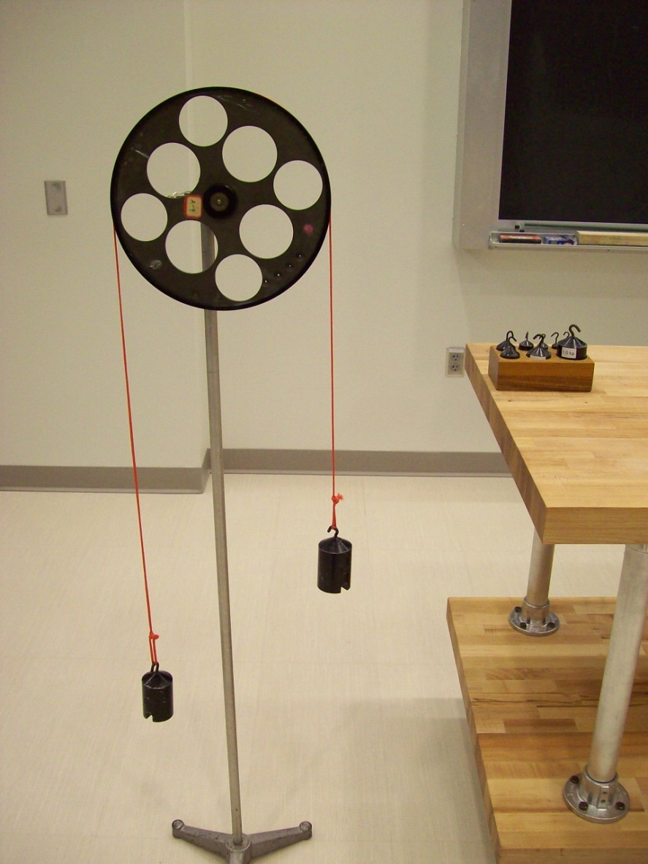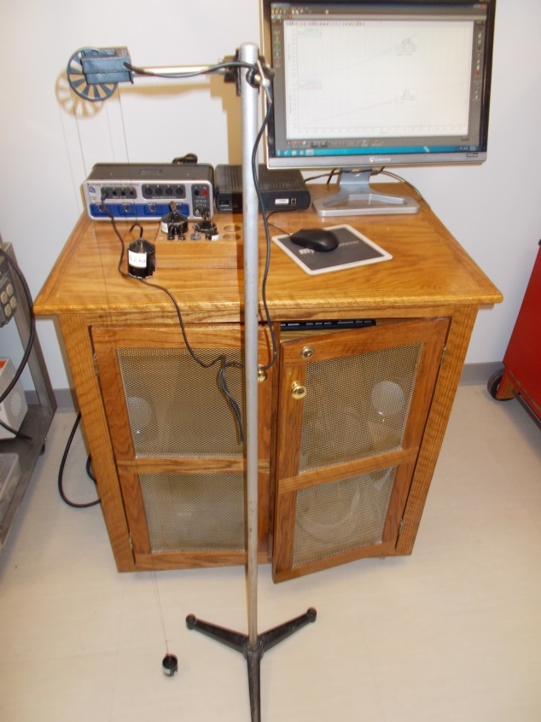
Location: Bc7, Bc3
MECHANICS | 1G20.30 | NEWTON'S SECOND LAW

Accelerated Reference Frames

Leaky Pail Drop
 | A hole is punched in the bottom of a water bottle. When the bottle is dropped or tossed, no water comes out of the hole.l
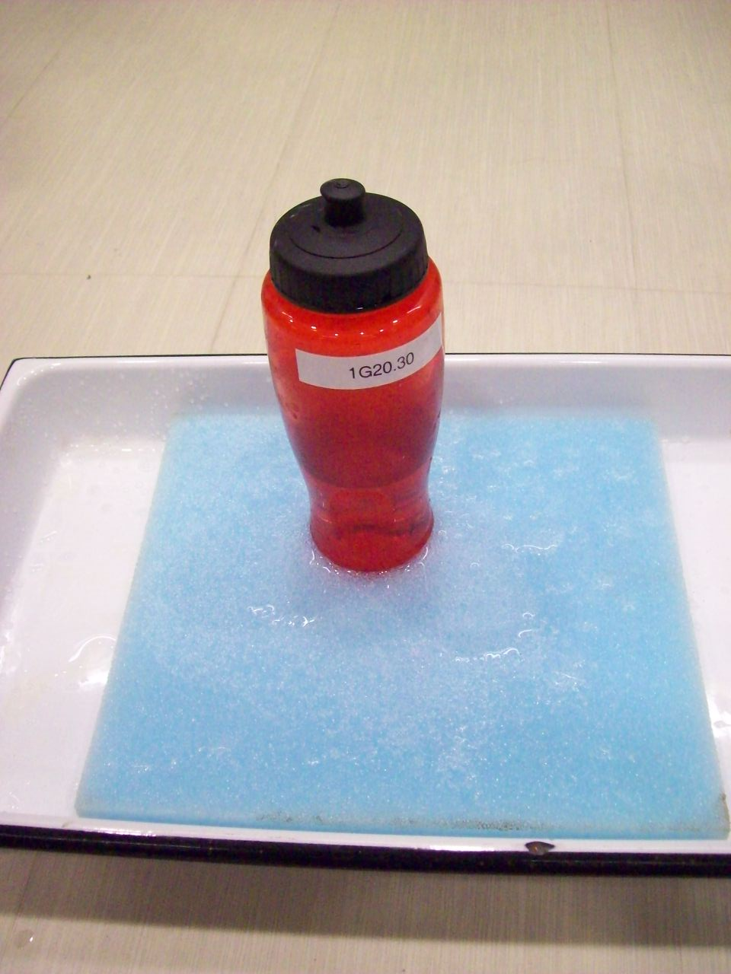
Location: Bc7

MECHANICS | 1G20.40 | NEWTON'S SECOND LAW
Accelerated Reference Frames

Cup and Weights
 | Hang 20g weights from rubber bands extending from the center over the edge of a plastic funnel. Drop the thing. It works best to stand on the lecture table for a longer fall. Use the yellow foam crash pad to cushion the fall.
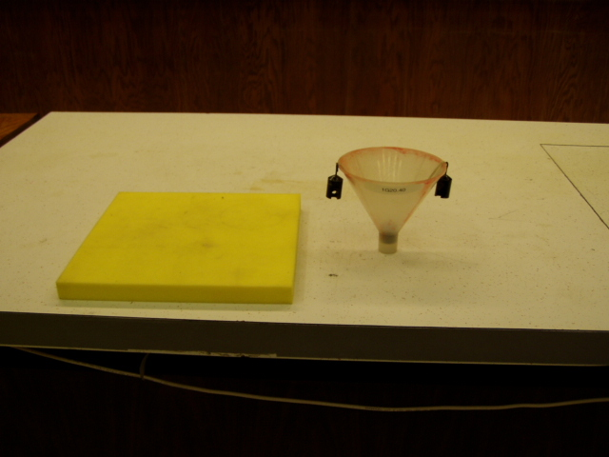Location: Bc7

MECHANICS | 1G20.41 | NEWTON'S SECOND LAW
Accelerated Reference Frames

Vanishing Weight
 | Stand on the lecture table holding a 1 kg mass hanging from a spring balance (the mass is secured to the balance with tape so that it doesn’t fall off); then step off of the table.
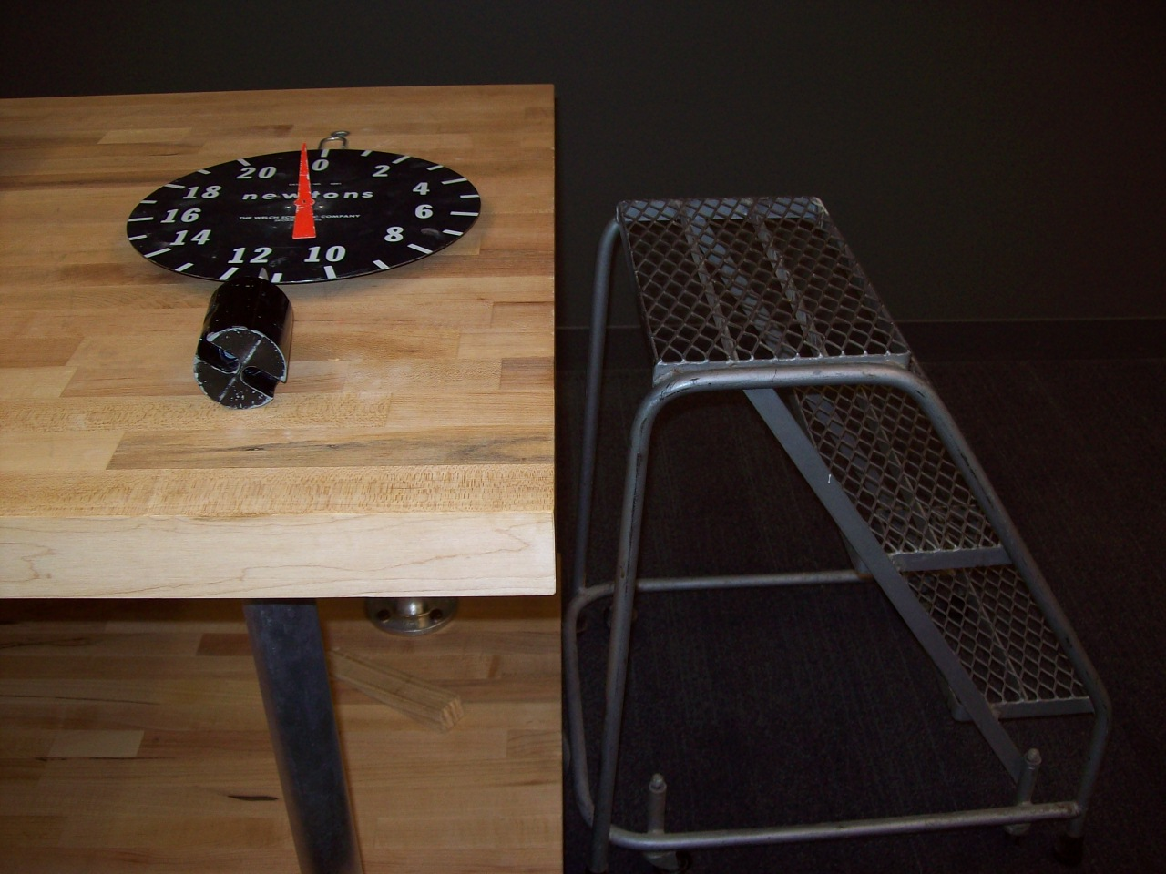
Location: Ba5

MECHANICS | 1G20.45 | NEWTON'S SECOND LAW
Accelerated Reference Frames

Dropped Slinky
Hold one end of the Slinky high in the air so that the other end is off the ground and visible. Let go of the top end and watch as the bottom end remains in place until the whole spring has contracted to its minimum length. Video capture will help with the spring observations and calculations.
Note that the top end of the Slinky falls faster than "g".
- Ronald Newburgh, George M. Andes, "The Falling Slinky", TPT, Vol. 33, #9, Dec. 1995, p. 586.
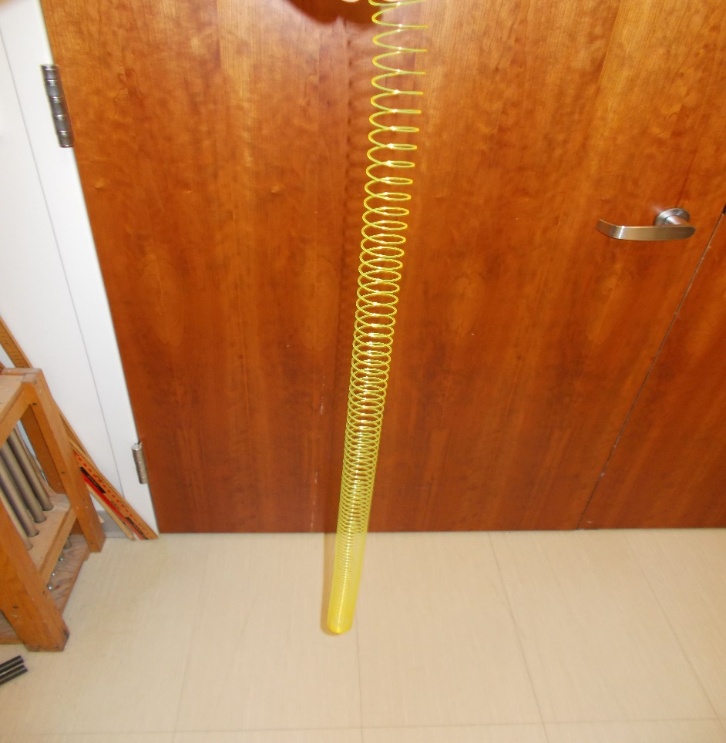
Location: Bc7
MECHANICS | 1G20.76 | NEWTON'S SECOND LAW
Accelerated Reference Frames

Float Accelerometer
 | A float in a jar of water is placed on a skateboard that can be accelerated. Also can be shown in circular motion (1D52.33)
Location: Bb7
MECHANICS | 1H10.10 | NEWTON'S THIRD LAW

Action and Reaction

Push Me Pull Me Carts
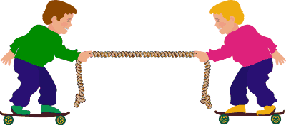 | Have two students stand on the carts (or skateboards) and grab the ends of the rope. Have only one student pull at a time and observe that they both move. Use a long stick for pushing, or push off of each other's hands.
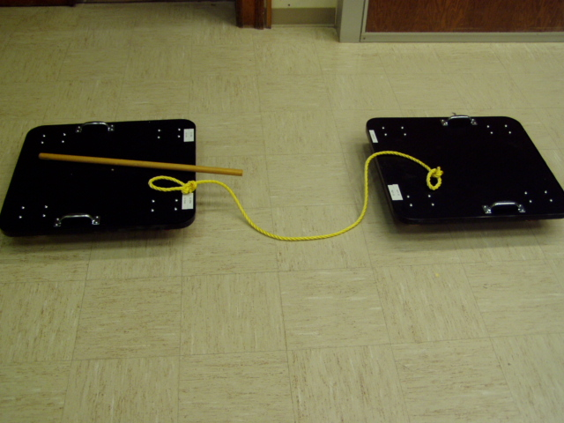
Location: Mb1, Cc4
MECHANICS | 1H10.20 | NEWTON'S THIRD LAW
Action and Reaction

Fan Cart with Sail
A sail is placed in front of a battery powered fan on a cart. Should the curved sail make the cart move when the fan blows on it?
A full explanation involves aerodynamics and the Coanda effect.

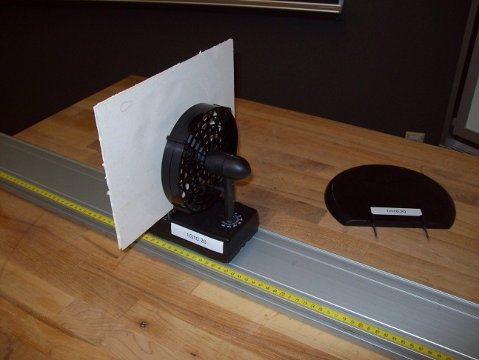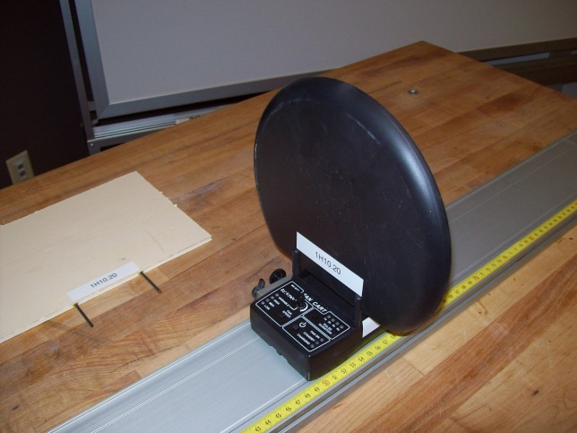

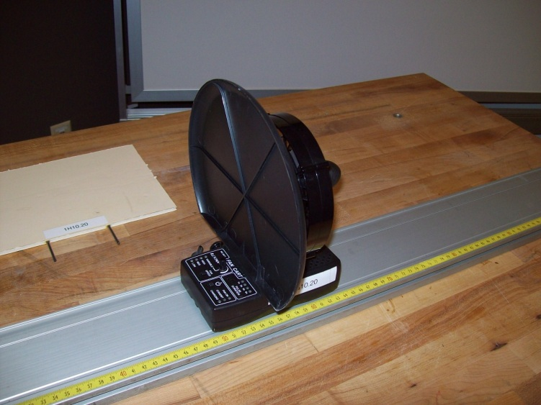
Location: Bc6
MECHANICS | 1H11.10 | NEWTON'S THIRD LAW

Recoil

Floor Cart and Medicine Ball
 | Stand on a human dynamics cart and throw a medicine ball or a Styrofoam ball.
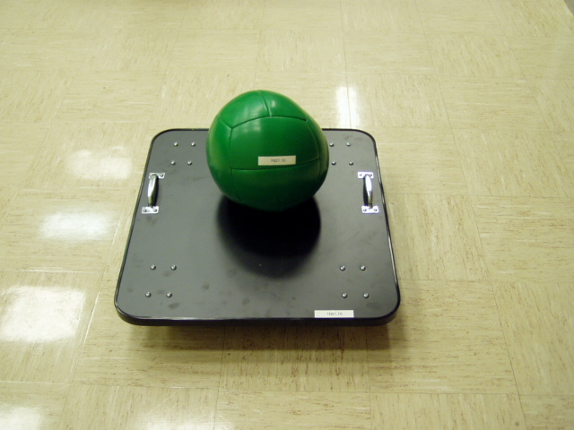Location: Mb1, Db2
MECHANICS | 1H11.30 | NEWTON'S THIRD LAW
Recoil

Liquid Nitrogen Cannon
 | Pour about 100 ml of LN2 into the barrel of the cannon. With the valve opened, hammer a stopper into the end of the cannon. Close the valve place the cannon on the cart and get out of the way. Heavier or lighter stoppers can be used.
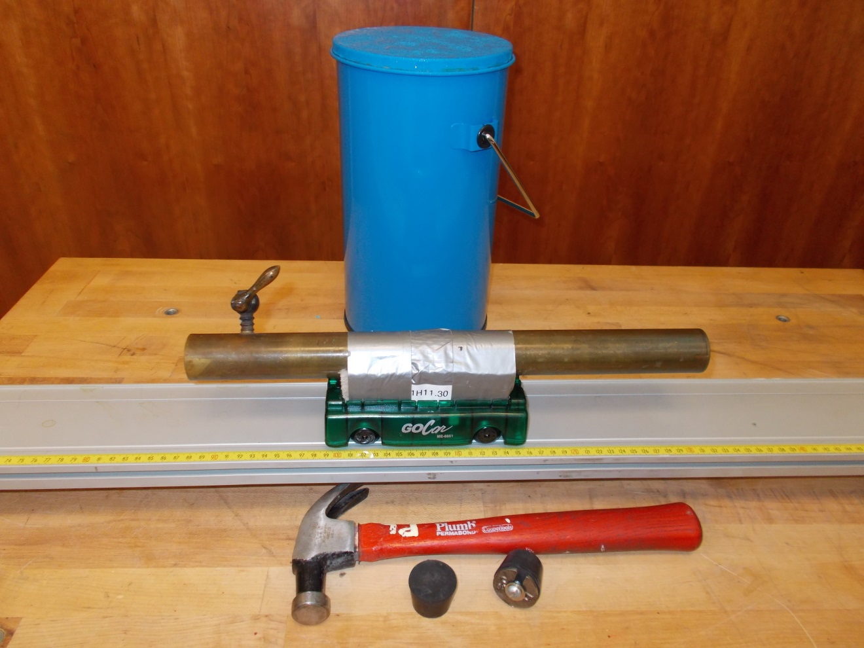Location: Bc6

MECHANICS | 1J10.10 | STATICS OF RIGID BODIES

Finding Center of Gravity

Map of State
Disc 03-20
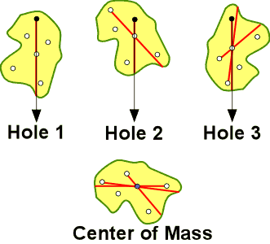 | Hang map of your state on a peg through the desired hole. Hang a plumb bob in front. Mark plump line with marker. Repeat with other holes. Where the lines cross is the center of gravity.
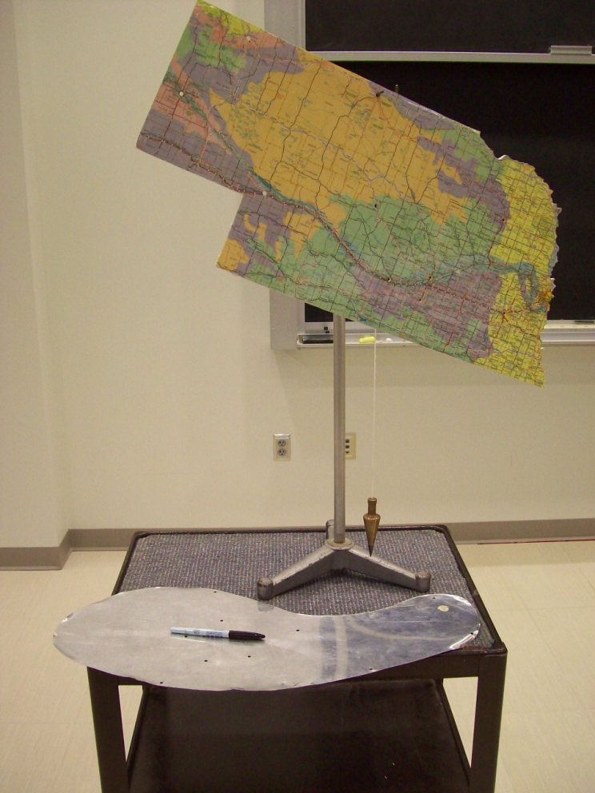
Location: Bc8
MECHANICS | 1J11.10 | STATICS OF RIGID BODIES

Exceeding Center of Gravity

Leaning Tower of Pisa
 | A model of the tower constructed in sections. Adding the top will cause it to tip over.
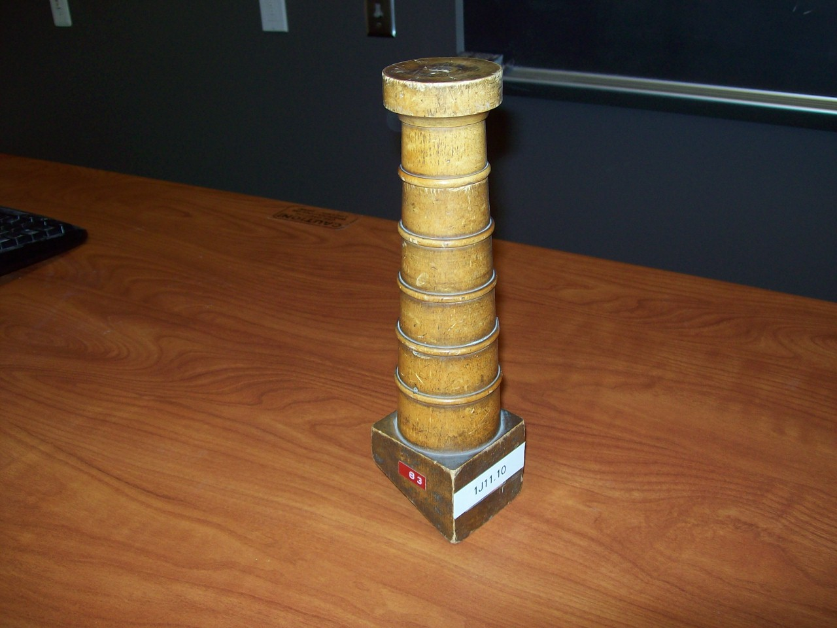
Location: Bc8
MECHANICS | 1J11.20 | STATICS OF RIGID BODIES
Exceeding Center of Gravity

Tower of Lire
AJP 23(4), 240; AJP 41(5), 715
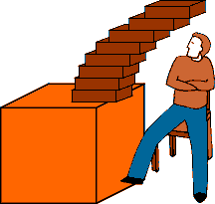 | A set of eight (we use ten) blocks or books is stacked so the top block is completely over the edge of the table. Step lengths go as L/2n. This can also be done with half meter sticks.
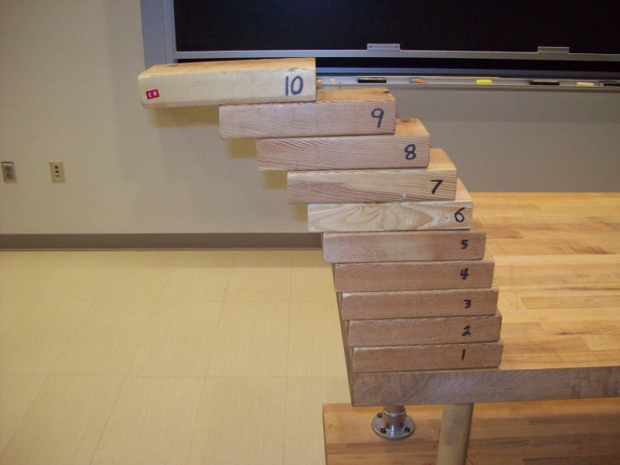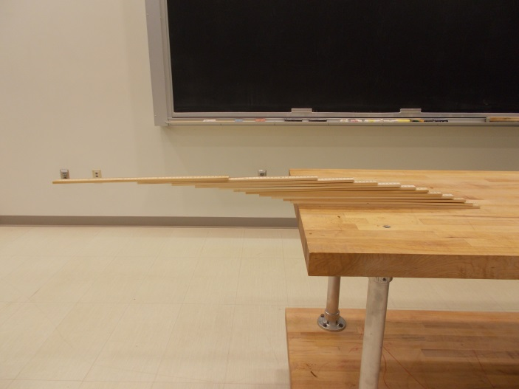
Location: Bc8

MECHANICS | 1J20.05 | STATICS OF RIGID BODIES

Stable, Unstable, and Neutral Equilibrium

Gömböc
- 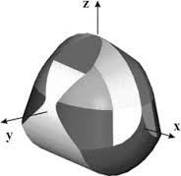 | An object of uniform density with one stable and one unstable equilibrium point. Shapes with a unique stable equilibrium are called monostatic; those with only one additional unstable equilibrium point are referred to as mono-monostatic. The Gömböc is the first convex, homogenous, mono-monostatic object.
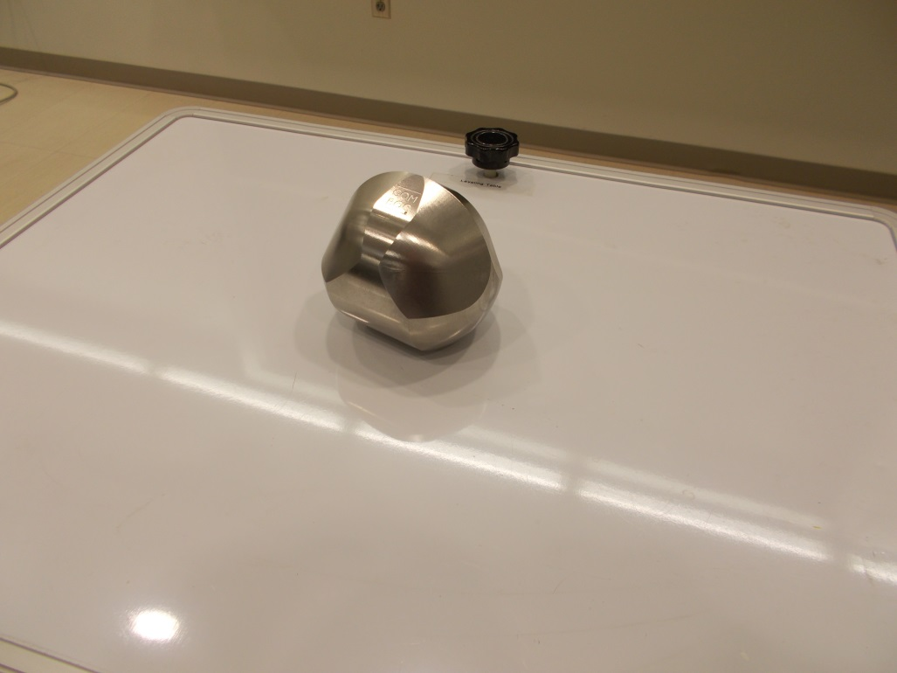
Location: Bd1

MECHANICS | 1J20.10 | STATICS OF RIGID BODIES
Stable, Unstable, and Neutral Equilibrium

Bowling Ball Stability
 | A bowling ball (we use a bocce ball) is placed in, on, and along side of a large aluminum hemisphere.
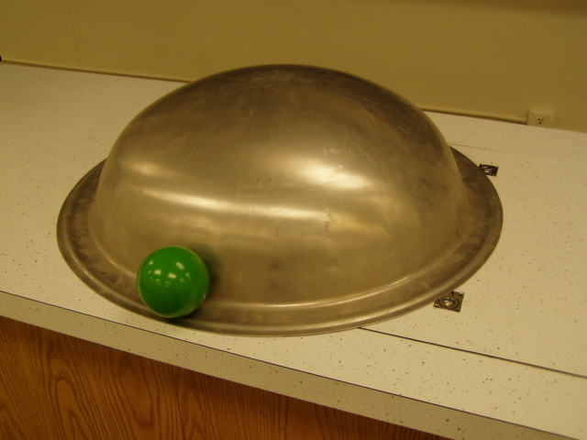 Location: Bc8, GdT

MECHANICS | 1J20.11 | STATICS OF RIGID BODIES
Stable, Unstable, and Neutral Equilibrium

Balance the Cone
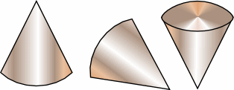 | A cone can show stable, unstable, and neutral equilibrium; a sphere shows only neutral equilibrium.
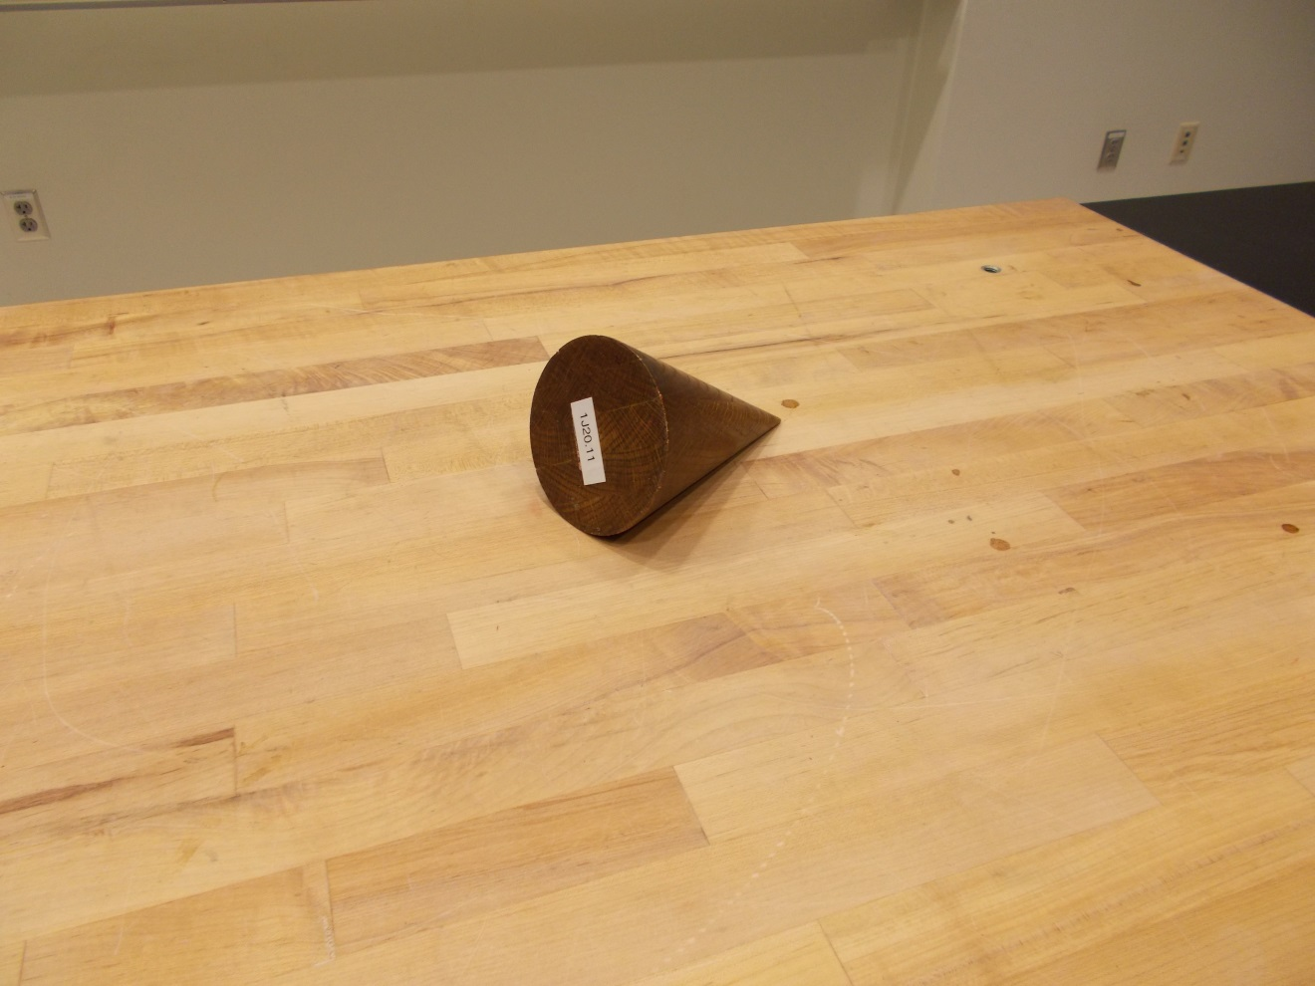
Location: Bc8

MECHANICS | 1J20.15 | STATICS OF RIGID BODIES
Stable, Unstable, and Neutral Equilibrium

Block on the Cylinder
 | A rectangular block is placed on a half cylinder first with the width less than the radius (stable) and then with the width greater than the radius (unstable). Various other shapes are shown.
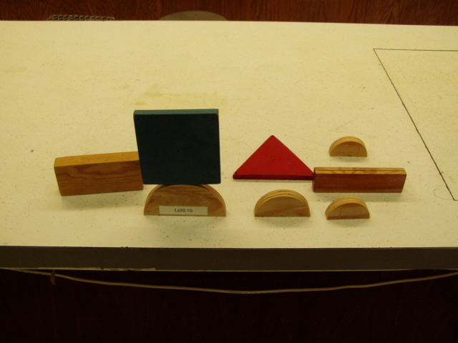Location: Bd1
MECHANICS | 1J20.25 | STATICS OF RIGID BODIES
Stable, Unstable, and Neutral Equilibrium

Twelve Nails on One
 | A technique to balance 12 nails on the head of a single upright nail.
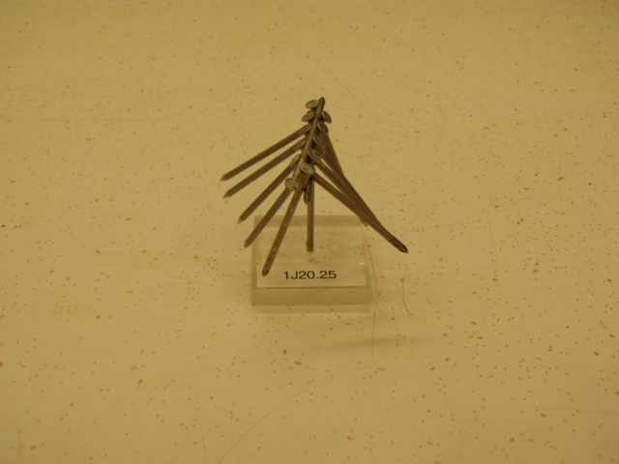Location: Bd1
MECHANICS | 1J20.35 | STATICS OF RIGID BODIES
Stable, Unstable, and Neutral Equilibrium

Horse and Rider
 | A toy horse has a weight attached to lower the center of mass.
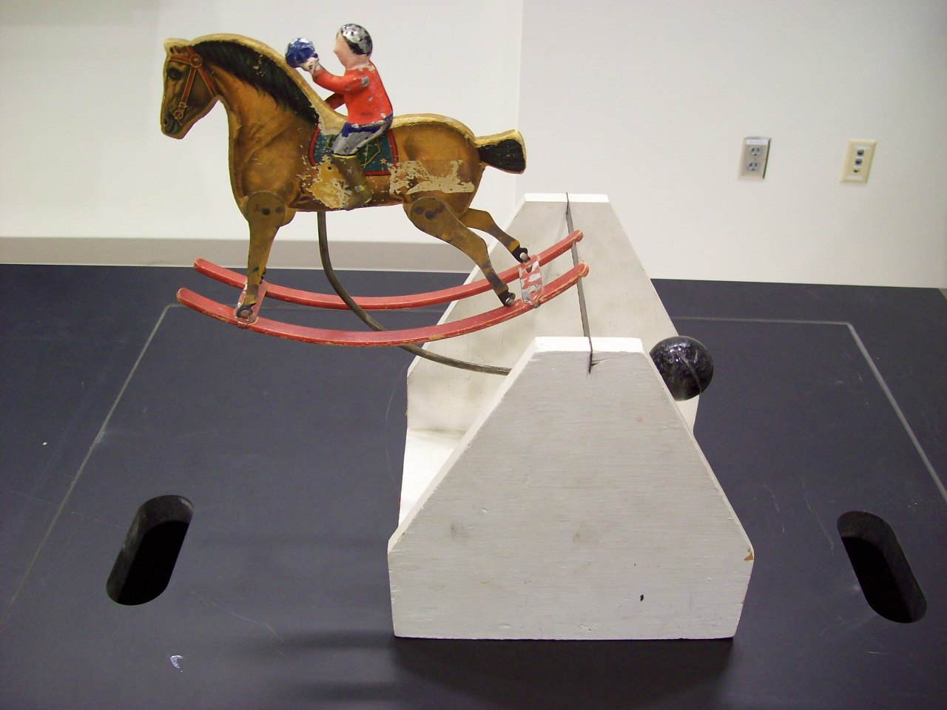
Location: Bd1
MECHANICS | 1J20.60 | STATICS OF RIGID BODIES
Stable, Unstable, and Neutral Equilibrium

Wine Butler
 | Stick the neck of a wine bottle through a hole in a slanted board and the whole thing will stand up, balanced.
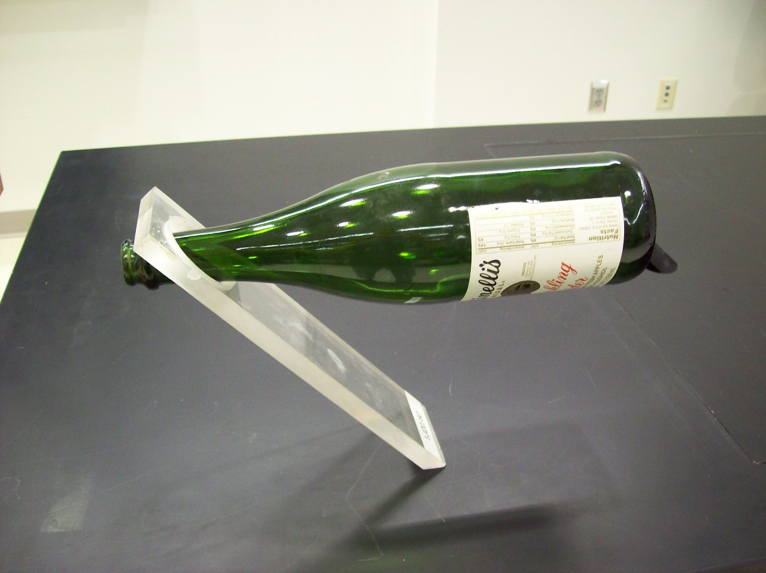
Location: Bd1

MECHANICS | 1J20.70 | STATICS OF RIGID BODIES
Exceeding Center of Gravity

Double Cone
 | A double cone rolls up an inclined “V” track..
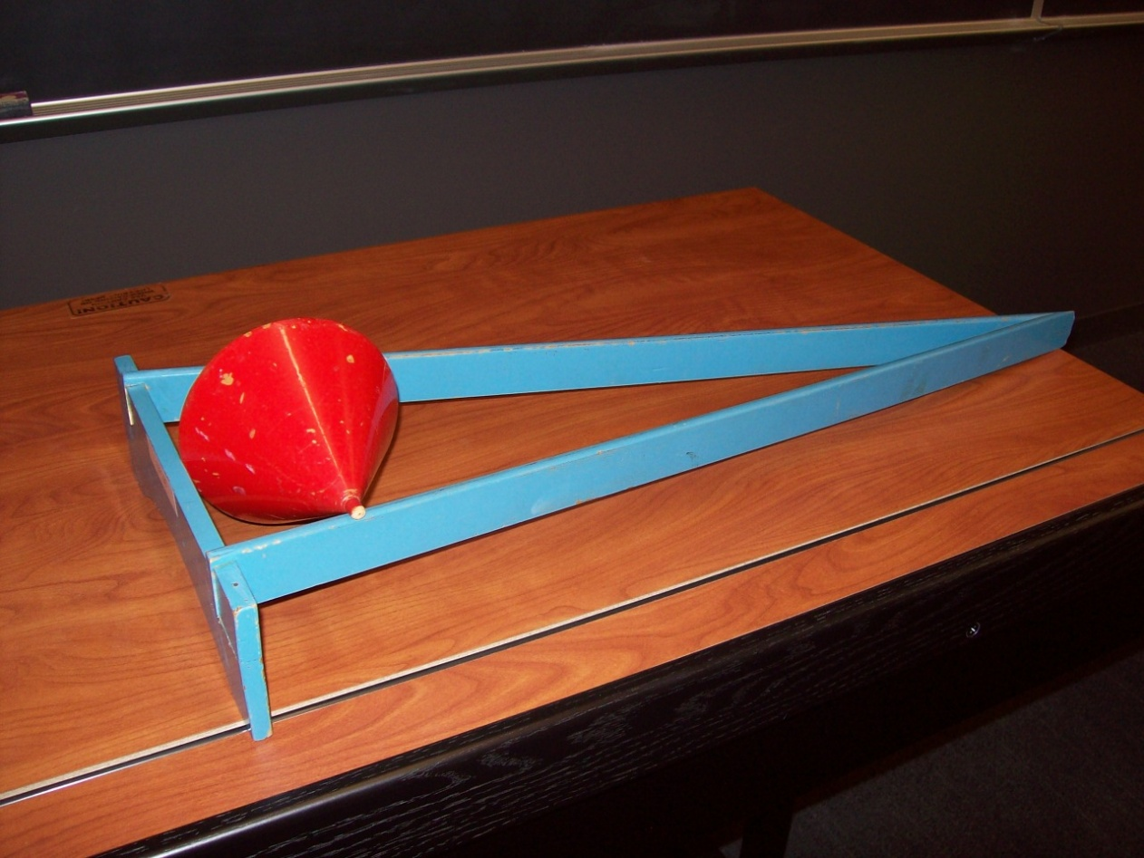
Location: Bc8

MECHANICS | 1J20.80 | STATICS OF RIGID BODIES
Stable, Unstable, and Neutral Equilibrium

Train Wheel Stability
 | A double cone (base to base) is stabile as it rolls down a track, whereas a double cone (apex to apex) isn’t.
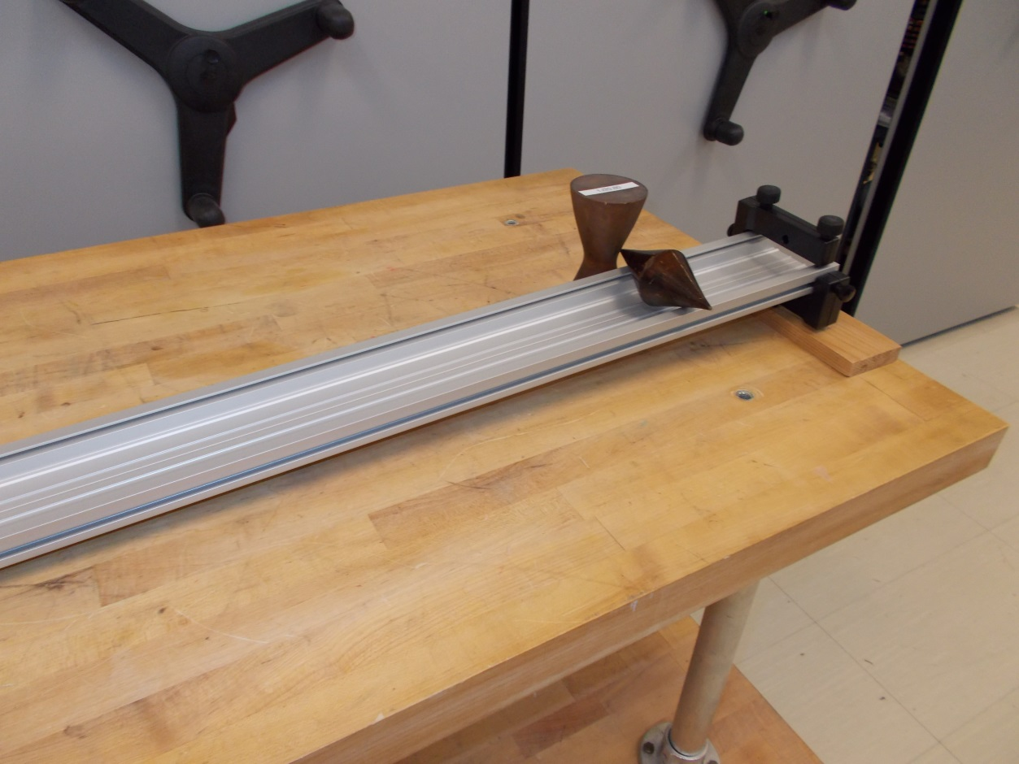
Cb1, Bd1
MECHANICS | 1J30.10 | STATICS OF RIGID BODIES

Resolution of Forces

Suspended Block
Disc 04-03
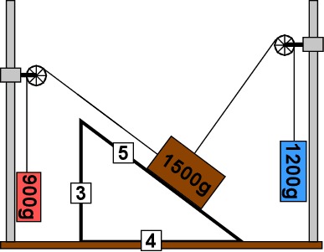 | The sides of the triangle are in the ration of 3:4:5. The 1500g block rests on a stop which can be removed after the force parallel to the incline is balanced. The block will be suspended in the same configuration as when on the incline. The masses to balance the perpendicular and parallel forces are 1200g and 900g, respectively. (I used 500, 400 and 300 g). The second version has built-in scales.
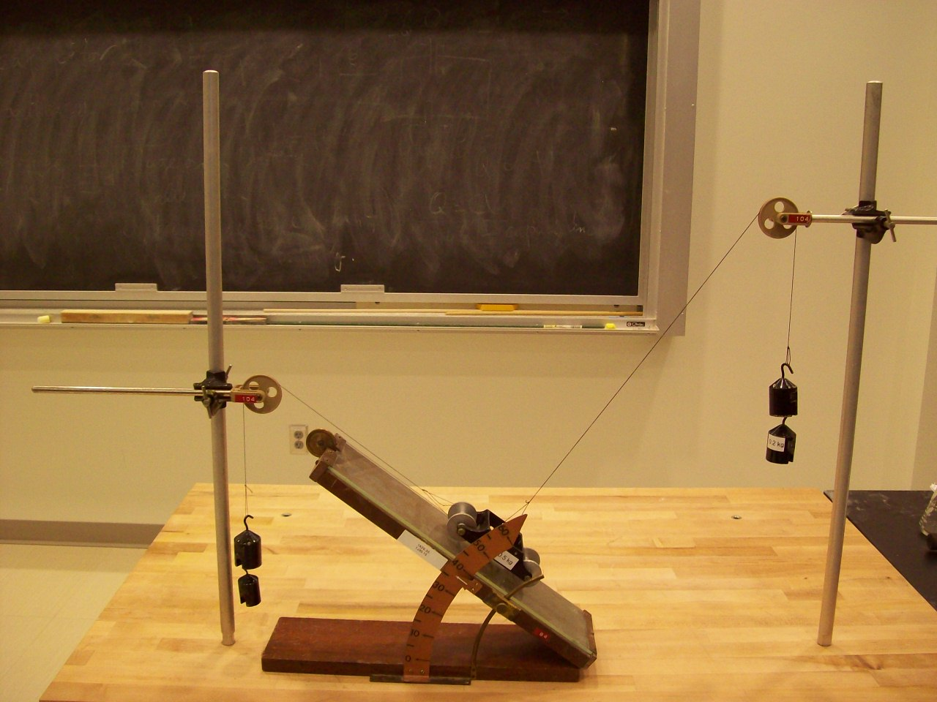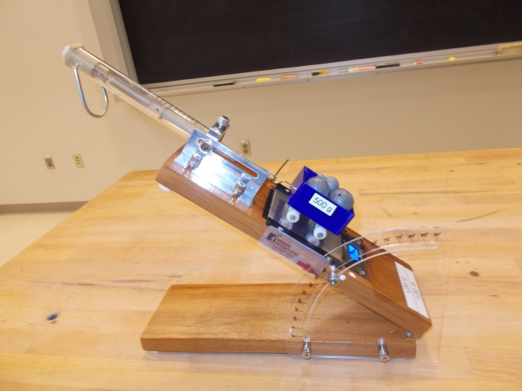
Location: Bd2
MECHANICS | 1J30.16 | STATICS OF RIGID BODIES
Resolution of Forces

Normal Force
 | A scale with a weight on it is tilted and the reading is observed to decrease as the angle at which it is tilted increases. The second version has a built-in digital scale.
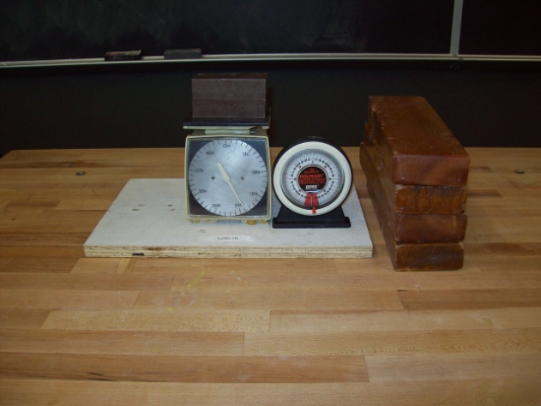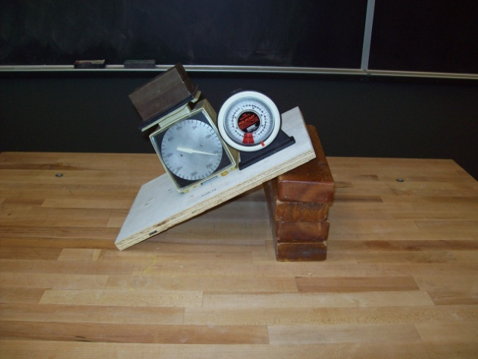
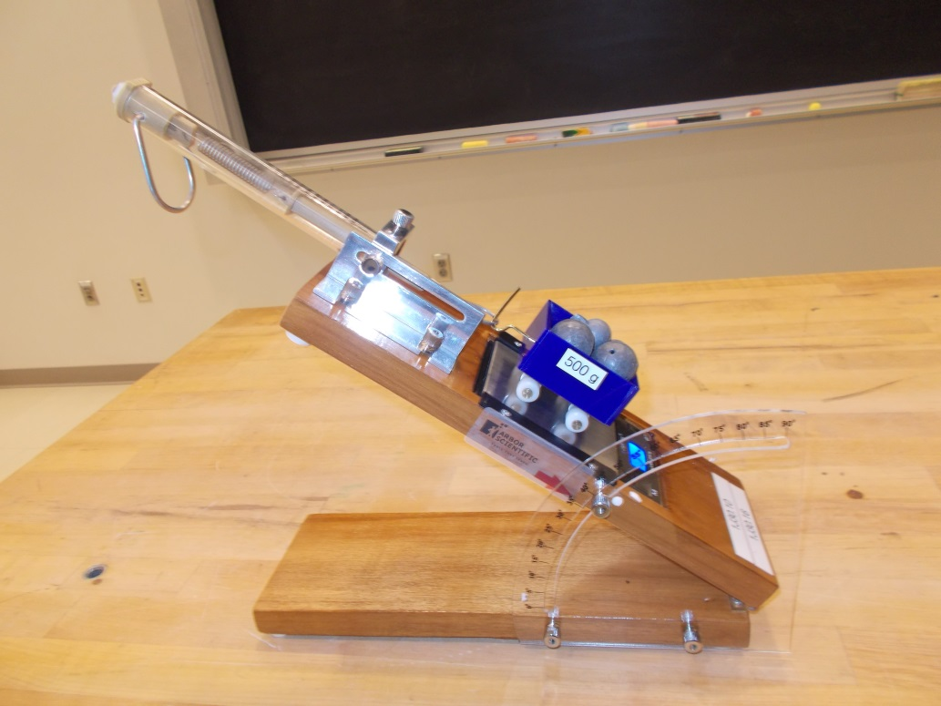
Location: Bd3
MECHANICS | 1J30.20 | STATICS OF RIGID BODIES
Resolution of Forces

Tension in a String
 | A spring scale is suspended between two strings. First: one string goes over a pulley to a weight while the other is tied off to a post. Second: now run the second string over a second pulley and hang an identical weight on it. Compare the scale readings in the first and second case.
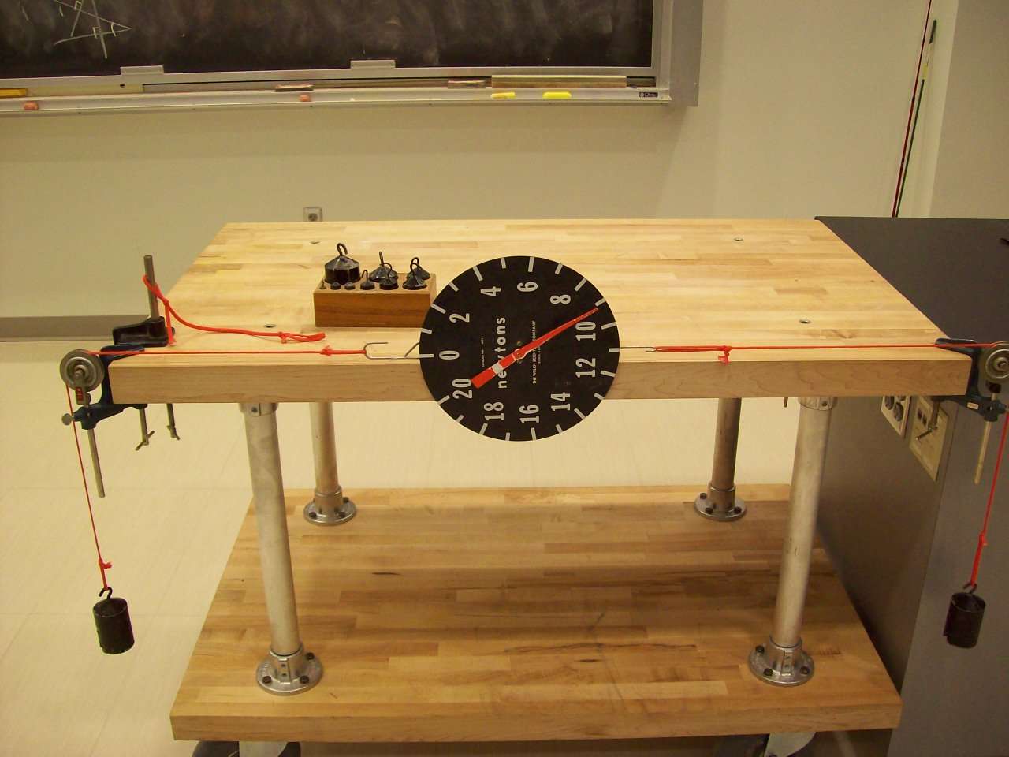Location: Bd2
MECHANICS | 1J30.25 | STATICS OF RIGID BODIES
Resolution of Forces

Rope and Three Students
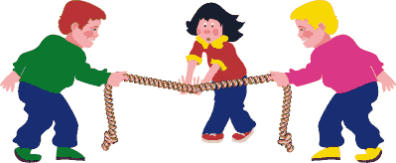 | A single student can easily deflect a rope held very taut by two other students.
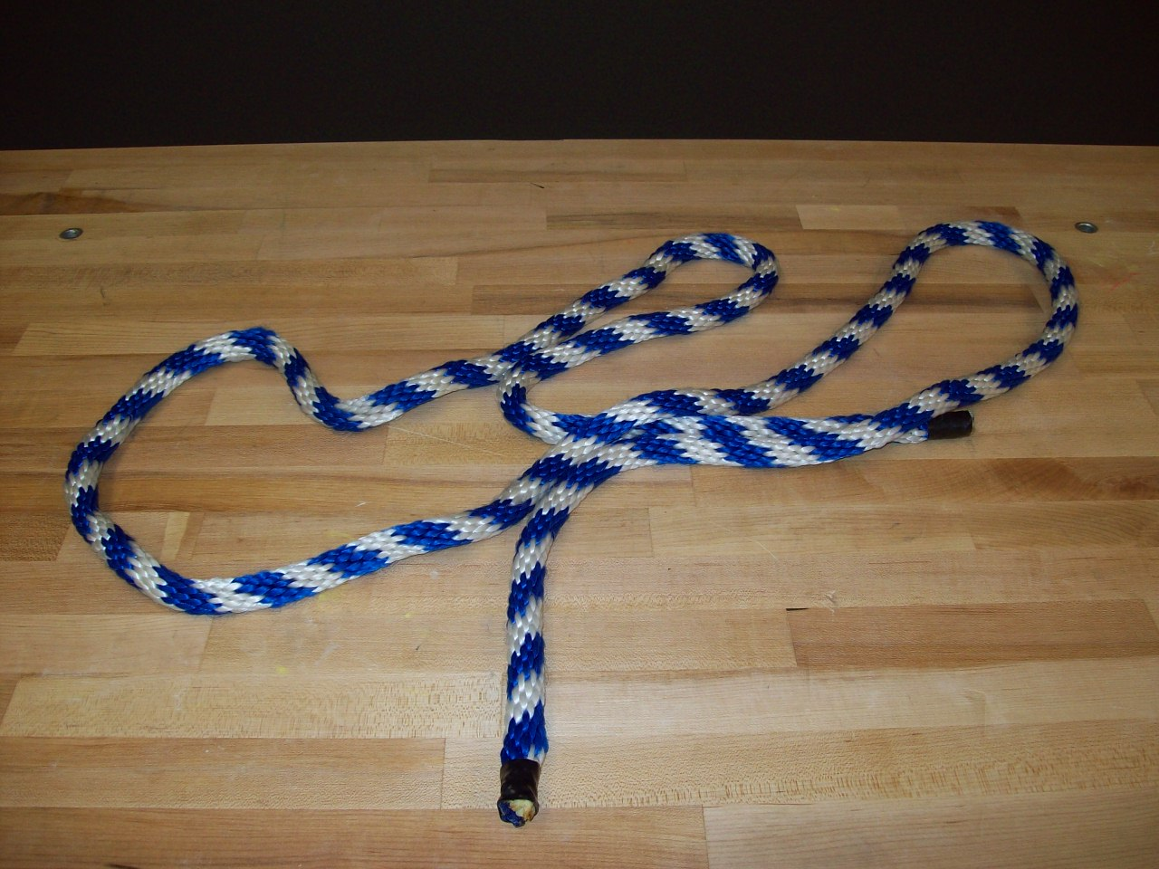
Location: Cc4

MECHANICS | 1J30.51 | STATICS OF RIGID BODIES
Resolution of Forces

Vertical Force Table
 | Two tension protractors measure the direction and magnitude of the tension in strings supporting a hanging mass.
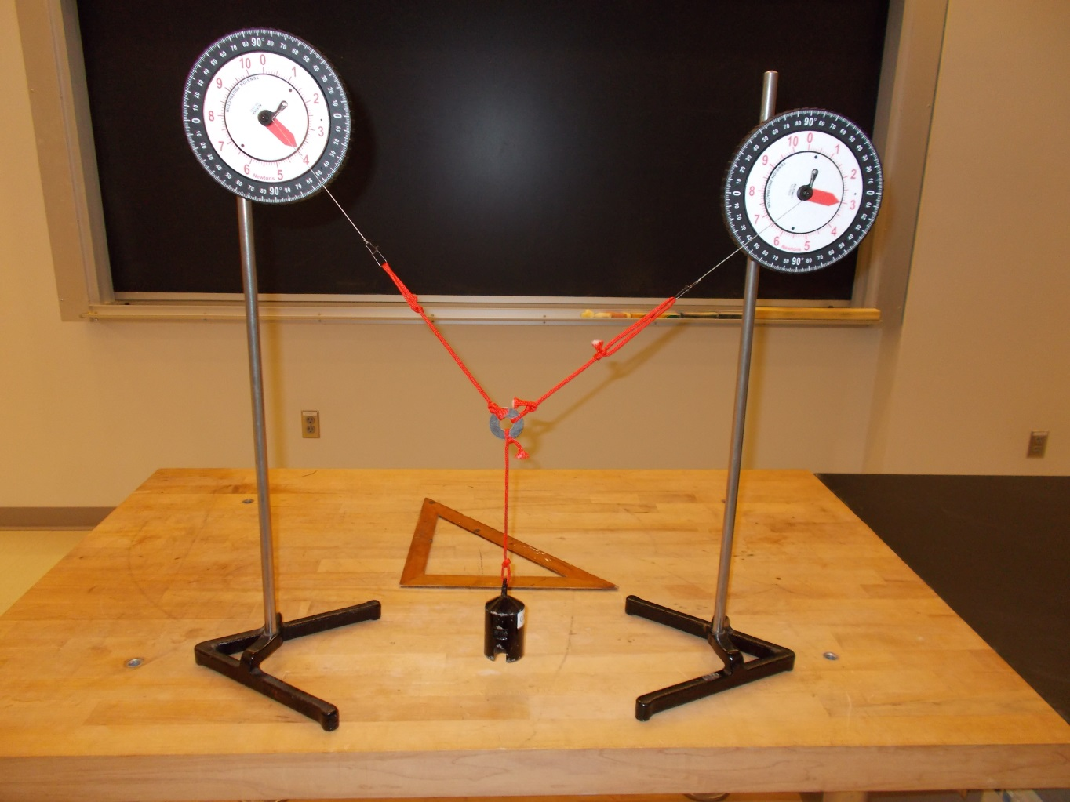
Location: Bd2,
MECHANICS | 1J30.52 | STATICS OF RIGID BODIES
Resolution of Forces

Force Table on OHP
 | A horizontal force table on an overhead projector. The image of the strings can be traced on the blackboard and a force diagram made from them.
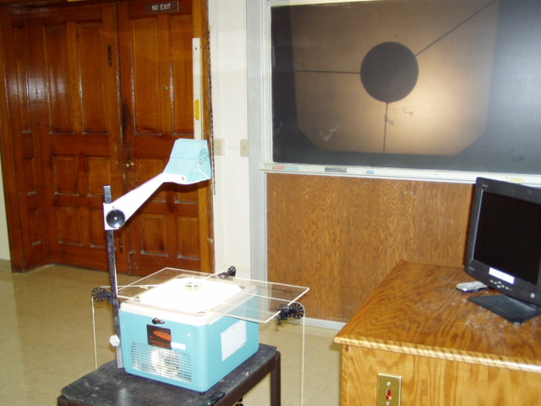Location: Bd2

MECHANICS | 1J40.10 | STATICS OF RIGID BODIES

Static Torque

Grip Bar
Disc 04-10
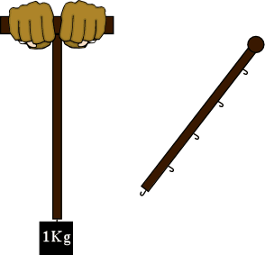 | A 1kg mass can be suspended from a bar at different places. The further from the handle grip, the harder it is to keep the stick level or to rotate the stick upwards.
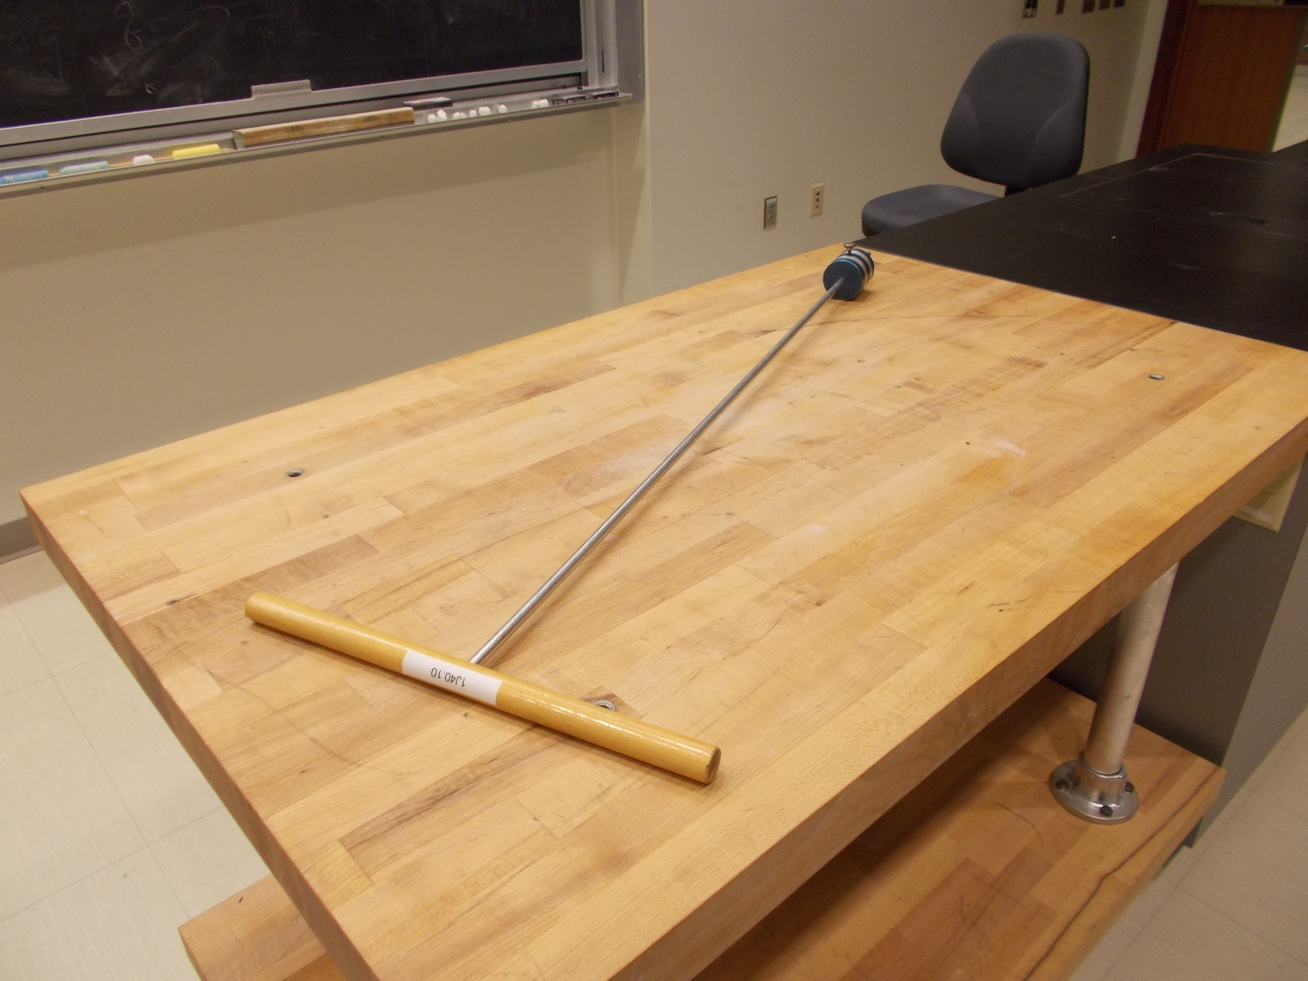
Location: Bd4

MECHANICS | 1J40.15 | STATICS OF RIGID BODIES
Static Torque

Torque Wrench
 | A torque wrench and bolt screwed into the table are shown.
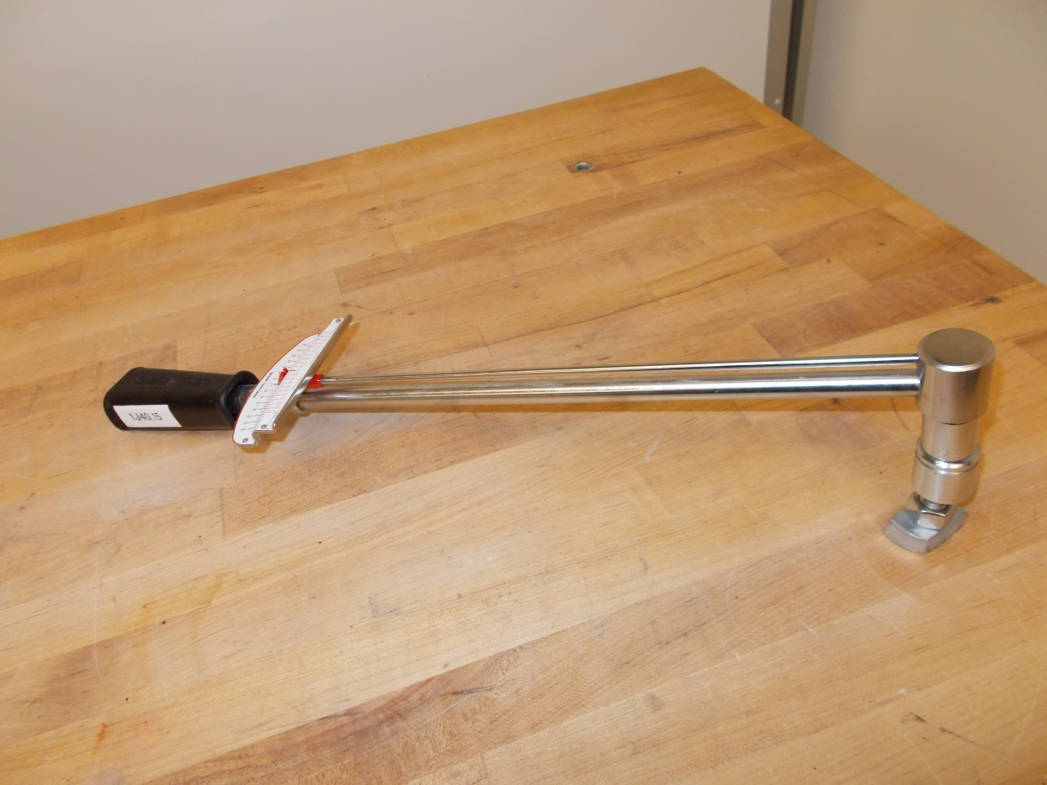
Location: Bd3
MECHANICS | 1J40.20 | STATICS OF RIGID BODIES
Static Torque

Meter Stick Balance
Disc 04-14
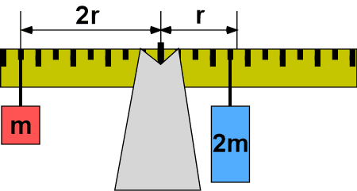 | Different combinations of mass at different distances from the pivot can be used to show torques in equilibrium. The meter stick’s mas is 151g. The weight hangers are 10 g. each and have a load limit of 1 Kg
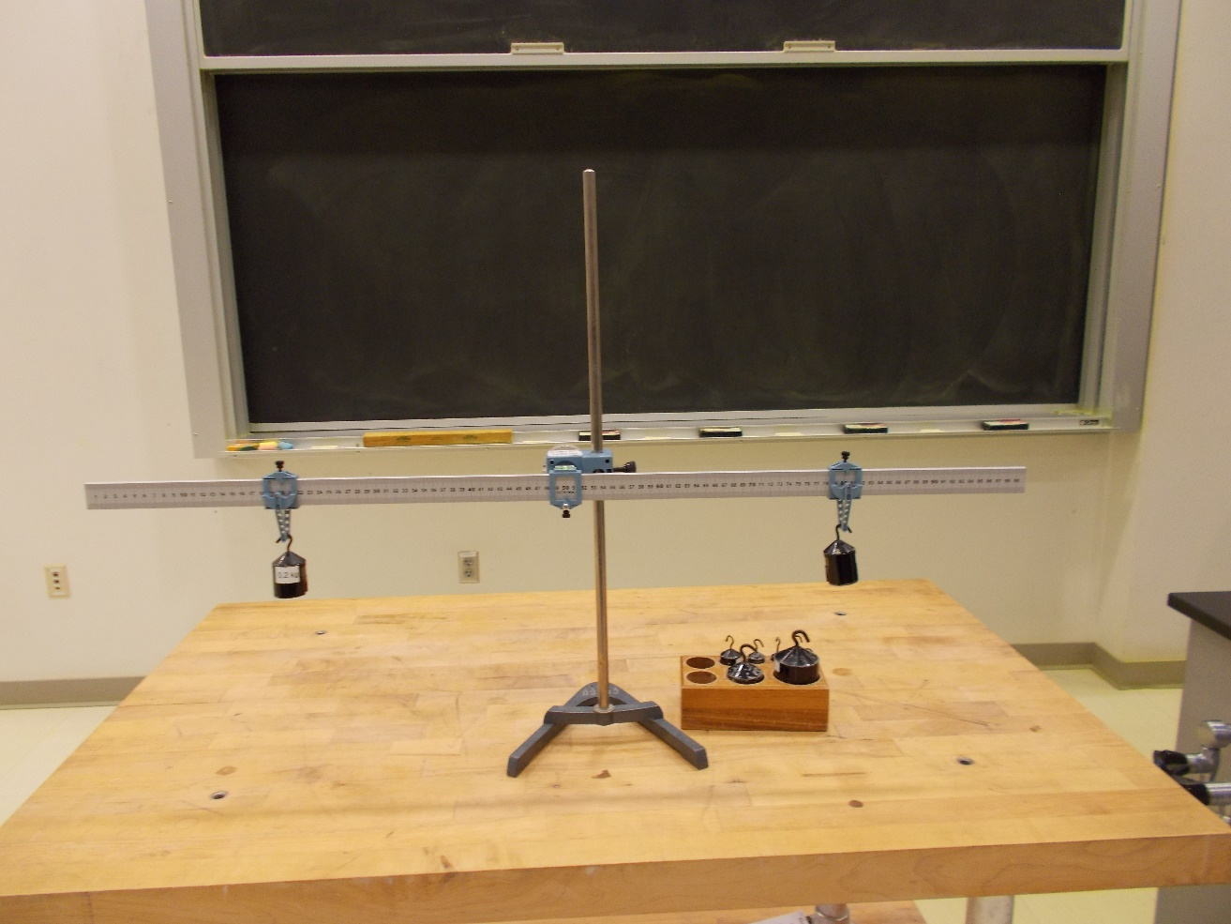
Location: Bd3
MECHANICS | 1J40.21, 1J40.32 | STATICS OF RIGID BODIES
Static Torque

Trap Door
 | A hinged board with handles at different distances from the hinge is used to illustrate torque.
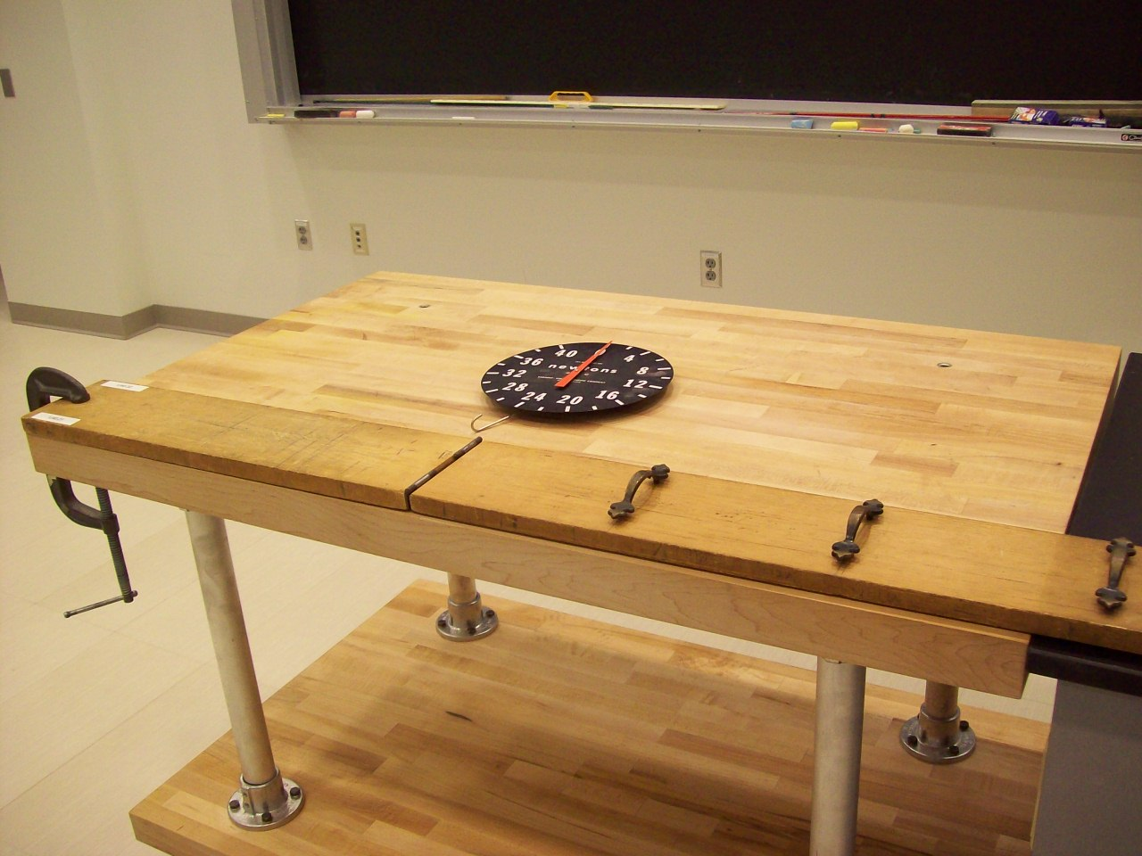
Location: Bd5
MECHANICS | 1J40.40 | STATICS OF RIGID BODIES
Static Torque

Loaded Beam
 | Large masses can be placed on a beam resting on two scales.
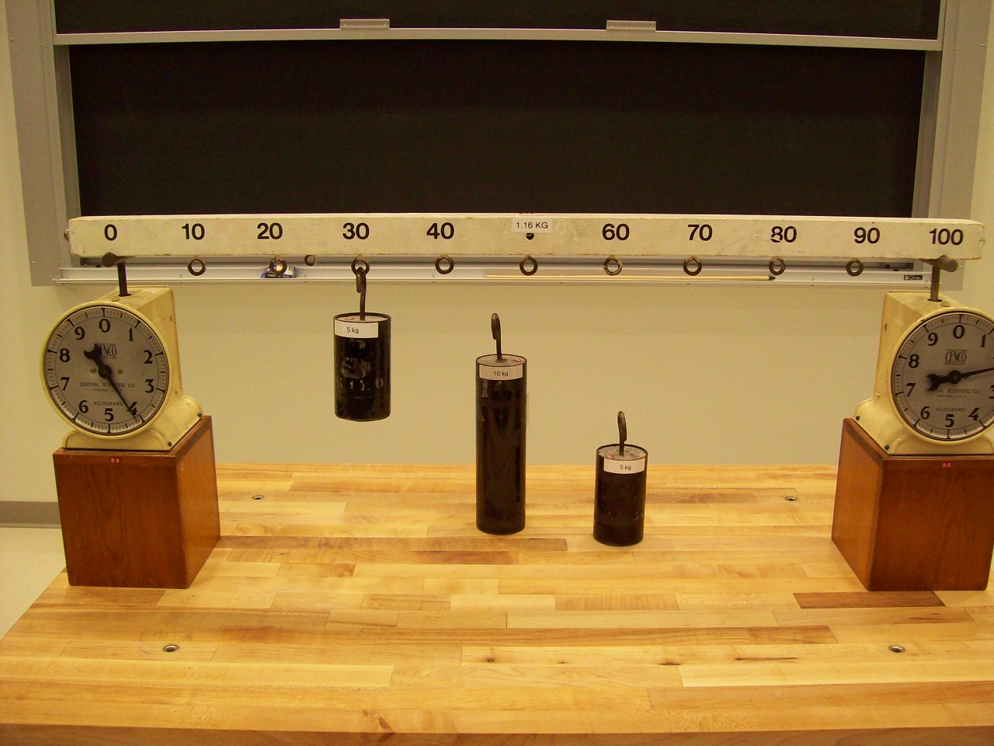
Location: Bd5
MECHANICS | 1J40.50 | STATICS OF RIGID BODIES
Static Torque

Roberval Balance
 | Neutral equilibrium is maintained at any position of the weights on the arms when the arms are in the middle position. It is not maintained if the arms are moved to the upper position. (Shown in the middle position.)
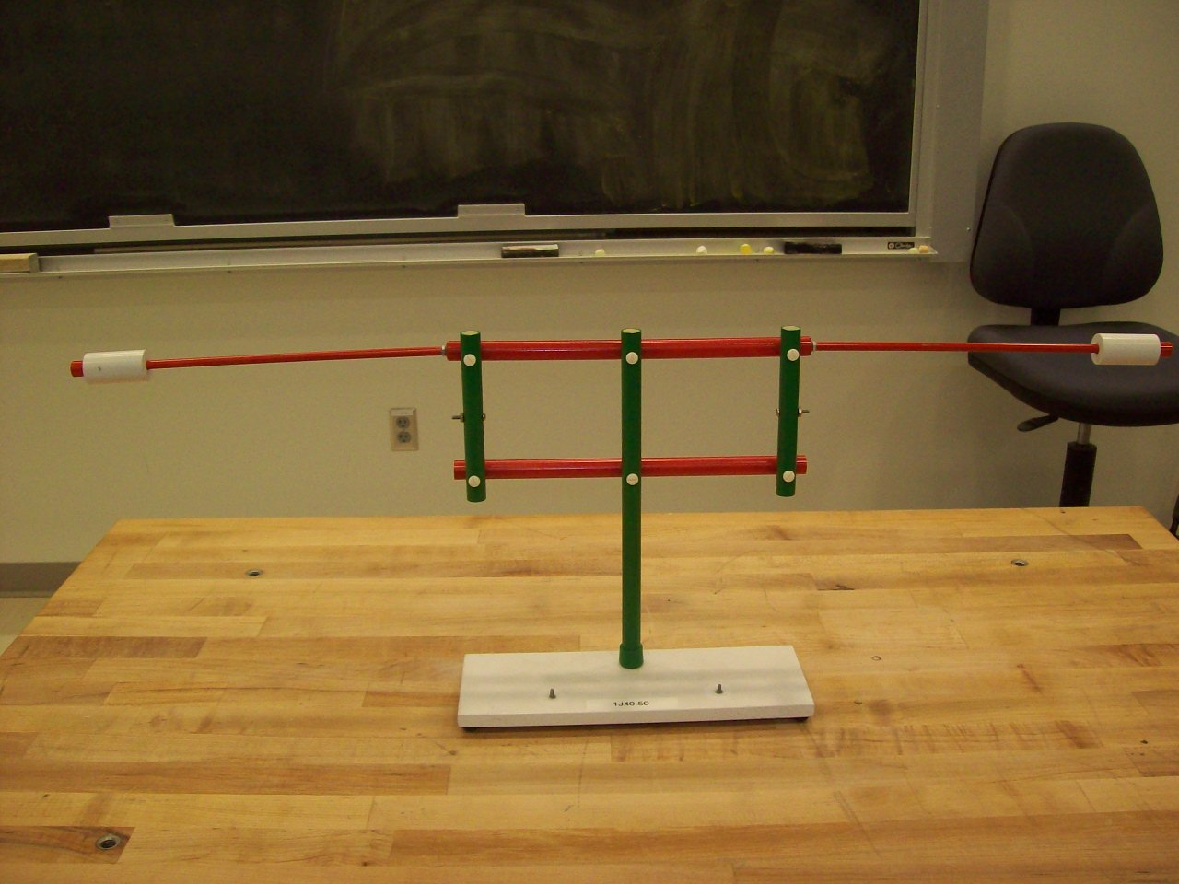Location: Bd6
MECHANICS | 1J40.51 | STATICS OF RIGID BODIES
Static Torque

Moment Arms
 | Equilibrium is maintained when the mass is moved from the upper arm to the lower as long as the moment arms about the pivot point are the same.
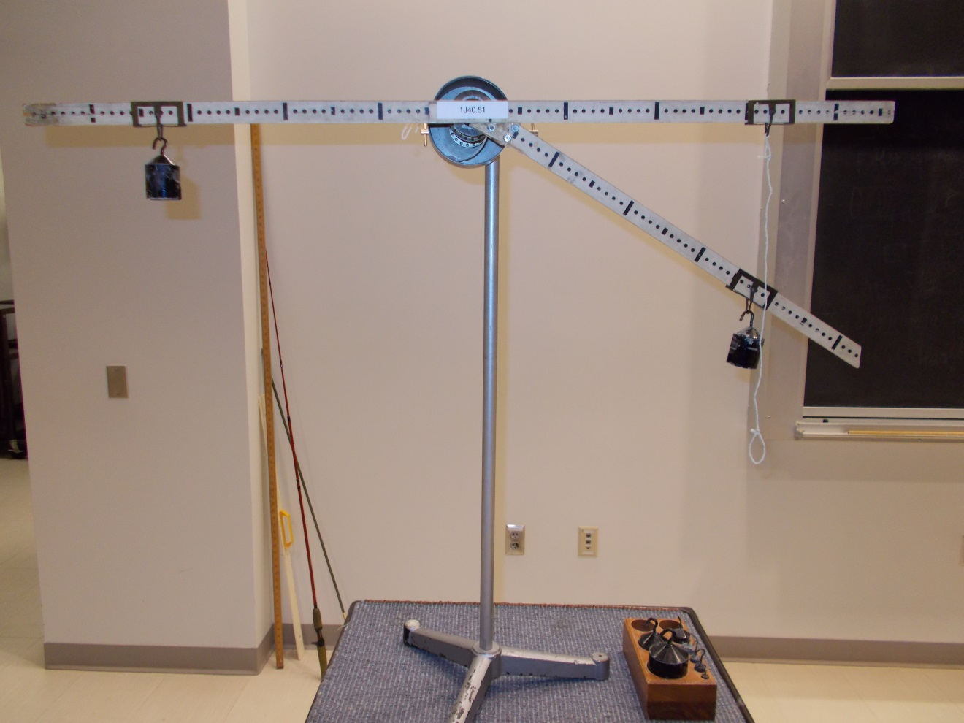Location: Bd7
MECHANICS | 1J40.70 | STATICS OF RIGID BODIES
Static Torque

Crane Boom
 | An illustration of statics. The load can be varied as well as the various angles. The spring scale measures the tension in the string supporting the boom. The meter stick’s mass is 151g and the mass hangers are 10 g each with a load limit of 1Kg.
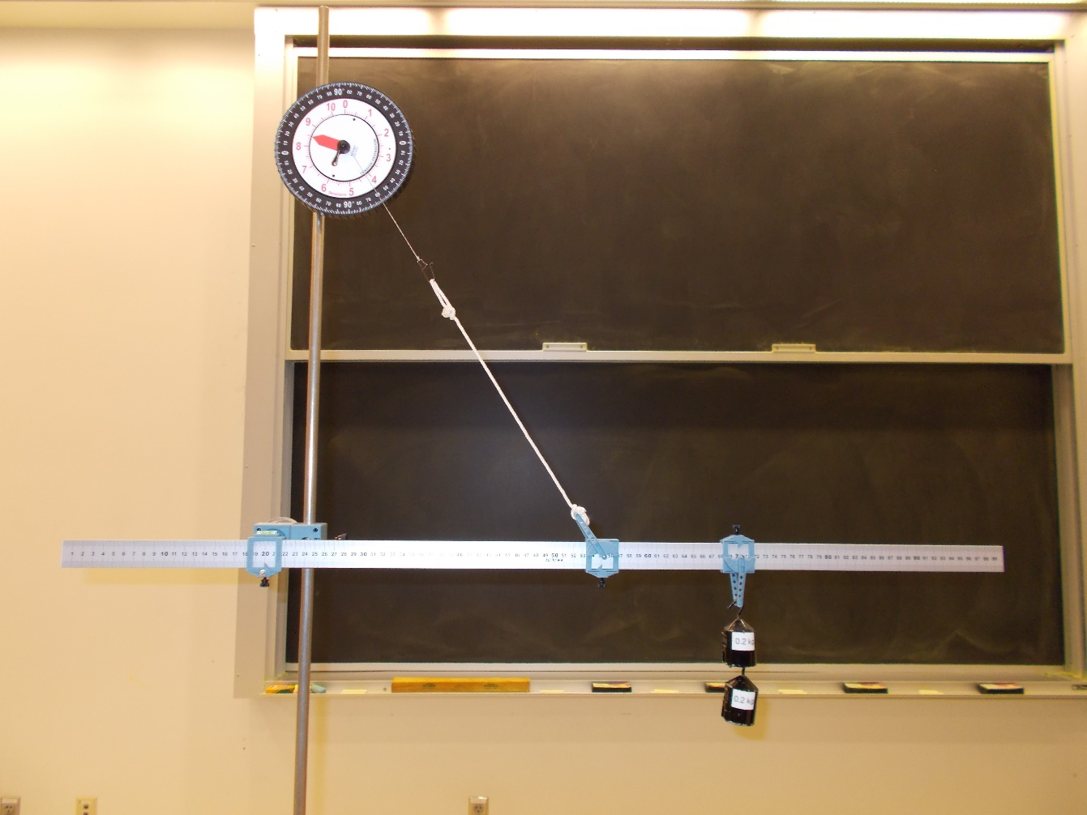
Location: Bd2, Bd3
MECHANICS | 1J40.71 | STATICS OF RIGID BODIES
Static Torque

Hanging Sign
 | An illustration of Statics
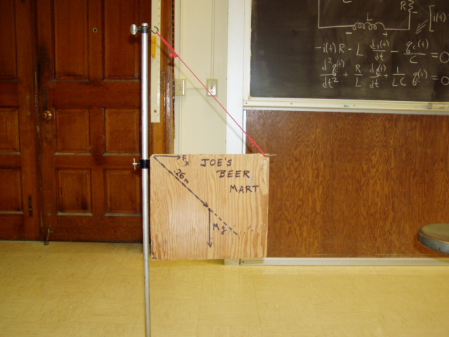Location: Bd6
MECHANICS | 1J40.75 | STATICS OF RIGID BODIES
Static Torque

Arm Model
 | A spring scale where the bicep would be measures the force necessary to hold a weight at various angles.
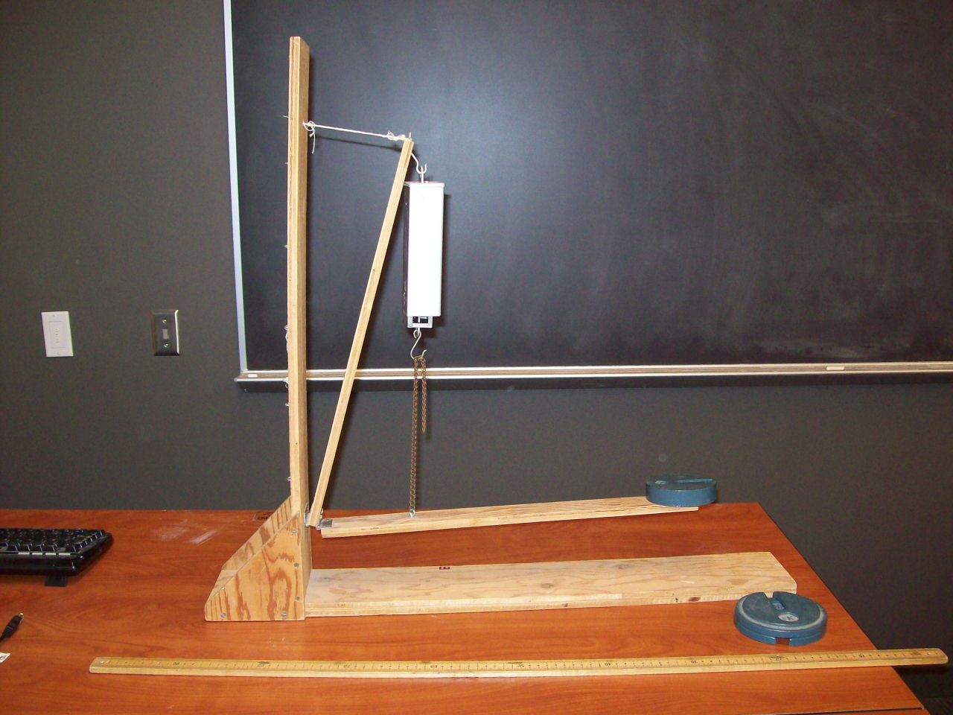
Location: Bd7
MECHANICS | 1K10.20a | APPLICATIONS OF NEWTON'S LAWS

Dynamic Torque

Ladder Against a Wall
Disc 04-18
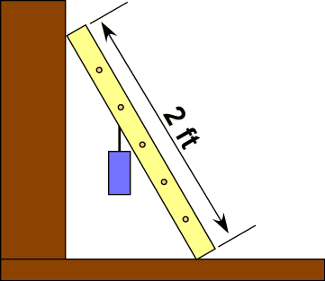 | A model ladder leans against a heavy wooden box and a mass is hung from a rung. Move the mass higher and higher or adjust the angle smaller and smaller until the ladder slips. Different materials can be used for the surfaces to show different static frictions. Our ladder is 1.10 m in length. The cm is 0.59 m from the bottom and its mass is 0.433 kg
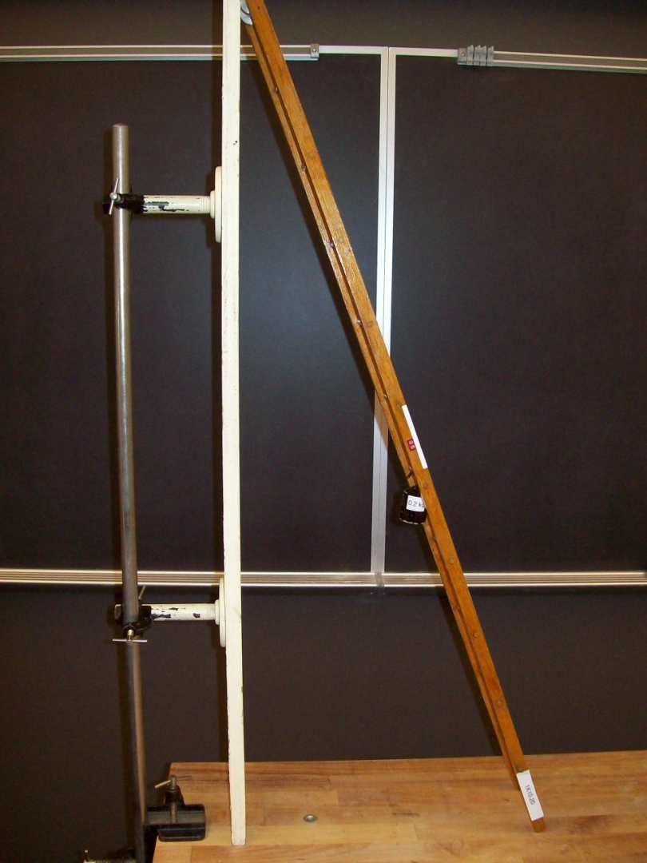
Location: Ca1
MECHANICS | 1K10.20b | APPLICATIONS OF NEWTON'S LAWS
Dynamic Torque

Ladder Against a Wall
 | Ladder problem with force transducer and Capstone software (Ladder.cap). Our ladder is 1.10 m in length. The cm is 0.59 m from the bottom and its mass is 0.433 kg. If the ladder is at a 60 degree angle and a 1 kg mass is at the 8th rung (0.81 m from the bottom), 5.4 N should be the force measured by the transducer. This requires some care to get accuracy.
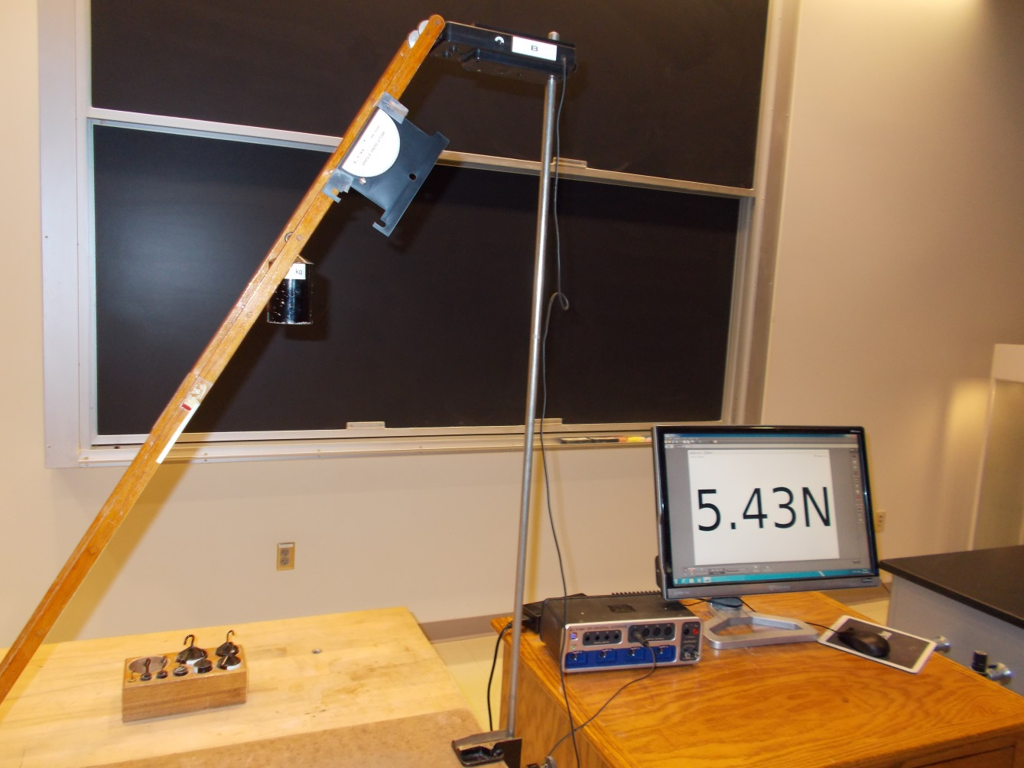
Location: Ca1
MECHANICS | 1K10.30 | APPLICATIONS OF NEWTON'S LAWS
Dynamic Torque

Walking the Spool
Disc 06-07
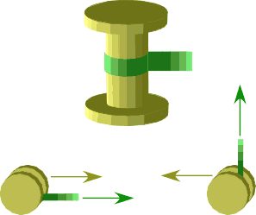 | Pull the rope that is wound around the spool. The angle between the rope and the table determines the direction the spool will roll. At some angle, the spool will not roll, but slide when you pull it.
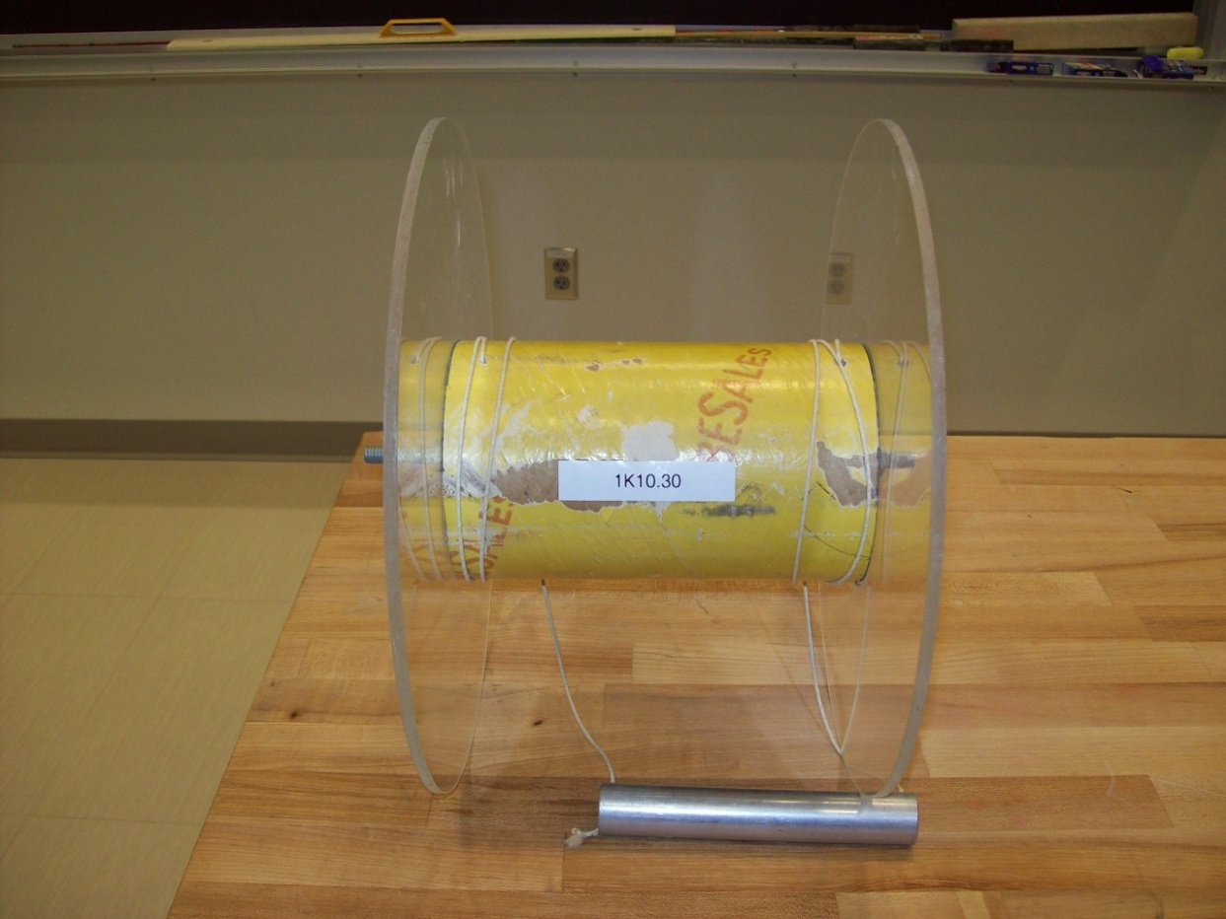
Location: Ca2

MECHANICS | 1K10.60 | APPLICATIONS OF NEWTON'S LAWS
Dynamic Torque

String Unwinding from a Pole
 | A weight hanging from a cord around a pole unwinds in a predictable way as the weight rotates around the pole in circles of increasing radius.
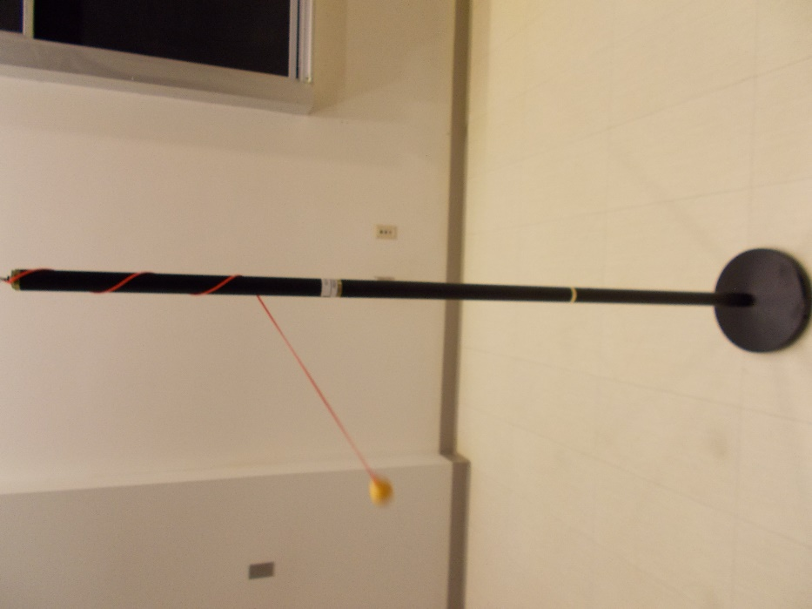
Location: Ca2, La5
MECHANICS | 1K20.10 | APPLICATIONS OF NEWTON'S LAWS

Friction

Friction Blocks - Surface Materials
Disc 03-05
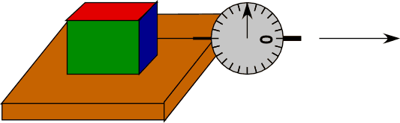 | Measure static friction by noting the scale reading just before the block slides. Measure sliding friction by pulling the block at a constant speed. Change the surface materials and note the different frictions. Use the FLIR camera to show where the work done by the force goes.
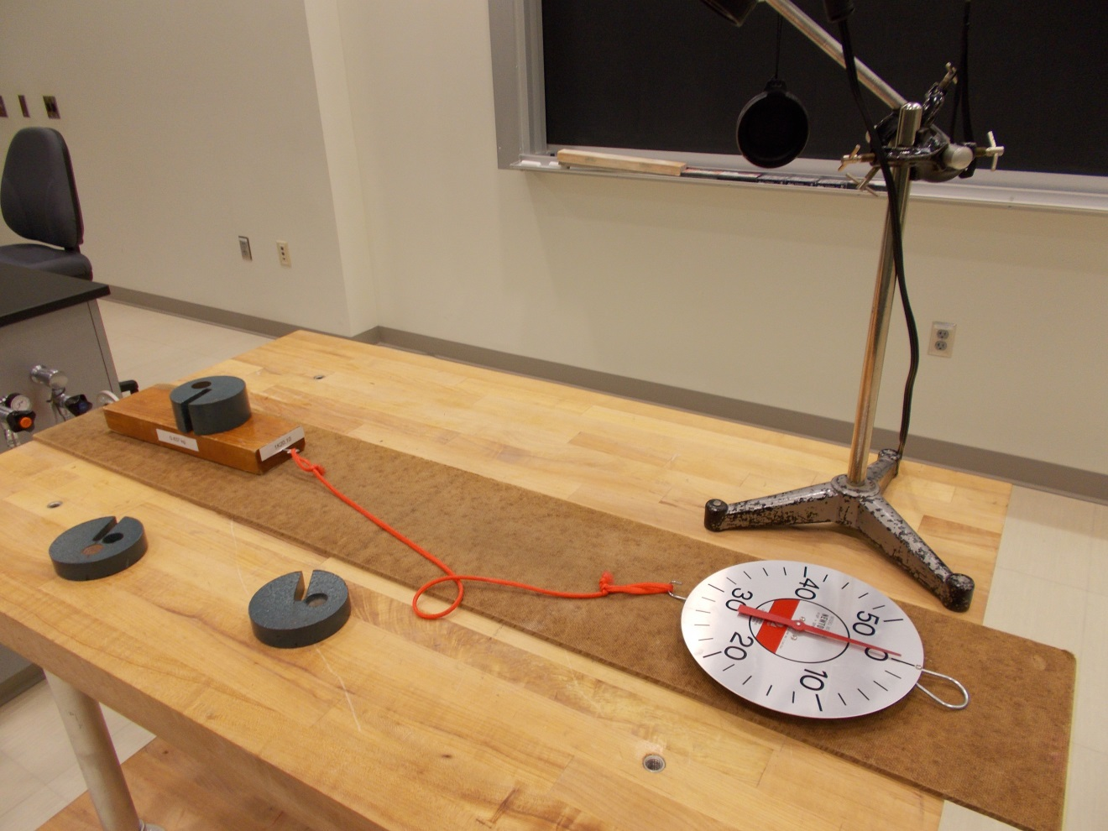
Location: Ca1, Ca3, FLIR cabinet
MECHANICS | 1K20.25 | APPLICATIONS OF NEWTON'S LAWS
Friction

Phonebook Friction
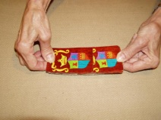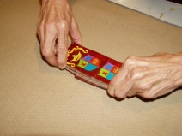 | Two phonebooks (in our case, catalogs) have their pages interleaved without any adhesive. They cannot be easily pulled apart and, as the photo shows, support the weight of a human. The combined frictional force of the individual pages and the increased normal force due to the component of the tension in the pages normal to the pages are responsible for this. Use the deck of cards to show this: the cards are hard to pull apart when grasped as shown in the first picture, but easy when held so that the normal force is not increased.

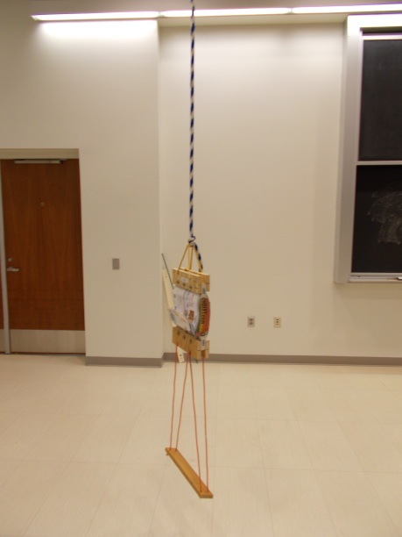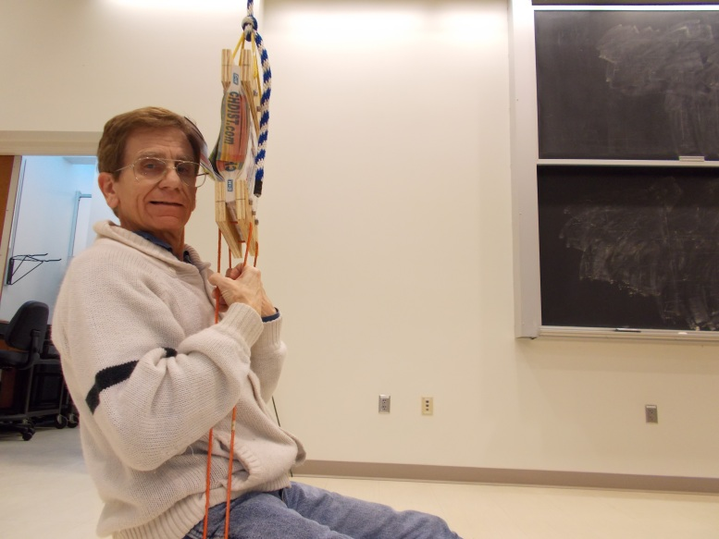
Location: Ca3
MECHANICS | 1K20.30 | APPLICATIONS OF NEWTON'S LAWS
Friction

Static vs. Sliding Friction
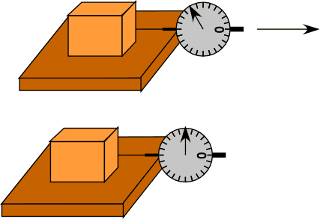 | Measure static friction by noting the scale reading just before the block slides. Measure sliding friction by pulling the block at a constant speed. Compare the two readings. This can also be done with Capstone (Friction- Kinetic and Static.cap), using the smart cart.
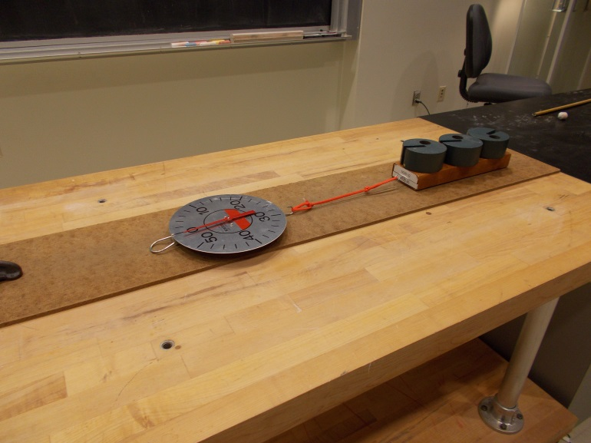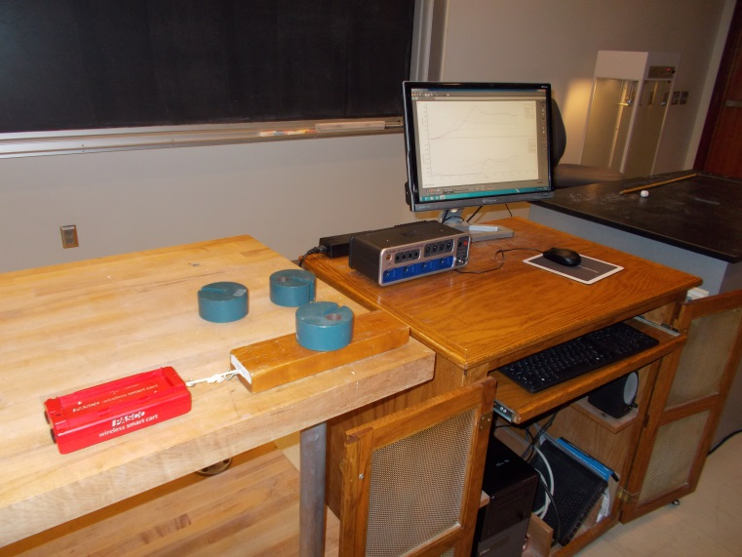
Location: Ba5, Bb2, Ca1, Ca3
MECHANICS | 1K20.35 | APPLICATIONS OF NEWTON'S LAWS
Friction

Angle of Repose
An incline is lifted until a block begins to slide. The block should slide with a more or less constant speed when the angle of repose is achieved.
The blocks have different surface materials (wood, cork and felt).
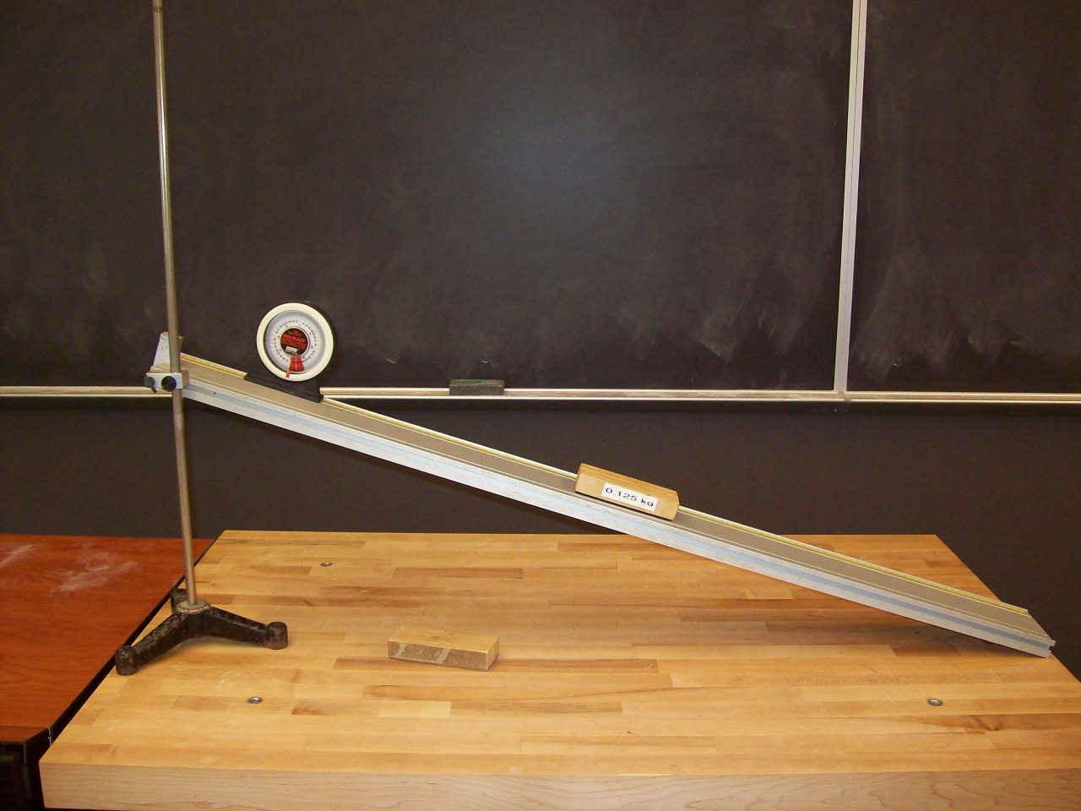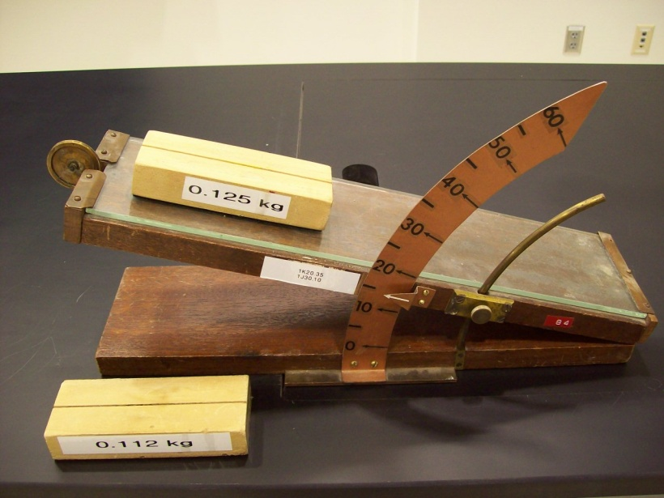
Location: AcT, Bd2, Bd3, Ca3

MECHANICS | 1K20.71 | APPLICATIONS OF NEWTON'S LAWS
Friction

Capstan
 | Heavy weights are suspended from a rope that is wrapped around a cylinder. CAUTION: Make sure the weights don’t slip off and injure you or the floor!
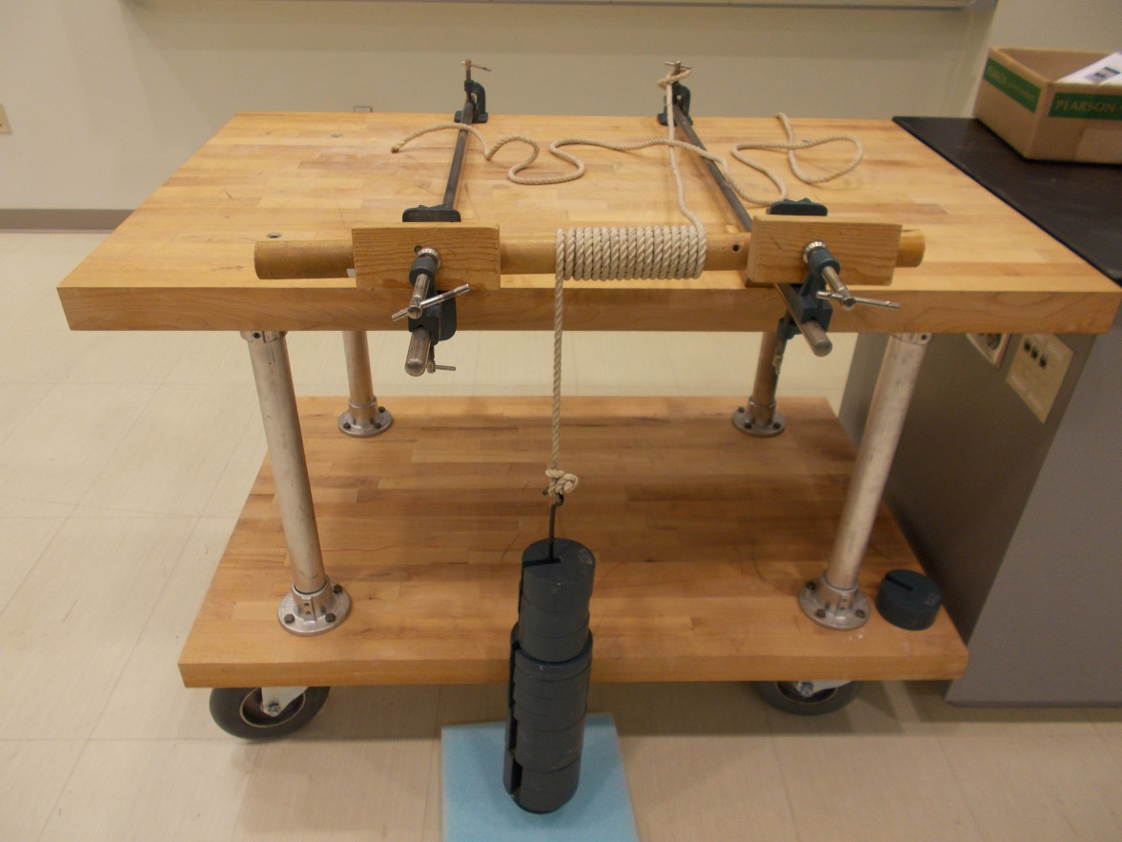
Location: Ca3
MECHANICS | 1K30.10 | APPLICATIONS OF NEWTON'S LAWS

Pressure

Bed of Nails
 | Lie down on a bed of nails. The smaller version is used with a balloon and you can change the number of nails.
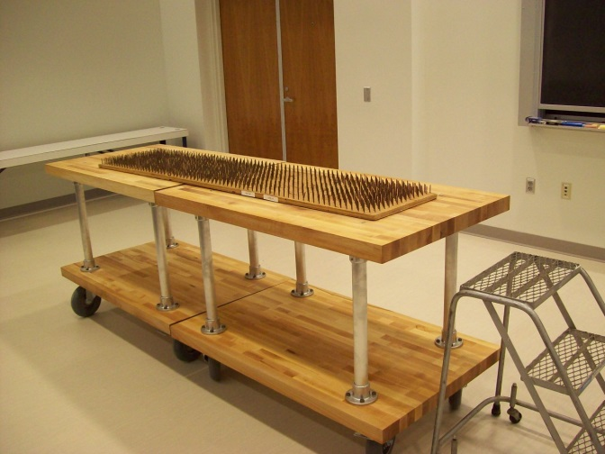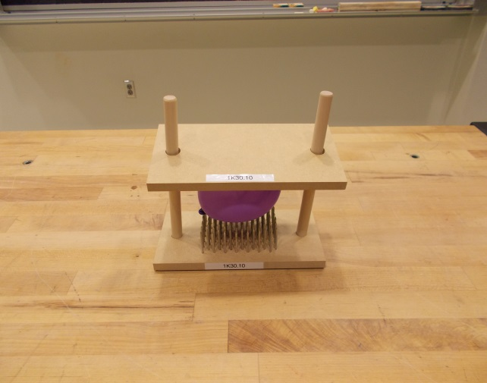
Location: By the door, Ca3

MECHANICS | 1L10.10 | GRAVITY

Universal Gravitational Constant

Cavendish Balance Video
Ztek Company Multimedia for Physics
http://www.ztek.com/physics/physics.html#Anchor-Physics-11481
Physics: CINEMA CLASSICS DVD 1
Mechanics (I)
ISBN: 1-56934-021-8 D00921 PCC 1- Mechanics (I)
Grade Level: 7+

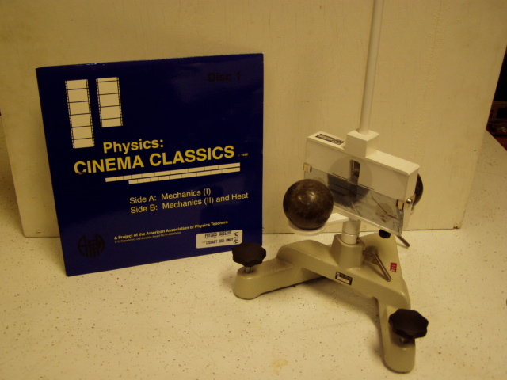
Location: Video Cabinet
MECHANICS | 1L10.30 | GRAVITY
Universal Gravitational Constant

Cavendish Balance
 | Standard Cavendish balance with a laser beam. There is a discussion of the balance shown in the photograph in the Meiners reference: 8-8.7 Use a small magnet to help damp out oscillations (lead is diamagnetic so the magnet “pushes” the small lead balls. Use stick on dots to mark the initial and final laser spot. They are about 40 cm. apart as set up below.
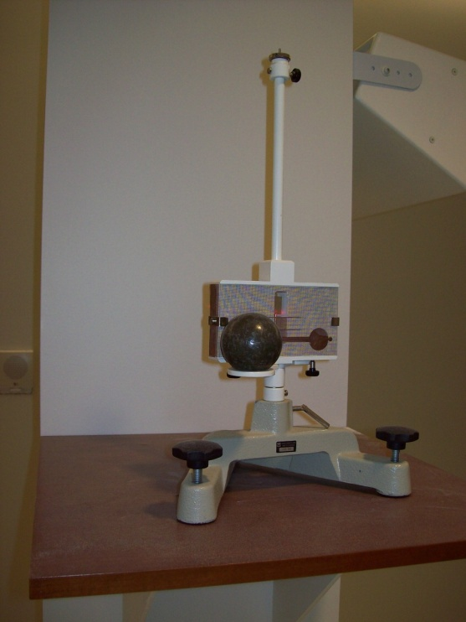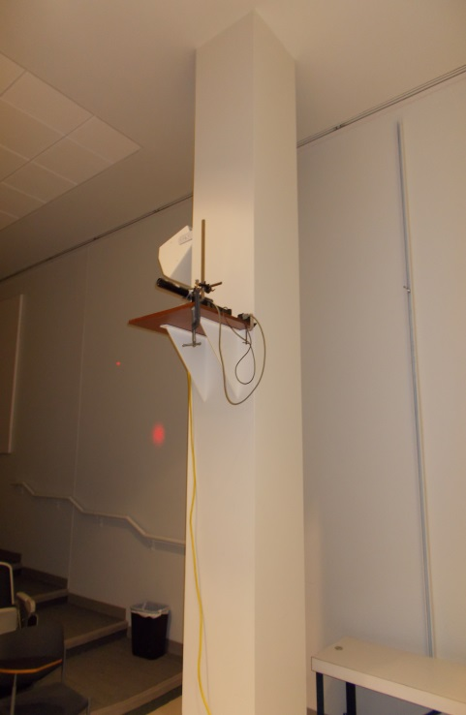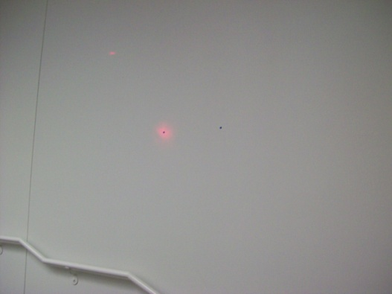
Location: Ca4
MECHANICS | 1L20.10 | GRAVITY

Orbits

Gravitational Wells
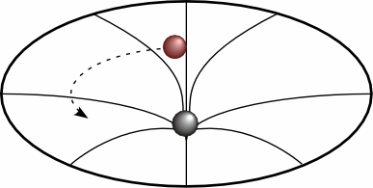 | A potential well with a 1/R profile.
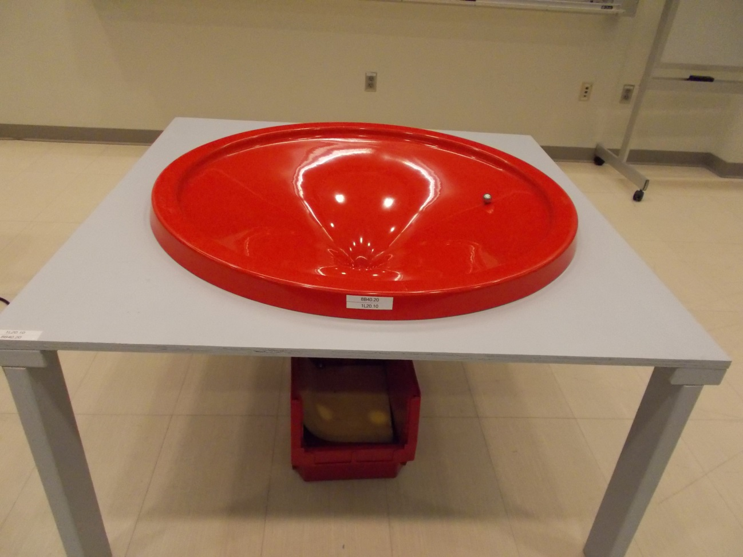
Location: OaT
MECHANICS | 1L20.40 | GRAVITY
Orbits

Sections of a Cone
 | A dissectible cone is cut several ways to give a circle, ellipse, parabola and hyperbola.
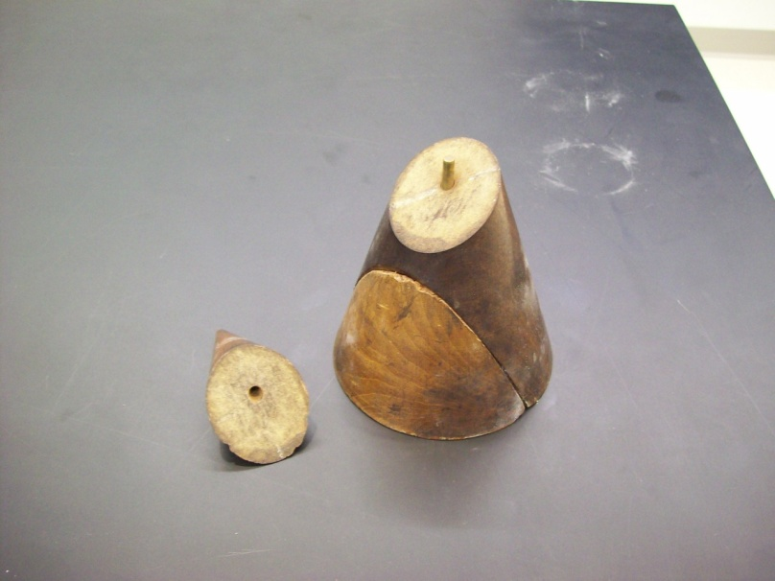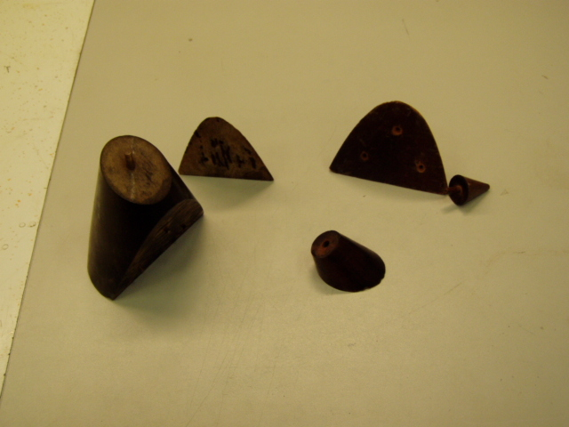
Location: Cab
Mechanics | 1L20.50 | Gravity
Orbits

Ellipse Drawer
 | Magnets hold a string and while the string is pulled taut with a piece of chalk, an ellipse can be drawn.
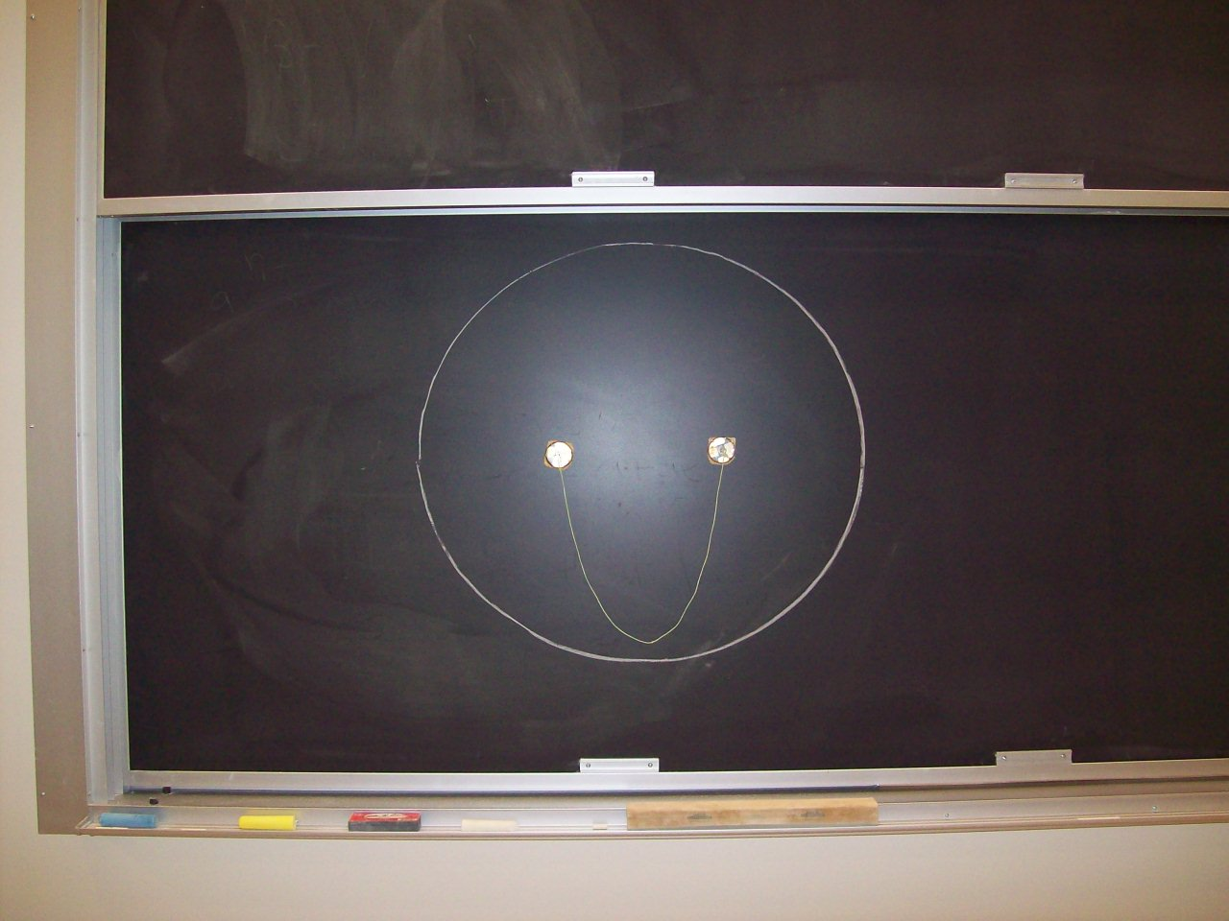
Location: Ca4
MECHANICS | 1M10.20 | WORK AND ENERGY

Work

Pile Driver
Disc 03-07
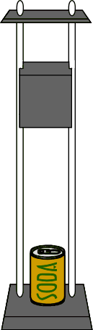 | Raise the mass to the desired height and let it fall freely. If the mass is raised twice as high, the nail will be driven twice as deep. The mass is 1 kg (more can be added; the photo has a total of 3 kg). A 16d nail has a mass of about 7g and a 10f has a mass of about 5g. The maximum distance the mass can fall is about 1.35 m. Option: Calculate the work needed to crush a soda can or drive a nail. Observe with FLIR camera.
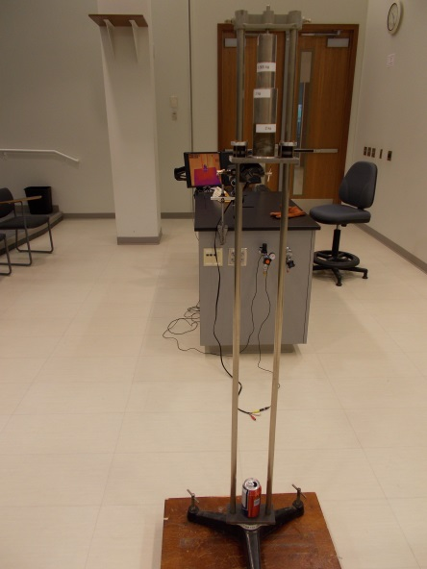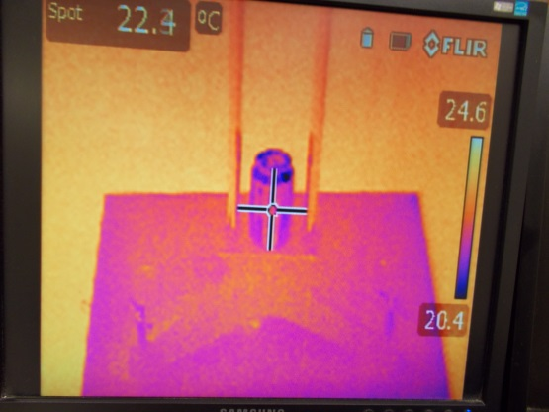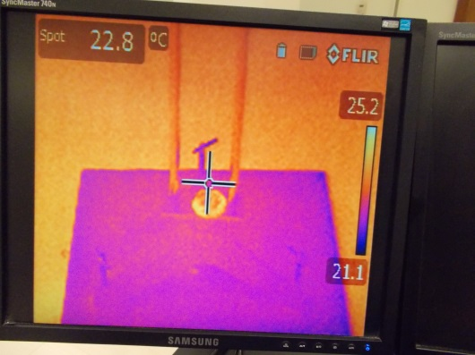
Location: Ca1, FLIR cabinet
MECHANICS | 1M20.01 | WORK AND ENERGY

Simple Machines

Simple Machines
 | A collection of simple machines is shown.
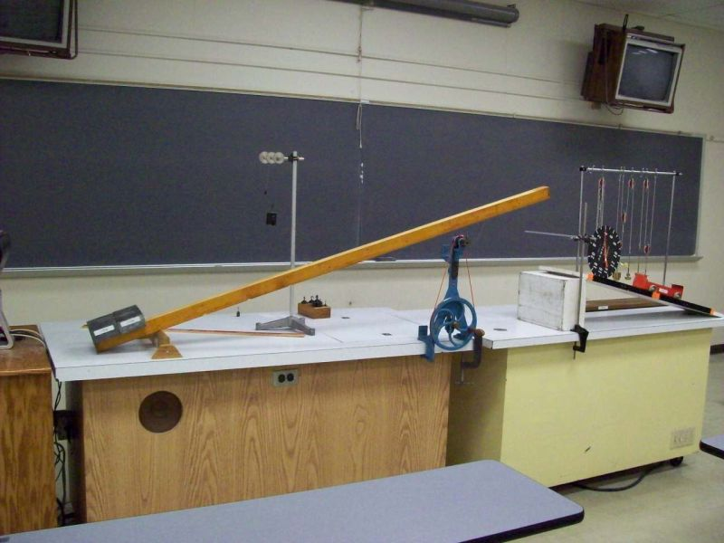
Location: Ca1, Cb2, Cb4, CaT, Qa1, Cb2, Cb4, Bb8

MECHANICS | 1M20.10 | WORK AND ENERGY
Simple Machines

Pulleys
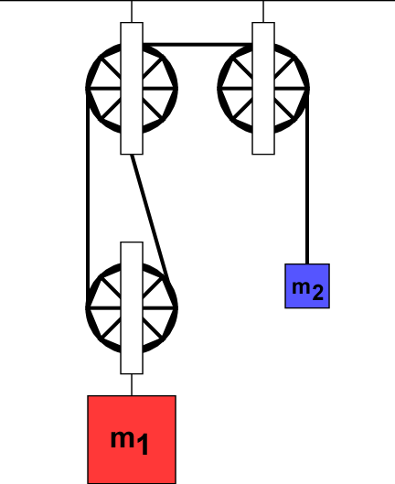 | An assortment of large pulleys can be rigged several ways.
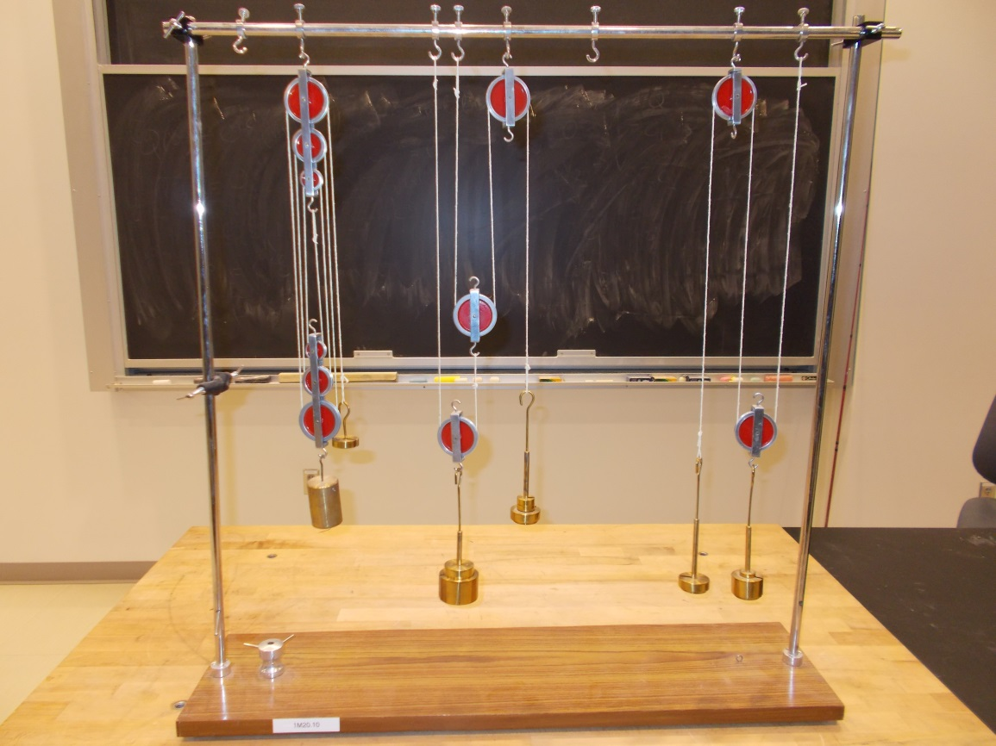
Location: Cb3

MECHANICS | 1M20.30 | WORK AND ENERGY
Simple Machines

Inclined Plane
 | Pull a heavy cart up an incline.
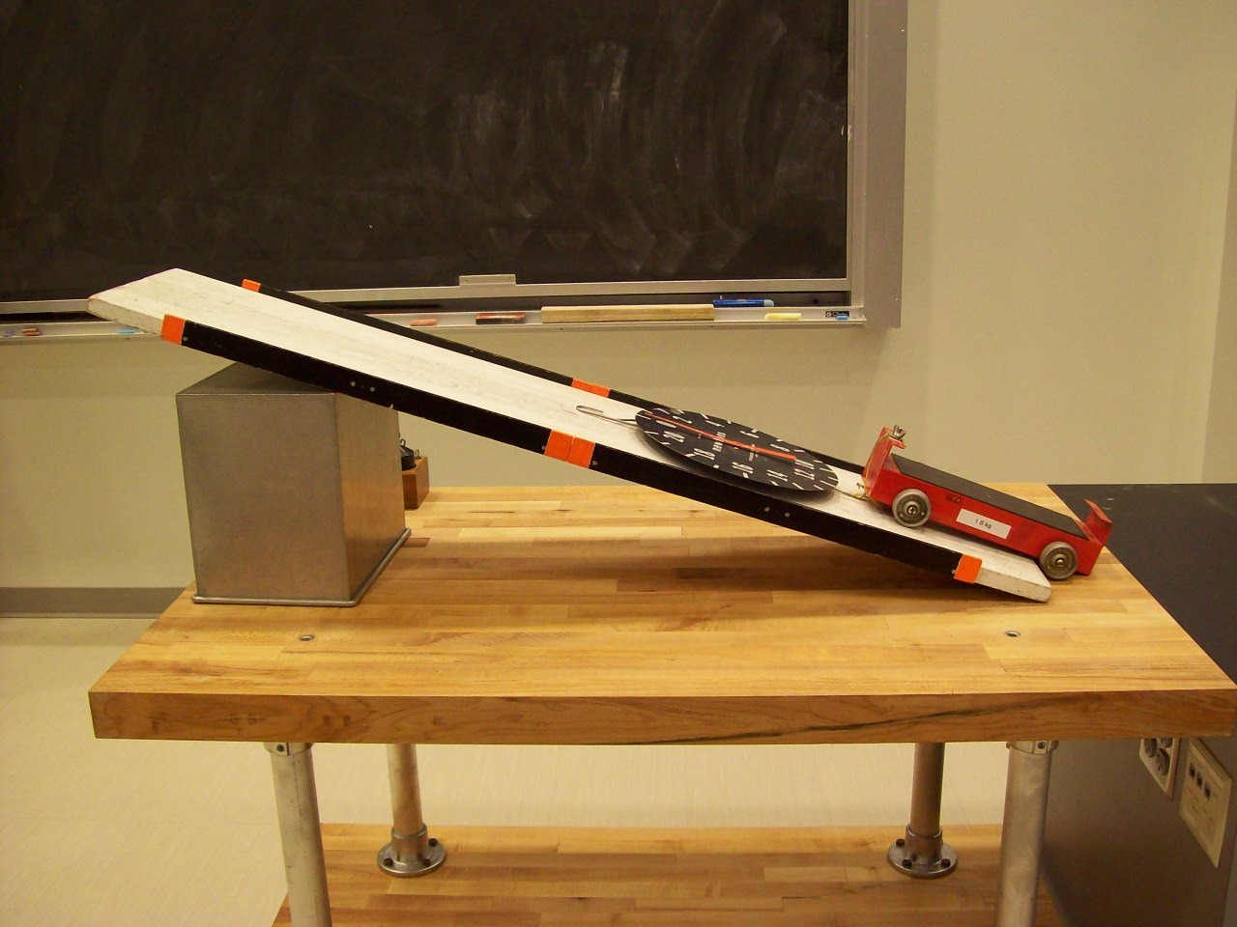
Location: Ca1, Bd3
MECHANICS | 1M20.40 | WORK AND ENERGY
Simple Machines

Levers
Lift the two heavy lead blocks with a fingertip. A crow bar and a claw hammer can also be shown with this demonstration.
Wash your hands after handling lead.

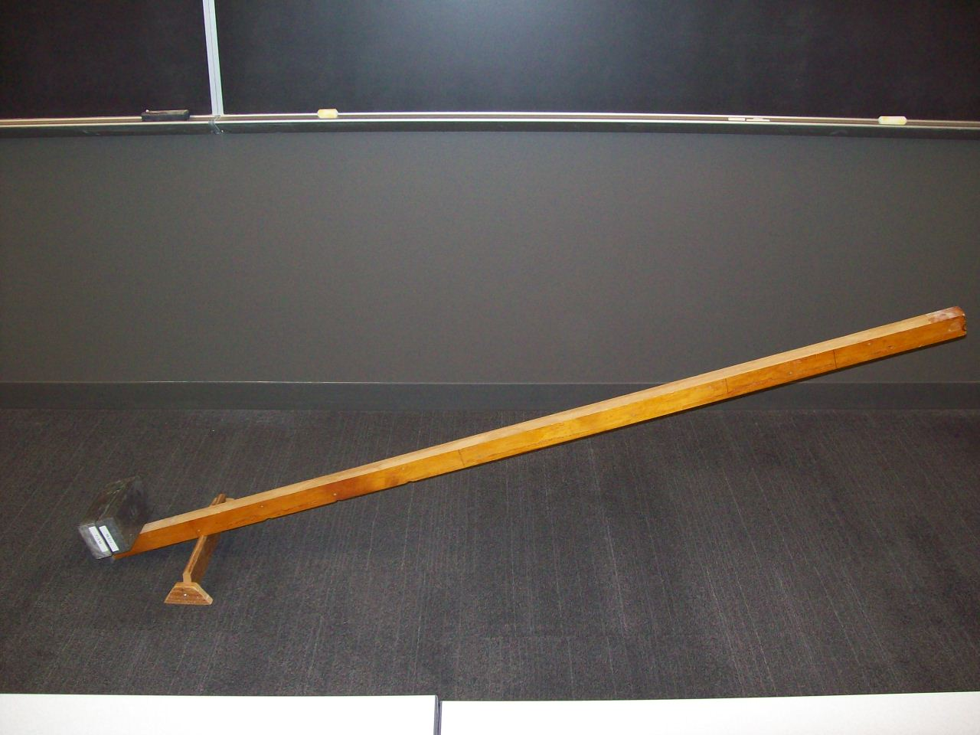Location: Ca1, CbT, Qa1
MECHANICS | 1M30.30 | WORK AND ENERGY

Non-Conservative Forces

The Woodpecker
 | A toy bird slides down a rod giving up energy to friction and pecking.
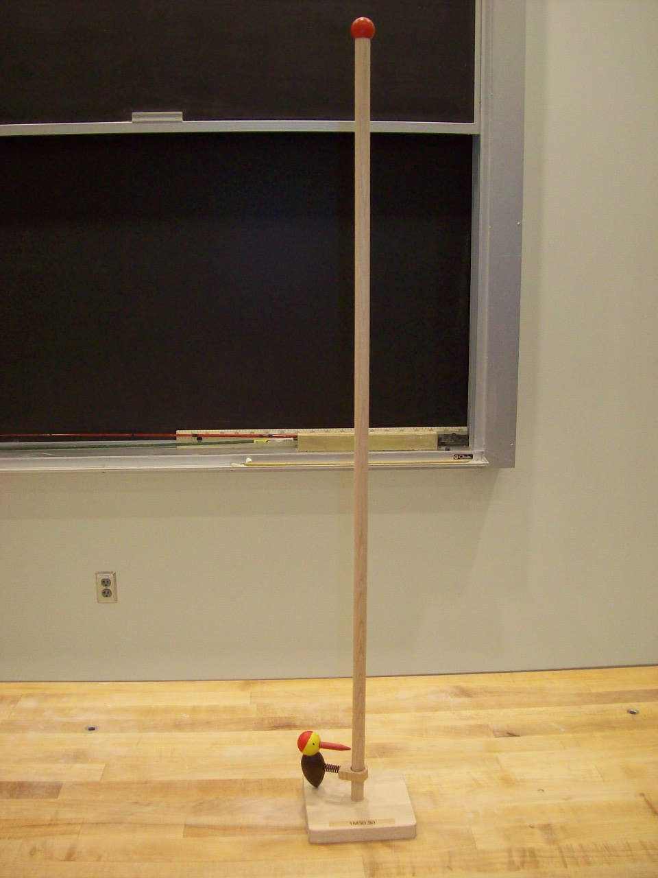
Location: Cb1
MECHANICS | 1M40.10 | WORK AND ENERGY

Conservation of Energy

Nose Basher
Disc 03-14
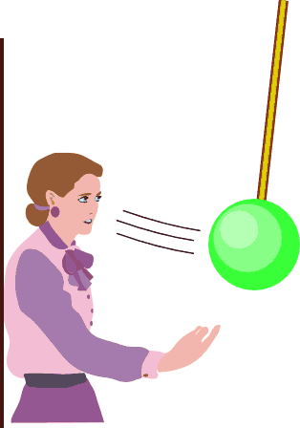 | Stand against the wall. Bring the bowling ball up to your nose or chin. Release the ball without giving it any initial velocity. Stand very still and wait for the return.
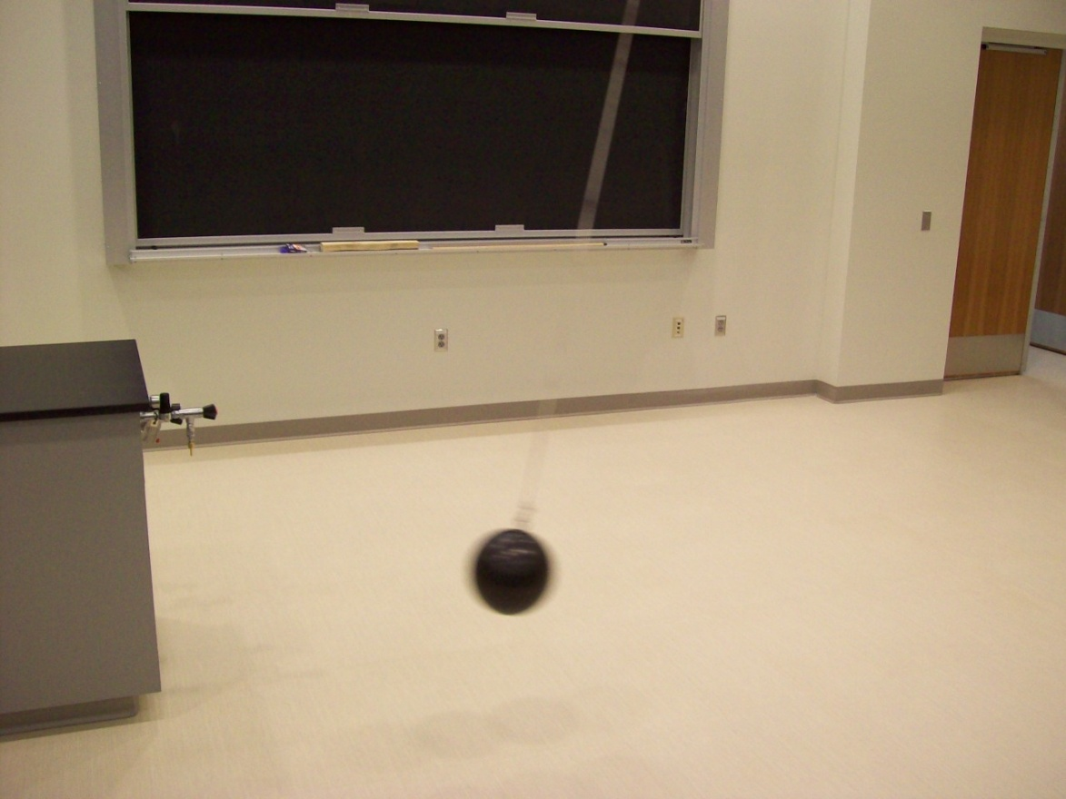
Location: Cc1
MECHANICS | 1M40.15 | WORK AND ENERGY
Conservation of Energy

Stopped Pendulum
Disc 03-13
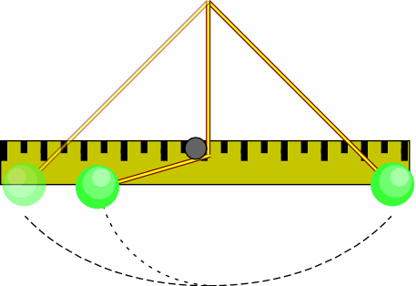 | Raise the pendulum a certain height. It will travel to nearly the same height on the opposite side whether it is "stopped" or not. The meter stick serves as a reference for the height of the pendulum.
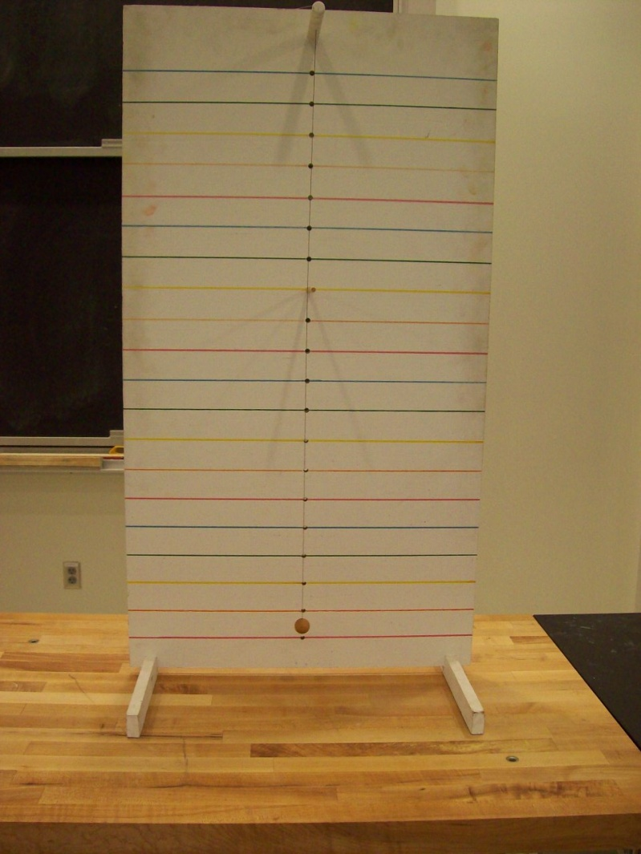
Location: Cb1
MECHANICS | 1M40.20 | WORK AND ENERGY
Conservation of Energy

Loop the Loop
Disc 06-09
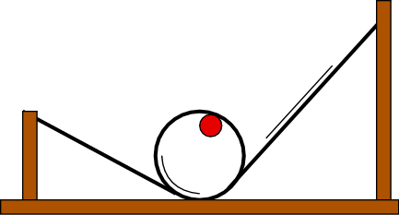 | Release the ball near the top of the track. The energy loss makes the minimum height necessary to complete the loop significantly higher than the calculated value.
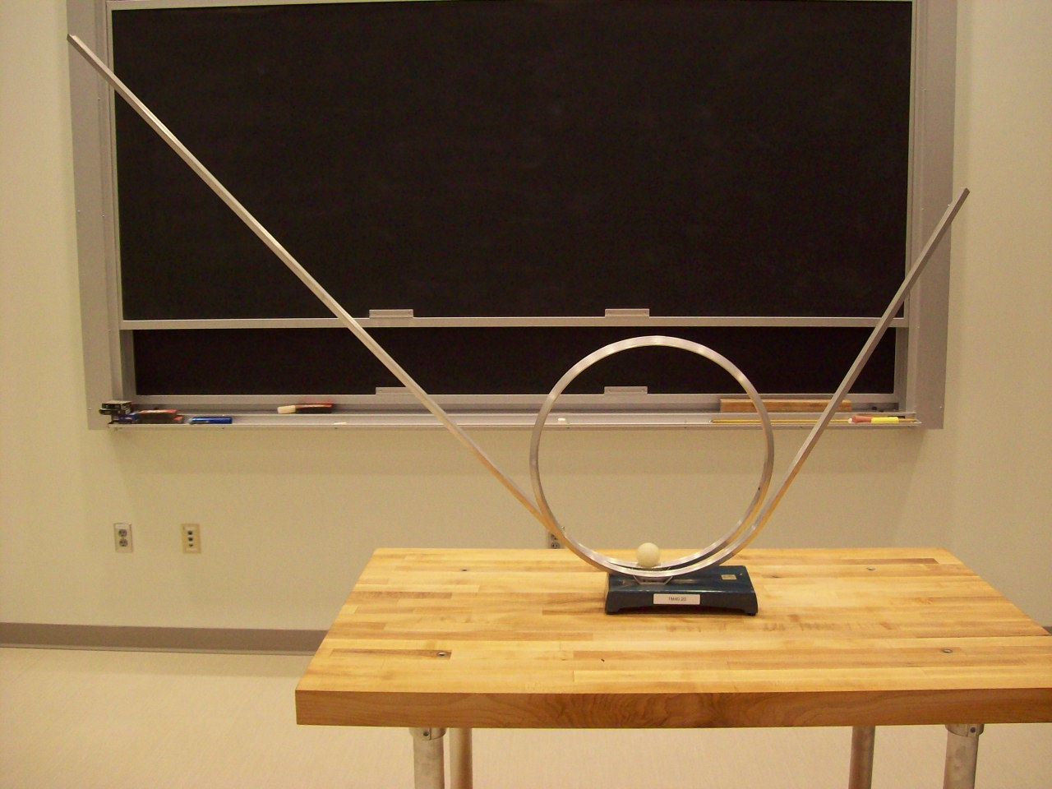
Location: Unistrut
MECHANICS | 1M40.30 | WORK AND ENERGY
Conservation of Energy

Ball in a Track
 | Release the ball near the top of the track. The ball will roll back and forth many times, only losing a small amount of its total energy each trip.
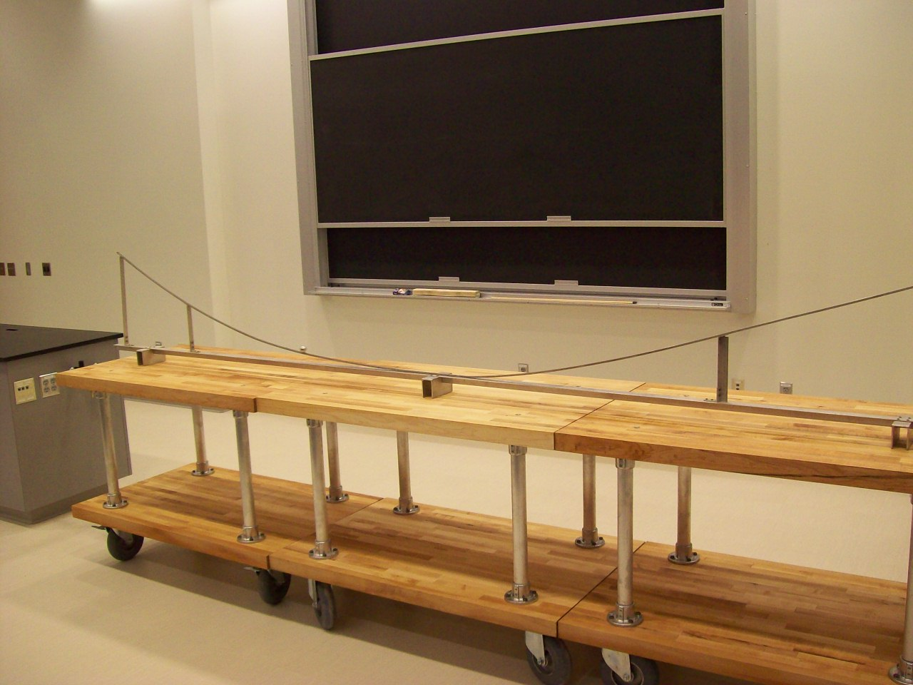
Location: CaT
MECHANICS | 1M40.31 | WORK AND ENERGY
Conservation of Energy

Deformed Air Track
 | Deform an air track and watch an air track cart oscillate back and forth. The period is 21 s.
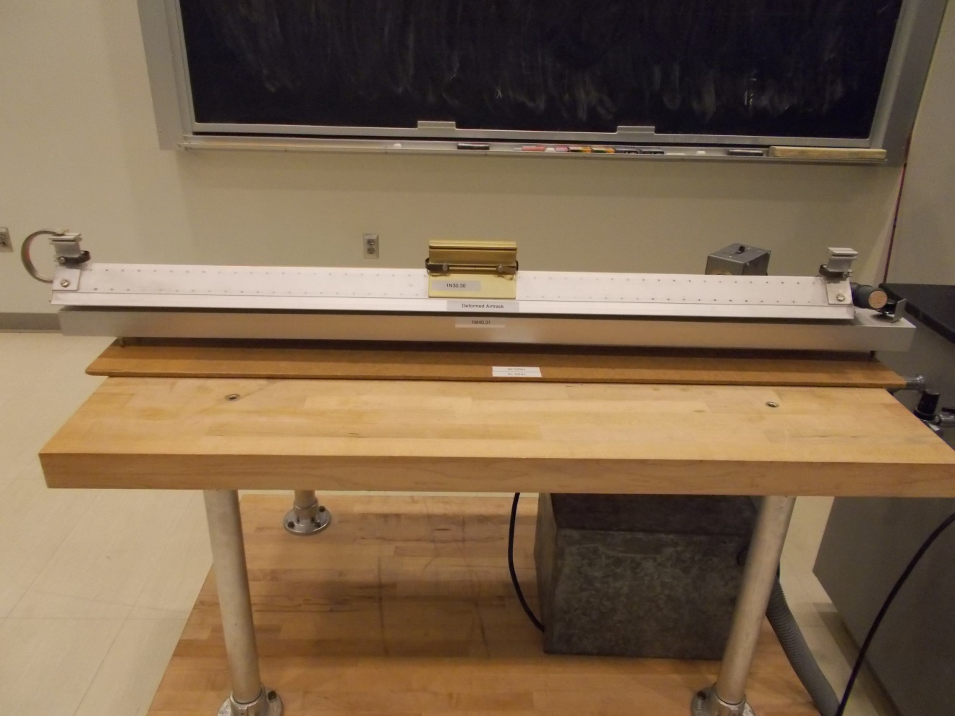Location: CcT
MECHANICS | 1M40.35 | WORK AND ENERGY
Conservation of Energy

Roller Coaster
 | A smart car rolls down a track with sections of different heights.Use the Capstone software and the file Roller Coaster.cap. It plots displacement and velocity vs. time allowing the measurement of the energy difference of the cart between high points and low points. The height difference is 0.03 m. This version works better.

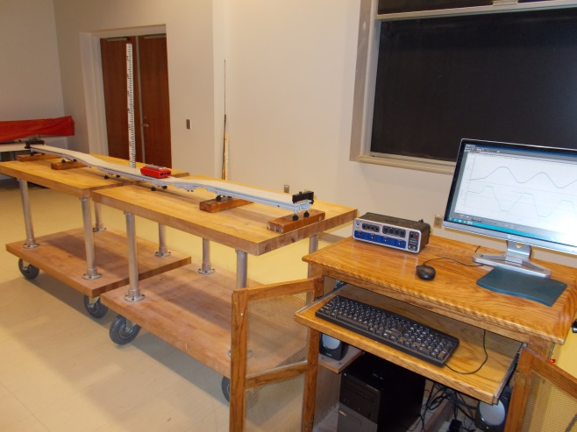
Location: Cc1, Bb2

MECHANICS | 1M40.40 | WORK AND ENERGY
Conservation of Energy

Ballistic Pendulum
 | Load the spring powered gun with the wooden bullet. Fire it into the pendulum bob and note the swing amplitude. The bullet can also be fired vertically. Parameters are printed on the back.
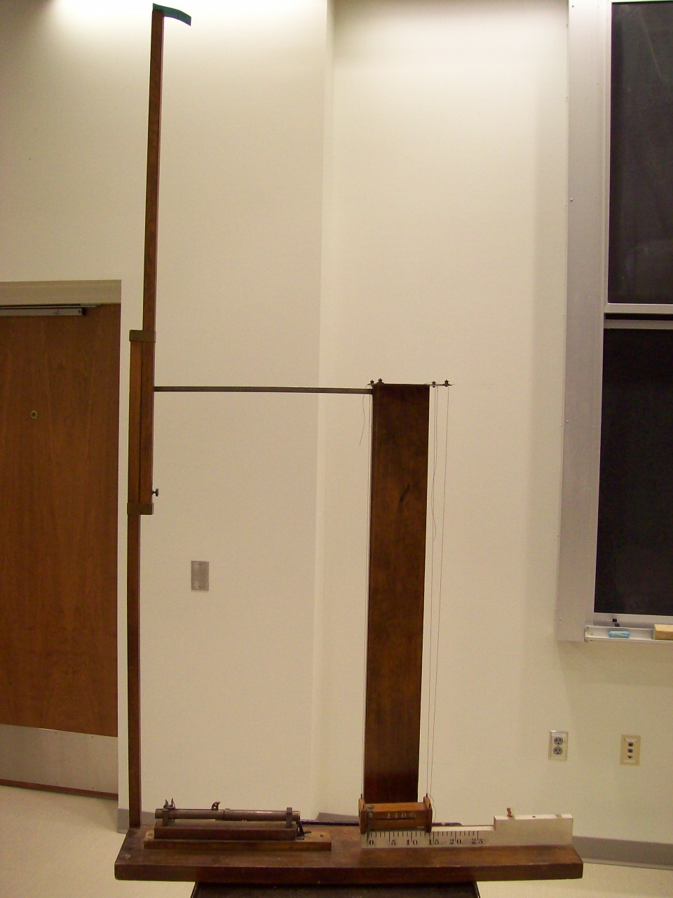
Location: Cc2
MECHANICS | 1M40.50
Conservation of Energy

Yo-Yo
 | Release a yo-yo and it will bottom out and wind up aghain. The time of fall can also be calculated and measured.
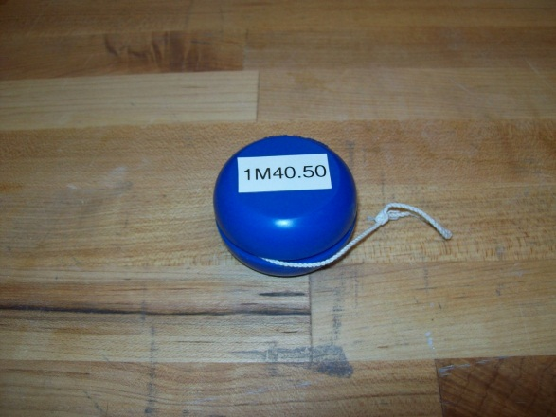
Location: Cc3

MECHANICS | 1M40.65
Conservation of Energy

Height of a Spring Launched Ball
 | The Pasco Mini Launcher is used to launch a ball vertically. Use the Capstone file Height of a Spring Launched Ball.cap. Load the ball to the (if you use the third stop, the ball will go 1.56 m high). Click on the Record button and launch the ball.
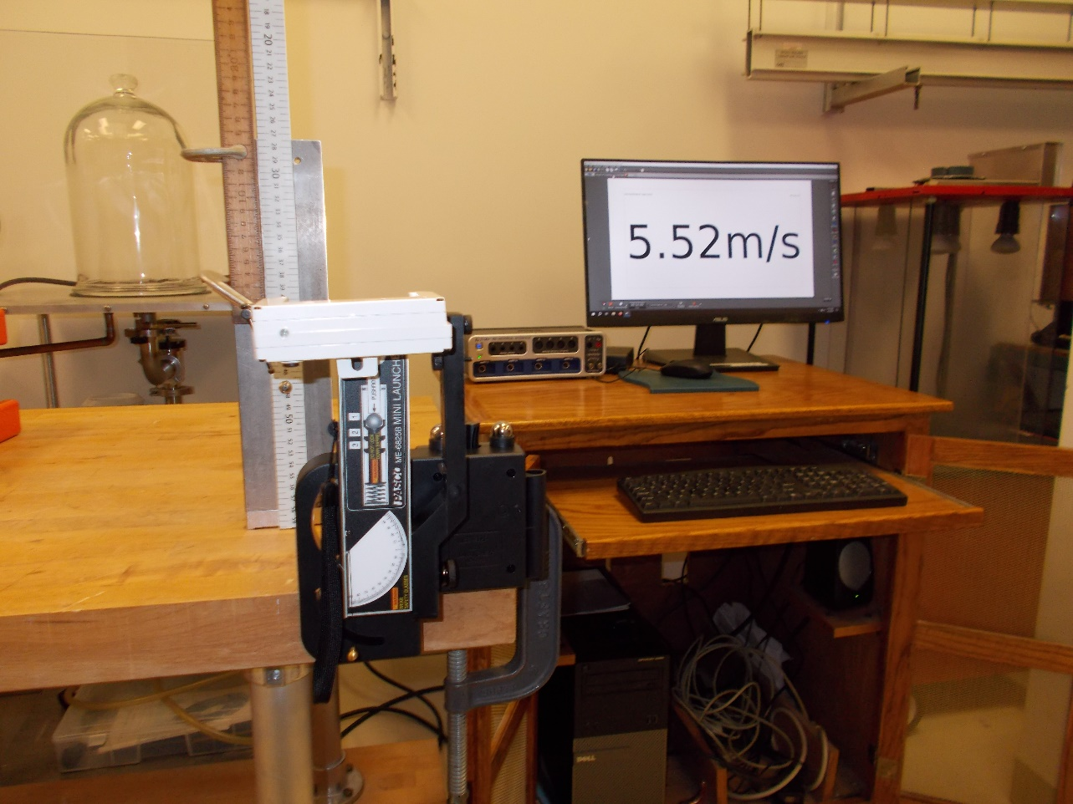
Location: Aa1, Cc3, BdT
MECHANICS | 1M40.90 | WORK AND ENERGY
Conservation of Energy

Rattleback
Spin it one way and it will come to a stop, wobbling, and then spin the other way. If the black, pivoting bar is centered on the celt, it will rotate as you would expect, simply turning, slowing down and stopping.
For a discussion, see: https://vimeo.com/93659724

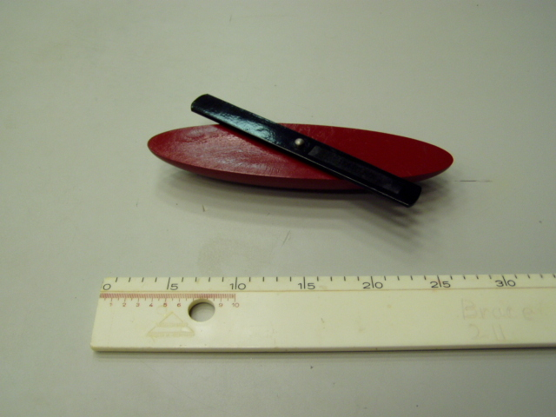Location: Cc3
MECHANICS | 1M40.91 | WORK AND ENERGY
Conservation of Energy

High Bounce Paradox
 | Flip a half handball inside out and drop it on the floor. It bounces higher than the height from which it was dropped.
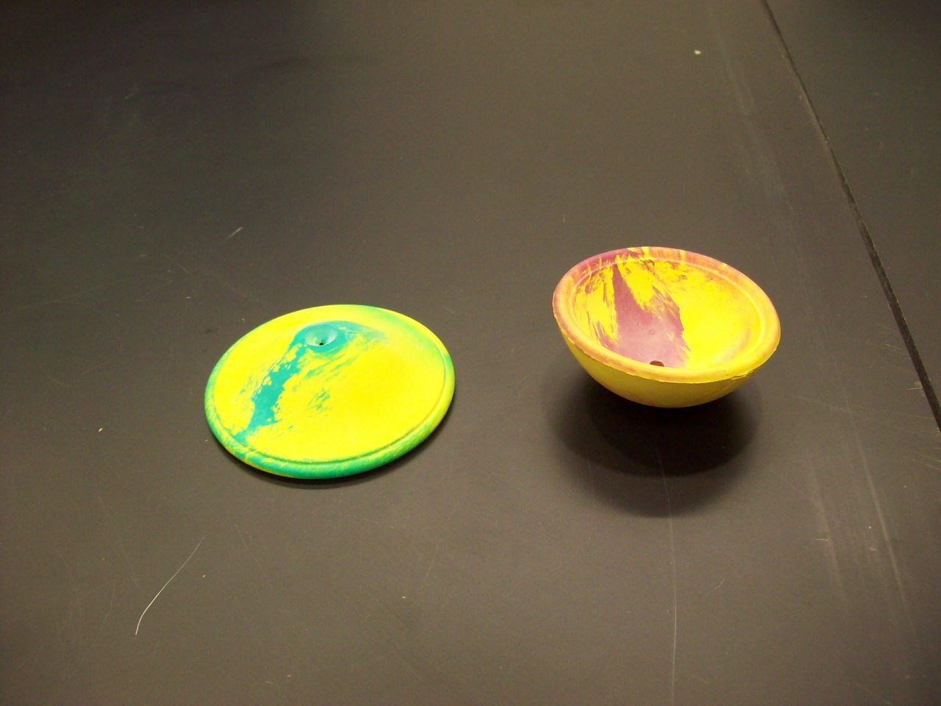
Location: Cc3

MECHANICS | 1M40.95 | WORK AND ENERGY
Conservation of Energy

Trebuchet
 | Make sure the thread is routed properly when loading. The ball will go several meters so be careful where you aim it. There is a simple analysis in “Dynamics of a Medieval Missile Launcher: The Trebuchet”, by James O’Connel (The Physics Teacher, Vol. 39, Nov. 2001, and a more detailed analysis in “Trebuchet Mechanics” by Donald B. Siano.
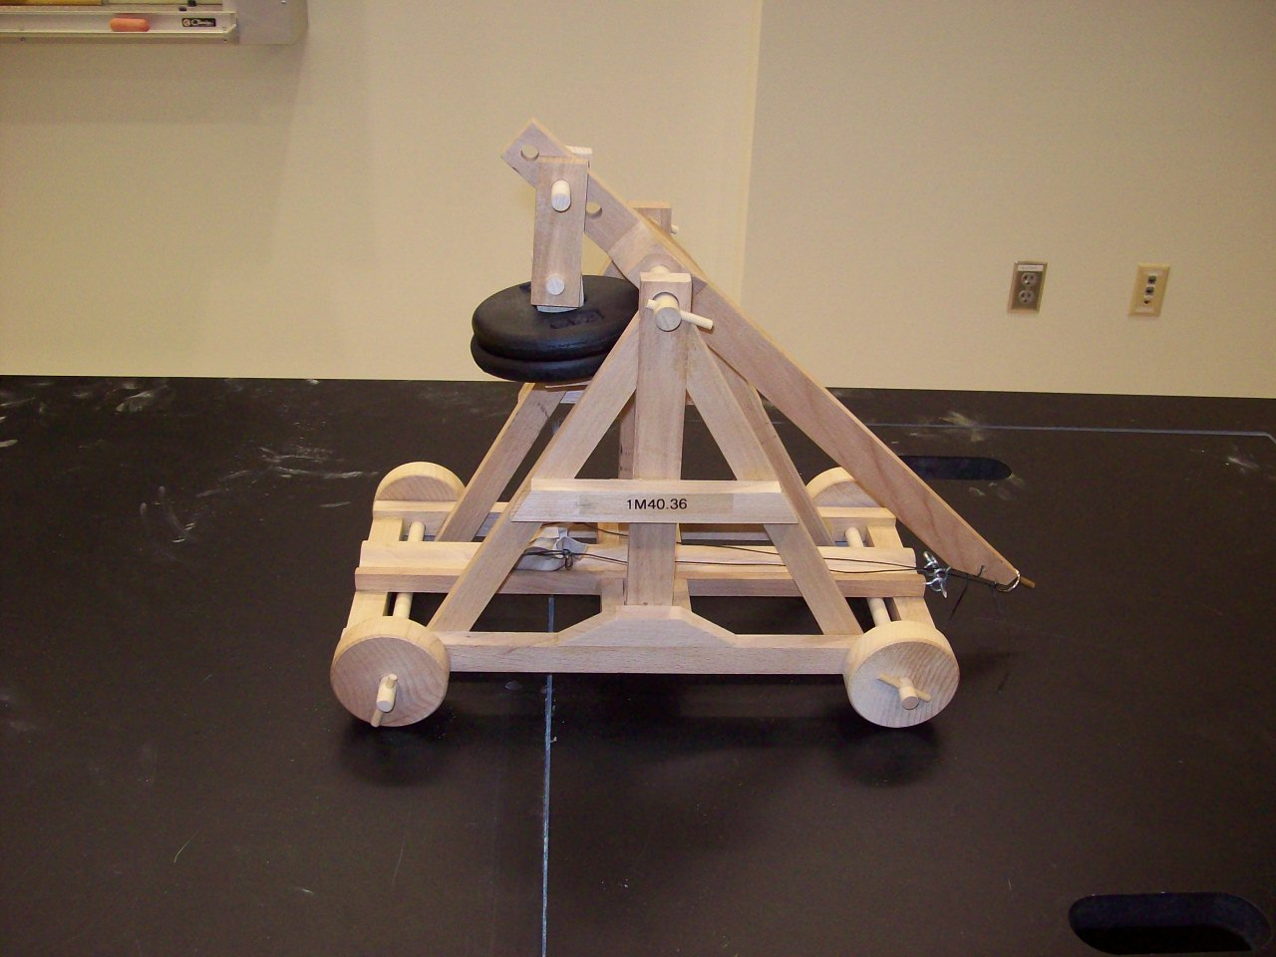
Location: Cb4
MECHANICS | 1N10.13 | LINEAR MOMENTUM AND COLLISIONS

Impulse and Thrust

Impulse Measurement
 | A Smart Cart is used to measure force and velocity in various collisions with an end stop. The computer integrates the force over time to calculate the impulse. Capstone file: Impulse and Momentum
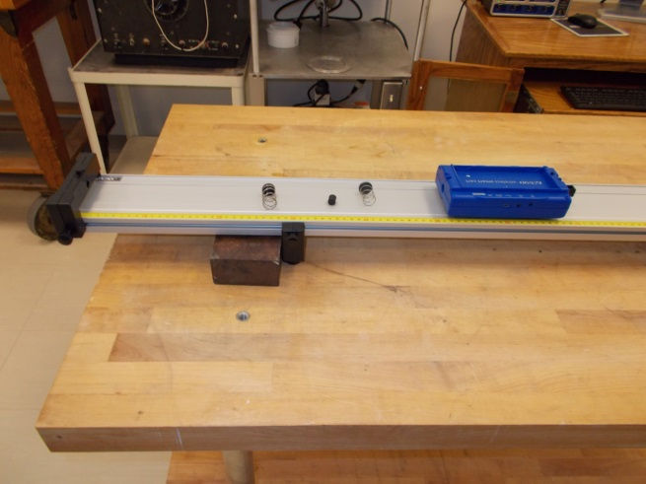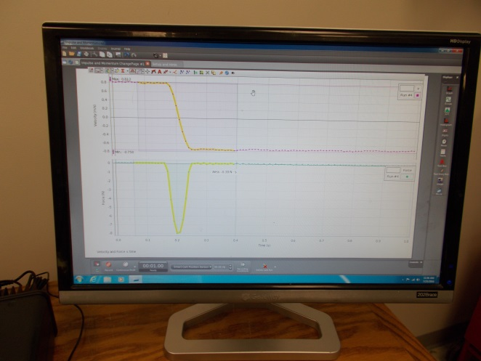
Location: Bb2, Cb1
MECHANICS | 1N10.20 | LINEAR MOMENTUM AND COLLISIONS
Impulse and Thrust

Egg in a Sheet
Disc 05-09
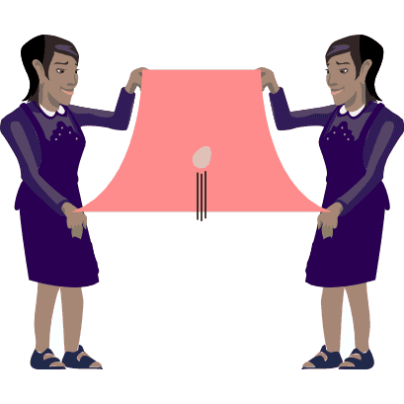 | Have two students hold a sheet slightly draped. Toss an egg into the sheet. Remember to remove the egg before throwing another! Shown is a wooden “egg”. If you want a real one you must give me enough time to get to a grocery store.
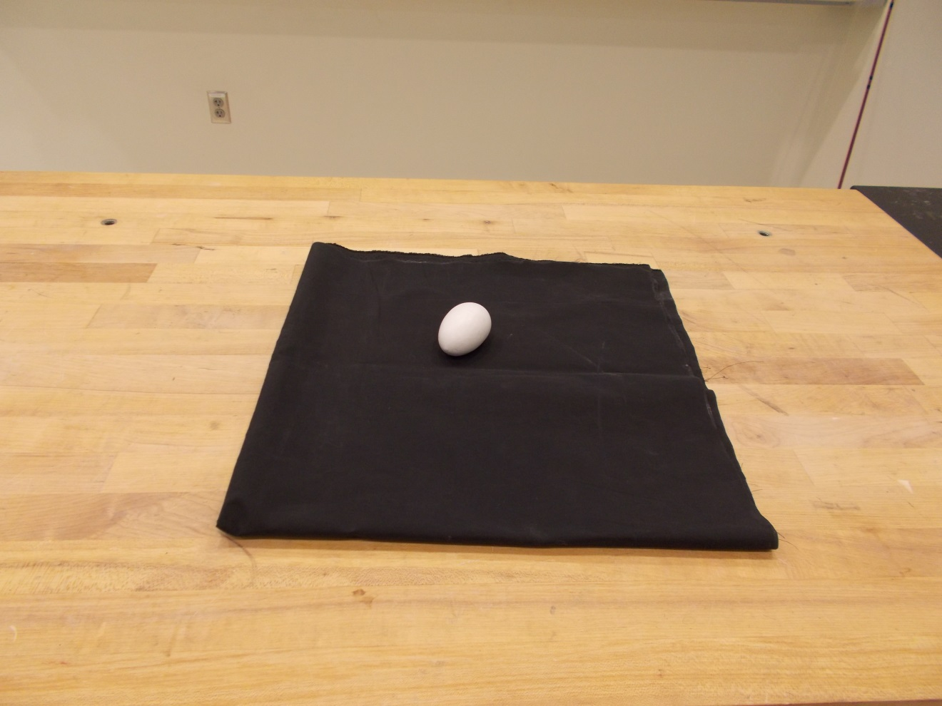Location: Bb4

MECHANICS | 1N20.10 | LINEAR MOMENTUM AND COLLISIONS

Conservation of Linear Momentum

See-Saw Center of Mass
 | Two spring loaded carts repel each other on a balanced board. Add masses to one and repeat.
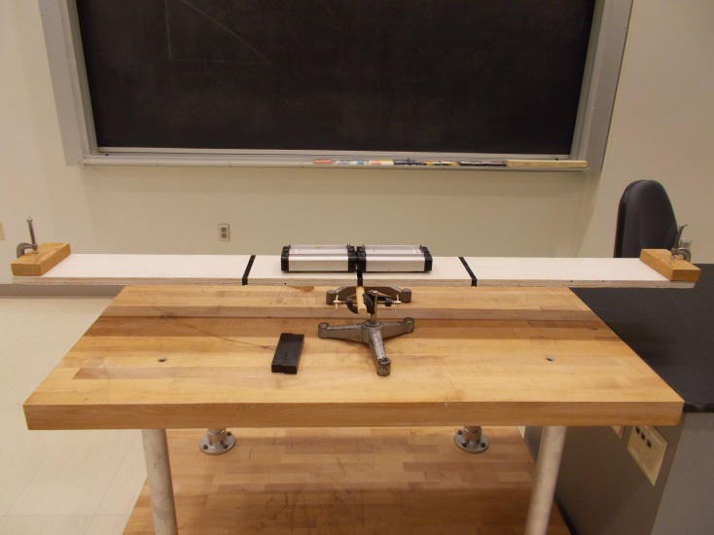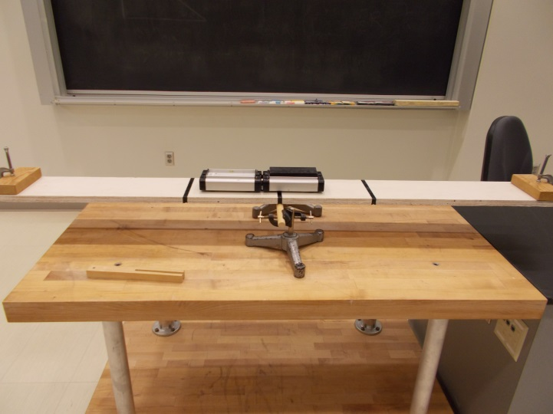
Location: Ca1, Cc4

MECHANICS | 1N20.15 | LINEAR MOMENTUM AND COLLISIONS
Conservation of Linear Momentum

Car on a Rolling Track
 | A motorized car is placed on a rolling track. When the button on it is pressed, there is a slight delay and the car runs for an adjustable amount of time. As it goes one way, the track goes the other. Also repeat giving the track an initial velocity.
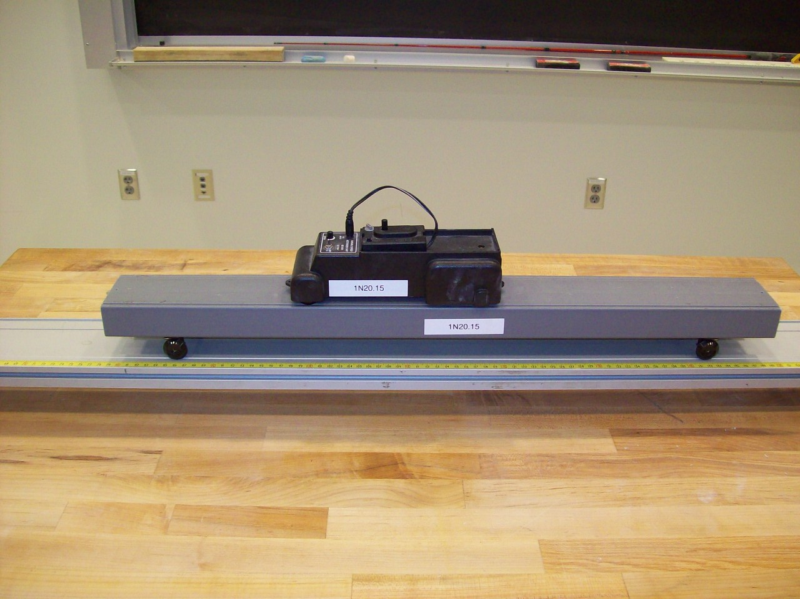
Location: AcT, Bb1, Bc5
MECHANICS | 1N20.17 | LINEAR MOMENTUM AND COLLISIONS
Conservation of Linear Momentum

Train on an Air Track
 | An HO gauge train on a track mounted on air track gliders. This is an alternate to 1N20.15; it is a bit fussier and harder to set up but has audience appeal because of the toy train.
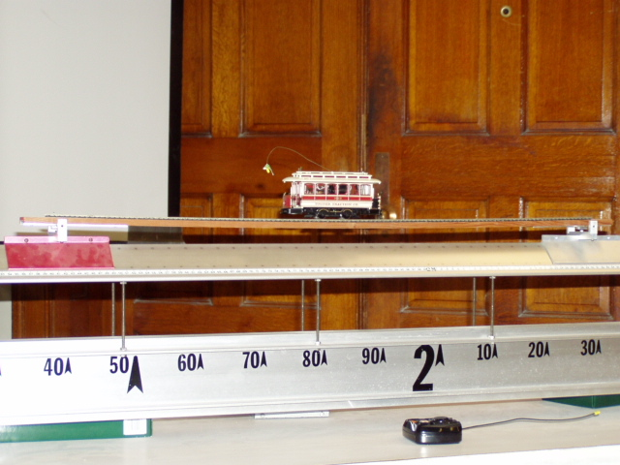Location: Unistrut, Cc4, CcT
MECHANICS | 1N20.20 | LINEAR MOMENTUM AND COLLISIONS
Conservation of Linear Momentum

Spring Apart Carts
Disc 02-19
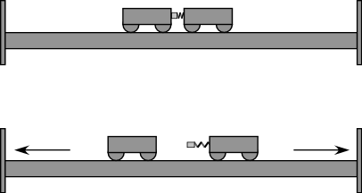 | Two carts are fixed together with a spring in between them. The trigger is tripped and the spring pushes the carts apart. Different masses in the carts give different exit velocities.
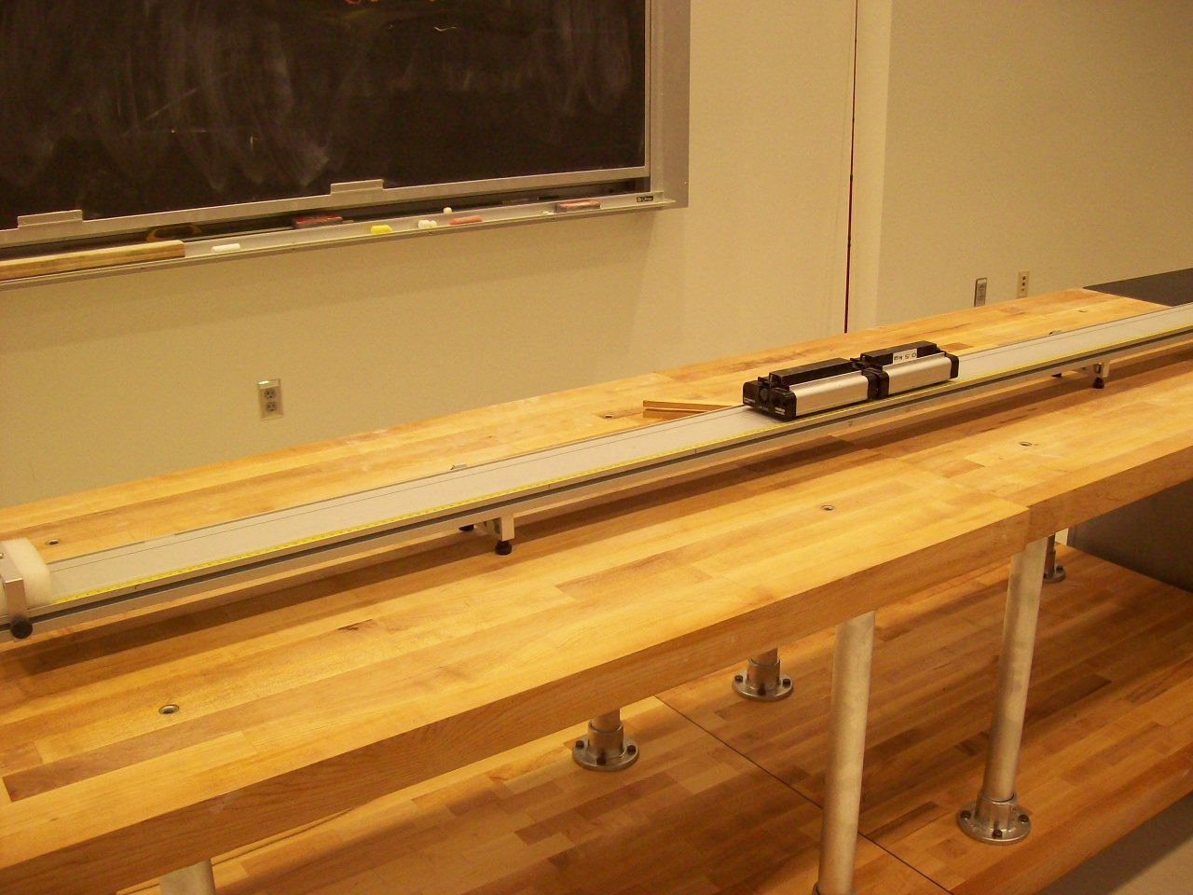
Location: Cc4, AcT

MECHANICS | 1N20.40 | LINEAR MOMENTUM AND COLLISIONS
Conservation of Linear Momentum

Putt Putt Boat
Be sure you fill the chamber with water. The operation of it can be likened to a Carnot engine. It makes a most satisfying “Putt-Putt” noise when running!
References:
- H. Richard Crane, "The Pop-Pop Boat", TPT, Vol. 35, # 3, p. 176-177, March 1997.
- Jearl Walker, "4.52, Toy Putt-Putt Boat", The Flying Circus of Physics Ed. 2, p. 199.

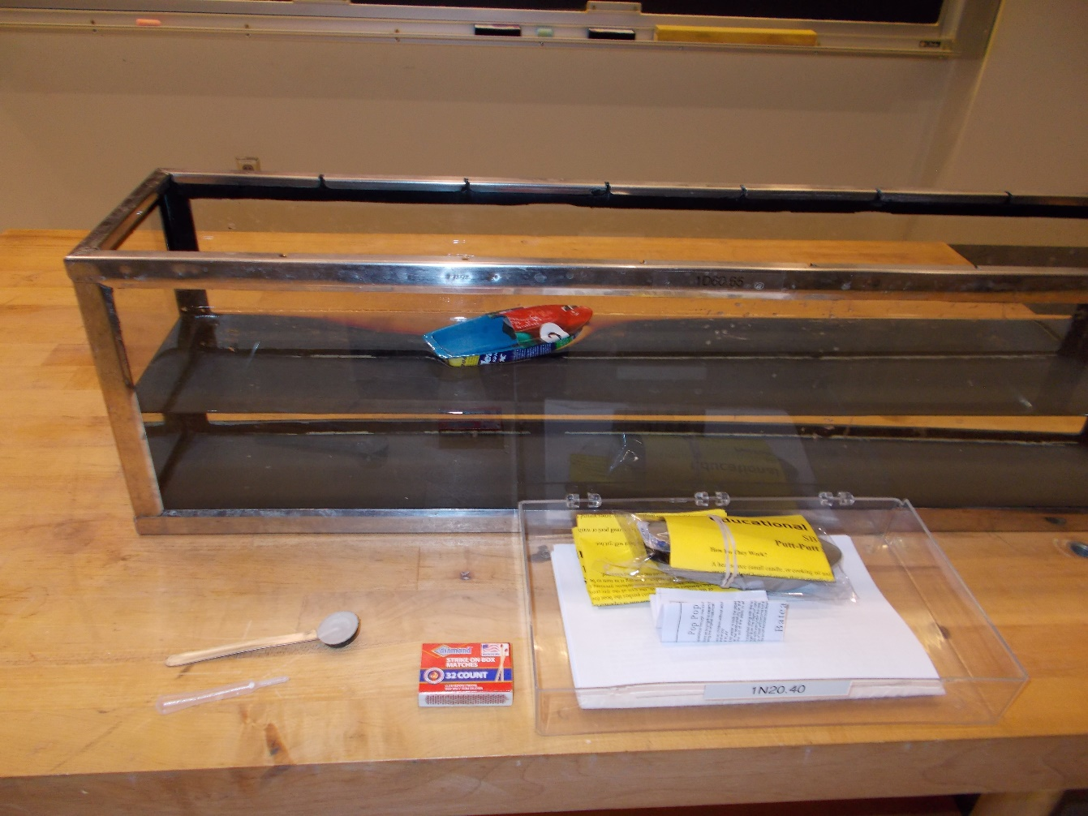
Location: Cc4, Nb6
MECHANICS | 1N21.10 | LINEAR MOMENTUM AND COLLISIONS

Mass and Momentum Transfer

Carts and Medicine Ball
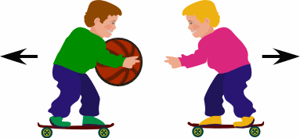 | Two people on roller carts throw a medicine ball to each other.
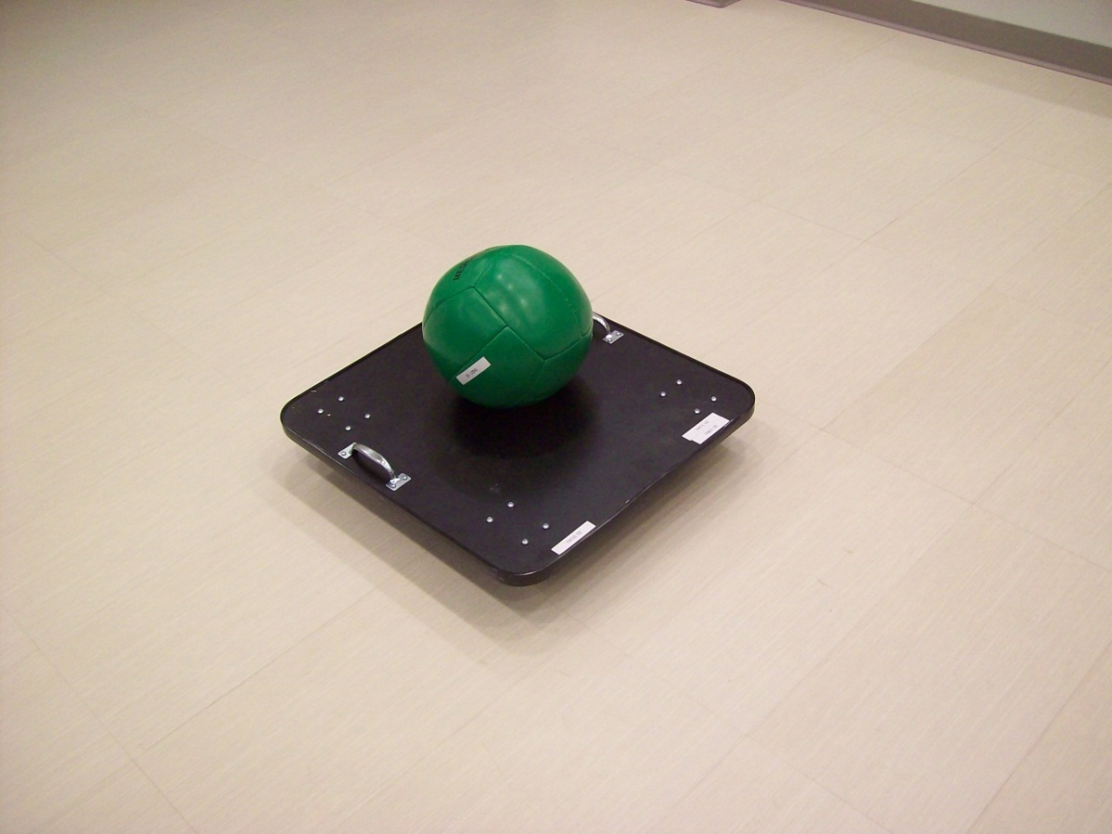
Location: Mb1, Db2

MECHANICS | 1N21.30 | LINEAR MOMENTUM AND COLLISIONS
Mass and Momentum Transfer

Ballistic Cart
 | Shoot a ball into a catcher mounted on a cart. Balls of two differing masses can be used and different muzzle velocities can be given to them. The steel ball is 0.066 kg. The catcher is 0.015 m long. A photogate timed version is shown as well as an un-instrumented version.
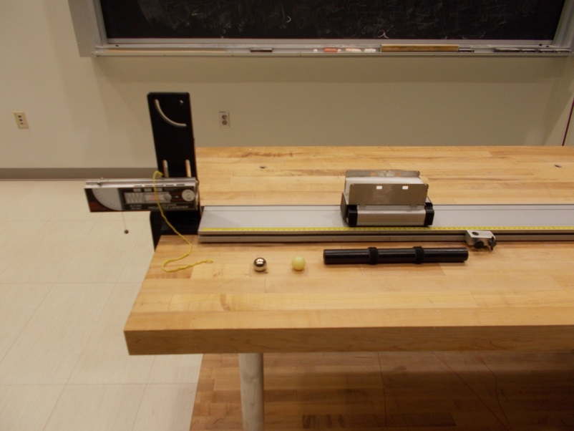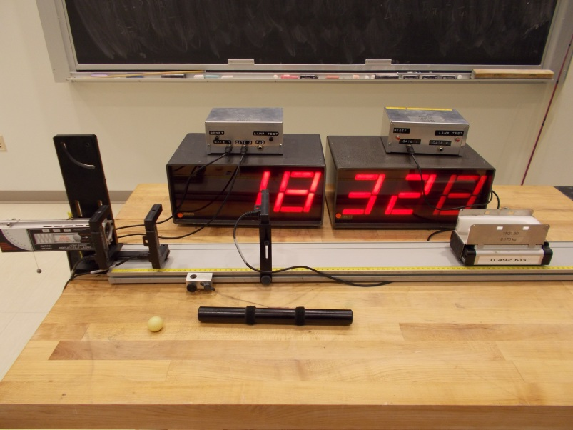
Location: AcT, Bc1, Cc4
MECHANICS | 1N22.10 | LINEAR MOMENTUM  AND COLLISIONS

Rockets

Fire Extinguisher Rocket
Disc 02-24
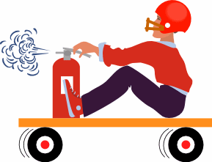 | Remove the expansion nozzle from a fire extinguisher and replace it with a length of pipe. Sit on a low-friction cart and face the nozzle away from you.
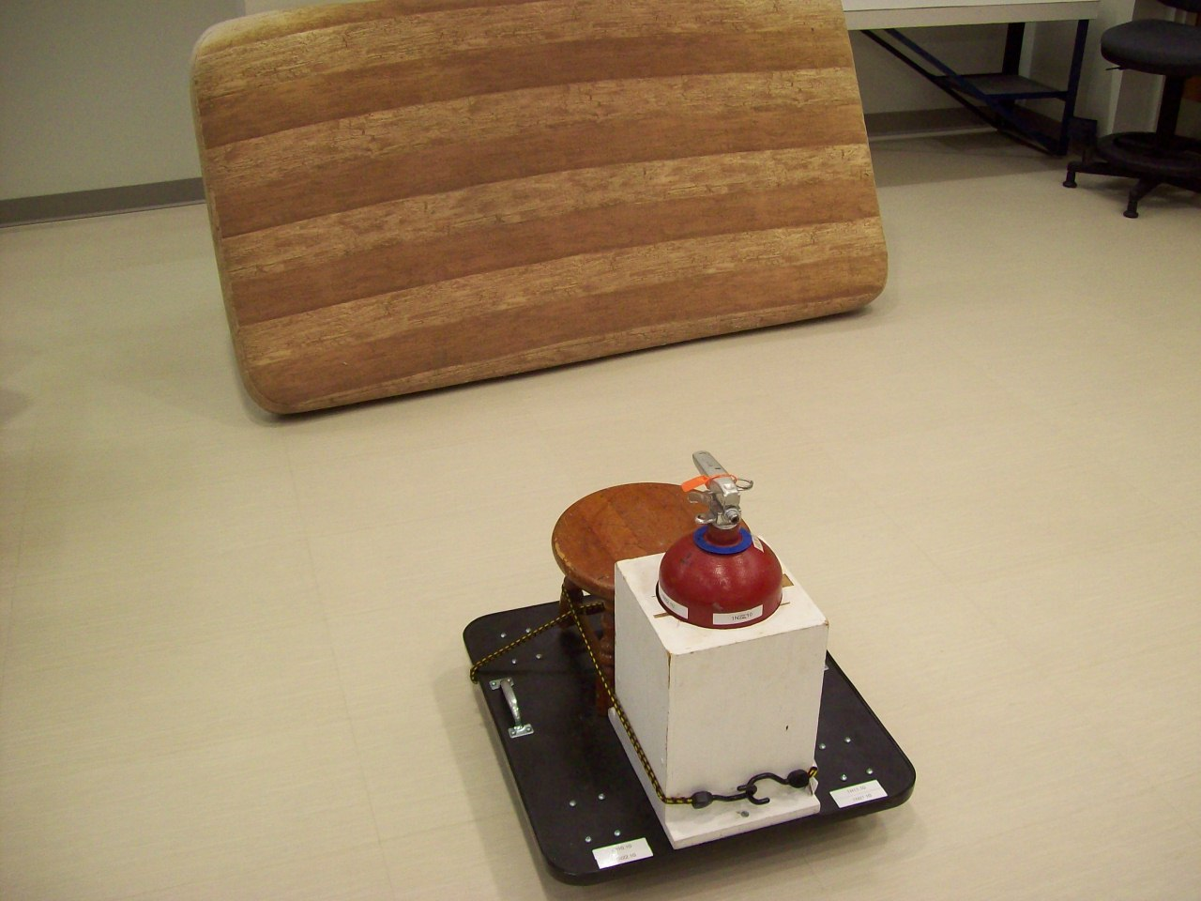
Location: MB1,Cc5

MECHANICS | 1N22.20 | LINEAR MOMENTUM AND COLLISIONS
Rockets

Water Rocket
Disc 02-23
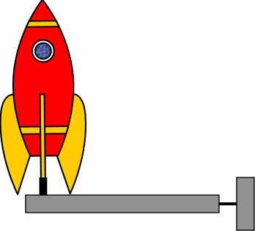 | Fill the rocket 1/3 with water. Pump it a specific number of times (your specification) and launch the rocket (you will probably get wet). Repeat the launch with the rocket filled with air to show the difference in range.
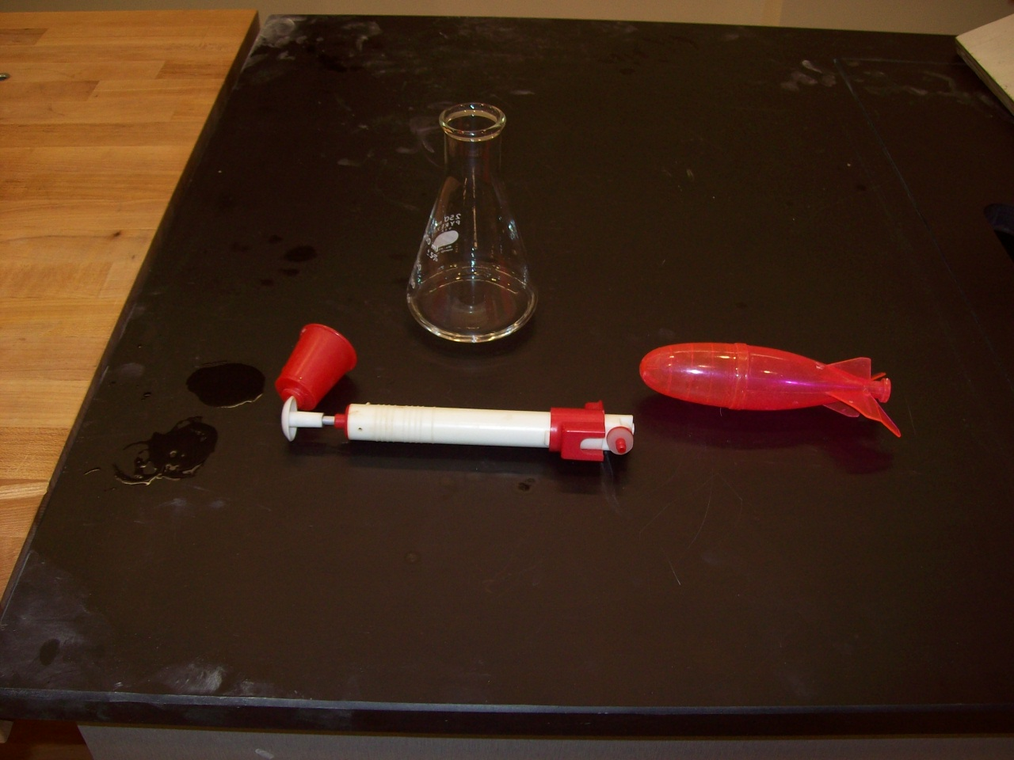Location: Cc4

MECHANICS | 1N30.10 | LINEAR MOMENTUM AND COLLISIONS

Collisions in 1D

Collision Balls
Disc 05-01
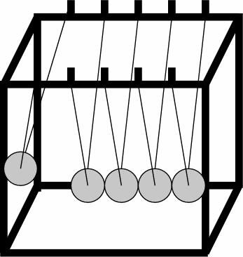 | One ball raised and let go on one end will give one ball launched out from the other. Try different numbers of balls. If it doesn't work well, there is probably an alignment problem. Make sure the threads are straight and the balls are in a perfect line. Be sure you understand that more is involved than just conservation of energy and momentum
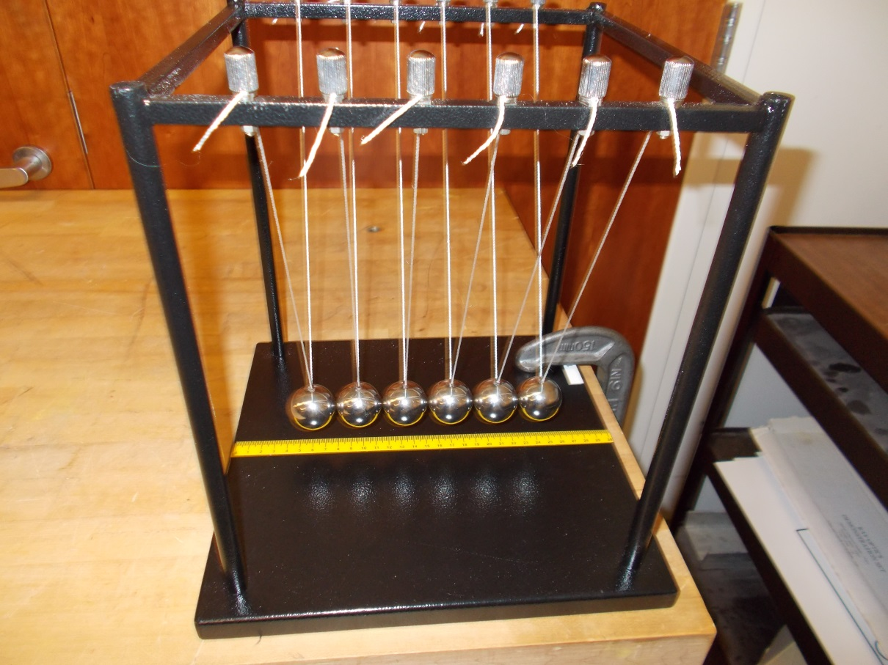
Location:Cd1

MECHANICS | 1N30.30 | LINEAR MOMENTUM AND COLLISIONS
Collisions in 1D

Air Track Collision Gliders
 | Air Track gliders with hook and loop on one side and springs on the other can be made to collide elastically or inelastically. 1N30.35 is easier to set up and works as well.
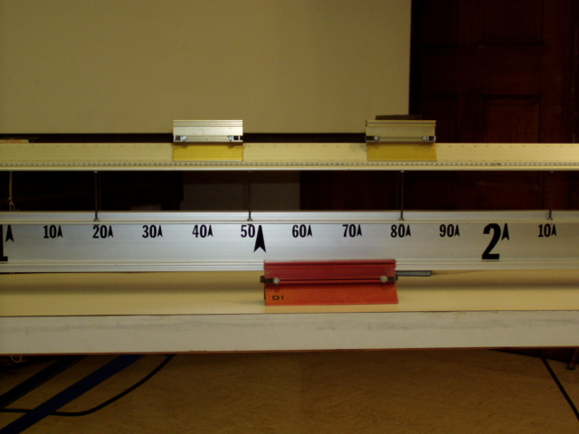Location: Unistrut, Bc5
MECHANICS | 1N30.35 | LINEAR MOMENTUM AND COLLISIONS
Collisions in 1D

Pasco Collision Carts
 | Carts with hook and loop on one side and magnets on the other can be made to collide elastically or inelastically. Masses can be added.
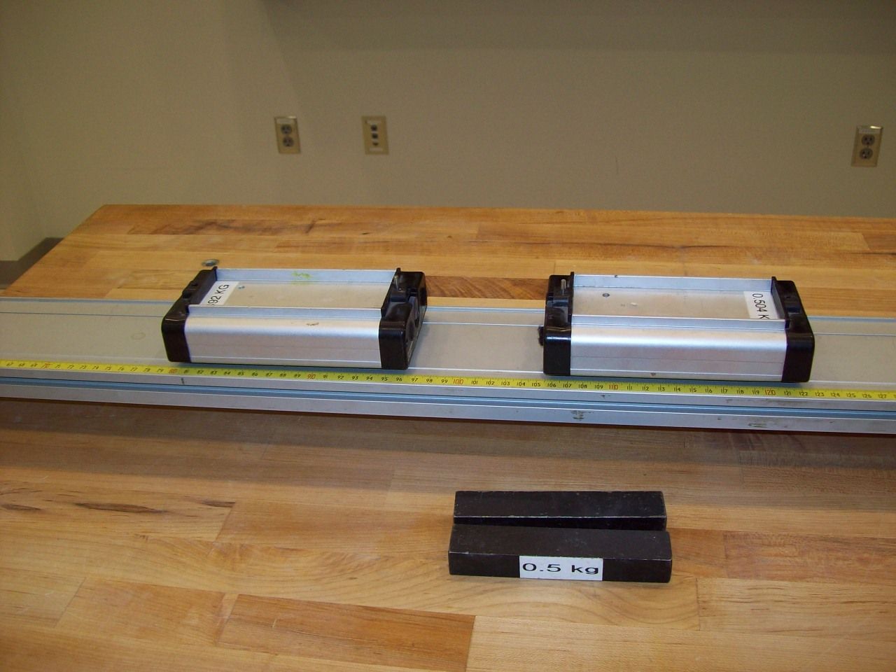
Location: Cc4, AcT
MECHANICS | 1N30.50 | LINEAR MOMENTUM AND COLLISIONS
Collisions in 1D

Rebounding Happy and Sad Balls
 | A happy ball and a sad ball are rolled down a ramp at a balanced block. The “happy” ball (more elastic) will knock it over whereas the “sad” one (a dead ball) will not.
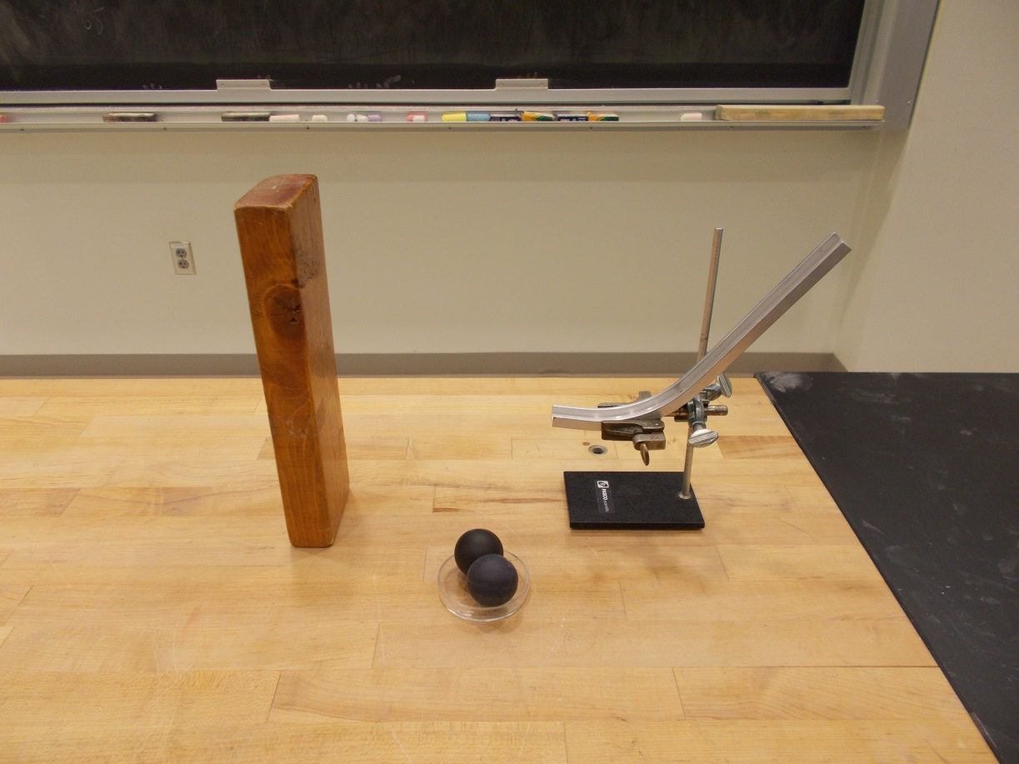
Location: Cd3
MECHANICS | 1N30.60, 8B10.50 | LINEAR MOMENTUM AND COLLISIONS
Collisions in 1D

Double Ball Drop
 | Drop the combination of a tennis ball resting on top of a basketball. The tennis ball will bounce much higher than the drop height when they hit the table. Practice will help insure a good release. Also shown in the picture is a multiple ball version. This demonstration also is listed in Astronomy as “Supernova Core Bounce.”
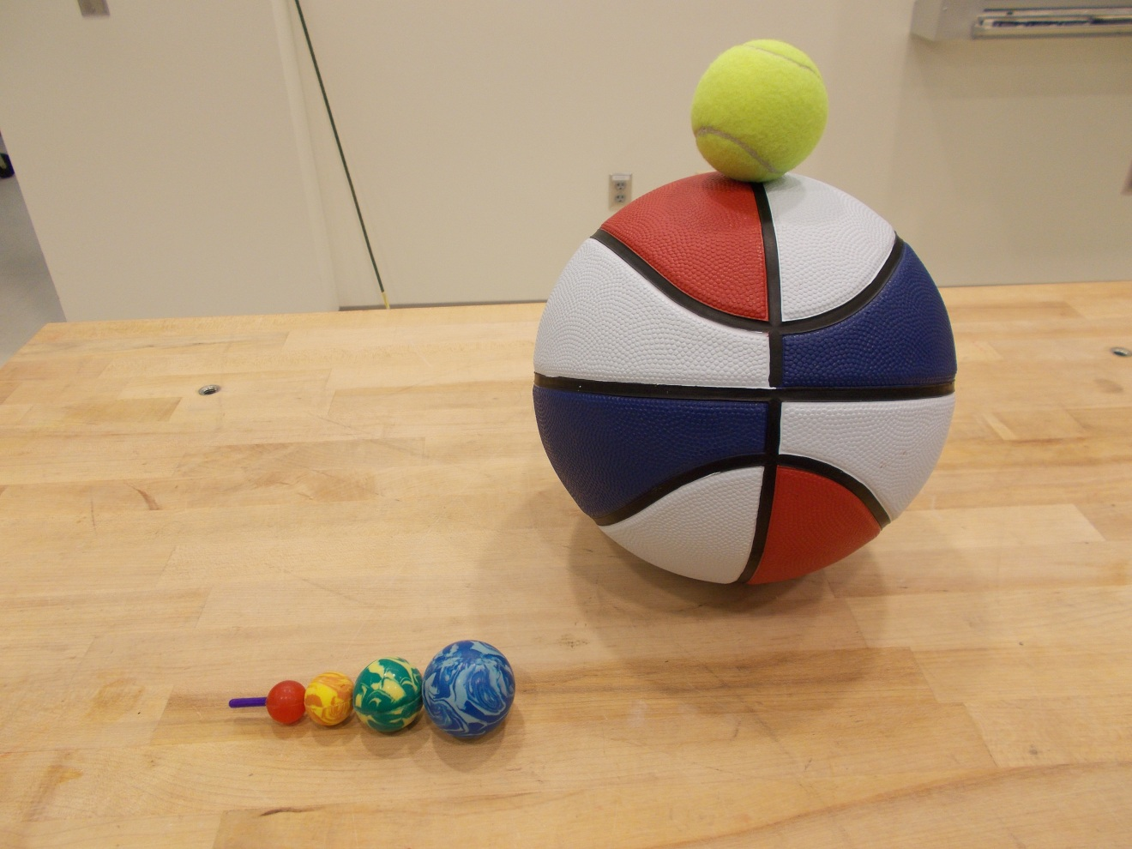Location: Cd3

MECHANICS | 1N30.62 | LINEAR MOMENTUM AND COLLISIONS
Collisions in 1D

Velocity Amplifier
 | Disks of different sizes, made of Sintra plastic are constrained to fall between vertical guides. Stack them in order with the largest at the bottom. Then lift the bottom one with the others on top of it and release the combination. The top disk will fly amazingly high completely leaving the apparatus. Various numbers of disk can be used as well as various drop heights
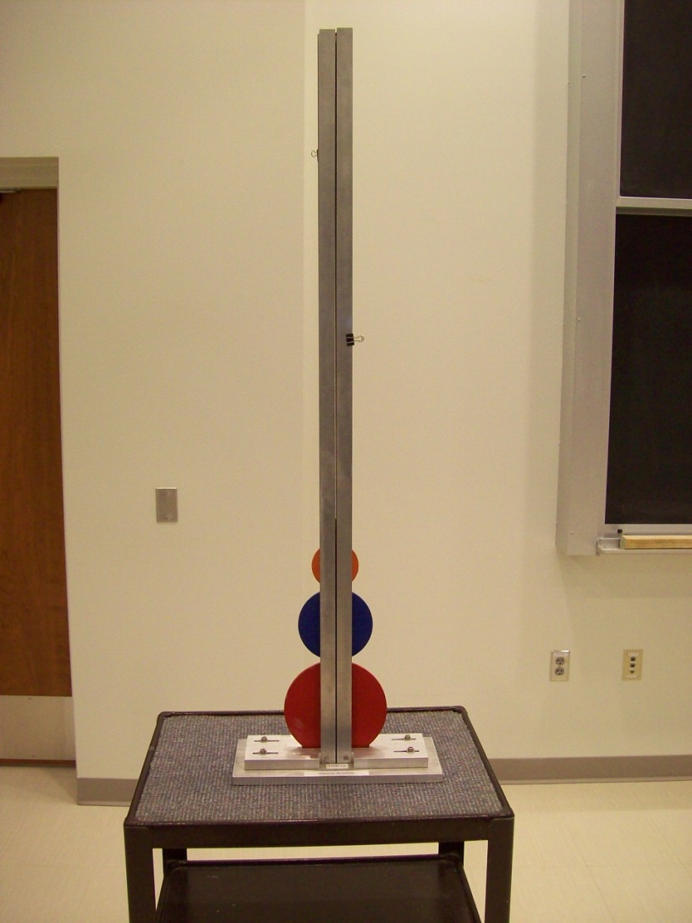
Location: Cb1
MECHANICS | 1N40.11 | LINEAR MOMENTUM AND COLLISIONS

Collisions in Two Dimensions

Orthogonal Hammers
 | Identical hammers hung at right angles hit a ball
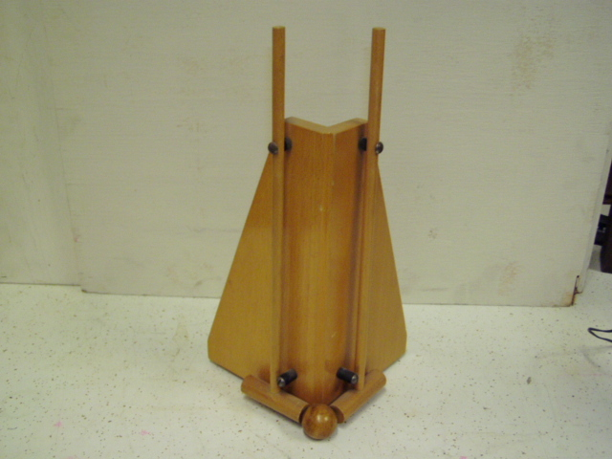Location: Cd3
MECHANICS | 1N40.20 | LINEAR MOMENTUM AND COLLISIONS
Collisions in Two Dimensions

Air Table Collisions
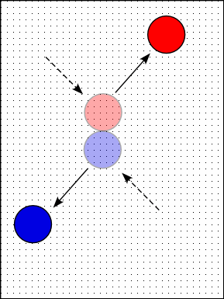 | Inelastic collisions between equal and unequal mass air pucks.  Elastic collisions can also be done with this apparatus.  Also shown are the “Kick Dis” disks which can be used on the floor. The second photograph shows the smaller air cushion table that mounts on the Overhead projector. A non-permanent pen may be used to mark the trajectories. Air Cushion Table manual section 2.6.2. Use two stacked orange discs as the target and projectile
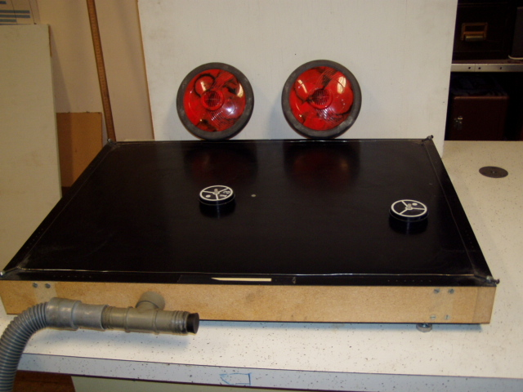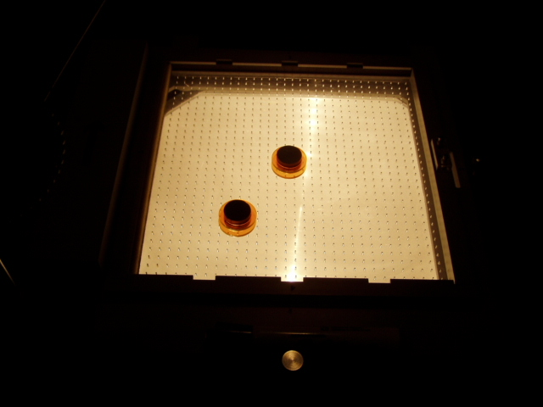
Location: Cd4, DaT, Ga5
MECHANICS | 1Q10.10 | ROTATIONAL DYNAMICS

Moment of Inertia

Inertia Wands and Two Students
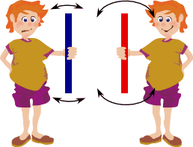 | The two wands have the same mass, but have the mass distributed differently. One has the mass concentrated in the middle, the other has the mass concentrated at the ends. Have two students rotate them back and forth as fast as they can to see the difference.
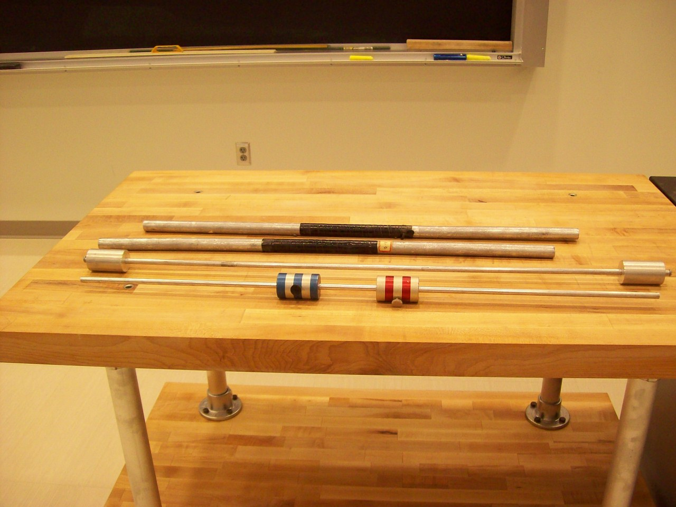
Location: Cd5

MECHANICS | 1Q10.20 | ROTATIONAL DYNAMICS
Moment of Inertia

Moment of Inertia Measurement
 | Various moment of inertia experiments can be done with Capstone (Rotational Dynamics.cap). Shown in the photograph, is the setup for the perpendicular axis theorem experiment, in which the moments about the axis through the center perpendicular to the disk and parallel to the disk can be measured or just compared. One can also use an adapter to mount the disk on the long aluminum platform to show the parallel axis theorem The equipment measures the fall of the mass, the angular position and the angular velocity of the disk.
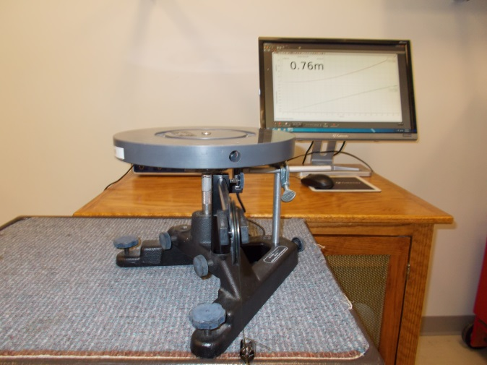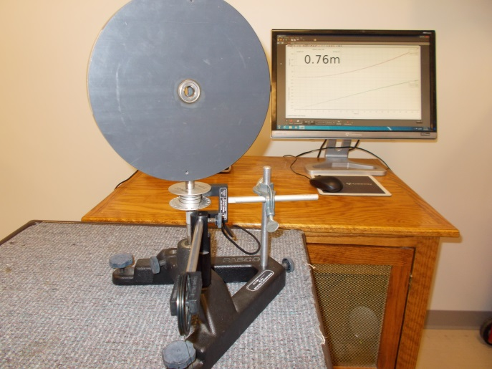
Location: Science Workshop Cabinet, Bc3

MECHANICS | 1Q10.26
Moment of Inertia

Angular Acceleration
 | A rotating platform is accelerated by a falling mass attached to a string that goes over a pulley to a drum with a diameter of 3 cm. The platforms rotational inertia is I = 0.012 kg-m². Its mass is 0.543 kg. additional movable masses of 0.275 kg can be attached to the platform. Angular position, velocity and the distance the mass falls are recorded. The graphed data can be fit by a parabola or a line.
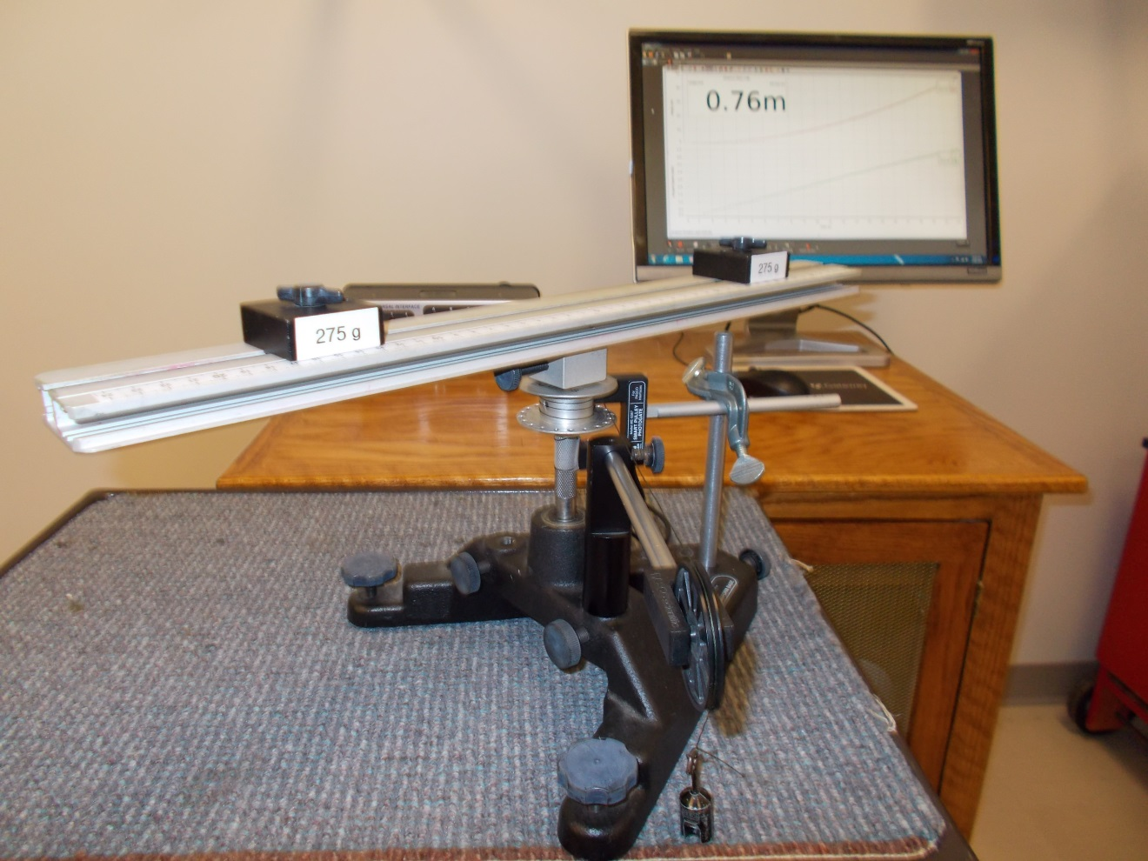
Location: Science Workshop Cabinet, Bc
MECHANICS | 1Q10.30 | ROTATIONAL DYNAMICS
Moment of Inertia

Ring, Disk, and Sphere Race
Disc 06-04
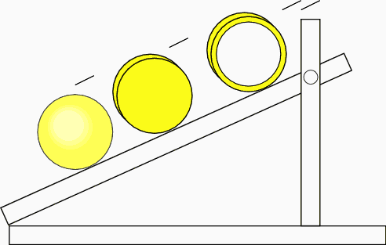 | Each item has the same diameter. After leveling the track from side to side, have the students predict which will win the race. Release them all at the same time and see which one gets to the bottom first. (The moment of inertia of a right circular cone is 3/10 MR².)
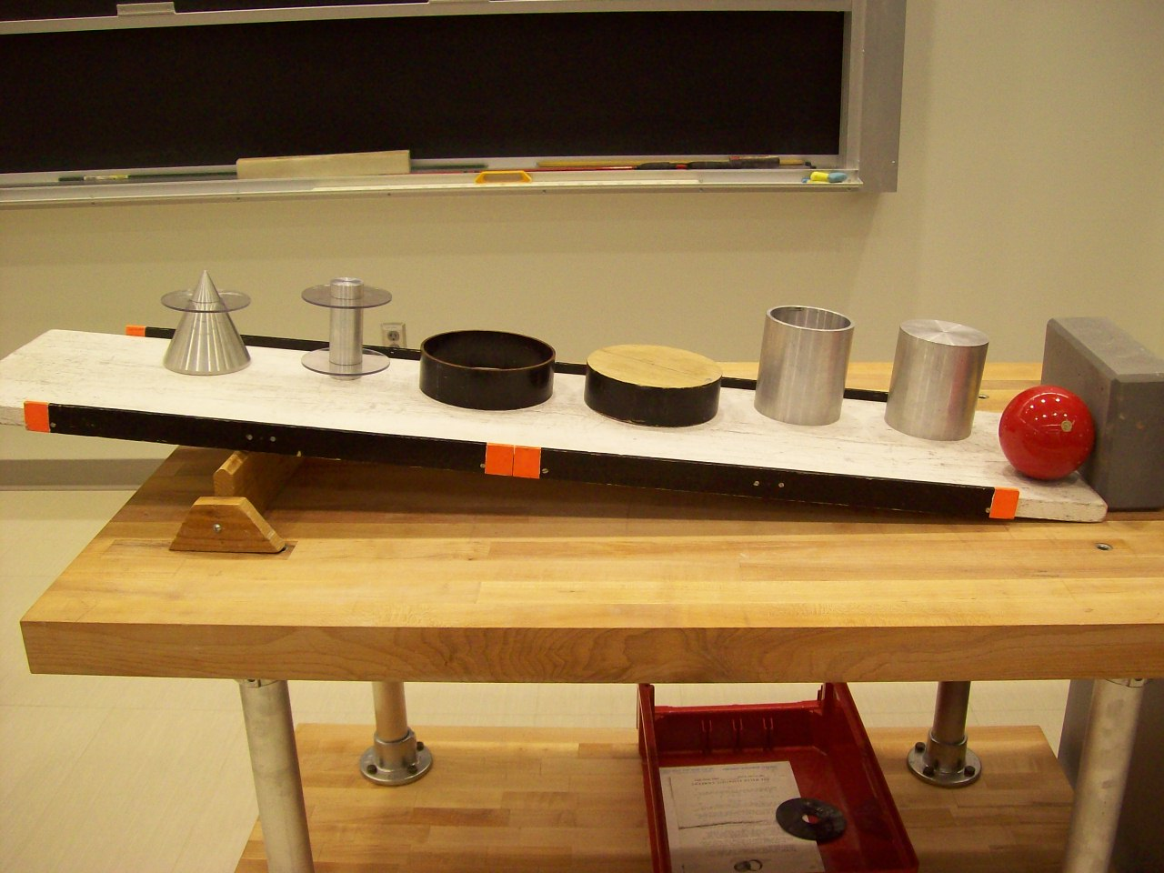
Location: Cd6

MECHANICS | 1Q10.50 | ROTATIONAL DYNAMICS
Moment of Inertia

Racing Soups
 | Two soup cans race down an incline. One is mostly liquid the other solid. It’s a good idea to read the reference article before showing this as the physics is more involved than it first seems.
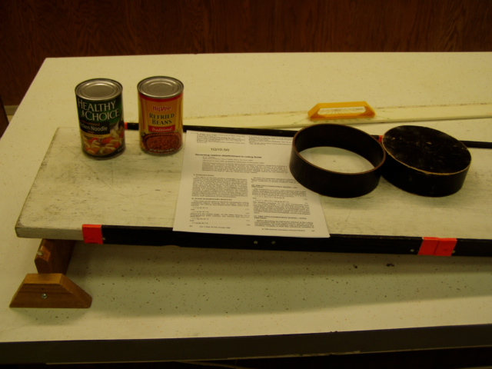Location: Cd6

MECHANICS | 1Q10.75 | ROTATIONAL DYNAMICS
Moment of Inertia

Parallel Axis Pendulum
 | The period of a board with a bearing attached to a pendulum rod is measured with the board free to rotate and then with the board locked in place on the rod. Because the rotational inertia of the board is not present in the first case, the period is smaller when the board is free to rotate.
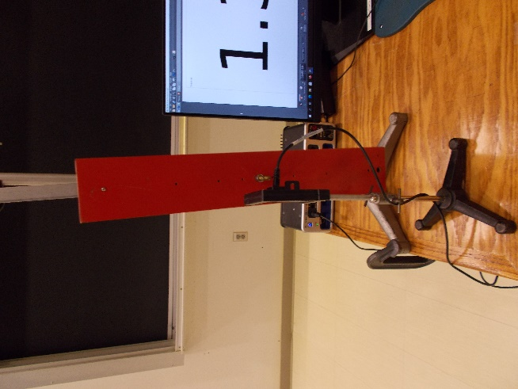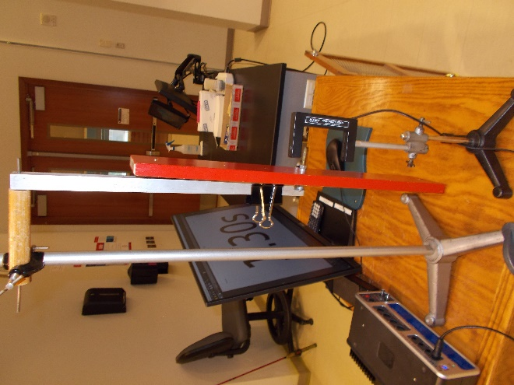
Location: Cd7
MECHANICS | 1Q20.10 | ROTATIONAL DYNAMICS

Rotational Energy

Adjustable Angular Momentum
Disc 06-01
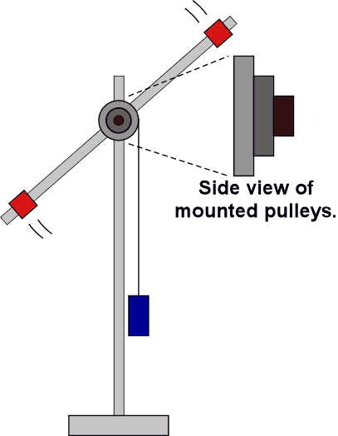 | The moment of inertia can be changed by sliding, the masses on the stick in or out. Use different masses to change the torque. This can also be done with Science Workshop (Rotational Atwood’s Machine.ds) as shown in the first picture. Angular position and velocity are displayed on the computer.
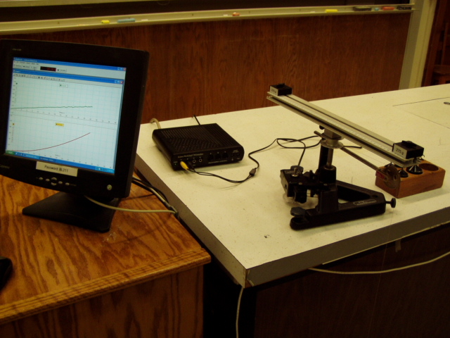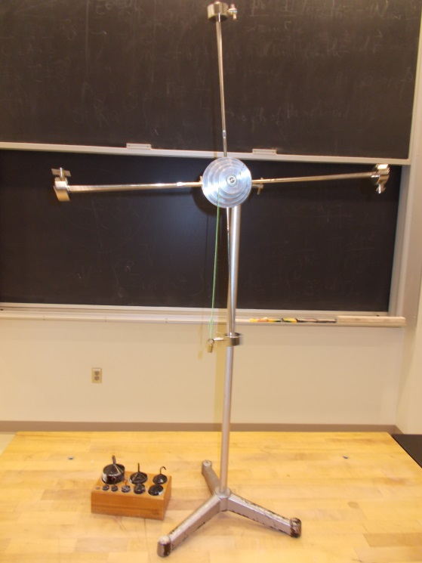
Location: Science Workshop cabinet, Bc3, Bd7

MECHANICS | 1Q20.20 | ROTATIONAL DYNAMICS
Rotational Energy

Bicycle Wheel Acceleration
 | A weight hung on a string wrapped around the circumference of a bicycle wheel applies a torque to it and gives it and angular acceleration.
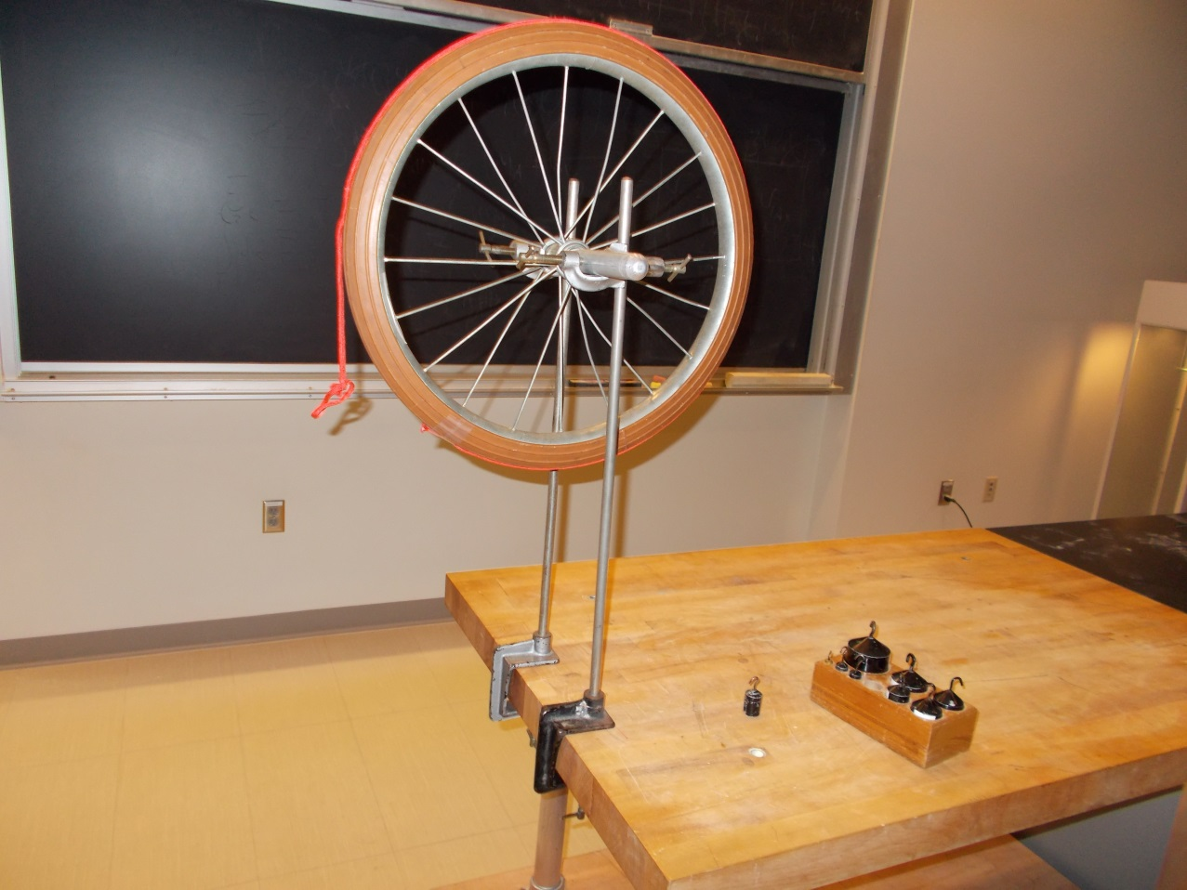
Location: Bb5

MECHANICS | 1Q20.50 | ROTATIONAL DYNAMICS
Rotational Energy

Faster than ”g”
 | Ball at the end of a falling board drops into a cup attached near the end of the board. Raise the board and place the stick in the marked positions to prop it up. Snatch the stick away.
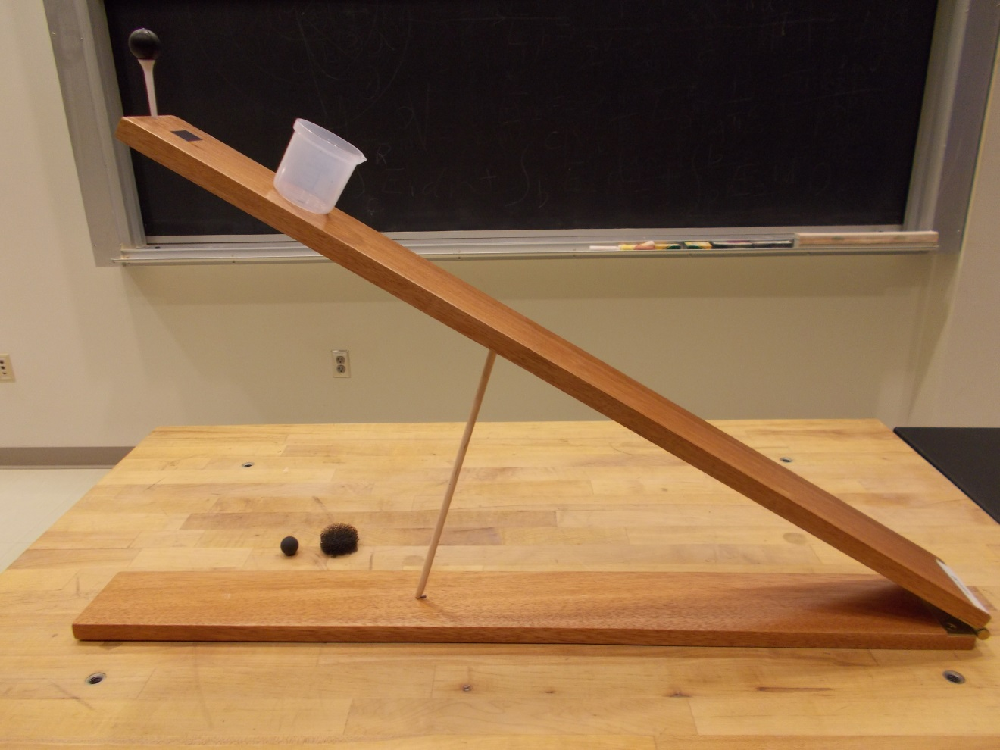
Location: Cd5

MECHANICS | 1Q20.65 | ROTATIONAL DYNAMICS
Rotational Energy

Falling Pencil
An inclined pencil is released from rest with its bottom end resting on a table. The bottom end will slide forward or backward or it will remain at rest at the start of the fall, then slide backward for a short period before sliding forward.
“The fall and bounce of pencils and other elongated objects”, Rod Cross, Am. J. Phys. 74 (1), January 2006
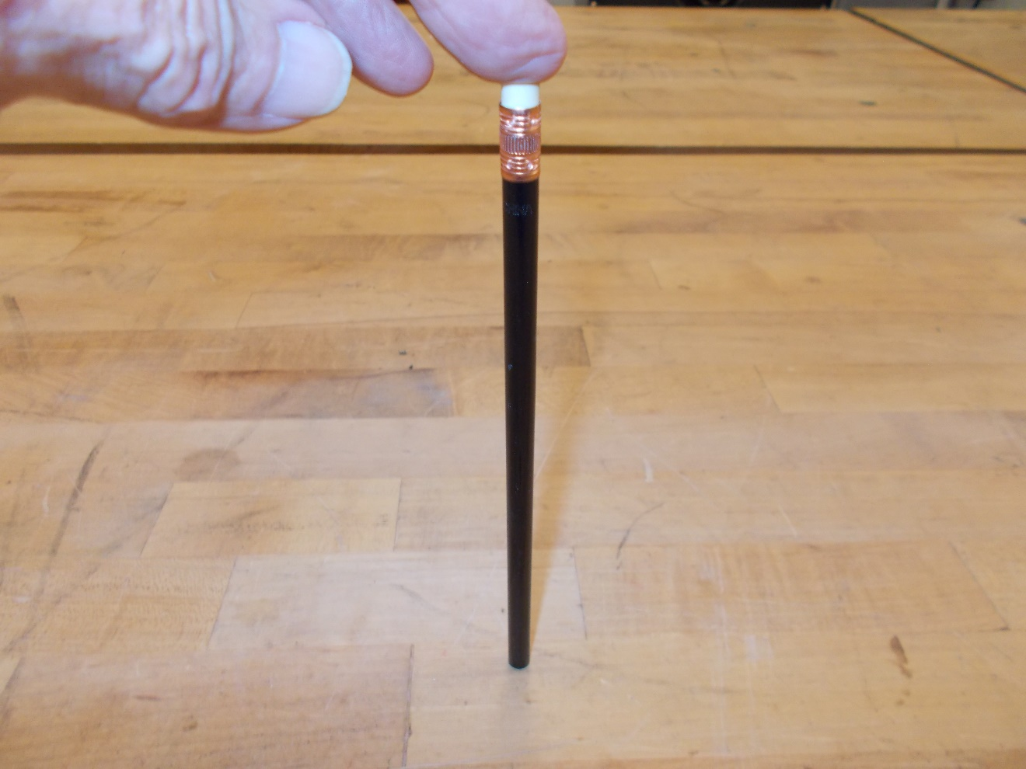
Location: Cd5

MECHANICS | 1Q20.70 | ROTATIONAL DYNAMICS
Rotational Energy

Flywheel Car
 | A toy car has a flywheel that stores rotational energy which can propel the car. Also shown is a larger version which can either be shown without a flywheel or with one of six different flywheels (red ones are made of steel, the other three are aluminum). The profiled flywheels of the same material have the same mass but different moments of inertia. Conservation of energy experiments can be done with the Data Studio file Flywheel.ds. The moments of inertia can be measured with the torsion oscillator arrangement shown.

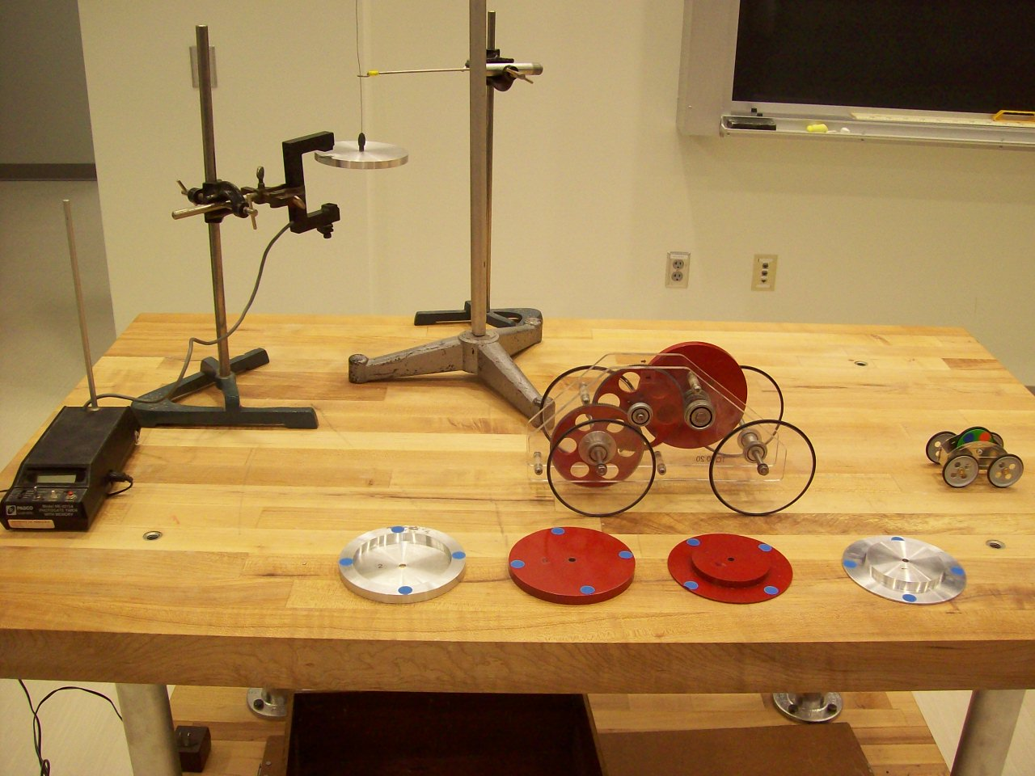
Location: Cd8
MECHANICS | 1Q30.10 | ROTATIONAL DYNAMICS

Transfer of Angular Momentum

Passing the Wheel
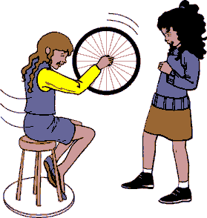 | Tip the spinning tire half way and hand it to a student on a turntable. This student tips it another half way and hands it back. Repeat until the spinning student it turning to fast for the hand off. You can add or subtract from the angular momentum depending on which way you tip the wheel.
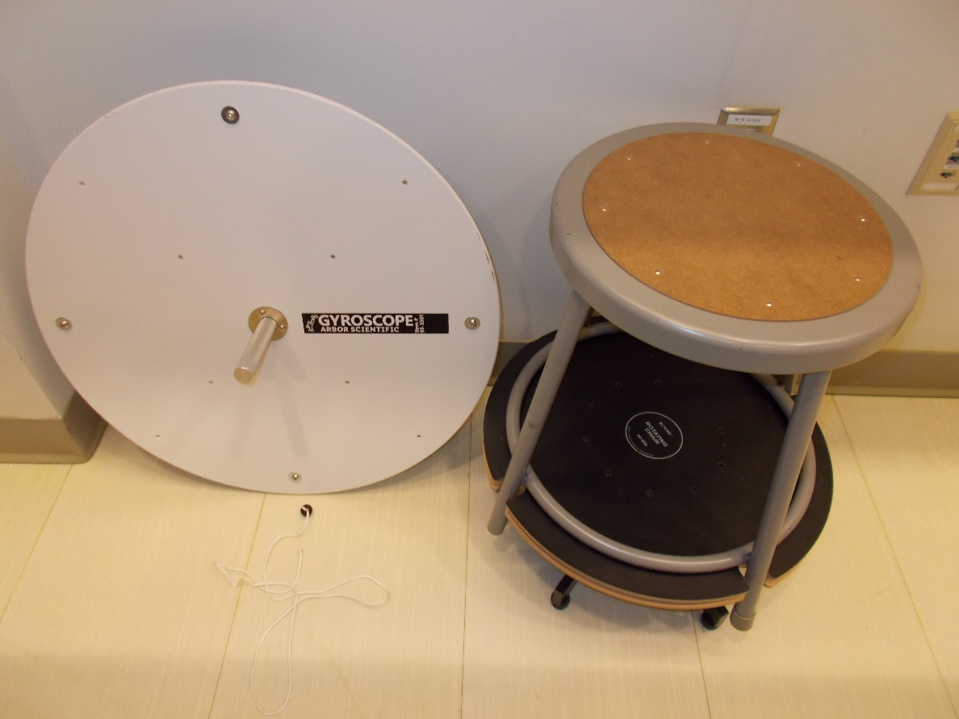
Location: Bb5, Da1
MECHANICS | 1Q40.10 | ROTATIONAL DYNAMICS

Conservation of Angular Momentum

Rotating Stool and Masses
Disc 07-04
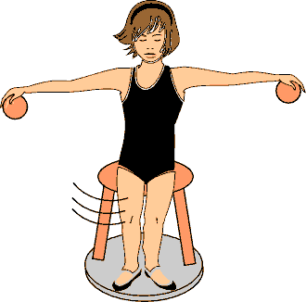 | Start a student rotating on the platform with the masses close to their body. Watch the change in spin as the student moves the masses further away.
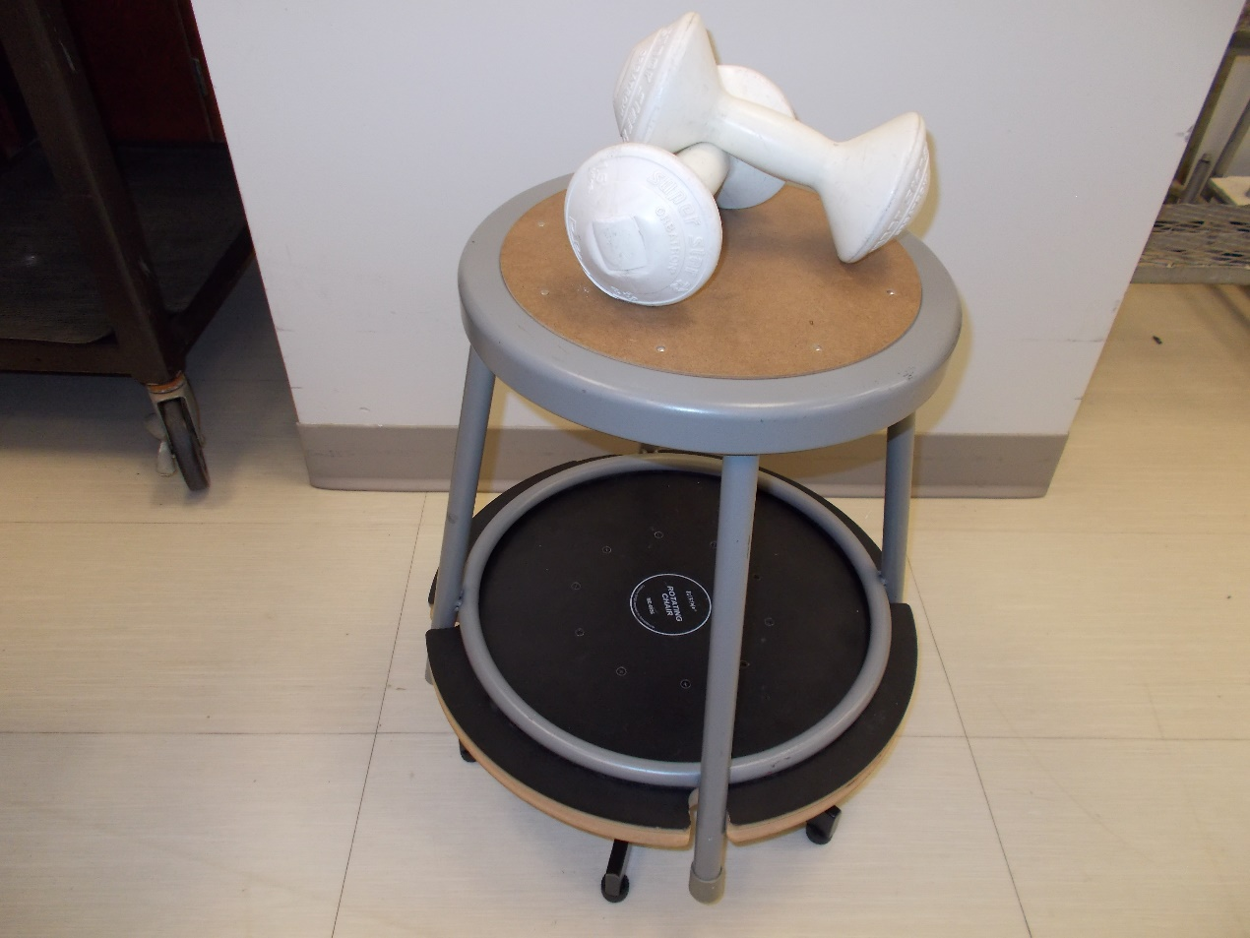
Location: Da1
MECHANICS | 1Q40.20 | ROTATIONAL DYNAMICS
Conservation of Angular Momentum

Squeezatron
 | Pull on the string while the apparatus is rotating and the moment of inertia is reduced causing the rotational velocity to increase. Two versions are shown in the photographs. The first uses Science Workshop equipment to measure the angular velocity so the initial and final angular momentum can be calculated. The rotating platform has a rotational inertia of 0.012 kg m² and the sliding mass is 0.275 kg. The Capstone file is “Angular Momentum Conservation. The second photograph shows a qualitative version.
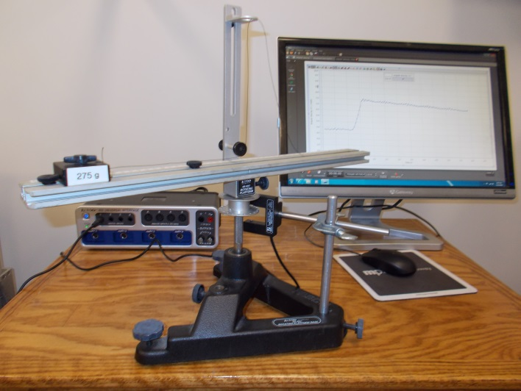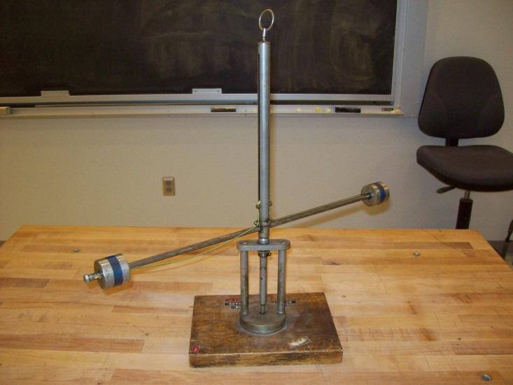
Location: Science Workshop Cabinet, Bc3, Cd7
MECHANICS | 1Q40.22 | ROTATIONAL DYNAMICS
Conservation of Angular Momentum

Rotating Hoberman Sphere
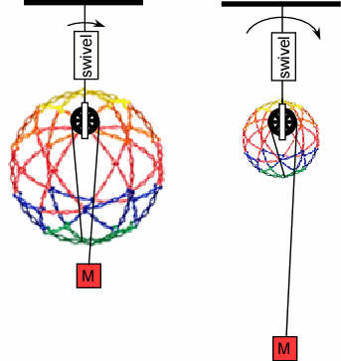 | A Hoberman sphere mobile has a ball bearing fishing swivel added so that it can rotate easily. Start it rotating in the expanded position. Pull on the string to collapse the sphere and observe the change in rotation speed.
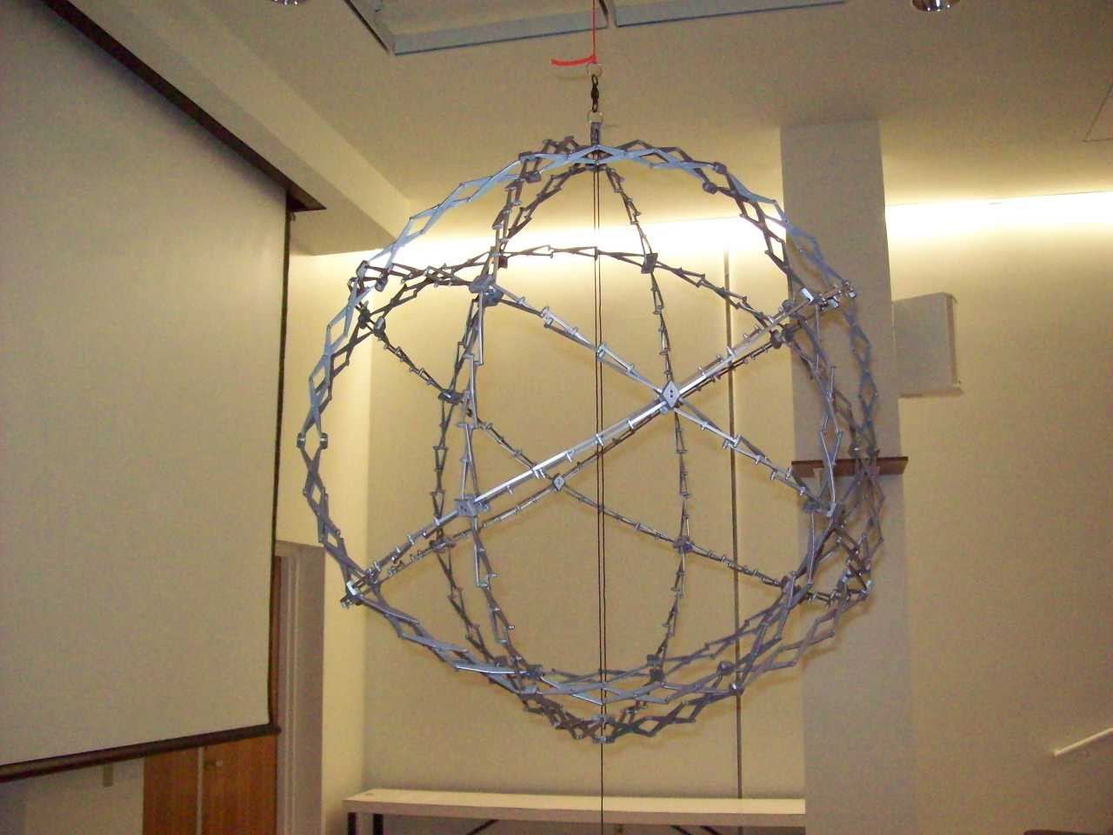
Location: Cd7

MECHANICS | 1Q40.23 | ROTATIONAL DYNAMICS
Conservation of Angular Momentum

Centrifugal Governor
 | A small governor is spun on a hand crank rotator.
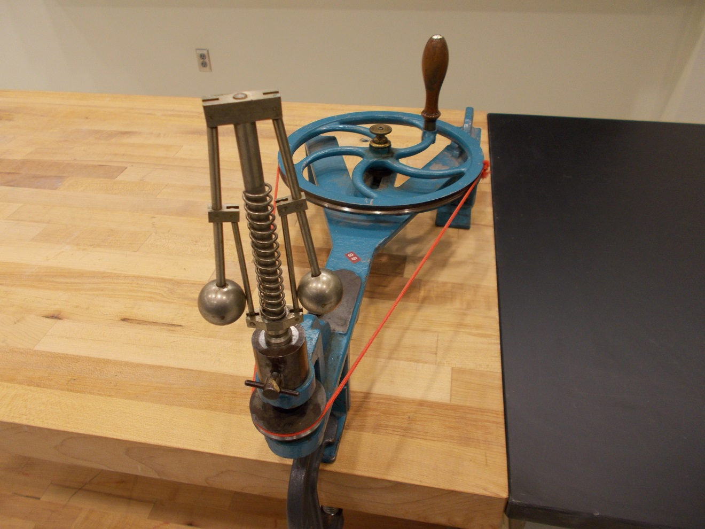
Location: Cd8

MECHANICS | 1Q40.30 | ROTATIONAL DYNAMICS
Conservation of Angular Momentum

Rotating Stool and Wheel
Disc 07-06
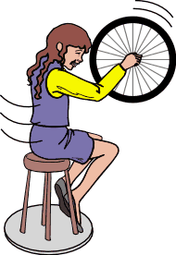 | A student rotating on the platform can tip a spinning wheel in order to spin. Tipping the wheel in the opposite direction spins the student the opposite direction.
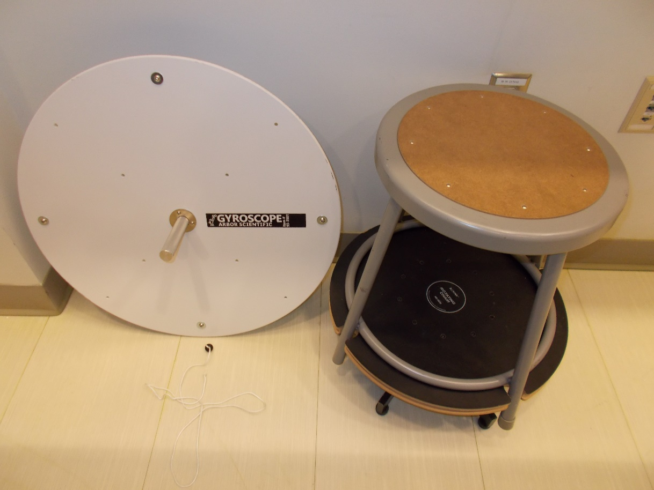
Location: Da1, Bb5
MECHANICS | 1Q40.50 | ROTATIONAL DYNAMICS
Conservation of Angular Momentum

Pocket Watch
 | Movement of a pocket watch balanced on a watch glass is magnified using a laser and a small mirror.
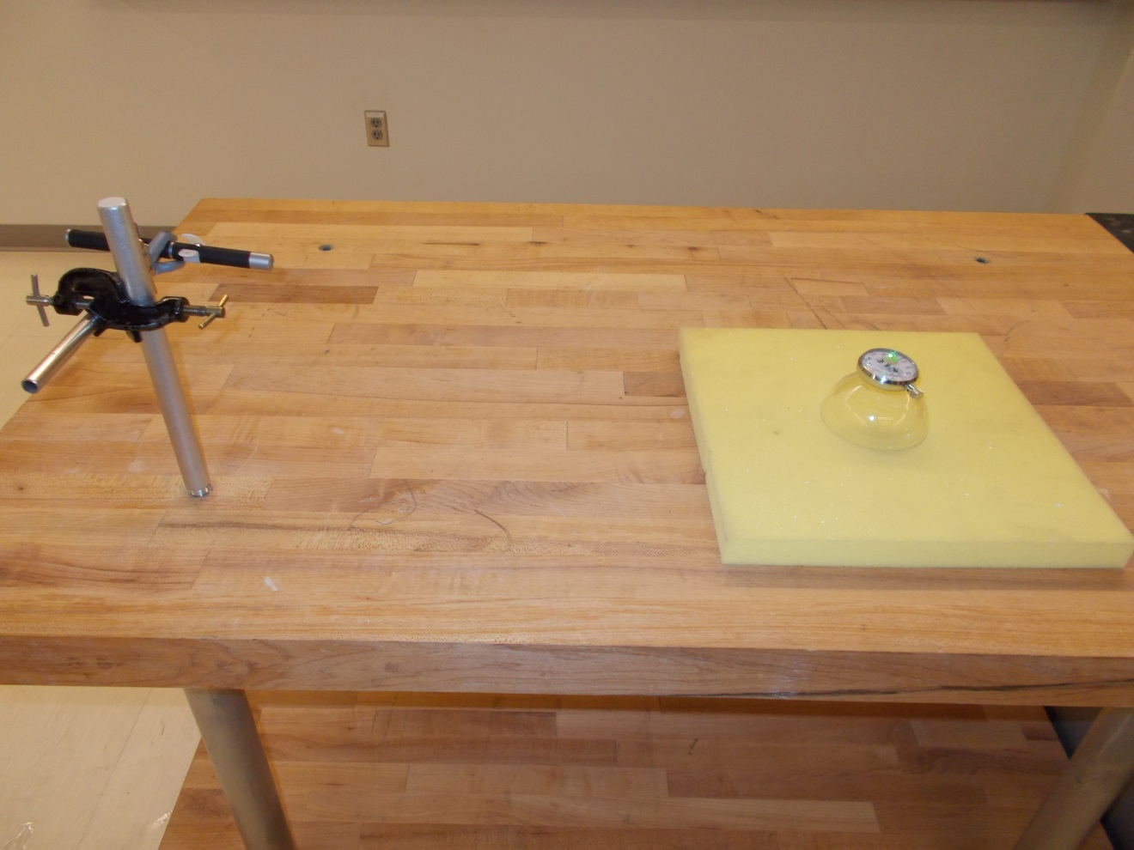Location: Cd8

MECHANICS | 1Q40.51 | ROTATIONAL DYNAMICS
Conservation of Angular Momentum

Rotational Collision
 | An iron ring is dropped on a rotating Disc while the angular velocity is monitored with a computer. The disc has a rotational inertia of 0.0091 kg-m², and the ring has a diameter of 12.7 cm , a thickness of 1 cm and a mass of 1.431 kg. Capstone file: Angular Momentum Conservation.
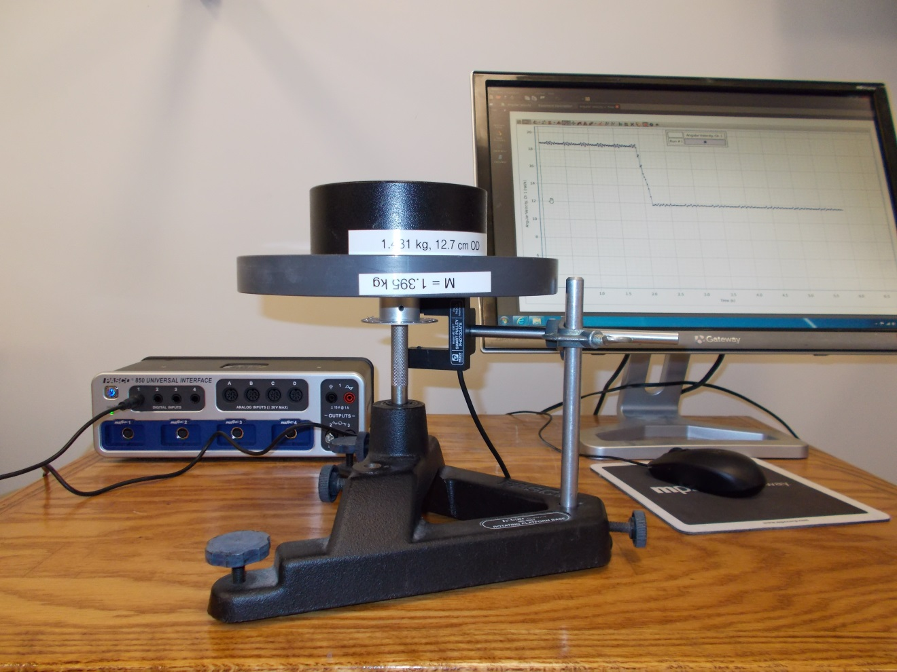
Location: Bc3
MECHANICS | 1Q40.53 | ROTATIONAL DYNAMICS
Conservation of Angular Momentum

Counter Rotating Disks
 | Spin the top, aluminum, disks up the lead screw. Hold both the aluminum disks and the bottom red disk steady and release them at the same time. As the aluminum disks spin up, the red disk will spin up in the opposite direction. When they collide, the entire apparatus will stop, showing the angular momentum is zero as it was to begin with. The aluminum disks can be removed to vary the moment of inertia.
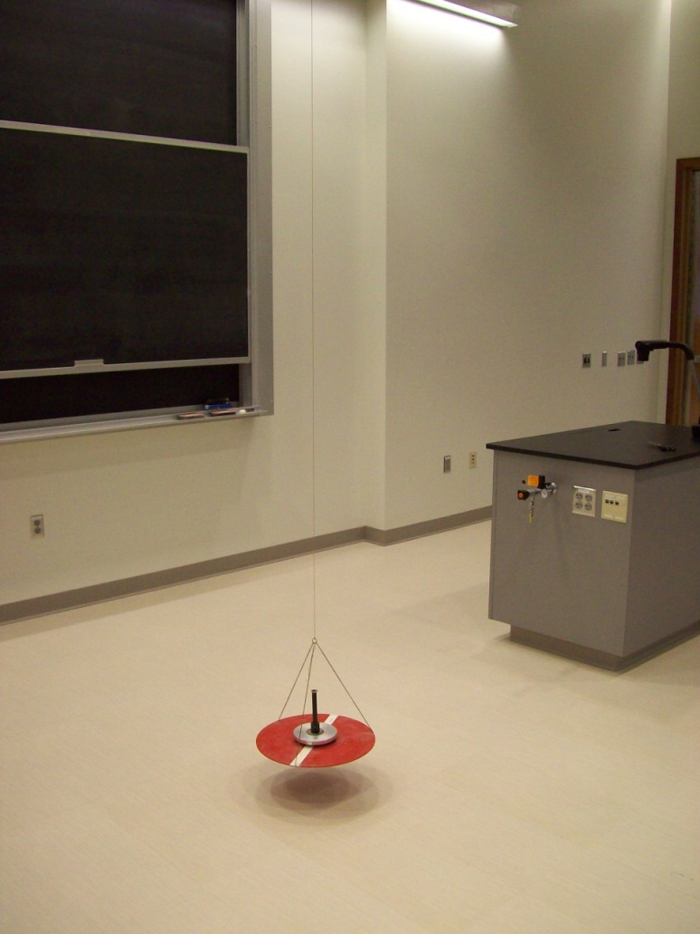
Location: Cd7
MECHANICS | 1Q40.60 | ROTATIONAL DYNAMICS
Conservation of Angular Momentum

Sewer Pipe Pull
Pull a sheet of paper horizontally from under a cylinder on a level surface. As soon as the cylinder leaves the paper it stops, dead. (Do this on a board that has been leveled with shims.)
Shown in the photograph are two cylinders with different moments. One will move further faster but both will come to a stop after leaving the paper.

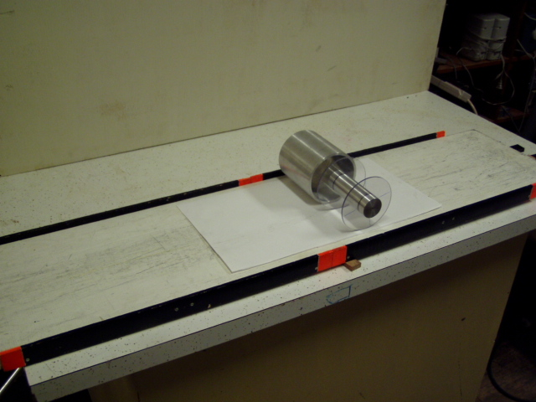Location: Cd6, Ca1
MECHANICS | 1Q40.80 | ROTATIONAL DYNAMICS
Conservation of Angular Momentum

Hero’s Engine
 | Cylindrical boiler pivots on a vertical axis with tangential pressure relief nozzles. Check water supply before using (requires hex key and wrench).
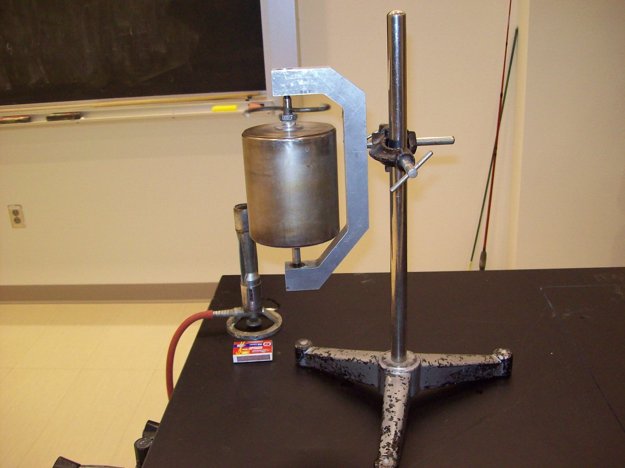Location: Ga6

MECHANICS | 1Q40.90 | ROTATIONAL DYNAMICS
Conservation of Angular Momentum

Feynman Sprinkler (Acoustic Version)
 | Drive Helmholtz resonators at their resonant frequency (440.22Hz). As air oscillates in and out, the resonators turn on the pivot support. Make sure the input RMS voltage to the amp is less than 0.5V and turn the volume so that the sound level at the pivot is 110dB (in the audience, less than 90 dB). Use hearing protection
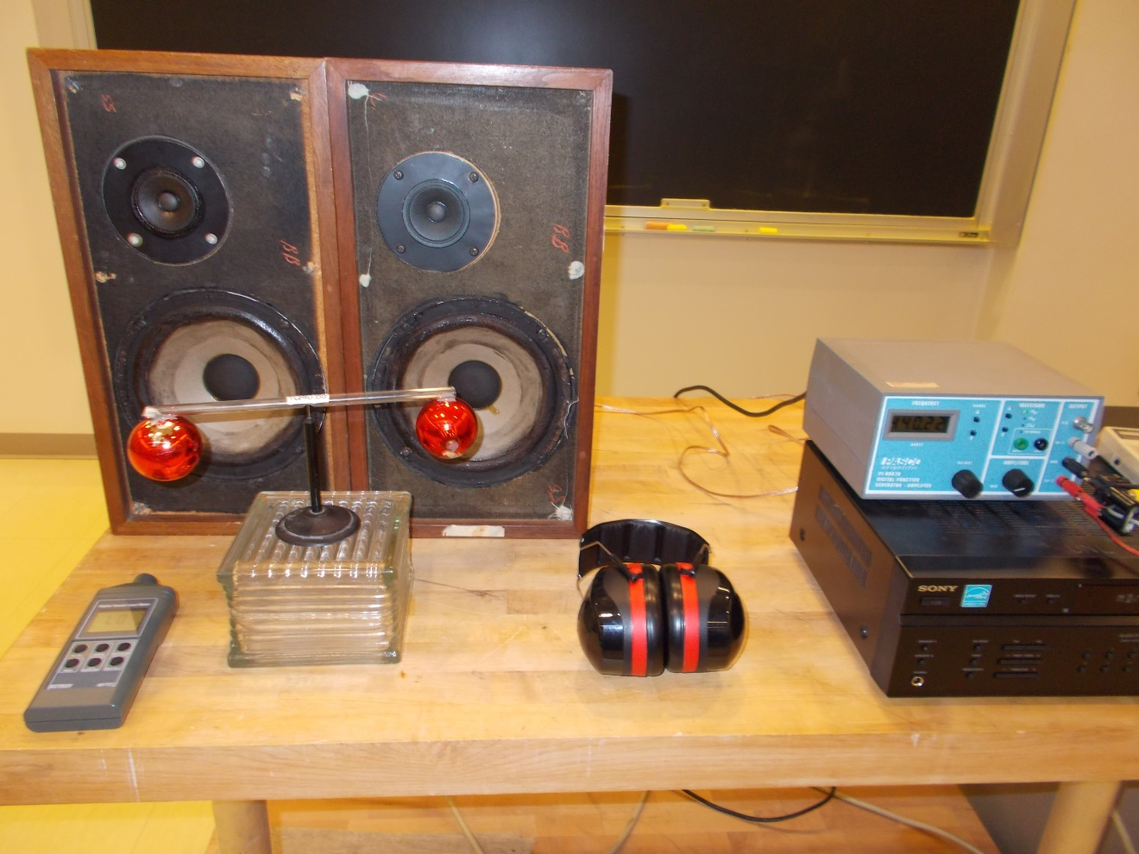
Location: Cd8, Ed3, Ed5, Fb4, Fb5, Gc2
MECHANICS | 1Q50.10 | ROTATIONAL DYNAMICS

Gyros

Precessing Pulley
 | Spin a large light pulley and either hang or hold it by the string as it precesses due to gravitational torque.
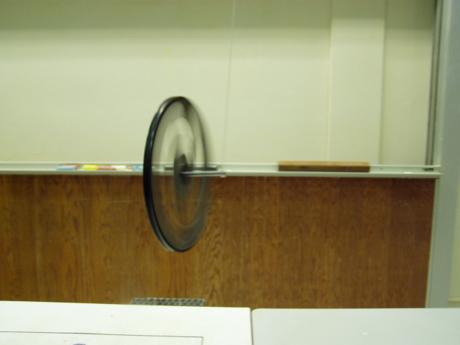Location: Bc7
MECHANICS | 1Q50.23 | ROTATIONAL DYNAMICS
Gyros

Bike Wheel Precession
 | A spinning bicycle is supported by a rope at the end of a long axle. Be careful about people running into the wheel if it is left hanging.
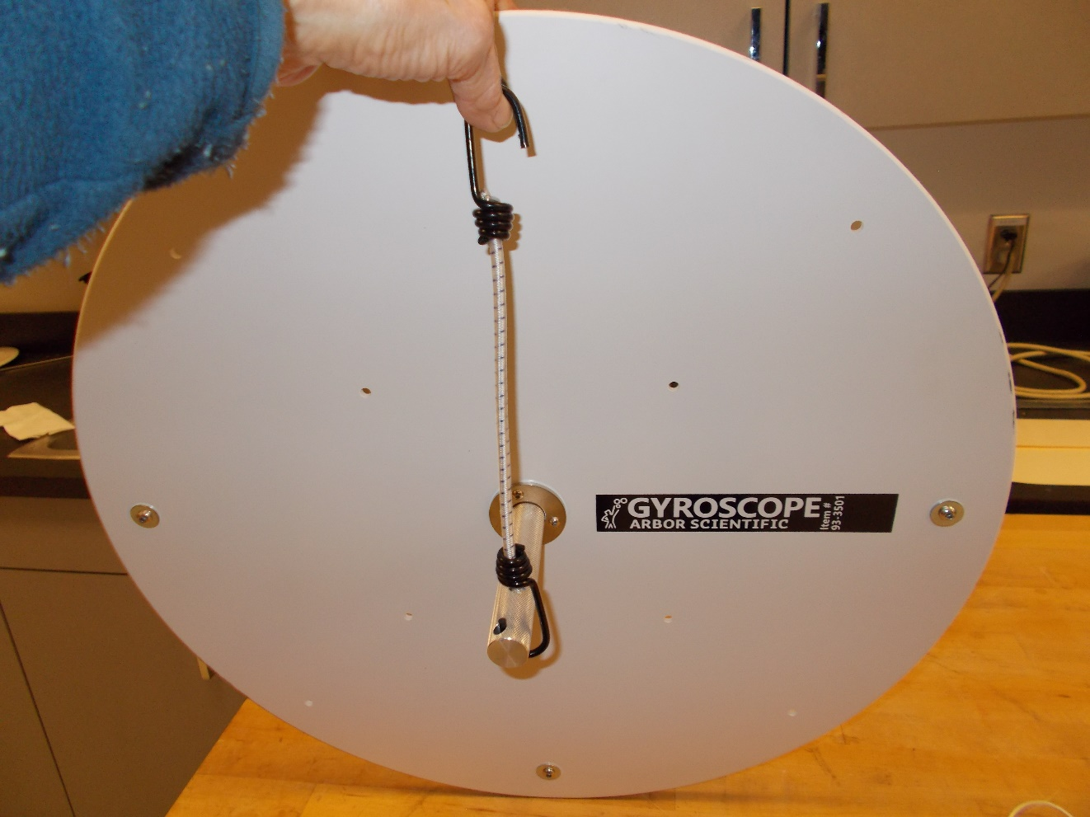
Location: Bc7, Da4
MECHANICS | 1Q50.25 | ROTATIONAL DYNAMICS
Gyros

Double Gyro
 | Two gyro discs are mounted coaxially. Try the standard demonstrations with the discs rotating in the same direction and in opposite directions.
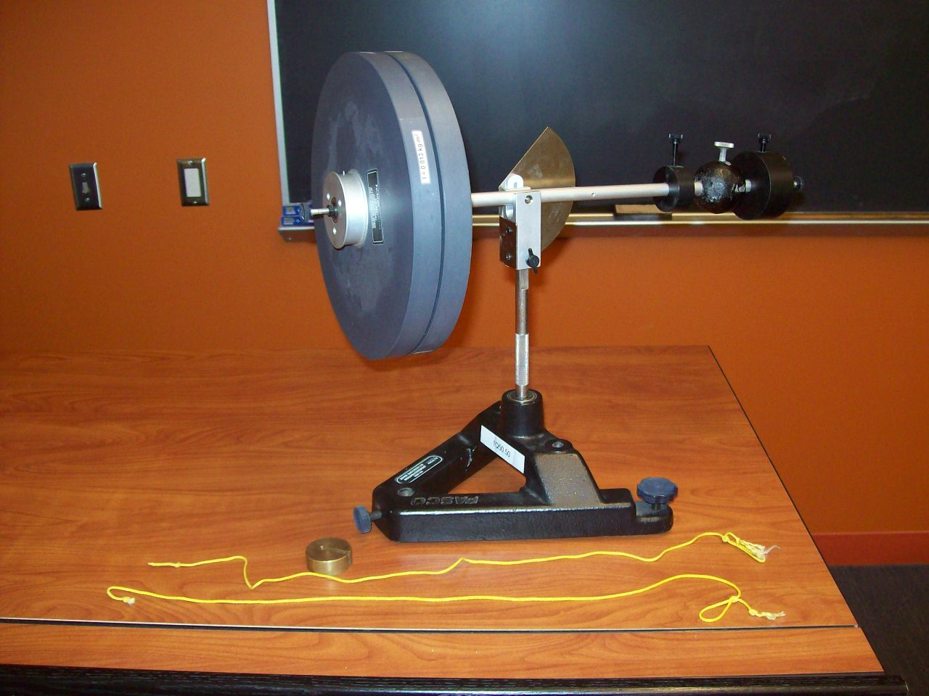Location: Da2,
MECHANICS | 1Q50.45 | ROTATIONAL DYNAMICS
Gyros

Air Bearing Gyro
 | Air suspension gyro with a 4 inch ball and various attachments. Use the a motor tool with a rubber roller bit to spin it up.
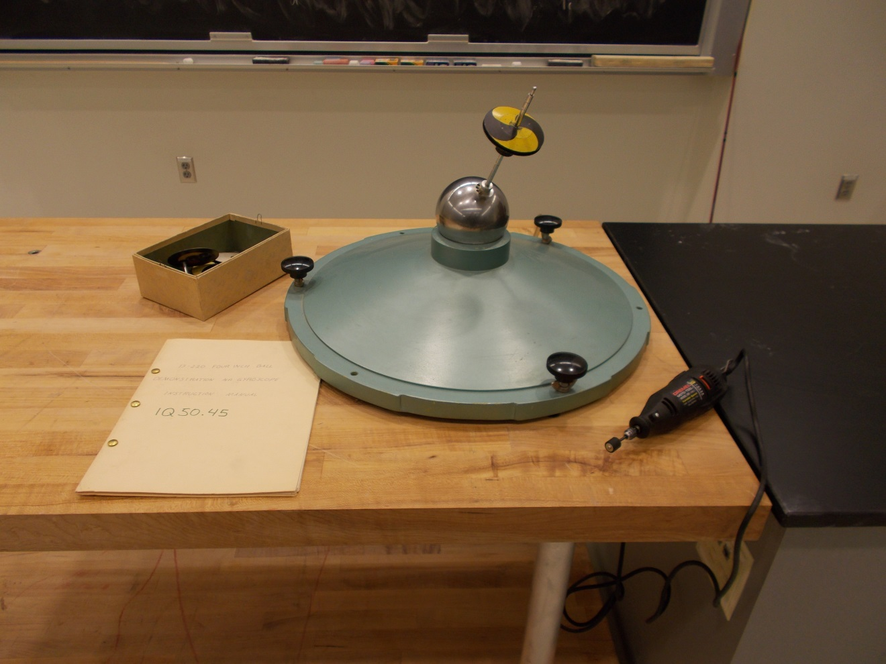Location: Da3
MECHANICS | 1Q50.30, 1Q50.50 | ROTATIONAL DYNAMICS
Gyros

Precessing Gyro
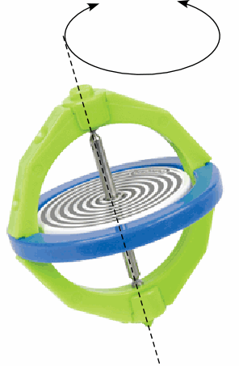 | A high quality gyroscope with a counterweight is used to show the fundamental precession equation with fair precision. Both a hand spun (Pasco) and motorized (Mitac) version are shown in the photograph.
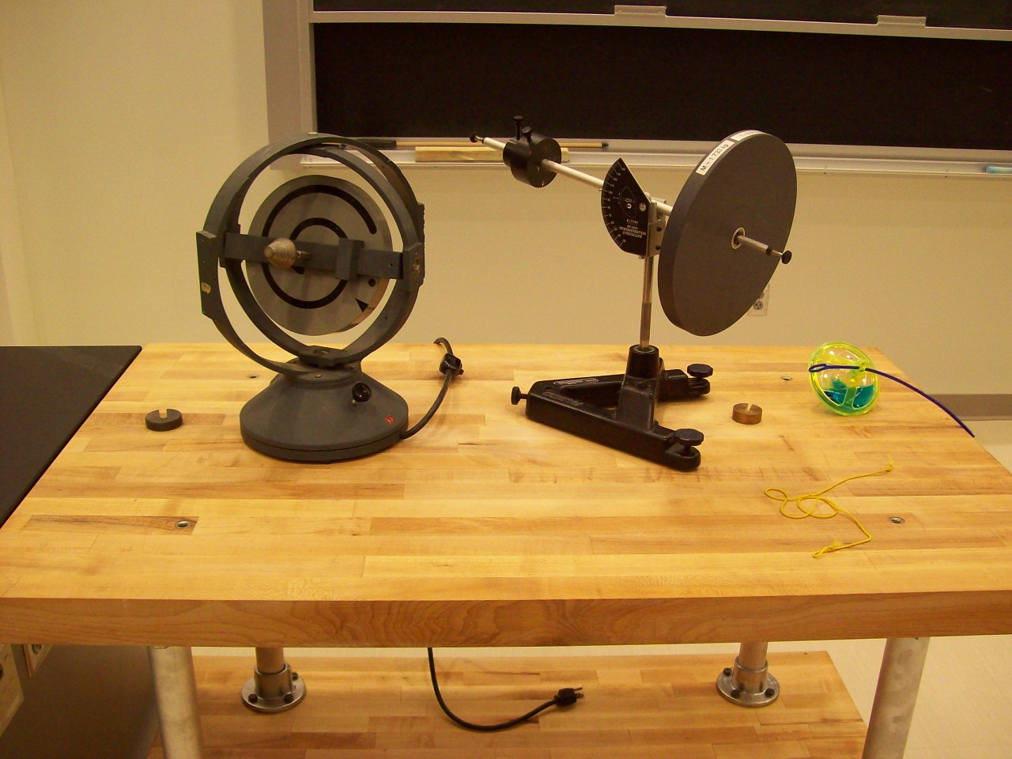
Location: Da2, Da4
MECHANICS | 1Q60.16 | ROTATIONAL DYNAMICS

Rotational Stability

Old Fashioned Top
 | An old fashioned top that you throw with a string. Aso shown is a modern version that will stay upright several minutes.
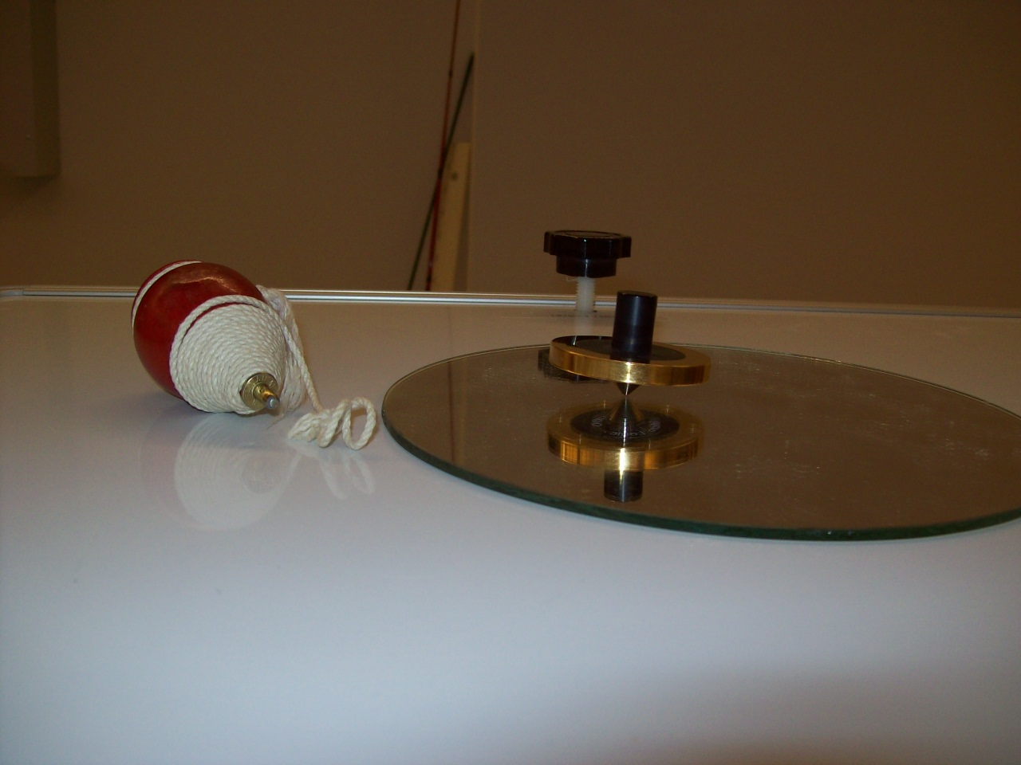Location: Da4
MECHANICS | 1Q60.25 | ROTATIONAL DYNAMICS
Rotational Stability

Spinning Coin
 | Euler’s Disk. The wobbling is explained in AJP 28(4), 449.
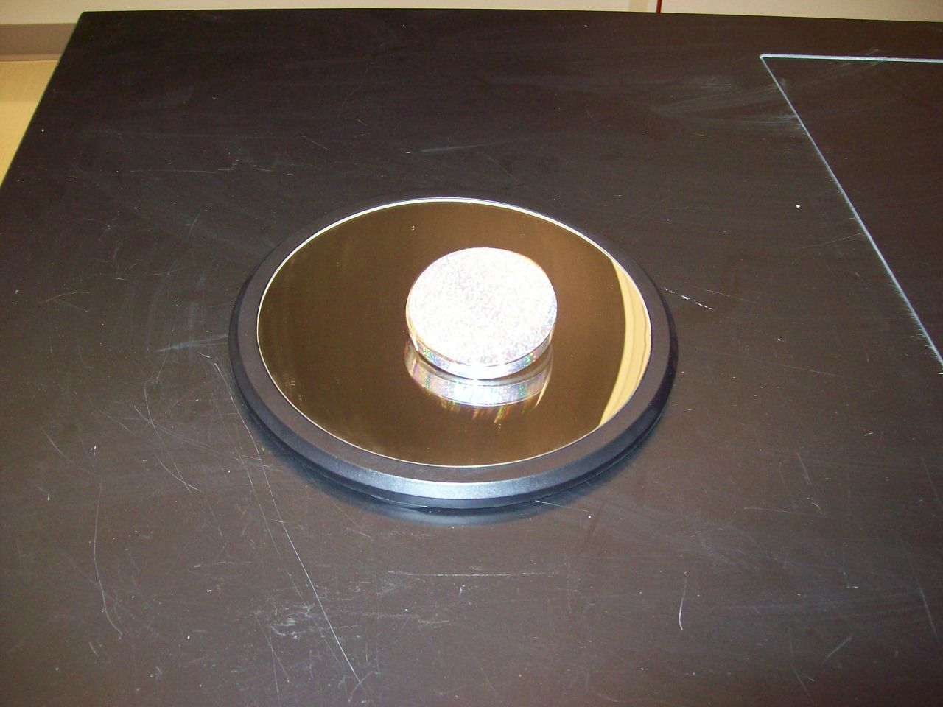Location: Da4

MECHANICS | 1Q60.26 | ROTATIONAL DYNAMICS
Rotational Stability

Spinning Rod
A rod whose length is 3 times its diameter and has one end marked with an “X” and the other with “3D”. Spin it by pressing down with your thumb on the “X”. As it spins, you will see 3 images of the “X” but you won’t see the “3D”. There are other rods in the set whose lengths are 2D, 4D and 5D. The end that is not pressed rolls without slipping on the table and the image of the “X” can be explained by adding the angular velocity vectors of the rotation about the major and minor axis of the rod.
The image of the “X” can be seen on a video camera.

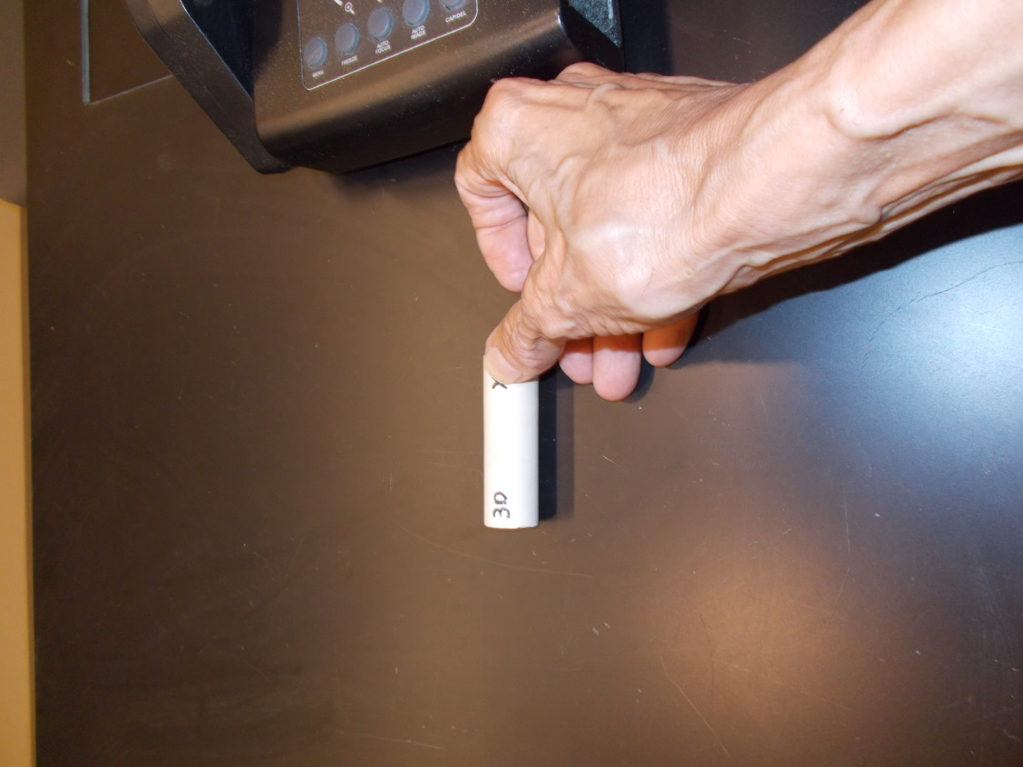
Location: Da4
MECHANICS | 1Q60.30 | ROTATIONAL DYNAMICS
Rotational Stability

Tippe Top
 | Show that the tippe top spins in the opposite of the expected direction when inverted.
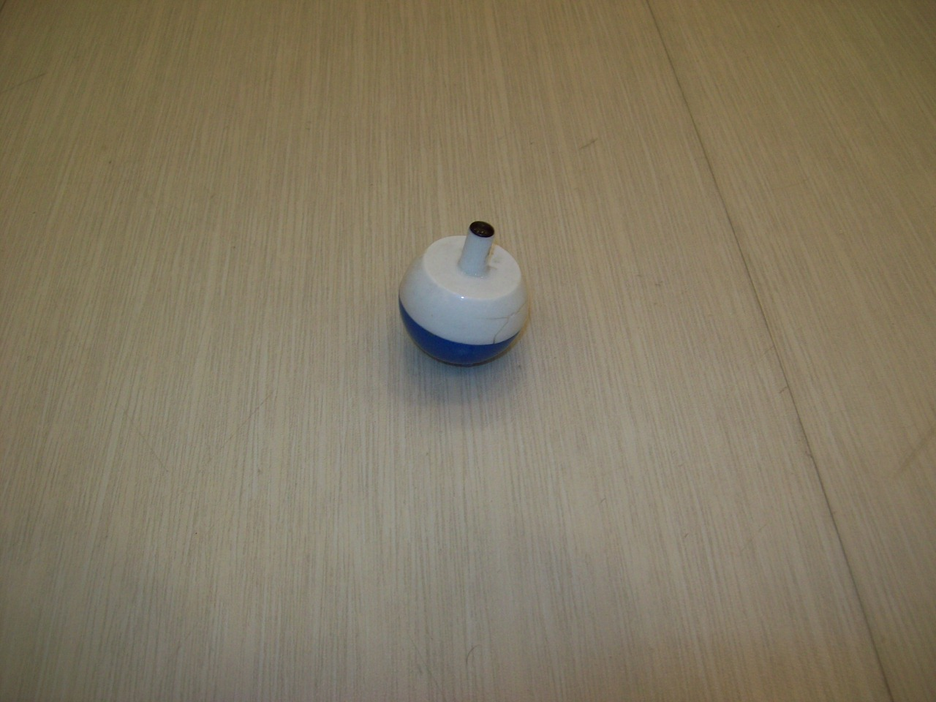Location: Da4
MECHANICS | 1Q60.35 | ROTATIONAL DYNAMICS
Rotational Stability

Spinning Football
 | Spin a football and it rises up to its pointed end. Also shown is the PhiTop which is a golden prolate ellipsoid (ratio of major to minor axis Φ = 1.618…) and will spin upright a long time when properly started.
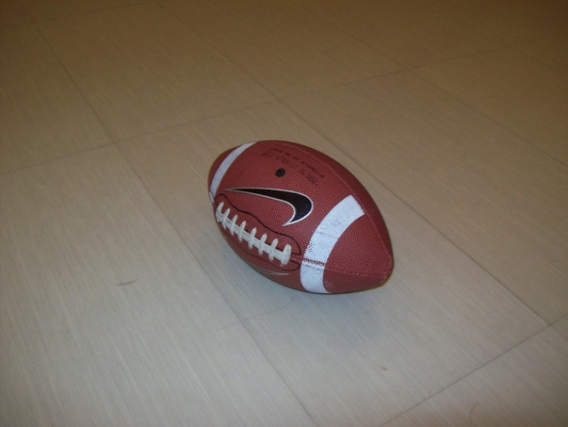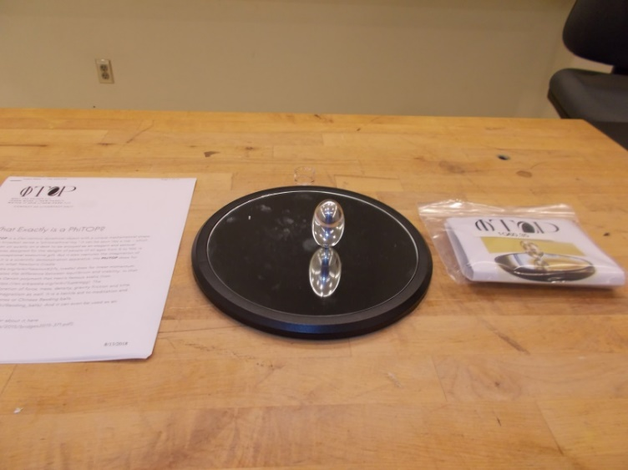
Location: Dc2

MECHANICS | 1Q60.38 | ROTATIONAL DYNAMICS
Rotational Stability

Hurricane Balls
Also called “Tornado Spheres”. Two balls stuck together are spun. The steady state motion is rotational motion about the center of mass, such that only one ball is in contact with the supporting surface as it rolls without slipping. Use compressed air to spin it up ever faster.
Jackson et al. Am. J. Phys. 83 (11), Nov. 2015
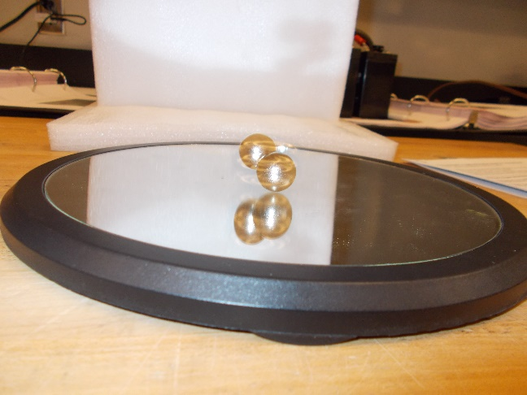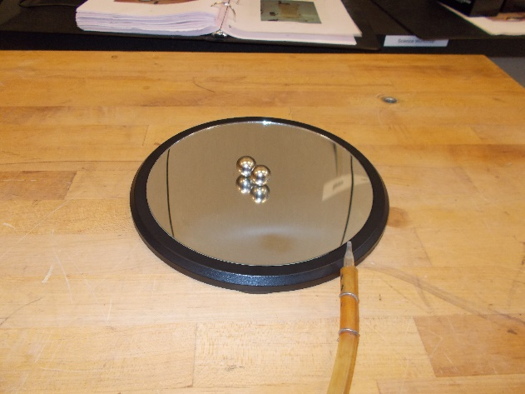
Location: Dc2
MECHANICS | 1Q60.40 | ROTATIONAL DYNAMICS
Rotational Stability

Tossing the Book
 | Throw a book or foam block in the air spinning it about each of its three principle axes.
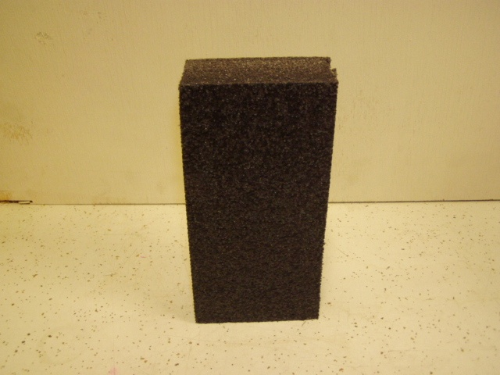Location: Da4
MECHANICS | 1Q60.50 | ROTATIONAL DYNAMICS
Rotational Stability

Spinning Lariat, Rod, Hoop and Disc
 | A rod, hoop, disc and endless chain can in turn be fastened to a drill chuck. On spinning, all objects assume an orientation which gives them a maximum symmetrical moment of inertia about the axis of spin. This can be explained either in terms of the applied angular impulse acting to align the angular momentum with the angular velocity or the total energy being minimized for a given angular velocity.
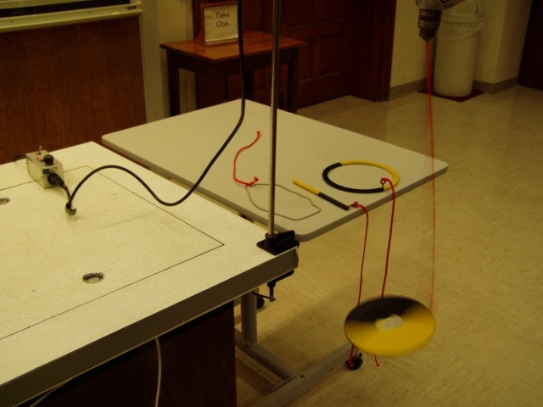Location: Da4

MECHANICS | 1Q60.51 | ROTATIONAL DYNAMICS
Rotational Stability

String Shooter
 | The string shooter uses a pair of rotating wheels to continuously propel a closed loop of string at constant speed. The loop quickly reaches a stable shape remaining suspended in the air.
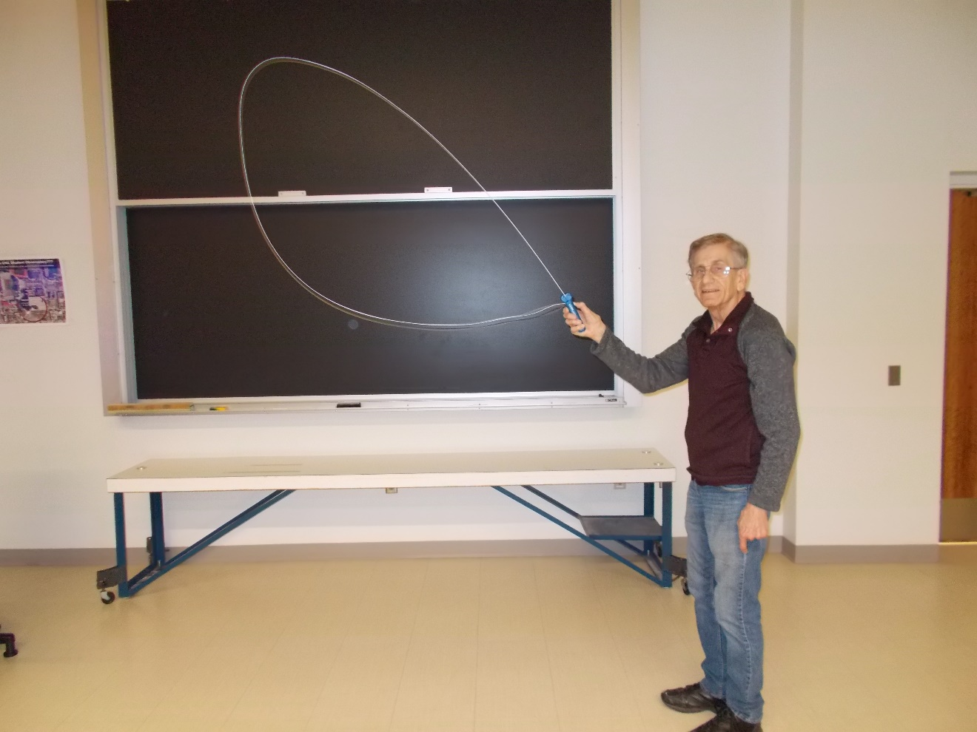
Location: Da4
MECHANICS | 1R10.10 | PROPERTIES OF MATTER

Hooke’s Law

Stretching a Spring
Disc 08-01
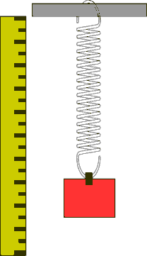 | Mark the beginning and end positions of several different masses. Compare the end positions of masses that are multiples, such as double or triple. The second version has springs of different spring constants but the same length.
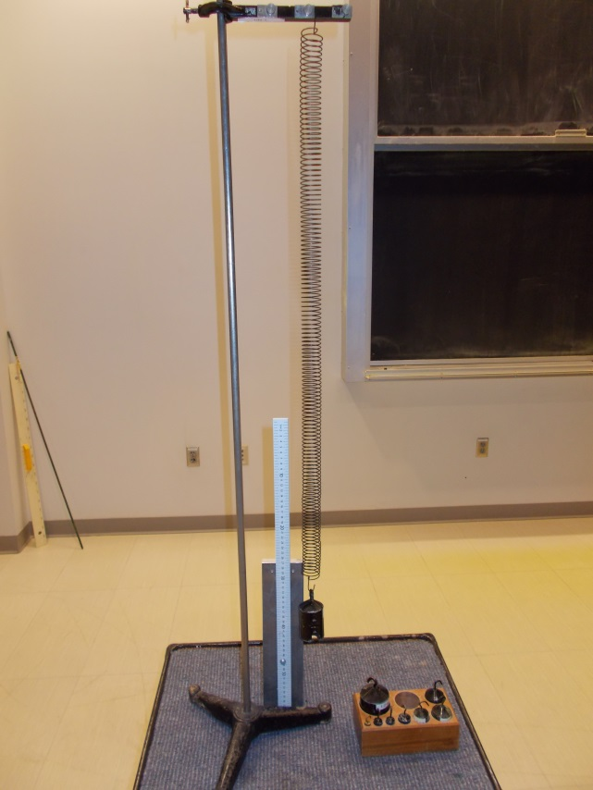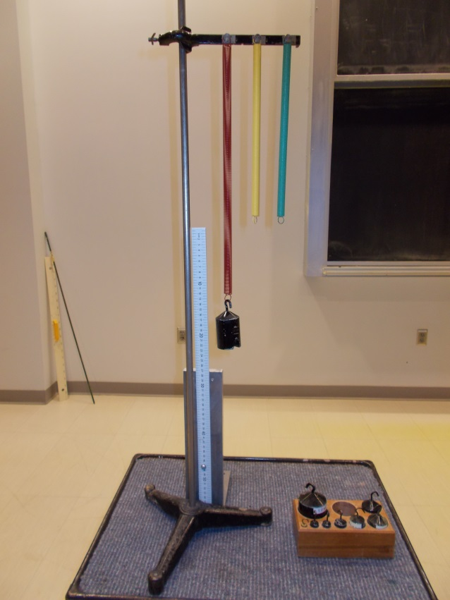

Location: Da5, Ab7

MECHANICS | 1R10.25 | PROPERTIES OF MATTER
Hooke’s Law

Pull on a Horizontal Spring
 | Hooke’s Law is demonstrated using a Smart Car, Spring and Pasco Capstone (Hooke’s Law.Cap). The spring constant can be measured either when the spring and cart are horizontal or inclined.
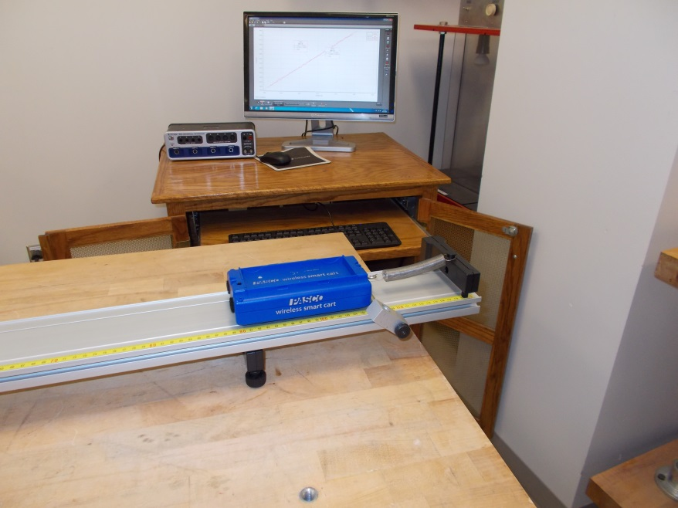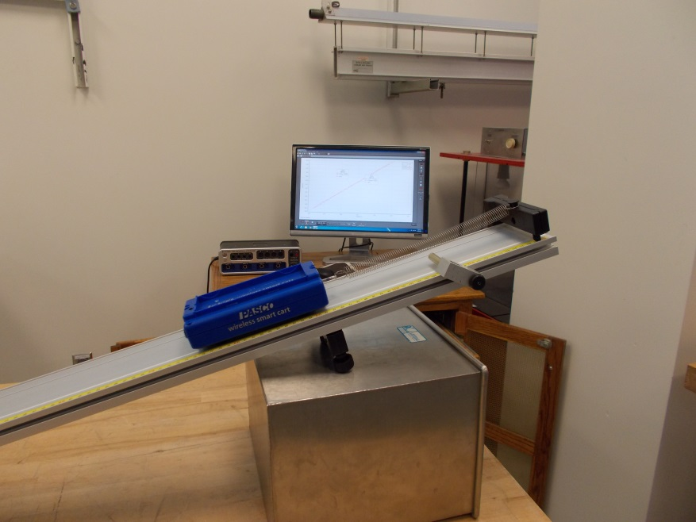
Location: Bb2, Cb2

MECHANICS | 1R10.30 | PROPERTIES OF MATTER
Hooke’s Law

Springs in Series and Parallel
 | When the wire connecting the two springs is removed, will the weight go up down or stay at the same height?
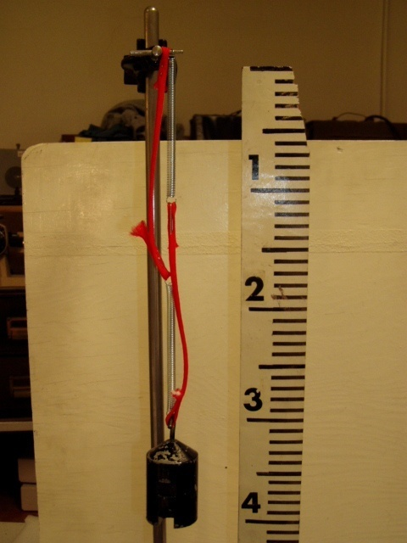
Location: Da5, Ab7
MECHANICS | 1R20.10 | PROPERTIES OF MATTER

Tensile and Compressive Stress

Breaking Wire
 | Add weights (20 kg or so) to a stainless steel wire hung from the ceiling. The wire is 0.5 mm in diameter and the distance from the table top to the support point above is 3.075 m.
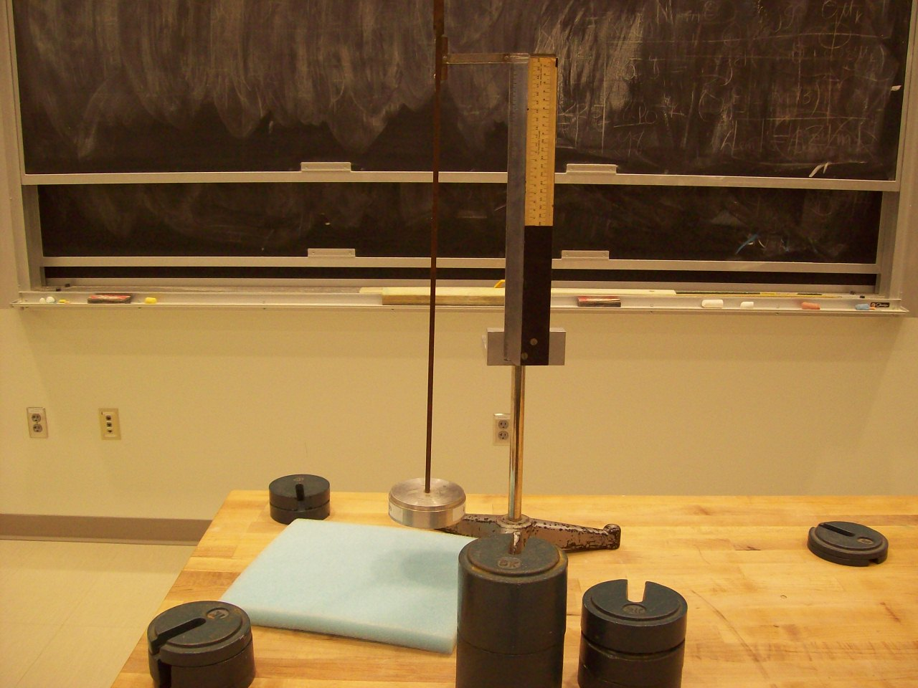
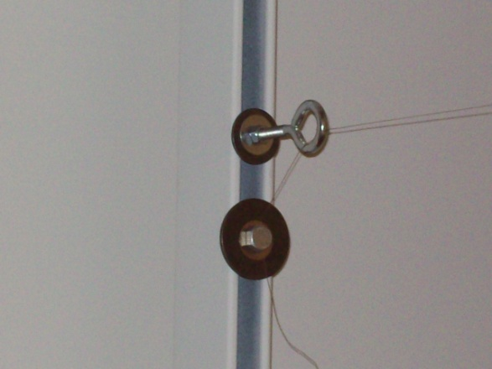
Location: Da6
MECHANICS | 1R20.11 | PROPERTIES OF MATTER
Tensile and Compressive Stress

Elastic Limit (Stress vs. Strain)
 | A sample coupon of various metals and thicknesses is mounted on an apparatus that can measure the stress and strain. The results are plotted on the computer using the Capstone file Stress Strain with SW sensors.cap. Do not use “Delete All Data” as the first data set is the calibration for the others.
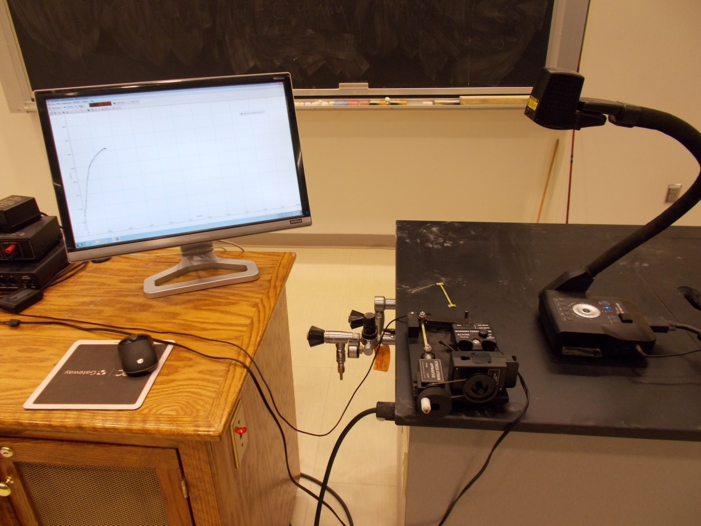Location: Da6
MECHANICS | 1R20.15 | PROPERTIES OF MATTER
Tensile and Compressive Stress

Young’s Modulus
 | Hang weights from a wire. Use a laser and optical lever to display the deflection.
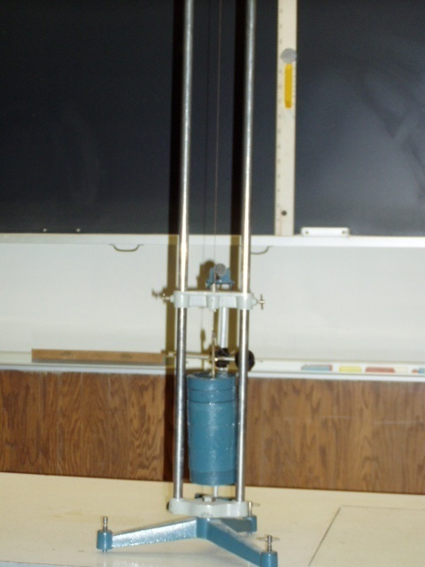
Location: Ca1
MECHANICS | 1R30.30 | PROPERTIES OF MATTER

Shear Stress

Spring Cube
 | A 4x4x4 cube of plastic balls is held together by springs. Also shown is cube with flexible, spring loaded corners.
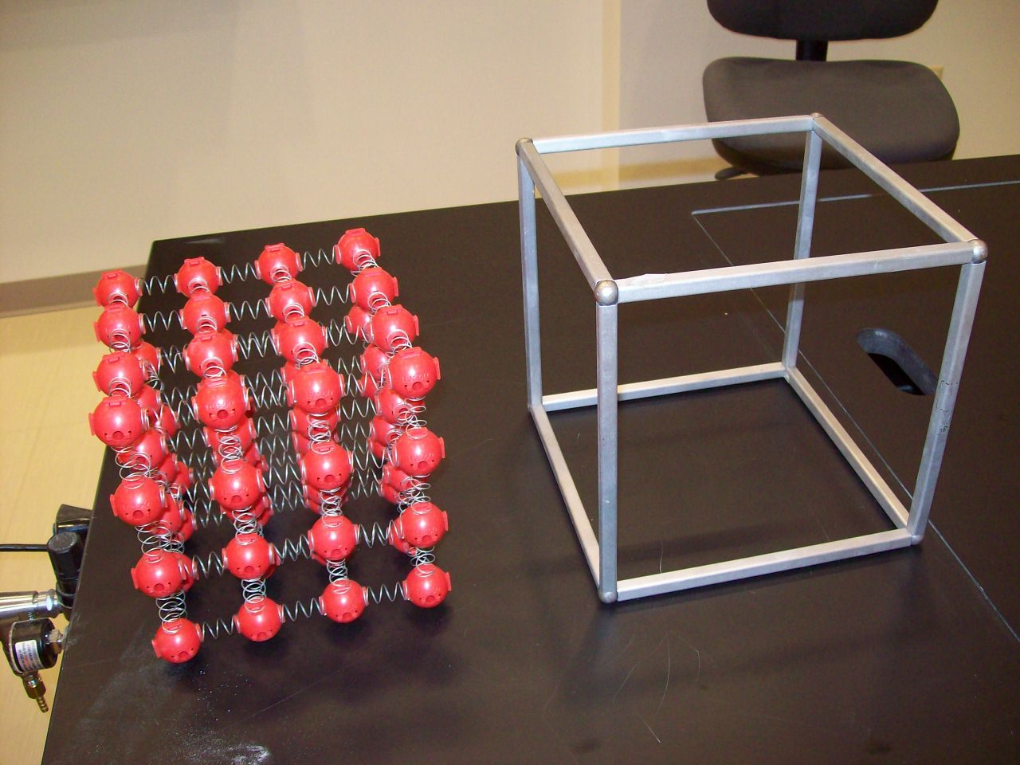
Location: Db1
MECHANICS | 1R30.40 | PROPERTIES OF MATTER
Shear Stress

Torsion Rod
 | A rod with indicators radiating from it is twisted.
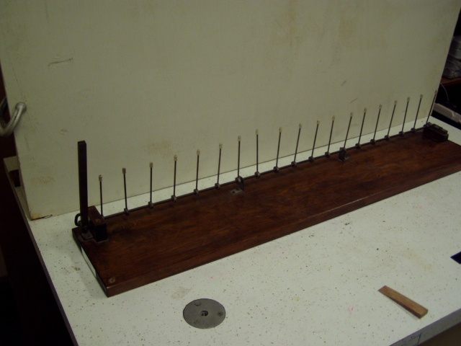Location: Db7
MECHANICS | 1R40.11, 1R40.30 | PROPERTIES OF MATTER

Coefficient of Restitution

Happy and Sad Balls
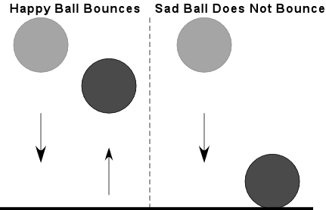 | Drop bounce and no-bounce balls.  Measure the height the bouncing ball is dropped from, and the height it bounces to, and calculate the coefficient of restitution.  The sad ball will not bounce as it is made from energy absorbing material. Also shown in the photograph are the “Atomic Trampoline” and my “Follow the Bouncing Ball” (1R40.11) apparatus.
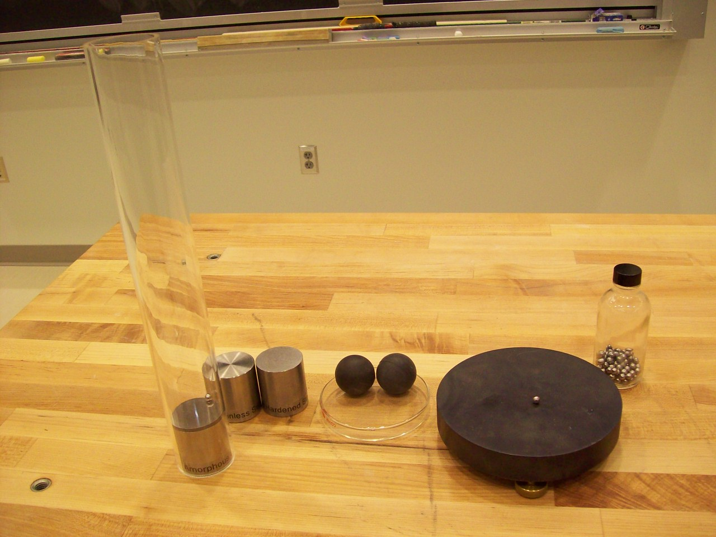
Location: Db1

MECHANICS | 1R50.18, 1R50.20 | PROPERTIES OF MATTER

Crystal Structure

Crystal Models
 | Show various crystal models; also show the elastic crystal model made of balls connected with springs.
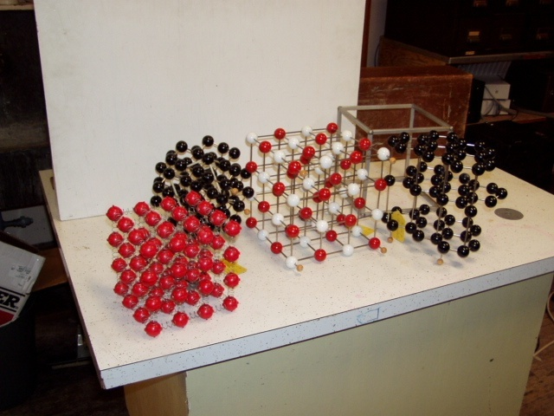
Location: Db3-6

MECHANICS | 1R50.40 | PROPERTIES OF MATTER
Crystal Structure

Faults in Crystal
 | One layer of BBs between two Lucite sides. Use on the overhead projector.

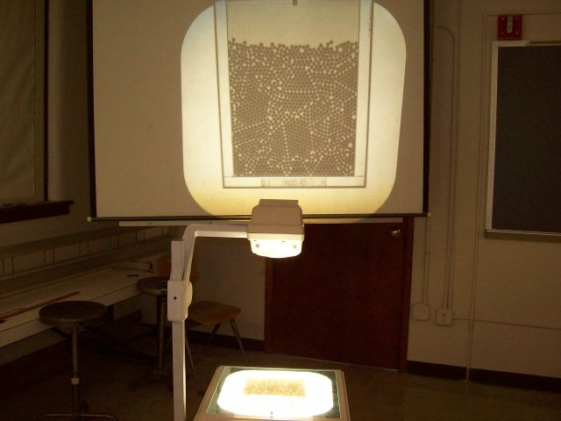
Location: Db1

