For the complete bibliography with references as well as an explanation of the classification scheme go to:
Demonstration Bibliography
The demonstration name listed in the bibliography is either the name listed on the reference or, if none is given, a simple descriptive name. In cases where there are several common names for a demonstration, the committee has chosen a preferred name.
The description is very brief. It is not intended to be a summary of the reference. One sentence is, in general, sufficient to describe the unique characteristics, if any, of an item. Each source has a unique numbering format. These unique formats are used identify references in the Bibliography.
The formats for the reference column and links to the sources are listed below:
Reference | Source
M-1 | Sutton
Ma-1 | Freier & Anderson
M-1d | Hilton
8-2.8 | Meiners
M-108 | Dick & Rae
1A 12.01 | University of Minnesota Handbook
AJP 52(1),85 | American Journal of Physics
TPT 15(5),300 | The Physics Teacher
Disc 01-01 | The Video Encyclopedia of Physics Demonstrations
PIRA 200 | Physics Instructional Resource Association
PIRA 500 | PIRA 500
PIRA 1000 | PIRA 1000

12/15/23

1
THERMAL PROPERTIES OF MATTER 5
Thermometry 5
Various Thermometers 5
Liquid Expansion 6
Thermal Expansion of Water 6
Solid Expansion 7
Bimetallic Strip 7
Ball and Ring 8
Expansion of a Tube 9
Sagging Wire 10
Properties of Materials at Low Temperatures 11
Lead Bell 11
Faith Bell 12
Smashing Rose and Tube 13
HEAT AND THE FIRST LAW 14
Heat Capacity and Specific Heat 14
Water and Aluminum on a Hot Plate 14
Metals in Water 15
Melting Wax 16
Convection 17
Convection Tube 17
Tea Bag Convection Levitation 18
Convection Cells or Rayleigh-Bernard Cell 19
Conduction 20
Conduction Rods 20
6 Conduction Rods 21
Conductivity of a Space Shuttle Tile 22
Matches on Hot Plates 23
Heat Propagation in a Copper Rod 24
Radiation 25
Light the Match 25
Reflection of Radiation 26
Infrared Spotlight 27
Leslie’s Cube 28
Selective Absorption and Transmission 29
Heat Transfer Applications 30
Four Thermos Bottles 30
Heating a Water Balloon 31
Mechanical Equivalent of Heat 32
Dropping Lead Shot 32
Smashing Balls 33
Hammer on Wood 34
Copper Barrel Crank 35
Heating by Bending 36
Heating by Friction 37
Cork Popper 38
Adiabatic Processes 39
Fire Syringe 39
Adiabatic Heating and Cooling 40
CHANGE OF STATE 41
PVT Surfaces 41
PVT Surfaces 41
Phase Changes: Liquid-Solid 42
Regelation 42
Freezing Liquid Nitrogen 43
Fire Extinguisher 44
Heat of Fusion of Water 45
Phase Changes: Liquid-Gas 46
Boiling by Cooling 46
Liquid Nitrogen in a Balloon 47
Heat of Vaporization of Water 48
Making Liquid Oxygen 49
Cooling by Evaporation 50
Freezing by Boiling 50
Drinking Bird 51
Dew Point and Humidity 52
Sling Psychrometer 52
Vapor Pressure 53
Pulse Glass 53
Sublimation 54
Sublimation of CO₂ 54
Blow up a Balloon with CO₂ 55
Phase Changes: Solid-Solid 56
Nitinol Wire 56
Critical Point 57
Critical Opalescence 57
Triple Point of Water Cell 58
KINETIC THEORY 59
Brownian Motion 59
Brownian Motion Cell 59
Mean Free Path 60
Crookes' Radiometer 60
Kinetic Motion 61
Molecular Motion Demonstrator 61
Air Table Molecules 62
Kinetic Theory Model 63
Molecular Dimensions 64
Oleic Acid Film 64
GAS LAW 65
Constant Pressure 65
Change of Volume with Change of Temperature 65
Balloon in LN2 66
Constant Temperature 67
Boyle’s Law Apparatus 67
Balloon in a Vacuum 68
Constant Volume 69
Constant Volume Bulb 69
ENTROPY AND THE SECOND LAW 70
Entropy 70
Time Reversal 70
Hilsch Tube 71
Heat Cycles 72
Hero’s Engine, Drinking Bird 72
Stirling Engine 73
Rubber Band Engine 74

THERMODYNAMICS | 4A10.10 | THERMAL PROPERTIES OF MATTER

Thermometry

Various Thermometers
 | Mercury, Gas, Resistance, Thermocouple, Bimetallic, IR and Galileo’s Thermometer, and the FLIR camera with an IR source are displayed.
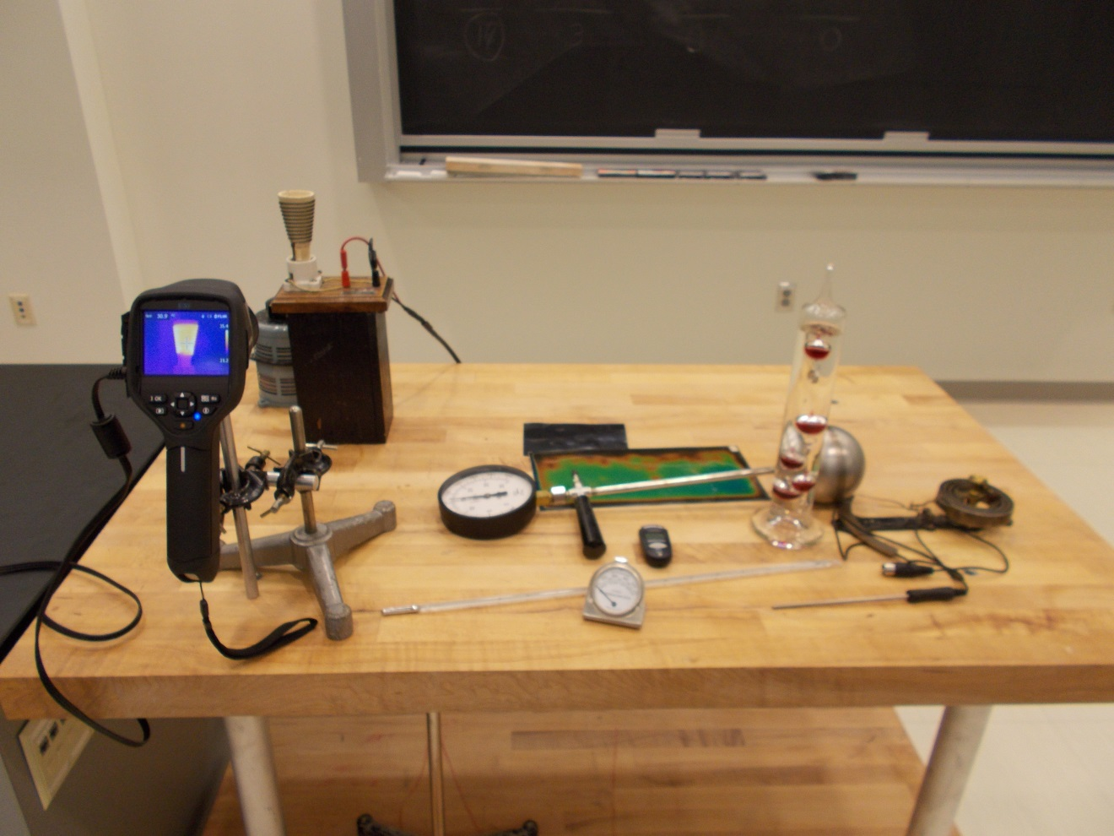Location: Fc1
THERMODYNAMICS | 4A20.10 | THERMAL PROPERTIES OF MATTER

Liquid Expansion

Thermal Expansion of Water
 | When heated with a flame, the meniscus drops before it rises because of the initial expansion of the glass.
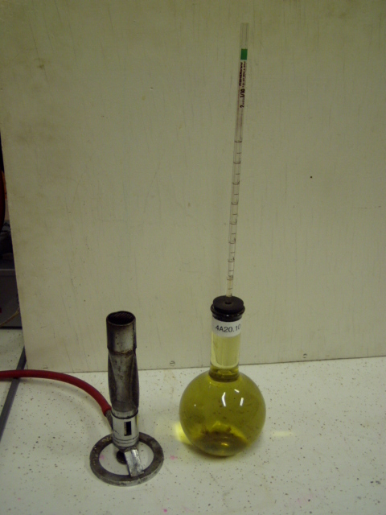
Location: Fd1
THERMODYNAMICS | 4A30.10 | THERMAL PROPERTIES OF MATTER

Solid Expansion

Bimetallic Strip
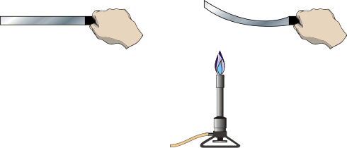 | Four bimetallic strips are made of copper/steel, brass/steel.  The coefficients of linear expansion are brass 19x10⁻⁶, copper 17x10⁻⁶ and steel 11x10⁻⁶, per degree Celcius.  When heated over a Bunsen burner, the strip curves toward the side with the smaller coefficient of thermal expansion. OR, when cooled in liquid nitrogen the strip curves the opposite direction.
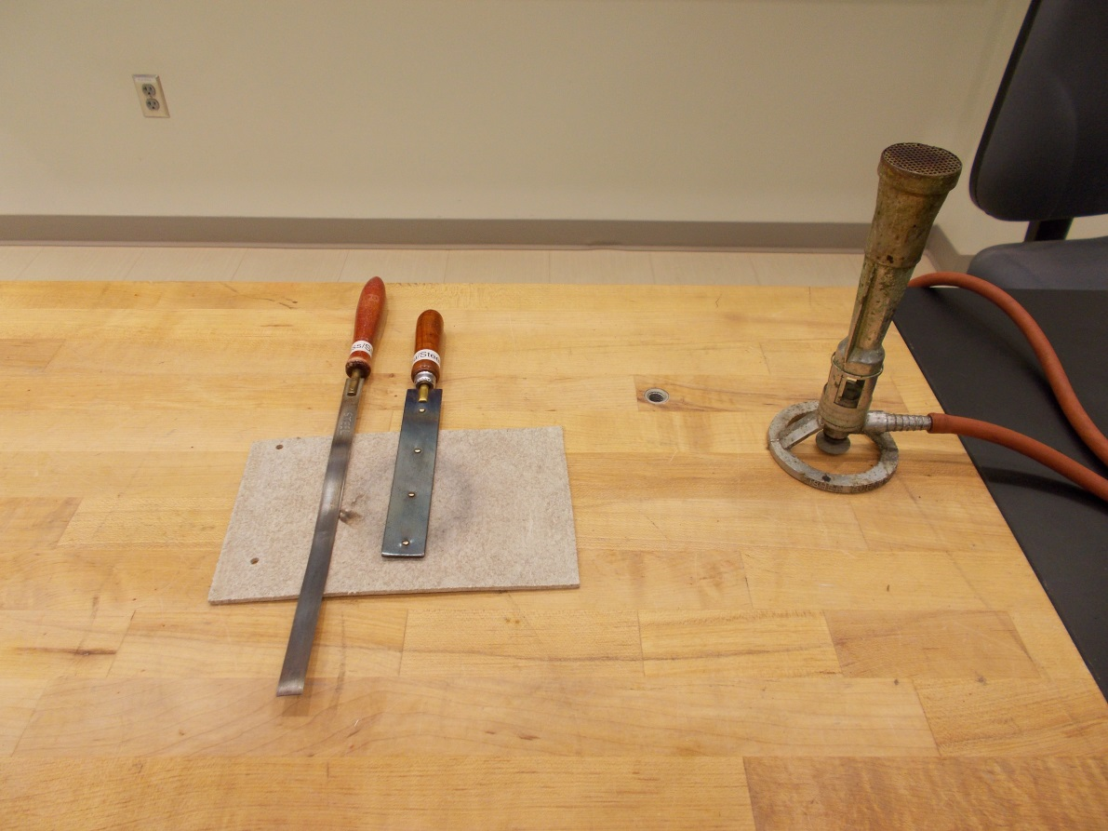
Location: Fc1

THERMODYNAMICS | 4A30.20 | THERMAL PROPERTIES OF MATTER
Solid Expansion

Ball and Ring
Disc 14-11
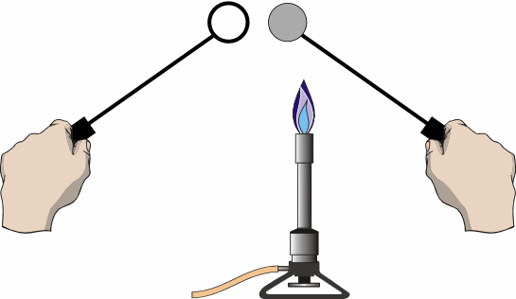 | Try putting the ring around the larger ball. At room temperature the ball is slightly larger the ring and will not pass through the ring.  Heat the ring over the Bunsen burner and try again.  The smaller ball will go through the ring when cold but won’t when heated  You may also cool the ball in liquid nitrogen. This takes several minutes.
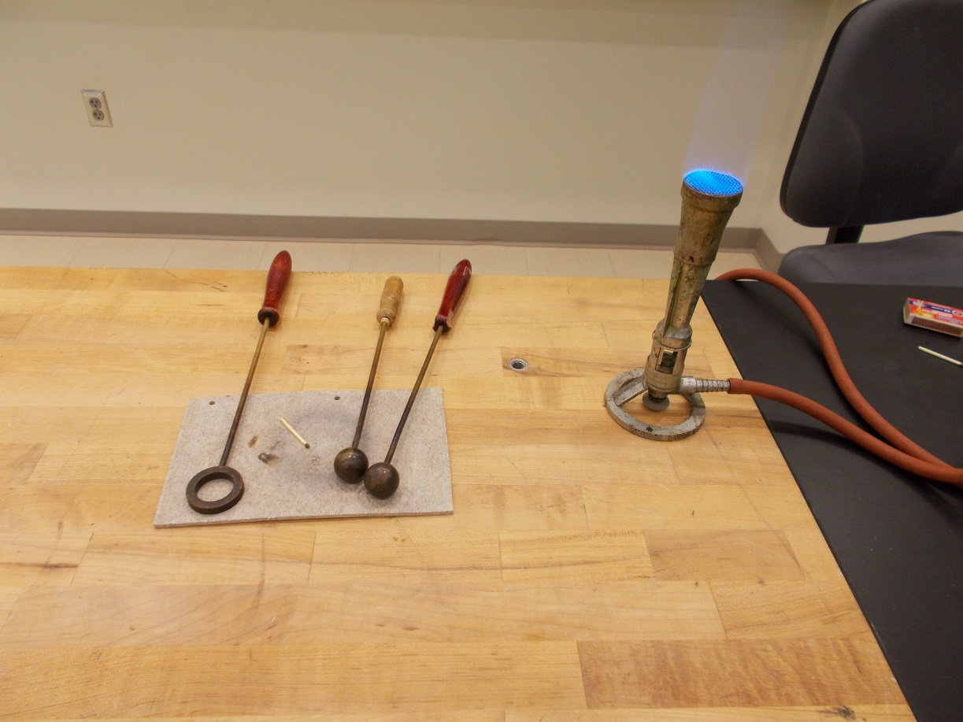
Location: Fc1

THERMODYNAMICS | 4A30.55 | THERMAL PROPERTIES OF MATTER
Solid Expansion

Expansion of a Tube
 | Steam is passed through tubes of various metals (Aluminum or Brass); one end of the tube rests on a pointer that shows the expansion. The diameter of the pointer is 0.237 cm. The length the rod expands is πdθ/360, where d is the pointer diameter and θ is the angular deflection. Use a 200 g mass on the end of the rod to make the frictional force between the pointer and rod greater, minimizing slippage.
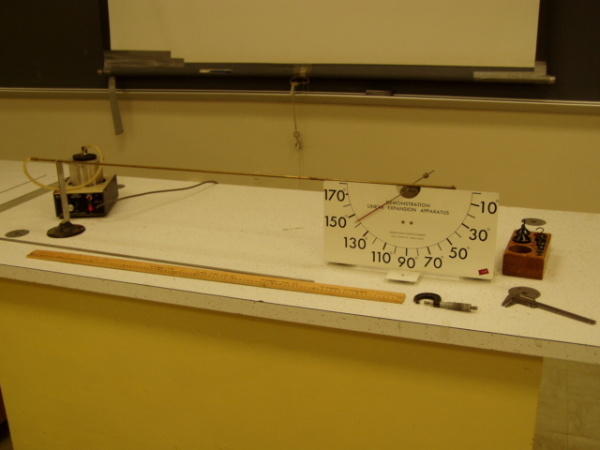Location: Fc3
THERMODYNAMICS | 4A30.60 | THERMAL PROPERTIES OF MATTER
Solid Expansion

Sagging Wire
 | Heat a length of nichrome wire electrically and watch it sag (no more than 60 V or it will melt in two). Use paper tabs to make the wire’s position more visible.
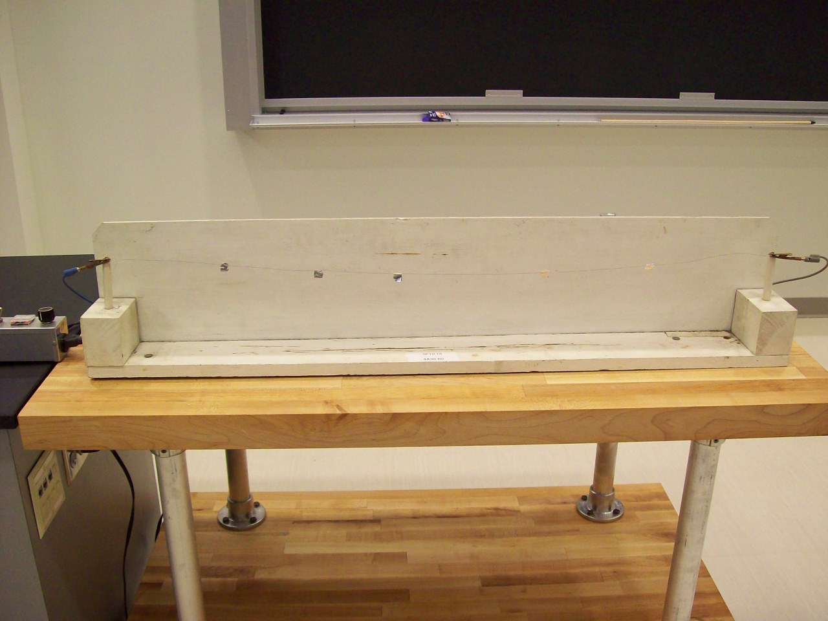
Location: Fc4
THERMODYNAMICS | 4A40.10 | THERMAL PROPERTIES OF MATTER

Properties of Materials at Low Temperatures

Lead Bell
 | Ring a lead bell before and after cooling in liquid nitrogen. One can also make a spring out of solder (use a 10 g mass for the spring).
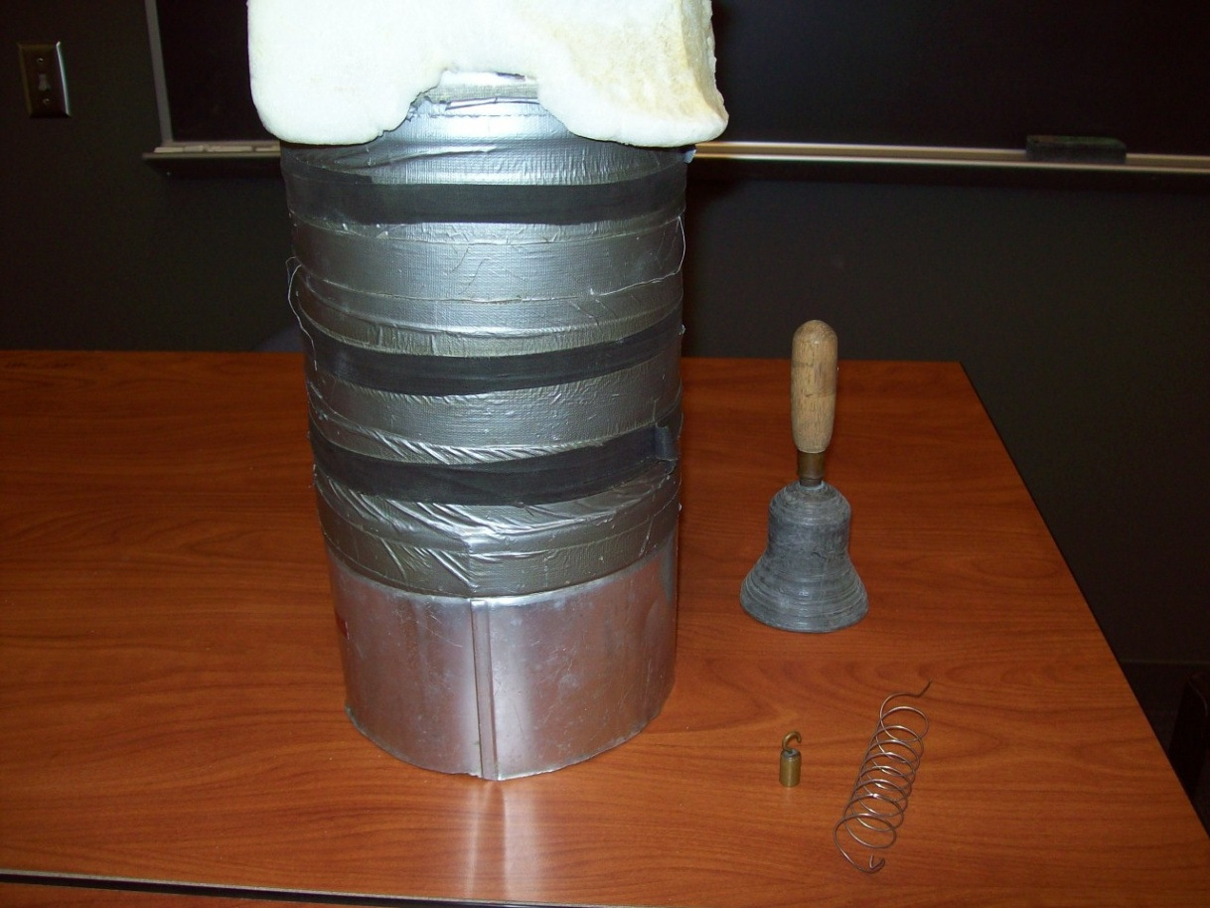
Location: Fc2, Ga2

THERMODYNAMICS | 4A40.12 | THERMAL PROPERTIES OF MATTER
Properties of Materials at Low Temperatures

Faith Bell
A bell makes a dull sound when struck. Heat the bell with an alcohol lamp and it rings clearly. The bell is made from an alloy that has a temperature dependent vibrational damping. Pour about 5 ml of ethanol from a graduated cylinder into the pot and light it. It takes about 2 minutes to work. The lid is used to put out the flame when done.
Use care around the open flame. Do not fill from the bulk container, and do not have the bulk container near the demonstration

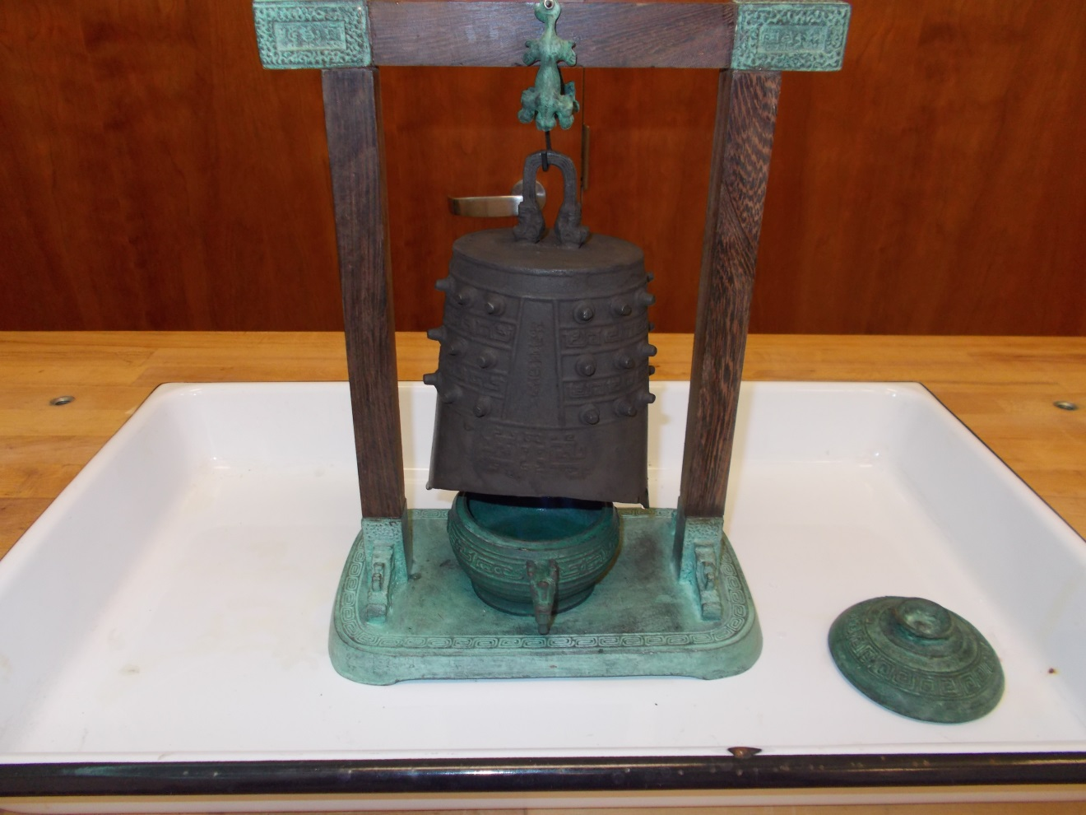
Location: Fc2
THERMODYNAMICS | 4A40.30 | THERMAL PROPERTIES OF MATTER
Properties of Materials at Low Temperatures

Smashing Rose and Tube
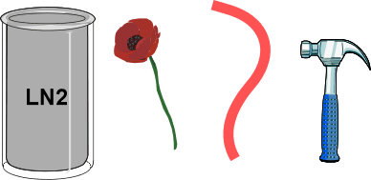 | Pour LN2 into the beaker.  Put the end of the rubber hose into the nitrogen. When the bubbling subsides, take it out and break it with a hammer.  Put the flower or some lettuce into the liquid nitrogen. When frozen, crumble it with your hand.
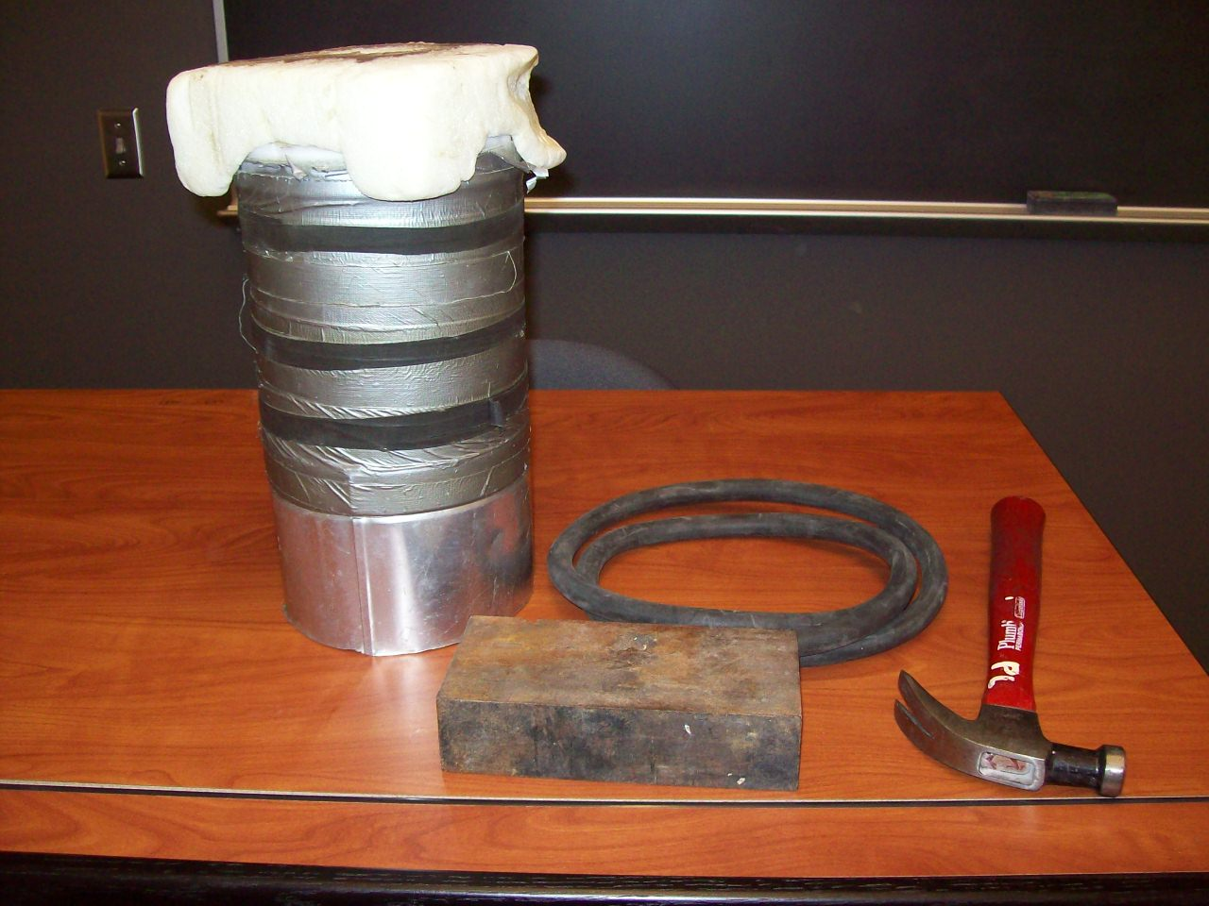Location: Fc2, Ga2
THERMODYNAMICS | 4B10.10 | HEAT AND THE FIRST LAW

Heat Capacity and Specific Heat

Water and Aluminum on a Hot Plate
 | Put 750 g of water in one beaker and a 750 g block of aluminum in another. Place both on a hot plate and monitor the temperature rise with Science Workshop. Wet the bottom of the aluminum block to be sure it makes good thermal contact with the bottom of the beaker. Use a clamp to hold the thermometer in the water away from the bottom of the beaker. Capstone file: Specific Heat.cap.
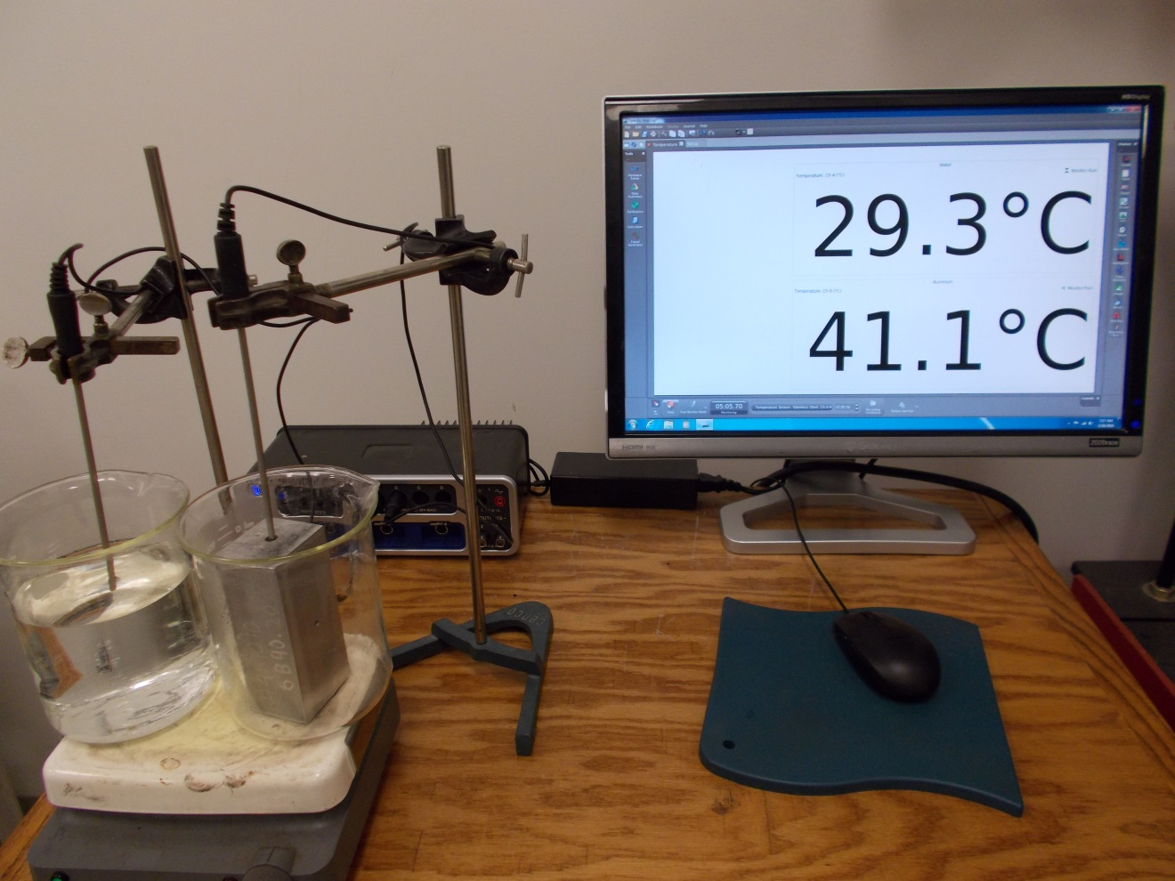Location: Science Workshop Cabinet, Fc5
THERMODYNAMICS | 4B10.28 | HEAT AND THE FIRST LAW
Heat Capacity and Specific Heat

Metals in Water
 | Heat a 32 gram slug of tin and copper in boiling water. Then dunk them each in a separate plastic cup filled with 200 grams of water and watch the temperature rise with an IR camera. Tin: c = 0.054 kcal/kg • °C; Copper: c = .092 kcal/kg • °C. (We also have slugs of steel, zinc, aluminum and lead of the same mass).
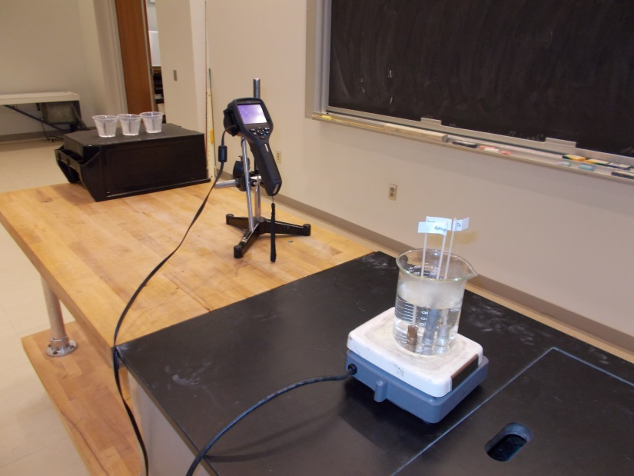
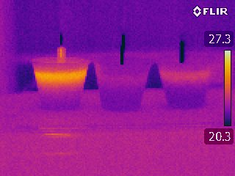
Location: Science Workshop Cabinet, Fc5
THERMODYNAMICS | 4B10.30 | HEAT AND THE FIRST LAW
Heat Capacity and Specific Heat

Melting Wax
 | Heat a 32 gram rod of aluminum, tin and copper in boiling water. Then drop them into a test tube filled to the same level with room temperature wax. Observe which metal melts down through the wax the furthest and the least. Tin: c = 0.054 kcal/kg • °C; Copper: c = 0.092 kcal/kg • °C; Aluminum: c = 0.215 kcal/kg • °C. (We also have slugs of steel, zinc and lead of the same mass).
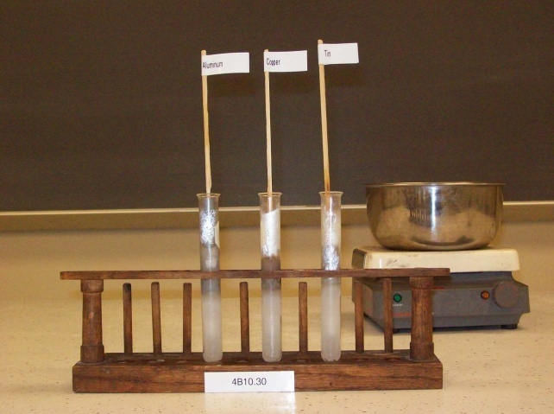
Location: Fc5

THERMODYNAMICS | 4B20.10, 4B20.20 | HEAT AND THE FIRST LAW

Convection

Convection Tube
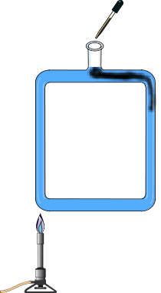 | A square tube is filled with water. Light the Bunsen burner and place under one side. Using the eye dropper, drop several drops of ink into the top hole. The ink shows the direction of fluid flow. Move the burner to the other side of the tube to reverse the flow. Shown in the Photograph are the versions we usually do.
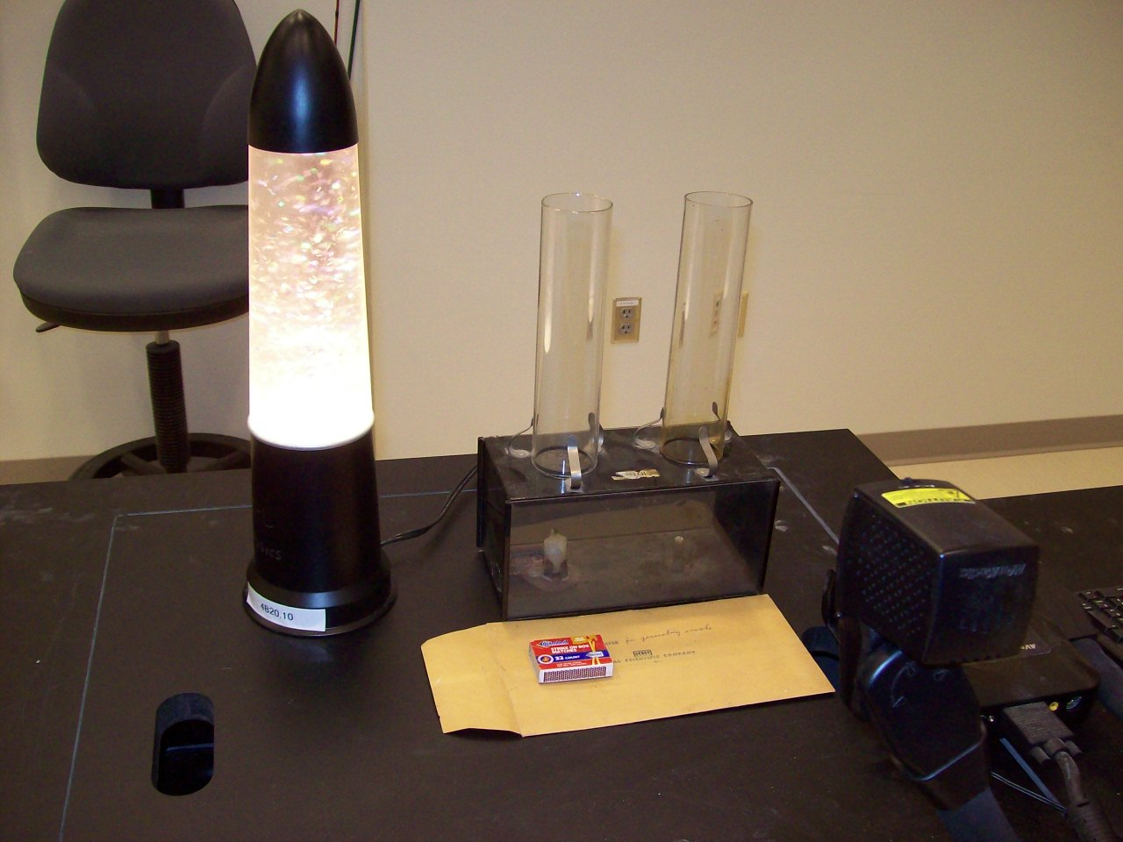Location: Fc5

THERMODYNAMICS | 4B20.35 | HEAT AND THE FIRST LAW
Convection

Tea Bag Convection Levitation
 | An emptied tea bag is formed into cylinder and balanced on one end. The upper end is lit with a match. As the bag burns, convection drives air upward above it and when the bag burns to the bottom, the bag will rise up off the table and go surprisingly high.
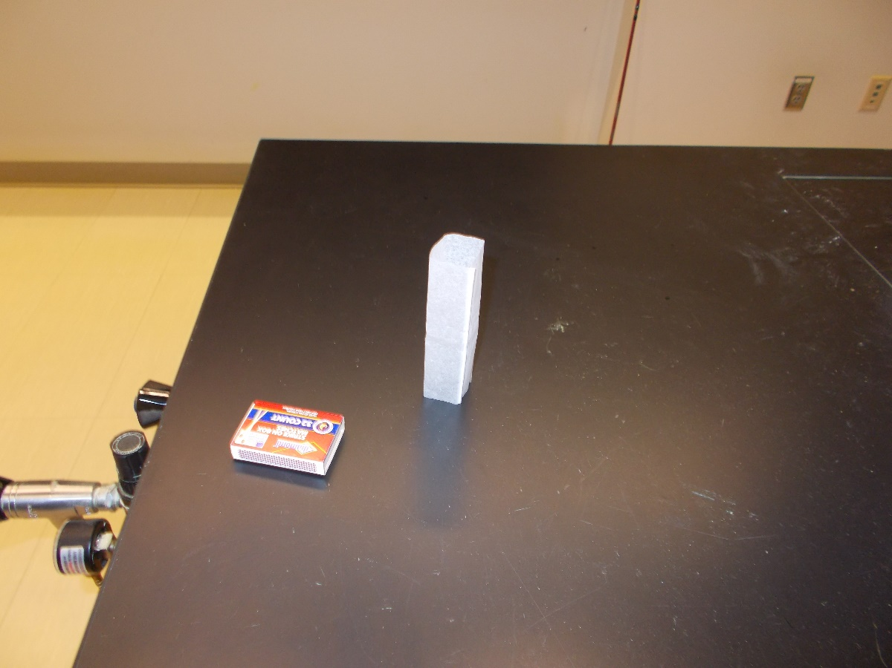
Location: Fc5

THERMODYNAMICS | 4B20.50 | HEAT AND THE FIRST LAW
Convection

Convection Cells or Rayleigh-Bernard Cell
Place the frying pan on the hot plate. Turn the hot plate to between 350 and 400 on the temperature dial. Pour in the oil/aluminum powder mixture to a depth of about a cm. CAUTION: The oil does not have to be very hot to give good convection cells. If the temperature is too high the oil may ignite.
Once the cells have formed they will appear very stable. You can use a spoon to disturb the cell structure and watch its reformation. Use both a video and FLIR camera.

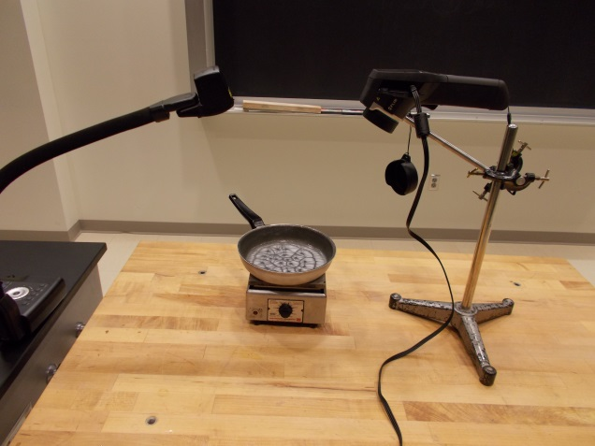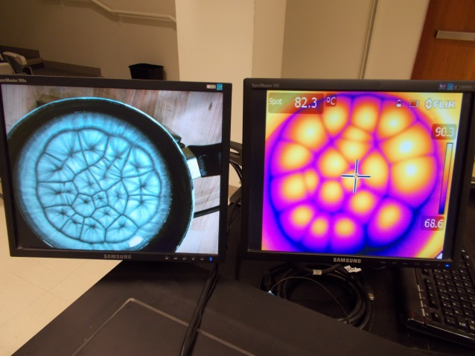
Location: La4

THERMODYNAMICS | 4B30.21 | HEAT AND THE FIRST LAW

Conduction

Conduction Rods
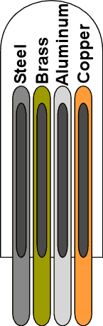 | Four rods with liquid crystal thermometers are placed in hot water to show different conduction rates.
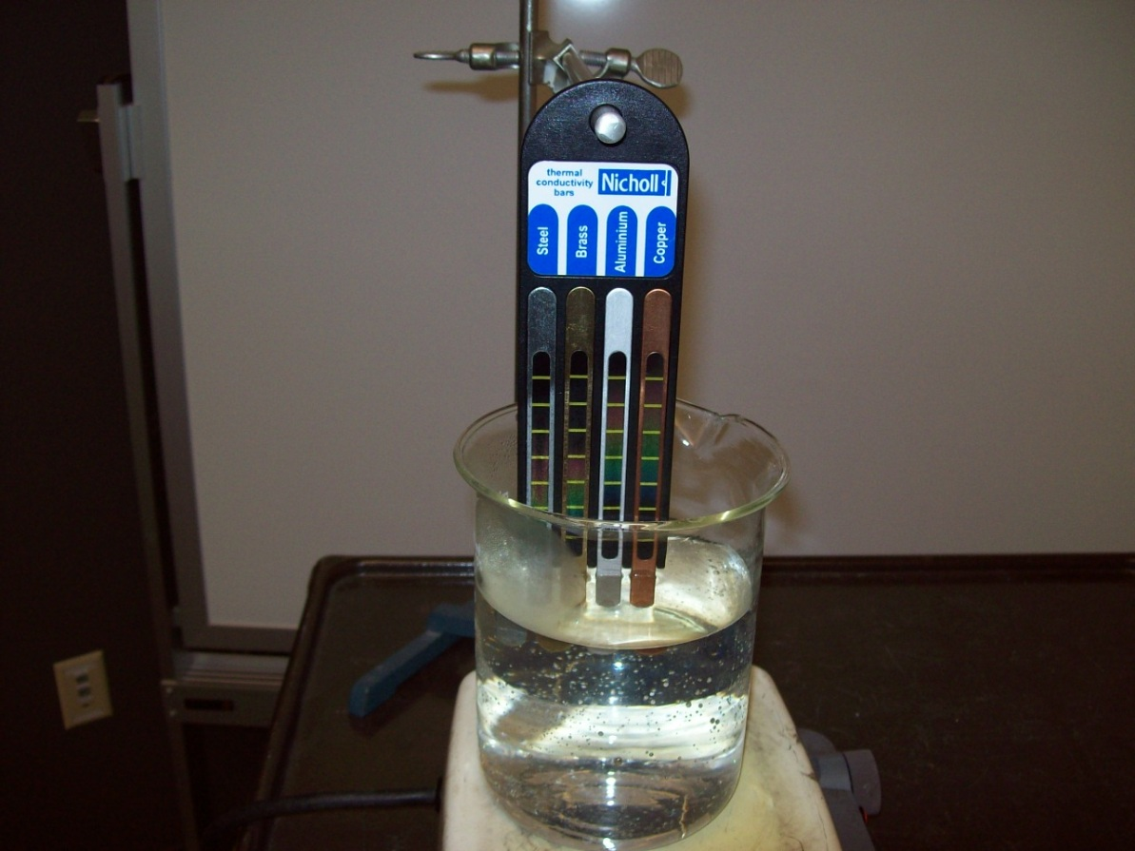Location: Fc6, Gb2

THERMODYNAMICS | 4B30.25 | HEAT AND THE FIRST LAW
Conduction

6 Conduction Rods
 | 6 rods (copper, aluminum, zinc, brass, steel wood) each have a nail mounted to the top with some wax. The bottoms of the rods are immersed in nearly boiling water, the FLIR camera shows the change in temperature along the various rods as heat is conducted up through them
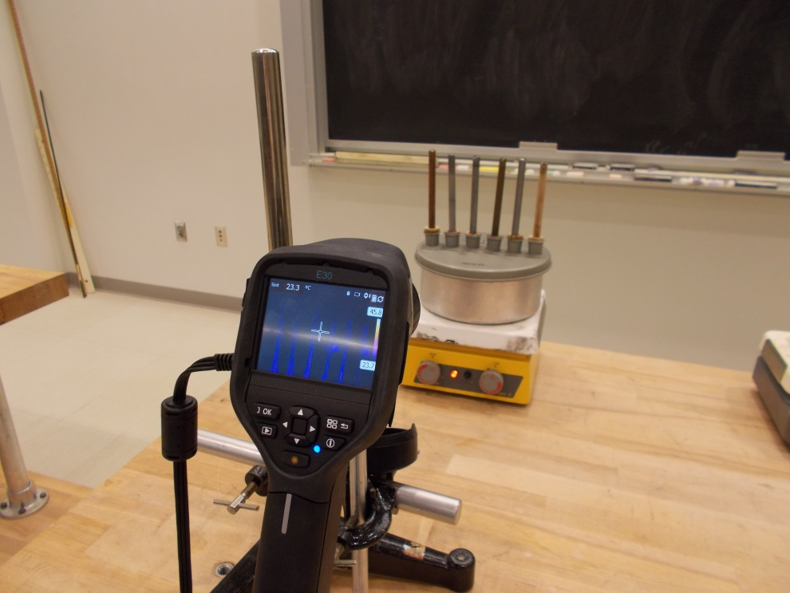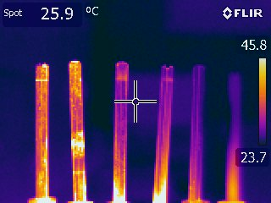
Location: Fc6
THERMODYNAMICS | 4B30.33 | HEAT AND THE FIRST LAW
Conduction

Conductivity of a Space Shuttle Tile
 | A space shuttle tile (white side down) is placed over a burner. After 5 minutes you can touch the center of the black side with no discomfort. Use the FLIR camera to show how cool it is comparted to the heated side.

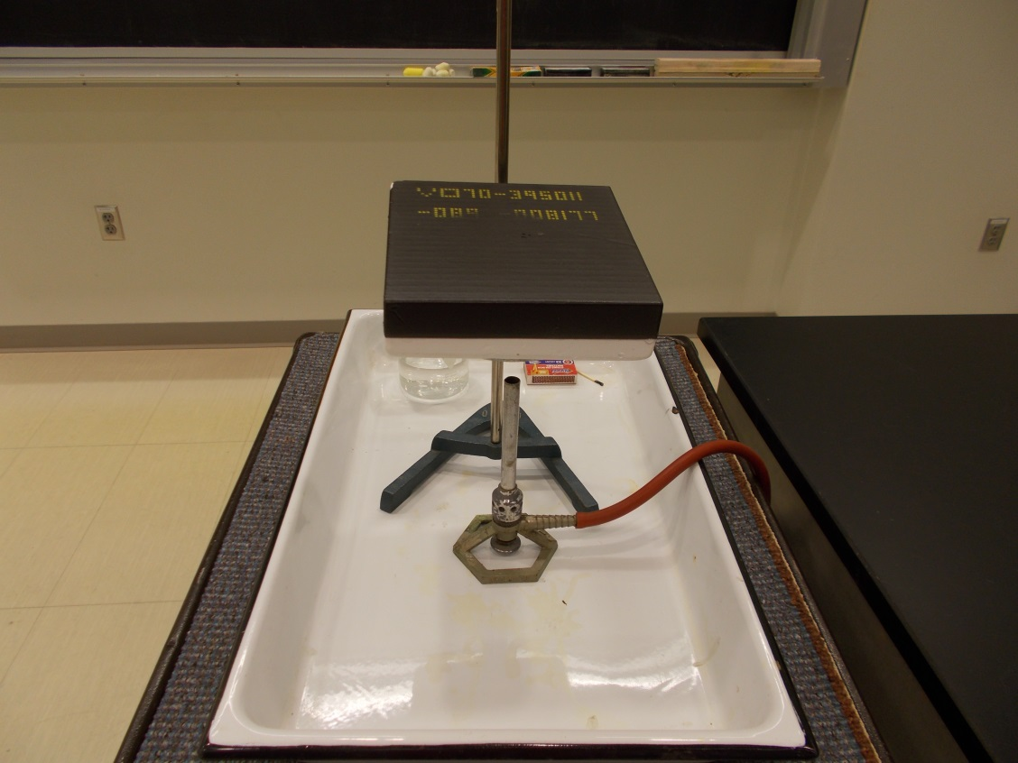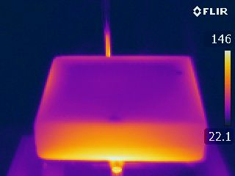
Location: Fc6

THERMODYNAMICS | 4B30.42 | HEAT AND THE FIRST LAW
Conduction

Matches on Hot Plates
 | Matches are placed on two different plates (asbestos tile and aluminum) over identical burners. Which match ignites first?
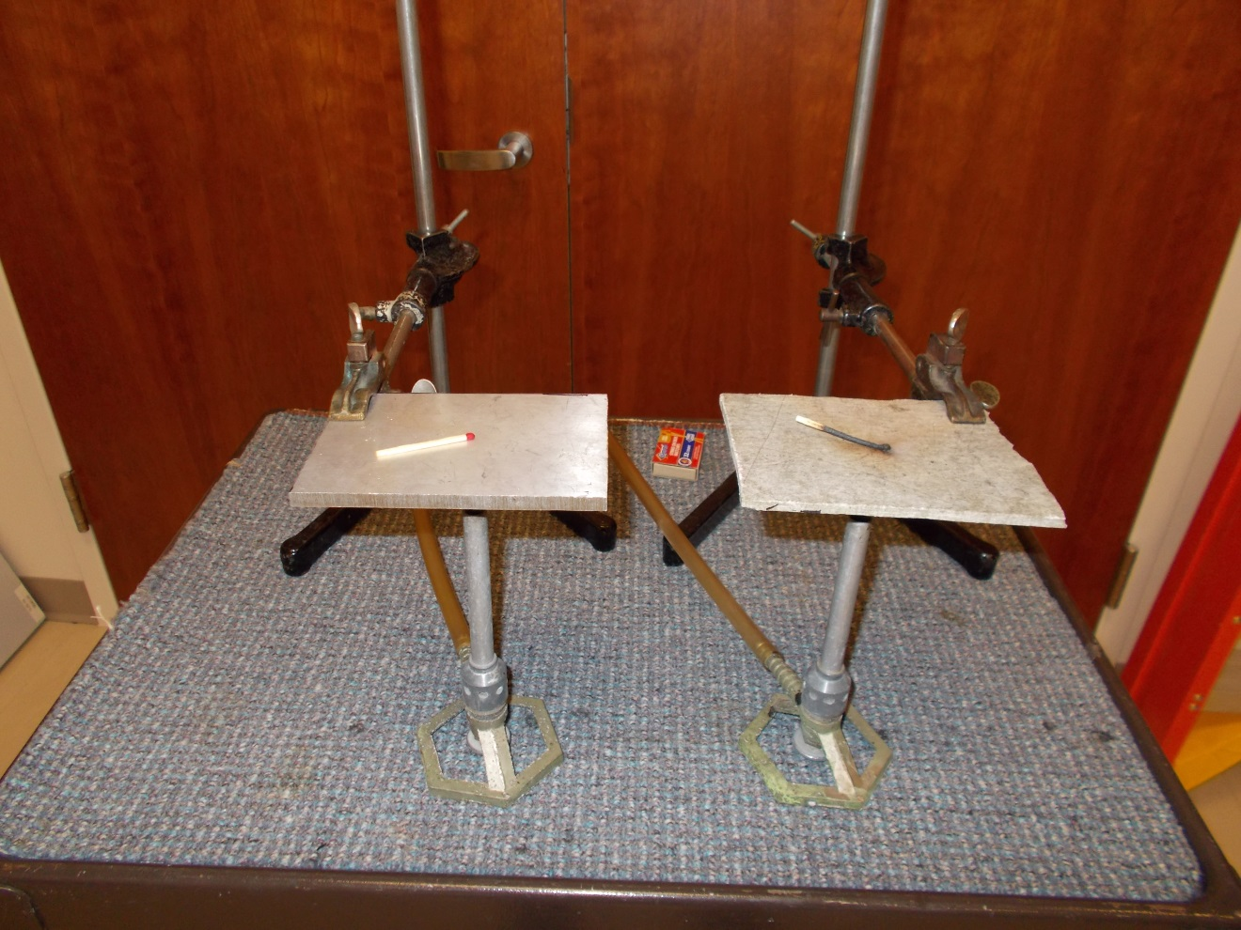
Location: Fc6
THERMODYNAMICS | 4B30.50 | HEAT AND THE FIRST LAW
Conduction

Heat Propagation in a Copper Rod
 | One end of a copper rod is heated with a burner and the rod is observed with the FLIR camera.
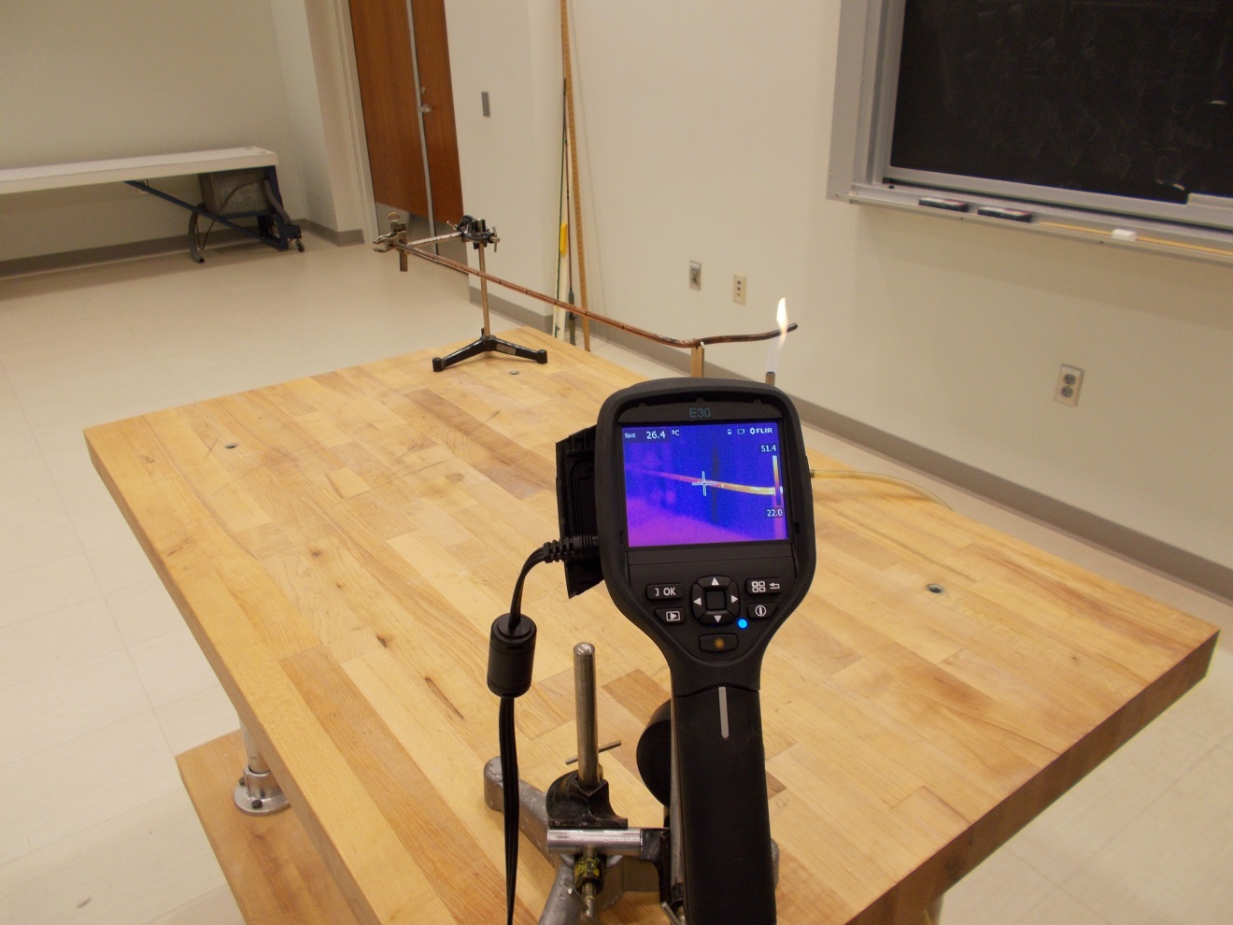Location: Fc6
THERMODYNAMICS | 4B40.10 | HEAT AND THE FIRST LAW

Radiation

Light the Match
Disc 22-04
Two reflectors are set a meter apart. One contains a heater controlled by a Variac. The other has a match at the focal point of the reflector. The reflectors have an f number of 0.38.
Turn the Variac all the way up and wait.
The match will light in about 1 minute. If it takes longer, something is wrong. Alignment is critical (it helps to do the alignment in a darkened room)! Use the FLIR camera to show the match temperature.

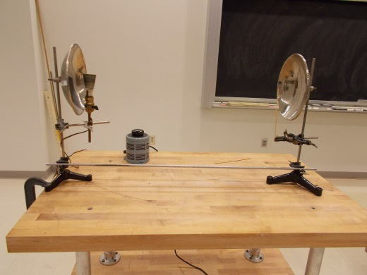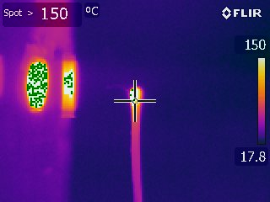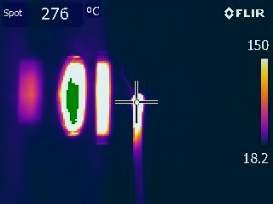
Location: Fc7

THERMODYNAMICS | 4B40.13 | HEAT AND THE FIRST LAW
Radiation

Reflection of Radiation
 | Show your reflected IR image in the blackboard using the FLIR camera.
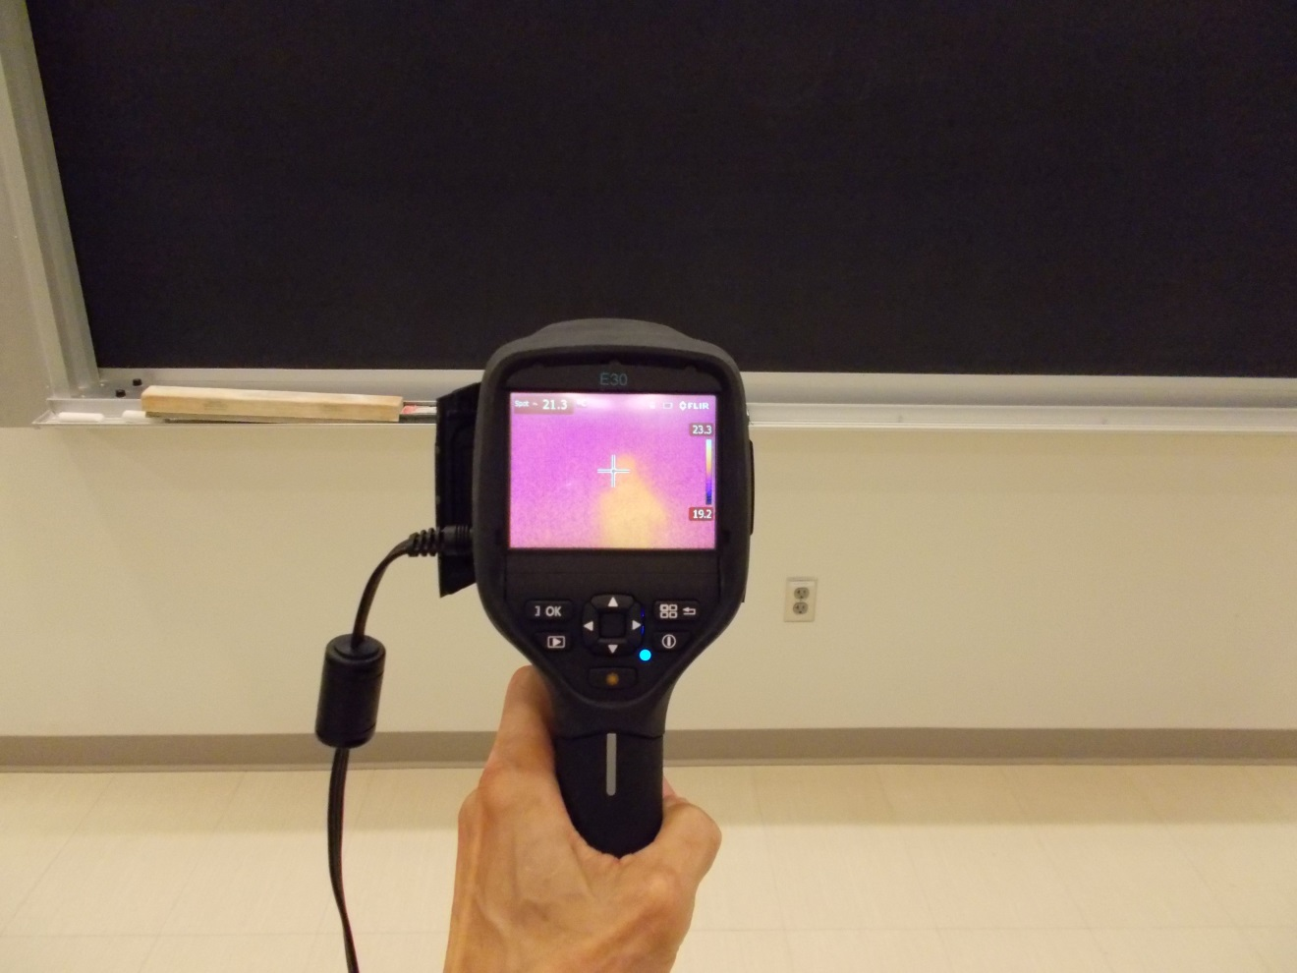Location: FLIR cabinet

THERMODYNAMICS | 4B40.20 | HEAT AND THE FIRST LAW
Radiation

Infrared Spotlight
 | A radiant heater with a parabolic reflector is aimed at the blackboard and the illuminated area is observed with the FLIR camera. Be careful to avoid the direct reflection.
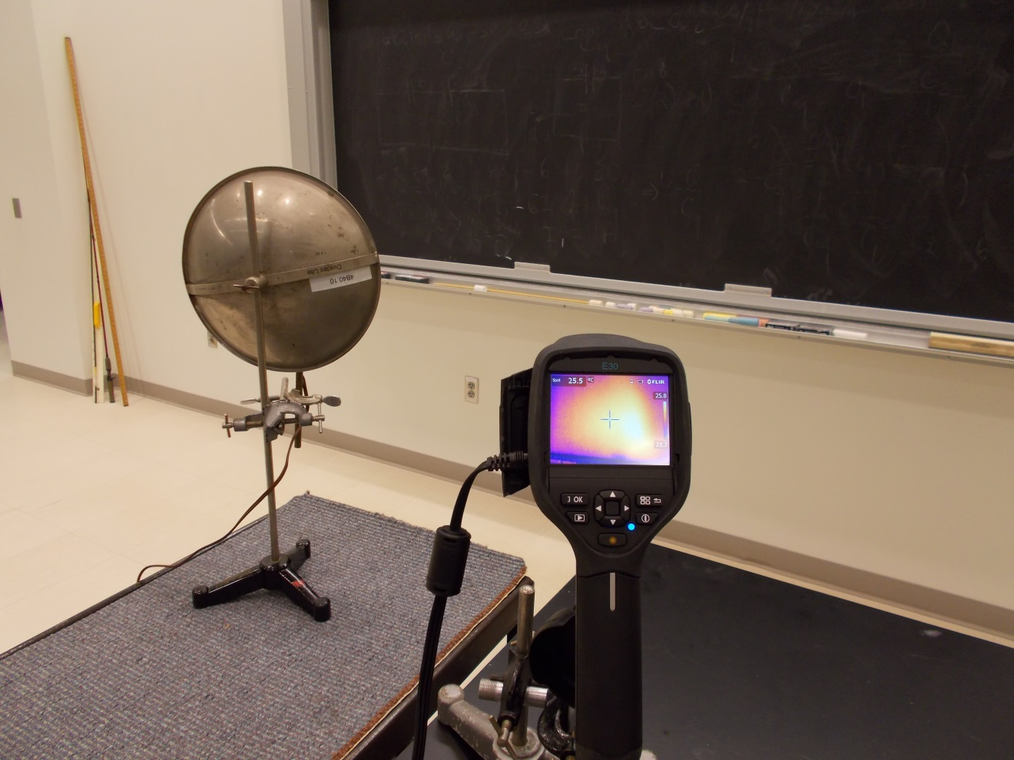Location: Fc7, FLIR cabinet

THERMODYNAMICS | 4B40.32 | HEAT AND THE FIRST LAW
Radiation

Leslie’s Cube
 | Fill the cube with hot water and observe with the FLIR camera. Rotate the cube to demonstrate Lambert’s Law. The white surface may surprise you as its IR emissivity is about the same as the black surface.
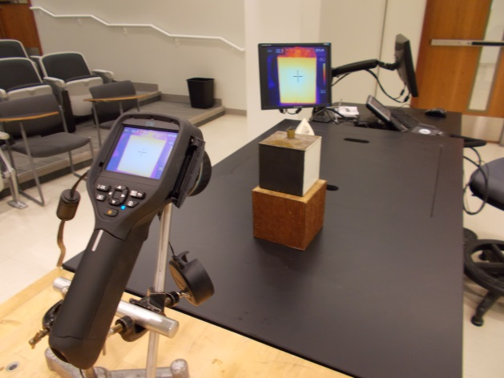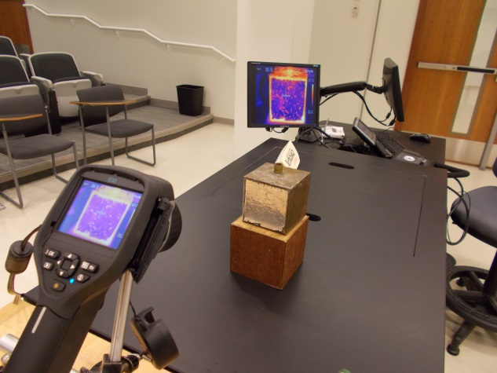Location: Fc6, FLIR cabinet

THERMODYNAMICS | 4B40.50 | HEAT AND THE FIRST LAW
Radiation

Selective Absorption and Transmission
 | Use the FLIR camera to try to see through a clear plastic sheet Repeat looking through a folded trash bag..
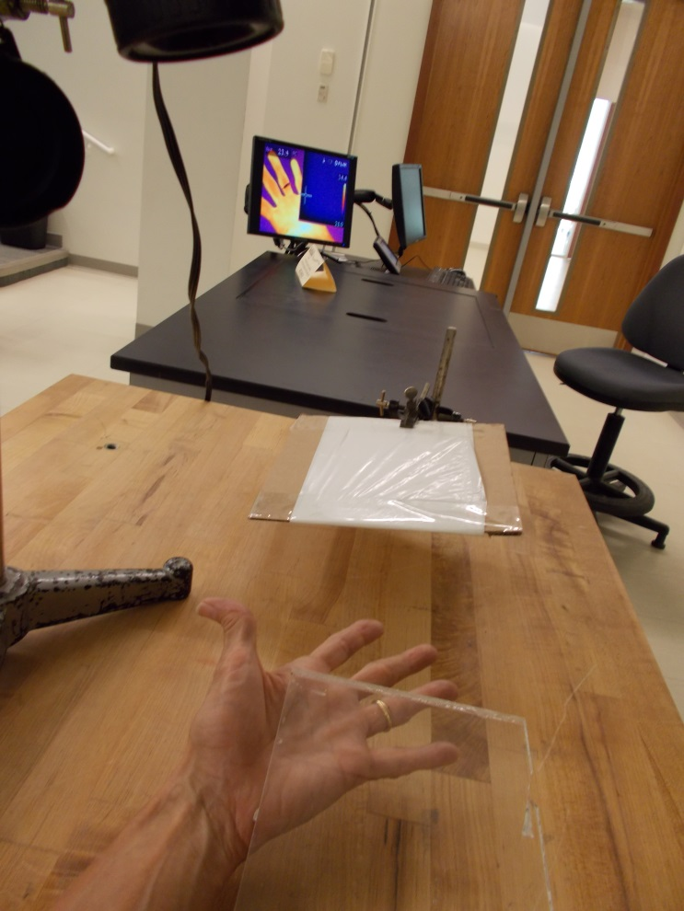
Location: Fc6, FLIR cabinet

THERMODYNAMICS | 4B50.10 | HEAT AND THE FIRST LAW

Heat Transfer Applications

Four Thermos Bottles
 | The four bottles are: silvered with a vacuum; silvered without a vacuum; unsilvered with a vacuum, and unsilvered without a vacuum. Fill them with hot water (250 ml each) and monitor the temperature of each. Use Science Workshop file “Four Thermos.ds” (it only plots 3 of the temperatures at a time). Observe with FLIR camera.
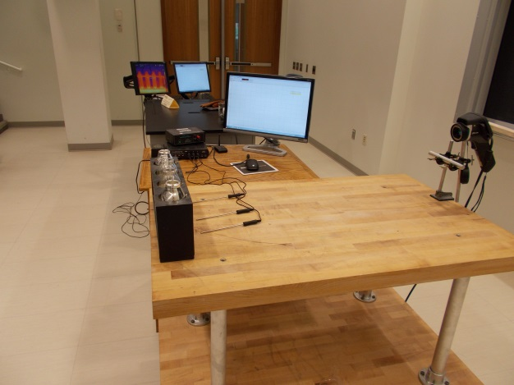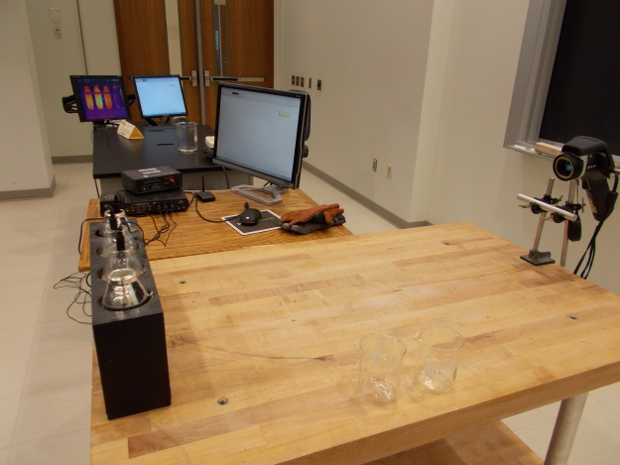
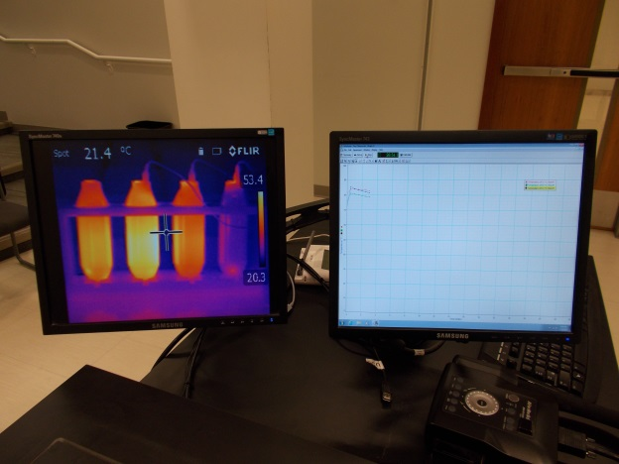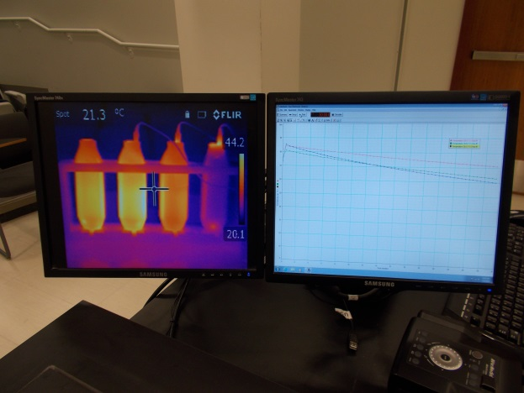
Location: Science Workshop Cabinet, Fc1, Gb2, FLIR cabinet
THERMODYNAMICS | 4B50.25 | HEAT AND THE FIRST LAW
Heat Transfer Applications

Heating a Water Balloon
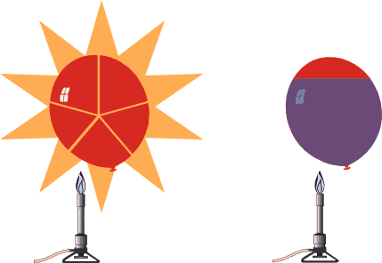 | A balloon filled with water will not pop like a similar balloon filled with air.
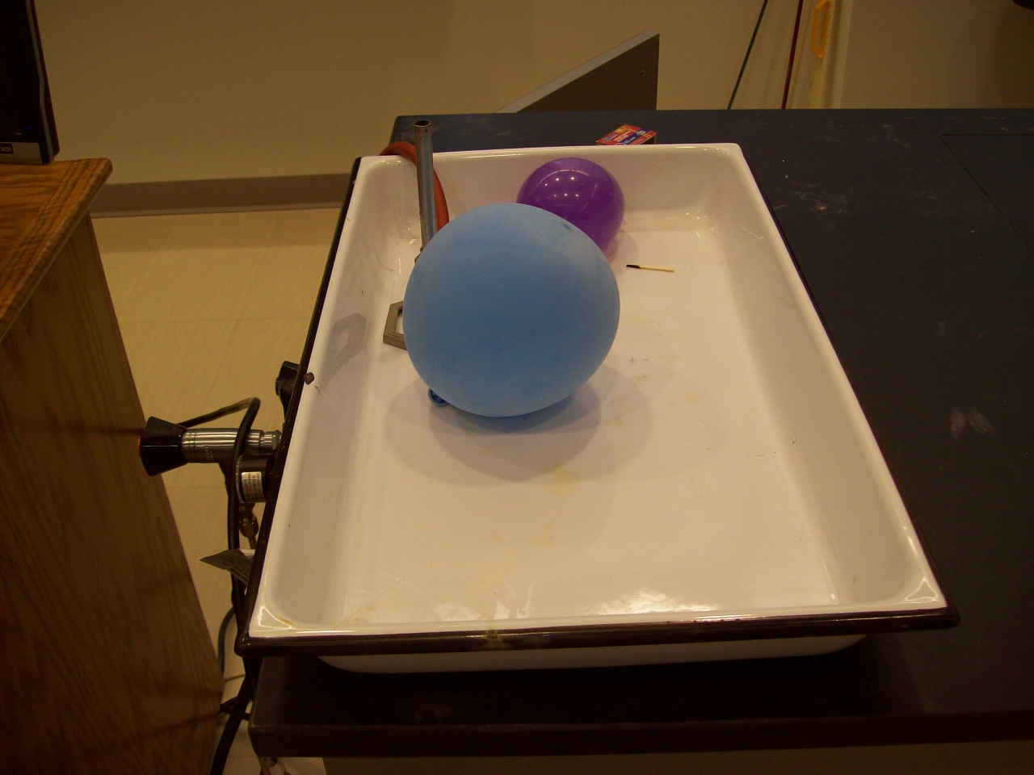Location: Gb1
THERMODYNAMICS | 4B60.11 | HEAT AND THE FIRST LAW

Mechanical Equivalent of Heat

Dropping Lead Shot
Disc 15-02
 | Shown in the photograph is a version with a thermistor connected to a computer using the Capstone file “Mechanical Equivalent of Heat”. The tube is 0.9 m long and contains 0.144 kg copper shot (0.09 kcal/kg • °C). Be sure to give the apparatus time to equilibrate with the environment and adjust the temperature scale.
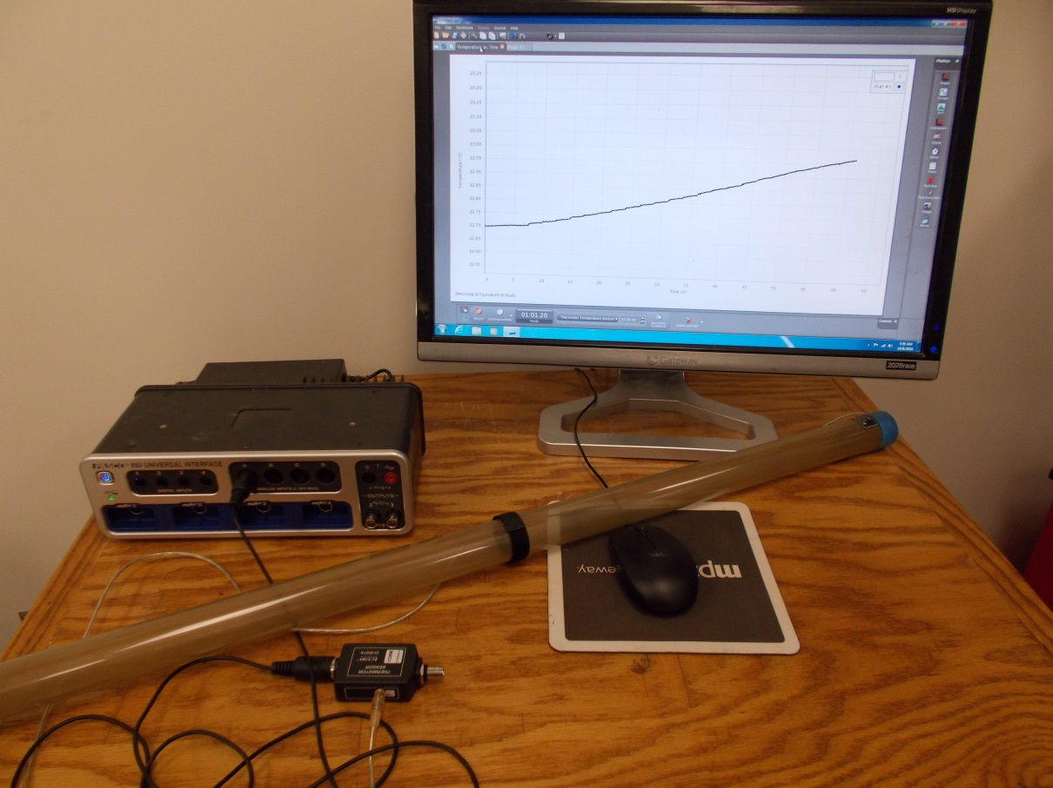
Location: Fd3

THERMODYNAMICS | 4B60.14 | HEAT AND THE FIRST LAW
Mechanical Equivalent of Heat

Smashing Balls
 | Bang two large ball bearings together with a piece of paper between them. The paper will smolder. Designate a “sniffer” from the audience to verify. Pass around the paper to let people see the charring around the hole caused by the smashing balls.
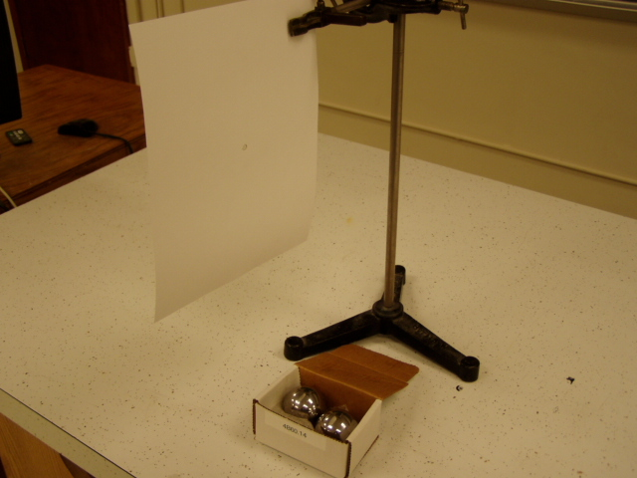Location: Fd4

THERMODYNAMICS | 4B60.15 | HEAT AND THE FIRST LAW
Mechanical Equivalent of Heat

Hammer on Wood
 | Hit a block of wood with a hammer and observe it with the FLIR camera. Also, Place happy-unhappy balls under the wood and see which one heats up the most.
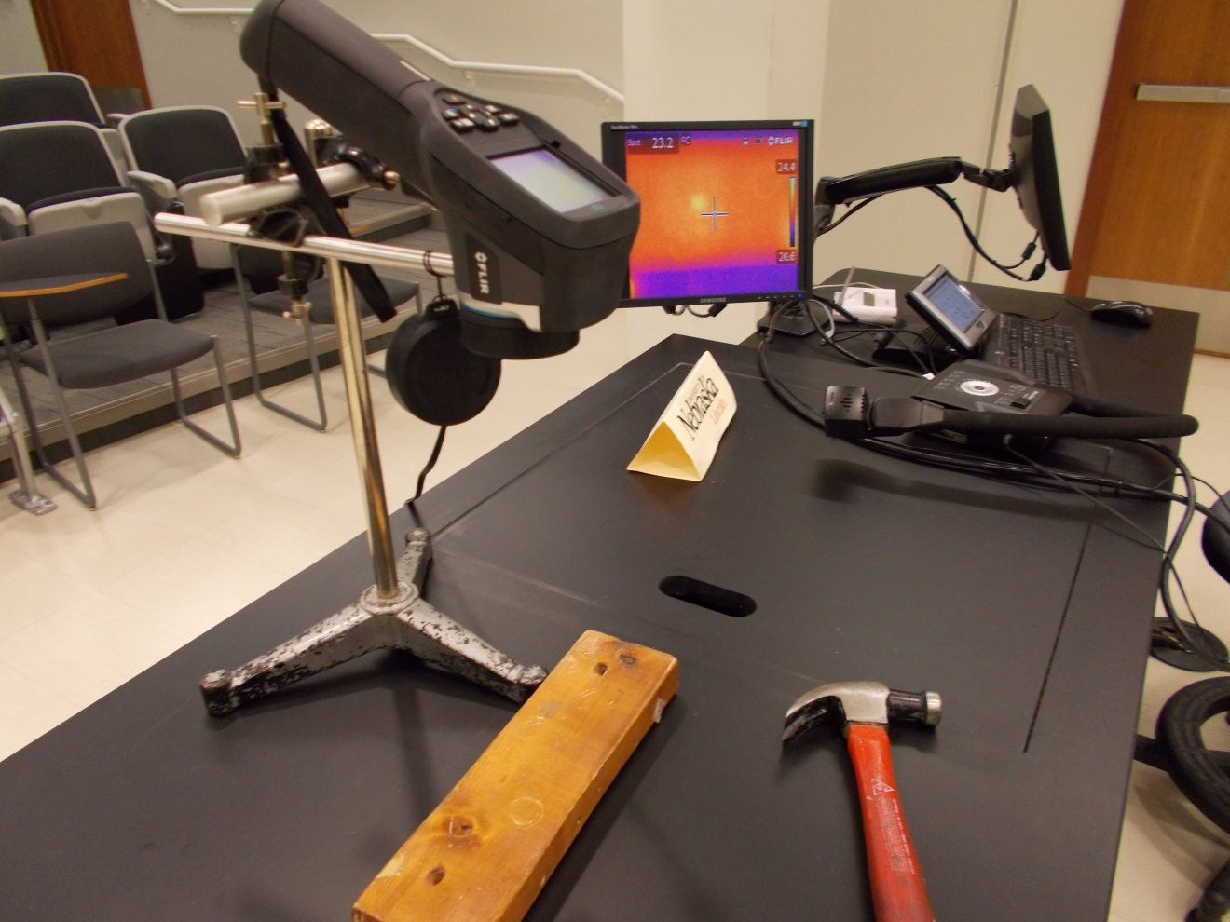Location: FLIR camera cabinet

THERMODYNAMICS | 4B60.20 | HEAT AND THE FIRST LAW
Mechanical Equivalent of Heat

Copper Barrel Crank
 | A heavy weight hangs from a cord that is wrapped around a copper calorimeter (mass 282 grams, diameter 3.16 cm). The number of wrappings is just enough so that as the crank is turned the belayed part of the cord goes slack and the weight doesn’t rise. As the frictional torque does work against the cord, the temperature of the calorimeter’s drum rises and is measured by a thermometer.
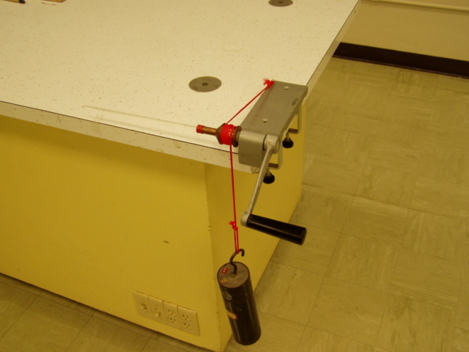Location: Fd4

THERMODYNAMICS | 4B60.41 | HEAT AND THE FIRST LAW
Mechanical Equivalent of Heat

Heating by Bending
 | A lead strip is observed with the FLIR camera and then observed again after flexing the strip a few times. Set the camera to manual so the temperature scale stays fixed.
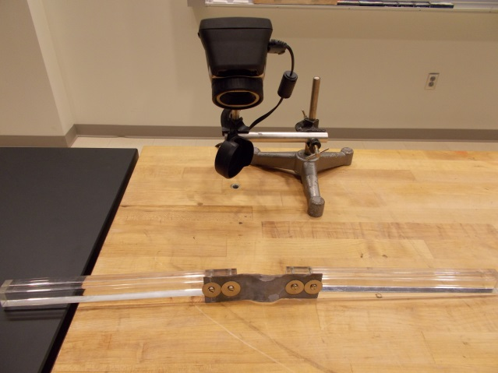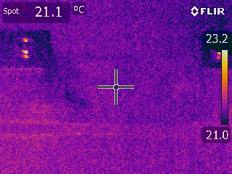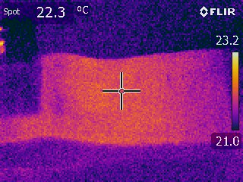
Location: Fd3

THERMODYNAMICS | 4B60.55 | HEAT AND THE FIRST LAW
Mechanical Equivalent of Heat

Heating by Friction
 | Drag a friction block across a surface and watch it heat with the FLIR camera.
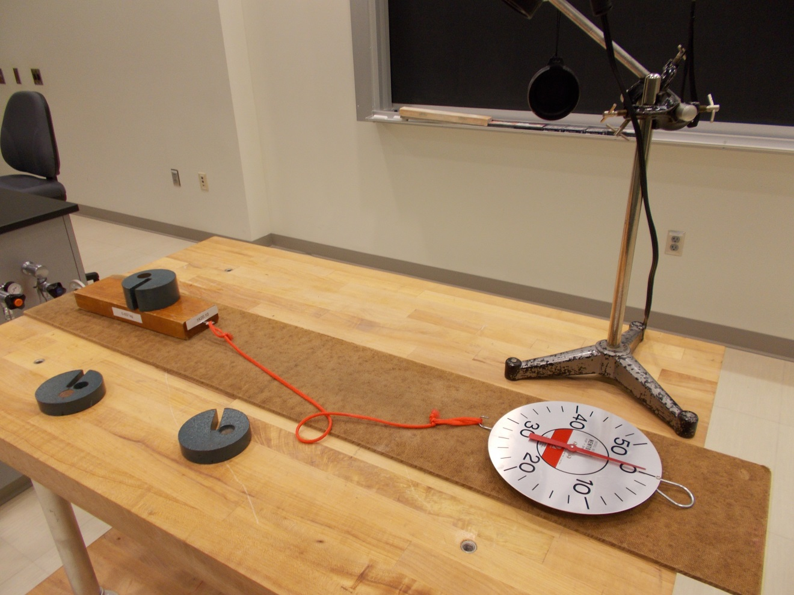
Location: Ca1, Ca3, FLIR cabinet

THERMODYNAMICS | 4B60.70 | HEAT AND THE FIRST LAW
Mechanical Equivalent of Heat

Cork Popper
 | Pour about 3 ml of water into the tube that has been chucked up in an electric drill. Put a stopper on the end of the tube and squeeze the tube with the wooden jaws while the drill is turning. As friction heats up the tube, the water will boil and pop the stopper.
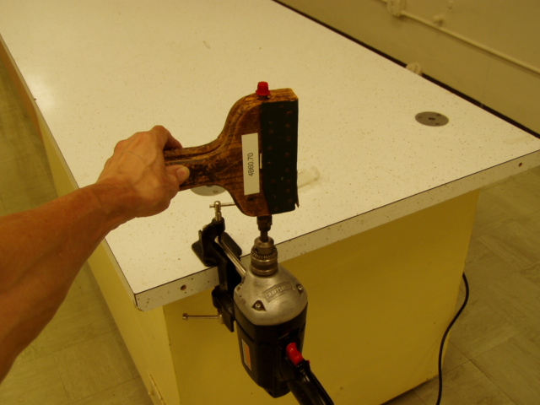Location: Fd4
THERMODYNAMICS | 4B70.10 | HEAT AND THE FIRST LAW

Adiabatic Processes

Fire Syringe
Place a bit of cotton in the tube. Replace the piston and strike it. The cotton will ignite.
Cotton ignites at 235 degrees C.

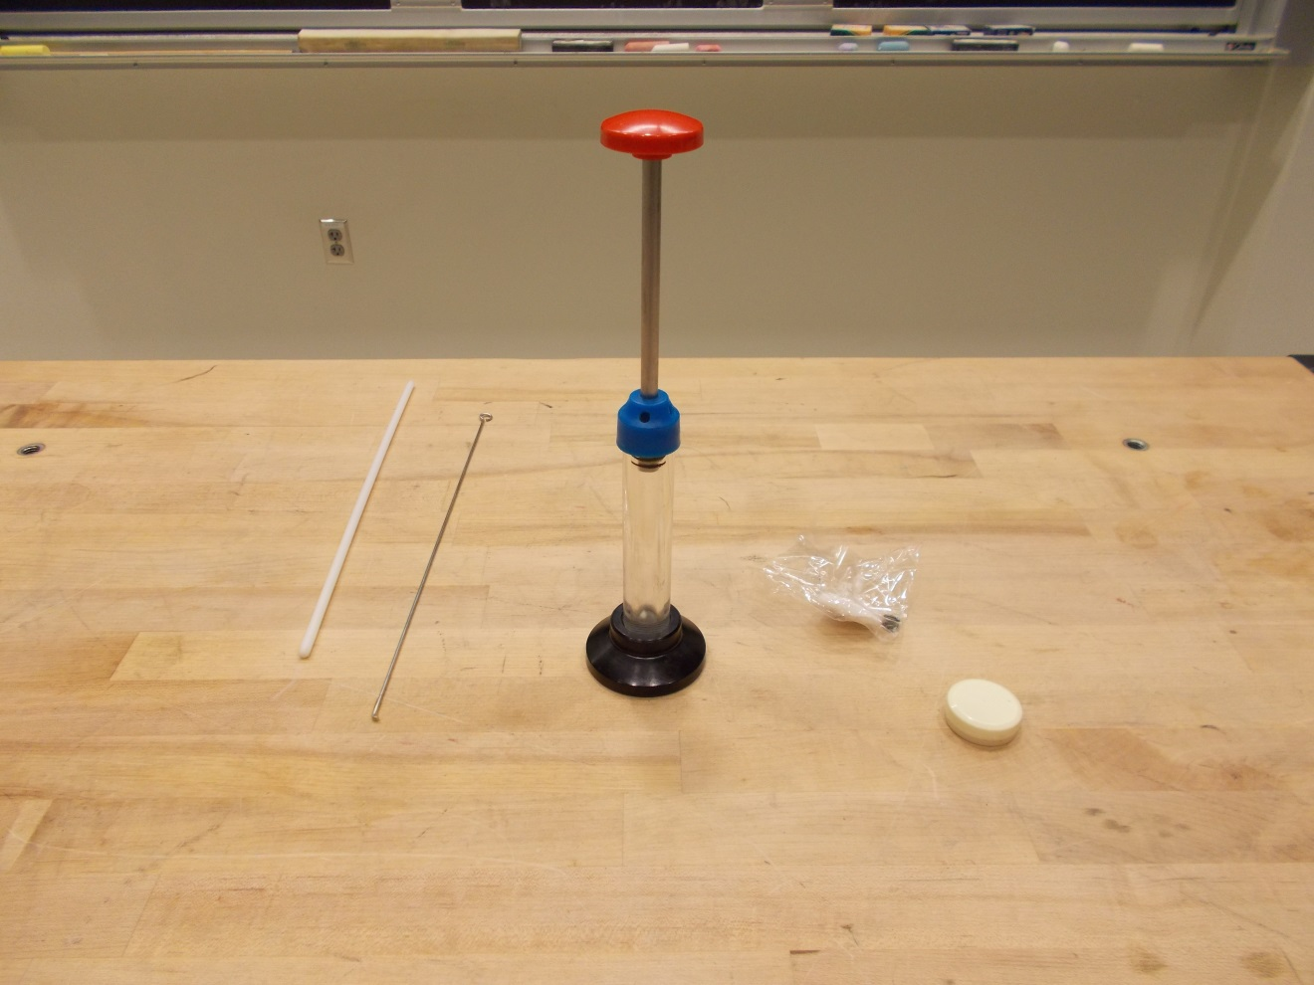Location: Fd4
THERMODYNAMICS | 4B70.30 | HEAT AND THE FIRST LAW
Adiabatic Processes

Adiabatic Heating and Cooling
The Adiabatic Gas Law Apparatus is used with the Capstone software to show variations in temperature, Pressure and volume as the piston is moved. The Capstone file is: “Adiabatic Gas Law”.
If the piston is moved quickly, the process is adiabatic; if it is moved slowly it is more nearly isothermal. Data collection is triggered by volume starting at 245 cc and ending at 110 cc.

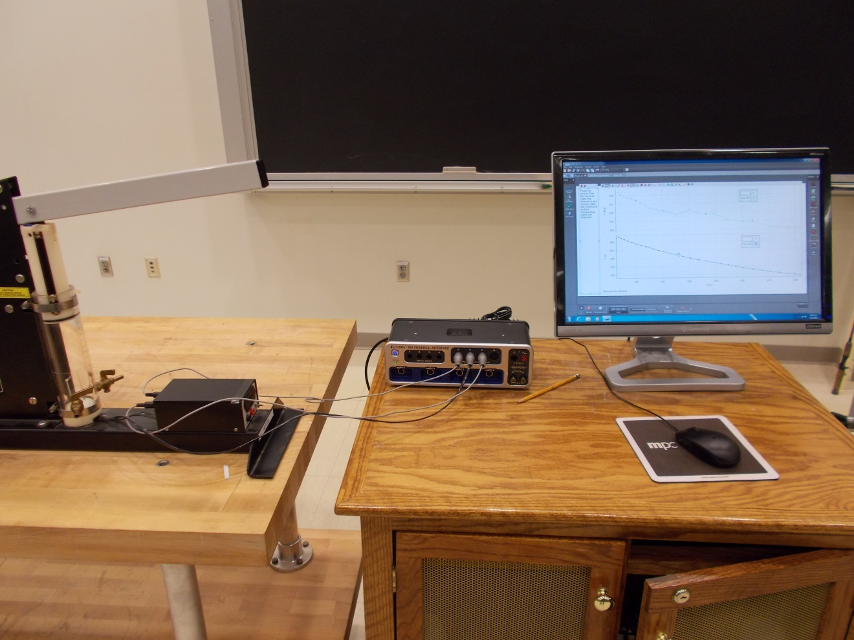Location: Science Workshop, Ga7
THERMODYNAMICS | 4C10.10 | CHANGE OF STATE

PVT Surfaces

PVT Surfaces
 | Three dimensional models of the PVT curve are shown for different substances.
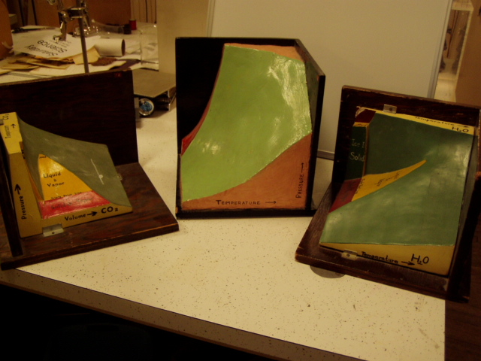Location: Fd5
THERMODYNAMICS | 4C20.30 | CHANGE OF STATE

Phase Changes: Liquid-Solid

Regelation
 | Cut through a block of ice with a wire (0.5 mm, stainless steel) loop that has a heavy weight (mass: 20.5 kg) hanging from it. It takes about 1 hour and 45 minutes for the wire to cut all the way through. The explanation for this is not as simple as you might think. See TPT 3(7), 301.
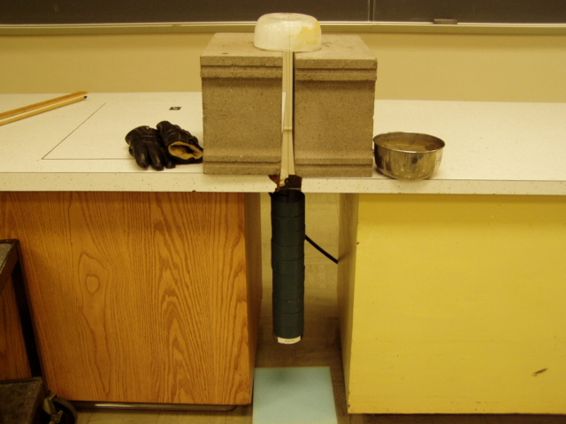Location: Ga1
THERMODYNAMICS | 4C20.40 | CHANGE OF STATE
Phase Changes: Liquid-Solid

Freezing Liquid Nitrogen
 | Put some liquid nitrogen into a clear Dewar and place it under a bell jar. Pump on it until it freezes. Crack the release valve and it will instantly liquefy again while the temperature remains below the boiling point.
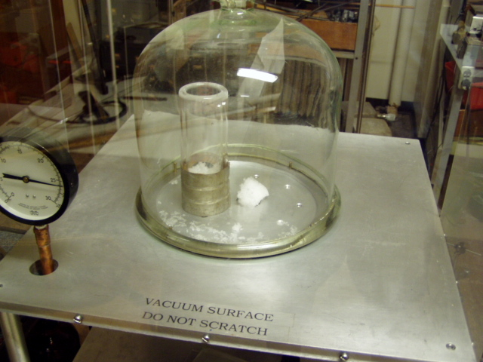Location: Ga2
THERMODYNAMICS | 4C20.45 | CHANGE OF STATE
Phase Changes: Liquid-Solid

Fire Extinguisher
 | Shoot off a CO₂ fire extinguisher.
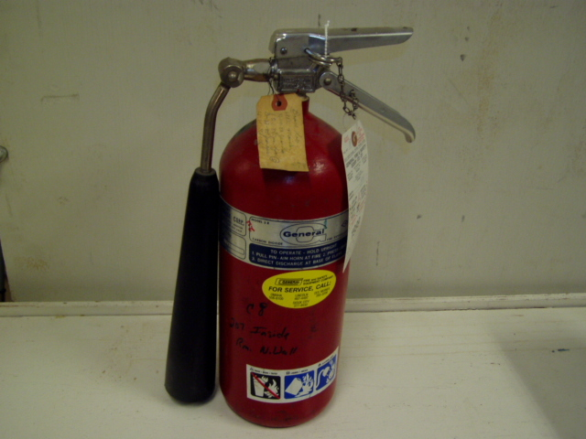Location: Ga1
THERMODYNAMICS | 4C20.50 | CHANGE OF STATE
Phase Changes: Liquid-Solid

Heat of Fusion of Water
 | Monitor the temperature of ice water as it is heated on a hot plate to boiling. The temperature vs. time plot is shown using Capstone file: melting ice.cap.
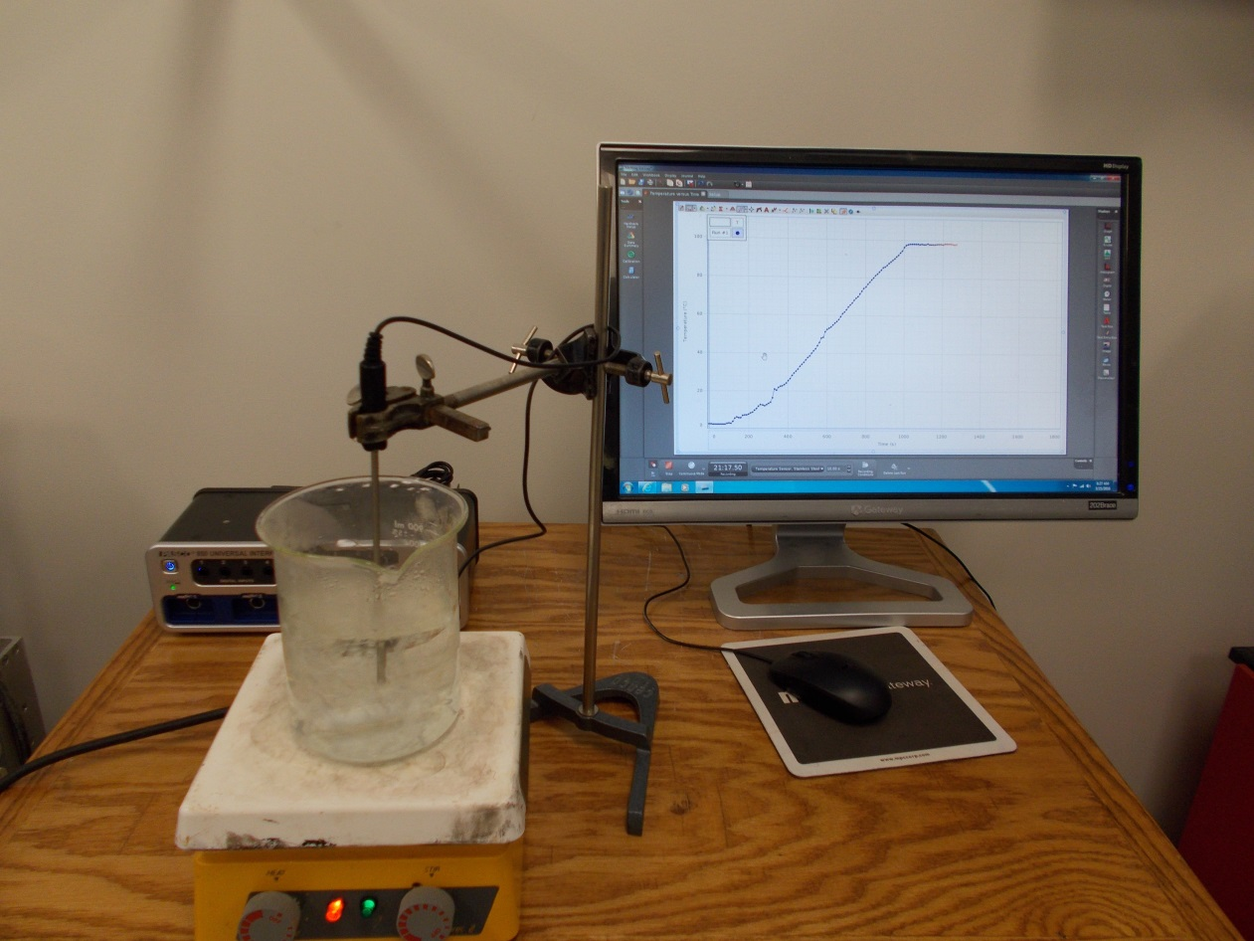
Location: Science Workshop Cabinet, Fc1, Gb2
THERMODYNAMICS | 4C30.10 | CHANGE OF STATE

Phase Changes: Liquid-Gas

Boiling by Cooling
Disc 15-10
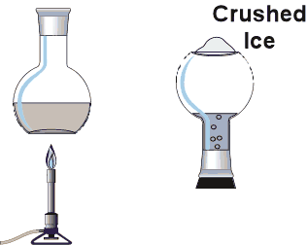 | Heat water to boiling in a Cincinnati flask.  Remove heat, stopper and invert.  Boiling continues again as ice is added to the dimple in the flask.
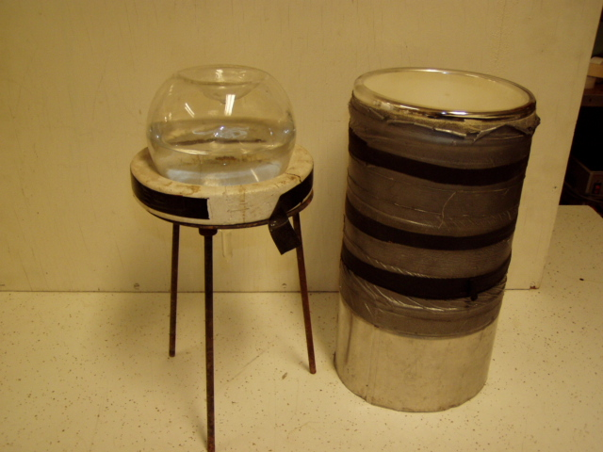Location: Ga2
THERMODYNAMICS | 4C30.35 | CHANGE OF STATE
Phase Changes: Liquid-Gas

Liquid Nitrogen in a Balloon
 | A small amount of liquid nitrogen (about a third of the test tube) blows up a balloon until it bursts.
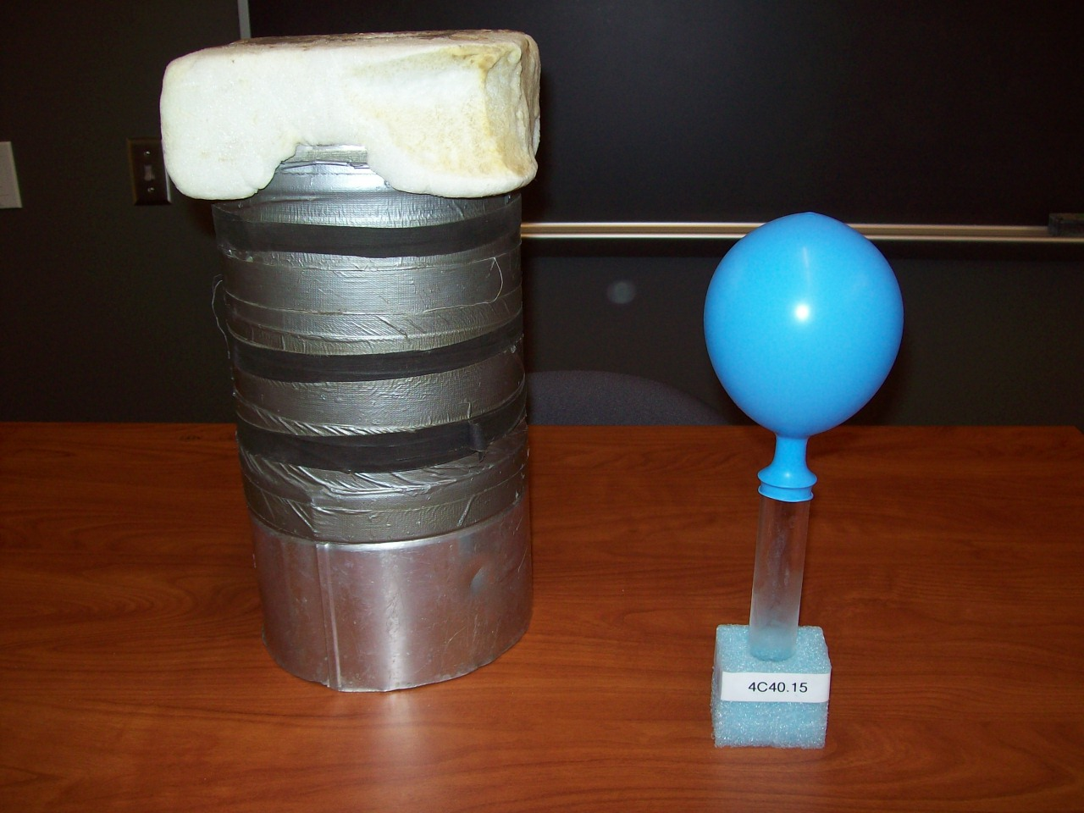
Location: Ga2, Gb2

THERMODYNAMICS | 4C30.40 | CHANGE OF STATE
Phase Changes: Liquid-Gas

Heat of Vaporization of Water
 | Monitor the temperature of ice water as it is heated on a hot plate to boiling. The temperature vs. time plot is shown using Science Workshop file: melting ice.ds.
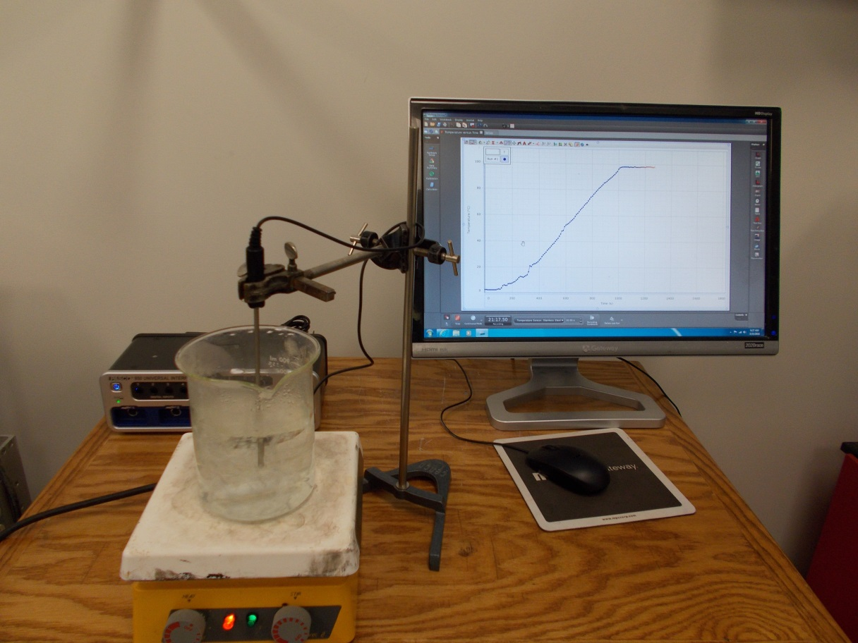
Location: Science Workshop Cabinet, Fc1, Gb2

THERMODYNAMICS | 4C30.80 | CHANGE OF STATE
Phase Changes: Liquid-Gas

Making Liquid Oxygen
 | Liquid oxygen (B.P. 90K) will drip from the outer surface of a thin brass cone filled with liquid nitrogen (B.P. 77K). Pre-cool the 150 ml clear dewar in a 5 l dewar filled with LN2, then remove it, fill the cone from the 5 l dewar, replace the smaller dewar in the 5 l dewar and place it under the cone. Generates about 75 ml LOX in a half hour.
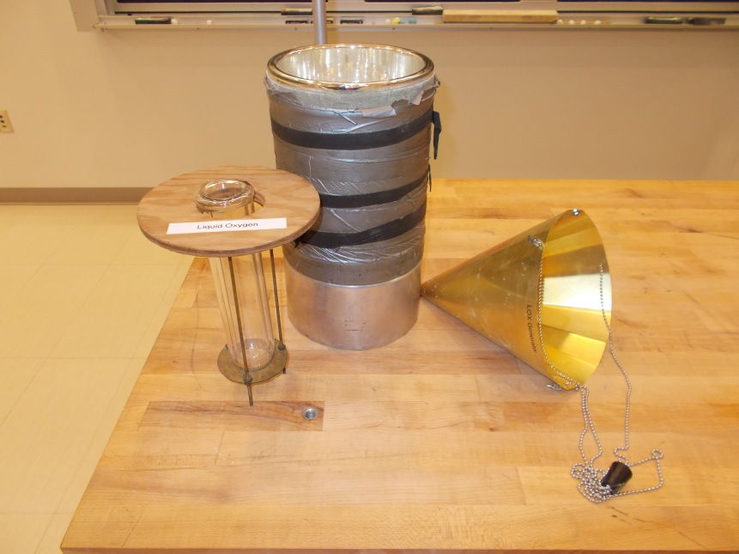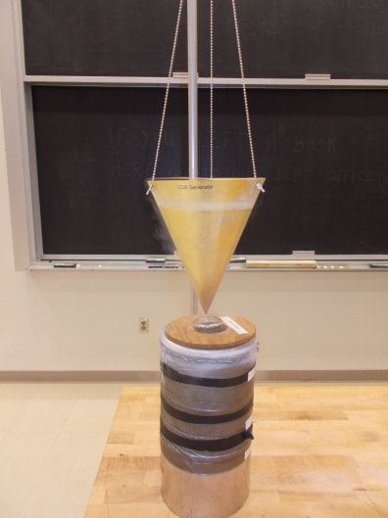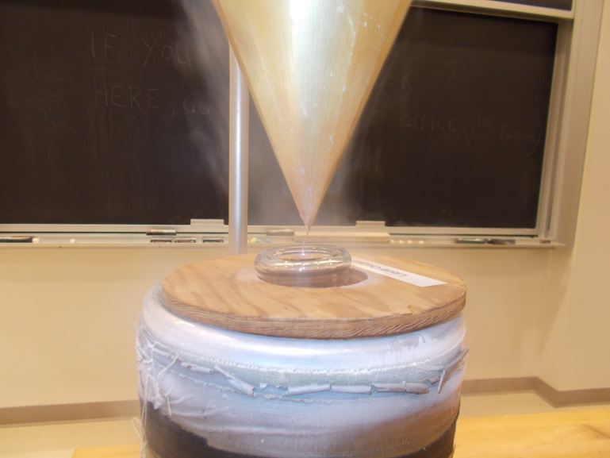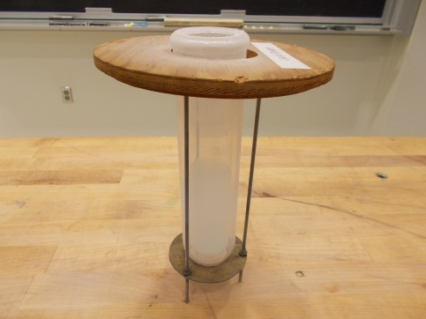
Location: Ga2, Hb6
THERMODYNAMICS | 4C31.20 | CHANGE OF STATE

Cooling by Evaporation

Freezing by Boiling
 | Evacuate a chamber containing a small amount of water. Use about 25 ml of water in a tall beaker. The beaker should be on top of an insulator and a piece of plastic that keeps the pumping line from being obstructed. Run the pump for about a half hour in the ballast position after doing this demonstration to get the water out of the pump oil.
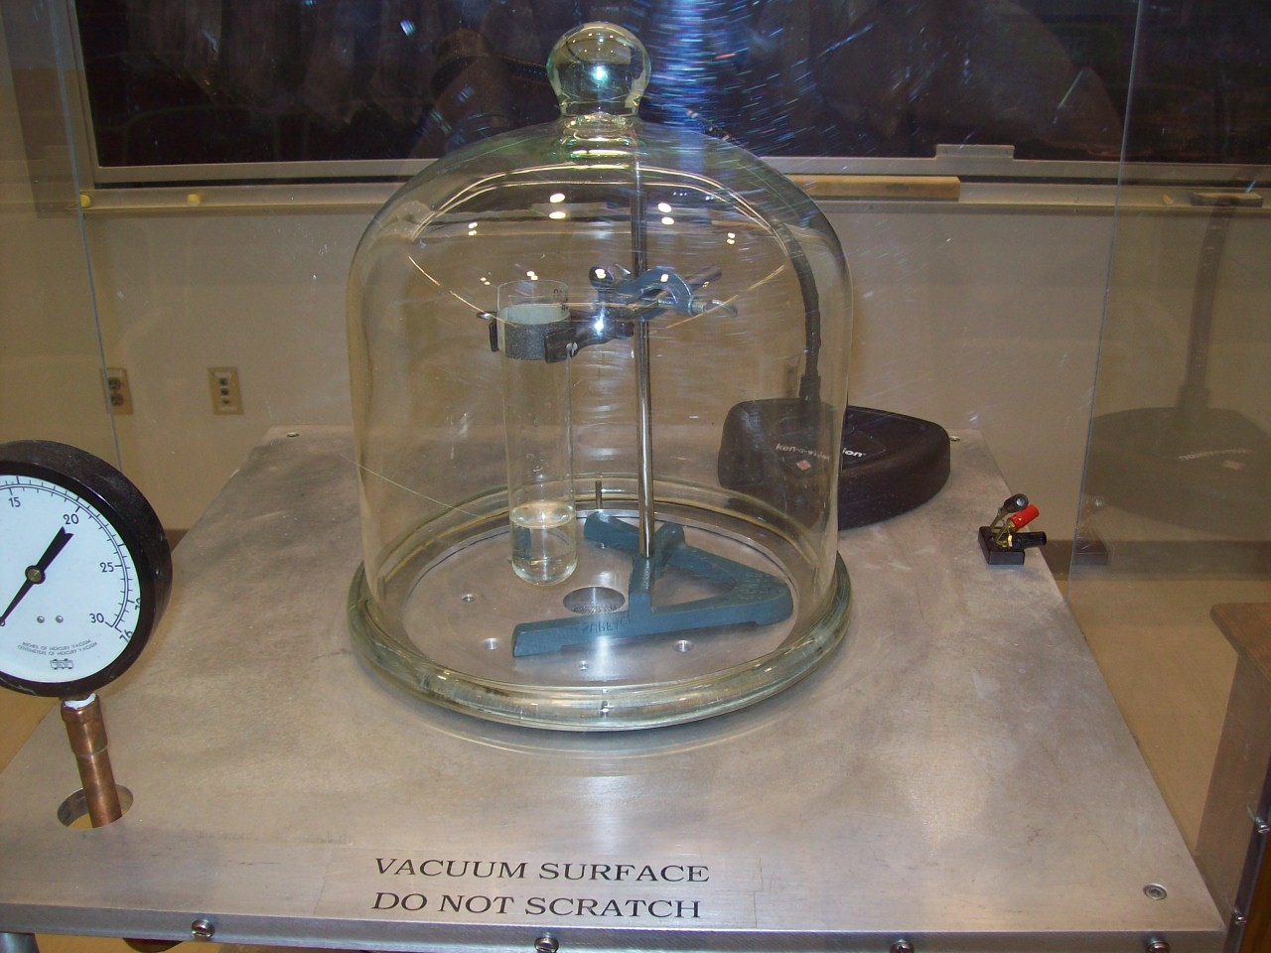
Location: Ga2
THERMODYNAMICS | 4C31.30 | CHANGE OF STATE
Cooling by Evaporation

Drinking Bird
Disc 15-12
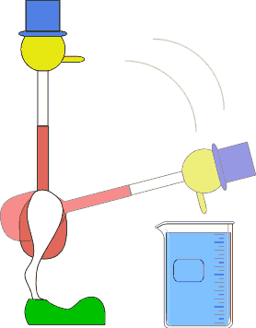 | Soak the bird's head in the water and let him "drink".
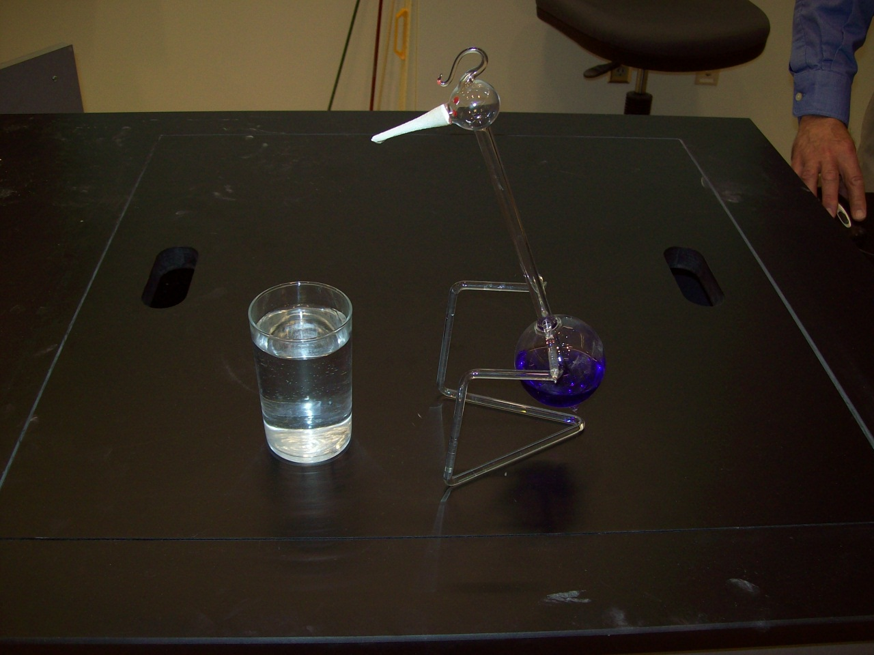Location: Ga2
THERMODYNAMICS | 4C32.10 | CHANGE OF STATE

Dew Point and Humidity

Sling Psychrometer
 | Use a commercial sling psychrometer to measure the relative humidity
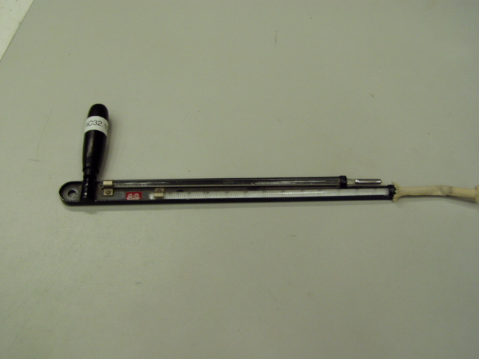Location: Ga2

THERMODYNAMICS | 4C33.50 | CHANGE OF STATE

Vapor Pressure

Pulse Glass
 | A tube with a bulb on each end partially filled with a volatile liquid is held by one bulb in the palm forcing the liquid into the other bulb.
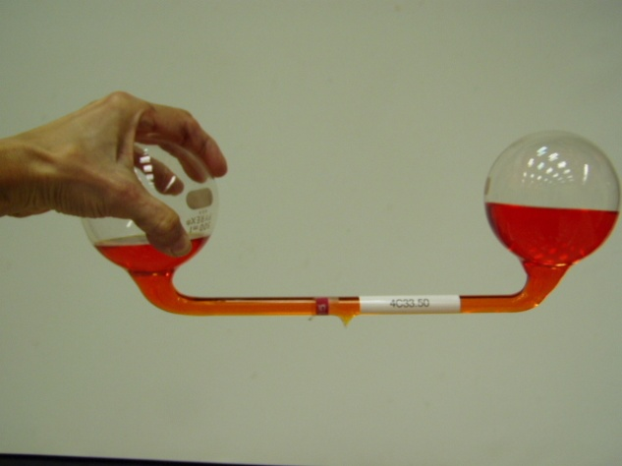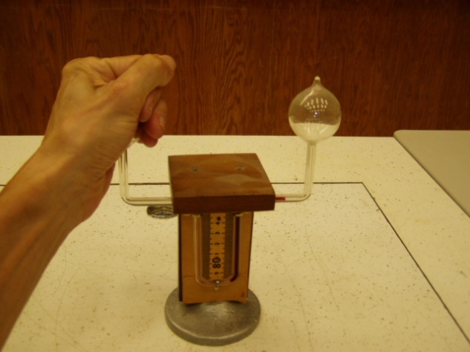
Location: Ga2
THERMODYNAMICS | 4C40.10 | CHANGE OF STATE

Sublimation

Sublimation of CO₂
 | Watch carbon dioxide sublimate.
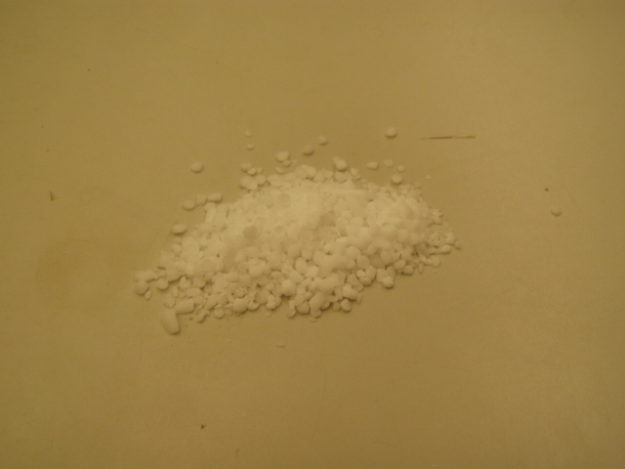Location: Chemical Stores (701 Hamilton)
THERMODYNAMICS | 4C40.15 | CHANGE OF STATE
Sublimation

Blow up a Balloon with CO₂
 | Attach a balloon to a test tube with dry ice and when the balloon is inflated, immerse the tube in liquid nitrogen.
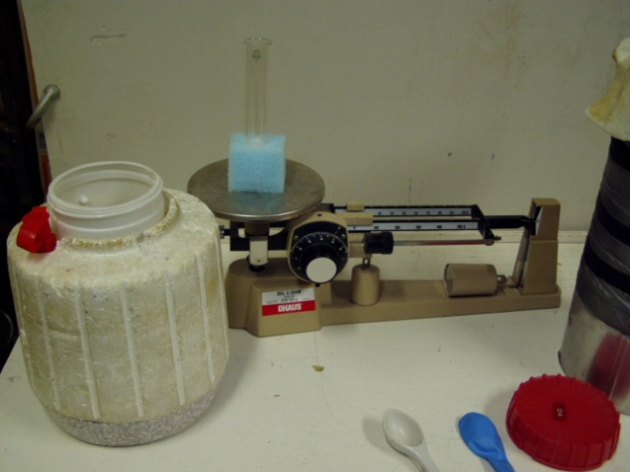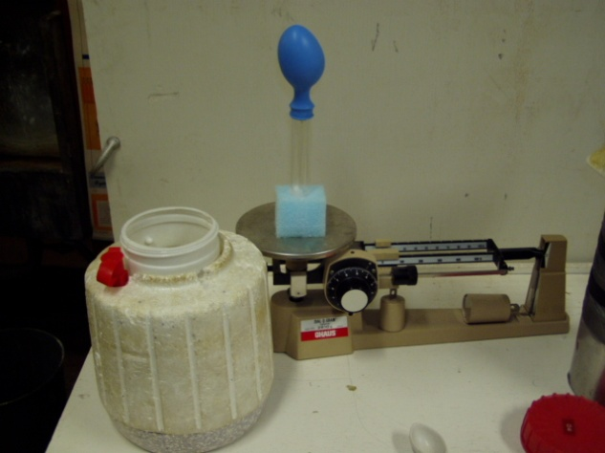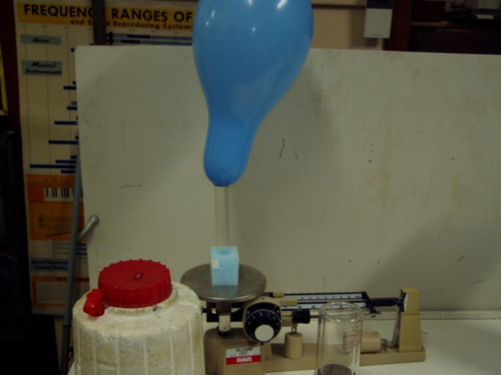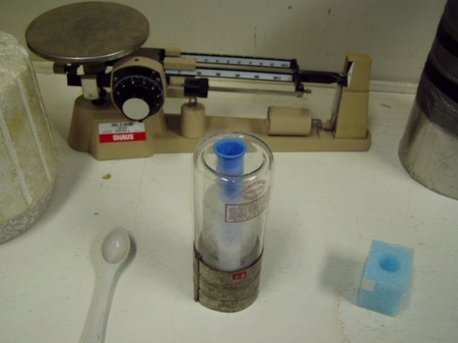
Location: Chemical Stores (701 Hamilton), Ga2, Gb1

THERMODYNAMICS | 4C45.15 | CHANGE OF STATE

Phase Changes: Solid-Solid

Nitinol Wire
 | Deform wire “N” and then place in boiling water. It will return to it set shape as it goes from its Martensite phase to its Austenite phase
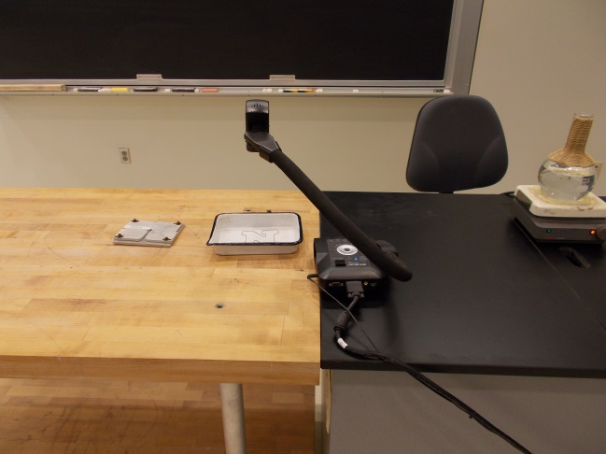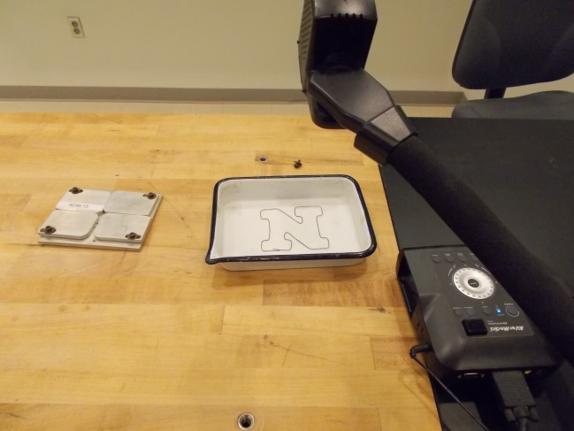
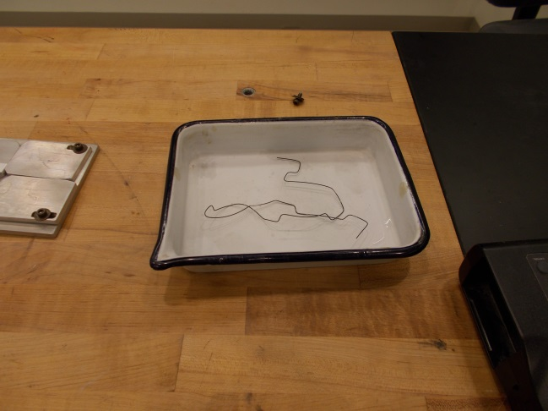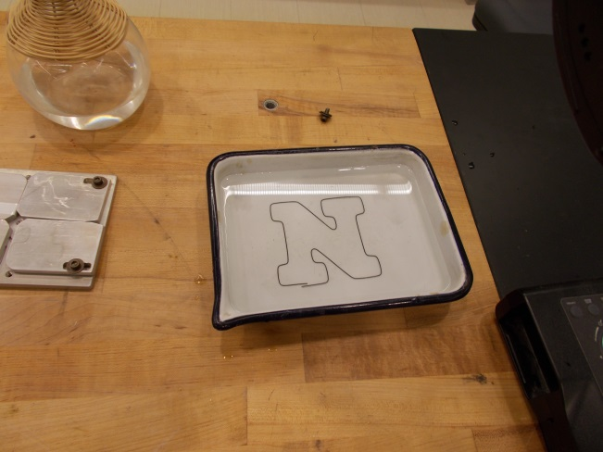
Location: Ga2

THERMODYNAMICS | 4C50.20 | CHANGE OF STATE

Critical Point

Critical Opalescence
 | A sealed chamber of Freon is heated to the critical point
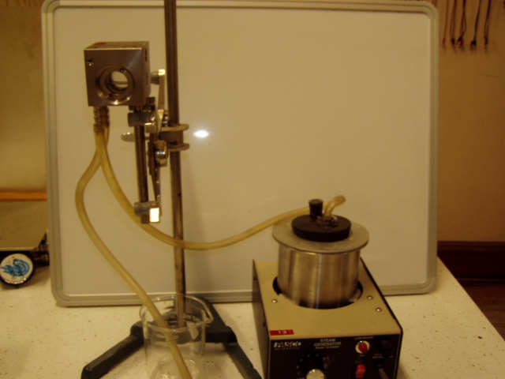 Location: Ga2, Gb2
THERMODYNAMICS | 4C50.40 | CHANGE OF STATE
Critical Point

Triple Point of Water Cell
 | Triple point cell. Prepare with dry ice and alcohol as the instructions on the container indicate.
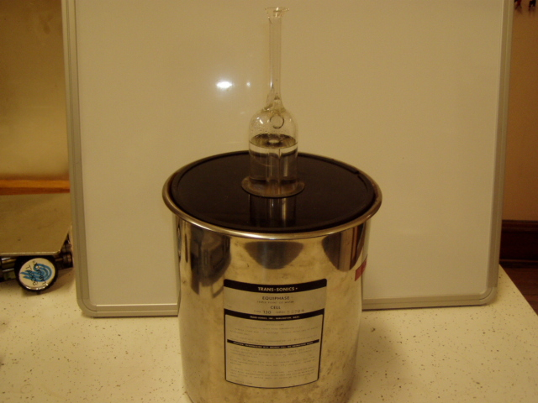Location: Ga7
THERMODYNAMICS | 4D10.40 | KINETIC THEORY

Brownian Motion

Brownian Motion Cell
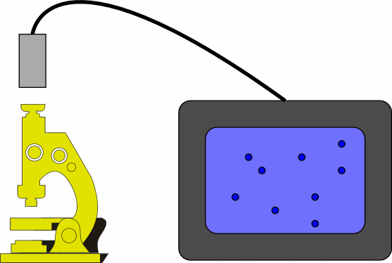 | Observe the motion of polystyrene spheres made by Dow through a microscope. The balls are about 1 micron in diameter. Put a drop of the solution on a slide then place a cover slide on top of it. Use a drop of oil with the oil immersion objective. The well slide works best (less systematic movement); if you use it, place a drop in the well then dilute it with water.
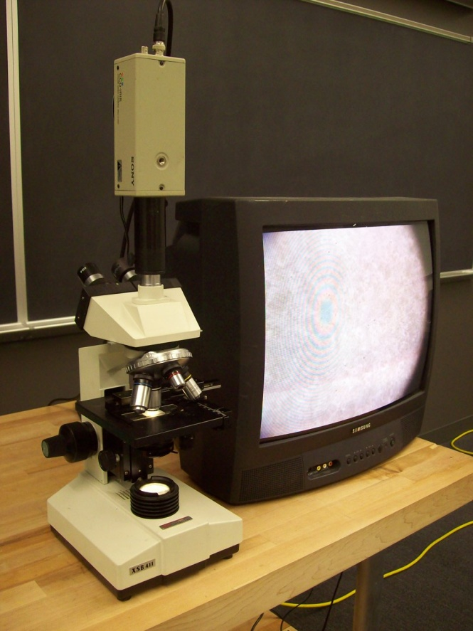
Location: Ga3
THERMODYNAMICS | 4D20.10 | KINETIC THEORY

Mean Free Path

Crookes' Radiometer
Disc 14-23
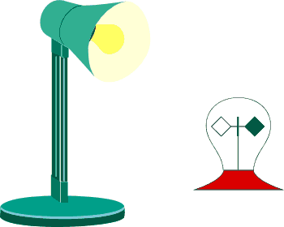 | This radiometer spins in the opposite direction from what theory predicts; the white side moves forward.  Turn on the light and watch it spin.
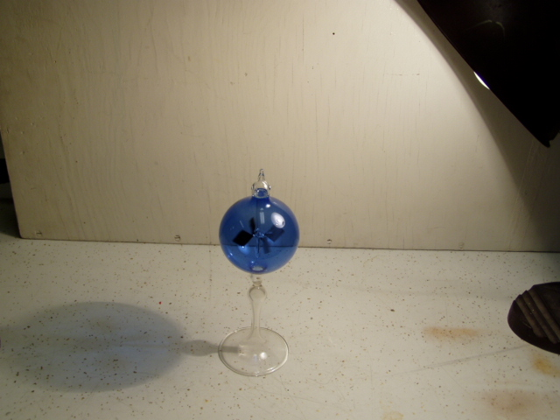Location: Ga3

THERMODYNAMICS | 4D30.20 | KINETIC THEORY

Kinetic Motion

Molecular Motion Demonstrator
 | The kinetic theory of gas is illustrated using a variable speed molecular motion demonstrator with the document camera.
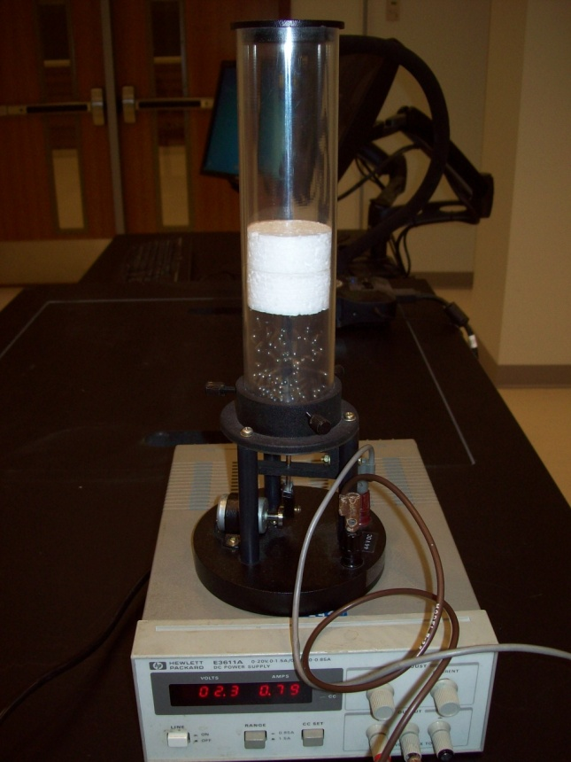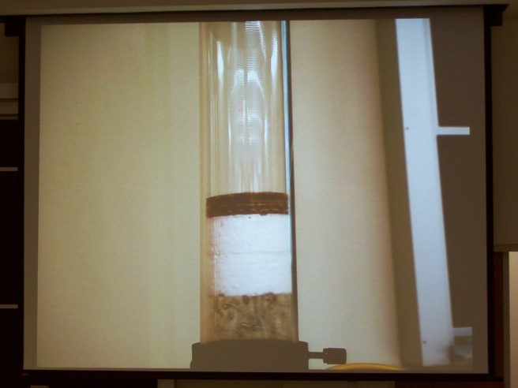
Location: Ga4
THERMODYNAMICS | 4D30.32 | KINETIC THEORY
Kinetic Motion

Air Table Molecules
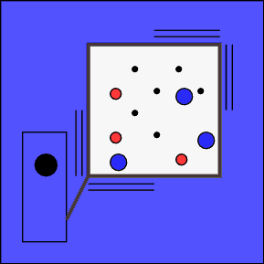 | Small magnets on plastic pucks placed on an air table that rest on an overhead projector, can be used to show many demonstrations of molecular kinetics. The table has magnetic bumpers and various attachments that can simulate motion of a molecule in a vacuum, in a gas, velocities of molecules, molecules of different masses, mixing temperatures of gases, adiabatic compression and expansion, pressure temperature dependence, pressure number dependence, diffusion, Brownian motion, law of atmospheres, phase changes, and heat conduction in solids; there are also several solid state and nuclear physics simulations as well
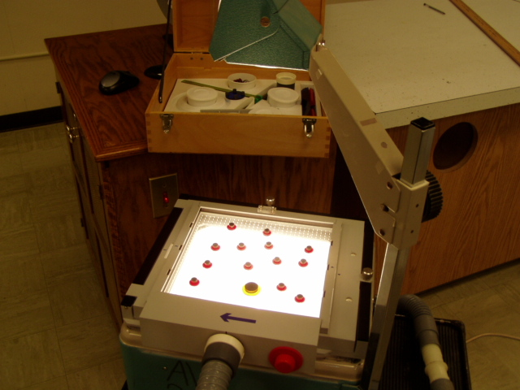Location: Ga5
THERMODYNAMICS | 4D30.40 | KINETIC THEORY
Kinetic Motion

Kinetic Theory Model
 | Mercury heated to boiling in an evacuated tube causes glass chips to fly about.
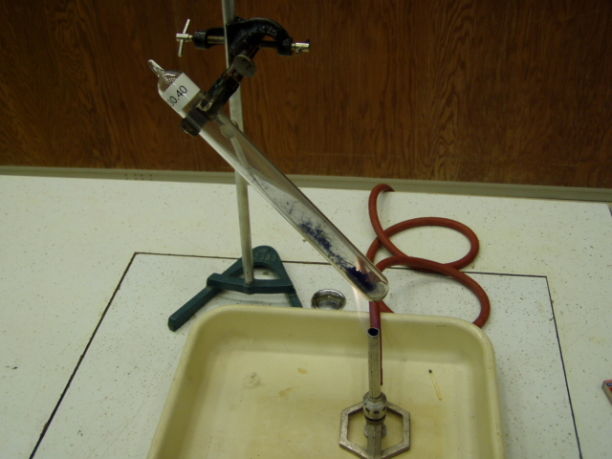Location: Ga4

THERMODYNAMICS | 4D40.10 | KINETIC THEORY

Molecular Dimensions

Oleic Acid Film
 | The length of an oleic acid molecule is estimated by creating a monolayer on the surface of water. The water is sprinkled with lycopodium powder so that the film is easily visible. Use a sewing machine needle to deliver a measured volume of oleic acid. The volume of the needle eye is 1.7 x 10⁻¹⁰ m³.After dipping the needle in the acid, wipe the tip with a paper towel to remove excess acid leaving only the eye filled.
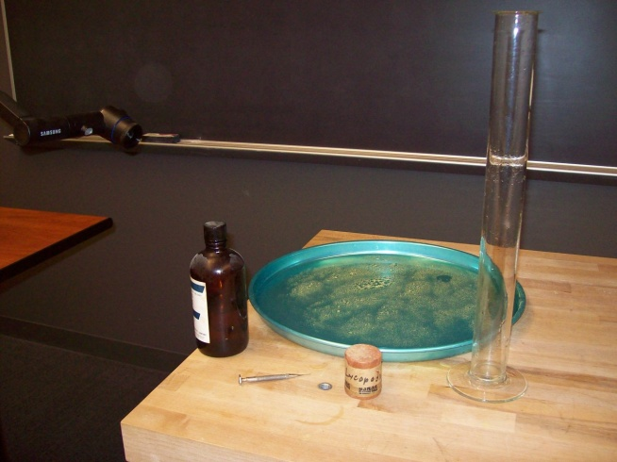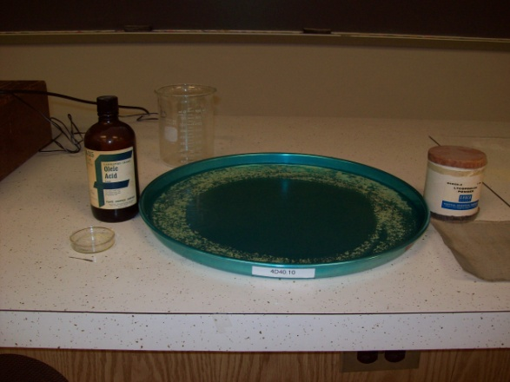
Location: Ga5
THERMODYNAMICS | 4E10.15 | GAS LAW

Constant Pressure

Change of Volume with Change of Temperature
 | The air under a piston in a cylinder is connected by a tube to a can. The can is heated raising the temperature of the air and the volume change is noted by the raising of the piston at constant pressure. There are two piston/cylinder sets with different diameters.
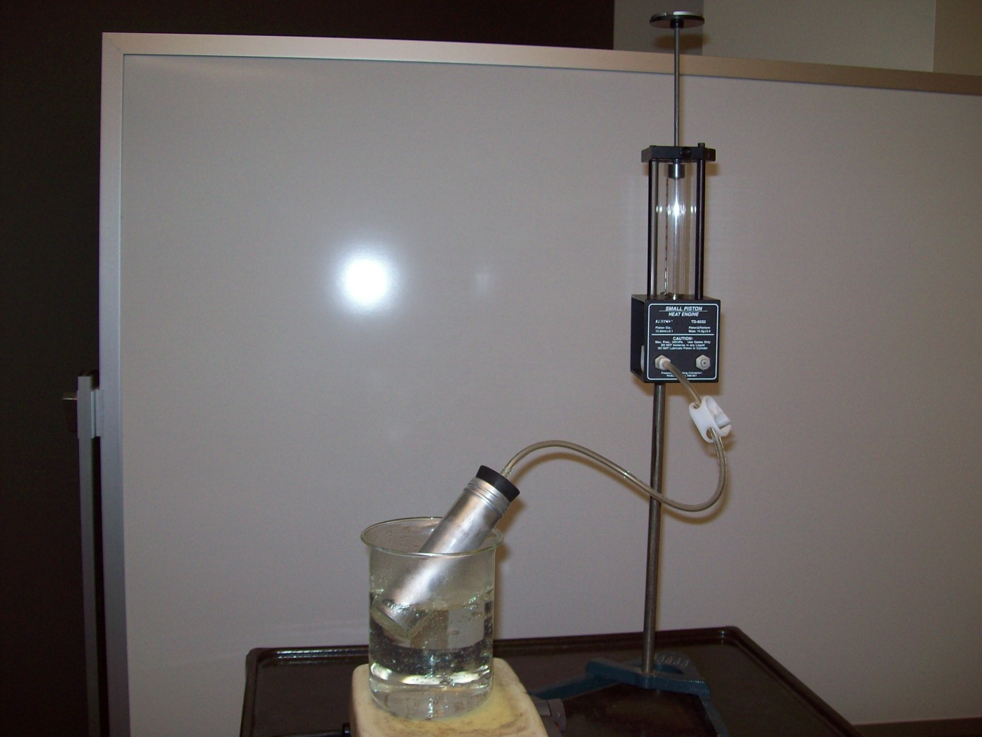Location: Ga4, Gb2
THERMODYNAMICS | 4E10.20 | GAS LAW
Constant Pressure

Balloon in LN2
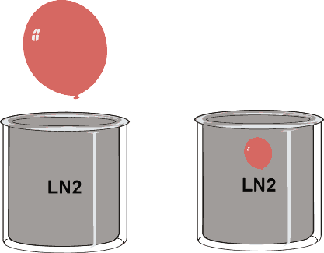 | An air-filled balloon sits in a beaker.  Pour liquid nitrogen over the balloon and watch it shrink.  Take the balloon out and it blows back up.
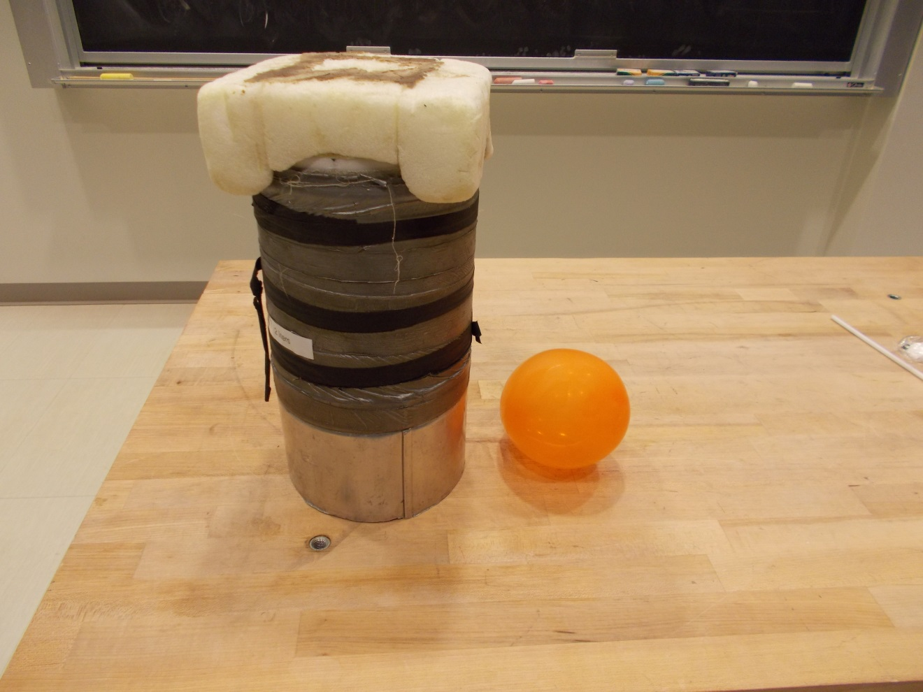Location: Ga2, Gb1
THERMODYNAMICS | 4E20.20 | GAS LAW

Constant Temperature

Boyle’s Law Apparatus
 | A syringe is connected to a pressure gauge. They are mounted on a clear piece of plastic that can be viewed with the document camera. Pressure vs. volume can be measured and plotted.
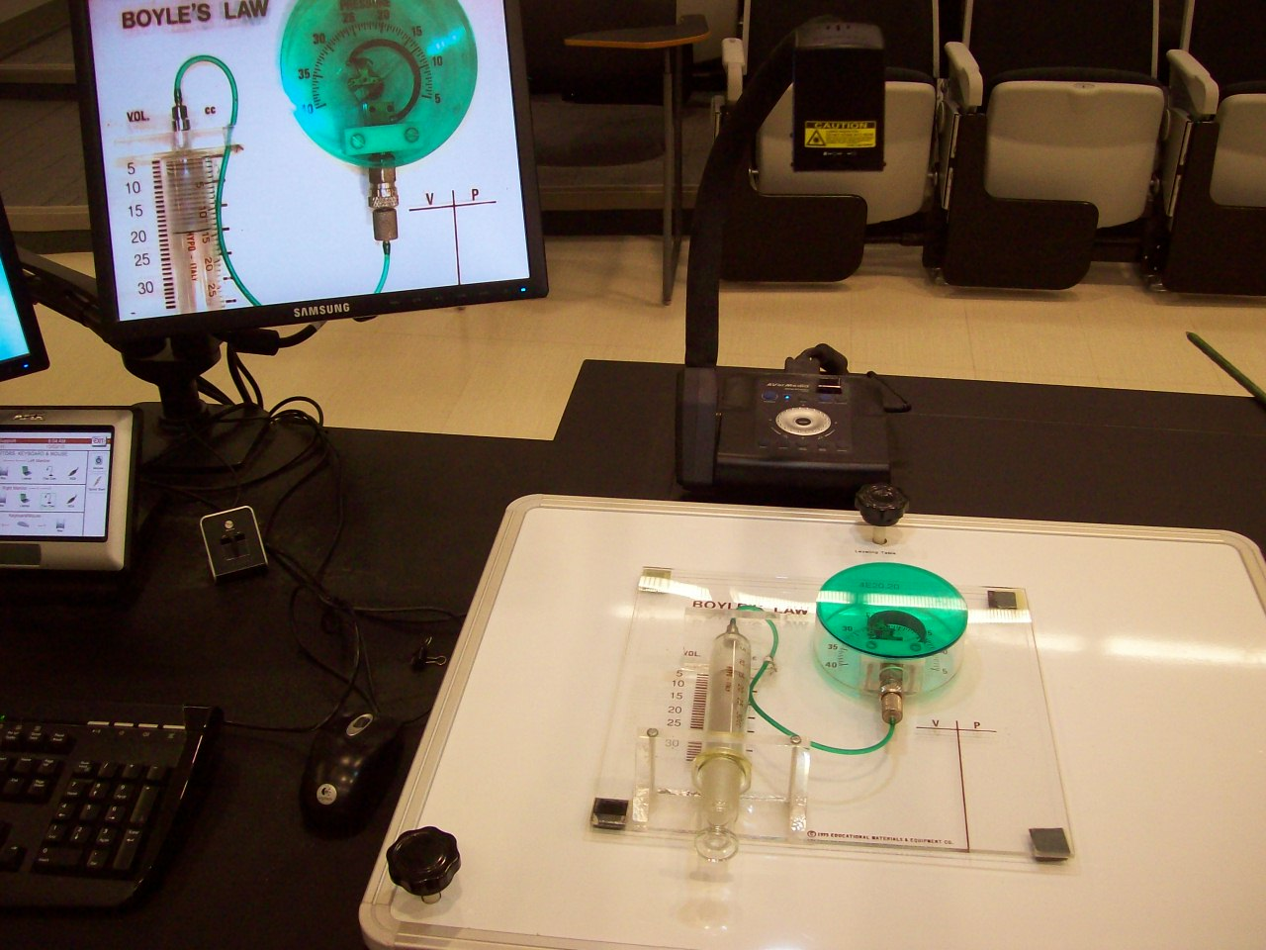
Location: Ga6
THERMODYNAMICS | 4E20.40 | GAS LAW
Constant Temperature

Balloon in a Vacuum
 | A partially inflated balloon is placed in a bell jar and the jar is evacuated. Also try a fresh marshmallow.
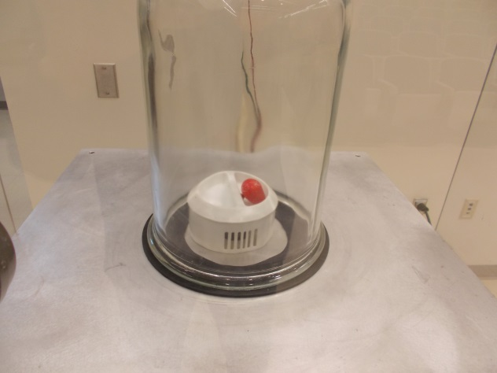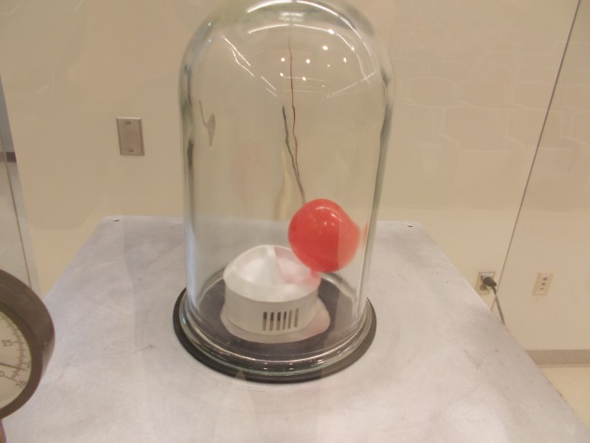
Location: Gb1
THERMODYNAMICS | 4E30.10 | GAS LAW

Constant Volume

Constant Volume Bulb
Disc 16-02
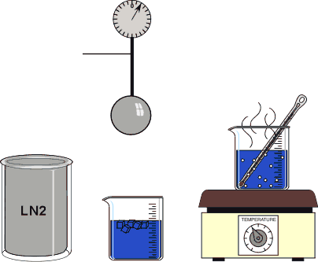 | The gauge measures the pressure in the sealed sphere in pounds per square inch. Atmospheric pressure is 14.7 lbs per square inch.  Read the pressure when the bulb is immersed in boiling water, ice water and LN2 (77 Kelvin).  Different gases may be put into the bulb.
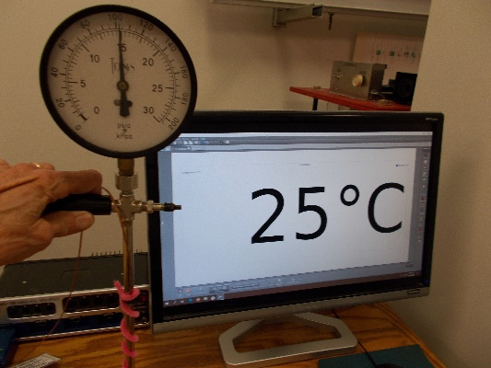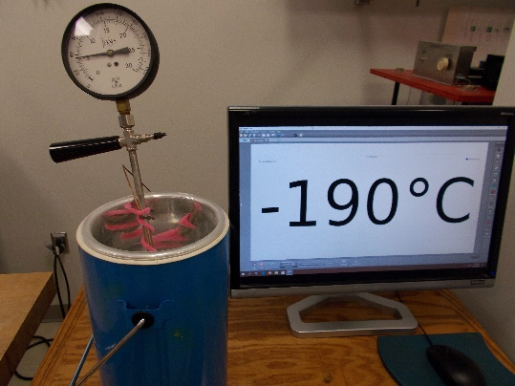
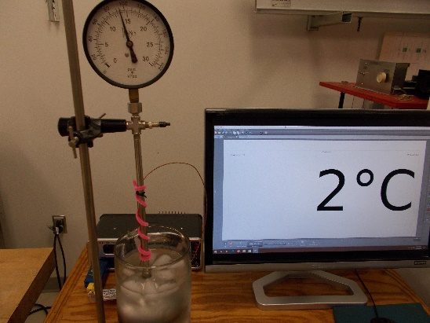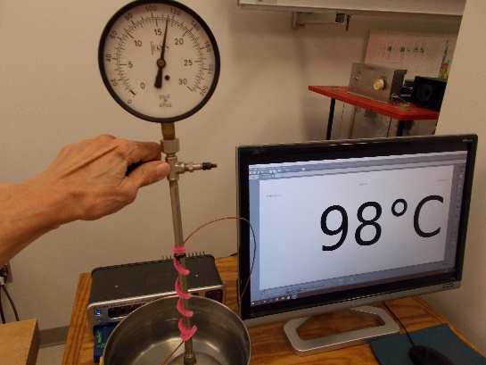
Location: Ga2, Ga6, Gb2
THERMODYNAMICS | 4F10.10 | ENTROPY AND THE SECOND LAW

Entropy

Time Reversal
 | A column of eosin dye solution in glycerin between two concentric cylinders appears to mix and unmix.
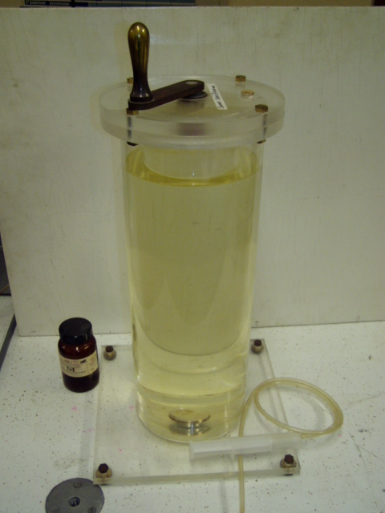
Location: Ga7
THERMODYNAMICS | 4F10.30 | ENTROPY AND THE SECOND LAW
Entropy

Hilsch Tube
 | The Hilsch tube is a sort of double vortex that separates hot air and cold air. Connect the hose to an air line and when you turn on the air, one side of the apparatus gets cold (the copper tube) while the other warms up. Observe with the FLIR camera.
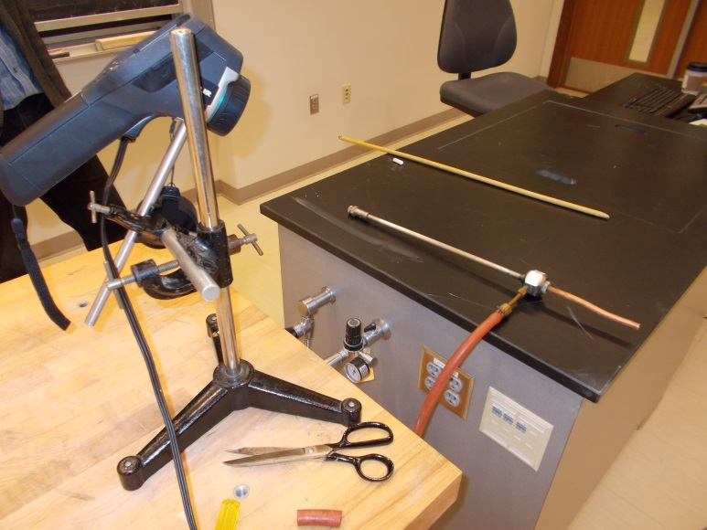
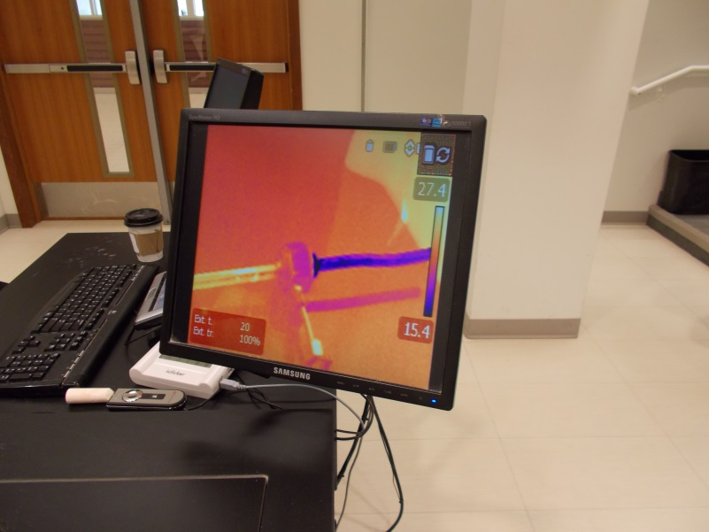
Location: Ga6
THERMODYNAMICS | 4F30.01 | ENTROPY AND THE SECOND LAW

Heat Cycles

Hero’s Engine, Drinking Bird
 | See 1Q40.80 and 4C31.30
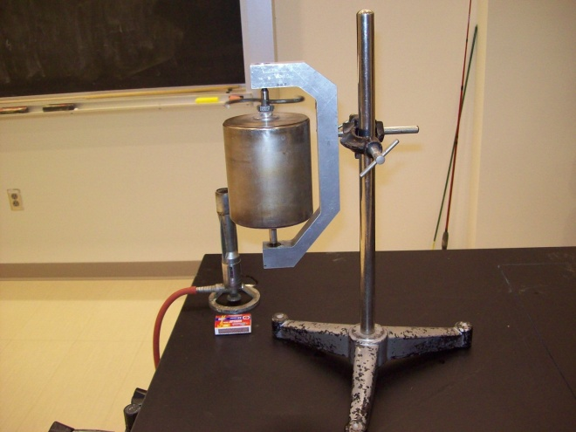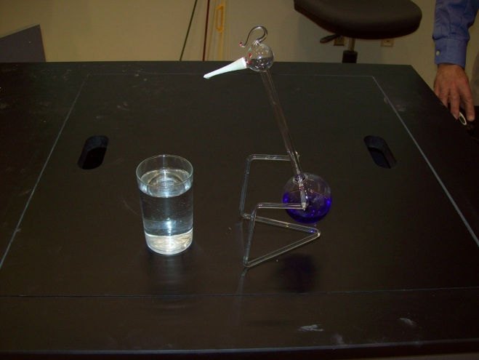
Location: Ga2, Ga6
THERMODYNAMICS | 4F30.10 | ENTROPY AND THE SECOND LAW
Heat Cycles

Stirling Engine
Disc 15-06
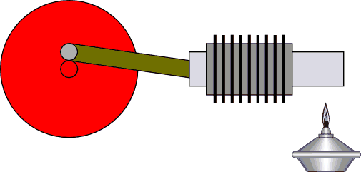 | Two engines are shown in the photograph. The large one uses hot water and ice water while the small one can run off of the heat from the palm of a hand in a cool room.  Start the engine by turning the fly-wheel in the proper direction (see your instructions)
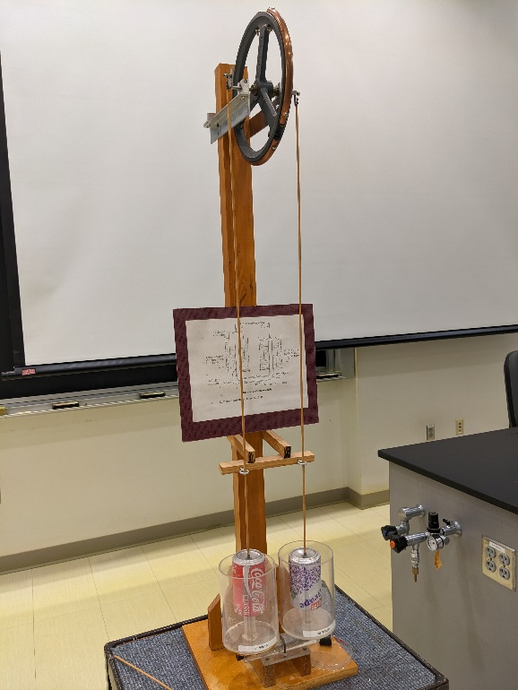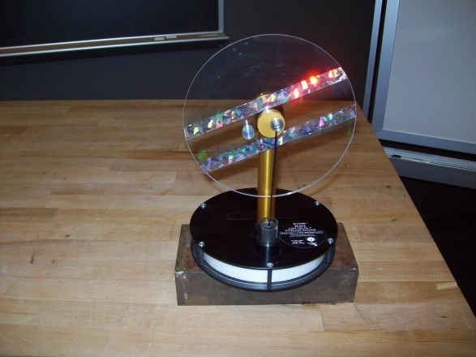
Location: Fd1, Ga6

THERMODYNAMICS | 4F30.70 | ENTROPY AND THE SECOND LAW
Heat Cycles

Rubber Band Engine
 | A wheel with rubber band spokes turns when heated locally with a heat cone. Be sure the wheel is well balanced before starting.
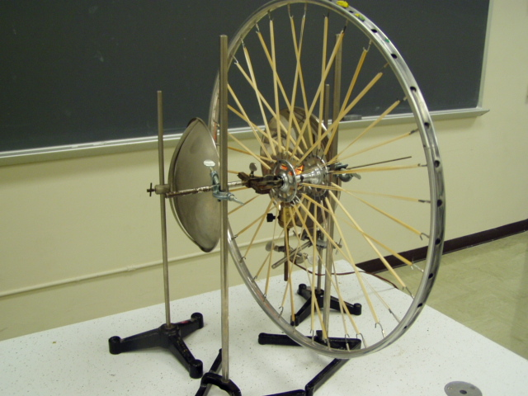
Location: Fd1

