Call for Proposals: Women’s & Gender Studies “No Limits” Conference 2020
University of Nebraska, Kearney
Friday, March 6, 2020 9:30am-5:30pm

Keynote Speaker: Dr. Lindsey Churchill
University of Central Oklahoma
Associate Professor of History and Director of Women’s, Gender & Sexuality Studies
“Reproductive Justice in a Red State”
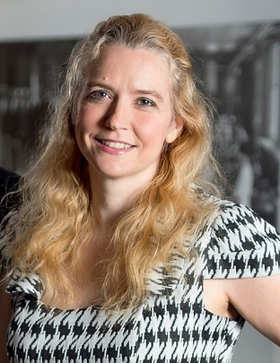

No Limits 2020:
- Is an annual student research conference dedicated to crossing boundaries between disciplines and exploring a wide range of issues related to women's and gender studies.
- Is open to undergraduates, graduate students, and recent graduates throughout the region.
- Welcomes proposals from any discipline or methodology, including creative writing, visual arts, film, music, performances, workshops, and academic papers.

Call for Proposals: Deadline for submissions is Friday, January 31, 2020
Students interested in presenting their work at the conference should submit the following information by email to Dr. Linda Van Ingen vaningenL1@unk.edu (type "No Limits” in the subject line):

- Project Information: title and abstract of approximately 250 words describing your project and its larger significance.
- Indicate if it is a paper presentation (20 minutes) or a poster presentation (48x36 inches)
- Your contact info: name, university affiliation, mailing address, email, phone.
- Your faculty mentor for this project.
- Biographical statement (about 50-75 words): your major/minor, hometown, academic and career goals, a fun fact.
- Send this information as an attachment AND in the body of your email.
Free and open to the public

Contact: Dr. Linda Van Ingen at 308-865-8772 vaningenL1@unk.edu
Annually co-sponsored on a rotating basis by NU Women’s & Gender Studies Programs at UNK, UNL, and UNO.

The University of Nebraska at Kearney is an affirmative action/equal opportunity institution

