Ger 282 advertised

Heimat-Homeland: Migrant women writing their airroots in German speaking countries.
(Taught in English. German majors can read/write in German for German credit.)

When writers choose or are forced to leave their homeland, they dig up their roots, and before burying them in new soil, they may just leave them dangling in the air. Why and how? Is a minority woman a migrant from within? What if you were born into a fascist time and can never shake those roots, never to arrive in your current country?
Raising more questions, dabbling in answers, reading May Ayim, Emine Sevgi Özdamar, Elif Shafak and Christa Wolf.

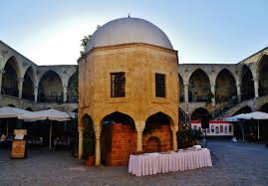

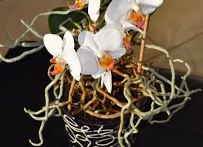

Book order:

*Christina Thürmer-Rohr: Vagabonding. Feminist Thinking cut loose. 0-8070-6756-3
*Ika Hugel Marshall The Invisible Woman ISBN 978-1-4331-0278-3
*May Ayim blues in black and White 0-86543-890-0
*Zsuzsa Bank The Swimmer 0-15-100032-5
-Melinda Nadj Abonji Fly away, pigeon 978-0857422125
*Emine Sevgi özdamar Life is a Caravanserai 1 898253 34 X
*Herta Müller Traveling on one leg 0-8101-1641-3
*Terezia Mora Day in Day out 978-0-06-083264-3
*Elif Shafak The Saint of Incipient Insanities 0-374-25357-9
*Christa Wolf Patterns of Childhood. 978-0374518448
*Else Lasker Schüler My Blue Piano 978-0-8156-1056-4

*Zsuzsa Bank The Swimmer 0-15-100032-5 (hard to find) leave out Spring 2020

