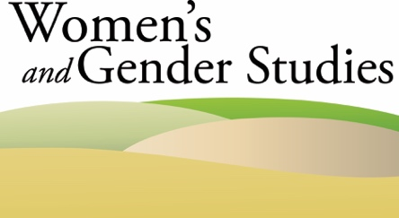

Co-Sponsorship Request Form

Please submit this form along with a CV and simple budget for the proposed speaker to:
Jennifer Haley at jhaley1@unl.edu.

Individual(s) and Department Seeking Co-sponsorship:

Contact Information:

Speaker or Event Name:

Title or Topic of Speaker’s Presentation:

Date of Event:

Amount of money requested from WGS:

Brief description of how speaker or event will address issues related to women’s and gender studies:

